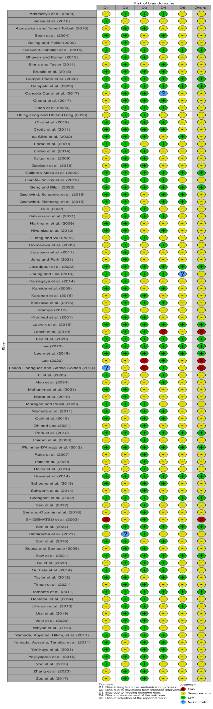

Figure4 Graph depicting the risk of bias

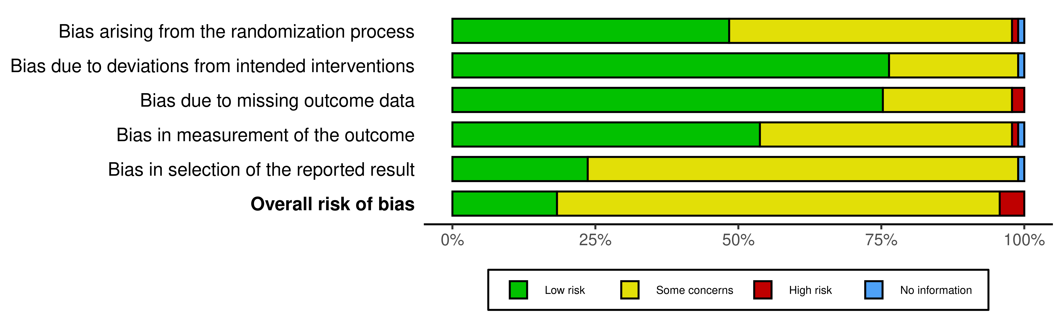

Figure 5 Risk of bias summary

