Supplementary material:

1: Visual Analogue Scale for Assessment of Pain
No pain______________________________________________________severe pain
Score=0 Score=100
How severe is your pain today? Place a vertical mark on the line above to indicate how bad you feel is your pain today.
The patient places a mark on the line to indicate his/her level of pain. The VAS score is determined by measuring in millimeters from the left hand end of the line to the point marked by the patient.

2: Mannequin for Recording Tender and Swollen Joints

3: Disease Activity Score in 28 Joints (DAS 28)

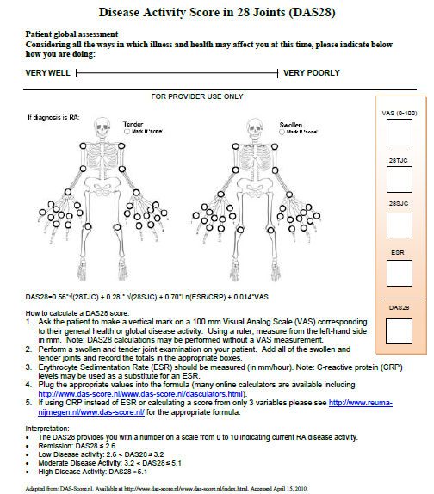

4: The Indian HAQ

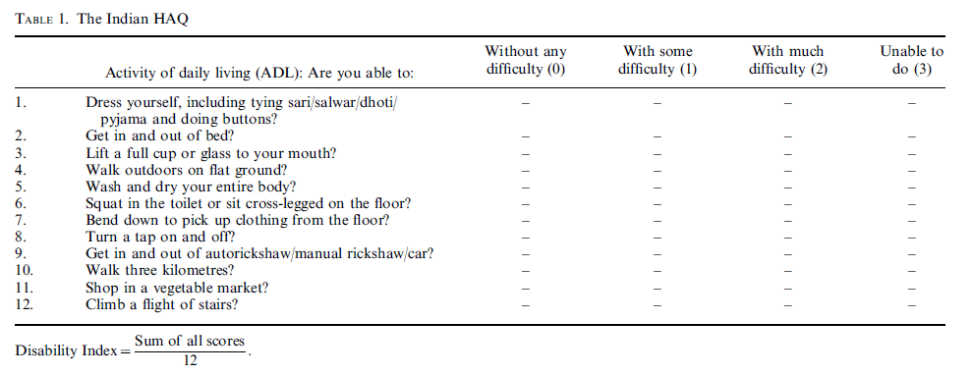

5: EULAR Criteria for Improvement in Disease Activity

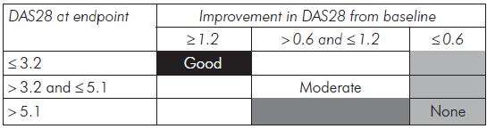

6: Geriatric Depression Scale (GDS-H) :

7: Activity of Daily Living (ADL- Barthel index)
Total score: ____/20
 | 0 | 1 | 2 | 3
Bowels | Incontinent | Occasional leaks (1/week) | Continent
Bladder | Incontinent/ catheterized | Occasional leaks (1/week) | Continent
Grooming | Needs help | Independent
Toilet use | Dependent | Needs help | Independent
Feeding | Dependent | Needs help | Independent
Dressing | Dependent | Needs help | Independent
Transfer (bed-chair-bed) | Unable | Major help by 1-2 people | Minor help verbal or physical | Independent
Mobility | Immobile | Wheel chair-independent | Walks with help of a person | Independent (may use aid)
Stairs | Unable | Needs help | Independent
Bathing | Unable | Independent

8: Instrumental ADL (IADL)
Total score: ____/8
Can you use the telephone? | Yes | No
Can you prepare meals? | Yes | No
Can you go to the market and do shopping? | Yes | No
Can you clean your home? | Yes | No
Can you wash your clothes? | Yes | No
Can you take your medicines? | Yes | No
Can you keep accounts and manage your money? | Yes | No
Can you use public transport? | Yes | No

9. Charlson risk index (CCI):
Condition | Assigned weights for diseases
Myocardial infarct | 1
Heart failure | 1
Peripheral vascular disease | 1
Cerebrovascular disease | 1
Dementia | 1
Chronic pulmonary disease | 1
Connective tissue disease | 1
Ulcer disease | 1
Mild liver disease | 1
Diabetes | 1
Hemiplegia | 2
Moderate or severe renal disease | 2
Diabetes with end organ damage | 2
Any tumor | 2
Leukemia | 2
Lymphoma | 2
Moderate or severe liver disease | 3
Metastatic solid tumor | 6
AIDS | 6
Weighted comorbidity classes
Low | 0 points
Medium | 1 to 2 points
High | 3 to 4 points
Very high | ≥5 points

