Supplements
S1 Flow diagram for study participants
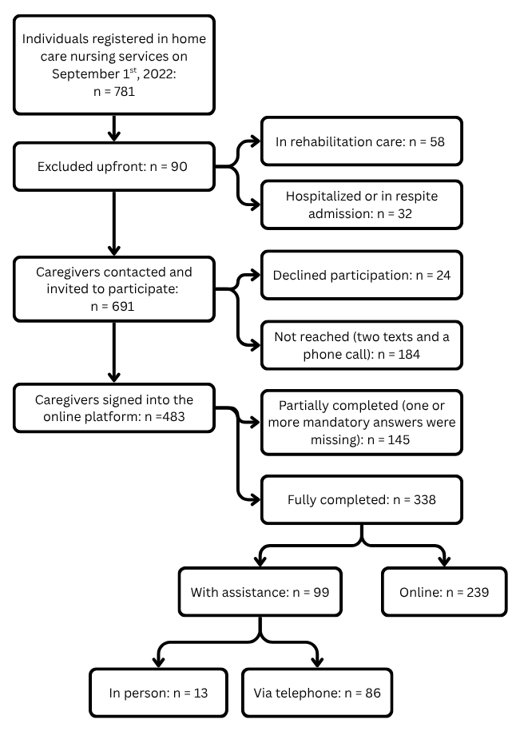
S2 Items from the Conceptual model and corresponding items from interRAI-SCaN
Element of burden from the model | Items from the instrument
Antecedents
Insufficient financial resources | Financial issues
Multiple responsibility conflict | Also caring for others
Lack of social participation | Decreased social participation
Attributes
Self-perception | Caring is stressful
Multifaceted strain  (The number of points from the included variables ranged from 0 to 19, with a higher number indicating more strain.) | Sleep quality
 | Presence of physical pain
 | Level of physical pain
 | Health conditions
 | Perceived inadequacy in caregiving
 | No time for myself
 | Exhaustion
 | Self-rated health
Over time | Length of caregiving
Consequences
Decreased care provision | I need to decrease caregiving
Decrease in quality of life | My life is good
Health deterioration  (Combined number of points for both variables, with a higher score indicating worse health). | Self-worth
 | Visits with health care professionals

S3 Comparison of scales by gender, only including cases in the regression (N=347)
 | Men (n=110) | Women (n=237) | Total  (n=347) | Statistics |  | sig
 | n (%) | n (%) | n (%)
Caregiver Well-Being Index (1-4) |  |  |  | χ² 10.809 | S | 0.013
Excellent well-being | 86 (78.2) | 144 (60.8) | 230 (66.3)
Good well-being | 11 (10.0) | 52 (21.9) | 63 (18.2)
Fair well-being | 7 (6.4) | 23 (9.7) | 30 (8.6)
Poor well-being | 6 (5.5) | 18 (7.6) | 24 (6.9)
Mean | 1.39 | 1.65 | 1.56 | f 7.352 | S | 0.013
SD | 0.836 | 0.940 | 0.92
Multifaceted Strain Scale (0-19) |  |  |  | f 7.477 | S | 0.001
Mean | 4.95 | 7.43 | 6.67
SD | 4.19 | 5.05 | 4.92
Role Overload Scale (0-4) |  |  |  | f 0.744 | S | 0.003
Mean | 0.64 | 1.00 | 0.89
SD | 0.95 | 1.08 | 1.05

S4 Correlation analysis of scales and background variables – Spearman’s rho
Variables | Caregiver Well-Being Index
CG role overload | 0.30*** | Role overload
CG multifaceted strain | 0.57*** | 0.30*** | Multifaceted strain
CG gender | 0.13* | 0.16** | 0.22***
CG age | 0.01 | -0.36*** | 0.08
CG marital status | 0.14** | 0.11* | 0.11*
Relationship to CR | -0.84 | 0.10 | -0.17*
CG decreased social participation | 0.44*** | 0.29*** | 0.51***
CG financial difficulties | 0.29*** | 0.27*** | 0.32***
CG multiple responsibility | 0.08 | 0.36*** | 0.20***
CG self-perceived burden | 0.39*** | 0.45*** | 0.44***
CG years of caregiving | 0.04 | -0.03 | 0.49
CG = Caregiver; CR = Care Recipient

