Supplementary material
Text S1: Distributional characteristics of continuous variables (age, BMI, and sleep duration) were examined using descriptive statistics, prior to their categorization based on widely used cut-offs in previous literature.
Table S1 Descriptive statistics and skewness for continuous variables before categorization
Variable | Mean | Standard Deviation | Skewness
Age | 67.05 | 6.30 | 0.94
BMI | 23.26 | 5.61 | 17.60
Sleep duration | 6.72 | 2.28 | -0.05
* Skewness values were used to assess the distribution of continuous variables prior to categorization.

Text S2: Subgroup analyses of the association between sarcopenia and the likelihood of successful aging
Figure S1 illustrates the stratified analysis of the association between sarcopenia and successful aging by sex, age group, education, and residence. Among male older adults aged 60 and above, after adjusting for confounding factors, compared to the participants without sarcopenia, the likelihood of successful aging in those with possible sarcopenia, and sarcopenia decreased by 37% (HR=0.63, 95% CI: 0.51-0.76), and 45% (HR=0.55, 95% CI: 0.42-0.70), respectively. For older women, the likelihood of successful aging in those with possible sarcopenia and sarcopenia declined by 41% (HR=0.59, 95% CI: 0.46-0.75), and 45% (HR=0.55, 95% CI: 0.41-0.75), respectively.
Among younger older adults aged 60-69 years, after adjusting for confounding factors, compared to the participants without sarcopenia, the likelihood of successful aging in those with possible sarcopenia, and sarcopenia decreased by 34% (HR=0.66, 95% CI: 0.56-0.78), and 49% (HR=0.51, 95% CI: 0.41-0.65), respectively. For older adults aged 70 and above, the likelihood of successful aging in those with possible sarcopenia and sarcopenia declined by 60% (HR=0.40, 95% CI: 0.27-0.59), and 39% (HR=0.51, 95% CI: 0.41-0.65), respectively.
Among rural older adults, after adjusting for confounding factors, compared to the participants without sarcopenia, the likelihood of successful aging in those with possible sarcopenia, and sarcopenia decreased by 27% (HR=0.73, 95% CI: 0.59-0.90), and 37% (HR=0.63, 95% CI: 0.49-0.80), respectively. For urban older adults, the likelihood of successful aging in those with possible sarcopenia and sarcopenia declined by 51% (HR=0.49, 95% CI: 0.39-0.62), and 54% (HR=0.46, 95% CI: 0.32-0.65), respectively.
Among illiterate older adults, after adjusting for confounding factors, compared to participants without sarcopenia, the likelihood of successful aging in those with possible sarcopenia, and sarcopenia decreased by 43% (HR=0.57, 95% CI: 0.37-0.86), and 44% (HR=0.56, 95% CI: 0.33-0.94), respectively. For older adults with an elementary school or below education level, the likelihood of successful aging in those with possible sarcopenia and sarcopenia declined by 37% (HR=0.63, 95% CI: 0.51-0.77), and 39% (HR=0.61, 95% CI: 0.48-0.78), respectively. For older adults with a middle school or above education level, the likelihood of successful aging in those with possible sarcopenia and sarcopenia declined by 41% (HR=0.59, 95% CI: 0.45-0.77), and 53% (HR=0.47, 95% CI: 0.31-0.71), respectively.

 | Successful aging
 | HR(95%CI) | Forest plot
Sex
Male
Possible sarcopenia | 0.63(0.51-0.76)
Sarcopenia | 0.55(0.42-0.70)
Female
Possible sarcopenia | 0.59(0.46-0.75)
Sarcopenia | 0.55(0.41-0.75)
Age
60-69 years
Possible sarcopenia | 0.66(0.56-0.78)
Sarcopenia | 0.51(0.41-0.65)
≥70 years
Possible sarcopenia | 0.40(0.27-0.59)
Sarcopenia | 0.61(0.41-0.91)
Residence
Rural
Possible sarcopenia | 0.73(0.59-0.90)
Sarcopenia | 0.63(0.49-0.80)
Urban
Possible sarcopenia | 0.49(0.39-0.62)
Sarcopenia | 0.46(0.32-0.65)
Education level
Illiterate
Possible sarcopenia | 0.57(0.37-0.86)
Sarcopenia | 0.56(0.33-0.94)
Elementary school or below
Possible sarcopenia | 0.63(0.51-0.77)
Sarcopenia | 0.61(0.48-0.78)
Middle school or above
Possible sarcopenia | 0.59(0.45-0.77)
Sarcopenia | 0.47(0.31-0.71)
Figure S1 Sarcopenia and likelihood of successful aging among older adults with stratified analysis in sex, age, education and residence. The forest plots illustrates the impact of sarcopenia on successful aging in older adults, stratified by sex, age, residence and education, with a non-sarcopenia reference group. Reference group was non-sarcopenia. Abbreviation: HR: hazard ratio; CI: confidence interval. HR was adjusted for sex, age group, marital status, residence, education, smoking, drinking, sleep duration and body mass index.

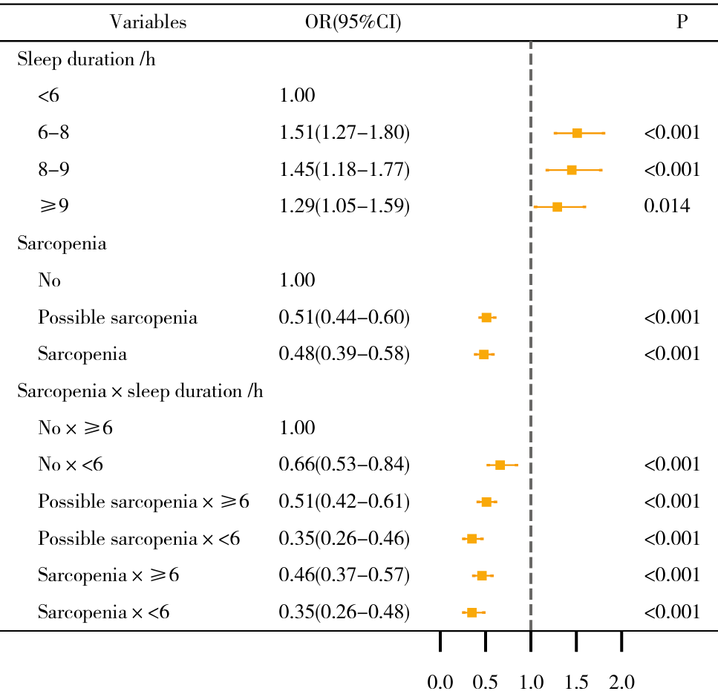
Figure S2 Independent and combined association of sarcopenia and sleep duration with the likelihood of achieving ≥4 components of successful aging among older people by logistic analysis. Abbreviation: OR, odds ratio; CI, confidence interval; h, hours. OR was adjusted for sex, age group, marital status, residence, education, smoking, drinking and body mass index.

Alt text: Forest plots illustrating the independent and combined impact of sarcopenia and sleep duration on the likelihood of achieving ≥4 components of successful aging in older adults aged 60 and above.

Table S2 Longitudinal associations of sleep duration and sarcopenia with successful aging using generalized linear mixed model (GLMM)
Variables | OR(95%CI) | P
Sleep duration /h
<6 | 1.00
6-<8 | 2.02(1.74-2.35) | <0.001
8-<9 | 2.16(1.82-2.56) | <0.001
≥9 | 1.47(1.24-1.74) | <0.001
Sarcopenia
No | 1.00
Possible sarcopenia | 0.45(0.38-0.52) | <0.001
Sarcopenia | 0.53(0.44-0.65) | <0.001
* OR, odds ratio; CI, confidence interval; h, hours. OR was adjusted for sex, age group, marital status, residence, education, smoking, drinking, body mass index and wave.

Figure S3 Conceptual framework illustrating the potential joint and independent association between sarcopenia and sleep duration with successful aging among older adults.
Successful aging
Sarcopenia status
Non-sarcopenia
Possible sarcopenia
& sarcopenia
Sleep duration per day
Adequate sleep:
≥6 hours
Inadequate sleep:
<6 hours
Joint effects
Shared mechanism

* Sarcopenia and inadequate sleep may independently and additively influence successful aging via shared and distinct biological mechanisms, including systemic inflammation, neuroendocrine dysregulation, and mitochondrial dysfunction. Orange boxes indicate risk factors (associated with a lower likelihood of successful aging); green boxes indicate protective factors (associated with a higher likelihood of successful aging).

Alt text: A conceptual framework showing how sarcopenia status and sleep duration independently and jointly influence successful aging, with potential shared mechanisms.

