Supplementary file 1: Consolidated criteria for reporting qualitative studies (COREQ): 32-item checklist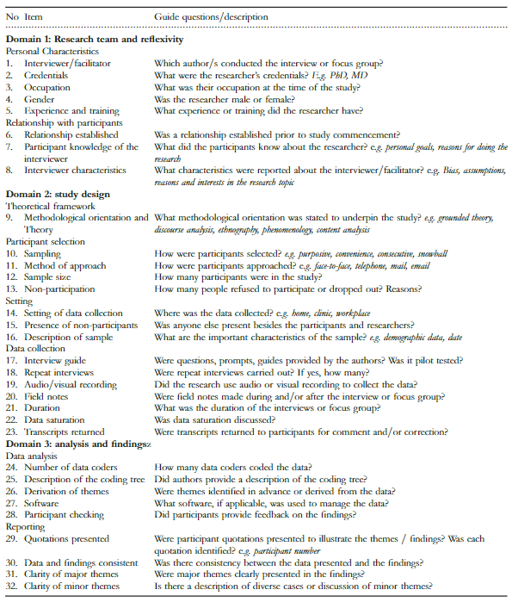
Downloaded from: https://www.equator-network.org/reporting-guidelines/coreq/. Accessed Dec 2023

