Supplemental Materials

Supplementary Table 1: Population characteristics for entire dataset (total cohort).

Risk factor | Total cohort (N=5816) | Did not fall (N=5251) | Fell (N=565) | P
Demographic data
Age (years) |  |  |  | <.001*
65-69 | 1088 (18.7%) | 1022 (19.5%) | 66 (11.7%)
70-74 | 1483 (25.5%) | 1357 (25.8%) | 126 (22.3%)
75-79 | 1288 (22.1%) | 1151 (21.9%) | 137 (24.2%)
80-84 | 1075 (18.4%) | 942 (17.9%) | 133 (23.5%)
85-90 | 627 (10.7%) | 561 (10.6%) | 66 (11.7%)
90+ | 255 (4.3%) | 218 (4.1%) | 37 (6.5%)
Female sex | 3216 (55.4%) | 2886 (54.9%) | 330 (58.4%) | 0.128
General health information
Overall health condition |  |  |  | <.001*
Excellent | 793 (13.6%) | 740 (14.1%) | 53 (9.3%)
Very good | 1926 (33.1%) | 1775 (33.8%) | 151 (26.7%)
Good | 1990 (34.2%) | 1804 (34.4%) | 186 (32.9%)
Fair | 907 (15.5%) | 769 (14.6%) | 138 (24.4%)
Poor | 200 (3.3%) | 163 (3.1%) | 37 (6.5%)
Heart attack¹ | 121 (2.0%) | 105 (1.9%) | 16 (2.8%) | 0.240
Heart disease¹ | 1050 (18.0%) | 916 (17.4%) | 134 (23.7%) | <.001*
High blood pressure¹ | 3977 (68.5%) | 3565 (67.9%) | 412 (72.9%) | 0.016*
Arthritis¹ | 3440 (59.2%) | 3054 (58.2%) | 386 (68.3%) | <.001*
Osteoporosis¹ | 1303 (22.3%) | 1166 (22.2%) | 137 (24.2%) | 0.300
Diabetes¹ | 1518 (26.0%) | 1338 (25.5%) | 180 (31.8%) | 0.001*
Lung disease¹ | 962 (16.5%) | 833 (15.9%) | 129 (22.8%) | <.001*
Stroke¹ | 106 (1.7%) | 89 (1.7%) | 17 (3.0%) | 0.040*
Dementia or alzheimers¹ | 139 (2.3%) | 121 (2.3%) | 18 (3.1%) | 0.246
Cancer¹ | 330 (5.6%) | 292 (5.5%) | 38 (6.7%) | 0.297
Broken or fractured bones¹ | 241 (4.0%) | 203 (3.8%) | 38 (3.9%) | 0.002*
Overnight hospital stay¹ | 1166 (20.0%) | 1021 (19.44%) | 145 (25.7%) | <.001*
Previous surgery¹ | 721 (12.3%) | 636 (12.1%) | 85 (15.0%) | 0.05
BMI [Mean (STD)] | 33.1 (7.6) | 33.4 (7.7) | 33.1 (7.5) | 0.424
Under a normal BMI | 34 (0.4%) | 29 (0.5%) | 5 (0.9%) | 0.489
Over the normal BMI | 5193 (89.5%) | 4694 (89.4%) | 499 (88.3%) | 0.476
Info. adjacent to health
Fell in the last month | 0 (0.0%) | 0 (0.0%) | 0 (0.0%) | 1.000
Worried about falling² | 1512 (26.0%) | 1282 (24.4%) | 230 (40.7%) | <.001*
Fell in the last year | 1402 (24.0%) | 1176 (22.4%) | 226 (40.0%) | <.001*
Depressive, anxious, or unsatisfied traits² |  |  |  | <.001*
Not at all | 2784 (47.9%) | 2577 (49.0%) | 207 (36.6%)
Several days | 2016 (34.8%) | 1804 (34.3%) | 212 (37.5%)
More than half the days | 484 (34.9%) | 410 (7.8%) | 74 (13.1%)
Nearly every day | 532 (9.0%) | 460 (8.8%) | 72 (12.7%)
Trouble sleeping² |  |  |  | 0.310
Never | 828 (14.2%) | 751 (14.3%) | 77 (13.6%)
Rarely (once a week or less) | 1478 (25.4%) | 1358 (25.9%) | 120 (21.2%)
Some nights (2-4 a week) | 1694 (29.1%) | 1535 (29.2%) | 159 (28.1%)
Most nights1 (5-6 a week) | 691 (11.8%) | 616 (11.7%) | 75 (13.3%)
Every night | 1125 (19.3%) | 991 (18.9%) | 134 (23.7%)
Lost 10 pounds¹ | 1470 (25.2%) | 1284 (24.4%) | 186 (32.9%) | <.001*
Information on home situation
situation
Total number in household [Mean(std)] | 1.98 (1.02) | 2.09 (1.15) | 1.97 (1.02) | 0.006*
Number of children (stepchildren)[Mean(std)] | 3.25 (2.45) | 3.32 (2.46) | 3.24 (2.45) | 0.448
Ramp at entrance of home | 506 (8.6%) | 446 (8.4%) | 60 (10.6%) | 0.104
Strong community links |  |  |  | 0.800
Do not agree | 160 (2.7%) | 142 (2.7%) | 18 (3.2%)
Agree a little | 1194 (20.5%) | 1079 (20.5%) | 115 (20.3%)
Agree a lot | 4462 (76.9%) | 4030 (76.7%) | 432 (76.4%)
Information on mobility / general ability
Uses a cane, walker, wheelchair, or scooter² | 1234 (21.2%) | 1036 (19.7%) | 198 (35.0%) | <.001*
Hearing problems | 1268 (21.8%) | 1107 (21.1%) | 161 (28.4%) | <.001*
Vision problems | 5462 (94.1%) | 4939 (94.0%) | 523 (92.6%) | 0.188
Problems with chewing or swallowing² | 440 (7.5%) | 370 (7.0%) | 70 (12.4%) | <.001*
Have problems speaking² | 198 (3.3%) | 162 (3.1%) | 36 (6.4%) | <.001*
Bothered by pain² | 3055 (52.6%) | 2705 (51.5%) | 350 (61.9%) | <.001*
Use medication for pain² |  |  |  | <.001*
Never | 2084 (35.9%) | 1897 (36.1%) | 187 (33.1%)
Rarely (once a week or less) | 1438 (24.7%) | 1330 (25.3%) | 108 (19.1%)
Some days (2-4 a week) | 1023 (17.5%) | 912 (17.4%) | 111 (19.6%)
Most days (5-6 a week) | 289 (4.9%) | 249 (4.7%) | 40 (7.1%)
Every day | 982 (16.8%) | 863 (16.4%) | 119 (21.1%)
Have breathing problems² | 1070 (18.4%) | 931 (17.7%) | 139 (24.6%) | <.001*
Limited strength in the body² | 2514 (43.2%) | 2181 (41.5%) | 333 (58.9%) | <.001*
Low energy² | 2421 (41.7%) | 2117 840.3%) | 304 (53.8%) | <.001*
Balance and coordination problems² | 1528 (26.3%) | 1278 (24.3%) | 250 (44.2%) | <.001*
Able to walk 6 blocks² | 4030 (69.4%) | 3722 (71.0%) | 308 (54.5%) | <.001*
Can walk up 20 stairs² | 4462 (76.9%) | 4105 (78.2%) | 357 (63.2%) | <.001*
Can carry 20 pounds² | 4434 (76.4%) | 4066 (77.4%) | 368 (65.1%) | <.001*
Able to get on knees and back up² | 2697 (33.5%) | 2507 (47.7%) | 190 (33.6%) | <.001*
Able to put a heavy object on a shelf² | 4979 (85.8%) | 4547 (86.6%) | 432 (76.5%) | <.001*
Can open a jar with one hand² | 4531 (78.0%) | 4136 (78.8%) | 395 (69.9%) | <.001*
Able to recall a portion of the date | 5725 (98.7%) | 5172 (98.5%) | 553 (97.9%) | 0.342
State of memory compared to a year ago |  |  |  | 0.130
Much worse | 35 (0.5%) | 29 (0.5%) | 6 (1.1%)
Worse | 596 (10.2%) | 524 (10.0%) | 72 (12.7%)
Same | 4948 (85.3%) | 4486 (85.4%) | 462 (81.8%)
Better | 185 (3.1%) | 166 (3.2%) | 19 (3.4%)
Much better | 52 (0.9%) | 46 (1.0%) | 6 (1.1%)
Used help to get outside² | 258 (4.3%) | 211 (4.0%) | 47 (8.3%) | <.001*
How often goes outside² |  |  |  | 0.037*
Never | 0 (0.0%) | 0 (0.0%) | 0 (0.0%)
Rarely (once a week or less) | 109 (1.8%) | 95 (1.8%) | 14 (2.5%)
Some days (2-4 a week) | 529 (9.0%) | 462 (8.8%) | 67 (11.8%)
Most days (5-6 a week) | 1008 (17.3%) | 923 (17.6%) | 85 (15.0%)
Every day | 4170 (71.9%) | 3771 (71.8%) | 399 (70.6%)
Difficulty in going outside² |  |  |  | <.001*
None | 5182 (89.3%) | 4741 (90.3%) | 441 (78%)
A little | 406 (6.9%) | 327 (6.2%) | 79 (14.0%)
Some | 181 (3.0%) | 147 (2.3%) | 34 (6.0%)
A lot | 47 (0.7%) | 36 (0.7%) | 11 (2.0%)
How often leaves their building vs a year ago |  |  |  | <.001*
Less often | 578 (9.9%) | 495 (9.4%) | 83 (14.7%)
About the same | 4762 (82.1%) | 4319 (82.2%) | 443 (78.4%)
More often | 476 (8.1%) | 437 (8.3%) | 39 (7.0%)
How often holds onto walls or furniture² |  |  |  | <.001*
Never | 3242 (55.8%) | 3014 (57.4%) | 228 (40.3%)
Rarely | 1298 (22.3%) | 1167 (22.2%) | 131 (23.2%)
Sometimes | 911 (15.6%) | 774 (14.7%) | 137 (24.2%)
Most times | 229 (3.8%) | 194 (3.7%) | 35 (6.2%)
Every time | 136 (2.2%) | 102 (1.9%) | 34 (6.0%)
Difficulty getting around inside the house² |  |  |  | <.001*
None | 5157 (88.9%) | 4713 (89.7%) | 444 (78.6%)
A little | 459 (7.8%) | 378 (7.2%) | 81 (14.3%)
Some | 184 (3.1%) | 149 (2.8%) | 35 (6.2%)
A lot | 16 (0.2%) | 11 (0.2%) | 5 (0.9%)
Difficulty getting out of bed² |  |  |  | <.001*
None | 5039 (86.9%) | 4588 (87.4%) | 451 (78.8%)
A little | 518 (8.8%) | 443 (8.4%) | 75 (13.3%)
Some | 219 (3.7%) | 188 (3.5%) | 31 (5.5%)
A lot | 40 (0.6%) | 32 (0.6%) | 8 (1.4%)
Ability to perform daily activities
activities
How often gets dressed vs a year ago |  |  |  | 0.056
Less often | 99 (1.6%) | 84 (1.6%) | 15 2 (6.0%)
Same | 5584 (96.2%) | 5052 (96.2%) | 532 (94.1%)
More often | 133 (2.2%) | 115 (2.1%) | 18 (3.2%)
Difficulty in washing up² |  |  |  | <.001*
None | 5353 (92.3%) | 4860 (92.5%) | 493 (87.2%)
A little | 336 (5.6%) | 284 (5.4%) | 52 (9.2%)
Some | 104 (1.7%) | 86 (1.6%) | 18 (3.1%)
A lot | 23 (0.3%) | 21 (0.4%) | 2 (0.3%)
How often wash up compared to last year |  |  |  | 0.129
Less often | 200 (3.3%) | 174 (3.3%) | 26 (4.6%)
Same | 5391 (92.9%) | 4879 (92.9%) | 512 (90.6%)
More often | 225 (3.8%) | 198 (3.7%) | 27 (4.8%)
Uses tools to aid in toilet use | 1318 (22.6%) | 1139 (21.7%) | 179 (31.7%) | <.001*
Difficulty using the toilet² |  |  |  | <.001*
None | 5598 (96.5%) | 5078 (96.7%) | 520 (92%)
A little | 153 (2.5%) | 118 (2.2%) | 35 (6.2%)
Some | 55 (0.7%) | 49 (1.0%) | 6 (1.1%)
A lot | 10 (0.1%) | 6 (0.1%) | 4 (0.7%)
Needs help using the toilet | 20 (0.2%) | 14 (0.2%) | 6 (1.0%) | 0.007*
Has a regular doctor | 5551 (95.7%) | 5011 (95.4%) | 540 (95.6%) | 0.959
Has seen a regular doctor in the last year | 5435 (93.7%) | 4896 (93.2%) | 539 (95.4%) | 0.060
NHATS performance
activities
Grip score |  |  |  | 0.027*
0 (worst) | 463 (7.9%) | 411 (7.8%) | 52 (9.2%)
1 | 1256 (21.6%) | 1120 (21.3%) | 136 (24.1%)
2 | 1398 (24%) | 1260 (24%) | 138 (24.4%)
3 | 1409 (24.2%) | 1266 (24.1%) | 143 (25.3%)
4 (best) | 1290 (22.1%) | 1194 (22.7%) | 96 (17.0%)
Balance score |  |  |  | <.001*
0 (worst) | 271 (4.6%) | 234 (4.4%) | 37 (6.5%)
1 | 1126 (19.3%) | 972 (18.5%) | 154 (27.2%)
2 | 1608 (27.6%) | 1433 (27.3%) | 175 (31.0%)
3 | 1453 (25.0%) | 1321 (25.1%) | 132 (23.3%)
4 (best) | 1358 (23.3%) | 1291 (24.6%) | 67 (11.9%)
Walking score |  |  |  | <.001*
0 (worst) | 201 (3.4%) | 173 (3.3%) | 28 (5.0%)
1 | 1399 (24.0%) | 1217 (23.2%) | 182 (32.2%)
2 | 1508 (25.9%) | 1354 (25.8%) | 102 (27.3%)
3 | 1377 (23.7%) | 1275 (24.3%) | 154 (18.0%)
4 (best) | 1331 (22.9%) | 1232 (23.5%) | 99 (17.5%)
Chair score |  |  |  | <.001*
0 (worst) | 830 (14.2%) | 718 (13.7%) | 112 (19.8%)
1 | 1198 (20.6%) | 1061 (20.2%) | 137 (24.2%)
2 | 1227 (21.1%) | 1112 (21.2%) | 115 (20.3%)
3 | 1349 (23.2%) | 1241 (23.6%) | 108 (19.1%)
4 (best) | 1212 (20.8%) | 1119 (21.3%) | 93 (16.4%)

For each participant, answers were recorded in one year, as well as the following. The responses in the first year were analyzed, and the model predicted the answer to a question in the following year: "Have you fallen in the last month?", in essence predicting falls one year in advance during the specific month in which the following round of interviews was conducted. When observing population characteristics, the total population is observed, as well as differences between the participants who had reported falling during the next round of interviews and those who had not.
*P<0.05
- The question refers to the time period of the year prior to the interview.
- The question refers to the time period of the month prior to the interview.

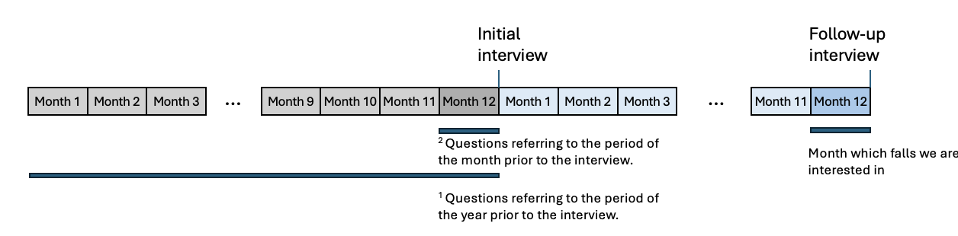
Supplementary Figure 1: Graphical representation of the interview timeline. The 1 and 2 superscripts refer to those describing features in Tables 1-3 and Supp Table 1.

Supplementary Table 2: Number of participants initially interviewed each year incorporated to form the dataset.

Year | 2012 | 2013 | 2014 | 2015 | 2016 | 2017 | 2018 | 2019 | 2021 | 2022 | Total
Number of participants initially interviewed | 2790 | 520 | 158 | 102 | 1708 | 337 | 112 | 55 | 13 | 21 | 5816

Performance activities were not recorded in 2020.

Supplementary Table 3: Category comparisons for Age variable
Risk factor category comparison | P
Age (years)
65-69 vs 70-74 | 0.025
70-74 vs 75-79 | 0.064
75-79 vs 80-84 | 0.209
80-84 vs 85-90 | 0.287
85-90 vs 90+ | 0.120

Supplementary Table 4: Category comparisons for the Health information variables
Risk factor category comparison | P
Overall health
Excellent vs Very good | 0.337
Very good vs Good | 0.104
Good vs Fair | <.001*
Fair vs Poor | 0.296
Use medication for pain²
Never vs Rarely | 0.139
Rarely vs Some days | 0.005
Some days vs Most days | 0.193
Most days vs Every day | 0.498
Nervous, anxious or unsatisfied traits²
Not at all vs Several days | <.001*
Several days vs More than half of the days | 0.008
More than half of the days vs Nearly every day | 0.133

Supplementary Table 5: Category comparisons for the Mobility information variables

Risk factor category comparison | P
How often leaves the building compared to a year ago
Less often vs About the same | <.001*
About the same vs More often | 0.474
How often holds onto walls or furniture
Never vs Rarely | <.001*
Rarely vs Sometimes | <.001*
Sometimes vs Most times | 1.000
Most times vs Every time | 0.031

Supplementary Table 6: Category comparisons for the Difficulty information variables
Risk factor category comparison | P
Difficulty using the toilet²
None vs A little | <.001*
A little vs Some | 0.086
Some vs A lot | 0.062
Difficulty getting out of bed²
None vs A little | <.001*
A little vs Some | 1.000
Some vs A lot | 0.478
Difficulty in washing up²
None vs A little | <.001*
A little vs Some | 0.77
Some vs A lot | 0.478
Difficulty getting around inside the house ²
None vs A little | <.001*
A little vs Some | 0.767
Some vs A lot | 0.397
Difficulty in going outside²
None vs A little | <.001*
A little vs Some | 0.938
Some vs A lot | 0.615

Supplementary Table 7: Category comparisons for the NHATS activities scores variables

Risk factor category comparison | P
Grip score
0 (worst) vs 1 | 0.880
1 vs 2 | 0.456
2 vs 3 | 0.855
3 vs 4 (best) | 0.161
Balance score
0 (worst) vs 1 | 1.000
1 vs 2 | 0.031*
2 vs 3 | 0.111
3 vs 4 (best) | <.001*
Walking score
0 (worst) vs 1 | 0.803
1 vs 2 | 0.021*
2 vs 3 | 0.010*
3 vs 4 (best) | 1.000
Chair score
0 (worst) vs 1 | 0.187
1 vs 2 | 0.110
2 vs 3 | 0.245
3 vs 4 (best) | 0.811

A

Supplementary Table 8: OR and confidence intervals for Logistic Regression with individual features.
Risk factor | OR | CI (95%)
Demographic data
Age (years)
65-69*
70-74 | 1.44 | 1.06-1.96
75-79 | 1.84 | 1.36-2.50
80-84 | 2.19 | 1.61-2.98
85-90 | 1.82 | 1.28-2.60
90+ | 2.63 | 1.71-4.03
Female sex | 1.15 | 0.97-1.37
General health information
Overall health condition
Excellent
Very good | 1.19 | 0.86-1.64
Good | 1.44 | 1.05-1.98
Fair | 2.51 | 1.80-3.49
Poor | 3.17 | 2.02-4.98
Heart attack¹ | 1.43 | 0.84-2.43
Heart disease¹ | 1.47 | 1.20-1.81
High blood pressure¹ | 1.27 | 1.05-1.55
Arthritis¹ | 1.55 | 1.29-1.87
Osteoporosis¹ | 1.12 | 0.91-1.37
Diabetes¹ | 1.37 | 1.13-1.65
Lung disease¹ | 1.57 | 1.27-1.94
Stroke¹ | 1.80 | 1.06-3.05
Dementia or alzheimers¹ | 1.40 | 0.84-2.31
Cancer¹ | 1.22 | 0.86-1.74
Broken or fractured bones¹ | 1.79 | 1.25-2.56
Overnight hospital stay¹ | 1.43 | 1.17-1.75
Previous surgery¹ | 1.29 | 1.01-1.64
BMI | 1.00 | 0.99-1.02
Under a normal BMI | 1.61 | 0.62-4.17
Over the normal BMI | 0.90 | 0.68-1.18
Info. adjacent to health
Fell in the last month | / | /
Worried about falling² | 2.13 | 1.78-2.54
Fell in the last year | 2.31 | 1.93-2.77
Depressive, anxious, or unsatisfied traits²

Not at all
Several days | 1.46 | 1.20-1.79
More than half the days | 2.25 | 1.69-2.99
Nearly every day | 1.95 | 1.46-2.59
Trouble sleeping²
Never
Rarely (once a week or less) | 0.86 | 0.64-1.16
Some nights (2-4 a week) | 1.01 | 0.76-1.34
Most nights1 (5-6 a week) | 1.19 | 0.85-1.66
Every night | 1.32 | 0.98-1.77
Lost 10 pounds¹ | 1.52 | 1.26-1.83
Information on home situation
situation
Total number in household | 1.11 | 1.03-1.20
Number of children (stepchildren) | 1.01 | 0.98-1.05
Ramp at entrance of home | 1.28 | 0.97-1.70
Strong community links
Do not agree
Agree a little | 0.84 | 0.50-1.42
Agree a lot | 0.85 | 0.51-1.39
Information on mobility / general ability
Uses a cane, walker, wheelchair, or scooter² | 2.20 | 1.82-2.64
Hearing problems | 1.49 | 1.23-1.81
Vision problems | 0.79 | 0.56-1.10
Problems with chewing or swallowing² | 1.87 | 1.42-2.45
Have problems speaking² | 2.14 | 1.47-3.10
Bothered by pain² | 1.53 | 1.28-1.83
Use medication for pain²
Never
Rarely (once a week or less) | 0.82 | 0.64-1.05
Some days (2-4 a week) | 1.23 | 0.96-1.58
Most days (5-6 a week) | 1.63 | 1.13-2.35
Every day | 1.40 | 1.10-1.78
Have breathing problems² | 1.51 | 1.23-1.86
Limited strength in the body² | 2.02 | 1.69-2.41
Low energy² | 1.72 | 1.45-2.05
Balance and coordination problems² | 2.47 | 2.07-2.95
Able to walk 6 blocks² | 0.49 | 0.41-0.59
Can walk up 20 stairs² | 0.48 | 0.40-5 0.58
Can carry 20 pounds² | 0.54 | 0.45-0.66
Able to get on knees and back up² | 0.55 | 0.46-0.67
Able to put a heavy object on a shelf² | 0.50 | 0.41-0.62
Can open a jar with one hand² | 0.63 | 0.52-0.76
Able to recall a portion of the date | 0.70 | 0.38-1.30
State of memory compared to a year ago
Much worse
Worse | 0.66 | 0.27-1.65
Same | 0.50 | 0.21-1.21
Better | 0.55 | 0.20-1.50
Much better | 0.63 | 0.19-2.14
Used help to get outside² | 2.17 | 1.56-3.01
How often goes outside²
Never | / | /
Rarely (once a week or less)
Some days (2-4 a week) | 0.98 | 0.53-1.82
Most days (5-6 a week) | 0.62 | 0.34-1.14
Every day | 0.72 | 0.41-1.27
Difficulty in going outside²
None
A little | 2.60 | 1.99-3.38
Some | 2.49 | 1.69-3.66
A lot | 3.28 | 1.66-6.50
How often leaves their building vs a year ago
Less often
About the same | 0.61 | 0.48-0.79
More often | 0.53 | 0.36-0.80
How often holds onto walls or furniture²

Never
Rarely | 1.48 | 1.18-1.86
Sometimes | 2.34 | 1.87-2.93
Most times | 2.38 | 1.62-3.50
Every time | 4.41 | 2.92-6.65
Difficulty getting around inside the house²
None
A little | 2.27 | 1.76-2.95
Some | 2.49 | 1.71-3.65
A lot | 4.82 | 1.67-13.95
Difficulty getting out of bed²
None
A little | 1.72 | 1.33-2.24
Some | 1.68 | 1.13-2.48
A lot | 2.54 | 1.16-5.55
Ability to perform daily activities
activities
How often gets dressed vs a year ago
Less often
Same | 0.59 | 0.34-1.03
More often | 0.88 | 0.42-1.84
Difficulty in washing up²
None
A little | 1.80 | 1.32-2.46
Some | 2.06 | 1.23-3.46
A lot | 0.94 | 0.22-4.016
How often wash up compared to last year
Less often
Same | 0.70 | 0.46-1.07
More often | 0.91 | 0.51-1.62
Uses tools to aid in toilet use | 1.67 | 1.39-2.02
Difficulty using the toilet²
None
A little | 2.90 | 1.97-4.27
Some | 1.20 | 0.51-2.80
A lot | 6.51 | 1.83-23.14
Needs help using the toilet | 4.02 | 1.54-10.49
Has a regular doctor | 1.03 | 0.68-1.58
Has seen a regular doctor in the last year | 1.50 | 1.00-2.26
NHATS performance
activities
Grip score
0 (worst)
1 | 0.96 | 0.68-1.35
2 | 0.87 | 0.62-1.21
3 | 0.89 | 0.64-1.25
4 (best) | 0.64 | 0.45-0.91
Balance score
0 (worst)
1 | 1.00 | 0.68-1.47
2 | 0.77 | 0.53-1.13
3 | 0.63 | 0.43-0.93
4 (best) | 0.33 | 0.21-0.50
Walking score
0 (worst)
1 | 0.92 | 0.60-1.42
2 | 0.70 | 0.46-1.08
3 | 0.49 | 0.32-0.77
4 (best) | 0.50 | 0.32-0.78
Chair score
0 (worst)
1 | 0.83 | 0.64-1.08
2 | 0.63 | 0.50-0.88
3 | 0.56 | 0.42-0.74
4 (best) | 0.53 | 0.40-0.71

*Because one category is considered as a reference by the model (automatically the first one), it has no coefficient as it has been absorbed by the intercept. Each CI is thus for the odds ratio of being in that category versus the reference.

Supplementary Table 9: Significant risk factors in the Logistic Regression with Lasso regularization associated with falls during the month 11 months after the initial interview

Risk factor | OR | CI 95%
Demographic data
Age | 1.09 | 1.00-1.21
General health information
BMI | 0.97 | 0.96-1.00
Information adjacent to health
Fallen in the past year | 1.76 | 1.43- 2.08
Information on home situation
Total number in household | 1.05 | 1.03-1.19
Information on mobility and general ability
Balance and coordination problems | 1.41 | 1.04-1.73
How often goes outside | 1.18 | 1.05-1.39
How often holds onto walls/furniture | 1.10 | 1.00-1.21
Scores on NHATS activities
Chair score | 1.00 | 1.00-1.20

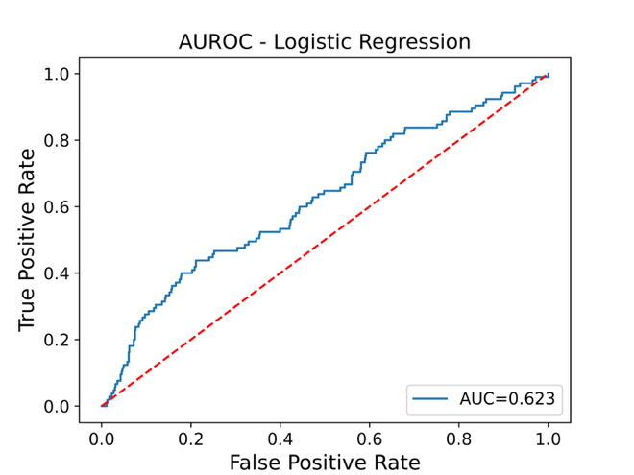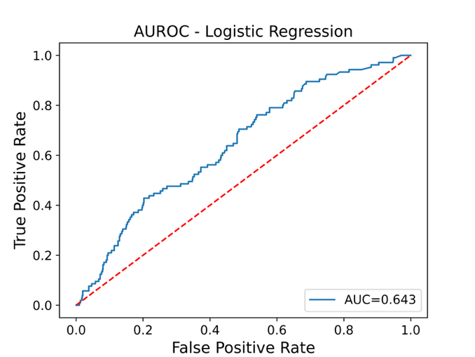
Supplementary Figure 2: AUROC for full (left) and reduced (right) logistic regression models. Models were trained on 5000 instances and validated on 816.

