Appendix 1. Model Structure and Parameters

Detailed descriptions of the model and parameters can be found in:
1) Jutkowitz E, Kane RL, Gaugler JE, MacLehose RF, Dowd B, Kuntz KM. Societal and Family Lifetime Cost of Dementia: Implications for Policy. J Am Geriatr Soc. 2017;65(10):2169-2175. PMID: 28815557; PMCID: PMC5657516
2) Jutkowitz E, Pizzi LT, Shewmaker P, Alarid-Escudero F, Epstein-Lubow G, Prioli KM, Gaugler JE, Gitlin LN. Cost effectiveness of non-drug interventions that reduce nursing home admissions for people living with dementia. Alzheimers Dement. 2023 Sep;19(9):3867-3893. PMID: 37021724; PMCID: PMC10524701.

Model Structure

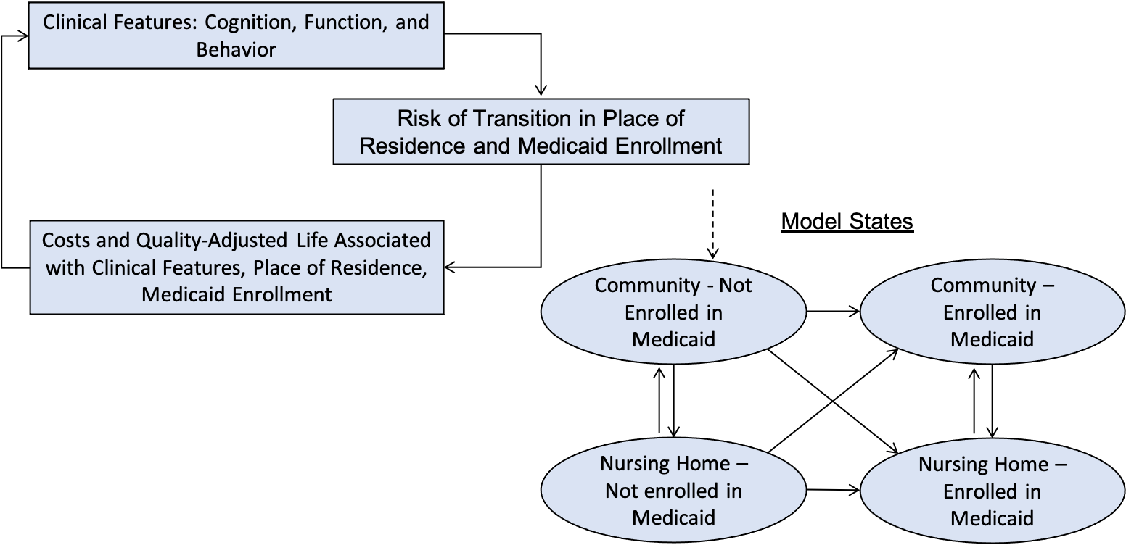

*Individuals can transition to death (not shown) from any state.

Parameter | Description | Key Reference
Clinical Features: Cognition, function, and behaviors | Trajectories based on data from the National Alzheimer’s Coordinating Center. | Jutkowitz et al. J Gerontol A Biol Sci Med Sci. 2017. PMID: 27129917 PMCID: PMC5344797.
Risk of Transition from Community to Nursing Home | Calibrated to time Medicare beneficiaries with dementia spend in a nursing home. | Jutkowitz et al. Alzheimers Dement. 2023. PMID: 37021724; PMCID: PMC10524701.
Risk of Transition from Nursing Home to Community | Medicare data and a competing risk Weibull proportional hazard model to estimate the time till a beneficiary returned to the community, died in the nursing home, or was censored. Race, sex, age of AD/ADRD onset, and an interaction term between race and sex were included as covariates.ª | Intrator et al, Health Services Research. 2011 PMID: 21029090; PMCID: PMC3015013.
Medicaid Enrollment | Medicare data and Weibull proportional hazards model to estimate the time to Medicaid enrollment. Race, sex, age of dementia onset, number of months spent in a nursing home, and an interaction term between race and sex were included as covariates.ª | Intrator et al, Health Services Research. 2011 PMID: 21029090; PMCID: PMC3015013.
Costs | Time Receiving Family Caregiving | Jutkowitz et al. Alzheimers Dement. 2017. PMID: 28161279 PMCID: PMC5644025
Costs | Time Receiving Paid Caregiving | Jutkowitz et al. Alzheimers Dement. 2017. PMID: 28161279 PMCID: PMC5644025
Costs | Medicare Expenditures | Jutkowitz et al. J Gerontol A Biol Sci Med Sci. 2017. PMID: 27129917 PMCID: PMC5344797.
Costs | Out-of-pocket Expenditures | Jutkowitz et al. Alzheimers Dement. 2017. PMID: 28161279 PMCID: PMC5644025
Costs | Long-term Care facility Expenditures | MetLife Mature Market Institute. Market Survey of Long-Term Care Costs. 2012
Costs | Medicaid Expenditures | Garfield et al. Kaiser Family Foundation. 2015  Bharmal et al. Am J Geriatr Psychiatry. 2012
Mortality | Age-, sex-, and race-mortality rates based on age of dementia diagnosis.ª | Mayeda et al. Alzheimers Dementa. 2017. PMID: 28174069 PMCID: PMC5496783
Preferences weights for people living with AD/ADRD^{b} | Mild (MMSE = 21-25)^{c} | Community 0.68; Nursing Home 0.71
Preferences weights for people living with AD/ADRD^{b} | Moderate (MMSE = 11-20) | Community 0.54; Nursing Home 0.48
Preferences weights for people living with AD/ADRD^{b} | Severe (MMSE = 0 - 10) | Community 0.37; Nursing Home 0.31
ª The data sources used to predict these outcomes did not include information on dementia clinical features of cognition, function, and behavior. ^{b} Preference weights obtained from Neumann PJ et al. (1999). Cost-effectiveness of donepezil in the treatment of mild or moderate Alzheimer's disease. Neurology, 52 (6), 1138-1145. ^{c} Our model uses the Mini-Mental State Examination to measure cognitive impairment and does not incorporate the Clinical Dementia Rating Scale. We used a published crosswalk (Perneczky R et al. Am J Geriatr Psychiatry. 2006) to map Mini-Mental State Examination scores to the Clinical Dementia Rating Scale in order to arrive at quality-of-life weights.

Appendix 2. Description of Interventions and Studies

Summary of Interventions
Author, Year, PMID | Arm | Description | Estimated Cost
Callahan et al. 2006, 16684985 | Augmented Usual Care | Any evaluation or treatment | N/A
Callahan et al. 2006, 16684985 | Collaborative Care | - 12 months of collaborative care management led by primary care physician and geriatric nurse practitioner who served as care manager.  - All patients recommended cholinesterase inhibitors unless contraindicated.  - All patients and caregivers received at minimum education on communication skills, coping skills, legal/financial advice, exercise guidelines (book and video tape), an Alzheimer’s Association caregiver guide. The geriatric nurse practitioner saw patients bimonthly and then over time monthly.  - The geriatric nurse practitioner saw patients bimonthly and then over time monthly. Sessions guided by Memory and Behavior Problem Checklist, which trigger nonpharmacologic approach followed by drug therapy as needed.  - Voluntary group sessions.  - Care managers supported by weekly clinical team meetings. | $1,500ª
Gitlin et al. 2010, 20810376, Fortinsky et al. 2020, 33367114 and Pizzi et al. 2022, 35047708 | Control | - Care as usual, three 20-minute telephone calls from research staff (not occupational therapists or nurses) to discuss care challenges.  - Educational information mailed to caregivers such as tips from the Alzheimer’s Association and government agencies. | N/A
 | COPE | - 10 sessions over 4 months with occupational therapists, 1 in-home sessions and 1 telephone session with advance practice nurse.  - Assessment of patient (deficits, capabilities and medical testing), home environment, caregiver concerns.  - Caregiver education (patient capabilities, potential effects of medications, pain, constipation, dehydration), training tailored to address concerns, and written action plan. | $2,050
Gitlin et al. 2013, 29192967 | Attention Control | - 8 telephone sessions with masters-level researcher that provided caregiver education. | N/A
Gitlin et al. 2013, 29192967 | TAP | - 8 in-home sessions with an occupational therapist.  - Assessment of patient (capabilities, executive and physical function, fall risk, daily routines, interest), caregivers (readiness), and environment.  - Caregivers are provided with activity plans, environmental modifications, and education to manage behaviors. | $1,000
Gitlin et al. 2001, 11220813 | Control | - Educational materials and a booklet describing home safety tips. | N/A
Gitlin et al. 2001, 11220813 | Skills2Care | - Multicomponent intervention led by an occupational therapist who trained caregivers in problem solving skills.  - 5 90-min sessions over 3-months. Occupational therapists developed plans to address daily care challenges, used role-play and direct observation to teach care plans and problem-solving skills.  - Occupational therapists proving ongoing coaching. | $1,000
ªIntervention was reported to cost $1,000 in 2006 and $1,500 after adjusting to 2015 dollars.

Design Details of Pivotal Studies
Author, Year, PMID | Intervention Name | Study Design | Study Dates | Setting | Inclusion Criteria | Exclusion Criteria
Callahan et al. 2006, 16684985 | Collaborative Care | RCT (physician unit of randomization) | 2002-2004 | Primary care | - Screen positive on cognitive testing or diagnosis of dementia;  - Diagnostic evaluation that met criteria for possible or probable Alzheimer disease. | - Residence in a nursing home;  - Unable to understand English;  - No access to telephone;  - No caregiving willing to participate in study.
Gitlin et a. 2010, 20810376, | COPE | RCT (person with dementia-caregiver dyads unit of randomization) | 2006-2008 | Home/community | Person with Dementia  - Physician diagnosis of probable Alzheimer’s disease or MMSE score <24;  - >21 years old, English speaking, needed help daily activities or had behavioral symptoms;  - Lived ≤5 miles of family caregiver.  Caregiver  - Provided ≥8 hours of weekly oversight or care;  - Planned to live in area for 9 mo;  - Not seeking nursing home placement;  - Reported difficulty managing patient functional decline or behaviors. | - Life expectancy <9 months;  - Active treatments for cancer;  - ≥3 acute hospitalizations in past year;  - Involvement in another caregiver trial;  - Patients with schizophrenia, bipolar disorder, dementia due to head trauma or MMSE = 0 or bedbound.
Fortinsky et al. 2020, 33367114 and Pizzi et al. 2022, 35047708 | COPE | RCT (embedded in Connecticut’s Medicaid; person with dementia-caregiver dyads unit of randomization) |  | Home and home and community service agency | - Enrolled in Connecticut Home Care Program for Elders (Medicaid funded program);  - Be receiving monthly home care plan from Medicaid;  - Dementia diagnosis. | - Schizophrenia or bipolar disorder;  - Bedbound;  - participation in concurrent experimental drug study; designed to treat agitation;  - unsafe home environment.
Gitlin et al. 2013, 29192967 | TAP | RCT person with dementia-caregiver dyads unit of randomization) | 2012-2015 | Home/community (evaluated in the VA) | Person with Dementia  - English speaking;  - MMSE ≤23, or diagnosis of dementia;  - Able to participate ≥2 self-care activities;  - If taking psychotropic, or antidementia drugs then on stable dose for 60 days.  Caregiver  - English-speaking primary caregiver ≥21 years of age;  - Living with Veteran;  - Accessible by phone and planned to live in area for 8 months;  - Willing to learn activities and managed ≥1 behavioral symptom in past month;  - Stable on medications. | - Not involved in another study.
Gitlin et al. 2001, 11220813 | Skills2Care | RCT person with dementia-caregiver dyads unit of randomization) | 1993-1996 | Home/community | Person with Dementia  - Dependence with ≥2 activities of daily living or ≥1 activity of daily living and dementia related behavior  Caregiver  - Live with person with dementia;  - Be the primary caregiver. | - Bedridden or not responsive to physical touch
MMSE = mini-mental state examination
Outcomes Modeled
Intervention, PMID | Outcome Definition (Measure) | Follow-up | Original Reported Values from Study | Calibration Target  (Cohen’s D, unless otherwise specified) | Predicted Outcomes  (Cohen’s D, unless otherwise specified)
Collaborative Care 16684985 | Number of Neuropsychiatric Inventory modules (NPI) | 12-months | Mean (SD)  Baseline (Control): 3.2 (2.8)  Baseline (Treated): 3.0 (2.7)  12 Months (Control): 3.5 (2.7)  12 Months (Treated): 2.5 (2.5) | 0.29 (-0.03 to 0.62) | 0.31 (0.11 to 0.52)
 |  | 18-months | Mean (SD)  Baseline (Control): 3.2 (2.8)  Baseline (Treated): 3.0 (2.7)  18 Months (Control): 3.6 (2.8)  18 Months (Treated): 2.3 (2.4) | 0.40 (0.08 to 0.73) | 0.39 (0.14 to 0.64)
COPE 20810376, 35047708,  33367114 | Fortinsky et al: Caregiver Assessment of Function and Upset  Gitlin et al: Overall functional dependence (Functional Independence Measures) | 4-months  12-months | Study 1:  Mean (95% CI)  At 4 Months:  Control: 2.8 (2.7, 3.0)  Treated: 2.8 (2.6, 2.9)  At 12 Months:  Control: 2.5 (2.4, 2.7)  Treated: 2.6 (2.5, 2.8)  Study 2:  Mean (SD)  Baseline (Control): 2.8 (1.3)  Baseline (Treated): 3.0 (1.2)  4 Months (Control): 3.3 (1.3)  4 Months (Treated): 3.7 (1.3) | Combined 4 Month Cohen’s D: 0.08 (-0.11, 0.28)  12 Month Cohen’s D:  -0.13 (-0.42, 0.15) | Combined 4 Month Cohen’s D: -0.01 (-0.14, 0.3)  12 Month Cohen’s D:  0.01 (-0.19, 0.21)
COPE 20810376, 35047708,  33367114 | Fortinsky et al: Behavioral and psychological symptom score  Gitlin et al: ABID (Agitated Behaviors in Dementia) Score | 4 Months  12 Months | Study 1:  Mean (95% CI)  At 4 Months:  Control: 12.7 (8.3, 17.1)  Treated: 9.7 (5.2, 14.2)  At 12 Months:  Control: 18.8 (15.8, 21.9)  Treated: 15.8 (12.8, 18.7)  Study 2:  Mean (SD)  Baseline (Control): 9.8 (10.7)  Baseline (Treated): 11.0 (14.6)  4 Months (Control): 5.5 (8.0)  4 Months (Treated): 6.7 (10.6) | Combined 4 Month Cohen’s D: 0.05 (-0.14, 0.25)  12 Month Cohen’s D: 0.20 (-0.09, 0.49) | Combined 4 Month Cohen’s D: 0.10 (-0.07, 0.26)  12 Month Cohen’s D:  0.15 (-0.09, 0.39)
COPE 20810376, 35047708,  33367114 | Medicare Cost Difference (Pizzi, et al) | 12-months | Cost Differences:  DID (95% CI)  Inpatient Hospitalizations:  -$2,725 (-$6,246, $795.25)  ED Visits:  -$2,897 (-$5,771, -$23.55)  Outpatient Visits:  -$133.93 (-$1,440, $326.16) | Medicare Costs:  -$5,576 (-$10,485, -$1,027) | Medicare Costs:  -$5,571 (-$10,162, -$793)
 | Nursing Home Stays Cost Difference (Pizzi, et al) | 12 Months | DID (95% CI)  -$1,662 (-$6,258, $2,934) | Nursing Home Stays Cost Difference:  -$1,662 (-$6,258, $2,934) | Nursing Home Stays Cost Difference:  -$660 (-$3,141, $1,784)
TAP 29192967 | Number of ADLs and IADLs needing assistance with | 4-months | Mean (SD)  Baseline (Control): 9.6 (3.3)  Baseline (Treated): 9.8 (3.8)  4 Months (Control): 10.8 (3.3)  4 Months (Treated): 10.2 (3.6) | 0.22 (-0.09 to 0.54) | 0.21 (-0.07 to 0.45)
 | Number of Behaviors (NPI-C) | 4-months | Mean (SD)  Baseline (Control): 5.5 (2.8)  Baseline (Treated): 5.3 (2.8)  4 Months (Control): 4.8 (2.5)  4 Months (Treated): 4.1 (2.2) | 0.18 (-0.13 to 0.49) | 0.2 (-0.11 to 0.50)
 | Time Spent Caregiving | 4-months | Mean Difference (95% CI)  Hours on activities of daily living: -0.53 (-1.20, -0.14)  Hours on instrumental activities of daily living: -1.09 (-2.34, -0.15)  Hours on duty: -0.28 (-2.25, -1.68)  Hours doing things: -0.99 (-2.28, -0.30) | Difference in Informal Care Hours: -2.89 (-5.64, -0.14) | Difference in Informal Care Hours: - 2.89 (-5.53, -0.42)
Skills2Care 11220813 | Functional dependence (  Activities of Daily Life Dependence and Instrumental Activities of Daily Life Dependence) | 3-months | ADL Dependence  Mean (SD)  Baseline (Control): 3.23 (1.36)  Baseline (Treated): 2.93 (1.49)  3 Months (Control): 3.57 (1.38)  3 Months (Treated): 3.24 (1.59)  IADL Dependence  Mean (SD)  Baseline (Control): 5.56 (0.50)  Baseline (Treated): 5.43 (0.62)  3 Months (Control): 5.75 (0.36)  3 Months (Treated): 5.54 (0.60) | Combined ADL and IADL Cohen’s D:  0.08 (-0.13, 0.29) | 0.08 (-0.15, 0.30)
 | Memory and Behavior Problems Checklist | 3-months | Mean (SD)  Baseline (Control): 18.74 (6.31)  Baseline (Treated): 20.25 (5.39)  3 Months (Control): 14.43 (9.82)  3 Months (Treated): 17.20 (7.73) | -0.22 (-0.52, 0.09) | -0.21 (-0.49, 0.10)
ªmean difference / pooled standard deviation
ADL = activities of daily living; DID = difference in difference; IADL = instrumental activities of daily living.

Meta Analysis of COPE Function Treatment Effect at 4 Months
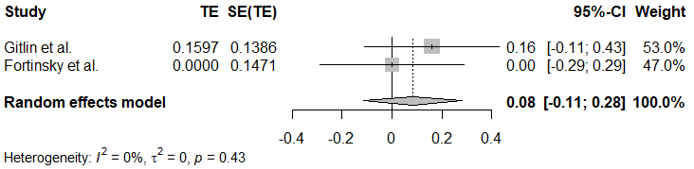

Meta Analysis of COPE Behavior Treatment Effect at 4 Months
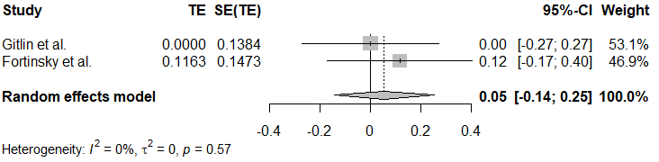

Meta Analysis of Skills2Care Behavior Treatment Effect
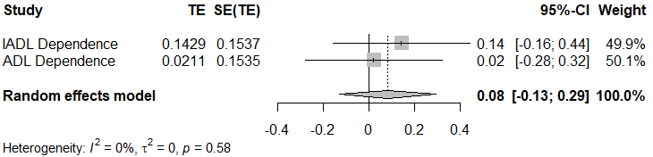

Appendix 3. Simulated Time to Treatment

Modeling the time to start an intervention for a simulated person is important because outcomes (e.g., transitioning to a nursing home or costs) are not accumulated at a constant rate. We modeled the time a simulated person receives an intervention based on months since a dementia diagnosis. We used months since a dementia diagnosis as the eligibility criteria since it is a measure that can be derived for all the included studies. The interventions report the sample’s cognition at baseline, but do not report the time people had been living with ADRD. We simulated 10,000 people to determine the distribution of time in months till they reached each studies baseline MMSE score. We then sample from these 10,000 values to determine the month a person would start treatment.

Baseline Cognition
Author, Year, PMID | Intervention | Cognition | Average month from dementia onset patients were predicted to start intervention
Callahan et al. 2006, 16684985 | Collaborative Care | MMSE: 17.9 ( 8.3) | 20 months
Gitlin et al. 2010, 20810376 | COPE | MMSE: 13.4 (8.1) | 29 months
Gitlin et al. 2013, 29192967 | TAP | MMSE: 16.6 (7.8) | 22 months
Gitlin et al. 2001, 11220813 | Skills2Care | No. months caregiving: 41 (32.5) | 41 months

Appendix 4. Calibration Description

For each parameter being calibrated, 5,000 parameter values are tested. The likelihood of each parameter is calculated from the observed distribution of Cohen’s D from the original paper. The likelihoods are then weighted by dividing each likelihood by the total summed likelihood over all tested parameters. An effective sample size (ESS) is calculated from these likelihoods, where the formula is the square of the summed likelihoods divided by the sum of the squared likelihoods. Once the effective sample size is calculated, that number of parameters is sampled from the 5,000 tested parameters with replacement, where the probability of a parameter being sampled is given by the weighted likelihood of the parameter.

Posterior Distribution Plots for Calibrated Parameters:
Behavior Time Parameters
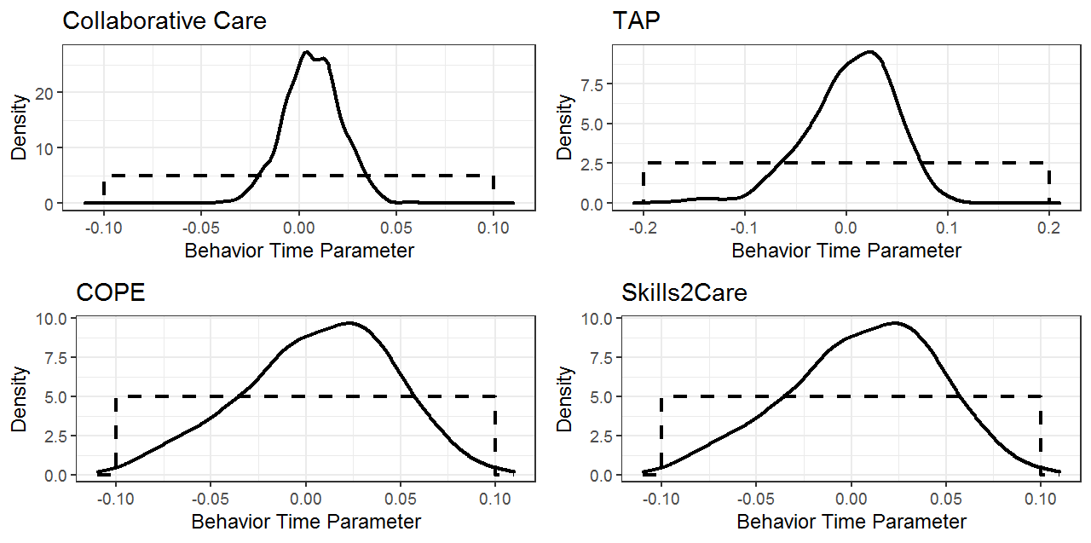
Note: Solid line represents posterior distribution, dashed line represents prior distribution
Function Time Parameters
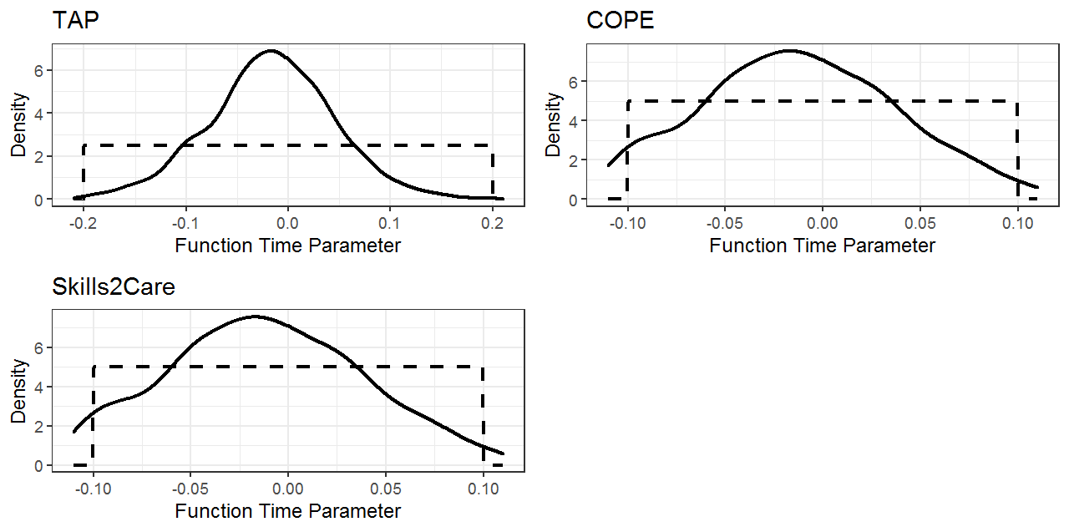
Note: Solid line represents posterior distribution, dashed line represents prior distribution

Other Parameters
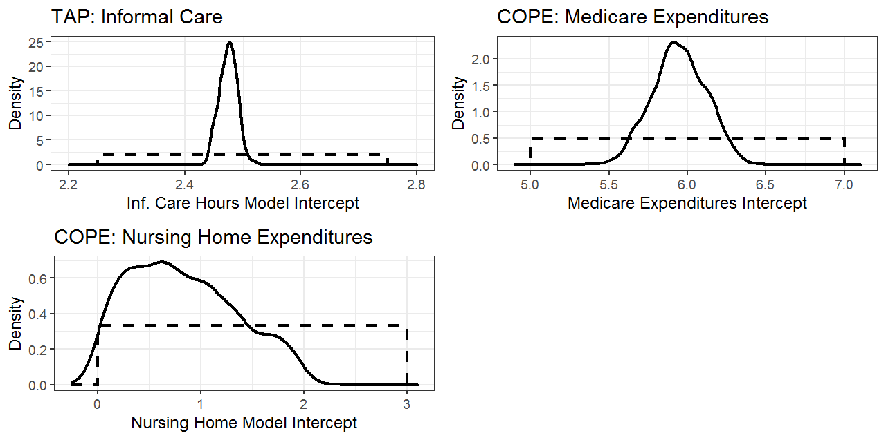
Note: Solid line represents posterior distribution, dashed line represents prior distribution

Boxplot of Calibration Results
Behavior Calibration Targets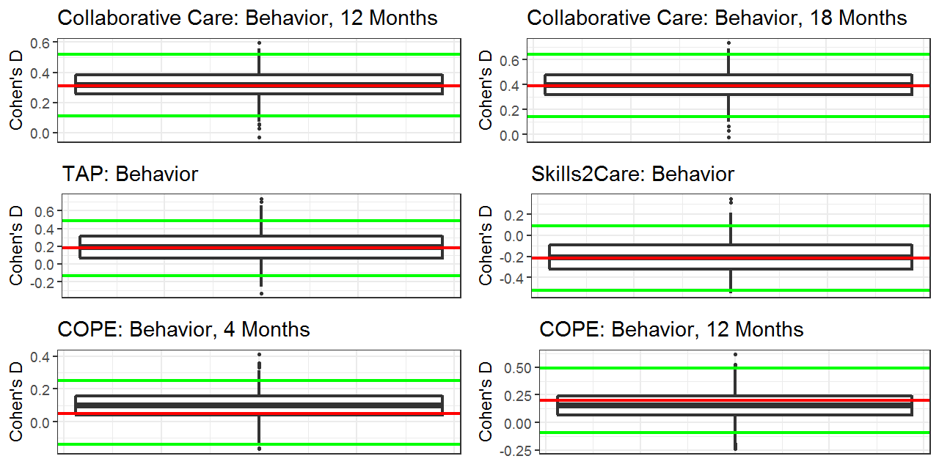
Note: Red line represents calibration target (e.g. observed Cohen’s D from study), green lines represent 95% CI for target.

Function Calibration Targets
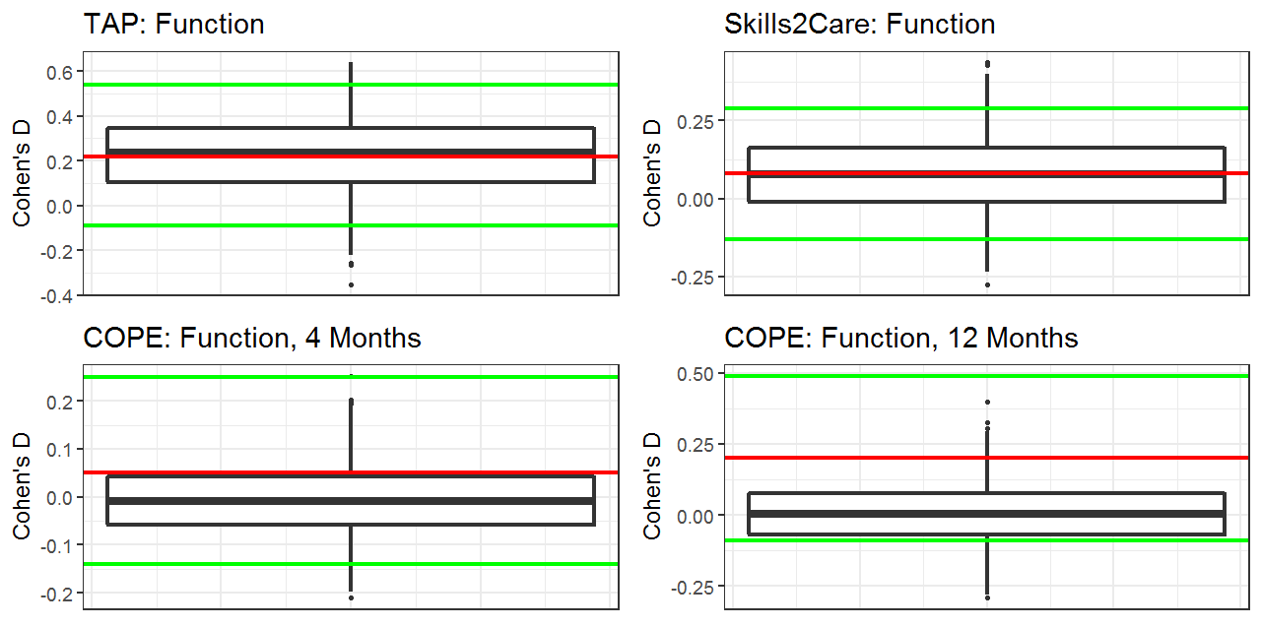
Note: Red line represents calibration target (e.g. observed Cohen’s D from study), green lines represent 95% CI for target.

Other Calibration Targets
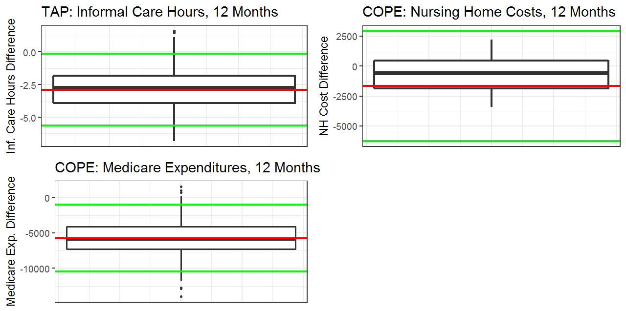
Note: Red line represents calibration target (e.g. observed Cohen’s D from study), green lines represent 95% CI for target.

Appendix 5. Value of Information Analysis

Author, Year, PMID | Intervention | Effective Sample | Parameters Evaluated in EVPPI | Population Assumption | ENBS Assumptions
Callahan et al. 2006, 16684985 | Collaborative Care | 153 |  | Prevalence population eligible for intervention: 1,033,333ª  Incidence factor (number of cases)^{b}: 75% (682,500) | Fixed cost of an NIH funded randomized trial: $1,050,000  Cost per patient enrolled in the trial: $2,000  Willingness-to-pay: $0
Gitlin et al. 2010, 20810376 | COPE | 209 |  | Prevalence population eligible for intervention: 1,033,333ª  Incidence factor (number of cases)^{b}: 66% (600,600)
Gitlin et al. 2013, 29192967 | TAP | 160 |  | Prevalence population eligible for intervention: 1,033,333ª  Incidence factor (number of cases)^{b}: 73% (664,300)
Gitlin et al. 2001, 11220813 | Skills2Care | 171 |  | Prevalence population eligible for intervention: 1,033,333ª  Incidence factor (number of cases)^{b}: 73% (664,300)
ª Assume that 1/6th of the 6,200,000 people with ADRD are eligible for treatment. ^{b}Poportion of 910,000 incidence cases eligible for treatment. We determined the proportion of simulated people with ADRD that were in the community at the start of each intervention (see Appendix 4 for additional details).
Appendix 6. Sensitivity Analysis

For the one-way sensitivity analysis, the optimistic perspective represents the endpoint of the 95% credible interval of the calibrated treatment parameter which corresponds with a lower treatment cost than the mean of the calibrated treatment parameter (the base case). Similarly, the pessimistic perspective represents the endpoint of the 95% credible interval of the calibrated treatment parameter which corresponds with a higher treatment cost than the base case.
The optimistic treatment cost is 25% lower than the base case treatment cost, and the pessimistic treatment cost is 25% higher. For implementation probability, in the optimistic perspective 75% of patients receive the treatment, and in the pessimistic perspective 50% of patients receive the treatment,

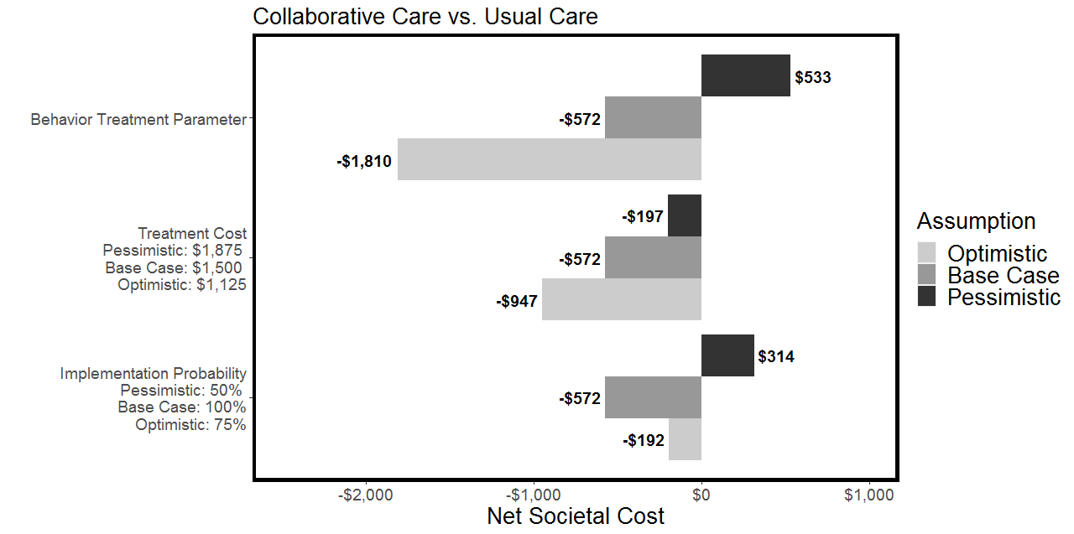
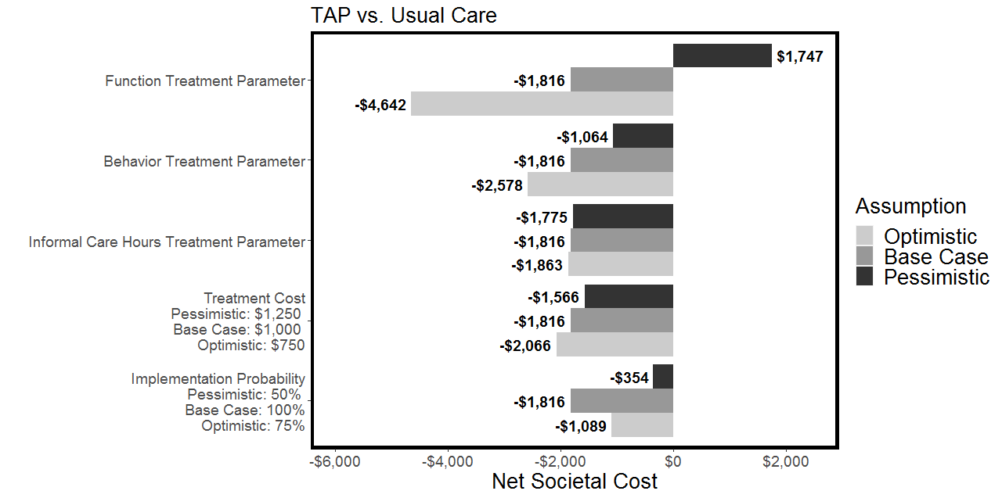
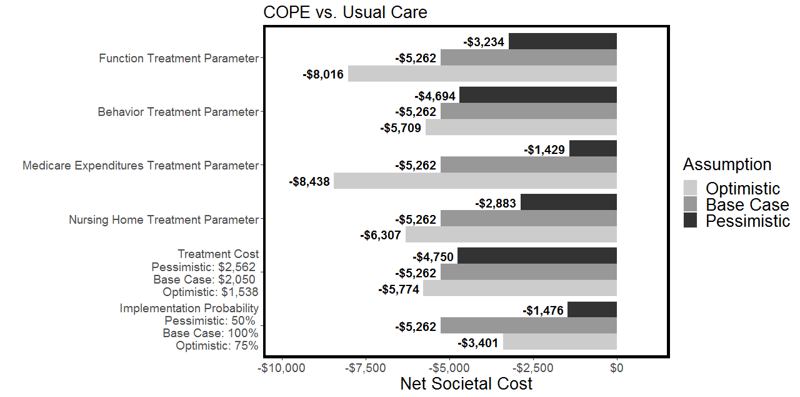
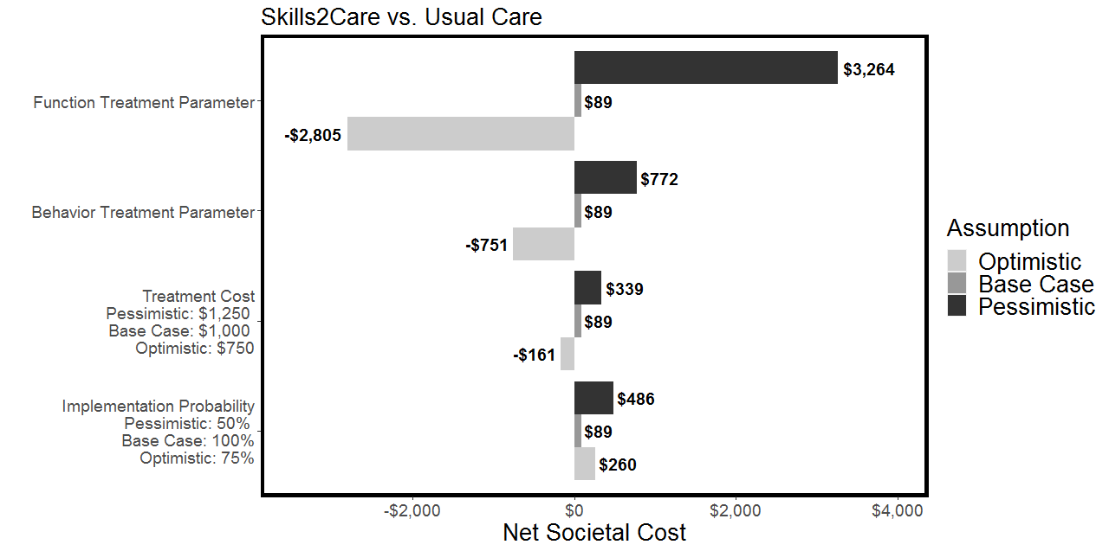

Structural Sensitivity Analysis: Difference in Lifetime Costs of Consecutive Treatment Engagement Compared to Usual Care and Equal Treatment Length (12 Months) and Distribution of Treatment Entrance Months

Intervention | Treatment Cost | Cost
Intervention | Treatment Cost | Formal Long-Term Care | Value of Informal Care | Out of Pocket Expenditures | Medicare and Medicaid | Total Net Societal Cost
Structural Sensitivity Analysis 1
Consecutive Treatment | $4,050 | -$1,243 | -$2,306 | -$2,982 | -$5,463 | -$7,944
Structural Sensitivity Analysis 2
COPE | $2,050 | -$802 | -$831 | -$1,780 | -$5,438 | -$6,800
TAP | $3,000* | -$2,322 | -$4,700 | -$1,009 | -$257 | -$5,290
Collaborative Care | $1,500 | -$1,100 | -$1,811 | -$901 | -$426 | -$2,738
Skills2Care | $4,000* | -$307 | -$643 | -$20 | $59 | $3,031
Note. Structural Sensitivity Analysis 1 - assumed people sequentially participate in each intervention based on the time people were predicted to be eligible for each intervention (Collaborative Care, COPE, TAP, Skills2Care). Structural Sensitivity Analysis 2 - modeled each intervention with the same baseline population and over a uniform 12-month period. Structural Sensitivity Analysis 3 (shown in Appendix 6) – models implementation success by varying the proportion of people who participated in each intervention.
*These treatments had a duration shorter than 12 months – TAP is 4 months so cost was multiplied by 3, S2C was 3 months so cost was multiplied by 4.

