Appendix A: An Illustration of Net Effect (NE) for Three Binary Contributing Factors
Let’s use the following example with three binary (present or absent) contributing factors, $x_{1}$, $x_{2}$ and $x_{3}$, to illustrate how to calculate NE. Notion ${\overline{y}}_{0}$ is the mean outcome score for those without any factor; ${\overline{y}}_{1}$, ${\overline{y}}_{2}$, and ${\overline{y}}_{3}$ are the mean scores for those with a single factor of $x_{1}$, $x_{2}$ and $x_{3}$, respectively; ${\overline{y}}_{12}$, ${\overline{y}}_{13}$, and ${\overline{y}}_{23}$ are the mean scores for those with two factors, respectively; and ${\overline{y}}_{123}$ is the mean score for those with all three factors. Among the six ($3!$=6) ordered scenarios: (1) $x_{1}x_{2}x_{3}$; (2) $x_{1}x_{3}x_{2}$; (3) $x_{2}x_{1}x_{3}$; (4) $x_{2}x_{3}x_{1}$; (5) $x_{3}x_{1}x_{2}$; and (6) $x_{3}x_{2}x_{1}$, there are:
- Two ($2!$) scenarios that contain the impact of factor $x_{1}$ for those with no other factor, i.e., scenarios (1) and (2). The marginal effect of $x_{1}$ for no other factor is $\left({\overline{y}}_{1}-{\overline{y}}_{0}\right)$;
- One ($1!)$ scenario that contains the impact of factor $x_{1}$ for those with only factor $x_{2}$, i.e., scenario (3). The marginal effect of $x_{1}$ for only $x_{2}$ is $\left({\overline{y}}_{12}-{\overline{y}}_{2}\right)$;
- One ($1!)$ scenario that contains the impact of factor $x_{1}$ for those with only factor $x_{3}$, i.e., scenario (5). The marginal effect of $x_{1}$ for only $x_{3}$ is $\left({\overline{y}}_{13}-{\overline{y}}_{3}\right)$; and
- Two ($2!)$ scenarios that contain the impact of factor $x_{1}$ for those with factors $x_{2}$ and $x_{3}$, i.e. scenarios (4) and (6). The marginal effect of $x_{1}$ for $x_{2}$ and $x_{3}$ is $\left({\overline{y}}_{123}-{\overline{y}}_{23}\right)$.
The NE for factor $x_{1}$ is the average of the marginal effect over all six scenarios:
$$NE\left(x_{1}\right)=\frac{1}{6}\left[2\left({\overline{y}}_{1}-{\overline{y}}_{0}\right)+\left({\overline{y}}_{12}-{\overline{y}}_{2}\right)+\left({\overline{y}}_{13}-{\overline{y}}_{3}\right)+2\left({\overline{y}}_{123}-{\overline{y}}_{23}\right)\right]$$
$$=\frac{1}{3}\left[\left({\overline{y}}_{1}-{\overline{y}}_{0}\right)+\frac{\left({\overline{y}}_{12}-{\overline{y}}_{2}\right)+\left({\overline{y}}_{13}-{\overline{y}}_{3}\right)}{2}+\left({\overline{y}}_{123}-{\overline{y}}_{23}\right)\right]$$
$$=\frac{1}{3}\left[\frac{\left({\overline{y}}_{1}-{\overline{y}}_{0}\right)}{\left(\begin{aligned}2 \\ 0\end{aligned}\right)}+\frac{\left({\overline{y}}_{12}-{\overline{y}}_{2}\right)+\left({\overline{y}}_{13}-{\overline{y}}_{3}\right)}{\left(\begin{aligned}2 \\ 1\end{aligned}\right)}+\frac{\left({\overline{y}}_{123}-{\overline{y}}_{23}\right)}{\left(\begin{aligned}2 \\ 2\end{aligned}\right)}\right].$$
Similarly, the NE for factors $x_{2}$ and $x_{3}$ are
$$NE\left(x_{2}\right)=\frac{1}{3}\left[\frac{\left({\overline{y}}_{2}-{\overline{y}}_{0}\right)}{\left(\begin{aligned}2 \\ 0\end{aligned}\right)}+\frac{\left({\overline{y}}_{12}-{\overline{y}}_{1}\right)+\left({\overline{y}}_{23}-{\overline{y}}_{3}\right)}{\left(\begin{aligned}2 \\ 1\end{aligned}\right)}+\frac{\left({\overline{y}}_{123}-{\overline{y}}_{13}\right)}{\left(\begin{aligned}2 \\ 2\end{aligned}\right)}\right]$$
and
$$NE\left(x_{3}\right)=\frac{1}{3}\left[\frac{\left({\overline{y}}_{3}-{\overline{y}}_{0}\right)}{\left(\begin{aligned}2 \\ 0\end{aligned}\right)}+\frac{\left({\overline{y}}_{13}-{\overline{y}}_{1}\right)+\left({\overline{y}}_{23}-{\overline{y}}_{2}\right)}{\left(\begin{aligned}2 \\ 1\end{aligned}\right)}+\frac{\left({\overline{y}}_{123}-{\overline{y}}_{12}\right)}{\left(\begin{aligned}2 \\ 2\end{aligned}\right)}\right],$$
respectively: The total effect (TE) of all three factors is ${(\overline{y}}_{123}-{\overline{y}}_{0})$, which equals the sum of the three individual NEs: $TE={\overline{y}}_{123}-{\overline{y}}_{0}=NE\left(x_{1}\right)+NE\left(x_{2}\right)+NE\left(x_{3}\right).$

The following figure presents hypothetical scores of HRQOL by three risk factors.
Factor 1 | Factor 2 | Factor3 |  | Outcome
0 | 0 | 0 | $${\overline{y}}_{0}$$ | 1.00
0 | 0 | 1 | $${\overline{y}}_{3}$$ | 0.80
0 | 1 | 0 | $${\overline{y}}_{2}$$ | 0.90
0 | 1 | 1 | $${\overline{y}}_{23}$$ | 0.85
1 | 0 | 0 | $${\overline{y}}_{1}$$ | 0.75
1 | 0 | 1 | $${\overline{y}}_{13}$$ | 0.60
1 | 1 | 0 | $${\overline{y}}_{12}$$ | 0.70
1 | 1 | 1 | $${\overline{y}}_{123}$$ | 0.40

The effect of factor 1 was $0.75-1.00=-0.25$ points if both factors 2 and 3 were absent. The effect of factor 1 was $0.70-0.90=-0.20$ points if factor 2 was present and factor 3 was absent. The effect of factor 1 was $0.60-0.80=-0.20$ points if factor 3 was present and factor 2 was absent. The effect of factor 1 was $0.40-0.85=-0.45$ points if both factors 2 and 3 were present. The NE for factor 1 was calculated as $\frac{1}{3}\left[\left(-0.25\right)+\frac{-0.20-0.20}{2}+(-0.45)\right]=-0.30$. Similarly, the NE for factor 2 was $-0.10$ and the NE for factor 3 was $-0.20$. The total effect (TE) of risk factors 1, 2 and 3 was $TE=\left(0.40-1.00\right)=-0.60$. The NE satisfies the additive property: the sum of the NE of these three factors was $\left(-0.30-0.10-0.20\right)=-0.6$0, the same as the TE.

 |  | NE1 |  | NE2 |  | NE3 | Sum
(a) | $${\overline{y}}_{1}-{\overline{y}}_{0}$$ | -0.25 | $${\overline{y}}_{2}-{\overline{y}}_{0}$$ | -0.10 | $${\overline{y}}_{3}-{\overline{y}}_{0}$$ | -0.20
(b) | $${\overline{y}}_{12}-{\overline{y}}_{2}$$ | -0.20 | ${\overline{y}}_{12}-{\overline{y}}_{1}$ | -0.05 | $${\overline{y}}_{13}-{\overline{y}}_{1}$$ | -0.15
(c) | $${\overline{y}}_{13}-{\overline{y}}_{3}$$ | -0.20 | $${\overline{y}}_{23}-{\overline{y}}_{3}$$ | 0.05 | $${\overline{y}}_{23}-{\overline{y}}_{2}$$ | -0.05
(d) | $${\overline{y}}_{123}-{\overline{y}}_{23}$$ | -0.45 | $${\overline{y}}_{123}-{\overline{y}}_{13}$$ | -0.20 | $${\overline{y}}_{123}-{\overline{y}}_{12}$$ | -0.30
NE |  | -0.30 |  | -0.10 |  | -0.20 | -0.60
 |  |  |  |  | Total Effect  $$TE={\overline{y}}_{123}-{\overline{y}}_{0}$$ |  | -0.60

Appendix B: Comparison of Regression Coefficients (Beta¹) to Net Effects (NE²) for the Six Activities of Daily Living (ADLs) on PCS.
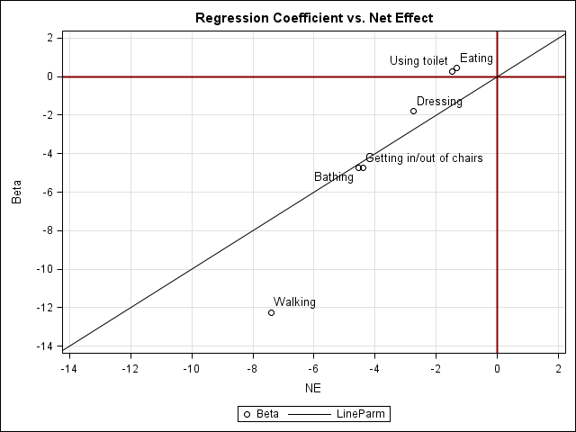
²: Betas were adjusted for age, race, gender, and other ADLs
²: NEs were age-race-gender standardized.

