Supplemental materials:
Supplemental Figure 1 Sample Flowchart
Supplemental Figure 2 Directed acyclic graph (DAG) explaining the association between the exposures, the outcome, and covariates included in the analyses
Supplemental Figure 3 Estimated E- value for a regression coefficient estimate of 0.08 and standard error of coefficient 0.02
Supplemental Table 1 Result of GBTM selection for the primary study
Supplemental Table 2 Associations between PA trajectories and cognition decline among participants: Sensitivity analyses
Supplemental Table 3 Associations between PA trajectories and cognition decline among participants: Sensitivity analyses

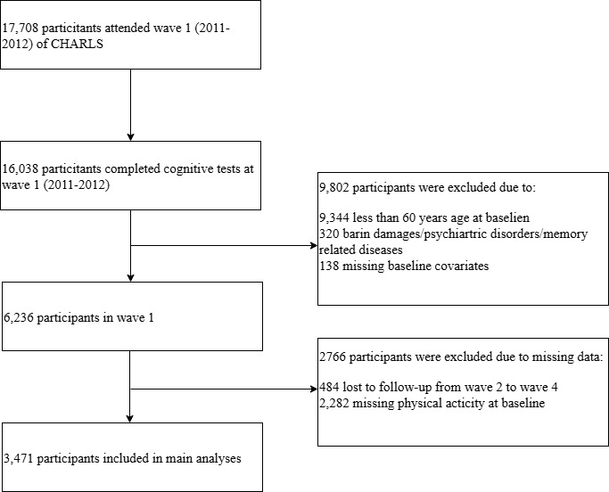
Supplemental Figure 1. Sample Flowchart (2011-2018; main analysis sample).

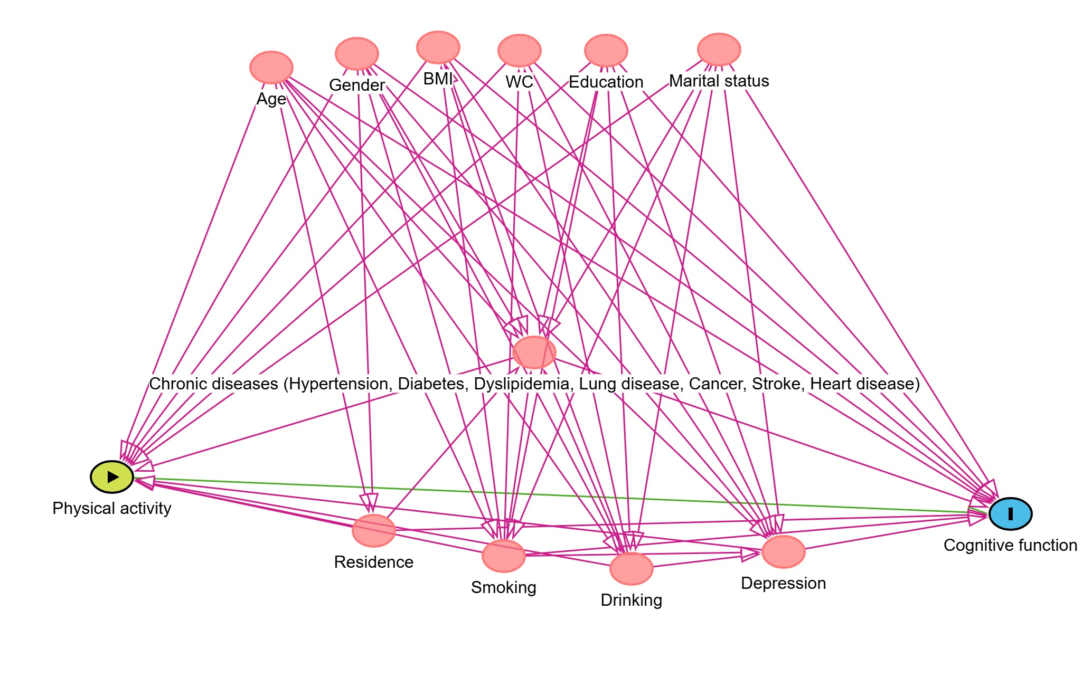
Supplemental Figure 2. Directed acyclic graph (DAG) explaining the association between the exposures, the outcome, and covariates included in the analyses
The yellow, blue, and pink nodes respectively represent the exposure, the outcome measured at the follow-up time, and the confounders of the sociodemographic, lifestyle-related, and health-related factors measured at the baseline. DAG was drawn using http://www.dagitty.net/.

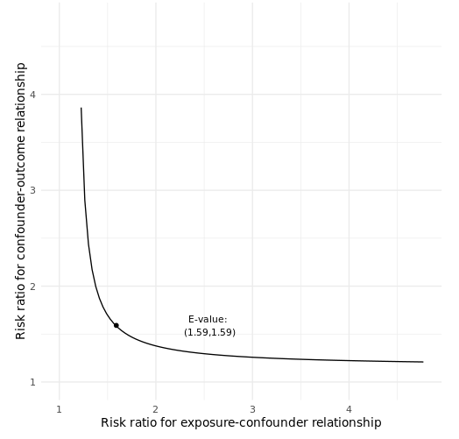
Supplemental Figure 3. Estimated E- value for a regression coefficient estimate of 0.08 and standard error of coefficient 0.02.

Supplemental Table 1 Result of GBTM selection for the primary study
Group | Polynomial | BIC | AIC | Log-likelihood | AvePP | OCC
1 | 2 | 121058.4 | 121015.4 | -55418.44 | - | -
2 | 2, 2 | 115375.5 | 115467.8 | -55099.19 | 0.842 | 6.78
2 | 1,2 | 120199.3 | 120255.0 | -55022.74 | 0.734 | 2.96
2 | 1,1 | 110255.4 | 110212.4 | -55168.89 | 0.823 | 7.97
3 | 2, 2, 2 | 117425.9 | 117358.2 | -54892.36 | 0.747 | 10.33
4 | 2, 2, 2, 2 | 114643.0 | 114526.1 | -56370.47 | 0.680 | 11.30
5 | 2, 2, 2, 2, 2 | 117277.8 | 117136.3 | -56026.51 | 0.761 | 10.54
BIC: Bayesian information criterion; AIC: Akaike information criterion; AvePP: Average posterior probability; OCC: Odds of correct classification.
For all the individuals assigned to a certain group, an AvePP will be calculated. For each trajectory group, an AvePP of assignment > 0.7 is indicative of good certainty of group assignments.
OCC = [b/(1-b)]/[a/(1-a)]. For each trajectory group, OCC >=5 suggests high assignment accuracy.
Supplemental Table 2 Associations between PA trajectories and cognition decline among participants: Sensitivity analyses
 | Episodic memory | Mental intactness | Global cognition
 | β (95%CI) | β (95%CI) | β (95%CI)
Low increasing | Reference | Reference | Reference
High decreasing | 0.022(-0.021,0.065) | 0.079(0.039,0.120) | 0.081(0.038,0.124)
B: estimate; CI: confidence interval. All models were adjusted for age, gender, BMI, WC, residence, education, marital status, smoking, drinking, hypertension, dyslipidemia, diabetes, lung disease, heart disease, stroke, and cancer.

Supplemental Table 3 Associations between PA trajectories and cognition decline among participants: Sensitivity analyses
 | Episodic memory | Mental intactness | Global cognition
 | β (95%CI) | β (95%CI) | β (95%CI)
Low increasing | Reference | Reference | Reference
High decreasing | 0.031(-0.011,0.072) | 0.089(0.051,0.126) | 0.099(0.059,0.140)
B: estimate; CI: confidence interval. All models were adjusted for age, gender, BMI, WC, residence, education, marital status, smoking, drinking, hypertension, dyslipidemia, diabetes, lung disease, heart disease, stroke, and cancer.

