Additional file 1
Dan Tang, et al. Different dimensions of smoking behavior and their associations with accelerated composite biomarkers-based biological aging in Chinese older adults

Contents
Table S1. Lifestyle assessment questionnaire.
Figure S1. Indicator screening flowchart for KDM biological age construction.
Figure S2. Histogram of KDM-AA in study participants.
Table S2. The R-squared of multiple linear regression for each smoking characteristic.
Figure S3. Multiple linear regression model diagnostic plot for smoking status.
Figure S4. Multiple linear regression model diagnostic plot for smoking initiation age.
Figure S5. Multiple linear regression model diagnostic plot for cigarettes smoked per day.
Figure S6. Multiple linear regression model diagnostic plot for smoking duration.
Figure S7. Multiple linear regression model diagnostic plot for years of smoking-to-age ratio.
Figure S8. Multiple linear regression model diagnostic plot for cumulative smoking pack-years.
Figure S9. Estimated associations between different dimensions of smoking behavior and continuous KDM-AA in smokers.
Table S3. Multinomial logistic regression for associations between different dimensions of smoking and severity of biological aging acceleration in smokers
Figure S10. Dose-response relationships between different smoking dimensions and KDM-AA in smokers.
Figure S11. Estimated associations between different dimensions of smoking behavior and continuous KDM-AA (using an alternative definition).
Figure S12. Estimated associations between different dimensions of smoking behavior and continuous KDM-AA based on imputed data set.
Figure S13. Estimated associations between different dimensions of smoking behavior and continuous KDM-AA after excluding extreme exposure and outcome data.
Figure S14. Estimated associations between different dimensions of smoking behavior and continuous KDM-AA after adjusting BMI.
Table S4. Multinomial logistic regression for associations between different dimensions of smoking and severity of biological aging acceleration (cutoff values of ±3 years)
Table S5. E-values of the estimated associations between different dimensions of smoking behavior and continuous KDM-AA.

Table S1. Lifestyle assessment questionnaire.
Lifestyles | Smoking ª | Smoking status | 1. Never smoker 2. Ex-smoker 3. Current smoker  □
Lifestyles | Smoking ª | Daily cigarette consumption | Average cigarettes per day
Lifestyles | Smoking ª | Age of smoking initiation | years old | Age for quitting smoking | years old
Lifestyles | Physical exercise | Exercise frequency | 1. Daily 2. More than once a week 3. Occasional 4. Inactive □
Lifestyles | Physical exercise | Duration of each exercise | minutes | Duration of consistent exercise | yeras
Lifestyles | Physical exercise | Specific exercise item
Lifestyles | Drinking | Drinking frequency | 1. Never 2. Occasional 3. Often 4. Daily □
Lifestyles | Drinking | Daily alcohol consumption | Average liang ^{b} per day
Lifestyles | Drinking | Do you quit drinking | 1. No 2. Yes, age for quitting drinking:  years old □
Lifestyles | Drinking | Age of drinking initiation | years old | Have been drunk in the last year | 1. Yes 2. No □
Lifestyles | Drinking | Types of alcohol | 1. Chinese baijiu 2. Beer 3. Wine 4. Huangjiu 5. Othres □
ª Smoking: “Never smokers” do not need to fill in “daily cigarette consumption”, “age of smoking initiation”, “age for quitting smoking”, etc. For ex-smokers, please fill in the information about the situation before quitting smoking.
^{b} liang: This is a unit of mass commonly used in China. 1 liang = 50 grams.

Figure S1. Indicator screening flowchart for KDM biological age construction.
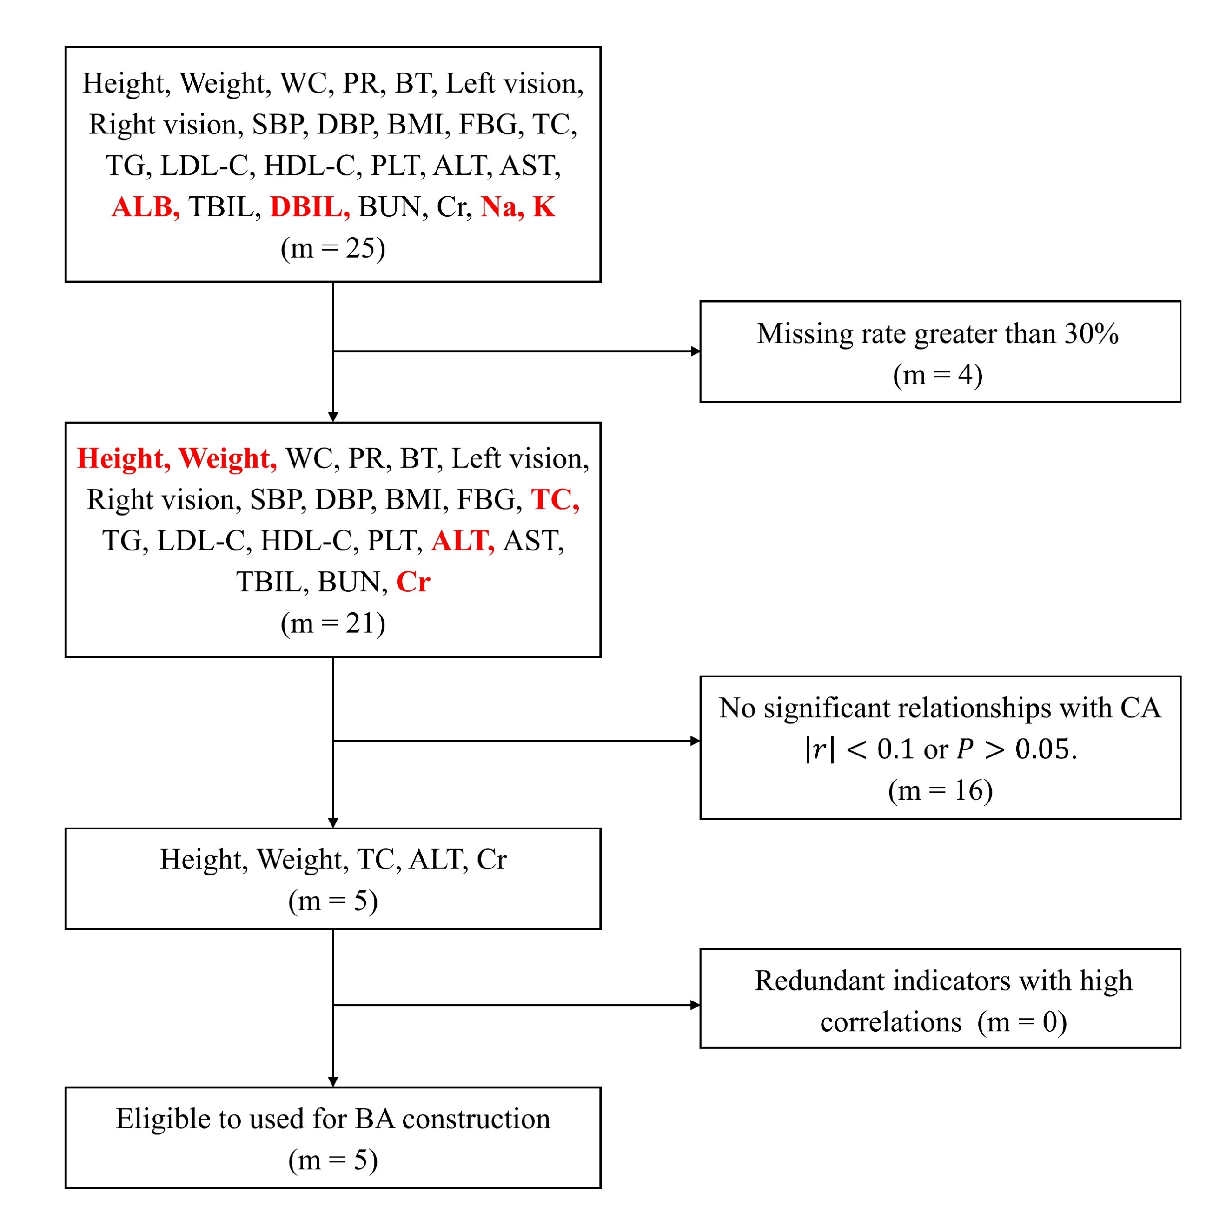
Abbreviations: WC = waist circumference; PR = pulse rate; BT = body temperature; SBP = systolic blood pressure; DBP = diastolic blood pressure; BMI = body mass index; FBG = fasting blood glucose; TC = total cholesterol; TG = triglyceride; LDL-C = low-density lipoprotein cholesterol; HDL-C = high-density lipoprotein cholesterol; PLT = platelet; ALT = alanine transaminase; AST = aspartate transaminase; ALB = albumin; TBIL = total bilirubin; DBIL = direct bilirubin; BUN = blood urea nitrogen; Cr = creatinine; Na = sodium; K = potassium.

Figure S2. Histogram of KDM-AA in study participants.
KDM-AA is the Klemera-Doubal method biological age acceleration (KDM-BA minus CA). The mean of the participants’ KDM-AA is 0.00, and the standard deviation is 1.65.

Table S2. The R-squared of multiple linear regression for each smoking characteristic.
Smoking characteristic | R-squared | adjust R-squared
Smoking status | 0.1318 | 0.1317
Smoking initiation age | 0.1316 | 0.1315
Cigarettes smoked per day | 0.1302 | 0.1300
Smoking duration | 0.1319 | 0.1318
Years of smoking-to-age ratio | 0.1319 | 0.1318
Cumulative smoking pack-years | 0.1307 | 0.1306

Figure S3. Multiple linear regression model diagnostic plot for smoking status.
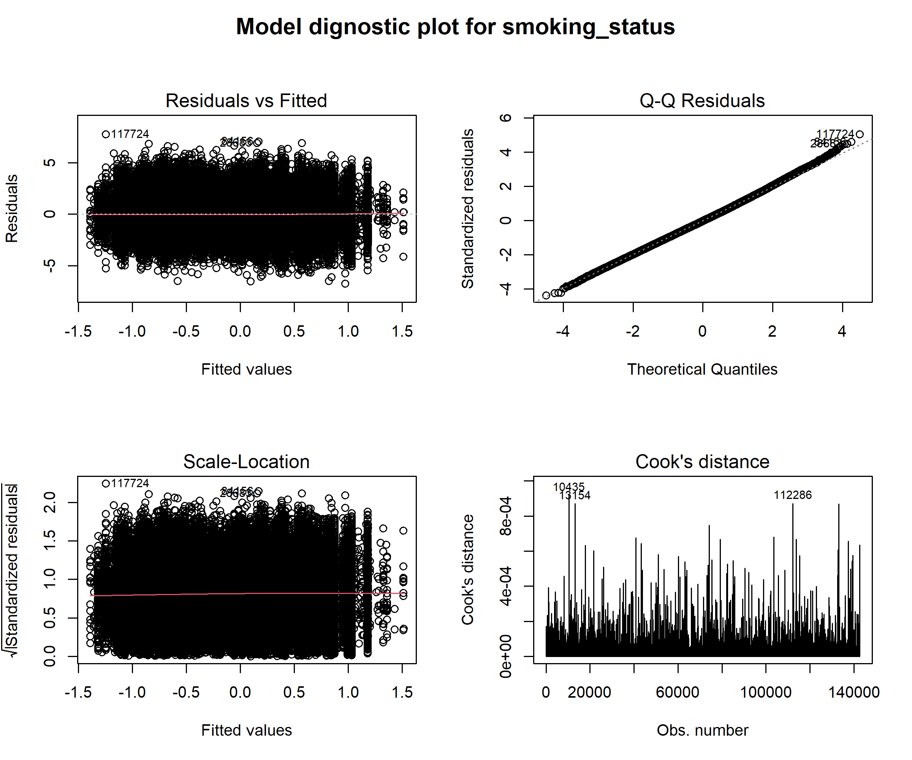

Figure S4. Multiple linear regression model diagnostic plot for smoking initiation age.
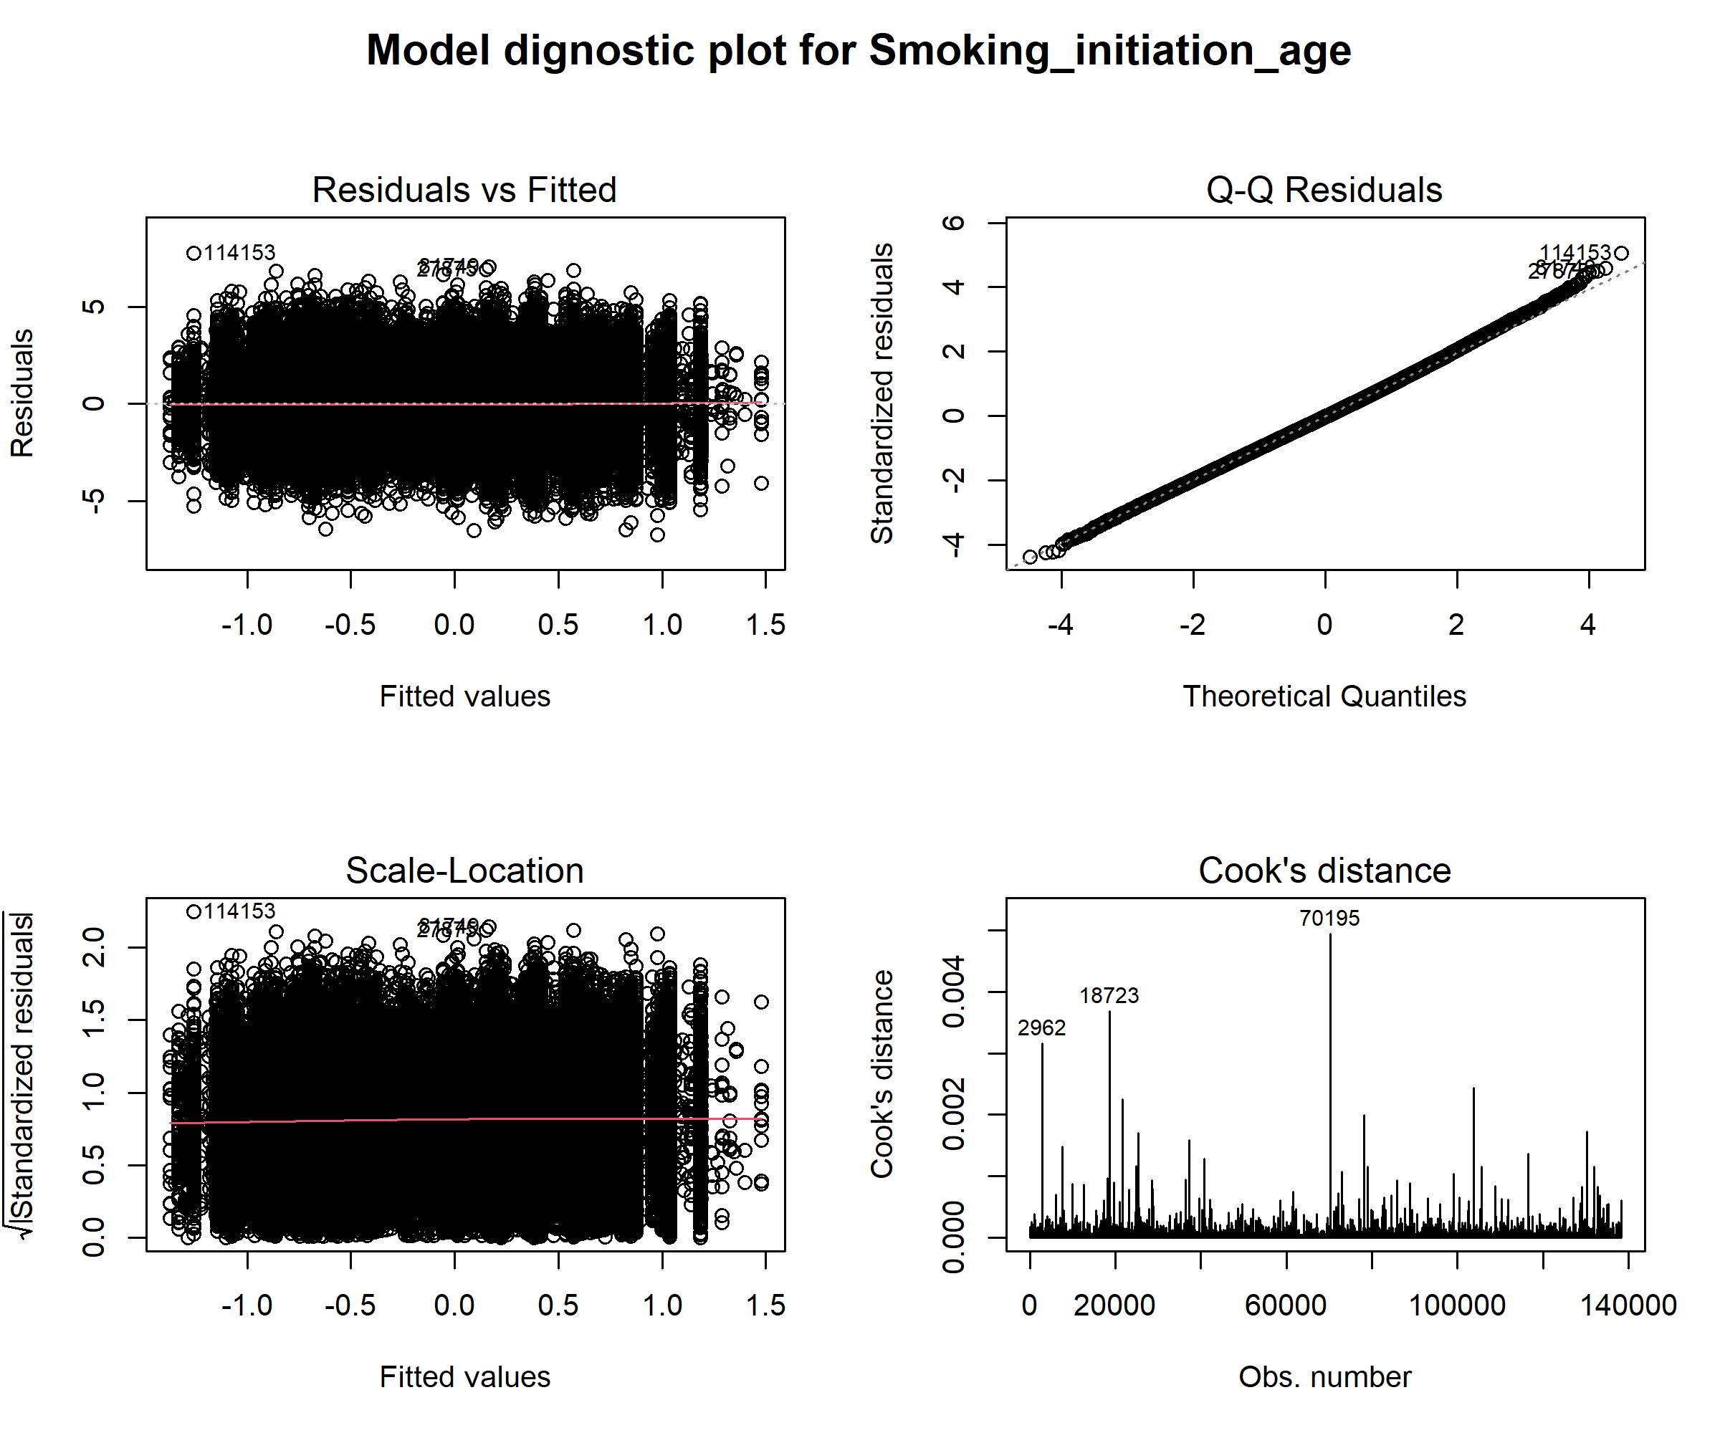

Figure S5. Multiple linear regression model diagnostic plot for cigarettes smoked per day.
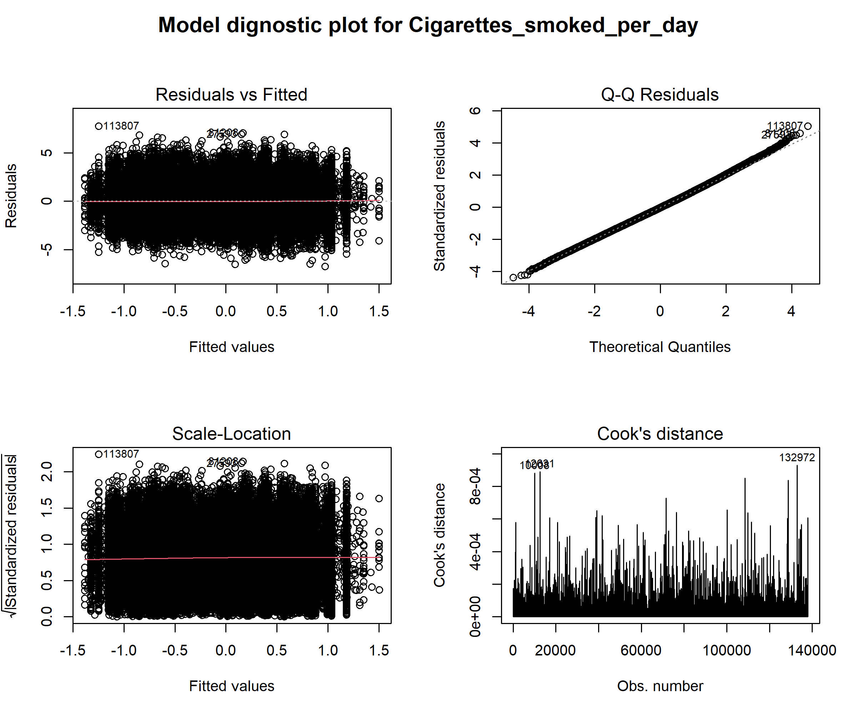

Figure S6. Multiple linear regression model diagnostic plot for smoking duration.
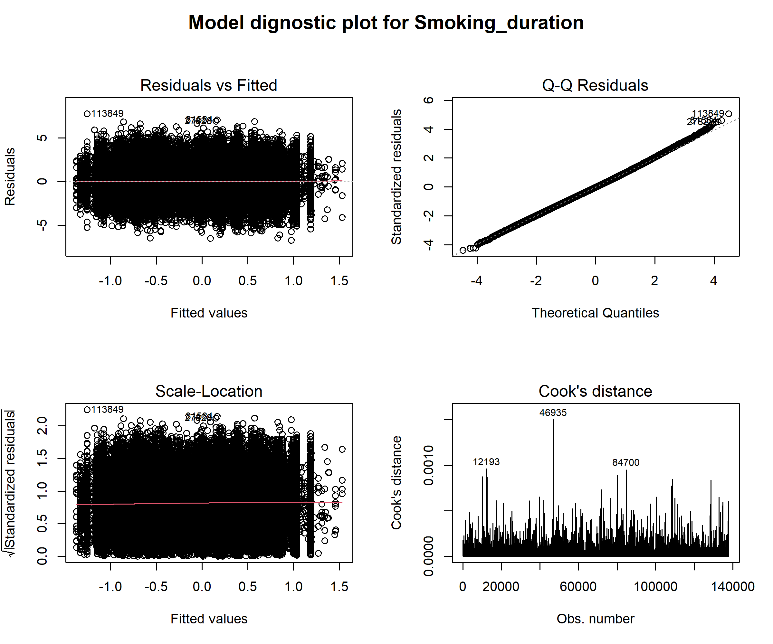

Figure S7. Multiple linear regression model diagnostic plot for years of smoking-to-age ratio.
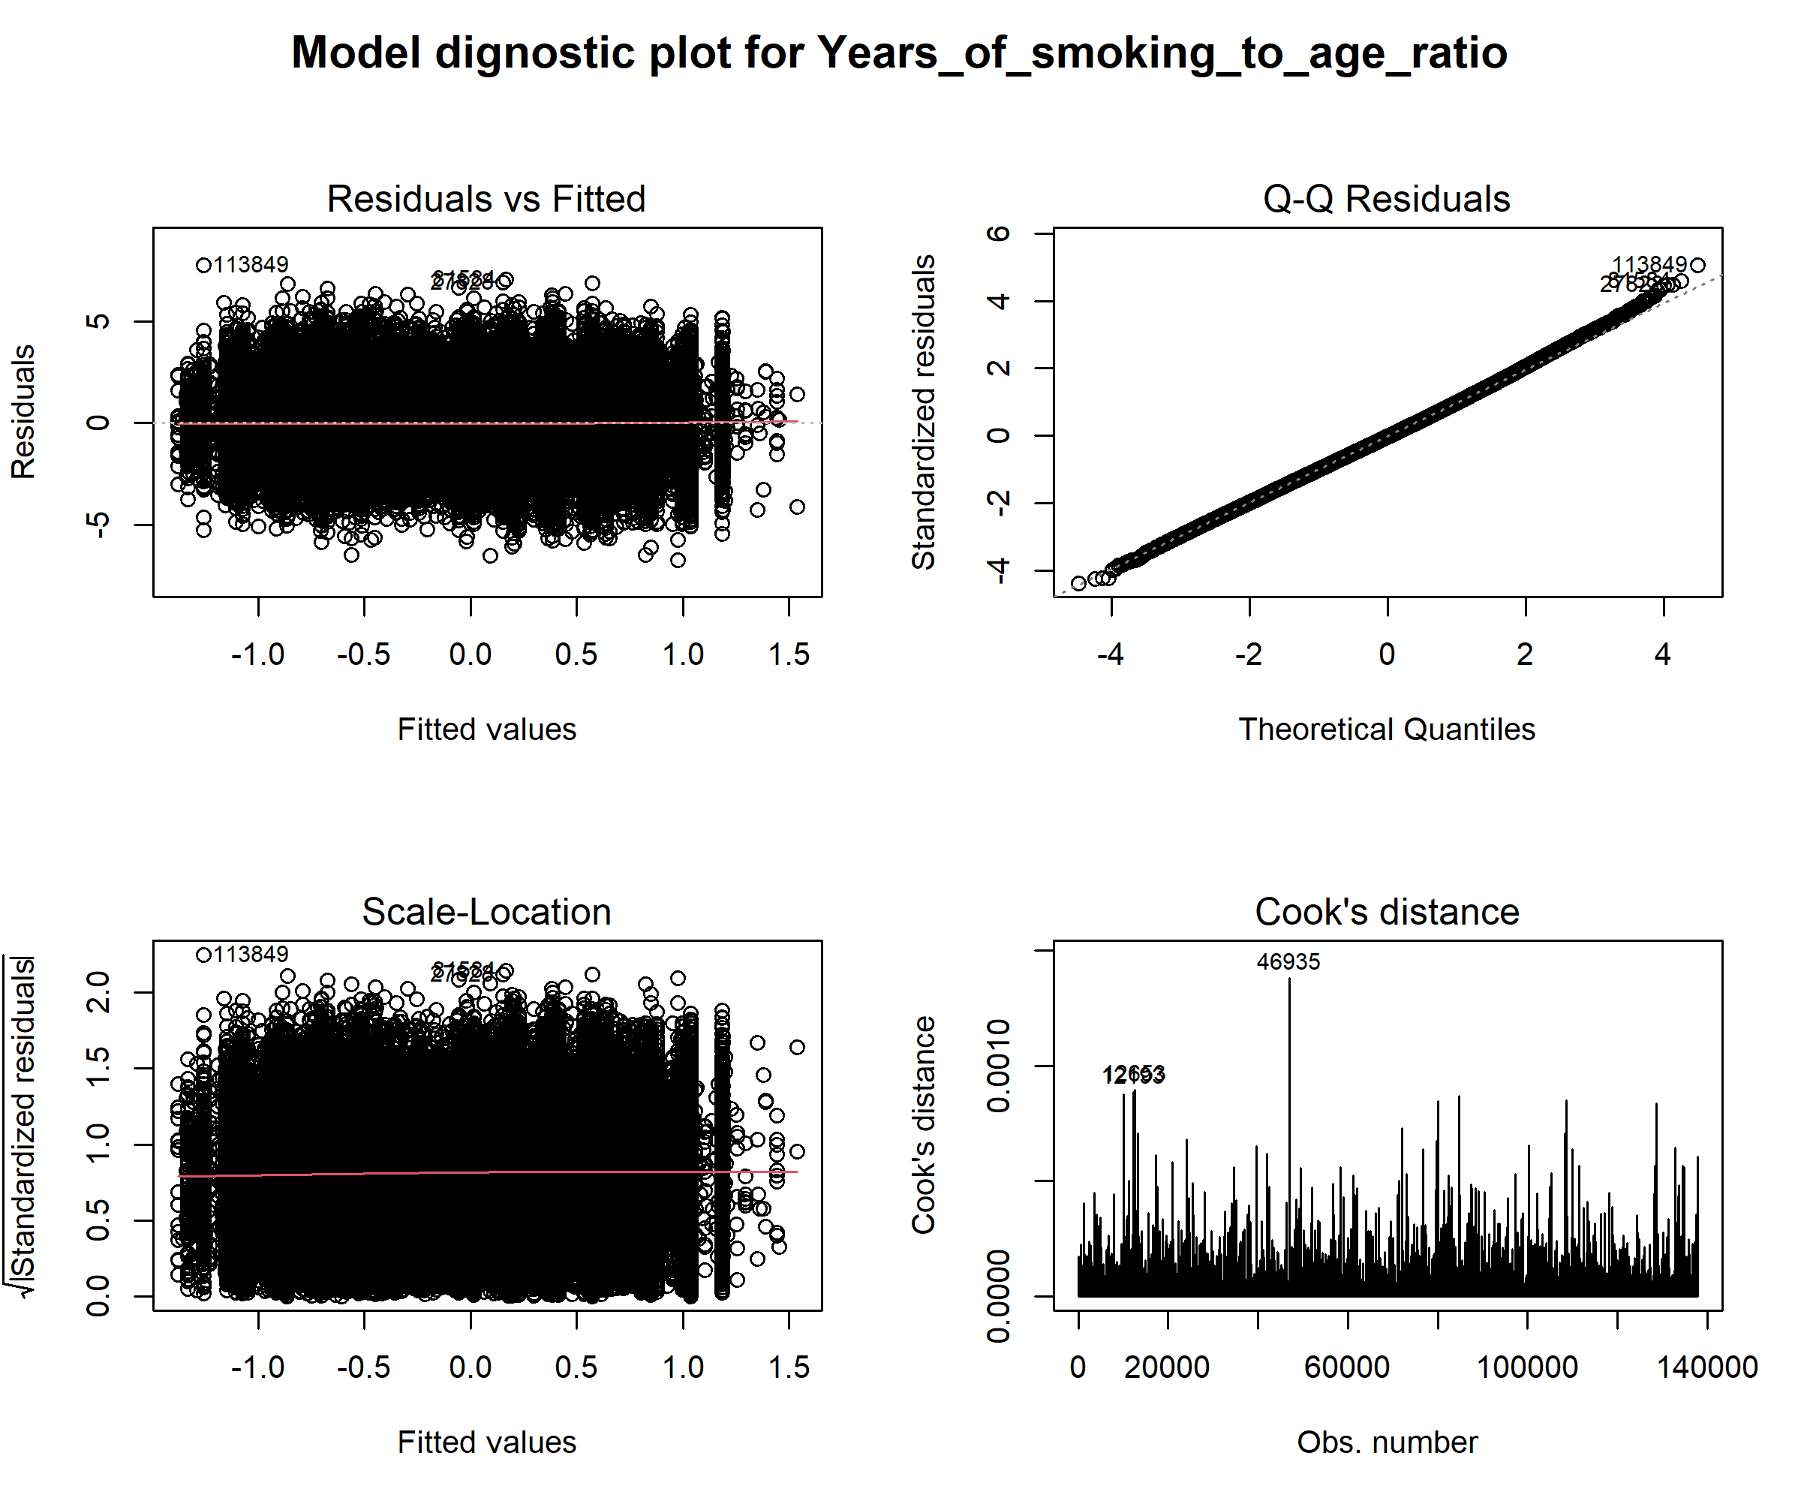

Figure S8. Multiple linear regression model diagnostic plot for cumulative smoking pack-years.
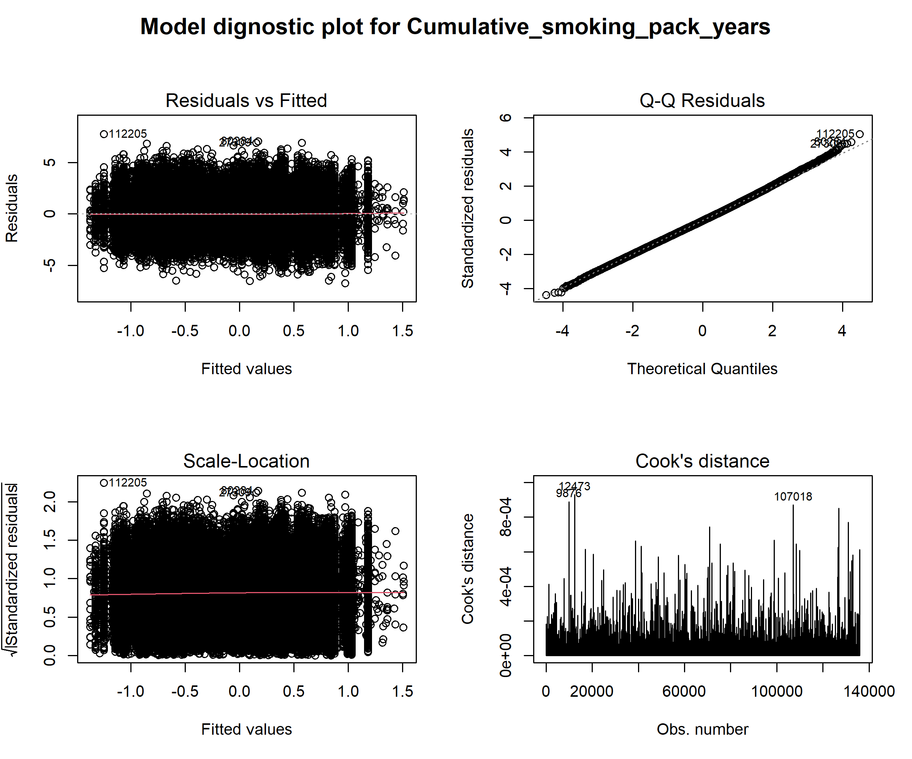

Figure S9. Estimated associations between different dimensions of smoking behavior and continuous KDM-AA in smokers.

The multiple linear regression models adjusted for gender, urbanicity, marital status, drinking frequency, exercise frequency, and self-reported doctor-diagnosed hypertension and diabetes. The amount of missing data varies for different dimensions of smoking, so that N in parentheses indicates the number of complete cases in the analysis corresponding to the specific smoking dimension. The boxes represent point estimations and error bars represent 95% CI. The numbers below error bars are numbers of participants in each exposure group.

Table S3. Multinomial logistic regression for associations between different dimensions of smoking and severity of biological aging acceleration in smokers
Dimensions of smoking | Severely accelerated  Vs reference group* | Substantially decelerated  Vs reference group*
Smoking initiation age (years)
>18 | 1 (ref) | 1 (ref)
12-18 | 1.02 (0.90, 1.16) | 0.96 (0.87, 1.05)
≤12 | 1.19 (0.65, 2.17) | 0.68 (0.39, 1.19)
Cigarettes smoked per day
<5 | 1 (ref) | 1 (ref)
5-20 | 1.22 (0.97, 1.53) | 1.02 (0.86, 1.20)
≥20 | 1.11 (0.89, 1.40) | 1.01 (0.86, 1.19)
Smoking duration (years)
≤20 | 1 (ref) | 1 (ref)
20-50 | 1.12 (0.80, 1.57) | 0.81 (0.65, 1.00)
>50 | 1.46 (1.04, 2.05) | 0.89 (0.72, 1.11)
Years of smoking-to-age ratio
<0.3 | 1 (ref) | 1 (ref)
0.3-0.7 | 0.99 (0.73, 1.35) | 0.82 (0.67, 1.01)
≥0.7 | 1.26 (0.93, 1.72) | 0.79 (0.64, 0.97)
Cumulative smoking pack-years
≤20 | 1 (ref) | 1 (ref)
20-40 | 1.06 (0.90, 1.25) | 0.99 (0.88, 1.11)
>40 | 1.01 (0.87, 1.18) | 0.93 (0.84, 1.04)
The multinomial logistic regression models adjusted for gender, urbanicity, marital status, drinking frequency, exercise frequency, and self-reported doctor-diagnosed hypertension and diabetes.
* The outcome was classified into three groups: severely accelerated aging was defined as KDM-AA ≥ 2; substantially decelerated aging was defined as KDM-AA ≤ -2; and the reference group was defined as -2 < KDM-AA < 2.
Figure S10. Dose-response relationships between different smoking dimensions and KDM-AA in smokers.

The restricted cubic splines regression models adjusted for gender, urbanicity, marital status, drinking frequency, exercise frequency, and self-reported doctor-diagnosed hypertension and diabetes. The solid lines represent point estimations and shaded intervals indicate 95% confidence intervals. The vertical dash lines represent the reference points, which are set to the median for each of parameters of smoking quantities.

Figure S11. Estimated associations between different dimensions of smoking behavior and continuous KDM-AA (using an alternative definition).

The multiple linear regression models adjusted for gender, urbanicity, marital status, drinking frequency, exercise frequency, and self-reported doctor-diagnosed hypertension and diabetes. The amount of missing data varies for different dimensions of smoking, so that N in parentheses indicates the number of complete cases in the analysis corresponding to the specific smoking dimension. The boxes represent point estimations and error bars represent 95% CI. The numbers below error bars are numbers of participants in each exposure group.

Figure S12. Estimated associations between different dimensions of smoking behavior and continuous KDM-AA based on imputed data set.

The multiple linear regression models adjusted for gender, urbanicity, marital status, drinking frequency, exercise frequency, and self-reported doctor-diagnosed hypertension and diabetes. The missing data for smoking exposure and covariates were imputed, so that N in parentheses are the same. The boxes represent point estimations and error bars represent 95% CI. The numbers below error bars are numbers of participants in each exposure group.

Figure S13. Estimated associations between different dimensions of smoking behavior and continuous KDM-AA after excluding extreme exposure and outcome data.

The multiple linear regression models adjusted for gender, urbanicity, marital status, drinking frequency, exercise frequency, and self-reported doctor-diagnosed hypertension and diabetes. The amount of missing data and extreme values varies for different dimensions of smoking, so that N in parentheses indicates the number of complete cases in the analysis corresponding to the specific smoking dimension. The boxes represent point estimations and error bars represent 95% CI. The numbers below error bars are numbers of participants in each exposure group.

Figure S14. Estimated associations between different dimensions of smoking behavior and continuous KDM-AA after adjusting BMI.

The multiple linear regression models adjusted for gender, urbanicity, marital status, drinking frequency, exercise frequency, and self-reported doctor-diagnosed hypertension and diabetes. The amount of missing data and extreme values varies for different dimensions of smoking, so that N in parentheses indicates the number of complete cases in the analysis corresponding to the specific smoking dimension. The boxes represent point estimations and error bars represent 95% CI. The numbers below error bars are numbers of participants in each exposure group.

Table S4. Multinomial logistic regression for associations between different dimensions of smoking and severity of biological aging acceleration (cutoff values of ±3 years)
Dimensions of smoking | Severely accelerated  Vs reference group* | Substantially decelerated  Vs reference group*
Smoking status
Never smoker | 1 (ref) | 1 (ref)
Ex-smoker | 1.31 (1.06, 1.63) | 0.90 (0.80, 1.01)
Current smoker | 1.69 (1.49, 1.91) | 0.70 (0.64, 0.76)
Smoking initiation age (years)
Never smoker | 1 (ref) | 1 (ref)
≤12 | 2.77 (1.12, 6.86) | 0.64 (0.26, 1.58)
12-18 | 1.72 (1.38, 2.14) | 0.69 (0.59, 0.81)
>18 | 1.63 (1.43, 1.86) | 0.75 (0.69, 0.82)
Cigarettes smoked per day
0 (Never smoker) | 1 (ref) | 1 (ref)
<5 | 1.83 (1.31, 2.55) | 0.79 (0.61, 1.03)
5-20 | 1.73 (1.47, 2.04) | 0.76 (0.68, 0.85)
≥20 | 1.69 (1.46, 1.96) | 0.70 (0.63, 0.78)
Smoking duration (years)
0 (Never smoker) | 1 (ref) | 1 (ref)
≤20 | 1.59 (0.94, 2.68) | 0.74 (0.50, 1.09)
20-50 | 1.39 (1.19, 1.62) | 0.69 (0.62, 0.76)
>50 | 2.06 (1.77, 2.41) | 0.80 (0.72, 0.90)
Years of smoking-to-age ratio
0 (Never smoker) | 1 (ref) | 1 (ref)
<0.3 | 1.98 (1.27, 3.10) | 0.79 (0.55, 1.14)
0.3-0.7 | 1.48 (1.26, 1.73) | 0.77 (0.69, 0.85)
≥0.7 | 1.84 (1.58, 2.14) | 0.70 (0.62, 0.77)
Cumulative smoking pack-years
0 (Never smoker) | 1 (ref) | 1 (ref)
≤20 | 1.77 (1.42, 2.22) | 0.81 (0.69, 0.95)
20-40 | 1.79 (1.48, 2.17) | 0.76 (0.66, 0.86)
>40 | 1.65 (1.42, 1.93) | 0.68 (0.61, 0.76)
The multinomial logistic regression models adjusted for gender, urbanicity, marital status, drinking frequency, exercise frequency, and self-reported doctor-diagnosed hypertension and diabetes.
* The outcome was classified into three groups: severely accelerated aging was defined as KDM-AA ≥ 3; substantially decelerated aging was defined as KDM-AA ≤ -3; and the reference group was defined as -3 < KDM-AA < 3.

Table S5. E-values of the estimated associations between different dimensions of smoking behavior and continuous KDM-AA.
Dimensions of smoking | β (95%CI） | Estimated E-value
Smoking status
Never smoker | 1 (ref) | -
Ex-smoker | 0.15 (0.11, 0.19) | 1.55
Current smoker | 0.33 (0.30, 0.36) | 2.04
Smoking initiation age (years)
Never smoker | 1 (ref) | -
≤12 | 0.55 (0.29, 0.81) | 2.67
12-18 | 0.32 (0.27, 0.37) | 2.02
>18 | 0.29 (0.26, 0.32) | 1.93
Cigarettes smoked per day
0 (Never smoker) | 1 (ref) | -
<5 | 0.25 (0.16, 0.33) | 1.81
5-20 | 0.32 (0.28, 0.35) | 2.00
≥20 | 0.32 (0.29, 0.35) | 2.00
Smoking duration (years)
0 (Never smoker) | 1 (ref) | -
≤20 | 0.16 (0.04, 0.28) | 1.57
20-50 | 0.27 (0.24, 0.30) | 1.88
>50 | 0.35 (0.31, 0.38) | 2.08
Years of smoking-to-age ratio
0 (Never smoker) | 1 (ref) | -
<0.3 | 0.17 (0.05, 0.29) | 1.61
0.3-0.7 | 0.26 (0.23, 0.29) | 1.84
≥0.7 | 0.35 (0.32, 0.39) | 2.10
Cumulative smoking pack-years
0 (Never smoker) | 1 (ref) | -
≤20 | 0.25 (0.20, 0.31) | 1.83
20-40 | 0.32 (0.28, 0.37) | 2.02
>40 | 0.33 (0.30, 0.36) | 2.04

