Supplemental Figure 1

Values of a) GDF-15 vs MOCA b) GDF-15 vs FFP, c ) IL-6 vs FFP. n values are listed above each boxplot. The median regression lines are indicated in red. Spearman’s 95% Confidence Interval are as follows: a) -0.143 ( -0.274, -0.015) b) .204 ( 0.085, 0.316) c) .189 ( 0.055, 0.304)

a
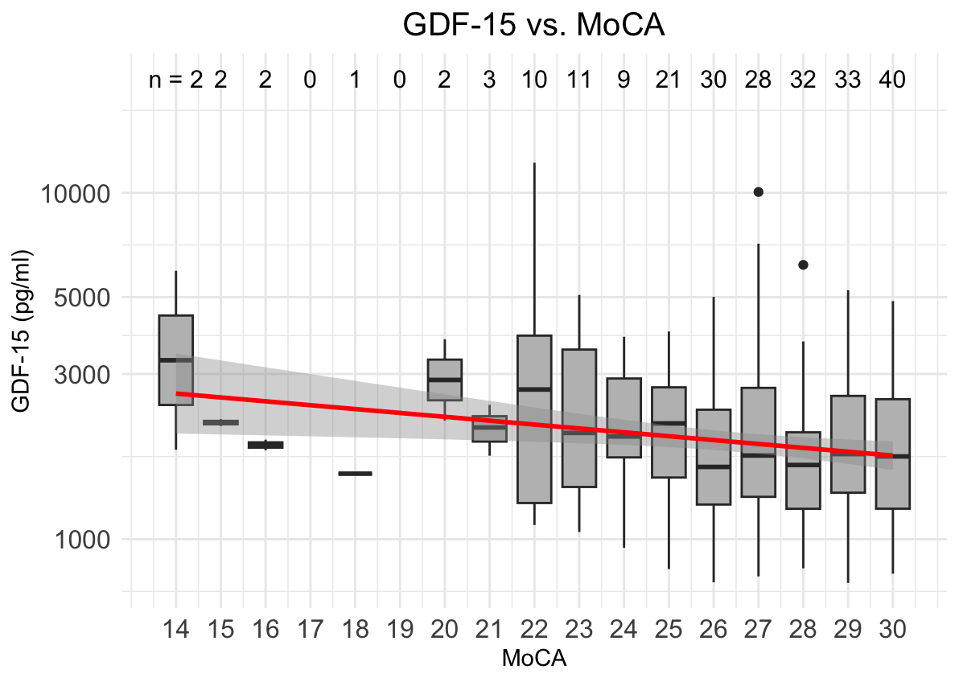
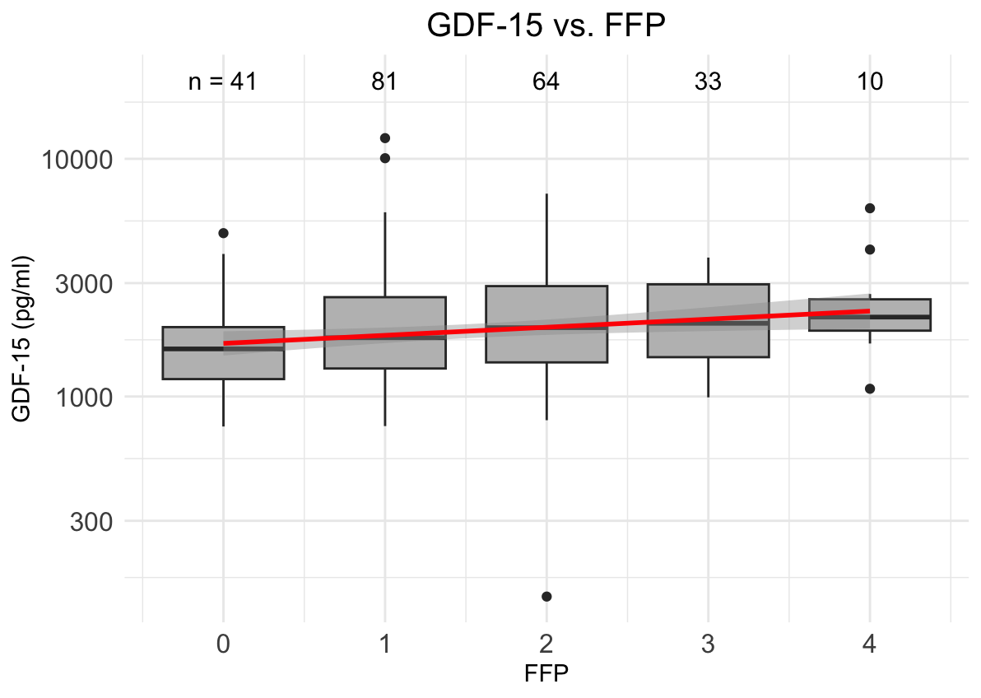
C
