Supplemental materials
Fig S1. Participant Screening flowchart.
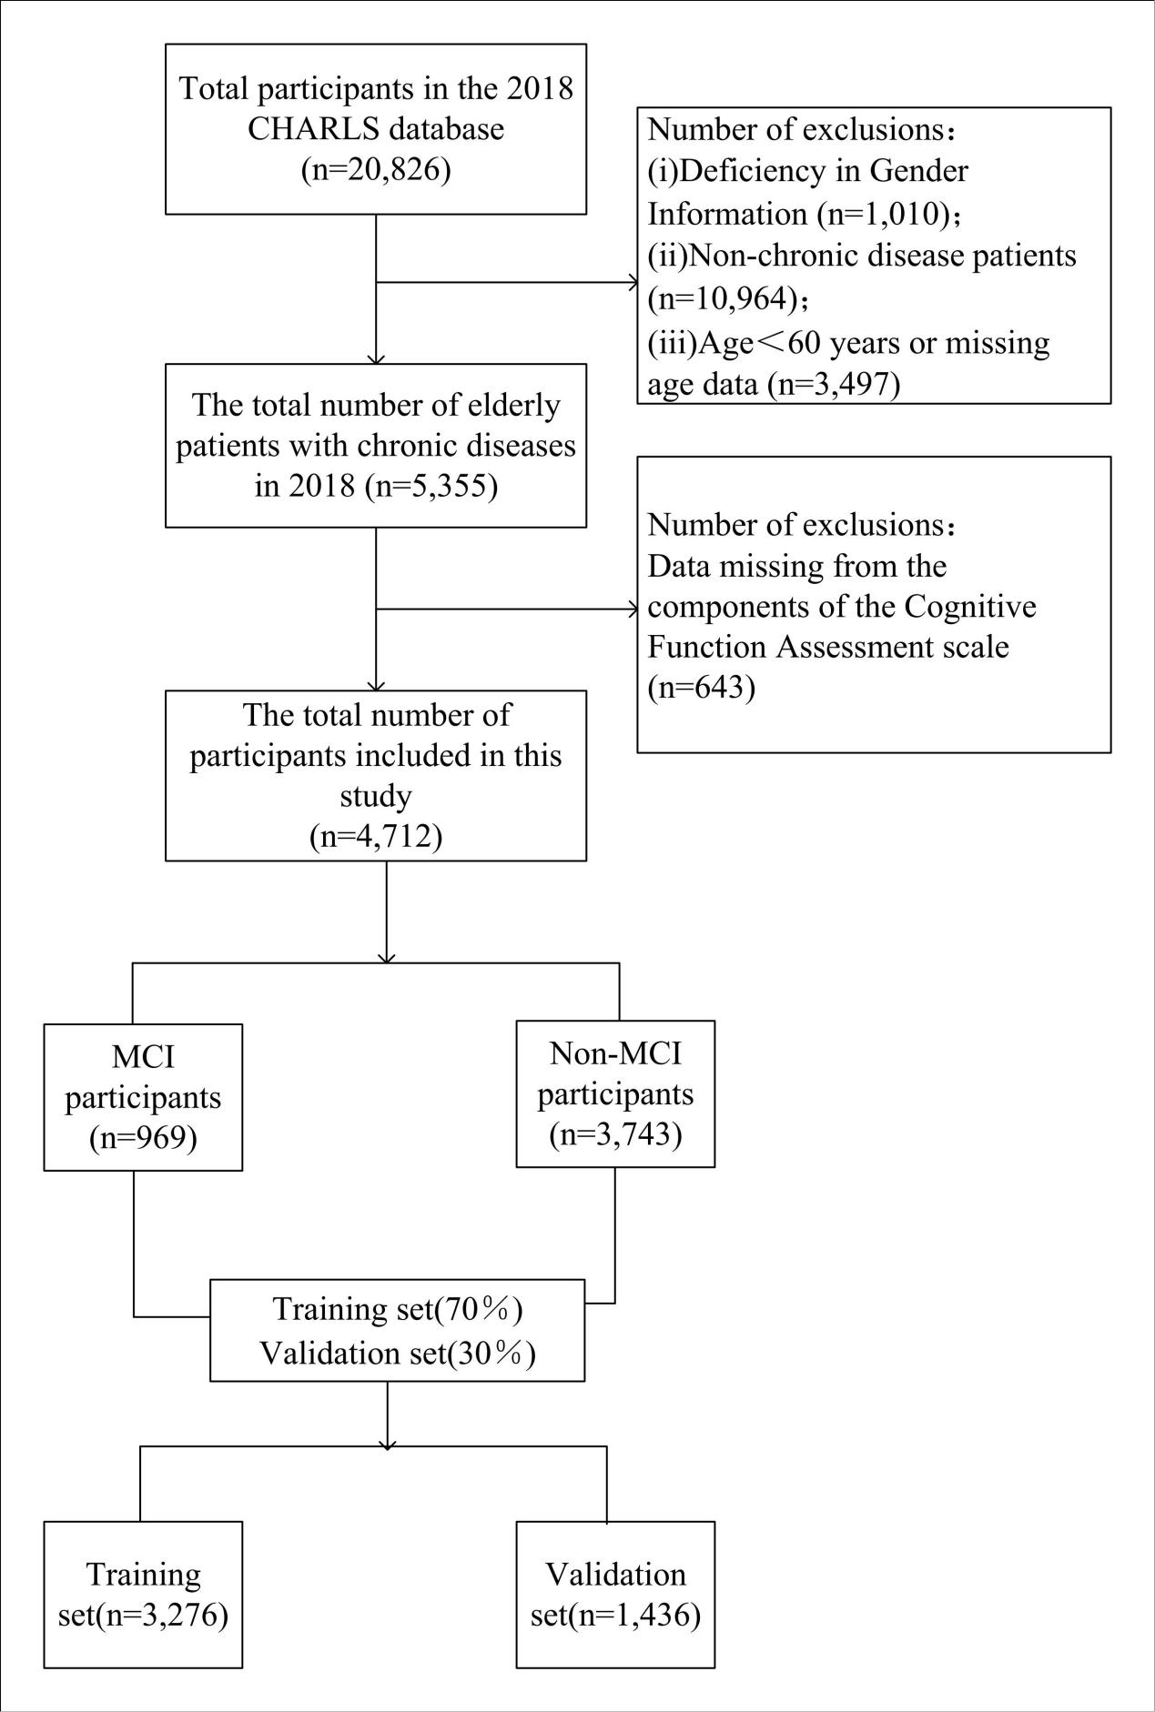

Fig S2. Age distribution and prevalence of MCI among older adults with chronic diseases.
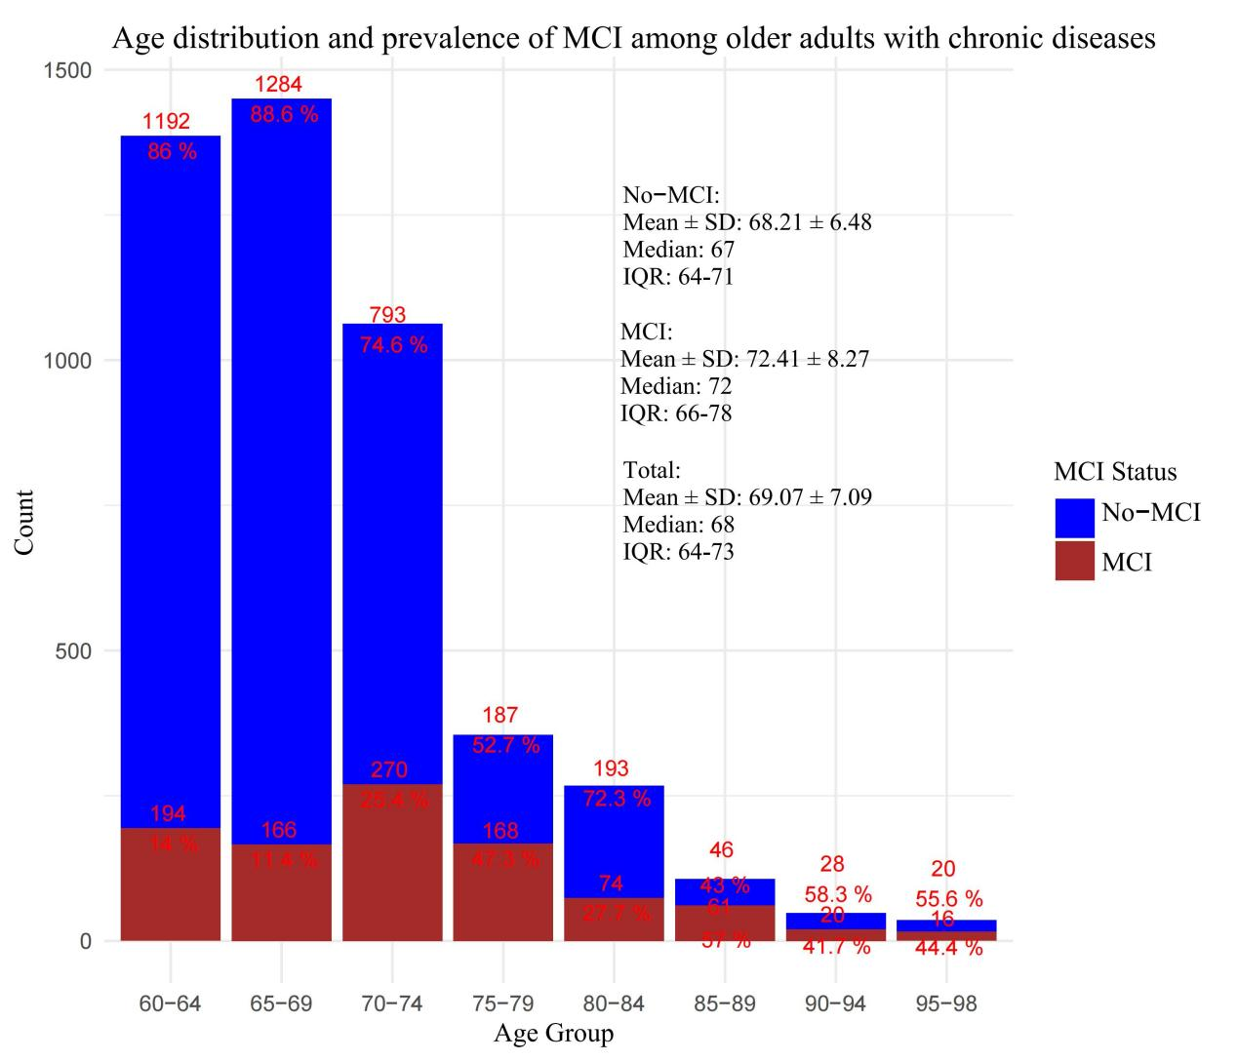

Fig S3. Distribution of each disease in the MCI group and the non-MCI group.

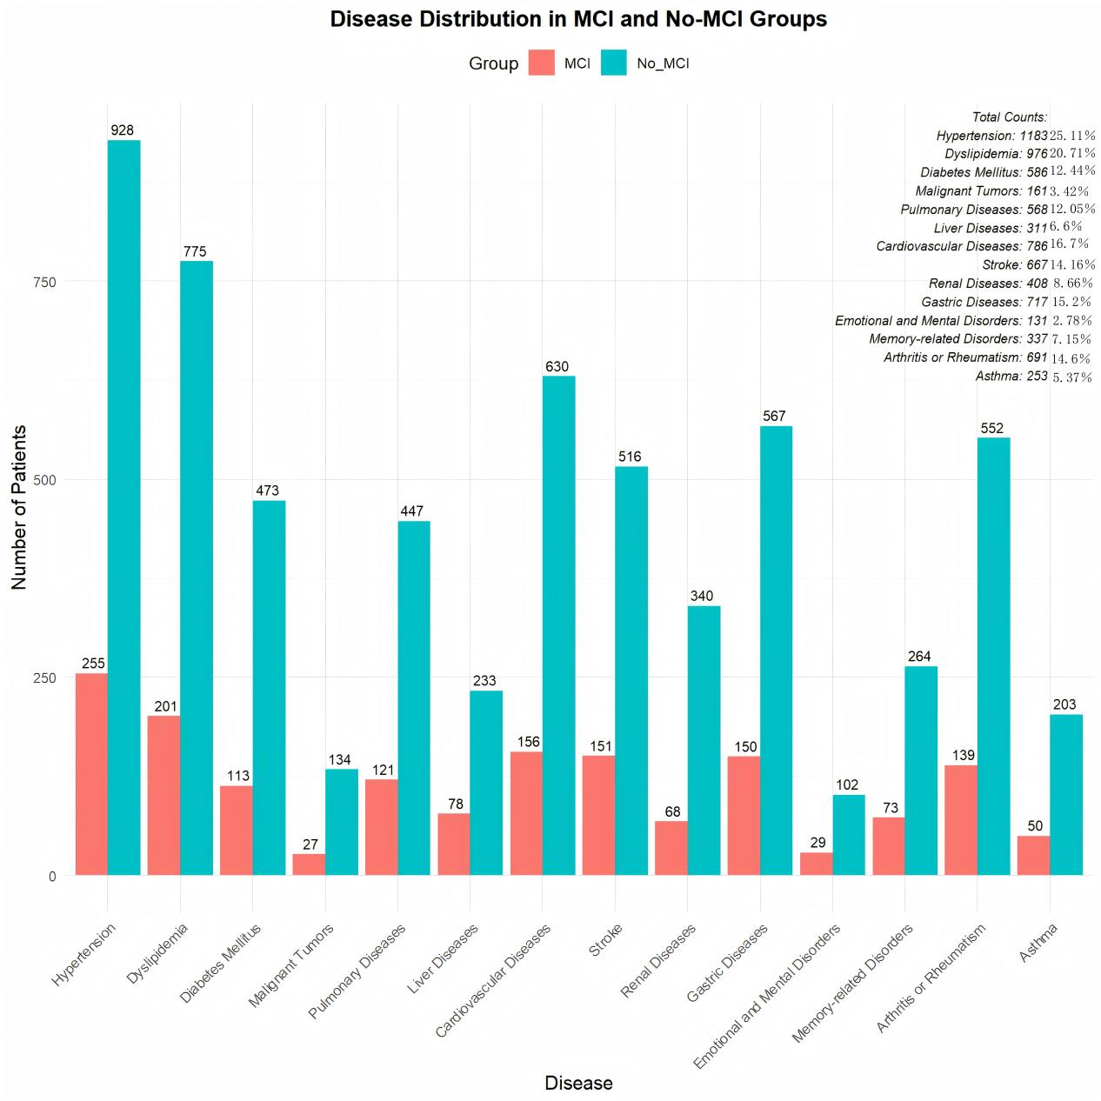

Table S1. Categorical variable assignment.
Variable | Variable assignment
Sex | Male = 1; female = 0
SCD | Yes = 1; NO = 0
Social activity | Yes = 1; NO = 0
Marital satisfaction | Yes = 1; NO = 0
Child satisfaction | Yes = 1; NO = 0
Residence | Urban = 1; Rural = 0
Air quality satisfaction | Yes = 1; NO = 0
Whether he has been hospitalized in the past year(%) | Yes = 1; NO = 0
Fall down(%) | Yes = 1; NO = 0
Hip fracture | Yes = 1; NO = 0
Life satisfaction | Yes = 1; NO = 0
Health satisfaction | Yes = 1; NO = 0
Medical insurance | Yes = 1; NO = 0
Smoke | Yes = 1; NO = 0
Drink | Yes = 1; NO = 0
Physical disability | Yes = 1; NO = 0
Depression | Yes = 1; NO = 0
Distant object vision | Good = 1; Common = 2; Bad = 3
Near object vision | Good = 1; Common = 2; Bad = 3
Hearing | Good = 1; Common = 2; Bad = 3
Be vexed by pain | No = 1; A little = 2; relatively much more = 3
Education | Below junior high school = 1; High school or vocational school = 2; College or above = 3
Physical activity | PA = 1; IPA = 0
Naptime | ＞90min = 1; ≤90min = 2; 0min = 3
Nighttime sleep | ＜6h = 1; ≥6h and ≤8h = 2; ＞8h = 3
Income | Low income = 1; Middle income = 2; High income = 3
Marriage | have a spouse = 1; have no spouse = 0
Age | 60~69 = 1; 70~79 = 2; ≥80 = 3

Table S2 The baseline characteristics of the total participants.
Variable | 2018 CHARLS(n=4712) | External validation(n=1000)
Sex(%)
Female | 2399(50.91％) | 517(51.7％)
Male | 2313(49.09％) | 483(48.3％)
SCD
Yes | 1362(28.90％) | 243(24.3％)
No | 3350(71.10％) | 757(75.7％)
Social activity
Yes | 2413(51.21％) | 498(49.8％)
No | 2299(48.79％) | 502(50.2％)
Marital satisfaction
Yes | 3911(83％) | 826(82.6％)
No | 801(17％) | 174(17.4％)
Child satisfaction
Yes | 4211(89.36％) | 689(68.9％)
No | 501(10.63％) | 311(31.1％)
Residence
Urban | 1334(28.3％) | 282(28.2％)
Rural | 3377(71.7％) | 718(71.8％)
Air quality satisfaction
Yes | 3733(79.22％) | 797(79.7％)
No | 979(20.78％) | 203(20.3％)
Whether he has been hospitalized in the past year
Yes | 1285(27.27％) | 245(24.5％)
No | 3427(72.73％) | 755(75.5％)
Fall down
Yes | 1162(24.66％) | 260(26％)
No | 3550(75.34％) | 740(74％)
Hip fracture
Yes | 179(3.8％) | 39(3.9％)
No | 4533(96.2％) | 961(96.1％)
Life satisfaction
Yes | 4101(87.04％) | 819(81.9％)
No | 611(12.96％) | 181(18.1％)
Health satisfaction
Yes | 2813(59.7％) | 610(61％)
No | 1899(40.3％) | 390(39％)
Medical insurance
Yes | 4572(97.03％) | 957(95.7％)
No | 140(2.97％) | 43(4.3％)
Smoke
Yes | 2065(43.82％) | 421(42.1％)
No | 2647(56.18％) | 579(57.9％)
Drink
Yes | 2280(48.39％) | 481(48.1％)
No | 2432(51.61％) | 519(51.9％)
Physical disability
Yes | 1859(39.45％) | 418(41.8％)
No | 2853(60.55％) | 582(58.2％)
Depression
Yes | 1089(23.11％) | 306(30.6％)
No | 3623(76.89％) | 694(69.4％)
Distant object vision
Good | 1032(21.9％) | 185(18.5％)
Common | 2322(49.28％) | 485(48.5％)
Bad | 1358(28.82％) | 330(33％)
Near object vision
Good | 1190(25.25％) | 254(25.4％)
Common | 2399(50.91％) | 493(49.3％)
Bad | 1123(23.84％) | 253(25.3％)
Hearing
Good | 1246(26.44％) | 277(27.7％)
Common | 2579(54.73％) | 513(51.3％)
Bad | 887(18.83％) | 210(21％)
Be vexed by pain
No | 1453(30.84％) | 277(27.7％)
A little | 2050(43.50％) | 463(46.3％)
relatively much more | 1209(25.66％) | 260(26％)
Education
Below junior high school | 2841(60.29％) | 481(48.1％)
High school or vocational school | 1415(30.03％) | 417(41.7％)
College or above | 456(9.68％) | 102(10.2％)
Physical activity
PA | 1127(23.9％) | 225(22.5％)
IPA | 3585(76.1％) | 775(77.5％)
Naptime
＞90min | 1434(30.44％) | 297(29.7％)
≤90min | 1214(25.76％) | 316(31.6％)
0min | 2064(43.8％) | 387(38.7％)
Nighttime sleep
＜6h | 1847(39.20％) | 382(38.2％)
≥6h and ≤8h | 2460(52.20％) | 510(51％)
＞8h | 405(8.6％) | 108(10.8％)
Income
Low income | 1694(35.95％) | 432(43.2％)
Middle income | 2014(42.74％) | 485(48.5％)
High income | 1004(21.31％) | 83(8.3％)
Marriage
have a spouse | 3849(81.69％) | 695(69.5％)
have no spouse | 863(18.31％) | 305(30.5％)
Age
60~69 | 2836(60.19％) | 527(52.7％)
70~79 | 1418(30.1％) | 302(30.2％)
≥80 | 458(9.71％) | 171(17.1％)
ADL score, M±SD | 5.44±1.31 | 3.28±1.59
Number of chronic diseases, M±SD | 1.7±1.09 | 2.97±2.66

variable | VIF | Tolerance
Sex | 1.719 | 0.582
SCD | 1.325 | 0.755
Social activity | 1.275 | 0.784
Marital satisfaction | 1.352 | 0.739
Child satisfaction | 1.360 | 0.735
Residence | 1.493 | 0.669
Air quality satisfaction | 1.291 | 0.775
Whether he has been hospitalized in the past year | 1.290 | 0.775
Fall down | 1.282 | 0.780
Hip fracture | 1.290 | 0.775
Life satisfaction | 1.347 | 0.743
Health satisfaction | 1.366 | 0.732
Medical insurance | 1.325 | 0.755
Smoke | 1.459 | 0.619
Drink | 1.387 | 0.685
Physical disability | 1.360 | 0.721
Depression | 1.478 | 0.735
Distant object vision | 1.439 | 0.677
Near object vision | 1.386 | 0.694
Hearing | 1.382 | 0.721
Be vexed by pain | 1.373 | 0.723
Education | 1.258 | 0.728
Physical activity | 1.262 | 0.795
Naptime | 1.264 | 0.793
Night time sleep | 1.330 | 0.791
Income | 1.369 | 0.752
Marriage | 1.352 | 0.730
Age | 1.365 | 0.739
ADL score | 1.373 | 0.732
Number of chronic diseases | 1.269 | 0.788
Table S3. Multicollinearity test for variables that are incorporated into the model.
VIF, variance inflation factors. Tolerance,1/VIF.

