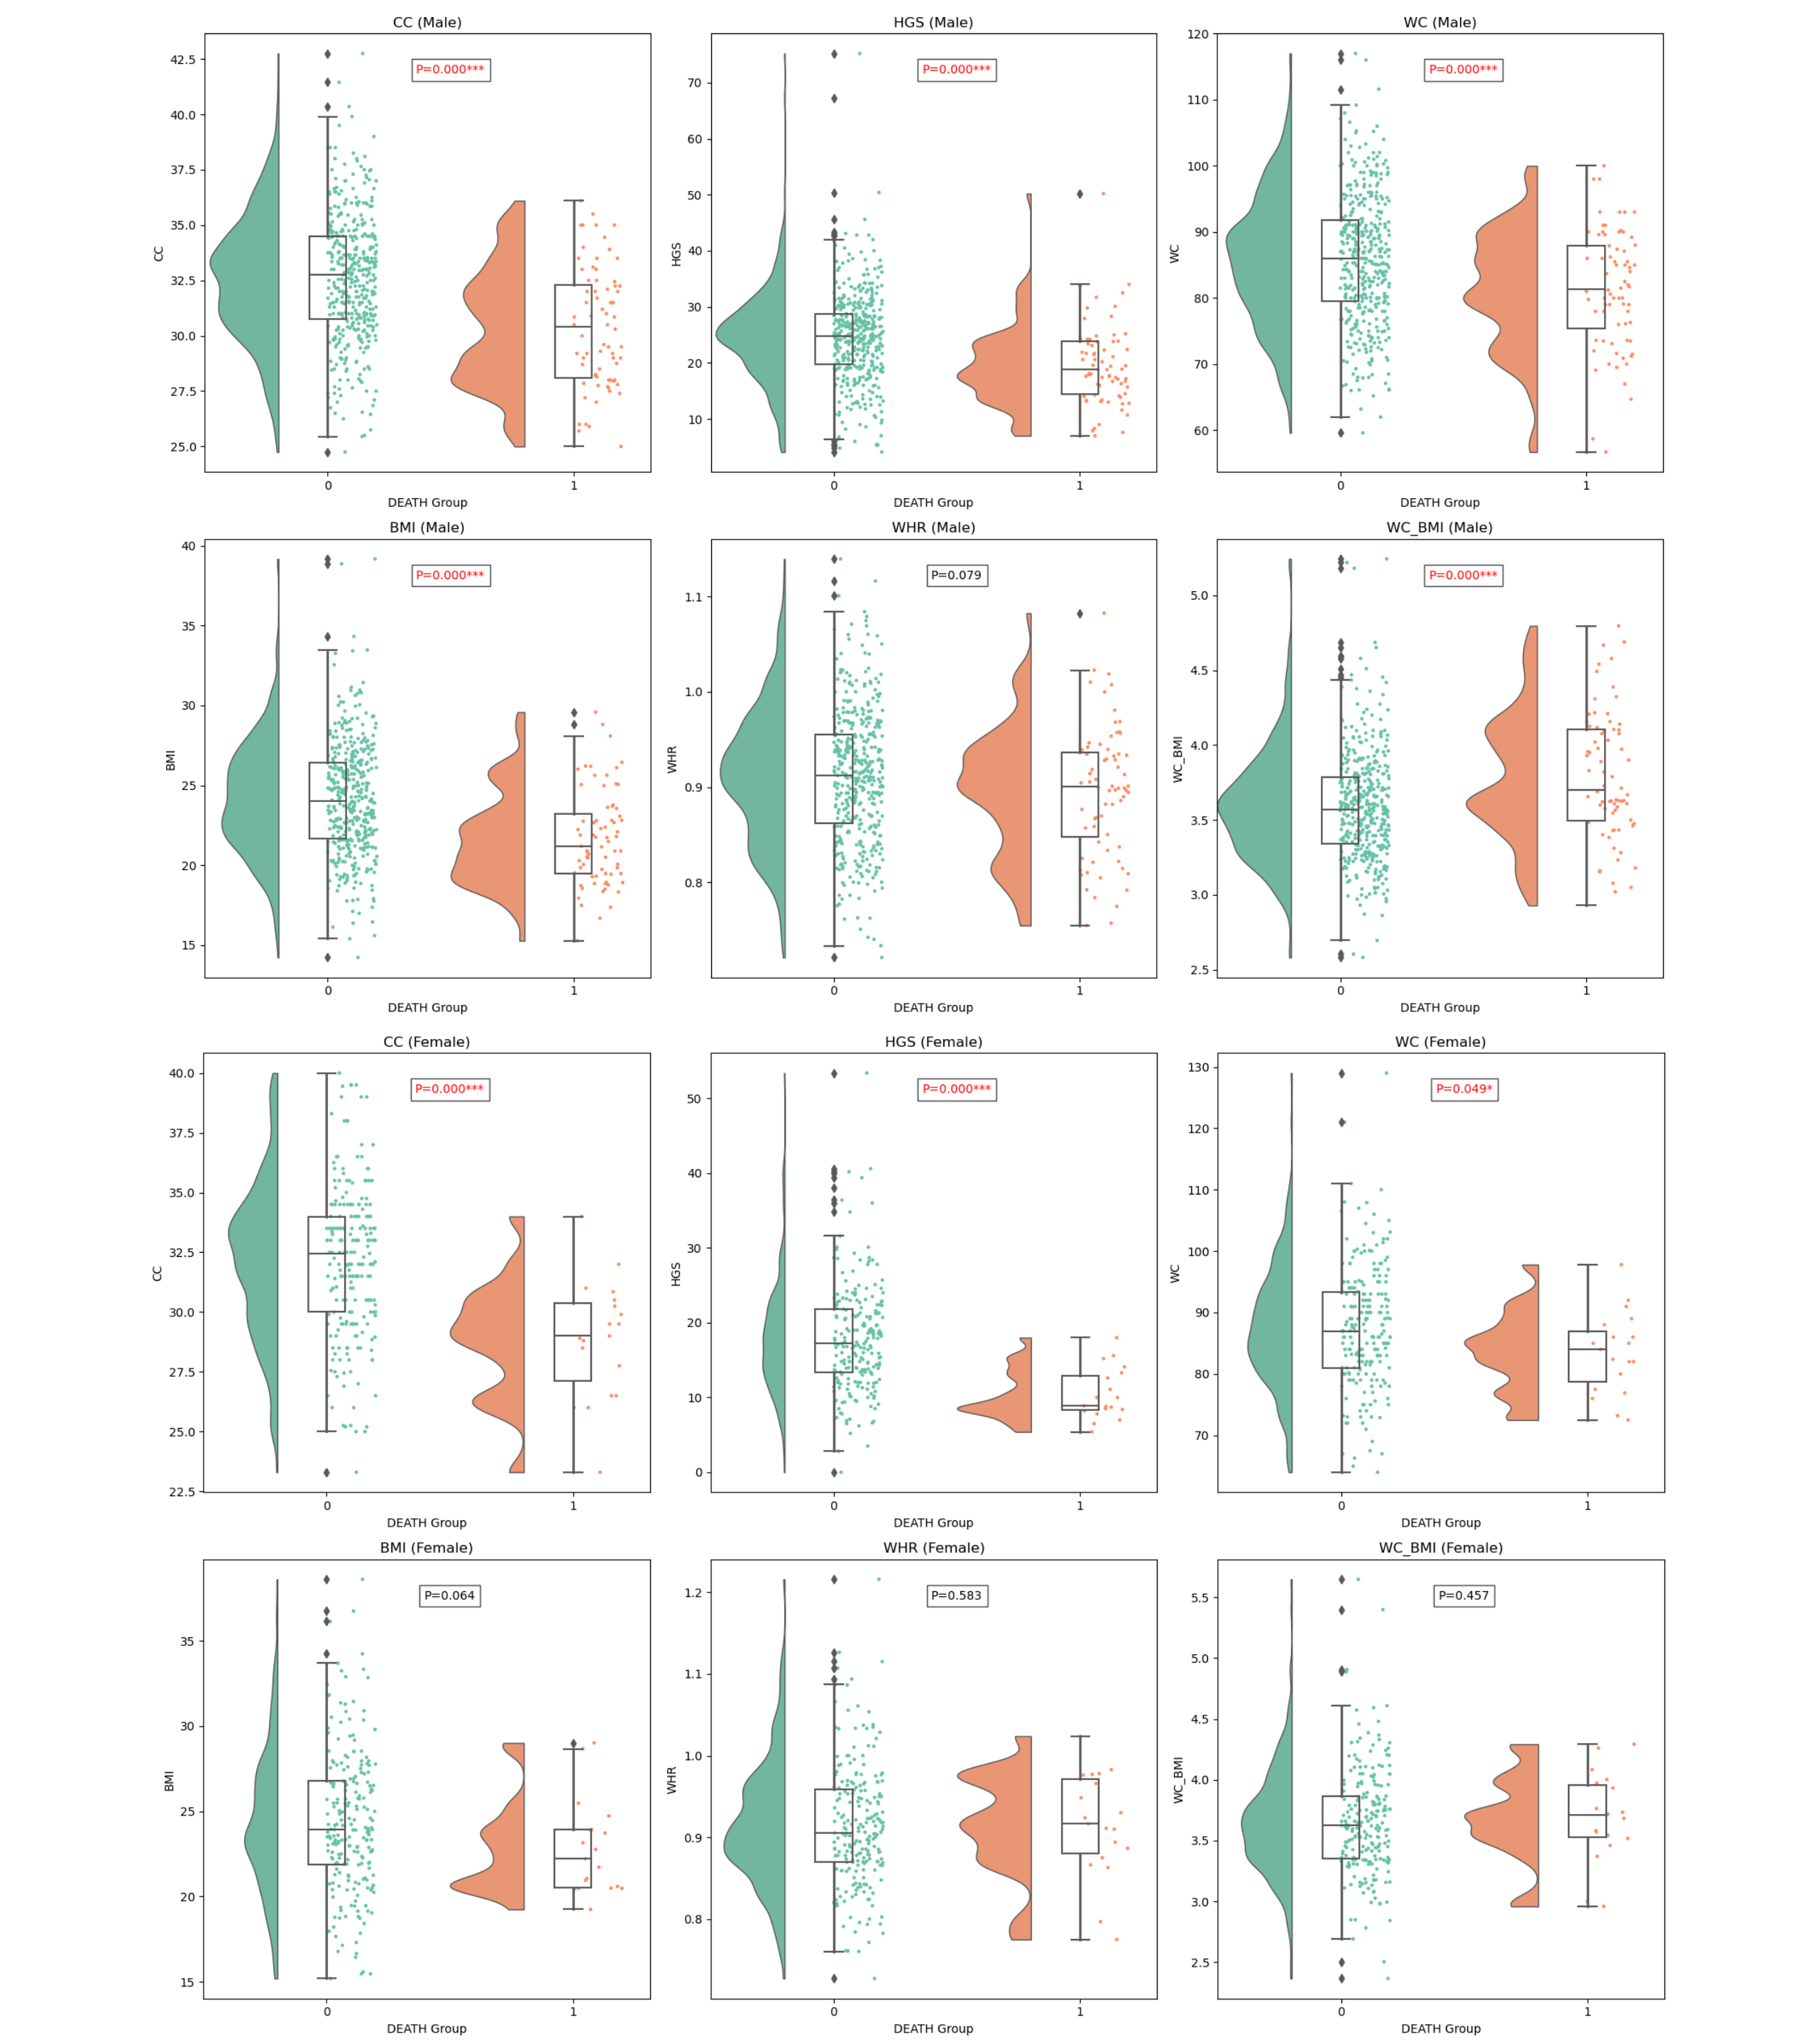
Figure 1S Differences in CC, HGS, WC, BMI, WHR, and WC_BMI between the survival group and the death group
Note: Green represents the survival group, and orange represents the death group. CC, calf circumference; HGS, handgrip strength; WC, waist circumference; BMI, body mass index; WHR, waist-to-hip ratio.

