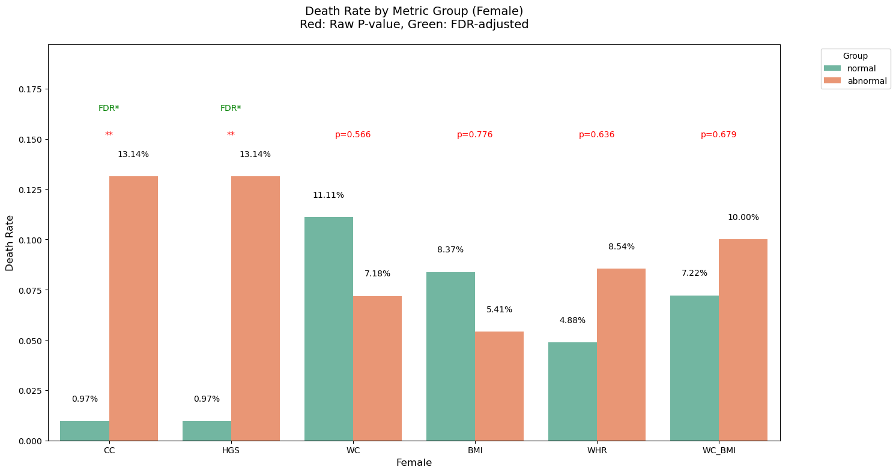 Figure 2S Mortality of patients in different CC, HGS, WC, BMI, WHR and WC_BMI groups
Note: CC, calf circumference; HGS, handgrip strength; WC, waist circumference; BMI, body mass index; WHR, waist-to-hip ratio. *: P＜0.05，**: P＜0.01，***: P＜0.001.

