Appendix

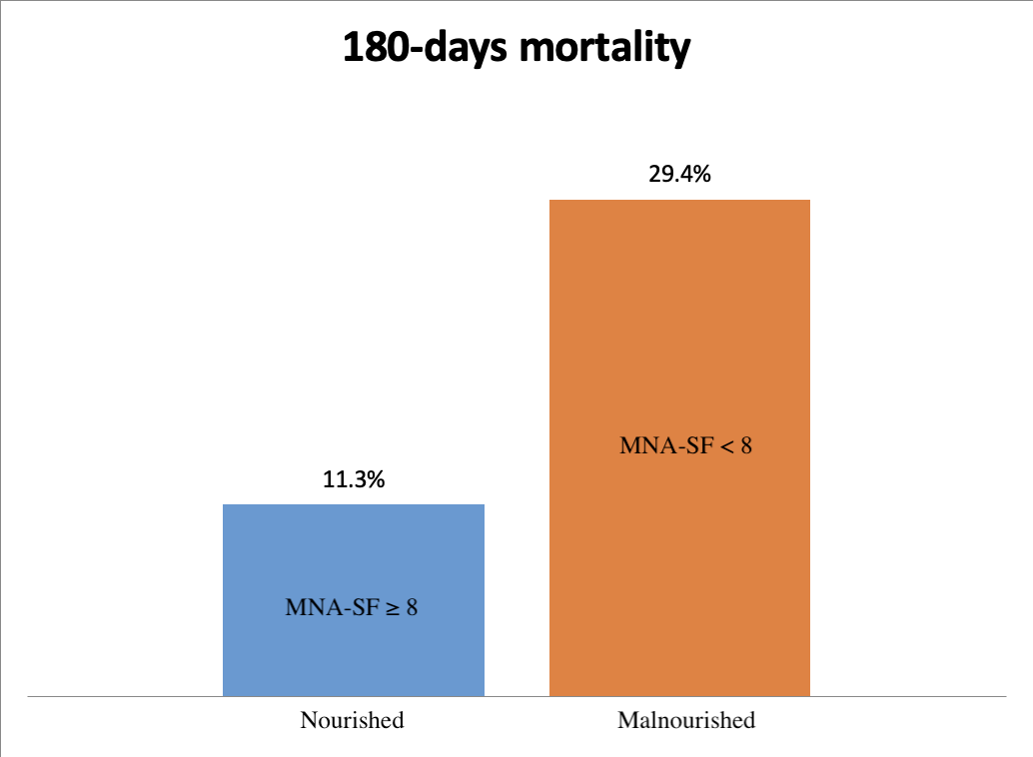
Supplementary figure 1:

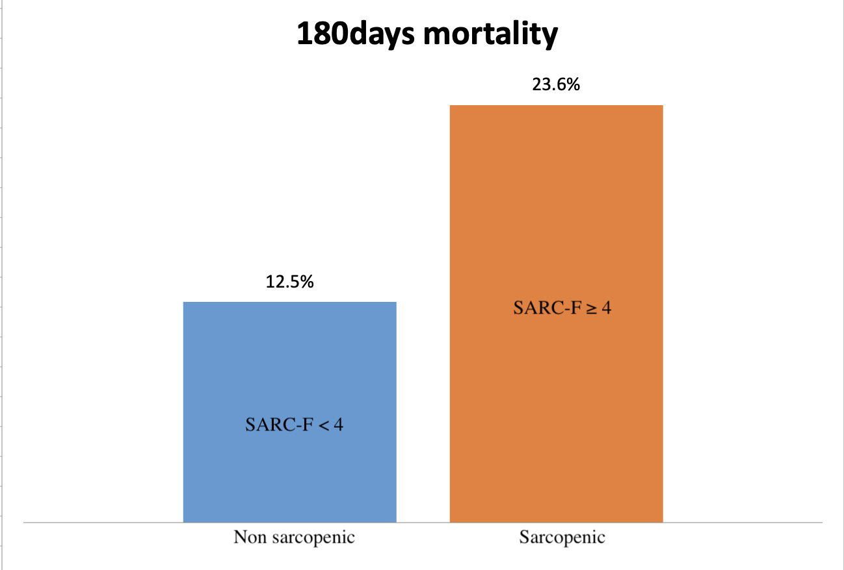
Supplementary figure 2 :

Supplementary figure 3 :
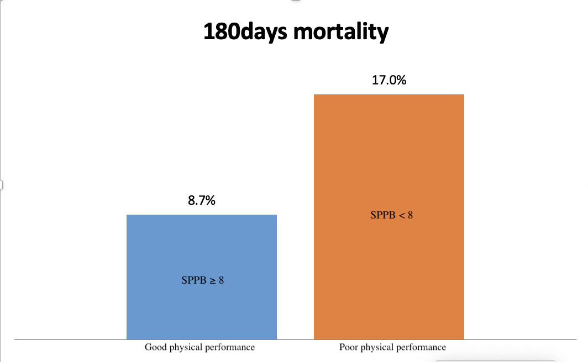
Supplementary figure 4 :

