Supplementary Table 1. Characteristics of study participants
 | Normal muscle mass  (n = 470) | Low muscle mass*  (n = 99) | P value
General information
Gender, n(%) |  |  | 0.9891
Male | 176 (37.5) | 37 (37.4)
Female | 294 (62.6) | 62 (62.6)
Age (years) | 66.78±4.03 | 67.81±5.30 | 0.0303
Medical history
Hypertension, n(%) | 99 (21.1) | 16 (16.2) | 0.2696
Diabetes mellitus, n(%) | 57 (12.1) | 12 (12.1) | 0.9986
Stroke, n(%) | 3 (0.6) | 0 (0.0) | 0.4254
Physical tests
BMI (kg/m²) | 25.37±2.75 | 21.91±2.24 | <0.0001
ASMI (kg/m²) | 6.89±0.82 | 5.82±0.68 | <0.0001
Handgrip strength (kg) | 23.36±12.35 | 21.29±6.4 | 0.1229
Gait Speed of 6-m walk (m/s) | 1.1±0.20 | 1.08±0.19 | 0.5967
Time of 5-time chair stand test (second) | 13.01±3.12 | 13.28±4.45 | 0.5174
Calf circumference (cm) | 37.41±2.75 | 35.06±2.46 | <0.0001
MNA score | 11.58±1.03 | 10.81±1.50 | <0.0001
Biochemical indicators
Hemoglobin (g/L) | 138.49±12.89 | 136.27±15.22 | 0.1335
Leukocyte (10⁹/L) | 5.82±1.36 | 5.54±1.14 | 0.0582
Neutrophil (10⁹/L) | 3.29±1.03 | 3.08±0.78 | 0.0541
Lymphocyte (10⁹/L) | 2.04±0.58 | 1.97±0.58 | 0.2634
Platelet (10⁹/L) | 220.84±52.86 | 214.97±49.54 | 0.3108
FBG (mmol/L) | 6.15±1.34 | 6.03±1.54 | 0.4111
ALT (U/L) | 21.66±11.27 | 20.3±9.03 | 0.2598
AST (U/L) | 22.73±7.47 | 22.81±5.96 | 0.9220
Total bilirubin (μmol/L) | 13.01±4.73 | 13.19±5.19 | 0.7380
Creatinine (μmol/L) | 67.68±15.78 | 68.02±48.58 | 0.9001
BUN (mmol/L) | 5.79±1.43 | 5.69±2.27 | 0.5858
Total cholesterol (mmol/L) | 5.33±1.03 | 5.31±1.03 | 0.9191
Triglyceride (mmol/L) | 1.55±0.92 | 1.39±1.33 | 0.1702
LDL-C (mmol/L) | 3.37±0.90 | 3.21±0.91 | 0.1031
HDL-C (mmol/L) | 1.41±0.33 | 1.55±0.35 | 0.0002
Data are expressed as mean±SD or n (%).
*Low muscle mass was defined based on the Asian Working Group for Sarcopenia 2019 criteria. The recommended cutoffs for ASMI measured by BIA were <7.0 kg/m2 for men and <5.7 kg/m2 for women.
BMI, body mass index; ASMI, appendicular skeletal muscle mass index; MNA, Mini Nutritional Assessment; FBG, fasting blood glucose; ALT, alanine aminotransferase; AST, aspartate; BUN, blood urea nitrogen; LDL-C, low-density lipoprotein cholesterol; HDL-C, high-density lipoprotein cholesterol.

Supplementary Table 2. Predictive performance of prediction model for low muscle mass
 | AUC | Accuracy | Kappa | Recall | Specificity | PPV | NPV | F1-score
Training set
Logistic | 0.888 | 0.872 | 0.485 | 0.681 | 0.897 | 0.471 | 0.955 | 0.557
RF | 0.944 | 0.892 | 0.547 | 0.805 | 0.902 | 0.485 | 0.976 | 0.606
SVM | 0.858 | 0.832 | 0.024 | 1.000 | 0.831 | 0.015 | 1.000 | 0.029
EN | 0.842 | 0.844 | 0.224 | 0.667 | 0.853 | 0.176 | 0.982 | 0.279
Test set
Logistic | 0.866 | 0.830 | 0.337 | 0.550 | 0.868 | 0.355 | 0.936 | 0.431
RF | 0.872 | 0.830 | 0.250 | 0.583 | 0.849 | 0.226 | 0.964 | 0.326
SVM | 0.786 | 0.819 | 0.000 | 0.000 | 0.819 | 0.000 | 0.000 | 0.000
EN | 0.855 | 0.842 | 0.225 | 0.833 | 0.842 | 0.161 | 0.993 | 0.270
RF, random forest; SVM, support vector machine; EN, elastic net; AUC, the area under the receiver operating characteristic curve; PPV, positive pred value; NPV, negative pred value.

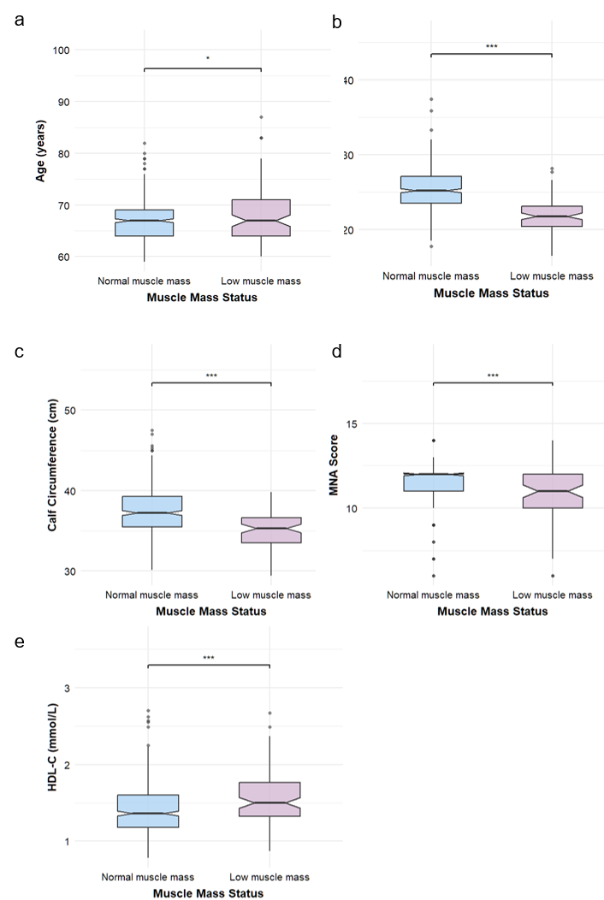

Figure. S1 Clinical characteristics of elderly participants stratified by muscle mass status (N = 569). Notched box plots comparing (a) age, (b) body mass index, (c) calf circumference, (d) MNA scores, and (e) high-density lipoprotein cholesterol between normal (blue) and low (purple) muscle mass groups. Notches represent 95% confidence intervals for the median. Statistical significance: *p<0.05, **p<0.01,***p<0.001. BMI, body mass index; MNA, Mini Nutritional Assessment; HDL-C, high-density lipoprotein cholesterol

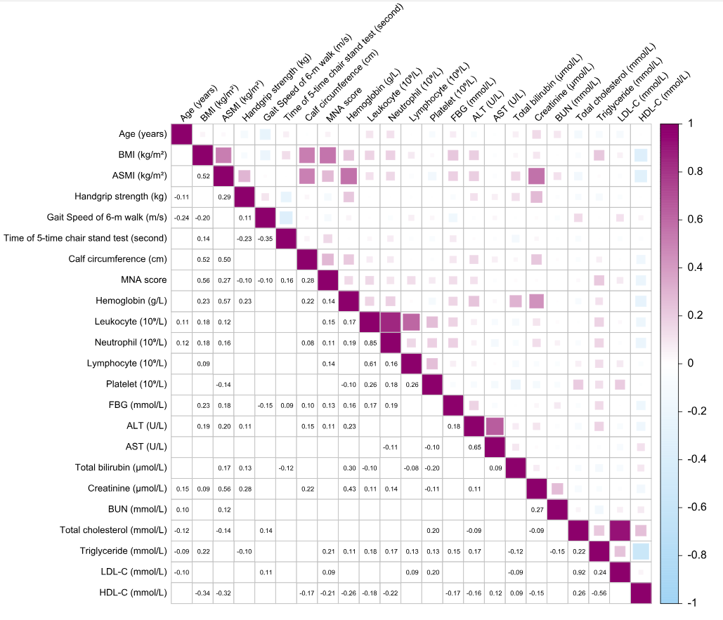

Figure. S2 Spearman correlation coefficients for participants’ characteristics. The size of the square and color intensity are proportional to the absolute value of the correlation coefficient. Warm color indicates a positive correlation, and cool color indicates a negative correlation. Only statistically significant correlation coefficients are shown (p<0.05). BMI, body mass index; ASMI, appendicular skeletal muscle mass index; MNA, Mini Nutritional Assessment; FBG, fasting blood glucose; ALT, alanine aminotransferase; AST, aspartate; BUN, blood urea nitrogen; LDL-C, low-density lipoprotein cholesterol; HDL-C, high-density lipoprotein cholesterol

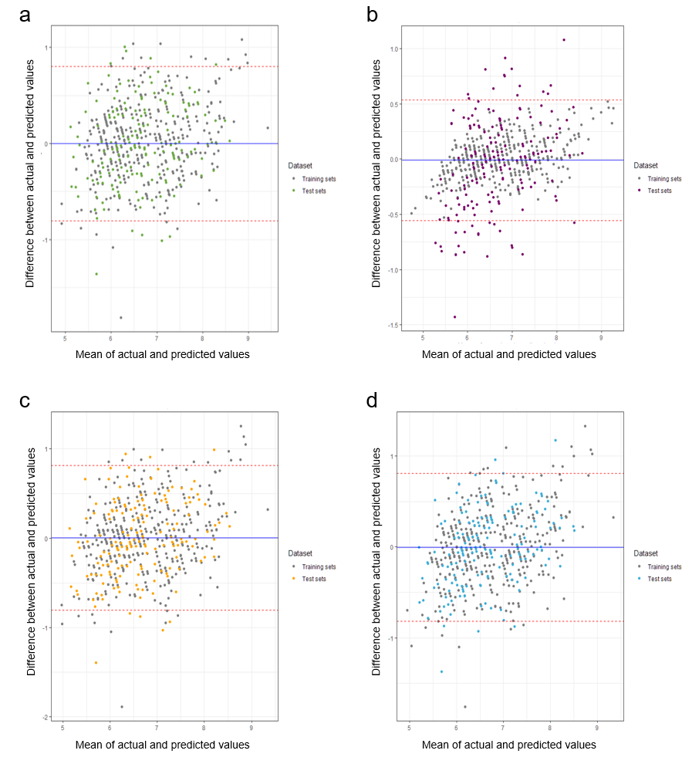

Figure. S3 Bland-Altman plots for (a) LM. (b) RF (c) SVM and (d) EN models. The x-axis represented the mean of ML model-estimated ASMI and measured ASMI, whereas the y-axis represented the difference (ML model-estimated ASMI – measured ASMI). LM, multiple linear model; RF, random forest; SVM, support vector machine; EN, elastic net; ASMI, appendicular skeletal muscle mass index

