Supplementary Table S1: Trends in the prevalence of polypharmacy and hyperpolypharmacy among US older adults, 2002-2017
 | Inflection point(s) (Year) | Segment | Slope | 95% CI | P-value  (Slope) | P-value  (Change in slope)
Polypharmacy | 1 (2011) | 2002-2011 | 0.38 | 0.23 ~ 0.53 | <.001 | <.001
Polypharmacy | 1 (2011) | 2011-2017 | -0.45 | -0.67 ~ -0.23 | <.001 | <.001
Polypharmacy | 0 (Full range) | 2002-2017 | 0.05 | -0.08 ~ 0.17 | .47 | NA
Hyperpolypharmacy | 1 (2006) | 2002-2006 | 0.87 | 0.14 ~ 1.59 | .02 | .02
Hyperpolypharmacy | 1 (2006) | 2006-2017 | -0.11 | -0.33 ~ 0.11 | .30 | .02
Hyperpolypharmacy | 0 (Full range) | 2002-2017 | 0.12 | -0.05 ~ 0.27 | .16 | NA
Abbreviations: CI, confidence interval; NA, not applicable; US, United States.
Supplementary Table S2: Trends in the prevalence of polypharmacy and hyperpolypharmacy by age among US older adults, 2002-2017
 | Age Group | Inflection point(s) (Year) | Segment | Slope | 95% CI | P-value  (Slope) | P-value  (Change in slope)
Polypharmacy | 65 - 74 | 1 (2011) | 2002-2011 | 0.30 | 0.10 ~ 0.50 | .01 | .01
Polypharmacy | 65 - 74 | 1 (2011) | 2011-2017 | -0.36 | -0.80 ~ 0.08 | .10 | .01
Polypharmacy | 65 - 74 | 0 (Full range) | 2002-2017 | 0.06 | -0.07 ~ 0.19 | .32 | NA
Polypharmacy | 75 - 84 | 1 (2015) | 2002-2015 | 0.25 | 0.10 ~ 0.40 | .01 | <.001
Polypharmacy | 75 - 84 | 1 (2015) | 2015-2017 | -2.80 | -4.22 ~ -1.37 | <.001 | <.001
Polypharmacy | 75 - 84 | 0 (Full range) | 2002-2017 | 0.06 | -0.14 ~ 0.25 | .54 | NA
Polypharmacy | ≥ 85 | 0 (Full range) | 2002-2017 | 0.22 | -0.11 ~ 0.54 | .10 | NA
Hyperpolypharmacy | 65 - 74 | 1 (2014) | 2002-2014 | 0.23 | 0.04 ~ 0.42 | .02 | .10
Hyperpolypharmacy | 65 - 74 | 1 (2014) | 2014-2017 | -1.27 | -3.08 ~ 0.54 | .15 | .10
Hyperpolypharmacy | 65 - 74 | 0 (Full range) | 2002-2017 | 0.08 | -0.09 ~ 0.25 | .33
Hyperpolypharmacy | 75 - 84 | 1 (2005) | 2002-2005 | 1.46 | 0.09 ~ 2.83 | .04 | .04
Hyperpolypharmacy | 75 - 84 | 1 (2005) | 2005-2017 | 0.01 | -0.24 ~ 0.27 | .91 | .04
Hyperpolypharmacy | 75 - 84 | 0 (Full range) | 2002-2017 | 0.19 | 0.00 ~ 0.39 | .05 | NA
Hyperpolypharmacy | ≥ 85 | 0 (Full range) | 2002-2017 | 0.11 | -0.13 ~ 0.35 | .34 | NA
Abbreviations: CI, confidence interval; NA, not applicable; US, United States.

Supplementary Table S3: Trends in the prevalence of polypharmacy and hyperpolypharmacy by sex among US older adults, 2002-2017
 | Sex | Inflection point(s) (Year) | Segment | Slope | 95% CI | P-value  (Slope) | P-value  (Change in slope)
Polypharmacy | Male | 1 (2011) | 2002-2011 | 0.55 | 0.14 ~ 0.97 | .01 | .02
Polypharmacy | Male | 1 (2011) | 2011-2017 | -0.40 | -1.01 ~ 0.21 | .18 | .02
Polypharmacy | Male | 0 (Full range) | 2002-2017 | 0.20 | -0.01 ~ 0.41 | .06 | NA
Polypharmacy | Female | 1 (2010) | 2002-2010 | 0.25 | 0.08 ~ 0.43 | .01 | <.001
Polypharmacy | Female | 1 (2010) | 2010-2017 | -0.49 | -0.74 ~ -0.24 | <.001 | <.001
Polypharmacy | Female | 0 (Full range) | 2002-2017 | -0.07 | -0.19 ~ 0.06 | .27 | NA
Hyperpolypharmacy | Male | 1 (2014) | 2002-2014 | 0.40 | 0.17 ~ 0.63 | .01 | .05
Hyperpolypharmacy | Male | 1 (2014) | 2014-2017 | -0.87 | -2.11 ~ 0.36 | .15 | .05
Hyperpolypharmacy | Male | 0 (Full range) | 2002-2017 | 0.24 | 0.07 ~ 0.42 | .01 | NA
Hyperpolypharmacy | Female | 1 (2007) | 2002-2007 | 0.77 | -0.13 ~ 1.68 | .09 | .03
Hyperpolypharmacy | Female | 1 (2007) | 2007-2017 | -0.27 | -0.54 ~ -0.01 | .05 | .03
Hyperpolypharmacy | Female | 0 (Full range) | 2002-2017 | 0.01 | -0.18 ~ 0.20 | .92 | NA
Abbreviations: CI, confidence interval; NA, not applicable; US, United States.

Supplementary Table S4: Trends in the prevalence of polypharmacy and hyperpolypharmacy by race among US older adults, 2002-2017
 | Races | Inflection point(s) (Year) | Segment | Slope | 95% CI | P-value  (Slope) | P-value  (Change in slope)
Polypharmacy | White | 1 (2010) | 2002-2010 | 0.40 | 0.20 ~ 0.60 | <.001 | <.001
Polypharmacy | White | 1 (2010) | 2010-2017 | -0.49 | -0.78 ~ -0.20 | .01 | <.001
Polypharmacy | White | 0 (Full range) | 2002-2017 | 0.003 | -0.15 ~ 0.15 | .97 | NA
Polypharmacy | African American | 0 (Full range) | 2002-2017 | 0.23 | 0.03 ~ 0.44 | .03 | NA
Polypharmacy | Asian | 2 (2007 & 2015) | 2002-2007 | 3.04 | 1.49 ~ 4.59 | <.001 | .01ª  .19
Polypharmacy | Asian | 2 (2007 & 2015) | 2007-2015 | -0.50 | -1.50 ~ 0.50 | .29 | .01ª  .19
Polypharmacy | Asian | 2 (2007 & 2015) | 2015-2017 | 5.28 | -3.90 ~ 14.46 | .23 | .01ª  .19
Polypharmacy | Asian | 0 (Full range) | 2002-2017 | 0.83 | 0.32 ~ 1.33 | .01 | NA
Polypharmacy | Other | 0 (Full range) | 2002-2017 | 0.33 | -0.49 ~ 1.14 | .40 | NA
Hyperpolypharmacy | White | 1 (2006) | 2002-2006 | 0.85 | 0.08 ~ 1.62 | .03 | .03
Hyperpolypharmacy | White | 1 (2006) | 2006-2017 | -0.07 | -0.30 ~ 0.17 | .54 | .03
Hyperpolypharmacy | White | 0 (Full range) | 2002-2017 | 0.14 | -0.02 ~ 0.30 | .08 | NA
Hyperpolypharmacy | African American | 2 (2006 & 2014) | 2002-2006 | 1.33 | -0.09 ~ 2.76 | .06 | .06ª  .21
Hyperpolypharmacy | African American | 2 (2006 & 2014) | 2006-2014 | -0.09 | -0.50 ~ 0.32 | .63 | .06ª  .21
Hyperpolypharmacy | African American | 2 (2006 & 2014) | 2014-2017 | -1.46 | -3.71 ~ 0.79 | .18 | .06ª  .21
Hyperpolypharmacy | African American | 0 (Full range) | 2002-2017 | 0.01 | -0.25 ~ 0.28 | .91 | NA
Hyperpolypharmacy | Asian | 1 (2011) | 2002-2011 | 0.16 | -0.18 ~ 0.50 | .32 | 0.049
Hyperpolypharmacy | Asian | 1 (2011) | 2011-2017 | -0.65 | -1.39 ~ 0.08 | .08 | 0.049
Hyperpolypharmacy | Asian | 0 (Full range) | 2002-2017 | -0.13 | -0.32 ~ -0.06 | .16 | NA
Hyperpolypharmacy | Other | 0 (Full range) | 2002-2017 | -0.50 | -0.97 ~ -0.03 | .04 | NA
Abbreviations: CI, confidence interval; NA, not applicable; US, United States.
Note: ªThe first p-value measures the significance of the slope change between the first and second segments. The second p-value measures the significance of the change between the second and third segments.

Supplementary Table S5: Trends in the total healthcare expenditure by polypharmacy category among US older adults, 2002-2017
 | Inflection point(s) (Year) | Segment | Slope | 95% CI | P-value  (Slope) | P-value  (Change in slope)
Medications <5 | 0 (Full range) | 2002-2017 | -7.23 | -78.27 ~ 63.81 | .83 | NA
Polypharmacy | 1 (2013) | 2002-2013 | -118.49 | -267.86 ~ 30.87 | .11 | .01
Polypharmacy | 1 (2013) | 2013-2017 | 1030.40 | 231.65 ~ 1829.20 | .02 | .01
Polypharmacy | 0 (Full range) | 2002-2017 | 60.40 | -77.19 ~ 197.94 | .36 | NA
Hyperpolypharmacy | 0 (Full range) | 2002-2017 | 54.90 | -287.43 ~ 397.16 | .74 | NA
Abbreviations: CI, confidence interval; NA, not applicable; US, United States.

Supplementary Table S6: Trends in the prescribed medication expenditure by polypharmacy category among US older adults, 2002-2017
 | Inflection point(s) (Year) | Segment | Slope | 95% CI | P-value  (Slope) | P-value  (Change in slope)
Medications <5 | 1 (2014) | 2002-2014 | -9.28 | -33.32 ~ 14.77 | .42 | .01
Medications <5 | 1 (2014) | 2014-2017 | 164.92 | 36.33 ~ 293.51 | .02 | .01
Medications <5 | 0 (Full range) | 2002-2017 | 12.10 | -7.98 ~ 32.25 | .22 | NA
Polypharmacy | 2 (2005 & 2012) | 2002-2005 | 259.21 | 37.43 ~ 481.00 | .03 | .01ª  .01
Polypharmacy | 2 (2005 & 2012) | 2005-2012 | -86.12 | -179.84 ~ 7.60 | .07 | .01ª  .01
Polypharmacy | 2 (2005 & 2012) | 2012-2017 | 189.88 | 33.05 ~ 346.70 | .02 | .01ª  .01
Polypharmacy | 0 (Full range) | 2002-2017 | 23.50 | -13.45 ~ 60.48 | .19 | NA
Hyperpolypharmacy | 1 (2014) | 2002-2014 | 98.08 | -17.93 ~ 214.09 | .09 | .01
Hyperpolypharmacy | 1 (2014) | 2014-2017 | 939.07 | 318.65 ~ 1559.50 | .01 | .01
Hyperpolypharmacy | 0 (Full range) | 2002-2017 | 199.00 | 102.78 ~ 296.21 | <.001 | NA
Abbreviations: CI, confidence interval; NA, not applicable; US, United States.
Note: ªThe first p-value measures the significance of the slope change between the first and second segments. The second p-value measures the significance of the change between the second and third segments.

Supplementary Table S7: Mean number of prescribed medications per older adult with hyperpolypharmacy in the US, 2002-2017
 | 2002 | 2003 | 2004 | 2005 | 2006 | 2007 | 2008 | 2009 | 2010 | 2011 | 2012 | 2013 | 2014 | 2015 | 2016 | 2017
Mean | 12.38 | 12.45 | 12.64 | 12.51 | 12.48 | 12.69 | 12.83 | 12.71 | 12.61 | 12.62 | 12.64 | 12.58 | 12.64 | 12.77 | 12.75 | 12.49
SE | 0.13 | 0.14 | 0.15 | 0.14 | 0.13 | 0.15 | 0.16 | 0.17 | 0.17 | 0.13 | 0.16 | 0.19 | 0.14 | 0.16 | 0.14 | 0.12
Abbreviations: SE, standard error; US, United States.

Supplementary Figure S1: Trends in the prevalence of polypharmacy and hyperpolypharmacy by race among US older adults, 2002-2017
- Polypharmacy
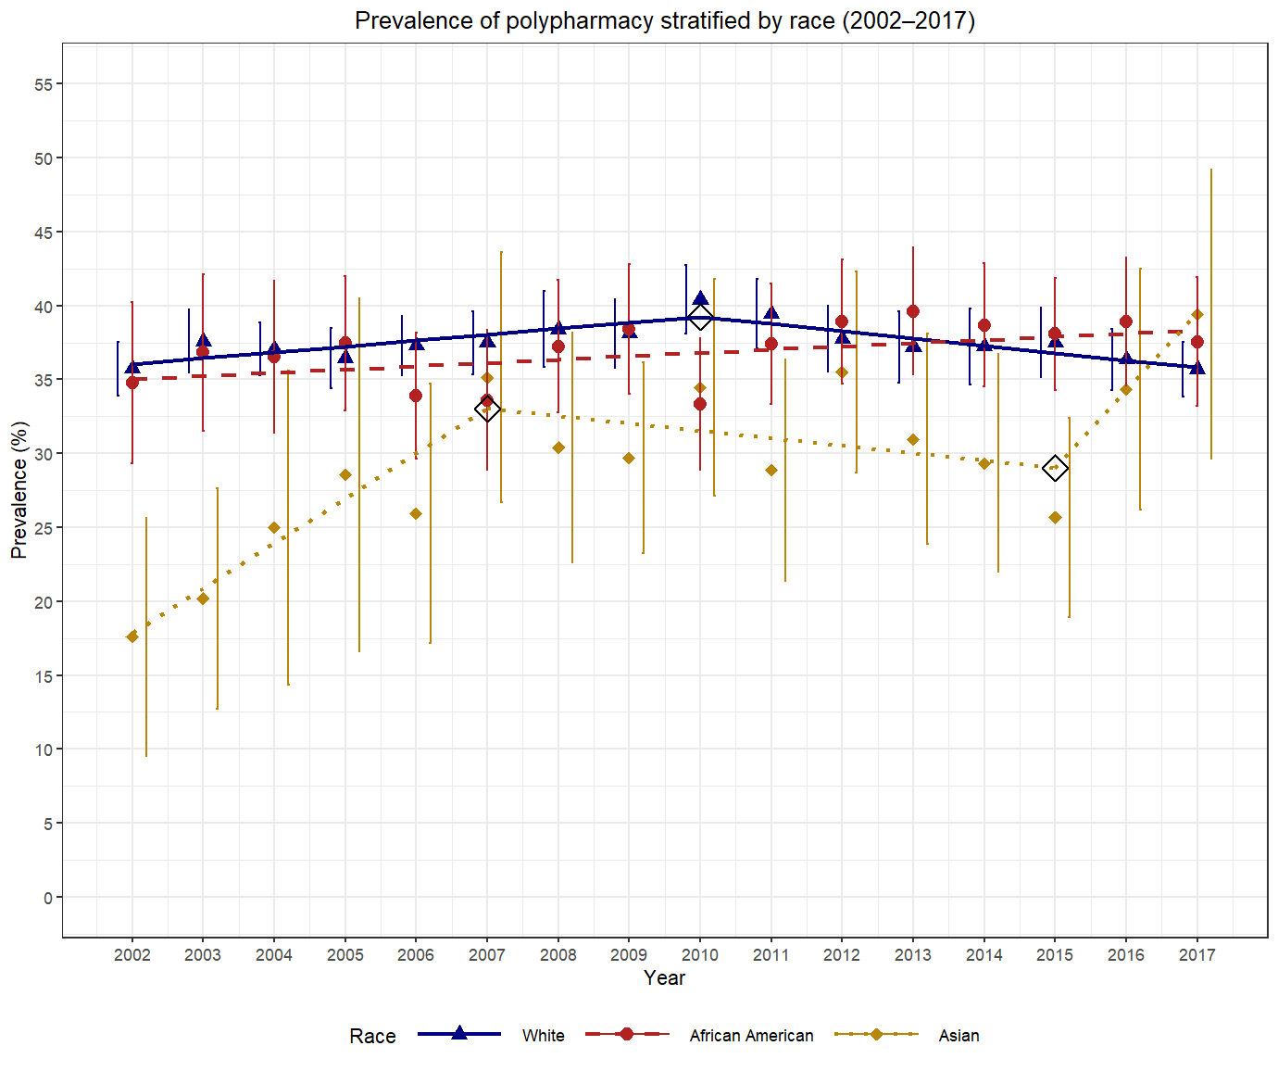
- Hyperpolypharmacy
