Supplementary Material

Association between sleep duration and healthy aging among older adults: evidence from the Behavioral Risk Factor Surveillance System

Supplementary table 1. Number and proportion of missing characteristics of the study population

Supplementary table 2. Association of sleep duration with four dimensions of healthy aging

Supplementary table 3. Association of sleep duration with healthy aging under Model II-based additional adjusted annual household income ($)

Supplementary table 4. Association of sleep duration with healthy aging after imputation

Supplementary fig.1 Spline curve for the association of sleep duration with the 4 dimensions of healthy aging

Supplementary fig. 2 Curves of the sensitivity analysis for unobserved confounders with E-value highlighted

Supplemental table 1. Number and proportion of missing characteristics of the study population
Characteristics | Missing (n, %)
Sex | 1, 0.00%
Race/ethnicity | 999, 2.85%
Marital status | 153, 0.44%
Educational attainment | 142, 0.41%
Employment status | 140, 0.40%
Smoking status | 223, 0.64%
Leisure-time physical activity | 64, 0.18%
BMI (kg/m²) | 1768, 5.04%
Abbreviations: BMI, body mass index (calculated as weight in kilograms divided by the square of height in meters).

Supplemental table 2. Association of sleep duration with four dimensions of healthy aging
Outcome,  sleep duration, h | No. | OR(95%CI), P
Outcome,  sleep duration, h | No. | Healthy aging,  No. (%) | Crude model, (n=35,056) | Adjusted model I (n=33,659) | Adjusted model Ⅱ (n=30,648)
No major chronic diseases
≤5 | 2,701 | 371 (13.7) | 0.47 (0.42,0.53), <0.05 | 0.53(0.47,0.60), <0.001 | 0.59 (0.52, 0.68), <0.001
6 | 6,026 | 1216 (20.2) | 0.74 (0.69,0.80), <0.001 | 0.78(0.72,0.85), <0.001 | 0.83 (0.76, 0.90), <0.001
7 | 9,958 | 2524 (25.4) | 1.00 | 1.00 | 1.00
8 | 12,118 | 3052 (25.2) | 0.99 (0.93,1.05), 0.784 | 1.04(0.97,1.10), 0.843 | 1.06 (0.99, 1.13), 0.098
≥9 | 4,253 | 775 (18.2) | 0.66 (0.60,0.72), <0.001 | 0.73(0.66,0.79), <0.001 | 0.76 (0.69, 0.84), <0.001
No physical impairment
≤5 | 2,701 | 1057 (39.1) | 0.30 (0.28,0.33), <0.001 | 0.36(0.33,0.40), <0.001 | 0.42 (0.38, 0.46), <0.001
6 | 6,026 | 3429 (56.9) | 0.62 (0.58,0.67), <0.001 | 0.66(0.62,0.71), <0.001 | 0.73 (0.68, 0.79), <0.001
7 | 9,958 | 6764 (67.9) | 1.00 | 1.00 | 1.00
8 | 12,118 | 7637 (63.0) | 0.80 (0.76,0.85), <0.001 | 0.84(0.79,0.89), <0.001 | 0.87 (0.82, 0.92), <0.001
≥9 | 4,253 | 2004 (47.1) | 0.42 (0.39,0.45), <0.001 | 0.47(0.44,0.51), <0.001 | 0.53 (0.49, 0.58), <0.001
No subjective cognitive impairment
≤5 | 2,701 | 2252 (83.4) | 0.47 (0.41,0.53), <0.001 | 0.55(0.48,0.62), <0.001 | 0.56 (0.49, 0.65), <0.001
6 | 6,026 | 5376 (89.2) | 0.77 (0.69,0.86), <0.001 | 0.82(0.73,0.91), <0.001 | 0.87 (0.78, 0.98), 0.024
7 | 9,958 | 9110 (91.5) | 1.00 | 1.00 | 1.00
8 | 12,118 | 11007 (90.8) | 0.92 (0.84,1.01), 0.090 | 0.97(0.88,1.07), 0.619 | 0.99 (0.89, 1.09), 0.834
≥9 | 4,253 | 3585 (84.3) | 0.50 (0.45,0.56), <0.001 | 0.56(0.50,0.63), <0.001 | 0.60 (0.53, 0.68), <0.001
No depression
≤5 | 2,701 | 1826 (67.6) | 0.38 (0.35,0.42), <0.001 | 0.45(0.41,0.50), <0.001 | 0.49 (0.44, 0.55), <0.001
6 | 6,026 | 4783 (79.4) | 0.70 (0.65,0.76), <0.001 | 0.76(0.70,0.83), <0.001 | 0.82 (0.74, 0.89), <0.001
7 | 9,958 | 8419 (84.6) | 1.00 | 1.00 | 1.00
8 | 12,118 | 10138 (83.7) | 0.94 (0.87,1.01), 0.074 | 0.98(0.91,1.05), 0.179 | 0.98 (0.90, 1.06), 0.597
≥9 | 4,253 | 3086 (72.3) | 0.48 (0.44,0.53), <0.001 | 0.53(0.49,0.58), <0.001 | 0.56 (0.51, 0.62), <0.001
Abbreviations: AI/AN: American Indian/Alaska Native; BMI, body mass index (calculated as weight in kilograms divided by the square of height in meters); OR, odds ratio; CI, conﬁdence interval.
Model I was adjusted for age group (65-69, 70-74, ≥75 years), sex (men, women), race/ethnicity (White, Black, Hispanic, American Indian/Alaska Native (AI/AN), Asian, Other race/Multiracial), marital status (married/living with partner, previously married, never married), educational attainment (<high school graduate, high school graduate/GED, some college/technical school, college graduate) and employment status (employed, unemployed, unable to work, student/homemaker/retired).
Model II was additionally adjusted for smoking status (current smoker, former smoker, never smoker), leisure-time physical activity (yes, no), BMI (<18.5 kg/m², 18.5-24.9 kg/m², 25.0-25.9 kg/m², ≥30.0 kg/m²).

Supplemental table 3. Association of sleep duration with healthy aging under Model II-based additional adjusted annual household income ($) ª
Sleep duration, hours | No. | Healthy aging, No. (%) | OR(95%CI)
Sleep duration, hours | No. | Healthy aging, No. (%) | Crude model, (n=35,056) | Adjusted model I, (n=33,659) | Adjusted model Ⅱ, (n=25,134)
≤5 | 2,701 | 224(8.3) | 0.37 (0.32,0.43), <0.001 | 0.51 (0.43, 0.59), <0.001 | 0.52 (0.44, 0.62), <0.001
6 | 6,026 | 878(14.6) | 0.70 (0.64,0.77), <0.001 | 0.79 (0.72, 0.87), <0.001 | 0.82 (0.74, 0.91), <0.001
7 | 9,958 | 1948(19.6) | 1.00 | 1.00 | 1.00
8 | 12,118 | 2250(18.6) | 0.94 (0.88,1.00), 0.060 | 0.96 (0.90, 1.03), 0.480 | 0.99 (0.92, 1.08)
≥9 | 4,253 | 482(11.3) | 0.53 (0.47,0.58), <0.001 | 0.65 (0.58, 0.73), <0.001 | 0.65 (0.57, 0.74), <0.001
ª Annual household income (<35,000$/ 35,000–75,000$/ >75,000$)
Abbreviations: AI/AN: American Indian/Alaska Native; BMI, body mass index (calculated as weight in kilograms divided by the square of height in meters); OR, odds ratio; CI, conﬁdence interval.
Model I was adjusted for age group (65-69, 70-74, ≥75 years), sex (men, women), race/ethnicity (White, Black, Hispanic, AI/AN, Asian, other race/multiracial), marital status (married/living with partner, previously married, never married), educational attainment (<high school graduate, high school graduate/GED, some college/technical school, college graduate) and employment status (employed, unemployed, unable to work, student/homemaker/retired).
Model II was additionally adjusted for smoking status (current smoker, former smoker, never smoker), leisure-time physical activity (yes, no), BMI (<18.5 kg/m², 18.5-24.9 kg/m², 25.0-25.9 kg/m², ≥30.0 kg/m²).

Supplemental table 4. Association of sleep duration with healthy aging after imputation
Sleep duration, hours | No. | Healthy aging, No. (%) | OR(95%CI)
Sleep duration, hours | No. | Healthy aging, No. (%) | Crude model, (n=35,056) | Adjusted model I, (n=35,056) | Adjusted model Ⅱ (n=35,056)
≤5 | 2,701 | 224(8.3) | 0.37 (0.32,0.43), <0.001 | 0.42 (0.37, 0.49), <0.001 | 0.49 (0.37, 0.49), <0.001
6 | 6,026 | 878(14.6) | 0.70 (0.64,0.77), <0.001 | 0.72 (0.66, 0.78), <0.001 | 0.78 (0.71, 0.85), <0.001
7 | 9,958 | 1948(19.6) | 1.00 | 1.00 | 1.00
8 | 12,118 | 2250(18.6) | 0.94 (0.88,1.00), 0.061 | 0.99 (0.92, 1.06), 0.669 | 1.02 (0.95, 1.09), 0.595
≥9 | 4,253 | 482(11.3) | 0.53 (0.47,0.58), <0.001 | 0.58 (0.52, 0.65), <0.001 | 0.65 (0.58, 0.73), <0.001
Abbreviations: AI/AN: American Indian/Alaska Native; BMI, body mass index (calculated as weight in kilograms divided by the square of height in meters); OR, odds ratio; CI, conﬁdence interval.
Model I was adjusted for age group (65-69, 70-74, ≥75 years), sex (men, women), race/ethnicity (White, Black, Hispanic, American Indian/Alaska Native (AI/AN), Asian, Other race/Multiracial), marital status (married/living with partner, previously married, never married), educational attainment (<high school graduate, high school graduate/GED, some college/technical school, college graduate) and employment status (employed, unemployed, unable to work, student/homemaker/retired).
Model II was additionally adjusted for smoking status (current smoker, former smoker, never smoker), leisure-time physical activity (yes, no), BMI (<18.5 kg/m², 18.5-24.9 kg/m², 25.0-25.9 kg/m², ≥30.0 kg/m²).

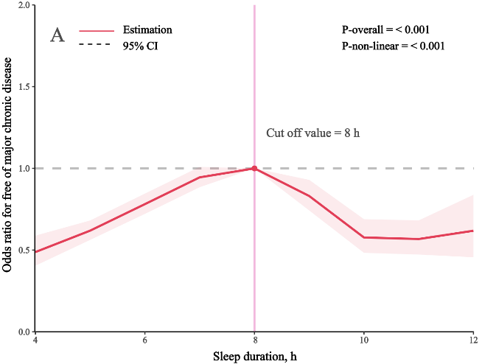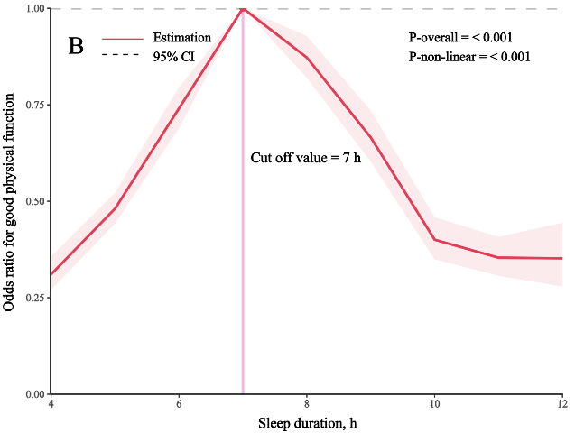
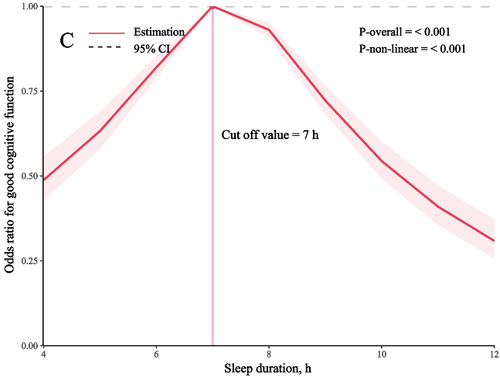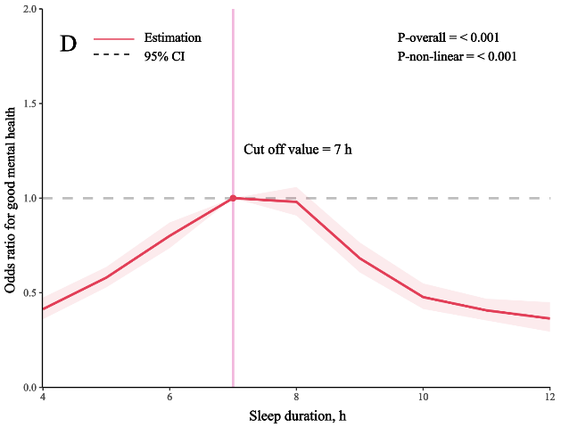
Supplemental fig. 1 Spline curve for the association of sleep duration with the 4 dimensions of healthy aging. (A) sleep duration and free of chronic diseases, (B) sleep duration and good physical function, (C) sleep duration and good mental health, (D) sleep duration and good cognitive function.
Adjusted for age group (65-69, 70-74, ≥75 years), sex (men, women), race/ethnicity (White, Black, Hispanic, American Indian/Alaska Native (AI/AN), Asian, Other race/Multiracial), marital status (married/living with partner, previously married, never married), educational attainment (<high school graduate, high school graduate/GED, some college/technical school, college graduate), employment status (employed, unemployed, unable to work, student/homemaker/retired), smoking status (current smoker, former smoker, never smoker), leisure-time physical activity (yes, no), BMI (<18.5 kg/m², 18.5-24.9 kg/m², 25.0-25.9 kg/m², ≥30.0 kg/m²).

Supplemental fig. 2 Curves of the sensitivity analysis for unobserved confounders with E-value highlighted (A: ≤5h VS 7h; B: 6h VS 7h; C: ≥9h VS 7h).

