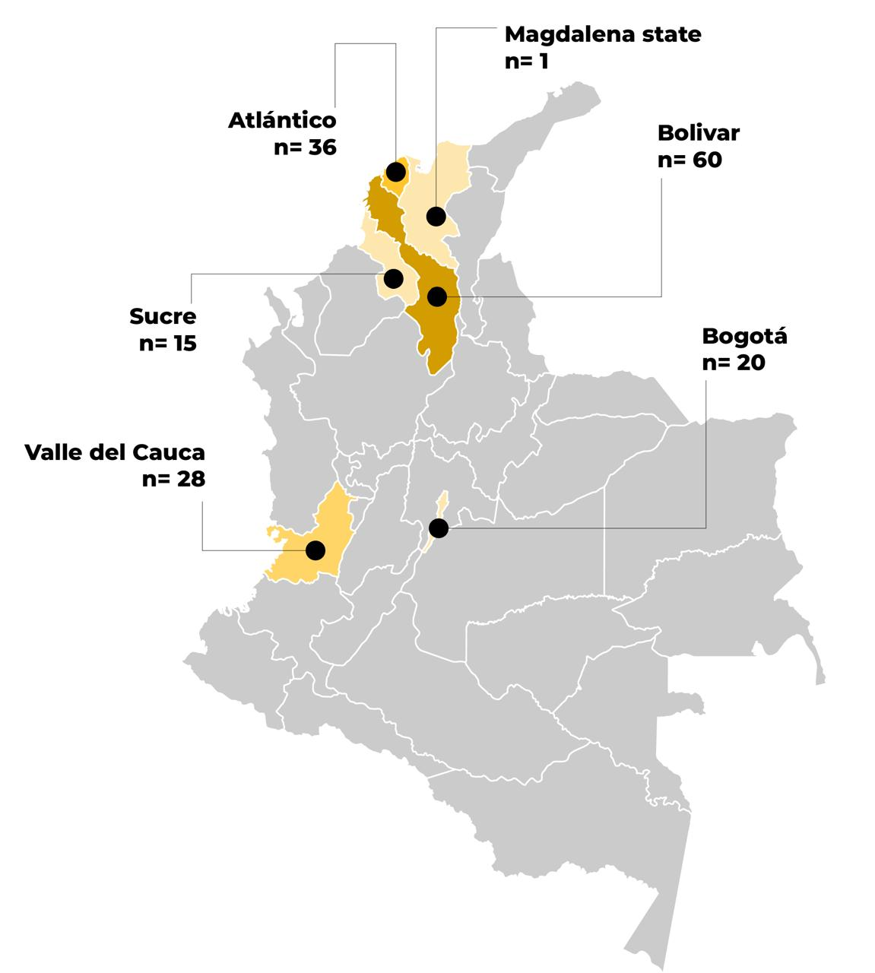
Figure S1. Geographical location of centenarians included in Colombia (N=160).

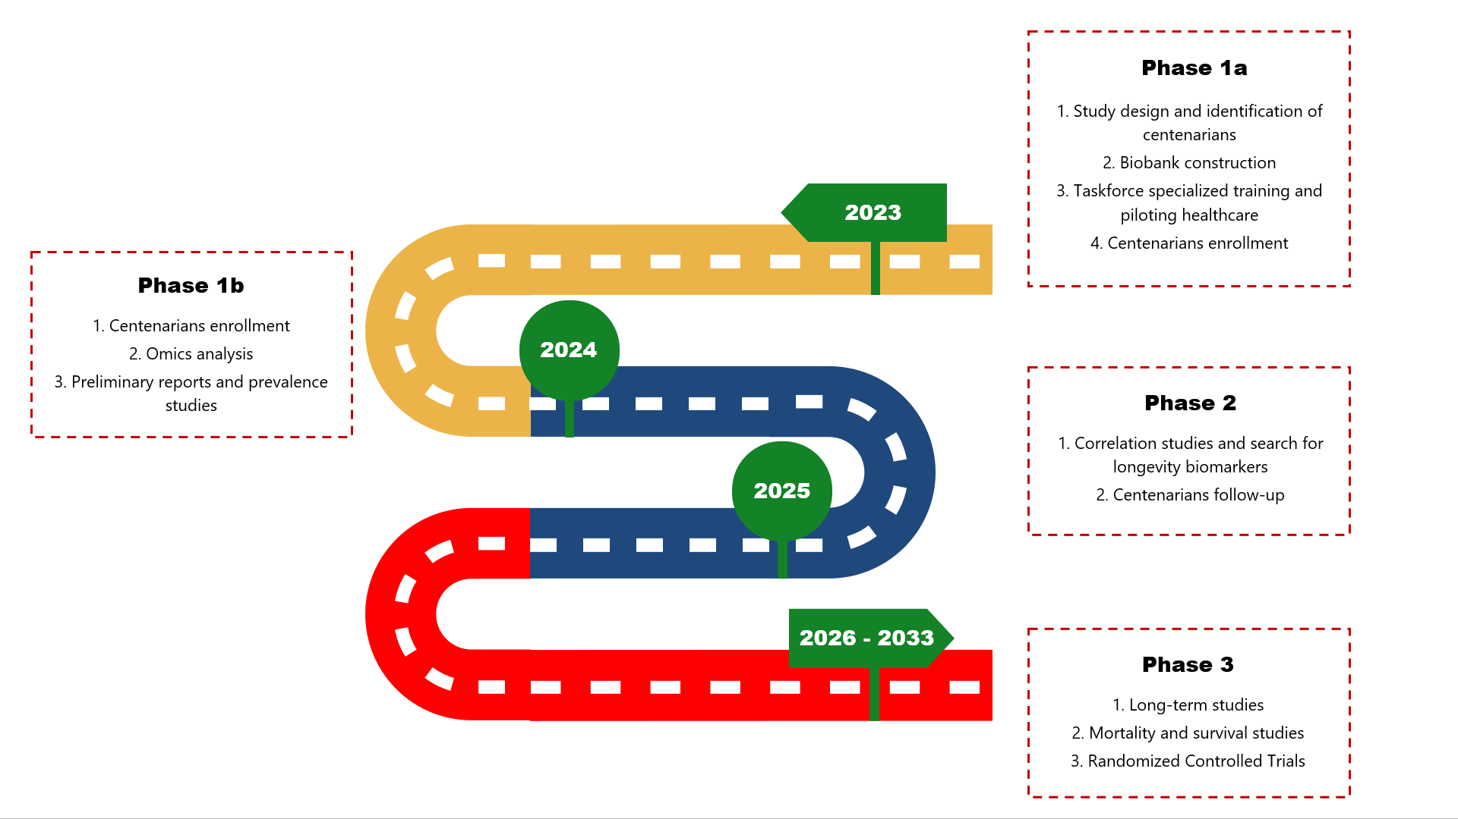
Figure S2. Study scheme for the application of a translational model based on centenarians for the prospective study of extreme longevity in Colombia by the Colombian Centenarian Project.

Table S1. Measurement domains and constructs assessed in the Colombian Centenarian Project (CCP).
Domain | Measurement / Instrument | Construct Assessed | Reference
Sociodemographic | Structured interview (CCP baseline survey) | Age, sex, marital status, residence, education, socioeconomic status, income, insurance, occupation | (10,22,23,24)
Clinical | Medical history and physical examination | Chronic diseases, blood pressure, heart rate, body mass index, medication use, pain, fatigue, frailty, sarcopenia | (29-31)
Functional | Barthel Index; Lawton & Brody Scale; Short Physical Performance Battery (SPPB); Downton Fall Risk Index | Basic and instrumental activities of daily living, mobility, functional capacity, and fall risk | (29,35,37)
Cognitive | Cognitive Assessment (MoCA); Clinical Dementia Rating Sum of Boxes (CDR-SB) | Global cognition, memory, orientation, and dementia severity | (38-40)
Emotional / Psychological | Yesavage Geriatric Depression Scale (Short Form); Geriatric Anxiety Inventory - Short Form (GAI-SF) | Depressive symptoms and anxiety levels | (41,42)
Nutritional | Mini Nutritional Assessment (MNA); Prognostic Nutritional Index (PNI) | Nutritional status and protein-energy balance | (33,40)
Biochemical | Serum biomarkers (vitamins, lipids, glycemia, inflammatory and hormonal profile) | Biological determinants of aging and physiological homeostasis | (30,45)
Sleep and Self-realization | Insomnia Severity Index (ISI); Satisfaction with Life Scale (SWLS) | Sleep quality, insomnia severity, and life satisfaction | (43,44)
Psychosocial and Prosociality | WHOQOL-BREF domains; structured items on caregiving, loneliness, and social contact | Self-perceived health, social support, prosociality, and quality of life | (29,32)

Table S2. Biochemical parameters and reference ranges for contextual interpretation.
Analyte | Median (IQR) | Reference Range (Adults) | Physiological / Clinical Interpretation
Hemoglobin (g/dL) | 11.8 (2.2) | 12.0-16.0 (female); 13.0-17.0 (male) | Slightly lower values are common in advanced age and may reflect age-related erythropoietic decline rather than pathology.
Hematocrit (%) | 35.7 (6.8) | 36-46 (female); 40-52 (male) | Mildly reduced hematocrit aligns with expected age-related changes.
MCV (µm³) | 93.0 (7.6) | 80-100 | Within normal range, consistent with normocytic profile.
MCH (pg) | 30.2 (3.3) | 27-33 | Normal erythrocyte hemoglobin content.
MCHC (g/dL) | 32.4 (2.5) | 31-36 | Normal.
Leukocytes (×10³/mm³) | 5.91 (2.45) | 4.0-10.0 | Within normal range.
Neutrophils (%) | 58.5 (20.9) | 40-75 | Normal.
Lymphocytes (%) | 30.0 (15.9) | 20-45 | Normal.
Platelets (×10³/mm³) | 221.7 (93.0) | 150-400 | Normal range; mild variability expected in aging.
Vitamin D (ng/mL) | 22.4 (19.8) | 30-100 | Below optimal; vitamin D insufficiency is common in centenarians.
Vitamin B12 (pg/mL) | 380.0 (310.5) | 200-900 | Within normal range.
Total Cholesterol (mg/dL) | 161.0 (48) | <200 desirable | Generally favorable lipid profile.
Glycemia (mg/dL) | 95.0 (30.5) | 70-110 (fasting) | Normal fasting range.
HbA1c (%) | 5.7 (0.56) | <5.7 normal; 5.7-6.4 prediabetes | Borderline values consistent with age-related metabolic adaptation.
Albumin (g/L) | 3.8 (0.59) | 3.5-5.0 | Within normal range.
Creatinine (mg/dL) | 0.92 (0.46) | 0.6-1.3 | Normal for elderly; reflects preserved renal function.
BUN (mg/dL) | 15.4 (6.98) | 7-20 | Normal.
AST (U/L) | 23.0 (11.2) | 10-40 | Normal.
ALT (U/L) | 15.0 (10.1) | 7-56 | Normal; low levels typical of advanced age.
GGT (U/L) | 23.8 (37.0) | 8-61 | Within expected range.
Total Bilirubin (mg/dL) | 0.6 (0.3) | 0.2-1.2 | Normal.
Ferritin (ng/mL) | 143.5 (126.4) | 15-200 (female); 30-400 (male) | Within normal range; reflects adequate iron stores.
CRP (mg/L) | 2.14 (4.3) | <5 | Normal to mildly elevated, consistent with low-grade inflammaging.
ESR (mm/h) | 28 (25.5) | <30 (female); <20 (male) | Mildly elevated, consistent with chronic inflammation in aging.
TSH (µUI/mL) | 2.43 (3.28) | 0.4-4.5 | Normal.
T4 (pg/mL) | 10.9 (5.5) | 8-18 | Normal thyroid function.
Estradiol (pg/mL) | 15.4 (15.1) | Postmenopausal <20; male <40 | Normal for age and sex.
Testosterone (ng/mL) | 0.3 (3.35) | 0.2-0.8 (female); 2.5-10 (male) | Age-expected decline; values within centenarian ranges.
DHT (pg/mL) | 34 (79.8) | 30-85 | Within expected range.
Prolactin (ng/mL) | 13 (7.95) | 4-23 | Normal.

