Supplementary Material
Supplementary Figure 1. Recruitment flowchart by setting
Supplementary Table 1. Baseline characteristic comparison by recruitment setting (N=50)
Supplementary Table 2. Comparison of baseline socio-demographic, clinical, and care-related features between patients who completed the study and those who withdrew
Supplementary Table 3. NPI single-item score ≥6 at baseline vs follow-up (N=42)
Supplementary Table 4. ADL (Katz Index) item-level dependence at baseline vs follow-up (N=42)
Supplementary Table 5. CNS-active medication changes between baseline and follow-up (N=42)

Supplementary Figure 1. Recruitment flowchart by setting

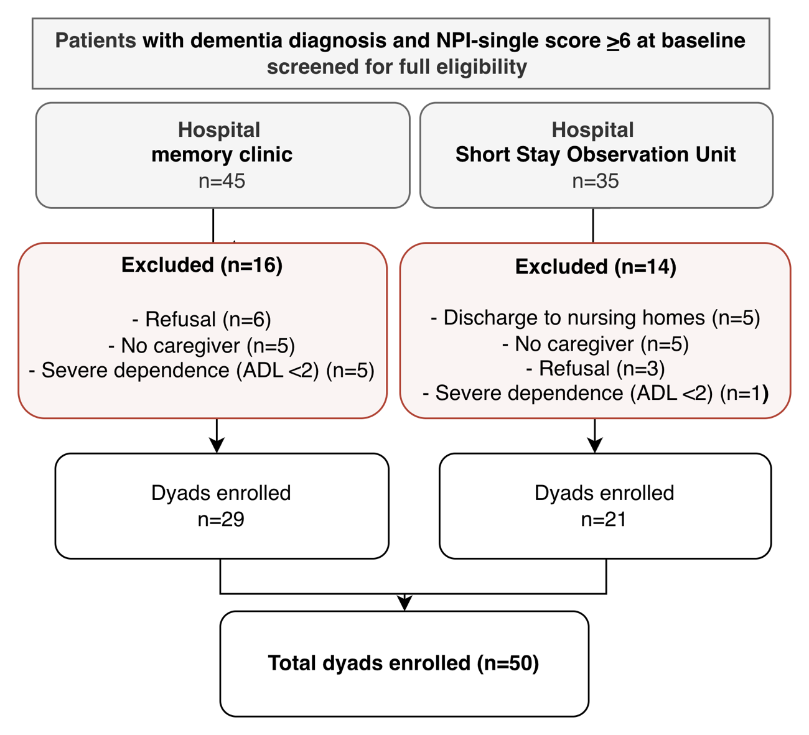

Supplementary Table 1. Baseline characteristic comparison by recruitment setting (N=50)

Baseline variables | Hospital  Memory clinic (N=29) | Hospital  Short Stay Observation Unit (N=21) | p-value
Age (years) | 80 (76–82) | 86 (81–87) | <0.001
Sex (female), n (%) | 17 (58.6) | 9 (42.9) | 0.390
Level of education, n (%)  Primary school  Secondary school  High school  University | 18 (62.1)  4 (13.8)  4 (13.8)  3 (10.3) | 10 (47.6)  4 (19.0)  3 (14.3)  4 (19.0) | 0.732
Married, n (%) | 21 (72.4) | 13 (61.9) | 0.543
Level of care at baseline (>12 hours/day), n (%) | 27 (93.1) | 21 (100.0) | 0.503
CFS | 6 (6–7) | 6 (6–7) | 0.957
Polypharmacy, n (%) | 12 (41.4) | 11 (52.4) | 0.567
NPI at baseline (frequency×severity) | 39 (17–53) | 47 (29–66) | 0.148
NPI at baseline  (caregiver distress) | 18 (11–29) | 26 (18–31) | 0.148
TUG (baseline) | 14 (13–20) | 26 (16–43) | 0.005
Katz Index (baseline) | 4 (3–5) | 3 (2–5) | 0.211
N. CNS-active medications (baseline) | 2 (0–2) | 1 (1–2) | 0.441
SCQ (baseline) | 52 (45–62) | 49 (44–59) | 0.680

Legend. Values are shown as n (%) or median (Q1–Q3). P-values are from Mann–Whitney U tests for continuous variables and Fisher’s exact tests for categorical variables. CFS= Clinical Frailty Scale; NPI= Neuropsychiatric Inventory; TUG = Timed Up and Go Test; CNS= Central nervous system; SCQ= Sense of Competence Questionnaire.
Supplementary Table 2. Comparison of baseline socio-demographic, clinical, and care-related features between patients who completed the study and those who withdrew
Variables | Completers (N=42) | Dropouts  (N=8) | p-value
Age (years) | 80 (78 - 86.5) | 83.5 (81 - 87.5) | 0.002
Sex (female) | 18 (42.8%) | 8 (100%) | 0.009
Recruitment setting  Memory clinic  Short Stay Observation Unit | 28 (66.7%)  14 (33.3%) | 1 (13.5%)  7 (86.5%) | 0.014
Level of education  Primary school  Secondary school  High school  University | 26 (61.9%)  6 (14.3%)  5 (11.9%)  5 (11.9%) | 2 (25%)  2 (25%)  2 (25%)  2 (25%) | 0.288
Marital status, (%)  Married  Widowed | 28 (66.7%)  14 (33.3%) | 6 (75%)  2 (25%) | 0.960
Level of care at baseline, (%)  >12 hours/day  4-12 hours/day  <3 hours/day | 31 (73.8%)  9 (21.4%)  2 (4.8%) | 8 (100%)  --  -- | 0.261
CFS, median (IQR) | 6 (6 – 7) | 6 (6 – 7) | 0.936
Polypharmacy, n (%) | 18 (42.8%) | 5 (62.5%) | 0.525
N° CNS-active medications, n (%)  0  1  2  >3 | 14 (33.3%)  9 (21.4%)  14 (33.3%)  5 (11.9%) | 2 (25%)  4 (50%)  2 (25%)  -- | 0.340

Legend: Values are reported as n (%) or median (Q1-Q3). CFS: Clinical Frailty Scale; CNS: Central nervous system.
Supplementary Table 3. NPI single-item score ≥6 at baseline vs follow-up (N=42)

NPI item | Baseline  (item score ≥6)  N=42 | Follow-up  (item score ≥6)  N=42 | p-value
Apathy/Indifference | 24 (57.1%) | 8 (19.0%) | <0.001
Irritability/Lability | 23 (54.8%) | 12 (28.6%) | 0.003
Agitation/Aggression | 23 (54.8%) | 14 (33.3%) | 0.049
Anxiety | 15 (35.7%) | 6 (14.3%) | 0.022
Aberrant motor behavior | 15 (35.7%) | 6 (14.3%) | 0.012
Sleep/Night-time behavior disturbances | 14 (33.3%) | 5 (11.9%) | 0.022
Delusions | 13 (31.0%) | 7 (16.7%) | 0.070
Depression/Dysphoria | 13 (31.0%) | 10 (23.8%) | 0.508
Appetite/Eating disturbances | 12 (28.6%) | 1 (2.4%) | 0.003
Disinhibition | 3 (7.1%) | 1 (2.4%) | 0.625
Hallucinations | 1 (2.4%) | 3 (7.1%) | 0.625
Euphoria/Elation | 0 (0.0%) | 0 (0.0%) | 1.000

Legend. Values are shown as n (%). Threshold ≥6 corresponds to moderate-to-severe symptom in NPI single-item score (frequency×severity). P-values are from the exact McNemar test for paired binary outcomes.

Supplementary Table 4. ADL (Katz Index) item-level dependence at baseline vs follow-up (N=42)
Single-item ADL (dependence) | Baseline  N=42 | Follow-up  N=42 | p-value
Bathing | 36 (85.7%) | 38 (90.5%) | 0.625
Dressing | 25 (59.5%) | 28 (66.7%) | 0.549
Toileting | 17 (40.5%) | 26 (61.9%) | 0.035
Transferring | 7 (16.7%) | 12 (28.6%) | 0.180
Continence | 4 (9.5%) | 13 (31.0%) | 0.035
Feeding | 0 (0.0%) | 4 (9.5%) | 0.125

Legend. Values are shown as n (%). P-values are from the exact McNemar test for paired binary outcomes.

Supplementary Table 5. CNS-active medication changes between baseline and follow-up
Variable | Total N=42
Any CNS-active medication change (n,%) | 20 (47.6%)
Added – any (n,%) | 17 (40.5%)
Atypical antipsychotic added | 11 (26.2%)
Trazodone added | 6 (14.3%)
Antiepileptic added | 4 (9.5%)
Antidepressant added | 3 (7.1%)
Acetylcholinesterase inhibitor added | 3 (7.1%)
NMDA receptor antagonist added | 2 (4.8%)
Typical antipsychotic added | 1 (2.4%)
Discontinued – any (n,%) | 5 (11.9%)
Atypical antipsychotic discontinued | 2 (4.8%)
Trazodone discontinued | 2 (4.8%)
Antidepressant discontinued | 1 (2.4%)
Acetylcholinesterase inhibitor discontinued | 1 (2.4%)
NMDA receptor antagonist discontinued | 1 (2.4%)
Benzodiazepine discontinued | 1 (2.4%)

Legend. Values are reported as n (%). Drug-class rows are not mutually exclusive (a patient may contribute to multiple entries if multiple changes occurred). [Antidepressants: sertraline, duloxetine, citalopram, escitalopram, paroxetine; benzodiazepine: estazolam; typical antipsychotics: haloperidol, promazine; atypical antipsychotics: quetiapine, risperidone; antiepileptics: pregabalin, gabapentin] CNS: Central nervous system.

