- supplementary figure
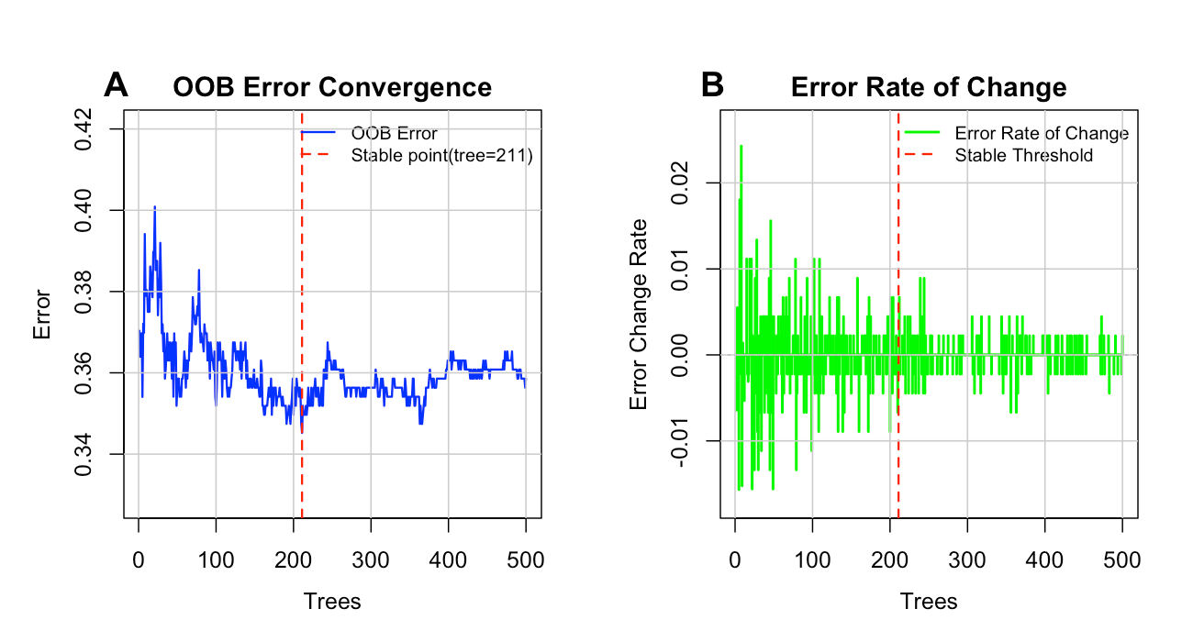
Fig A1 OBB error convergence plot and error variation rate analysis for elderly health management needs predicted by the RF model

- supplementary tables
B1-B3
Table B1 Descriptive Statistics of Variables for Individuals Aged 60 and Above in Guangxi (N=641)
Variables | Total  (n=641) | Non-HMN(n=360) | HMN (n=281) | X² | P
Household Registration Status |  |  |  | 12.523 | <0.001
Rural | 448 (69.9) | 272 (75.6) | 176 (62.6)
Urban | 193 (30.1) | 88 (24.4) | 105 (37.4)
Age (years) |  |  |  | 12.499 | <0.01
60～ | 152 (23.7) | 74 (20.6) | 78 (27.8)
65～ | 189 (29.5) | 97 (26.9) | 92(32.7)
70～ | 155 (24.2) | 103 (28.6) | 52 (18.5)
≥75 | 145 (22.6) | 86 (23.9) | 59 (21.0)
Spouse |  |  |  | 1.748 | 0.186
No | 186 (29.0) | 112 (31.1) | 74 (26.3)
Yes | 455 (71.0) | 248 (68.9) | 207 (73.7)
Educational level |  |  |  | 23.308 | <0.001
Elementary school and below | 316 (49.3) | 203 (56.4) | 113 (40.2)
Junior high/vocational school | 143 (22.3) | 79 (21.9) | 64 (22.8)
High School | 93 (14.5) | 39 (10.8) | 54 (19.2)
College/Undergraduate | 62 (9.7) | 30 (8.3) | 32 (11.4)
Bachelor's degree or above | 27 (4.2) | 9 (2.5) | 18 (6.4)
Occupation |  |  |  | 27.647 | <0.001
Party and government organs/public institutions personnel | 97 (15.1) | 45 (12.5) | 52 (18.5)
Enterprise employees | 58 (9.0) | 24 (6.7) | 34 (12.1)
Farmers | 306 (47.7) | 178 (49.4) | 128 (45.6)
Self-employed | 67 (10.5) | 35 (9.7) | 32 (11.4)
Freelancing | 60 (9.4) | 33 (9.2) | 27 (9.6)
Unemployed | 53 (8.3) | 45(12.5) | 8(2.8)
Monthly per capita income (RMB) |  |  |  | 25.482 | <0.001
＜800 | 108 (16.8) | 80 (22.2) | 28 (10.0)
800～ | 194(30.3) | 118 (32.8) | 76 (27.0)
1500～ | 234 (36.5) | 111 (30.8) | 123 (43.8)
≥3000 | 105 (16.4) | 51 (14.2) | 54 (19.2)
Health Insurance Type |  |  |  | 6.363 | 0.095
Urban Employee Medical Insurance | 87 (13.6) | 39 (10.8) | 48 (17.1)
Urban and Rural Residents' Medical Insurance | 517 (80.7) | 298 (82.8) | 219 (77.9)
Commercial Insurance | 10 (1.6) | 5 (1.4) | 5 (1.8)
None | 27(4.2) | 18 (5.0) | 9(3.2)
Duration of chronic disease (years) |  |  |  | 3.004 | 0.699
None | 213 (33.2) | 113 (31.4) | 100 (35.6)
0～ | 100(15.6) | 54 (15.0) | 46(16.4)
3～ | 128 (20.0) | 71(19.7) | 57(20.3)
5～ | 135(21.1) | 82(22.8) | 53(18.9)
10～ | 40 (6.2) | 25(6.9) | 15(5.3)
≥15 | 25 (3.9) | 15 (4.2) | 10 (3.6)
History of critical illness |  |  |  | 0.216 | 0.642
No | 545 (85.0) | 304 (84.4) | 241 (85.8)
Yes | 96 (15.0) | 56 (15.6) | 40 (14.2)
Health Check Frequency |  |  |  | 28.276 | <0.001
Every six months | 72 (11.2) | 28 (7.8) | 44 (15.7)
Once a year | 201 (31.4) | 93 (25.8) | 108 (38.4)
Irregular | 292 (45.6) | 189 (52.5) | 103 (36.7)
Rarely | 76 (11.9) | 50 (13.9) | 26 (9.3%)
Smoking |  |  |  | 1.027 | 0.598
No | 381 (59.4) | 219 (60.8) | 162 (57.7)
Quit | 128 (20.0) | 67 (18.6) | 61 (21.7)
Yes | 132 (20.6) | 74(20.6) | 58 (20.6)
Alcohol consumption |  |  |  | 3.592 | 0.166
No | 346 (54.0) | 201 (55.8) | 145 (51.6)
Quit | 116 (18.1) | 56 (15.6) | 60 (21.4)
Yes | 179 (27.9) | 103 (28.6) | 76 (27.0)
Insomnia status |  |  |  | 0.419 | 0.518
No | 390 (60.8) | 223 (61.9) | 167 (59.4)
Yes | 251 (39.2) | 137 (38.1) | 114 (40.6)
Health Activities |  |  |  | 50.179 | <0.001
Frequently | 67 (10.5) | 21 (5.8) | 45 (16.4)
Occasionally | 188 (29.3) | 97 (26.9) | 91 (32.4)
Rarely | 176 (27.5) | 86 (23.9) | 90 (32.0)
Never | 210 (32.8) | 156 (43.3) | 54 (19.2)
Self-care ability |  |  |  | 0.552 | 0.759
Able to care for oneself | 526 (82.1) | 297 (82.5) | 229 (81.5)
Requires appropriate assistance from others | 102 (15.9) | 57 (15.8) | 45 (16.0)
Unable to care for oneself | 13 (2.0) | 6 (1.7) | 7 (2.5)
Children's Emotional Support |  |  |  | 15.380 | <0.01
Very Good | 157 (24.5) | 70 (19.4) | 87 (31.0)
Good | 314 (49.0) | 180 (50.0) | 134 (47.7)
Average | 132 (20.6) | 86 (23.9) | 46 (16.4)
Not very good | 22 (3.4) | 12 (3.3) | 10 (3.6)
Poor | 16(2.5) | 12 (3.3) | 4(1.4)
Social Functioning |  |  |  | 28.797 | <0.001
Very Good | 111 (17.3) | 42 (11.7) | 69 (24.6)
Good | 284(44.3) | 154 (42.8) | 130 (46.3)
Average | 196 (30.6) | 133 (36.9) | 63 (22.4)
Not very good | 40 (6.2) | 23 (6.4) | 17 (6.0)
Poor | 10 (1.6) | 8 (2.2) | 2 (0.7)

Table B2 Multivariate logistic regression analysis of health management needs among older adults
Variable | Estimate | Std.Error | Wald | Pr(>|z|) | OR | OR 95CI
(Intercept) | -0.601 | 0.758 | 0.628 | 0.428 | 0.548 | 0.124-2.443
Household registration2 | 0.17 | 0.286 | 0.352 | 0.553 | 1.185 | 0.674-2.077
Age2 | -0.062 | 0.304 | 0.042 | 0.838 | 0.94 | 0.517-1.706
Age3 | -0.503 | 0.329 | 2.342 | 0.126 | 0.605 | 0.316-1.148
Age4 | -0.208 | 0.347 | 0.357 | 0.55 | 0.813 | 0.41-1.604
Education2 | 0.182 | 0.304 | 0.36 | 0.548 | 1.2 | 0.66-2.175
Education3 | 0.457 | 0.35 | 1.703 | 0.192 | 1.579 | 0.796-3.148
Education4 | 0.196 | 0.444 | 0.194 | 0.659 | 1.216 | 0.504-2.898
Education5 | 1.102 | 0.62 | 3.157 | 0.076 | 3.01 | 0.924-10.765
Occupation2 | 0.489 | 0.474 | 1.064 | 0.302 | 1.631 | 0.648-4.182
Occupation3 | 0.259 | 0.406 | 0.406 | 0.524 | 1.295 | 0.586-2.892
Occupation4 | 0.135 | 0.5 | 0.073 | 0.787 | 1.145 | 0.429-3.07
Occupation5 | -0.24 | 0.496 | 0.235 | 0.628 | 0.786 | 0.295-2.075
Occupation6 | -0.88 | 0.601 | 2.145 | 0.143 | 0.415 | 0.122-1.305
Spouse1 | 0.312 | 0.267 | 1.37 | 0.242 | 1.366 | 0.812-2.316
Monthly income2 | 0.662 | 0.384 | 2.959 | 0.085 | 1.938 | 0.924-4.196
Monthly income3 | 1.027 | 0.384 | 7.156 | 0.008 | 2.794 | 1.336-6.052
Monthly income4 | 0.763 | 0.455 | 2.808 | 0.094 | 2.144 | 0.885-5.302
Health insurance2 | 0.087 | 0.41 | 0.045 | 0.832 | 1.091 | 0.49-2.463
Health insurance3 | 0.187 | 0.89 | 0.044 | 0.834 | 1.206 | 0.205-7.147
Health insurance4 | 0.814 | 0.709 | 1.316 | 0.251 | 2.256 | 0.547-9.034
Smoke2 | 0.088 | 0.279 | 0.1 | 0.752 | 1.092 | 0.63-1.888
Smoke3 | 0.25 | 0.29 | 0.739 | 0.39 | 1.284 | 0.726-2.271
Insomnia1 | 0.387 | 0.231 | 2.799 | 0.094 | 1.472 | 0.937-2.324
Check up2 | -0.333 | 0.398 | 0.702 | 0.402 | 0.717 | 0.325-1.554
Check up3 | -0.734 | 0.398 | 3.412 | 0.065 | 0.48 | 0.218-1.041
Check up4 | -0.464 | 0.491 | 0.895 | 0.344 | 0.629 | 0.238-1.638
Self care2 | 0.442 | 0.31 | 2.032 | 0.154 | 1.556 | 0.848-2.868
Self care3 | 0.305 | 0.909 | 0.112 | 0.738 | 1.356 | 0.204-7.86
Health activities2 | -0.127 | 0.424 | 0.09 | 0.764 | 0.88 | 0.379-2.014
Health activities3 | 0.206 | 0.434 | 0.227 | 0.634 | 1.229 | 0.521-2.878
Health activities4 | -1.052 | 0.457 | 5.312 | 0.021 | 0.349 | 0.141-0.849
Social capability2 | -0.489 | 0.342 | 2.047 | 0.152 | 0.613 | 0.311-1.194
Social capability3 | -0.903 | 0.413 | 4.785 | 0.029 | 0.405 | 0.178-0.905
Social capability4 | -0.474 | 0.585 | 0.656 | 0.418 | 0.622 | 0.194-1.942
Social capability5 | -0.875 | 0.984 | 0.79 | 0.374 | 0.417 | 0.047-2.58
PCR2 | -0.055 | 0.292 | 0.035 | 0.851 | 0.947 | 0.534-1.684
PCR3 | 0.246 | 0.398 | 0.381 | 0.537 | 1.278 | 0.587-2.801
PCR4 | 0.891 | 0.736 | 1.464 | 0.226 | 2.437 | 0.564-10.381
PCR5 | 0.783 | 0.891 | 0.772 | 0.38 | 2.188 | 0.344-12.218
Table B3 Variable Assignments for Elderly Health Management Needs
Variables | Assignment mode
Household registration | Rural=1; Urban=2
Age | 60–64=1; 65–69=2; 70–74=3; ≥75=4
Education | Primary school or below=1; Junior high/Technical secondary=2; High school=3; College/Bachelor=4; Postgraduate and above=5
Occupation | Government/Institution staff=1; Enterprise employee=2; Farmer=3; Self-employed=4; Freelancer=5; Unemployed=6
Spouse | No=0; Yes=1
Monthly income | <800=1; 800–1499=2; 1500–2999=3; ≥3000=4
Health insurance | Urban employee medical insurance=1; Urban-rural resident medical insurance=2; Commercial insurance=3; None=4
Smoke | No=1; Former smoker=2; Current smoker=3
Insomnia | No=0; Yes=1
Check up | Every 6 months=1; Every year=2; Irregular=3; Almost never=4
Self care | Fully independent=1; Needs assistance=2; Dependent=3
Health activities | Regular participation=1; Occasional participation=2; Rare participation=3; No participation=4
Social capability | Very good=1; Good=2; Fair=3; Poor=4; Very poor=5
PCR | Very good=1; Good=2; Fair=3; Poor=4; Very poor=5

