Additional file 3: Figure S1. Missing data across candidate predictors (N = 514)
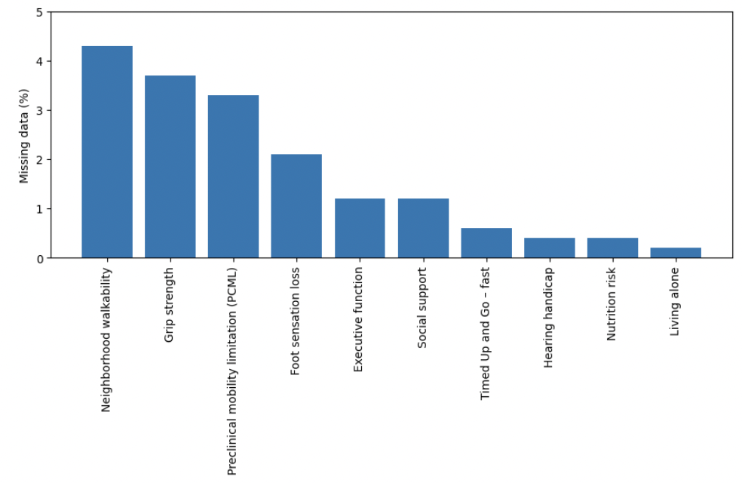
Notes: Only variables with ≥1 missing observation are shown. Percentages were calculated using the full sample (N = 514). No candidate predictor exceeded 5% missingness.

