Supplementary Materials
Appendix 1. Reference categories for categorical variables
Variable | Categories (reference in bold) | Coding approach
Sex | Female, Male | Binary dummy
Age | Continuous (per year increase) | Continuous
Comorbidity count | Continuous (per diagnosis increase) | Continuous
Polypharmacy | <5 medications, ≥5 medications | Binary dummy
Home care at discharge | No, Yes | Binary dummy
Fall risk* | High, Medium, Low | Dummy variables
Care Intensity Score | High, Moderate, Partially autonomous | Dummy variables
Delirium risk | Absent, Present | Binary dummy
Marital status | Partnered, Widowed, Separated/Other | Dummy variables
Living situation | With others, Alone | Binary dummy
Length of stay | Continuous (per day increase) | Continuous
ICU admission | No, Yes | Binary dummy
Note: Continuous predictors were entered per unit increase. Categorical predictors were coded as dummy variables with reference categories as shown.
*in the regression outputs, the variable “Fall risk” corresponds to “Geriatric risk factor”.

Appendix 2. Care intensity score
The Care intensity score (IAS) is a self-developed measure derived from the result-oriented nursing assessment within the electronic nurse assessment tool for acute care (effiziente PflegeAnalyse AcuteCare: ePA-AC©), a structured documentation tool widely implemented in German-speaking healthcare settings ^{[1]}. The IAS quantifies patients’ functional status and care dependency across seven domains of basic care needs, conceptually building on tools like the Self-Care Index (SPI)^{[2]}.
Each domain is rated on a scale from 0 (independent) to 2 (fully dependent), resulting in a total score ranging from 0-14. Higher scores reflect greater care intensity and dependency during hospitalization. The IAS provides a structured quantification of nursing effort and care complexity, particularly relevant for outcome analysis and transitional care strategies ^{[1]}.
IAS Domains and scoring
Domain | 0 (Independent) | 1 (Partial dependence) | 2 (Dependent)
Alimentazione (Feeding) | Autonomous | Partially dependent | Dependent
Dinamiche relazionali (Social support) | Simple | Moderately complex | Complex
Eliminazione (elimination, incl. stoma/catheter care) | Autonomous | Partially dependent | Dependent
Igiene e cura del corpo (Hygiene) | Autonomous | Partially dependent | Dependent
Stato cute e mucose (Skin) | Intact | At risk of alteration | Altered
Mobilità & Orientamentoª (Mobility / Orientation) | – | – | –
Note: ªMobility and Orientation are assessed separately as part of a structured fall risk screening within the broader geriatric assessment and are not included in the IAS sum. They are documented as categorical variables (e.g., disoriented, dependent mobility) and serve as clinical risk flags rather than contributing to the IAS scoring range.
IAS Score interpretation
Total IAS Score | Category | Care intensity
0–2 | Partially autonomous | Low
3–8 | Patient requiring moderate care | Medium
9–14 | Patient requiring maximum care | High
Note: Patients’ domain scores are summed (range 0–14).

Appendix 3. HOSPITAL Score Feasibility Assessment
The HOSPITAL score requires seven components, as per the original derivation and international validation studies, that require the following components:
Component / points attributed | Availability in dataset | Notes
Hemoglobin at discharge <12 g/dL (1 point) | Not available | Lab results not systematically linked to discharge dataset
Oncology service discharge (2 points) | Available | Dataset includes relevant ICD-10/DRG codes
Sodium at discharge <135 mmol/L (1 point) | Not available | Lab data not available
Procedure during index hospitalisation (1 point) | Available | Retrieved from DRG/administrative data
Index admission type – non elective (urgent/emergent) (1 point) | Not available | Admission type not recorded
Admissions (Number of admissions in the prior year) (0-1=0 points; 2-5=2 points; ≥ 6 = 5 points) | Not available | No linkage to prior-year encounters beyond index year
Length of stay ≥5 days (2 points) | Available | LOS data included
Note: Because 4 of 7 core variables were unavailable (hemoglobin, sodium, admission type, prior-year admissions), a full HOSPITAL score could not be calculated. A restricted “HOSPITAL-lite” was deemed unrepresentative and prone to bias. Therefore, we benchmarked against a simplified LACE index (AUC = 0.707, 95% CI 0.694–0.720) instead.

Appendix 4. Hyperparameter tuning grids for ML models (RF and XGBoost)
Summary of hyperparameters tested for Random Forest and Extreme Gradient Boosting models. Optimal settings were selected by repeated k-fold cross-validation using lowest RMSE and highest R².
Random Forest (RF)
Hyperparameter | Values tested | Selection criterion
mtry (no. of variables tried at each split) | (3, 5, 7, 9, 11, 13, 15, 17, 19, 21, 23, 25, 27, 29, 31, 33, 35) | Lowest RMSE and highest R² from repeated k-fold CV
Abbreviations: RMSE = root mean squared error; R² = coefficient of determination; CV = cross-validation.

Extreme Gradient Boosting (XGBoost)
Hyperparameter | Values tested | Notes
nrounds | 100 | Fixed number of boosting iterations
max_depth | 6 | Maximum tree depth
eta (learning rate) | 0.1 | Shrinkage parameter
gamma | 0 | Minimum loss reduction to make a split
colsample_bytree | 0.8 | Fraction of features sampled per tree
min_child_weight | 1 | Minimum sum of instance weight (hessian) per child
subsample | 0.8 | Fraction of observations sampled per tree
Selection criterion | Optimal combination selected by repeated k-fold CV
Abbreviations: RMSE = root mean squared error; R² = coefficient of determination; CV = cross-validation

Appendix 5. Baseline characteristics by 30-day post-discharge mortality
Domain | Predictor | Alive at 30 days (n = 9,349) | Dead within 30 days (n = 80) | p-value*
Demographics | Age, mean ± SD, y | 78.0 ± 7.6 | 82.1 ± 7.9 | <0.001
 | Female sex, n (%) | 4,260 (45.6) | 28 (35.0) | 0.08
 | Partnered, n (%) | 6,286 (67.2) | 53 (66.3) | 0.88
 | Widowed, n (%) | 1,708 (18.3) | 17 (21.3) | 0.50
 | Living alone, n (%) | 3,026 (32.4) | 26 (32.5) | 0.98
Clinical status | Comorbidity count, median (IQR) | 6 (3–10) | 8 (5–12) | <0.001
 | ICU admission, n (%) | 706 (7.6) | 4 (5.0) | 0.40
 | Polypharmacy ≥5 meds, n (%) | 7,717 (82.6) | 74 (92.5) | 0.04
Geriatric assessments | Delirium risk present, n (%) | 7,945 (85.0) | 72 (90.0) | 0.24
 | IAS (care intensity), n (%) |  |  | 0.12
 | – Partially autonomous | 5,084 (54.4) | 35 (43.8)
 | – Medium | 3,834 (41.0) | 36 (45.0)
 | – High | 431 (4.6) | 9 (11.3)
 | Fall risk, n (%) |  |  | 0.08
 | – Medium | 4,700 (50.3) | 51 (63.8)
 | – Low | 2,419 (25.9) | 18 (22.5)
 | – High | 2,230 (23.8) | 11 (13.8)
Hospital stay | Length of stay, median (IQR), days | 5 (3–8) | 7 (4–10) | 0.02
Post-discharge | Home care support at discharge, n (%) | 2,541 (27.2) | 40 (50.0) | <0.001
Note: Baseline characteristics by 30-day post-discharge mortality status. Values are presented as mean ± SD, median (IQR), or n (%). *P-values calculated using X² (or Fisher’s exact test) for categorical variables and Wilcoxon rank-sum test for continuous variables. Percentages are based on available data; totals may not sum due to missing values.
Abbreviations: SD = standard deviation; IQR = interquartile range; ICU = intensive care unit; IAS = care intensity score.

Appendix 6. Primary diagnoses and DRG diagnostic categories (n= 9 429)
Category | Subcategory (ICD-10 Chapter^{[3]} / DRG Major Group^{[4]}) | n | % of cohort
Primary diagnosis (ICD-10) | Medical [A & B (Infectious diseases), C & D (Neoplasms, blood), E (Endocrine), G (Nervous), H (Eye, Ear), I (Circulatory), J (Respiratory), K (Digestive), P (Perinatal), Q (Congenital), R (Symptoms), Y (External causes)] | 6 463 | 68.3
 | Surgical [L (Skin), M (Musculoskeletal), V (External causes), X (External causes, e.g. accidents)] | 897 | 9.5
 | Mental health (F: Mental and behavioral disorders)) | 143 | 1.5
 | Injury-related diagnoses ª (S; T) | 966 | 10.3
 | Gynecologic, Genitourinary ^{b} (N; O) | 945 | 10.0
 | Other (U; Factors influencing health status, supplementary codes) | 15 | 0.2
DRG category (major) | Circulatory system (e.g. heart failure, MI) | 2 210 | 23.4
 | Respiratory system (e.g. pneumonia, COPD) | 1 785 | 18.9
 | Digestive system (e.g. GI bleeding, cholecystitis) | 1 178 | 12.5
 | Musculoskeletal system (e.g. hip fracture) | 945 | 10.0
 | Nervous system (e.g. stroke, seizure) | 809 | 8.6
 | Renal/urinary system | 628 | 6.7
 | Infectious & parasitic diseases | 525 | 5.6
 | Other (each < 5 %) | 1 349 | 14.3
Abbreviations: ICD-10: International Classification of Diseases, 10th Revision; DRG: Diagnosis-Related Group; MI: Myocardial Infarction; COPD: Chronic Obstructive Pulmonary Disease; GI: Gastrointestinal
Note:
ª Diagnosis of injury/trauma; may or may not be surgically treated
^{b} These chapters include both obstetric and gynecologic diagnoses. In our older cohort, these codes captured relevant urogenital and gynecologic conditions (e.g., prolapse, bleeding, pelvic organ disease) and were therefore retained in the analysis.

Appendix 7. Exploratory correlation analysis (Table and Figures)
 | Comorbidity count | LOS | 30-day readmission | Time to readmission | ED Visits | Age
Comorbidity count | 1.00 | 0.57 | 0.23 | – | – | 0.21
LOS | 0.57 | 1.00 | – | – | – | –
30-day readmission | 0.23 | – | 1.00 | –0.50 | 0.30 | –
Time to readmission | – | – | –0.50 | 1.00 | – | –
ED visits | – | – | 0.30 | – | 1.00 | –0.06
Age | 0.21 | – | – | – | –0.06 | 1.00
Abbreviations: LOS: Length of Stay; ED: Emergency Department
Note: Values represent Pearson correlation coefficients. “ – “ indicates, that the correlation was not reported or not calculated due to data limitations or irrelevance.

Fig. 1: Scatterplot showing a moderate positive correlation between the number of secondary diagnoses and hospital length of stay (r = 0.57, p < 0.001). Each point represents an individual discharge.
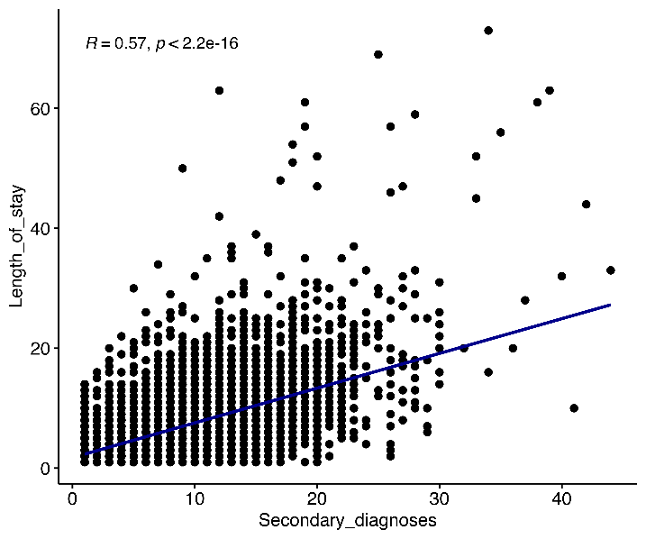
Fig. 2: Inverse correlation between likelihood of readmission and time to readmission (r = –0.50, p < 0.001). Suggests clustering of readmissions early after discharge.
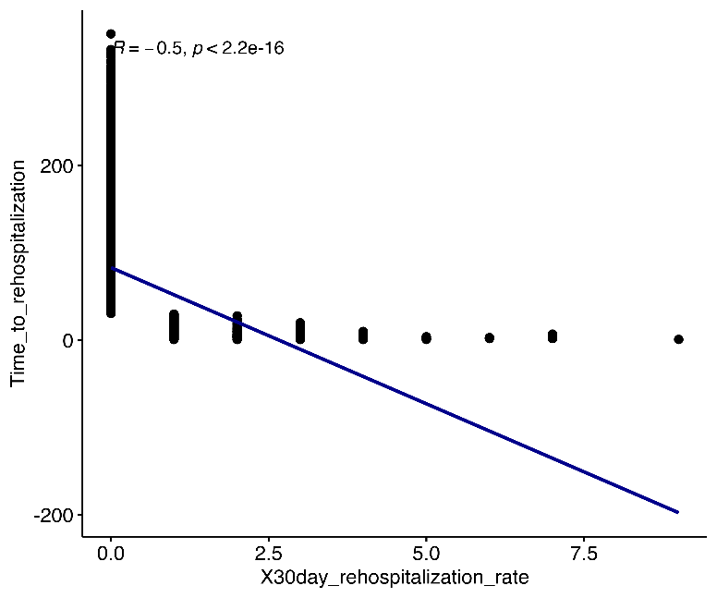
Fig. 3: Scatterplot showing a positive correlation between the number of ED visits within 30 days after discharge and 30-day readmission count (r = 0.30, p < 0.001). Higher ED activity was associated with increased readmission likelihood.
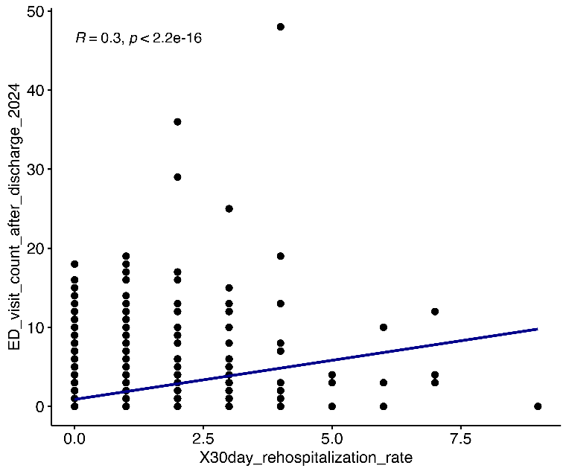

Appendix 8. Full multivariable logistic regression model
Predictor | Coefficient (β) | Standard Error | OR | 95% CI | p-value
Comorbidity count (per diagnosis) | 0.11 | 0.009 | 1.12 | 1.10–1.14 | < 0.001
Male sex | 0.35 | 0.059 | 1.42 | 1.27–1.60 | < 0.001
Polypharmacy (≥ 5 medications) | 0.60 | 0.10 | 1.83 | 1.51–2.21 | < 0.001
Home care at discharge | 0.48 | 0.060 | 1.61 | 1.43–1.81 | < 0.001
Low fall risk (vs. high) | 0.34 | 0.085 | 1.41 | 1.23–1.61 | < 0.001
Moderate care intensity (IAS) (vs. high) | 0.13 | 0.13 | 1.30 | 1.01–1.67 | 0.047
Age (per year) | –0.01 | 0.008 | 0.99 | 0.97–1.00 | 0.007
Length of stay (per day) | –0.02 | 0.0052 | 0.98 | 0.97–0.99 | 0.004
Marital status (separated) | –0.048 | 0.082 | 0.95 | 0.81-1.12 | 0.56
Marital status (widowed) | 0.161 | 0.077 | 1.17 | 1.01-1.35 | 0.035* (borderline)
Hospital site ª (1, 2, 3, and 4) | null coefficients | wide CIs | NS | >0.60
Geriatric risk factor (medium) | 0.097 | 0.075 | 1.10 | 0.95–1.27 | 0.20
Increased risk of delirium (NS) | 0.151 | 0.101 | 1.16 | 0.95-1.41 | 0.14
Care intensity (partially autonomous) | 0.045 | 0.145 | 1.05 | 0.78-1.42 | 0.76
ICU admission | -0.182 | 0.105 | 0.83 | 0.68-1.02 | 0.08 (borderline)
Intercept | –2.58 | 0.16 | — | — | —
AIC | — | — | — | — | 8512.5
Note: Full multivariable logistic regression model including all 17 predictors. Regression coefficients (β), standard errors (SE), odds ratios (OR), 95% confidence intervals (CI), and p-values are reported. The model intercept and Akaike Information Criterion (AIC) are also shown. Categorical predictors were dummy coded; the number of coefficients exceeded the number of conceptual predictors (n = 17).

ª Hospital site was included as a categorical variable (dummy coded with 4 sites, reference = Hospital site 1). None of the hospital site predictors were statistically significant (all p > 0.60).

Abbreviations: IAS: Intensity of Assistance Score; AIC: Akaike Information Criterion, NS: not significant

Appendix 9. Fine–Gray competing risks model for 30-day readmission (competing event: 30-day mortality)
Predictor | Subdistribution Hazard Ratio (sHR) | 95% CI | p-value
Age (per year) | 1.000 | 0.994–1.006 | 0.98
ICU admission (yes vs. no) | 0.871 | 0.729–1.041 | 0.13
Length of stay (per day) | 0.981 | 0.971–0.991 | <0.001
Comorbidity count (per diagnosis) | 1.110 | 1.099–1.121 | <0.001
Note: Model fit: Likelihood ratio X²= 608 (df = 4), p < 0.001.

Appendix 10. Pairwise AUC comparisons between logistic regression and comparator models. Logistic regression (LR) baseline AUC 0.716 (95% CI 0.703-0.728).
Comparison | AUC (absolute) | p-value (DeLong) | p-value (Holm adjusted) | Interpretation
LR vs LACE | +0.009 (0.716 vs 0.707) | <0.001 | <0.01 | LR significantly better
LR vs RF | +0.006 (0.716 vs 0.710) | 0.18 | ns | No significant difference
LR vs XGBoost | +0.004 (0.716 vs 0.712) | 0.21 | ns | No significant difference
LR vs Ridge | +0.008 (0.716 vs 0.708) | 0.09 | ns | No significant difference
LR vs LASSO | +0.031 (0.716 vs 0.685) | <0.001 | <0.01 | LR significantly better
LR vs kNN | +0.020 (0.716 vs 0.696) | <0.01 | 0.04 | LR significantly better
Note: Pairwise AUC comparisons between logistic regression (LR) and comparator models.
Area under the curve (AUC) differences were assessed using DeLong’s test for correlated ROC curves. Reported p-values were adjusted for multiple testing using the Holm method. Significant results (p < 0.05 after adjustment) indicate models with lower discrimination compared to LR.

Abbreviations: AUC = area under the curve; LR = logistic regression; ns = not significant; LACE = Length of stay, Acuity, Comorbidity, ED use index; kNN = k-nearest neighbors.

Appendix 11. Confusion matrix and classification metrics for the logistic regression model
 | Observed readmission
Predicted | Observed NO (7,584) | Observed YES (1,845)
No | 7 356 (TN) | 1 706 (FN)
Yes | 228 (FP) | 139 (TP)
Note: Confusion matrices and detailed classification metrics for the logistic regression model at the prespecified 10% risk threshold. Derived performance metrics are reported, including sensitivity, specificity, positive predictive value (PPV), negative predictive value (NPV).

Derived metrics: Sensitivity: 139/1,845 = 7.5%, Specificity: 7,442/7,584 = 98.1%; PPV: 139/281 =49.5.%; NPV: 7,442/9,148 = 81.4%

Appendix 12. Decision curve analysis

Figure 2: Decision curve analysis
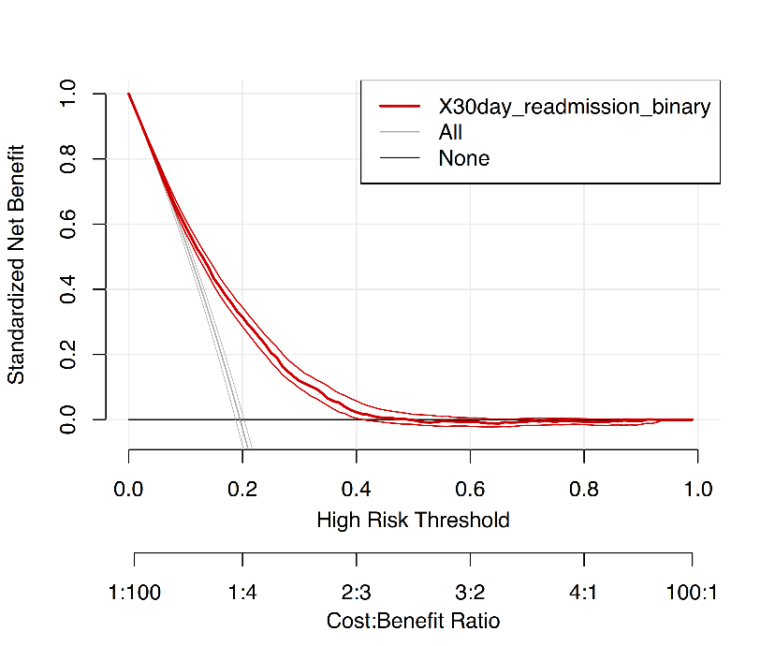

Note: DCA of the logistic regression model for 30-day readmission. Net benefit is plotted against threshold probability. The logistic regression model outperformed the “treat all” and “treat none” strategies between threshold probabilities of 5% and 20%, supporting its potential clinical utility in discharge planning. Beyond 30%, the net benefit declined, suggesting limited added value for more restrictive intervention thresholds.

Appendix 13. Secondary outcome: Time to readmission (OLS regression, n=3,441)
Predictor | Estimate (β) | SE | 95% CI Lower | 95% CI Upper | p-value
Age at admission | 0.71 | 0.21 | 0.30 | 1.12 | 0.0006
Secondary diagnoses (count) | –1.42 | 0.27 | –2.00 | –0.96 | <0.0001
Length of stay | 0.11 | 0.24 | –0.35 | 0.57 | 0.65
Biological sex (male) | –7.11 | 2.61 | –12.24 | –1.99 | 0.0067
Marital status (widowed) | 2.29 | 3.35 | –4.28 | 8.87 | 0.48
Fall risk (low) | –9.82 | 4.30 | –18.25 | –1.38 | 0.023
Fall risk (medium) | 0.80 | 3.15 | –5.37 | 6.97 | 0.80
Increased risk of delirium | 1.21 | 4.63 | –7.87 | 10.30 | 0.79
IAS (medium care) | –3.39 | 5.16 | –14.21 | 7.42 | 0.53
IAS (partially autonomous) | 0.49 | 6.16 | –11.59 | 12.56 | 0.94
Home care services (yes) | –7.15 | 2.71 | –12.45 | –2.68 | 0.0081
Polypharmacy (yes) | –0.71 | 4.45 | –9.43 | 8.02 | 0.87
ICU admission (yes) | 3.25 | 4.50 | –5.58 | 12.08 | 0.47
Model fit: R² = 0.025; RMSE = 69.6 days.

Note:OLS regression of time (days) to first readmission among patients ≥65 years. Positive β indicates longer time to readmission.

Abbreviations: OLS= Ordinary least squares

Appendix 14a: Model performance metrics for 30-day post-discharge mortality (n= 9,429; 80 events)
Metric | Estimate
AUC (apparent) | 0.790 (95% CI 0.743-0.838)
Brier score | 0.008
Calibration slope | 10.88 (SE 2.14, p < 0.001)
Intercept (in-the-large) | -4.887
Hosmer–Lemeshow (X², df=8) | 14.63; p = 0.067
Note: Discrimination and calibration metrics for logistic regression model predicting 30-day post-discharge mortality. Model showed poor discrimination and miscalibration, reflecting the rarity of the outcome.

Appendix 14b: Machine learning classification for 30-day post-discharge mortality (n = 9,429; 80 events, 0.85%)
Model | AUC (95% CI) | Sensitivity (Recall) (%) | Specificity  (%) | PPV*  (Precision) | NPV (%) | Notes
Logistic regression | 0.790 (0.743-0.838) | 0 | 100 | NA | 80.4 | Identified no deaths
LASSO | 0.500 (0.500–0.500) | 0 | 100 | NA | 99.3 | No deaths identified
Ridge regression | 0.758 (0.646–0.871) | 0 | 100 | NA | 99.3 | No deaths identified
kNN | 0.521 (0.397–0.645) | 0 | 100 | NA | 99.3 | No deaths identified
Random Forest | 0.655 (0.513–0.797) | 0 | 100 | NA | 99.3 | No deaths identified
XGBoost | 0.690 (0.558–0.821) | 0 | 100 | NA | 99.3 | No deaths identified
Note: All models showed modest AUC (0.500–0.758) but 0% sensitivity, 100% specificity, reflecting severe class imbalance (80/9,429 = 0,85% deaths) and limited predictive value.
*PPV could not be calculated because no positive predictions were made (TP + FP = 0).

