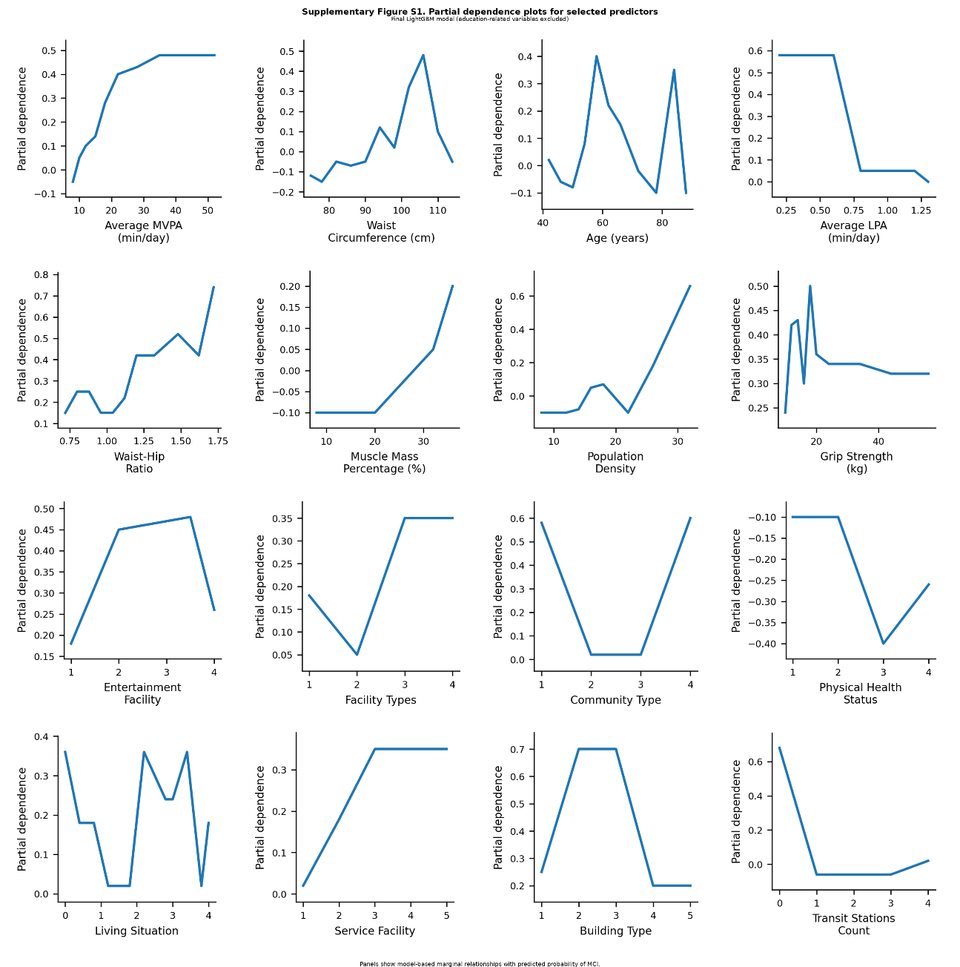
Supplementary Figure S1. Partial dependence plots for selected predictors in the final LightGBM model

