Supplementary materials
Table S1. Definitions and measurement criteria for key study variables.
Table S2. Goodness-of-fit statistics for joint trajectory models with 1 to 6 latent classes.
Table S3. Baseline characteristics of participants.
Table S4. Cox proportional hazards regression analysis of the association between joint sleep–depression trajectories and the risk of incident chronic diseases and multimorbidity.
Table S5. Comparative performance metrics of seven machine learning algorithms in the validation set.
Table S6. Baseline characteristics of participants (unimputed data).
Table S7. Cox proportional hazards regression analysis of the association between joint sleep–depression trajectories and the risk of incident chronic diseases and multimorbidity. (unimputed data).
Table S8. Comparative performance metrics of seven machine learning algorithms (unimputed data).
Table S9. Cox proportional hazards regression analysis of the association between joint sleep–depression trajectories and the risk of incident chronic diseases and multimorbidity during the 2018–2020 follow-up period.
Table S10. Cox proportional hazards regression analysis comparing the risk of incident chronic diseases and multimorbidity between Group 2 and Group 3.

Figure S1. Flow diagram for participants included in the study.
Figure S2. Forest plot of joint sleep–depression trajectories and risk of multiple incident chronic diseases and multimorbidity (unimputed data).
Figure S3. Kaplan–Meier cumulative incidence curves for chronic diseases and multimorbidity stratified by joint trajectory groups(unimputed data).
Figure S4. Feature selection results based on unimputed data.
Figure S5. Comparative performance of seven predictive models using unimputed data.
Figure S6. SHAP-based interpretability for the top-performing model (unimputed data).
Figure S7. Forest plot of joint sleep–depression trajectories and risk of multiple incident chronic diseases and multimorbidity during the 2018–2020 follow-up period.
Figure S8. Web-based risk calculator for predicting membership in the high-risk joint sleep–depression trajectory.

Table S1. Definitions and measurement criteria for key study variables.

Variables | Description in CHARLS
Social participation | Defined as participation in any social activities within the past month.
Social isolation score | Classified into four levels based on social environment: Low (strong support, frequent contact); Mild (slight limitations); Moderate (notable risk, limited engagement); and High (critical lack of support, minimal interaction).
Balance | Assessed by the ability to maintain a tandem stance (heel-to-toe) for up to 60 seconds.
Chair stand test | Based on the time required to complete five chair stands. Performance categorized via SPPB criteria: Low (≥13.7 s), Moderate (11.2–13.6 s), and High (≤11.1 s).
Lung function | Assessed via Peak Expiratory Flow (PEF). Categorized as: Low (≤400 L/min), Moderate (401–600 L/min), and High (≥601 L/min).
ADL | Yes: Ability to perform all basic self-care tasks (e.g.bathing, dressing, eating) without assistance.  No: Requiring assistance with at least one task.
IADL | Yes: Ability to perform all complex daily tasks (e.g., shopping, cooking, managing finances) without assistance.  No: Requiring assistance with at least one task.
Body pain | Defined by self-reported frequent pain and quantified by the number of painful sites (range: 0–15). Higher counts indicate greater pain burden.
Cognition score | A composite score (range: 0–21) summing episodic memory (0–10; immediate/delayed recall) and mental status (0–11; orientation, calculation, drawing). Higher scores indicate better cognitive function.

Abbreviations: ADL, Activities of Daily Living; IADL, Instrumental Activities of Daily Living; PEF, Peak Expiratory Flow; CHARLS, China Health and Retirement Longitudinal Study.

Table S2. Goodness-of-fit statistics for joint trajectory models with 1 to 6 latent classes.

Number of classes | AIC | BIC | Group membership (%) |  |  |  |  |  | Ave PP (%)
1 | 394678.5 | 394746.7 | 100 |  |  |  |  |  | 100
2 | 379483.7 | 379637.3 | 51.3 | 48.7 |  |  |  |  | 93.6 | 95.0
3 | 376407.2 | 376637.5 | 27.2 | 46.8 | 26.0 |  |  |  | 88.9 | 86.7 | 90.6
4 | 373540.3 | 373855.7 | 24.4 | 27.2 | 25.0 | 23.4 |  |  | 81.3 | 88.4 | 83.0 | 88.9
5 | 372755.3 | 372256.1 | 20.8 | 24.5 | 20.1 | 3.8 | 30.8 |  | 79.1 | 84.2 | 81.1 | 86.2 | 83.1
6 | 373640.5 | 374138.4 | 18.5 | 22.1 | 19.3 | 3.2 | 28.4 | 8.5 | 76.5 | 81.0 | 78.4 | 82.1 | 80.5 | 75.2

Abbreviations:AIC, Akaike Information Criterion; BIC, Bayesian Information Criterion;
Ave PP, Average Posterior Probability.

Table S3. Baseline characteristics of participants.

Variables | Total (n = 3221) | G1 (n = 788) | G2 (n = 875) | G3 (n = 805) | G4 (n = 753) | P
Demographic Characteristics
Age, Mean ± SD | 65.80 ± 4.93 | 65.59 ± 4.78 | 66.08 ± 5.17 | 65.62 ± 4.93 | 65.88 ± 4.80 | 0.130
Gender, n(%) |  |  |  |  |  | <.001
Female | 1596 (49.55) | 288 (36.55) | 409 (46.74) | 398 (49.44) | 501 (66.53)
Male | 1625 (50.45) | 500 (63.45) | 466 (53.26) | 407 (50.56) | 252 (33.47)
Education, n(%) |  |  |  |  |  | <.001
Primary School | 3022 (93.82) | 694 (88.07) | 814 (93.03) | 780 (96.89) | 734 (97.48)
Secondary School | 154 (4.78) | 66 (8.38) | 48 (5.49) | 24 (2.98) | 16 (2.12)
College and Above | 45 (1.40) | 28 (3.55) | 13 (1.49) | 1 (0.12) | 3 (0.40)
Marital status, n(%) |  |  |  |  |  | <.001
Have spouse | 2718 (84.38) | 706 (89.59) | 737 (84.23) | 668 (82.98) | 607 (80.61)
No spouse | 503 (15.62) | 82 (10.41) | 138 (15.77) | 137 (17.02) | 146 (19.39)
Hukou, n(%) |  |  |  |  |  | <.001
Agriculture | 2577 (80.01) | 546 (69.29) | 658 (75.20) | 695 (86.34) | 678 (90.04)
Non-agriculture | 617 (19.16) | 233 (29.57) | 207 (23.66) | 104 (12.92) | 73 (9.69)
Unified residence | 27 (0.84) | 9 (1.14) | 10 (1.14) | 6 (0.75) | 2 (0.27)
Residence, n(%) |  |  |  |  |  | <.001
Urban | 1060 (32.91) | 350 (44.42) | 342 (39.09) | 206 (25.59) | 162 (21.51)
Rural | 2161 (67.09) | 438 (55.58) | 533 (60.91) | 599 (74.41) | 591 (78.49)
Region, n(%) |  |  |  |  |  | <.001
Western | 1071 (33.25) | 181 (22.97) | 265 (30.29) | 274 (34.04) | 351 (46.61)
Eastern | 1445 (44.86) | 420 (53.30) | 410 (46.86) | 364 (45.22) | 251 (33.33)
Central | 514 (15.96) | 130 (16.50) | 153 (17.49) | 119 (14.78) | 112 (14.87)
Northeast | 191 (5.93) | 57 (7.23) | 47 (5.37) | 48 (5.96) | 39 (5.18)
Socioeconomic Factors
Retirement, n(%) |  |  |  |  |  | <.001
No | 2669 (82.86) | 560 (71.07) | 698 (79.77) | 721 (89.57) | 690 (91.63)
Yes | 552 (17.14) | 228 (28.93) | 177 (20.23) | 84 (10.43) | 63 (8.37)
Medical insurance, n(%) |  |  |  |  |  | 0.039
No | 150 (4.66) | 24 (3.05) | 40 (4.57) | 40 (4.97) | 46 (6.11)
Yes | 3071 (95.34) | 764 (96.95) | 835 (95.43) | 765 (95.03) | 707 (93.89)
HPCC, Mean ± SD | 6216.07 ± 7608.53 | 7314.83 ± 9941.84 | 6690.13 ± 8232.85 | 5490.73 ± 5993.31 | 5290.81 ± 4930.70 | <.001
Life satisfaction, n(%) |  |  |  |  |  | <.001
Not satisfied | 77 (2.39) | 2 (0.25) | 5 (0.57) | 18 (2.24) | 52 (6.91)
Slightly dissatisfied | 386 (11.98) | 31 (3.93) | 72 (8.23) | 121 (15.03) | 162 (21.51)
Moderately satisfied | 2006 (62.28) | 508 (64.47) | 579 (66.17) | 486 (60.37) | 433 (57.50)
Very satisfied | 694 (21.55) | 227 (28.81) | 205 (23.43) | 165 (20.50) | 97 (12.88)
Extremely satisfied | 58 (1.80) | 20 (2.54) | 14 (1.60) | 15 (1.86) | 9 (1.20)
Lifestyle and Behaviors
Smoking Status, n(%) |  |  |  |  |  | <.001
Never smoked | 1865 (57.90) | 425 (53.93) | 498 (56.91) | 450 (55.90) | 492 (65.34)
Former smoker | 331 (10.28) | 89 (11.29) | 92 (10.51) | 75 (9.32) | 75 (9.96)
Current smoker | 1025 (31.82) | 274 (34.77) | 285 (32.57) | 280 (34.78) | 186 (24.70)
Alcohol Consumption, n(%) |  |  |  |  |  | <.001
Non-drinker | 1887 (58.58) | 436 (55.33) | 484 (55.31) | 487 (60.50) | 480 (63.75)
Occasional drinker | 356 (11.05) | 74 (9.39) | 90 (10.29) | 100 (12.42) | 92 (12.22)
Frequent drinker | 978 (30.36) | 278 (35.28) | 301 (34.40) | 218 (27.08) | 181 (24.04)
Nap duration, Mean ± SD | 33.34 ± 43.07 | 39.84 ± 45.92 | 30.47 ± 40.85 | 37.83 ± 45.34 | 25.07 ± 38.15 | <.001
Social participation, n(%) |  |  |  |  |  | <.001
No | 1741 (54.05) | 364 (46.19) | 454 (51.89) | 456 (56.65) | 467 (62.02)
Yes | 1480 (45.95) | 424 (53.81) | 421 (48.11) | 349 (43.35) | 286 (37.98)
Social isolation score, n(%) |  |  |  |  |  | <.001
Low | 1120 (34.77) | 346 (43.91) | 325 (37.14) | 266 (33.04) | 183 (24.30)
Mild | 1573 (48.84) | 355 (45.05) | 394 (45.03) | 402 (49.94) | 422 (56.04)
Moderate | 395 (12.26) | 65 (8.25) | 111 (12.69) | 105 (13.04) | 114 (15.14)
High | 133 (4.13) | 22 (2.79) | 45 (5.14) | 32 (3.98) | 34 (4.52)
Health Status Indicators
BMI, Mean ± SD | 23.10 ± 3.69 | 23.68 ± 3.61 | 23.10 ± 3.61 | 23.06 ± 3.77 | 22.52 ± 3.70 | <.001
Waist circumference, Mean ± SD | 84.36 ± 12.31 | 85.93 ± 11.86 | 84.59 ± 12.92 | 84.40 ± 12.16 | 82.40 ± 11.97 | <.001
SBP, Mean ± SD | 131.50 ± 21.12 | 132.11 ± 20.38 | 131.85 ± 21.61 | 131.16 ± 20.98 | 130.79 ± 21.45 | 0.583
DBP, Mean ± SD | 74.42 ± 11.47 | 75.11 ± 11.43 | 74.39 ± 11.54 | 74.25 ± 11.53 | 73.90 ± 11.35 | 0.204
Grip strength,  Mean ± SD | 30.30 ± 10.15 | 33.81 ± 9.59 | 30.48 ± 9.91 | 29.68 ± 9.99 | 27.08 ± 9.99 | <.001
Balance, n(%) |  |  |  |  |  | <.001
No | 793 (24.62) | 144 (18.27) | 198 (22.63) | 218 (27.08) | 233 (30.94)
Yes | 2428 (75.38) | 644 (81.73) | 677 (77.37) | 587 (72.92) | 520 (69.06)
Chair stand test, n(%) |  |  |  |  |  | <.001
Low | 583 (18.10) | 91 (11.55) | 146 (16.69) | 152 (18.88) | 194 (25.76)
Moderate | 689 (21.39) | 136 (17.26) | 204 (23.31) | 170 (21.12) | 179 (23.77)
High | 1949 (60.51) | 561 (71.19) | 525 (60.00) | 483 (60.00) | 380 (50.46)
Lung function, n(%) |  |  |  |  |  | <.001
Low | 2749 (85.35) | 620 (78.68) | 733 (83.77) | 702 (87.20) | 694 (92.16)
Moderate | 441 (13.69) | 156 (19.80) | 135 (15.43) | 94 (11.68) | 56 (7.44)
High | 31 (0.96) | 12 (1.52) | 7 (0.80) | 9 (1.12) | 3 (0.40)
ADL, n(%) |  |  |  |  |  | <.001
No | 2595 (80.57) | 737 (93.53) | 744 (85.03) | 661 (82.11) | 453 (60.16)
Yes | 626 (19.43) | 51 (6.47) | 131 (14.97) | 144 (17.89) | 300 (39.84)
IADL, n(%) |  |  |  |  |  | <.001
No | 2492 (77.37) | 706 (89.59) | 730 (83.43) | 598 (74.29) | 458 (60.82)
Yes | 729 (22.63) | 82 (10.41) | 145 (16.57) | 207 (25.71) | 295 (39.18)
Disability, n(%) |  |  |  |  |  | <.001
No | 2614 (81.15) | 682 (86.55) | 730 (83.43) | 646 (80.25) | 556 (73.84)
Yes | 607 (18.85) | 106 (13.45) | 145 (16.57) | 159 (19.75) | 197 (26.16)
Vision, n(%) |  |  |  |  |  | <.001
Poor | 895 (27.79) | 118 (14.97) | 205 (23.43) | 241 (29.94) | 331 (43.96)
Fair | 1289 (40.02) | 313 (39.72) | 382 (43.66) | 334 (41.49) | 260 (34.53)
Good | 709 (22.01) | 232 (29.44) | 201 (22.97) | 164 (20.37) | 112 (14.87)
Very Good | 291 (9.03) | 113 (14.34) | 76 (8.69) | 57 (7.08) | 45 (5.98)
Excellent | 37 (1.15) | 12 (1.52) | 11 (1.26) | 9 (1.12) | 5 (0.66)
Hearing, n(%) |  |  |  |  |  | <.001
Poor | 515 (15.99) | 78 (9.90) | 131 (14.97) | 142 (17.64) | 164 (21.78)
Fair | 1451 (45.05) | 305 (38.71) | 413 (47.20) | 353 (43.85) | 380 (50.46)
Good | 878 (27.26) | 265 (33.63) | 240 (27.43) | 220 (27.33) | 153 (20.32)
Very Good | 341 (10.59) | 123 (15.61) | 85 (9.71) | 81 (10.06) | 52 (6.91)
Excellent | 36 (1.12) | 17 (2.16) | 6 (0.69) | 9 (1.12) | 4 (0.53)
Teeth loss, n(%) |  |  |  |  |  | 0.048
No | 2830 (87.86) | 708 (89.85) | 773 (88.34) | 707 (87.83) | 642 (85.26)
Yes | 391 (12.14) | 80 (10.15) | 102 (11.66) | 98 (12.17) | 111 (14.74)
SRH, n(%) |  |  |  |  |  | <.001
Poor | 134 (4.16) | 6 (0.76) | 21 (2.40) | 34 (4.22) | 73 (9.69)
Fair | 796 (24.71) | 63 (7.99) | 192 (21.94) | 230 (28.57) | 311 (41.30)
Average | 1623 (50.39) | 422 (53.55) | 489 (55.89) | 401 (49.81) | 311 (41.30)
Good | 495 (15.37) | 213 (27.03) | 130 (14.86) | 107 (13.29) | 45 (5.98)
Very Good | 173 (5.37) | 84 (10.66) | 43 (4.91) | 33 (4.10) | 13 (1.73)
Body pain, Mean ± SD | 1.51 ± 2.88 | 0.31 ± 1.18 | 1.05 ± 2.27 | 1.50 ± 2.65 | 3.30 ± 3.94 | <.001
History of falls, n(%) |  |  |  |  |  | <.001
No | 2624 (81.47) | 705 (89.47) | 718 (82.06) | 675 (83.85) | 526 (69.85)
Yes | 597 (18.53) | 83 (10.53) | 157 (17.94) | 130 (16.15) | 227 (30.15)
Cognition score, Mean ± SD | 10.36 ± 4.35 | 12.15 ± 3.92 | 10.89 ± 4.03 | 9.77 ± 4.29 | 8.49 ± 4.35 | <.001
Chronic diseases count, Mean ± SD | 1.54 ± 1.41 | 1.12 ± 1.19 | 1.56 ± 1.38 | 1.47 ± 1.32 | 2.03 ± 1.58 | <.001

Note: Data are presented as mean ± standard deviation (SD) for continuous variables and frequency (percentage) for categorical variables. P values were derived from one-way ANOVA for continuous variables and Chi-square tests for categorical variables.
Abbreviations: BMI, Body Mass Index; SBP, Systolic Blood Pressure; DBP, Diastolic Blood Pressure; HPCC, Household Per Capita Consumption expenditure; ADL, Activities of Daily Living; IADL, Instrumental Activities of Daily Living; SRH, Self-Rated Health;
Group definitions: G1, normal-stable sleep and low-stable depression; G2, short-stable sleep and low-stable depression; G3, normal-increasing sleep and moderate-increasing depression; G4, short-decreasing sleep and high-increasing depression.

Table S4. Cox proportional hazards regression analysis of the association between joint sleep–depression trajectories and the risk of incident chronic diseases and multimorbidity.

Disease / Group | Model 1 |  | Model 2 |  | Model 3
Disease / Group | HR (95% CI) | P | HR (95% CI) | P | HR (95% CI) | P
Hypertension
G1 | Ref | - | Ref | - | Ref | -
G2 | 1.08 (0.95, 1.22) | 0.253 | 1.08 (0.95, 1.22) | 0.254 | 1.12 (0.99, 1.27) | 0.085
G3 | 1.19 (1.05, 1.35) | 0.006 | 1.20 (1.06, 1.36) | 0.004 | 1.25 (1.09, 1.42) | 0.001
G4 | 1.44 (1.26, 1.64) | <0.001 | 1.45 (1.26, 1.65) | <0.001 | 1.48 (1.27, 1.73) | <0.001
Dyslipidemia
G1 | Ref | - | Ref | - | Ref | -
G2 | 1.22 (1.08, 1.39) | 0.002 | 1.25 (1.10, 1.42) | 0.001 | 1.22 (1.07, 1.40) | 0.003
G3 | 1.36 (1.19, 1.55) | <0.001 | 1.37 (1.20, 1.56) | <0.001 | 1.34 (1.17, 1.53) | <0.001
G4 | 1.80 (1.57, 2.07) | <0.001 | 1.86 (1.62, 2.13) | <0.001 | 1.78 (1.53, 2.08) | <0.001
Diabetes
G1 | Ref | - | Ref | - | Ref | -
G2 | 1.29 (1.08, 1.53) | 0.004 | 1.32 (1.11, 1.57) | 0.002 | 1.27 (1.06, 1.51) | 0.008
G3 | 1.25 (1.04, 1.49) | 0.015 | 1.26 (1.06, 1.51) | 0.01 | 1.17 (0.97, 1.41) | 0.103
G4 | 1.85 (1.55, 2.21) | <0.001 | 1.93 (1.61, 2.31) | <0.001 | 1.63 (1.32, 1.99) | <0.001
Heart disease
G1 | Ref | - | Ref | - | Ref | -
G2 | 1.50 (1.28, 1.75) | <0.001 | 1.52 (1.30, 1.78) | <0.001 | 1.41 (1.21, 1.66) | <0.001
G3 | 1.51 (1.29, 1.77) | <0.001 | 1.52 (1.30, 1.78) | <0.001 | 1.37 (1.16, 1.61) | <0.001
G4 | 2.18 (1.85, 2.56) | <0.001 | 2.24 (1.90, 2.64) | <0.001 | 1.82 (1.52, 2.19) | <0.001
Stroke
G1 | Ref | - | Ref | - | Ref | -
G2 | 1.38 (1.09, 1.75) | 0.007 | 1.39 (1.10, 1.76) | 0.006 | 1.31 (1.03, 1.67) | 0.027
G3 | 1.83 (1.45, 2.30) | <0.001 | 1.83 (1.45, 2.30) | <0.001 | 1.68 (1.32, 2.13) | <0.001
G4 | 3.04 (2.42, 3.83) | <0.001 | 3.08 (2.44, 3.87) | <0.001 | 2.56 (1.98, 3.30) | <0.001
Chronic lung disease
G1 | Ref | - | Ref | - | Ref | -
G2 | 1.70 (1.42, 2.03) | <0.001 | 1.69 (1.41, 2.03) | <0.001 | 1.51 (1.25, 1.81) | <0.001
G3 | 1.99 (1.67, 2.38) | <0.001 | 1.98 (1.65, 2.37) | <0.001 | 1.71 (1.42, 2.06) | <0.001
G4 | 3.31 (2.76, 3.96) | <0.001 | 3.27 (2.73, 3.93) | <0.001 | 2.35 (1.92, 2.88) | <0.001
Asthma
G1 | Ref | - | Ref | - | Ref | -
G2 | 1.50 (1.11, 2.03) | 0.009 | 1.49 (1.10, 2.01) | 0.011 | 1.32 (0.97, 1.80) | 0.077
G3 | 1.63 (1.20, 2.21) | 0.002 | 1.59 (1.17, 2.15) | 0.003 | 1.39 (1.01, 1.90) | 0.041
G4 | 2.91 (2.16, 3.91) | <0.001 | 2.83 (2.10, 3.81) | <0.001 | 2.23 (1.61, 3.10) | <0.001
Liver disease
G1 | Ref | - | Ref | - | Ref | -
G2 | 1.18 (0.94, 1.47) | 0.158 | 1.19 (0.95, 1.49) | 0.129 | 1.05 (0.83, 1.32) | 0.691
G3 | 1.31 (1.05, 1.65) | 0.017 | 1.33 (1.06, 1.67) | 0.013 | 1.12 (0.89, 1.42) | 0.338
G4 | 2.10 (1.67, 2.63) | <0.001 | 2.15 (1.71, 2.70) | <0.001 | 1.50 (1.16, 1.95) | 0.002
Cancer
G1 | Ref | - | Ref | - | Ref | -
G2 | 1.54 (1.05, 2.26) | 0.029 | 1.48 (1.01, 2.18) | 0.047 | 1.37 (0.92, 2.03) | 0.122
G3 | 1.43 (0.95, 2.14) | 0.084 | 1.41 (0.94, 2.12) | 0.095 | 1.26 (0.82, 1.92) | 0.292
G4 | 2.03 (1.35, 3.05) | 0.001 | 1.90 (1.26, 2.86) | 0.002 | 1.56 (1.05, 2.31) | 0.029
Digestive disease
G1 | Ref | - | Ref | - | Ref | -
G2 | 1.40 (1.21, 1.62) | <0.001 | 1.40 (1.21, 1.62) | <0.001 | 1.23 (1.06, 1.43) | 0.006
G3 | 1.46 (1.26, 1.69) | <0.001 | 1.47 (1.27, 1.70) | <0.001 | 1.23 (1.06, 1.43) | 0.008
G4 | 2.31 (1.98, 2.69) | <0.001 | 2.31 (1.99, 2.70) | <0.001 | 1.66 (1.40, 1.97) | <0.001
Kidney disease
G1 | Ref | - | Ref | - | Ref | -
G2 | 1.84 (1.51, 2.25) | <0.001 | 1.84 (1.51, 2.25) | <0.001 | 1.56 (1.27, 1.91) | <0.001
G3 | 1.81 (1.47, 2.23) | <0.001 | 1.84 (1.49, 2.26) | <0.001 | 1.42 (1.15, 1.77) | 0.001
G4 | 3.28 (2.67, 4.03) | <0.001 | 3.30 (2.68, 4.06) | <0.001 | 2.00 (1.58, 2.52) | <0.001
Arthritis
G1 | Ref | - | Ref | - | Ref | -
G2 | 1.50 (1.31, 1.70) | <0.001 | 1.49 (1.31, 1.70) | <0.001 | 1.35 (1.18, 1.54) | <0.001
G3 | 1.52 (1.33, 1.74) | <0.001 | 1.52 (1.33, 1.74) | <0.001 | 1.29 (1.13, 1.49) | <0.001
G4 | 2.07 (1.79, 2.40) | <0.001 | 2.05 (1.77, 2.38) | <0.001 | 1.50 (1.27, 1.77) | <0.001
Memory-related disorders
G1 | Ref | - | Ref | - | Ref | -
G2 | 1.93 (1.44, 2.60) | <0.001 | 1.92 (1.43, 2.58) | <0.001 | 1.63 (1.21, 2.21) | 0.001
G3 | 2.44 (1.81, 3.27) | <0.001 | 2.48 (1.84, 3.33) | <0.001 | 1.97 (1.46, 2.68) | <0.001
G4 | 4.77 (3.58, 6.34) | <0.001 | 4.76 (3.57, 6.35) | <0.001 | 3.08 (2.25, 4.22) | <0.001
Multimorbidity
G1 | Ref | - | Ref | - | Ref | -
G2 | 1.40 (1.27, 1.54) | <0.001 | 1.40 (1.27, 1.55) | <0.001 | 1.31 (1.19, 1.45) | <0.001
G3 | 1.50 (1.36, 1.66) | <0.001 | 1.51 (1.37, 1.67) | <0.001 | 1.37 (1.24, 1.52) | <0.001
G4 | 2.35 (2.10, 2.63) | <0.001 | 2.37 (2.12, 2.66) | <0.001 | 1.97 (1.74, 2.23) | <0.001

Note: Data are presented as Hazard Ratio (95% Confidence Interval).
Model 1: Adjusted for age, sex, educational attainment, marital status, Hukou status, residence, and geographic region.
Model 2: Additionally adjusted for smoking status, alcohol consumption, nap duration, social participation, and social isolation.
Model 3: Further adjusted for body mass index (BMI), waist circumference, blood pressure, grip strength, balance, chair stand test, lung function, ADL/IADL disability, sensory function, tooth loss, self-rated health, body pain, history of falls, cognitive function, and baseline chronic disease count.
Group definitions: G1, normal-stable sleep and low-stable depression; G2, short-stable sleep and low-stable depression; G3, normal-increasing sleep and moderate-increasing depression; G4, short-decreasing sleep and high-increasing depression.
Abbreviations: HR, Hazard Ratio; CI, Confidence Interval; Ref, Reference group.

Table S5. Comparative performance metrics of seven machine learning algorithms in the validation set.

Model | AUC | Accuracy | Precision | Sensitivity | Specificity | F1 Score
Logistic | 0.8035 | 0.8193 | 0.6413 | 0.2911 | 0.9647 | 0.4123
Decision Tree | 0.7581 | 0.8071 | 0.5556 | 0.2669 | 0.9475 | 0.4014
Random Forest | 0.7816 | 0.8123 | 0.5874 | 0.2789 | 0.9536 | 0.4094
XGBoost | 0.8054 | 0.8201 | 0.6514 | 0.3010 | 0.9652 | 0.4228
LightGBM | 0.7889 | 0.8115 | 0.5749 | 0.2806 | 0.9470 | 0.4232
SVM | 0.7993 | 0.8127 | 0.602 | 0.2732 | 0.9606 | 0.3862
ANN | 0.8051 | 0.8211 | 0.6473 | 0.2972 | 0.9632 | 0.4279

Abbreviations: AUC, Area Under the Receiver Operating Characteristic Curve; SVM, Support Vector Machine; ANN, Artificial Neural Network; XGBoost, eXtreme Gradient Boosting; LightGBM, Light Gradient Boosting Machine.

Table S6. Baseline characteristics of participants (unimputed data).

Variables | Total (n = 1989) | G1 (n = 510) | G2 (n = 546) | G3 (n = 502) | G4 (n = 431) | P
Demographic Characteristics
Age, Mean ± SD | 65.46 ± 4.67 | 65.17 ± 4.57 | 65.62 ± 4.80 | 65.51 ± 4.84 | 65.55 ± 4.43 | 0.428
Gender, n(%) |  |  |  |  |  | <.001
Female | 924 (46.46) | 180 (35.29) | 241 (44.14) | 235 (46.81) | 268 (62.18)
Male | 1065 (53.54) | 330 (64.71) | 305 (55.86) | 267 (53.19) | 163 (37.82)
Education, n(%) |  |  |  |  |  | <.001
Primary School | 1872 (94.12) | 452 (88.63) | 507 (92.86) | 489 (97.41) | 424 (98.38)
Secondary School | 93 (4.68) | 44 (8.63) | 30 (5.49) | 12 (2.39) | 7 (1.62)
College and Above | 24 (1.21) | 14 (2.75) | 9 (1.65) | 1 (0.20) | 0 (0.00)
Marital status, n(%) |  |  |  |  |  | 0.005
Have spouse | 1719 (86.43) | 462 (90.59) | 474 (86.81) | 424 (84.46) | 359 (83.29)
No spouse | 270 (13.57) | 48 (9.41) | 72 (13.19) | 78 (15.54) | 72 (16.71)
Hukou, n(%) |  |  |  |  |  | <.001
Agriculture | 1597 (80.29) | 351 (68.82) | 422 (77.29) | 433 (86.25) | 391 (90.72)
Non-agriculture | 377 (18.95) | 153 (30.00) | 119 (21.79) | 65 (12.95) | 40 (9.28)
Unified residence | 15 (0.75) | 6 (1.18) | 5 (0.92) | 4 (0.80) | 0 (0.00)
Residence, n(%) |  |  |  |  |  | <.001
Urban | 612 (30.77) | 219 (42.94) | 194 (35.53) | 114 (22.71) | 85 (19.72)
Rural | 1377 (69.23) | 291 (57.06) | 352 (64.47) | 388 (77.29) | 346 (80.28)
Region, n(%) |  |  |  |  |  | <.001
Western | 644 (32.38) | 115 (22.55) | 161 (29.49) | 166 (33.07) | 202 (46.87)
Eastern | 850 (42.74) | 265 (51.96) | 246 (45.05) | 208 (41.43) | 131 (30.39)
Central | 352 (17.70) | 84 (16.47) | 104 (19.05) | 87 (17.33) | 77 (17.87)
Northeast | 143 (7.19) | 46 (9.02) | 35 (6.41) | 41 (8.17) | 21 (4.87)
Socioeconomic Factors
Retirement, n(%) |  |  |  |  |  | <.001
No | 1654 (83.16) | 358 (70.20) | 449 (82.23) | 450 (89.64) | 397 (92.11)
Yes | 335 (16.84) | 152 (29.80) | 97 (17.77) | 52 (10.36) | 34 (7.89)
Medical insurance, n(%) |  |  |  |  |  | 0.135
No | 92 (4.63) | 15 (2.94) | 25 (4.58) | 26 (5.18) | 26 (6.03)
Yes | 1897 (95.37) | 495 (97.06) | 521 (95.42) | 476 (94.82) | 405 (93.97)
HPCC, Mean ± SD | 6073.77 ± 6693.55 | 6761.52 ± 6337.77 | 6737.56 ± 8430.05 | 5528.45 ± 6204.80 | 5054.21 ± 4706.83 | <.001
Life satisfaction, n(%) |  |  |  |  |  | <.001
Not satisfied | 41 (2.06) | 1 (0.20) | 2 (0.37) | 9 (1.79) | 29 (6.73)
Slightly dissatisfied | 212 (10.66) | 16 (3.14) | 38 (6.96) | 68 (13.55) | 90 (20.88)
Moderately satisfied | 1239 (62.29) | 328 (64.31) | 359 (65.75) | 307 (61.16) | 245 (56.84)
Very satisfied | 456 (22.93) | 149 (29.22) | 138 (25.27) | 107 (21.31) | 62 (14.39)
Extremely satisfied | 41 (2.06) | 16 (3.14) | 9 (1.65) | 11 (2.19) | 5 (1.16)
Lifestyle and Behaviors
Smoking Status, n(%) |  |  |  |  |  | 0.054
Never smoked | 1117 (56.16) | 275 (53.92) | 307 (56.23) | 266 (52.99) | 269 (62.41)
Former smoker | 215 (10.81) | 56 (10.98) | 57 (10.44) | 54 (10.76) | 48 (11.14)
Current smoker | 657 (33.03) | 179 (35.10) | 182 (33.33) | 182 (36.25) | 114 (26.45)
Alcohol Consumption, n(%) |  |  |  |  |  | <.001
Non-drinker | 1116 (56.11) | 269 (52.75) | 292 (53.48) | 294 (58.57) | 261 (60.56)
Occasional drinker | 241 (12.12) | 50 (9.80) | 57 (10.44) | 70 (13.94) | 64 (14.85)
Frequent drinker | 632 (31.77) | 191 (37.45) | 197 (36.08) | 138 (27.49) | 106 (24.59)
Nap duration, Mean ± SD | 33.58 ± 43.20 | 39.75 ± 45.42 | 30.02 ± 41.61 | 37.36 ± 44.59 | 26.38 ± 39.34 | <.001
Social participation, n(%) |  |  |  |  |  | <.001
No | 1023 (51.43) | 226 (44.31) | 265 (48.53) | 269 (53.59) | 263 (61.02)
Yes | 966 (48.57) | 284 (55.69) | 281 (51.47) | 233 (46.41) | 168 (38.98)
Social isolation score, n(%) |  |  |  |  |  | <.001
Low | 747 (37.56) | 233 (45.69) | 224 (41.03) | 182 (36.25) | 108 (25.06)
Mild | 958 (48.16) | 223 (43.73) | 239 (43.77) | 243 (48.41) | 253 (58.70)
Moderate | 213 (10.71) | 44 (8.63) | 58 (10.62) | 56 (11.16) | 55 (12.76)
High | 71 (3.57) | 10 (1.96) | 25 (4.58) | 21 (4.18) | 15 (3.48)
Health Status Indicators
BMI, Mean ± SD | 23.05 ± 3.56 | 23.60 ± 3.37 | 23.08 ± 3.48 | 23.00 ± 3.62 | 22.42 ± 3.71 | <.001
Waist circumference, Mean ± SD | 84.56 ± 11.67 | 86.40 ± 10.88 | 85.01 ± 11.78 | 84.36 ± 11.65 | 82.03 ± 12.02 | <.001
SBP, Mean ± SD | 131.18 ± 20.97 | 132.49 ± 19.94 | 131.43 ± 21.98 | 130.57 ± 20.38 | 130.02 ± 21.51 | 0.283
DBP, Mean ± SD | 73.88 ± 11.27 | 74.91 ± 11.24 | 73.85 ± 11.31 | 73.39 ± 11.28 | 73.27 ± 11.20 | 0.091
Grip strength,  Mean ± SD | 31.17 ± 9.86 | 34.09 ± 9.42 | 31.53 ± 9.82 | 30.49 ± 9.84 | 28.07 ± 9.43 | <.001
Balance, n(%) |  |  |  |  |  | 0.008
No | 466 (23.43) | 100 (19.61) | 117 (21.43) | 128 (25.50) | 121 (28.07)
Yes | 1523 (76.57) | 410 (80.39) | 429 (78.57) | 374 (74.50) | 310 (71.93)
Chair stand test, n(%) |  |  |  |  |  | <.001
Low | 335 (16.84) | 57 (11.18) | 84 (15.38) | 94 (18.73) | 100 (23.20)
Moderate | 434 (21.82) | 92 (18.04) | 121 (22.16) | 112 (22.31) | 109 (25.29)
High | 1220 (61.34) | 361 (70.78) | 341 (62.45) | 296 (58.96) | 222 (51.51)
Lung function, n(%) |  |  |  |  |  | <.001
Low | 1686 (84.77) | 409 (80.20) | 447 (81.87) | 433 (86.25) | 397 (92.11)
Moderate | 289 (14.53) | 97 (19.02) | 96 (17.58) | 64 (12.75) | 32 (7.42)
High | 14 (0.70) | 4 (0.78) | 3 (0.55) | 5 (1.00) | 2 (0.46)
ADL, n(%) |  |  |  |  |  | <.001
No | 1651 (83.01) | 479 (93.92) | 473 (86.63) | 426 (84.86) | 273 (63.34)
Yes | 338 (16.99) | 31 (6.08) | 73 (13.37) | 76 (15.14) | 158 (36.66)
IADL, n(%) |  |  |  |  |  | <.001
No | 1589 (79.89) | 456 (89.41) | 465 (85.16) | 391 (77.89) | 277 (64.27)
Yes | 400 (20.11) | 54 (10.59) | 81 (14.84) | 111 (22.11) | 154 (35.73)
Disability, n(%) |  |  |  |  |  | <.001
No | 1625 (81.70) | 437 (85.69) | 466 (85.35) | 401 (79.88) | 321 (74.48)
Yes | 364 (18.30) | 73 (14.31) | 80 (14.65) | 101 (20.12) | 110 (25.52)
Vision, n(%) |  |  |  |  |  | <.001
Poor | 512 (25.74) | 78 (15.29) | 116 (21.25) | 143 (28.49) | 175 (40.60)
Fair | 821 (41.28) | 207 (40.59) | 251 (45.97) | 205 (40.84) | 158 (36.66)
Good | 427 (21.47) | 140 (27.45) | 120 (22.00) | 104 (20.72) | 63 (14.62)
Very Good | 202 (10.16) | 76 (14.90) | 52 (9.52) | 43 (8.57) | 31 (7.19)
Excellent | 27 (1.36) | 9 (1.76) | 7 (1.28) | 7 (1.39) | 4 (0.93)
Hearing, n(%) |  |  |  |  |  | <.001
Poor | 287 (14.43) | 45 (8.82) | 76 (13.92) | 81 (16.14) | 85 (19.72)
Fair | 906 (45.55) | 199 (39.02) | 263 (48.17) | 224 (44.62) | 220 (51.04)
Good | 543 (27.30) | 169 (33.14) | 148 (27.11) | 136 (27.09) | 90 (20.88)
Very Good | 231 (11.61) | 86 (16.86) | 56 (10.26) | 55 (10.96) | 34 (7.89)
Excellent | 22 (1.11) | 11 (2.16) | 3 (0.55) | 6 (1.20) | 2 (0.46)
Teeth loss, n(%) |  |  |  |  |  | 0.143
No | 1756 (88.29) | 460 (90.20) | 488 (89.38) | 438 (87.25) | 370 (85.85)
Yes | 233 (11.71) | 50 (9.80) | 58 (10.62) | 64 (12.75) | 61 (14.15)
SRH, n(%) |  |  |  |  |  | <.001
Poor | 58 (2.92) | 2 (0.39) | 7 (1.28) | 17 (3.39) | 32 (7.42)
Fair | 463 (23.28) | 42 (8.24) | 116 (21.25) | 131 (26.10) | 174 (40.37)
Average | 1039 (52.24) | 281 (55.10) | 313 (57.33) | 255 (50.80) | 190 (44.08)
Good | 309 (15.54) | 128 (25.10) | 84 (15.38) | 74 (14.74) | 23 (5.34)
Very Good | 120 (6.03) | 57 (11.18) | 26 (4.76) | 25 (4.98) | 12 (2.78)
Body pain, Mean ± SD | 1.38 ± 2.76 | 0.36 ± 1.36 | 0.89 ± 2.02 | 1.43 ± 2.59 | 3.16 ± 3.93 | <.001
History of falls, n(%) |  |  |  |  |  | <.001
No | 1635 (82.20) | 451 (88.43) | 448 (82.05) | 431 (85.86) | 305 (70.77)
Yes | 354 (17.80) | 59 (11.57) | 98 (17.95) | 71 (14.14) | 126 (29.23)
Cognition score, Mean ± SD | 10.84 ± 4.16 | 12.51 ± 3.65 | 11.38 ± 3.73 | 10.15 ± 4.30 | 8.98 ± 4.18 | <.001
Chronic diseases count, Mean ± SD | 1.49 ± 1.38 | 1.13 ± 1.20 | 1.48 ± 1.33 | 1.43 ± 1.33 | 2.00 ± 1.57 | <.001

Note: Data are based on the unimputed dataset (N = 1,989) to assess the robustness of findings. Values are presented as mean ± standard deviation (SD) for continuous variables and frequency (percentage) for categorical variables. P values were derived from one-way ANOVA for continuous variables and Chi-square tests for categorical variables.
Abbreviations: BMI, Body Mass Index; SBP, Systolic Blood Pressure; DBP, Diastolic Blood Pressure; HPCC, Household Per Capita Consumption expenditure; ADL, Activities of Daily Living; IADL, Instrumental Activities of Daily Living; SRH, Self-Rated Health;
Group definitions: G1, normal-stable sleep and low-stable depression; G2, short-stable sleep and low-stable depression; G3, normal-increasing sleep and moderate-increasing depression; G4, short-decreasing sleep and high-increasing depression.

Table S7. Cox proportional hazards regression analysis of the association between joint sleep–depression trajectories and the risk of incident chronic diseases and multimorbidity. (unimputed data).

Disease / Group | Model 1 |  | Model 2 |  | Model 3
Disease / Group | HR (95% CI) | P | HR (95% CI) | P | HR (95% CI) | P
Hypertension
G1 | Ref | - | Ref | - | Ref | -
G2 | 1.06 (0.91, 1.24) | 0.428 | 1.06 (0.91, 1.24) | 0.427 | 1.12 (0.96, 1.32) | 0.147
G3 | 1.25 (1.07, 1.46) | 0.005 | 1.26 (1.08, 1.47) | 0.004 | 1.34 (1.14, 1.58) | <0.001
G4 | 1.53 (1.30, 1.81) | <0.001 | 1.54 (1.30, 1.82) | <0.001 | 1.74 (1.44, 2.11) | <0.001
Dyslipidemia
G1 | Ref | - | Ref | - | Ref | -
G2 | 1.22 (1.04, 1.44) | 0.015 | 1.25 (1.06, 1.47) | 0.008 | 1.23 (1.04, 1.45) | 0.015
G3 | 1.39 (1.18, 1.64) | <0.001 | 1.40 (1.19, 1.65) | <0.001 | 1.38 (1.16, 1.64) | <0.001
G4 | 1.77 (1.49, 2.11) | <0.001 | 1.83 (1.53, 2.18) | <0.001 | 1.79 (1.47, 2.18) | <0.001
Diabetes
G1 | Ref | - | Ref | - | Ref | -
G2 | 1.35 (1.09, 1.67) | 0.006 | 1.38 (1.12, 1.71) | 0.003 | 1.34 (1.08, 1.67) | 0.008
G3 | 1.25 (1.00, 1.57) | 0.048 | 1.28 (1.02, 1.60) | 0.03 | 1.21 (0.96, 1.53) | 0.104
G4 | 1.89 (1.50, 2.37) | <0.001 | 1.98 (1.57, 2.49) | <0.001 | 1.76 (1.36, 2.28) | <0.001
Heart disease
G1 | Ref | - | Ref | - | Ref | -
G2 | 1.45 (1.22, 1.75) | <0.001 | 1.46 (1.21, 1.77) | <0.001 | 1.40 (1.15, 1.70) | <0.001
G3 | 1.48 (1.22, 1.80) | <0.001 | 1.48 (1.22, 1.80) | <0.001 | 1.38 (1.13, 1.69) | 0.002
G4 | 2.06 (1.68, 2.53) | <0.001 | 2.10 (1.70, 2.58) | <0.001 | 1.78 (1.41, 2.24) | <0.001
Stroke
G1 | Ref | - | Ref | - | Ref | -
G2 | 1.50 (1.11, 2.02) | 0.009 | 1.49 (1.10, 2.02) | 0.009 | 1.41 (1.04, 1.92) | 0.028
G3 | 1.89 (1.40, 2.55) | <0.001 | 1.86 (1.37, 2.51) | <0.001 | 1.71 (1.26, 2.34) | <0.001
G4 | 3.01 (2.23, 4.07) | <0.001 | 2.99 (2.20, 4.05) | <0.001 | 2.52 (1.78, 3.51) | <0.001
Chronic lung disease
G1 | Ref | - | Ref | - | Ref | -
G2 | 1.69 (1.35, 2.11) | <0.001 | 1.68 (1.34, 2.11) | <0.001 | 1.49 (1.18, 1.87) | <0.001
G3 | 2.06 (1.65, 2.58) | <0.001 | 2.07 (1.65, 2.58) | <0.001 | 1.77 (1.42, 2.23) | <0.001
G4 | 3.47 (2.76, 4.35) | <0.001 | 3.47 (2.76, 4.36) | <0.001 | 2.40 (1.86, 3.09) | <0.001
Asthma
G1 | Ref | - | Ref | - | Ref | -
G2 | 1.55 (1.07, 2.24) | 0.021 | 1.54 (1.06, 2.23) | 0.023 | 1.33 (0.91, 1.95) | 0.136
G3 | 1.67 (1.15, 2.42) | 0.007 | 1.63 (1.12, 2.37) | 0.01 | 1.38 (0.94, 2.02) | 0.105
G4 | 2.89 (2.00, 4.19) | <0.001 | 2.84 (1.96, 4.12) | <0.001 | 2.09 (1.39, 3.14) | <0.001
Liver disease
G1 | Ref | - | Ref | - | Ref | -
G2 | 1.19 (0.91, 1.57) | 0.219 | 1.20 (0.91, 1.58) | 0.205 | 1.05 (0.79, 1.40) | 0.727
G3 | 1.35 (1.02, 1.78) | 0.036 | 1.36 (1.03, 1.79) | 0.032 | 1.14 (0.85, 1.52) | 0.378
G4 | 1.99 (1.49, 2.65) | <0.001 | 2.02 (1.51, 2.69) | <0.001 | 1.56 (1.21, 2.03) | <0.001
Cancer
G1 | Ref | - | Ref | - | Ref | -
G2 | 1.33 (0.83, 2.13) | 0.229 | 1.28 (0.80, 2.05) | 0.307 | 1.14 (0.71, 1.85) | 0.586
G3 | 1.51 (0.94, 2.43) | 0.09 | 1.48 (0.92, 2.39) | 0.105 | 1.28 (0.78, 2.10) | 0.326
G4 | 2.01 (1.23, 3.29) | 0.006 | 1.86 (1.13, 3.05) | 0.014 | 1.37 (1.03, 1.70) | 0.035
Digestive disease
G1 | Ref | - | Ref | - | Ref | -
G2 | 1.35 (1.13, 1.61) | 0.001 | 1.35 (1.13, 1.62) | 0.001 | 1.19 (0.99, 1.43) | 0.059
G3 | 1.41 (1.18, 1.69) | <0.001 | 1.42 (1.19, 1.71) | <0.001 | 1.21 (1.00, 1.46) | 0.052
G4 | 2.13 (1.76, 2.59) | <0.001 | 2.15 (1.77, 2.61) | <0.001 | 1.54 (1.24, 1.91) | <0.001
Kidney disease
G1 | Ref | - | Ref | - | Ref | -
G2 | 2.03 (1.57, 2.62) | <0.001 | 2.03 (1.57, 2.63) | <0.001 | 1.78 (1.37, 2.31) | <0.001
G3 | 1.84 (1.41, 2.41) | <0.001 | 1.85 (1.41, 2.43) | <0.001 | 1.51 (1.14, 1.99) | 0.004
G4 | 3.56 (2.72, 4.65) | <0.001 | 3.58 (2.74, 4.69) | <0.001 | 2.31 (1.71, 3.13) | <0.001
Arthritis
G1 | Ref | - | Ref | - | Ref | -
G2 | 1.62 (1.37, 1.90) | <0.001 | 1.61 (1.37, 1.89) | <0.001 | 1.47 (1.24, 1.73) | <0.001
G3 | 1.76 (1.49, 2.08) | <0.001 | 1.76 (1.49, 2.07) | <0.001 | 1.51 (1.27, 1.80) | <0.001
G4 | 2.37 (1.96, 2.86) | <0.001 | 2.34 (1.94, 2.82) | <0.001 | 1.72 (1.40, 2.12) | <0.001
Memory-related disorders
G1 | Ref | - | Ref | - | Ref | -
G2 | 1.97 (1.34, 2.90) | <0.001 | 1.96 (1.33, 2.88) | <0.001 | 1.68 (1.13, 2.49) | 0.01
G3 | 2.75 (1.88, 4.01) | <0.001 | 2.77 (1.90, 4.05) | <0.001 | 2.26 (1.53, 3.35) | <0.001
G4 | 5.04 (3.47, 7.33) | <0.001 | 5.04 (3.46, 7.34) | <0.001 | 3.52 (2.34, 5.32) | <0.001
Multimorbidity
G1 | Ref | - | Ref | - | Ref | -
G2 | 1.44 (1.28, 1.63) | <0.001 | 1.45 (1.28, 1.63) | <0.001 | 1.36 (1.20, 1.54) | <0.001
G3 | 1.65 (1.46, 1.86) | <0.001 | 1.66 (1.47, 1.87) | <0.001 | 1.51 (1.33, 1.72) | <0.001
G4 | 2.52 (2.19, 2.91) | <0.001 | 2.54 (2.20, 2.93) | <0.001 | 2.18 (1.86, 2.55) | <0.001

Note: Data are based on the unimputed data to assess the robustness of the primary findings. Results are presented as Hazard Ratio (95% Confidence Interval).
Model 1: Adjusted for age, sex, educational attainment, marital status, Hukou status, residence, and geographic region.
Model 2: Additionally adjusted for smoking status, alcohol consumption, nap duration, social participation, and social isolation.
Model 3: Further adjusted for body mass index (BMI), waist circumference, blood pressure, grip strength, balance, chair stand test, lung function, ADL/IADL disability, sensory function, tooth loss, self-rated health, body pain, history of falls, cognitive function, and baseline chronic disease count.
Group definitions: G1, normal-stable sleep and low-stable depression; G2, short-stable sleep and low-stable depression; G3, normal-increasing sleep and moderate-increasing depression; G4, short-decreasing sleep and high-increasing depression.
Abbreviations: HR, Hazard Ratio; CI, Confidence Interval; Ref, Reference group.

Table S8. Comparative performance metrics of seven machine learning algorithms (unimputed data).

Model | AUC | Accuracy | Precision | Sensitivity | Specificity | F1 Score
Logistic | 0.7921 | 0.8323 | 0.6176 | 0.2809 | 0.9598 | 0.4062
Decision Tree | 0.7372 | 0.8204 | 0.5546 | 0.2207 | 0.9590 | 0.3458
Random Forest | 0.778 | 0.8285 | 0.5855 | 0.2977 | 0.9513 | 0.4147
XGBoost | 0.7960 | 0.8348 | 0.6429 | 0.2709 | 0.9652 | 0.4212
LightGBM | 0.7795 | 0.8222 | 0.5494 | 0.2977 | 0.9435 | 0.4061
SVM | 0.7905 | 0.8279 | 0.6087 | 0.2341 | 0.9652 | 0.3582
ANN | 0.7915 | 0.8247 | 0.5521 | 0.3545 | 0.9335 | 0.4318

Abbreviations: AUC, Area Under the Receiver Operating Characteristic Curve; SVM, Support Vector Machine; ANN, Artificial Neural Network; XGBoost, eXtreme Gradient Boosting; LightGBM, Light Gradient Boosting Machine.

Table S9. Cox proportional hazards regression analysis of the association between joint sleep–depression trajectories and the risk of incident chronic diseases and multimorbidity during the 2018–2020 follow-up period.

Disease / Group | Model 1 |  | Model 2 |  | Model 3
Disease / Group | HR (95% CI) | P | HR (95% CI) | P | HR (95% CI) | P
Hypertension
G1 | Ref | - | Ref | - | Ref | -
G2 | 0.85 (0.66, 1.10) | 0.208 | 0.85 (0.66, 1.10) | 0.213 | 0.90 (0.69, 1.16) | 0.398
G3 | 0.95 (0.74, 1.22) | 0.684 | 0.96 (0.75, 1.23) | 0.754 | 1.01 (0.77, 1.29) | 0.879
G4 | 1.36 (1.05, 1.76) | 0.018 | 1.37 (1.06, 1.78) | 0.016 | 1.43 (1.07, 1.90) | 0.015
Dyslipidemia
G1 | Ref | - | Ref | - | Ref | -
G2 | 1.26 (1.00, 1.58) | 0.051 | 1.29 (1.03, 1.63) | 0.03 | 1.29 (1.02, 1.63) | 0.031
G3 | 1.48 (1.18, 1.86) | <0.001 | 1.49 (1.19, 1.87) | <0.001 | 1.48 (1.18, 1.87) | <0.001
G4 | 1.72 (1.35, 2.20) | <0.001 | 1.79 (1.40, 2.28) | <0.001 | 1.82 (1.40, 2.38) | <0.001
Diabetes
G1 | Ref | - | Ref | - | Ref | -
G2 | 1.23 (0.90, 1.68) | 0.19 | 1.24 (0.91, 1.69) | 0.18 | 1.19 (0.87, 1.64) | 0.271
G3 | 1.30 (0.95, 1.77) | 0.102 | 1.29 (0.95, 1.77) | 0.108 | 1.23 (0.89, 1.70) | 0.204
G4 | 1.87 (1.36, 2.58) | <0.001 | 1.89 (1.37, 2.60) | <0.001 | 1.68 (1.18, 2.39) | 0.004
Heart disease
G1 | Ref | - | Ref | - | Ref | -
G2 | 1.29 (0.98, 1.71) | 0.075 | 1.32 (1.00, 1.75) | 0.053 | 1.24 (0.93, 1.65) | 0.14
G3 | 1.19 (0.89, 1.59) | 0.241 | 1.19 (0.89, 1.59) | 0.249 | 1.07 (0.80, 1.45) | 0.648
G4 | 1.70 (1.26, 2.29) | 0.001 | 1.74 (1.29, 2.35) | <0.001 | 1.45 (1.04, 2.01) | 0.027
Stroke
G1 | Ref | - | Ref | - | Ref | -
G2 | 1.79 (1.09, 2.94) | 0.022 | 1.73 (1.06, 2.85) | 0.03 | 1.67 (1.01, 2.76) | 0.044
G3 | 2.38 (1.47, 3.86) | <0.001 | 2.34 (1.44, 3.79) | <0.001 | 2.19 (1.34, 3.59) | 0.002
G4 | 4.46 (2.78, 7.15) | <0.001 | 4.24 (2.63, 6.81) | <0.001 | 3.65 (2.20, 6.06) | <0.001
Chronic lung disease
G1 | Ref | - | Ref | - | Ref | -
G2 | 1.79 (1.24, 2.59) | 0.002 | 1.76 (1.22, 2.53) | 0.003 | 1.63 (1.13, 2.37) | 0.01
G3 | 1.66 (1.13, 2.43) | 0.009 | 1.66 (1.13, 2.43) | 0.01 | 1.50 (1.02, 2.22) | 0.041
G4 | 2.79 (1.90, 4.10) | <0.001 | 2.70 (1.83, 3.97) | <0.001 | 2.17 (1.43, 3.29) | <0.001
Asthma
G1 | Ref | - | Ref | - | Ref | -
G2 | 1.63 (0.98, 2.73) | 0.062 | 1.63 (0.97, 2.72) | 0.063 | 1.45 (0.86, 2.45) | 0.161
G3 | 1.45 (0.85, 2.47) | 0.176 | 1.41 (0.83, 2.42) | 0.204 | 1.20 (0.70, 2.08) | 0.507
G4 | 2.29 (1.35, 3.88) | 0.002 | 2.25 (1.32, 3.84) | 0.003 | 1.71 (1.10, 2.97) | 0.018
Liver disease
G1 | Ref | - | Ref | - | Ref | -
G2 | 1.11 (0.71, 1.75) | 0.65 | 1.11 (0.71, 1.75) | 0.646 | 1.02 (0.64, 1.61) | 0.941
G3 | 1.07 (0.67, 1.72) | 0.771 | 1.08 (0.68, 1.74) | 0.743 | 0.96 (0.59, 1.55) | 0.852
G4 | 1.76 (1.11, 2.80) | 0.016 | 1.75 (1.10, 2.79) | 0.019 | 1.47 (1.01, 2.18) | 0.036
Cancer
G1 | Ref | - | Ref | - | Ref | -
G2 | 1.40 (0.75, 2.63) | 0.294 | 1.39 (0.74, 2.61) | 0.309 | 1.17 (0.61, 2.22) | 0.638
G3 | 1.43 (0.76, 2.72) | 0.271 | 1.43 (0.75, 2.73) | 0.273 | 1.13 (0.58, 2.19) | 0.719
G4 | 1.41 (0.69, 2.86) | 0.347 | 1.39 (0.68, 2.84) | 0.371 | 0.90 (0.41, 1.97) | 0.798
Digestive disease
G1 | Ref | - | Ref | - | Ref | -
G2 | 1.25 (0.94, 1.67) | 0.131 | 1.26 (0.94, 1.68) | 0.127 | 1.13 (0.84, 1.52) | 0.411
G3 | 1.26 (0.94, 1.69) | 0.122 | 1.26 (0.94, 1.69) | 0.124 | 1.09 (0.80, 1.47) | 0.588
G4 | 2.03 (1.49, 2.77) | <0.001 | 2.04 (1.49, 2.79) | <0.001 | 1.51 (1.07, 2.11) | 0.018
Kidney disease
G1 | Ref | - | Ref | - | Ref | -
G2 | 1.52 (1.03, 2.24) | 0.035 | 1.50 (1.02, 2.22) | 0.04 | 1.33 (0.90, 1.97) | 0.159
G3 | 2.00 (1.37, 2.92) | <0.001 | 1.96 (1.34, 2.88) | <0.001 | 1.60 (1.08, 2.37) | 0.019
G4 | 3.15 (2.13, 4.66) | <0.001 | 3.04 (2.05, 4.51) | <0.001 | 1.97 (1.28, 3.03) | 0.002
Arthritis
G1 | Ref | - | Ref | - | Ref | -
G2 | 1.02 (0.76, 1.37) | 0.897 | 1.00 (0.74, 1.34) | 0.982 | 0.96 (0.71, 1.29) | 0.785
G3 | 1.21 (0.91, 1.61) | 0.188 | 1.21 (0.91, 1.60) | 0.199 | 1.13 (0.84, 1.51) | 0.433
G4 | 1.43 (1.12, 1.95) | <0.001 | 1.39 (1.10, 1.90) | 0.007 | 1.21 (1.01, 1.54) | 0.047
Memory-related disorders
G1 | Ref | - | Ref | - | Ref | -
G2 | 2.17 (1.45, 3.24) | <0.001 | 2.13 (1.42, 3.19) | <0.001 | 1.99 (1.32, 2.98) | 0.001
G3 | 2.91 (1.96, 4.34) | <0.001 | 2.89 (1.94, 4.31) | <0.001 | 2.60 (1.73, 3.91) | <0.001
G4 | 4.67 (3.14, 6.95) | <0.001 | 4.51 (3.02, 6.73) | <0.001 | 3.57 (2.33, 5.46) | <0.001
Multimorbidity
G1 | Ref | - | Ref | - | Ref | -
G2 | 1.13 (0.92, 1.39) | 0.257 | 1.11 (0.90, 1.37) | 0.321 | 1.09 (0.88, 1.34) | 0.437
G3 | 1.30 (1.05, 1.60) | 0.015 | 1.30 (1.05, 1.60) | 0.014 | 1.25 (1.01, 1.55) | 0.041
G4 | 1.70 (1.31, 2.19) | <0.001 | 1.67 (1.29, 2.17) | <0.001 | 1.51 (1.15, 2.00) | 0.003

Note: Data are derived from the landmark sensitivity analysis restricted to the 2018–2020 follow-up period. Results are presented as Hazard Ratio (95% Confidence Interval).
Model 1: Adjusted for age, sex, educational attainment, marital status, Hukou status, residence, and geographic region.
Model 2: Additionally adjusted for smoking status, alcohol consumption, nap duration, social participation, and social isolation.
Model 3: Further adjusted for body mass index (BMI), waist circumference, blood pressure, grip strength, balance, chair stand test, lung function, ADL/IADL disability, sensory function, tooth loss, self-rated health, body pain, history of falls, cognitive function, and baseline chronic disease count.
Group definitions: G1, normal-stable sleep and low-stable depression; G2, short-stable sleep and low-stable depression; G3, normal-increasing sleep and moderate-increasing depression; G4, short-decreasing sleep and high-increasing depression.
Abbreviations: HR, Hazard Ratio; CI, Confidence Interval; Ref, Reference group.

Table S10. Cox proportional hazards regression analysis comparing the risk of incident chronic diseases and multimorbidity between Group 2 and Group 3.

Disease / Group | Model 1 |  | Model 2 |  | Model 3
Disease / Group | HR (95% CI) | P | HR (95% CI) | P | HR (95% CI) | P
Hypertension
G2 | Ref | - | Ref | - | Ref | -
G3 | 1.11 (0.99, 1.26) | 0.082 | 1.12 (0.99, 1.26) | 0.071 | 1.12 (0.99, 1.26) | 0.076
Dyslipidemia
G2 | Ref | - | Ref | - | Ref | -
G3 | 1.12 (0.99, 1.26) | 0.078 | 1.10 (0.97, 1.24) | 0.122 | 1.09 (0.96, 1.23) | 0.181
Diabetes
G2 | Ref | - | Ref | - | Ref | -
G3 | 0.98 (0.83, 1.15) | 0.821 | 0.97 (0.82, 1.14) | 0.692 | 0.93 (0.79, 1.10) | 0.375
Cancer
G2 | Ref | - | Ref | - | Ref | -
G3 | 0.96 (0.67, 1.38) | 0.83 | 0.99 (0.69, 1.42) | 0.95 | 0.95 (0.66, 1.38) | 0.8
Chronic lung disease
G2 | Ref | - | Ref | - | Ref | -
G3 | 1.16 (0.99, 1.35) | 0.064 | 1.16 (0.99, 1.35) | 0.071 | 1.12 (0.96, 1.31) | 0.147
Liver disease
G2 | Ref | - | Ref | - | Ref | -
G3 | 1.12 (0.90, 1.39) | 0.312 | 1.12 (0.91, 1.40) | 0.290 | 1.08 (0.87, 1.34) | 0.486
Heart disease
G2 | Ref | - | Ref | - | Ref | -
G3 | 1.00 (0.86, 1.15) | 0.958 | 0.99 (0.86, 1.14) | 0.861 | 0.95 (0.83, 1.10) | 0.522
Stroke
G2 | Ref | - | Ref | - | Ref | -
G3 | 1.35 (1.09, 1.66) | 0.007 | 1.34 (1.09, 1.65) | 0.009 | 1.31 (1.06, 1.61) | 0.012
Kidney disease
G2 | Ref | - | Ref | - | Ref | -
G3 | 0.98 (0.82, 1.18) | 0.862 | 1.00 (0.83, 1.19) | 0.967 | 0.92 (0.77, 1.10) | 0.351
Digestive disease
G2 | Ref | - | Ref | - | Ref | -
G3 | 1.04 (0.91, 1.19) | 0.57 | 1.04 (0.91, 1.19) | 0.53 | 1.00 (0.87, 1.14) | 0.96
Memory-related disorders
G2 | Ref | - | Ref | - | Ref | -
G3 | 1.29 (1.01, 1.64) | 0.036 | 1.31 (1.03, 1.67) | 0.031 | 1.23 (1.01, 1.58) | 0.045
Arthritis
G2 | Ref | - | Ref | - | Ref | -
G3 | 1.02 (0.90, 1.15) | 0.782 | 1.02 (0.90, 1.16) | 0.717 | 0.96 (0.85, 1.09) | 0.542
Asthma
G2 | Ref | - | Ref | - | Ref | -
G3 | 1.07 (0.82, 1.40) | 0.592 | 1.06 (0.81, 1.39) | 0.661 | 1.05 (0.80, 1.37) | 0.742
Multimorbidity
G2 | Ref | - | Ref | - | Ref | -
G3 | 1.07 (0.97, 1.19) | 0.152 | 1.08 (0.97, 1.19) | 0.151 | 1.05 (0.95, 1.16) | 0.376

Note: Data are presented as Hazard Ratio (95% Confidence Interval).
Model 1: Adjusted for age, sex, educational attainment, marital status, Hukou status, residence, and geographic region.
Model 2: Additionally adjusted for smoking status, alcohol consumption, nap duration, social participation, and social isolation.
Model 3: Further adjusted for body mass index (BMI), waist circumference, blood pressure, grip strength, balance, chair stand test, lung function, ADL/IADL disability, sensory function, tooth loss, self-rated health, body pain, history of falls, cognitive function, and baseline chronic disease count.
Group definitions: G2, short-stable sleep and low-stable depression; G3, normal-increasing sleep and moderate-increasing depression.
Abbreviations: HR, Hazard Ratio; CI, Confidence Interval; Ref, Reference group.

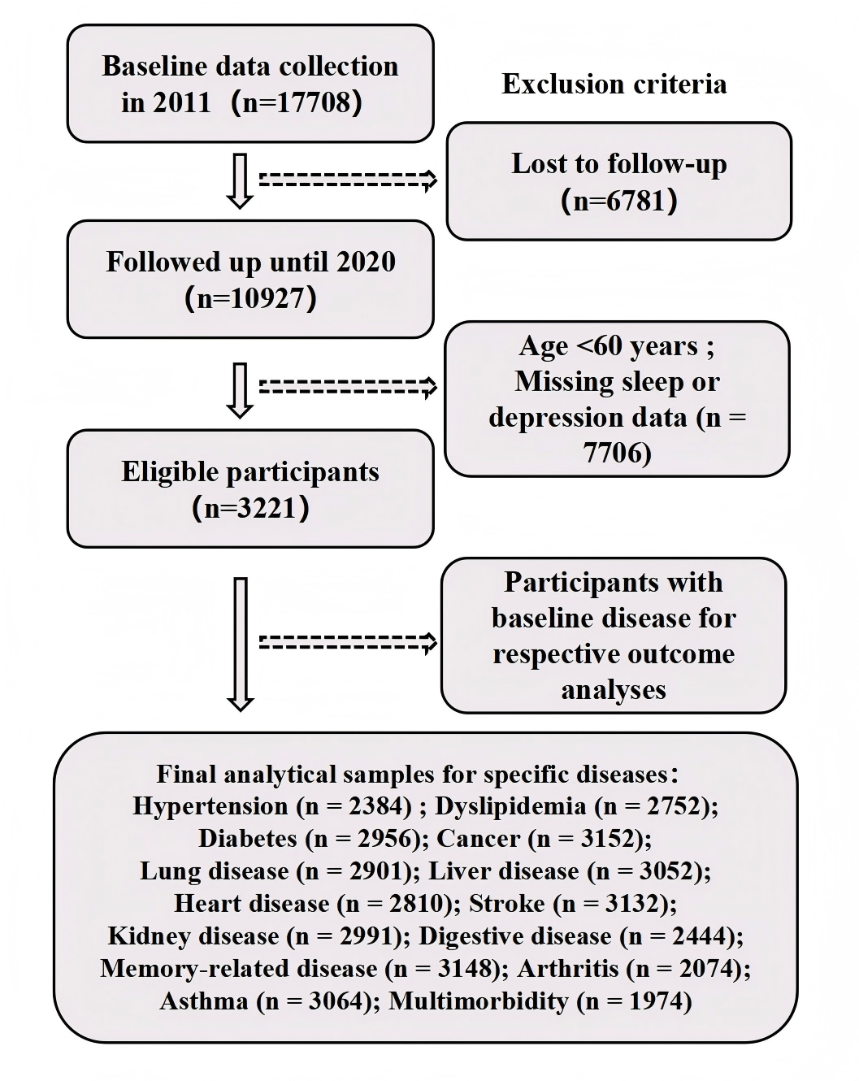

Figure S1. Flow diagram for participants included in the study.

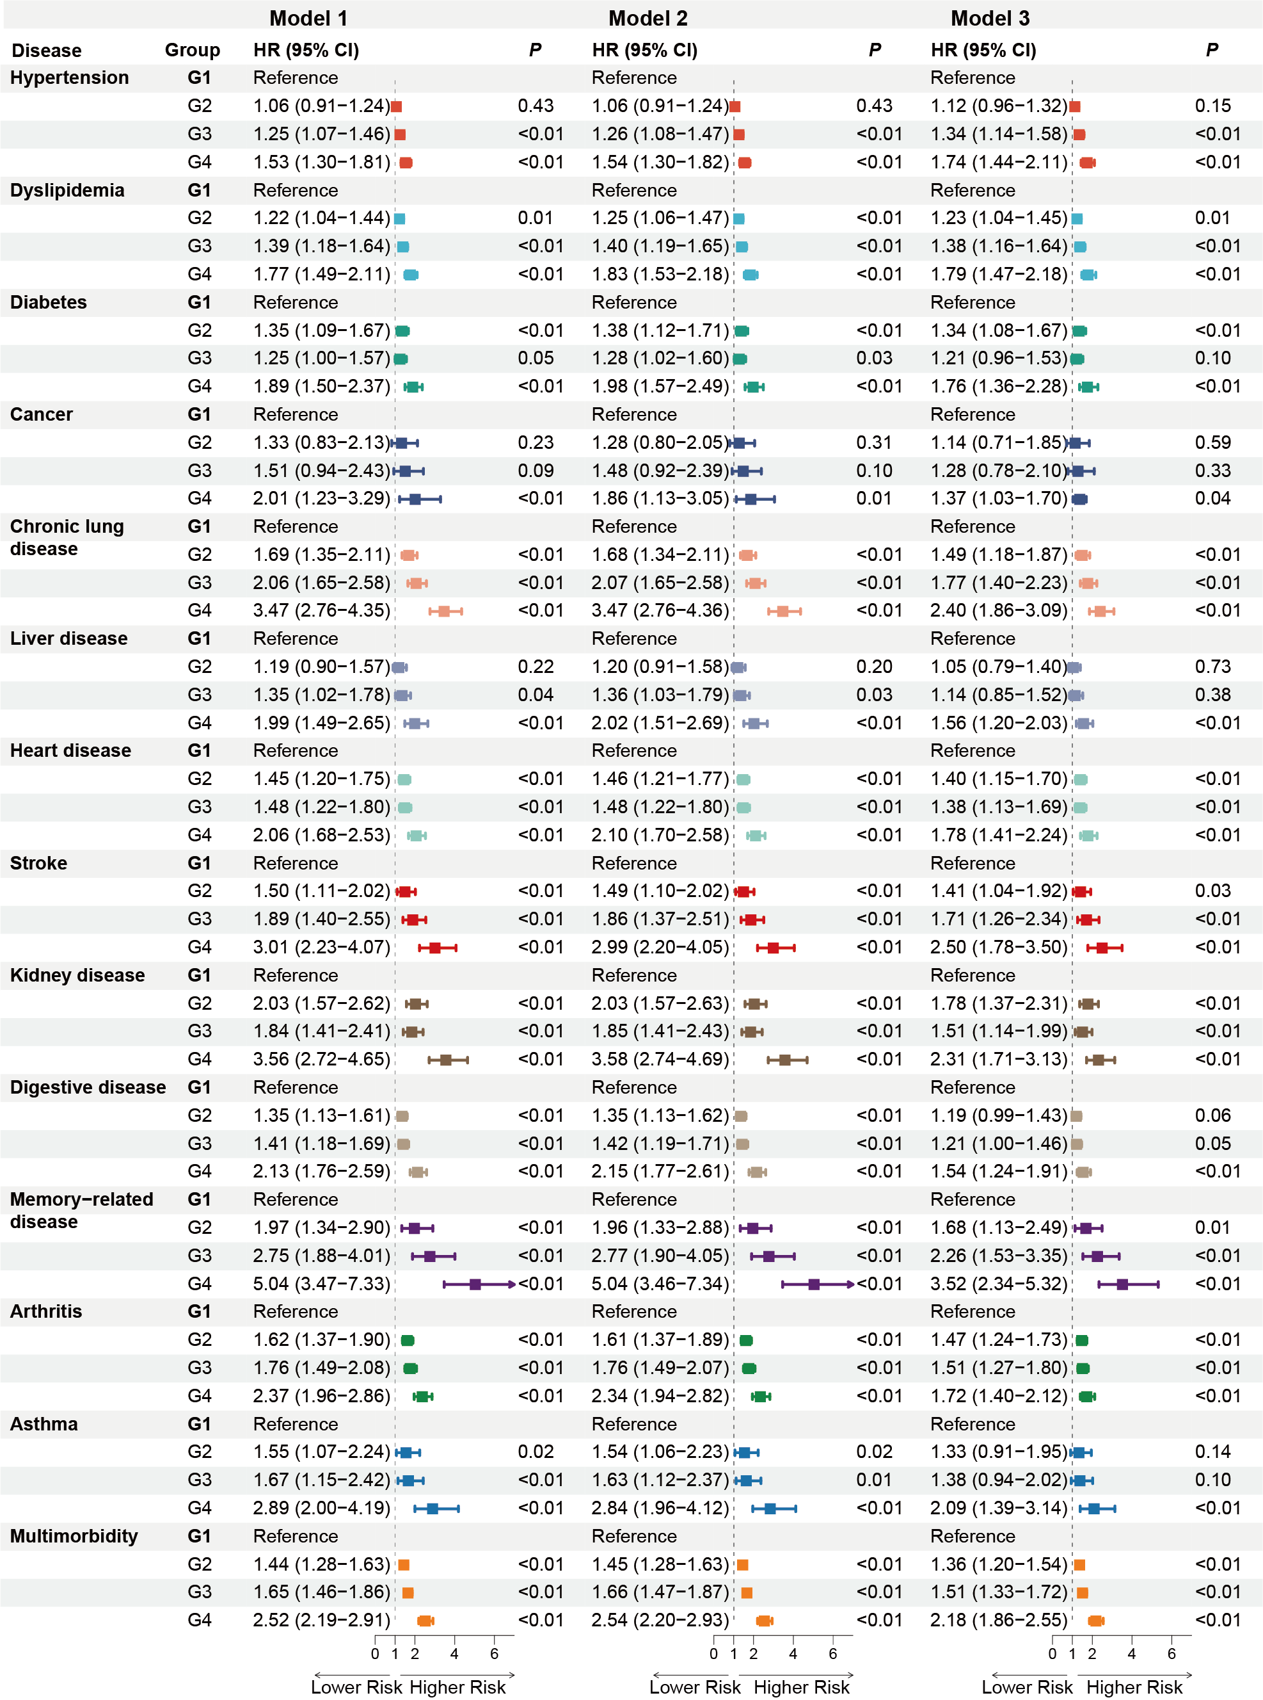

Figure S2. Forest plot of joint sleep–depression trajectories and risk of multiple incident chronic diseases and multimorbidity (unimputed data).

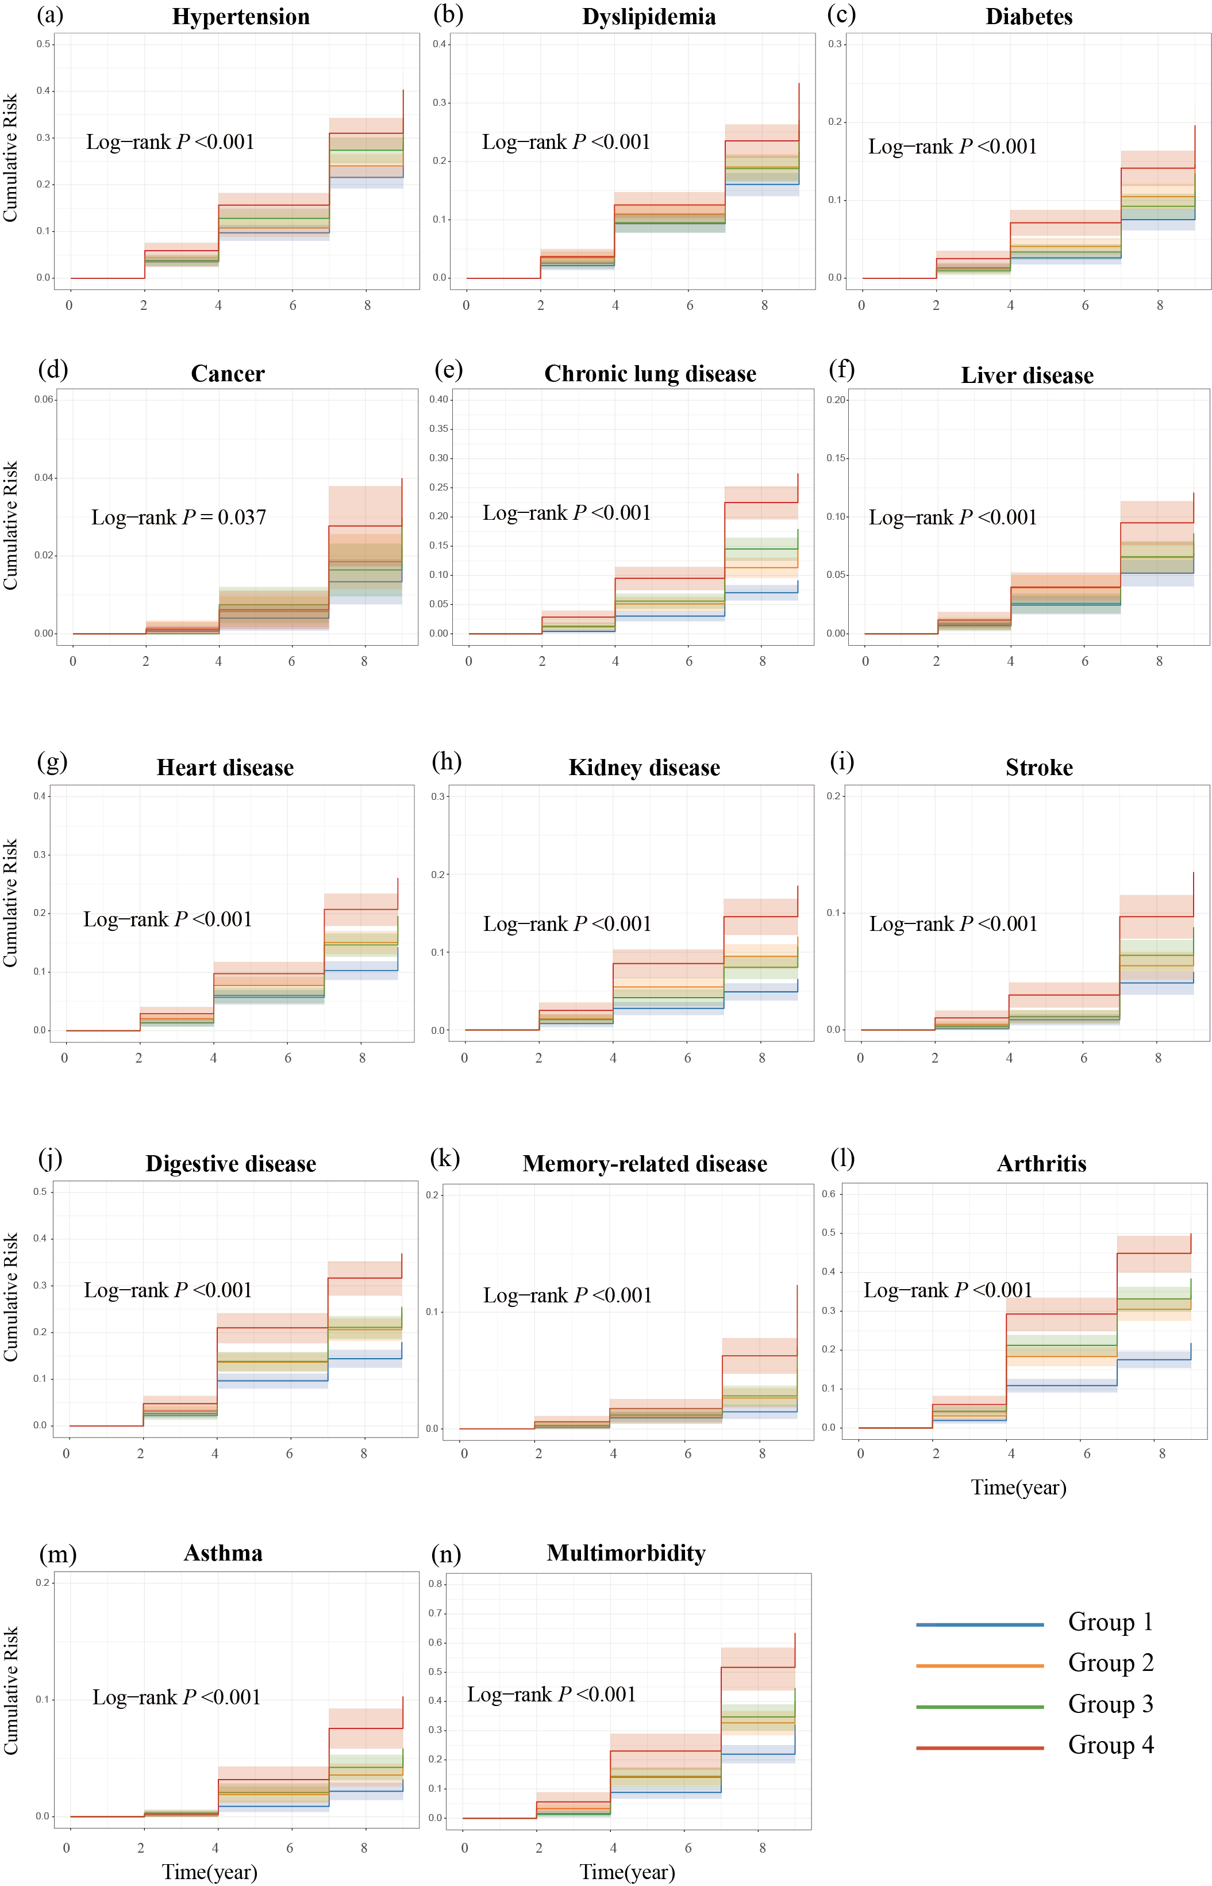
Figure S3. Kaplan–Meier cumulative incidence curves for chronic diseases and multimorbidity stratified by joint trajectory groups(unimputed data). (a–m) Cumulative incidence curves for the 13 specific chronic diseases; (n) cumulative incidence curve for multimorbidity.
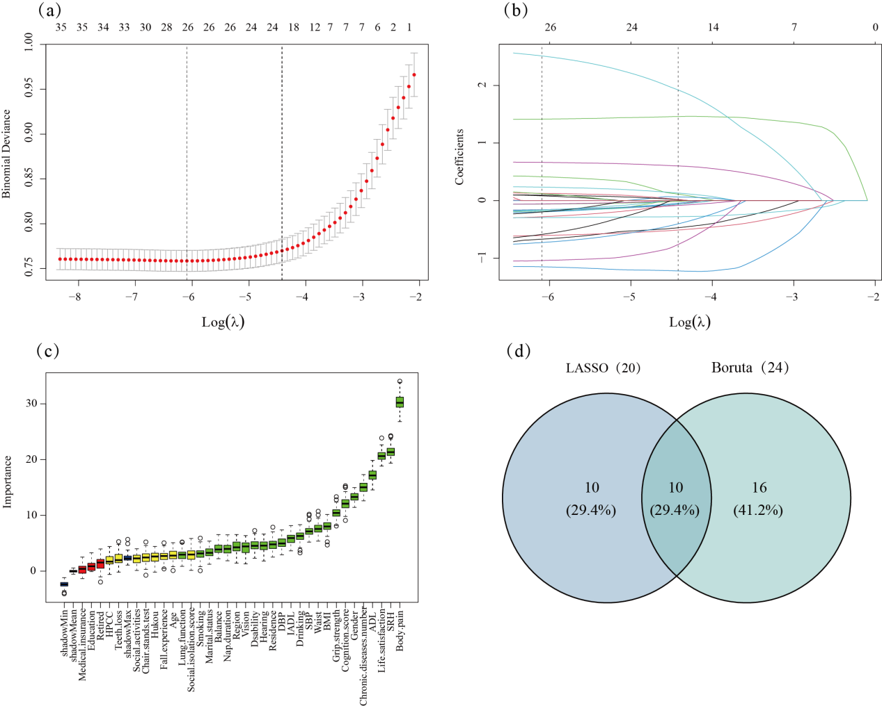
Figure S4. Feature selection results based on unimputed data. (a) LASSO parameter selection via cross-validation; (b) LASSO coefficient profiles: The left dashed line indicates the minimum error(λmin), while the right dashed line indicates the 1-standard-error rule(λ1se); (c) Feature importance ranking via the Boruta algorithm: green boxplots indicate confirmed important features, and blue boxplots represent shadow features; (d) Venn diagram illustrating the intersection of selected features.

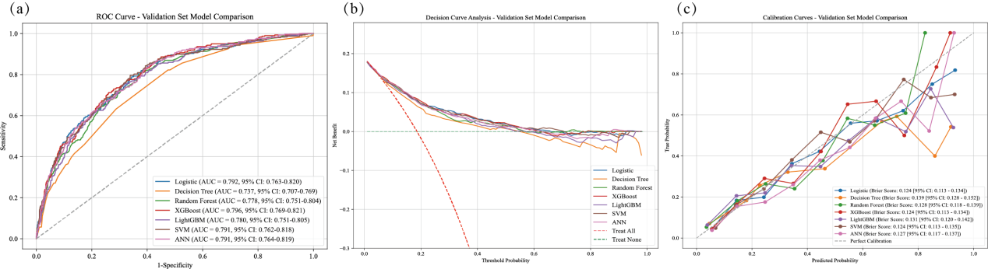

Figure S5. Comparative performance of seven predictive models using unimputed data. (a) ROC curves; (b) decision curve analysis (DCA); (c) calibration curves.

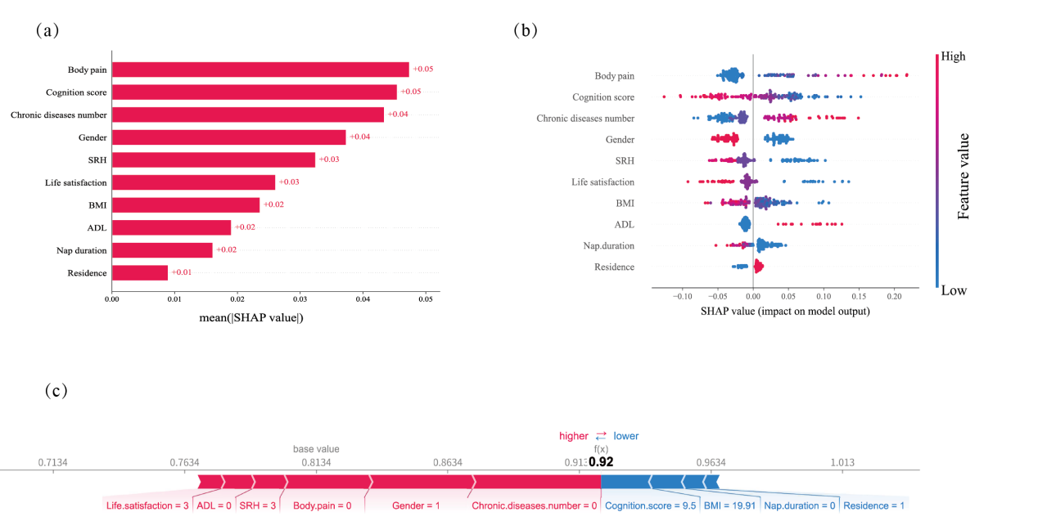

Figure S6. SHAP-based interpretability for the top-performing model (unimputed data). (a) Bar plot ranking features by mean absolute SHAP value; (b) SHAP beeswarm plot illustrating global feature importance and directional effects (red and blue dots indicate high and low feature values, respectively); (c) local interpretability analysis via a force plot for a representative individual case.

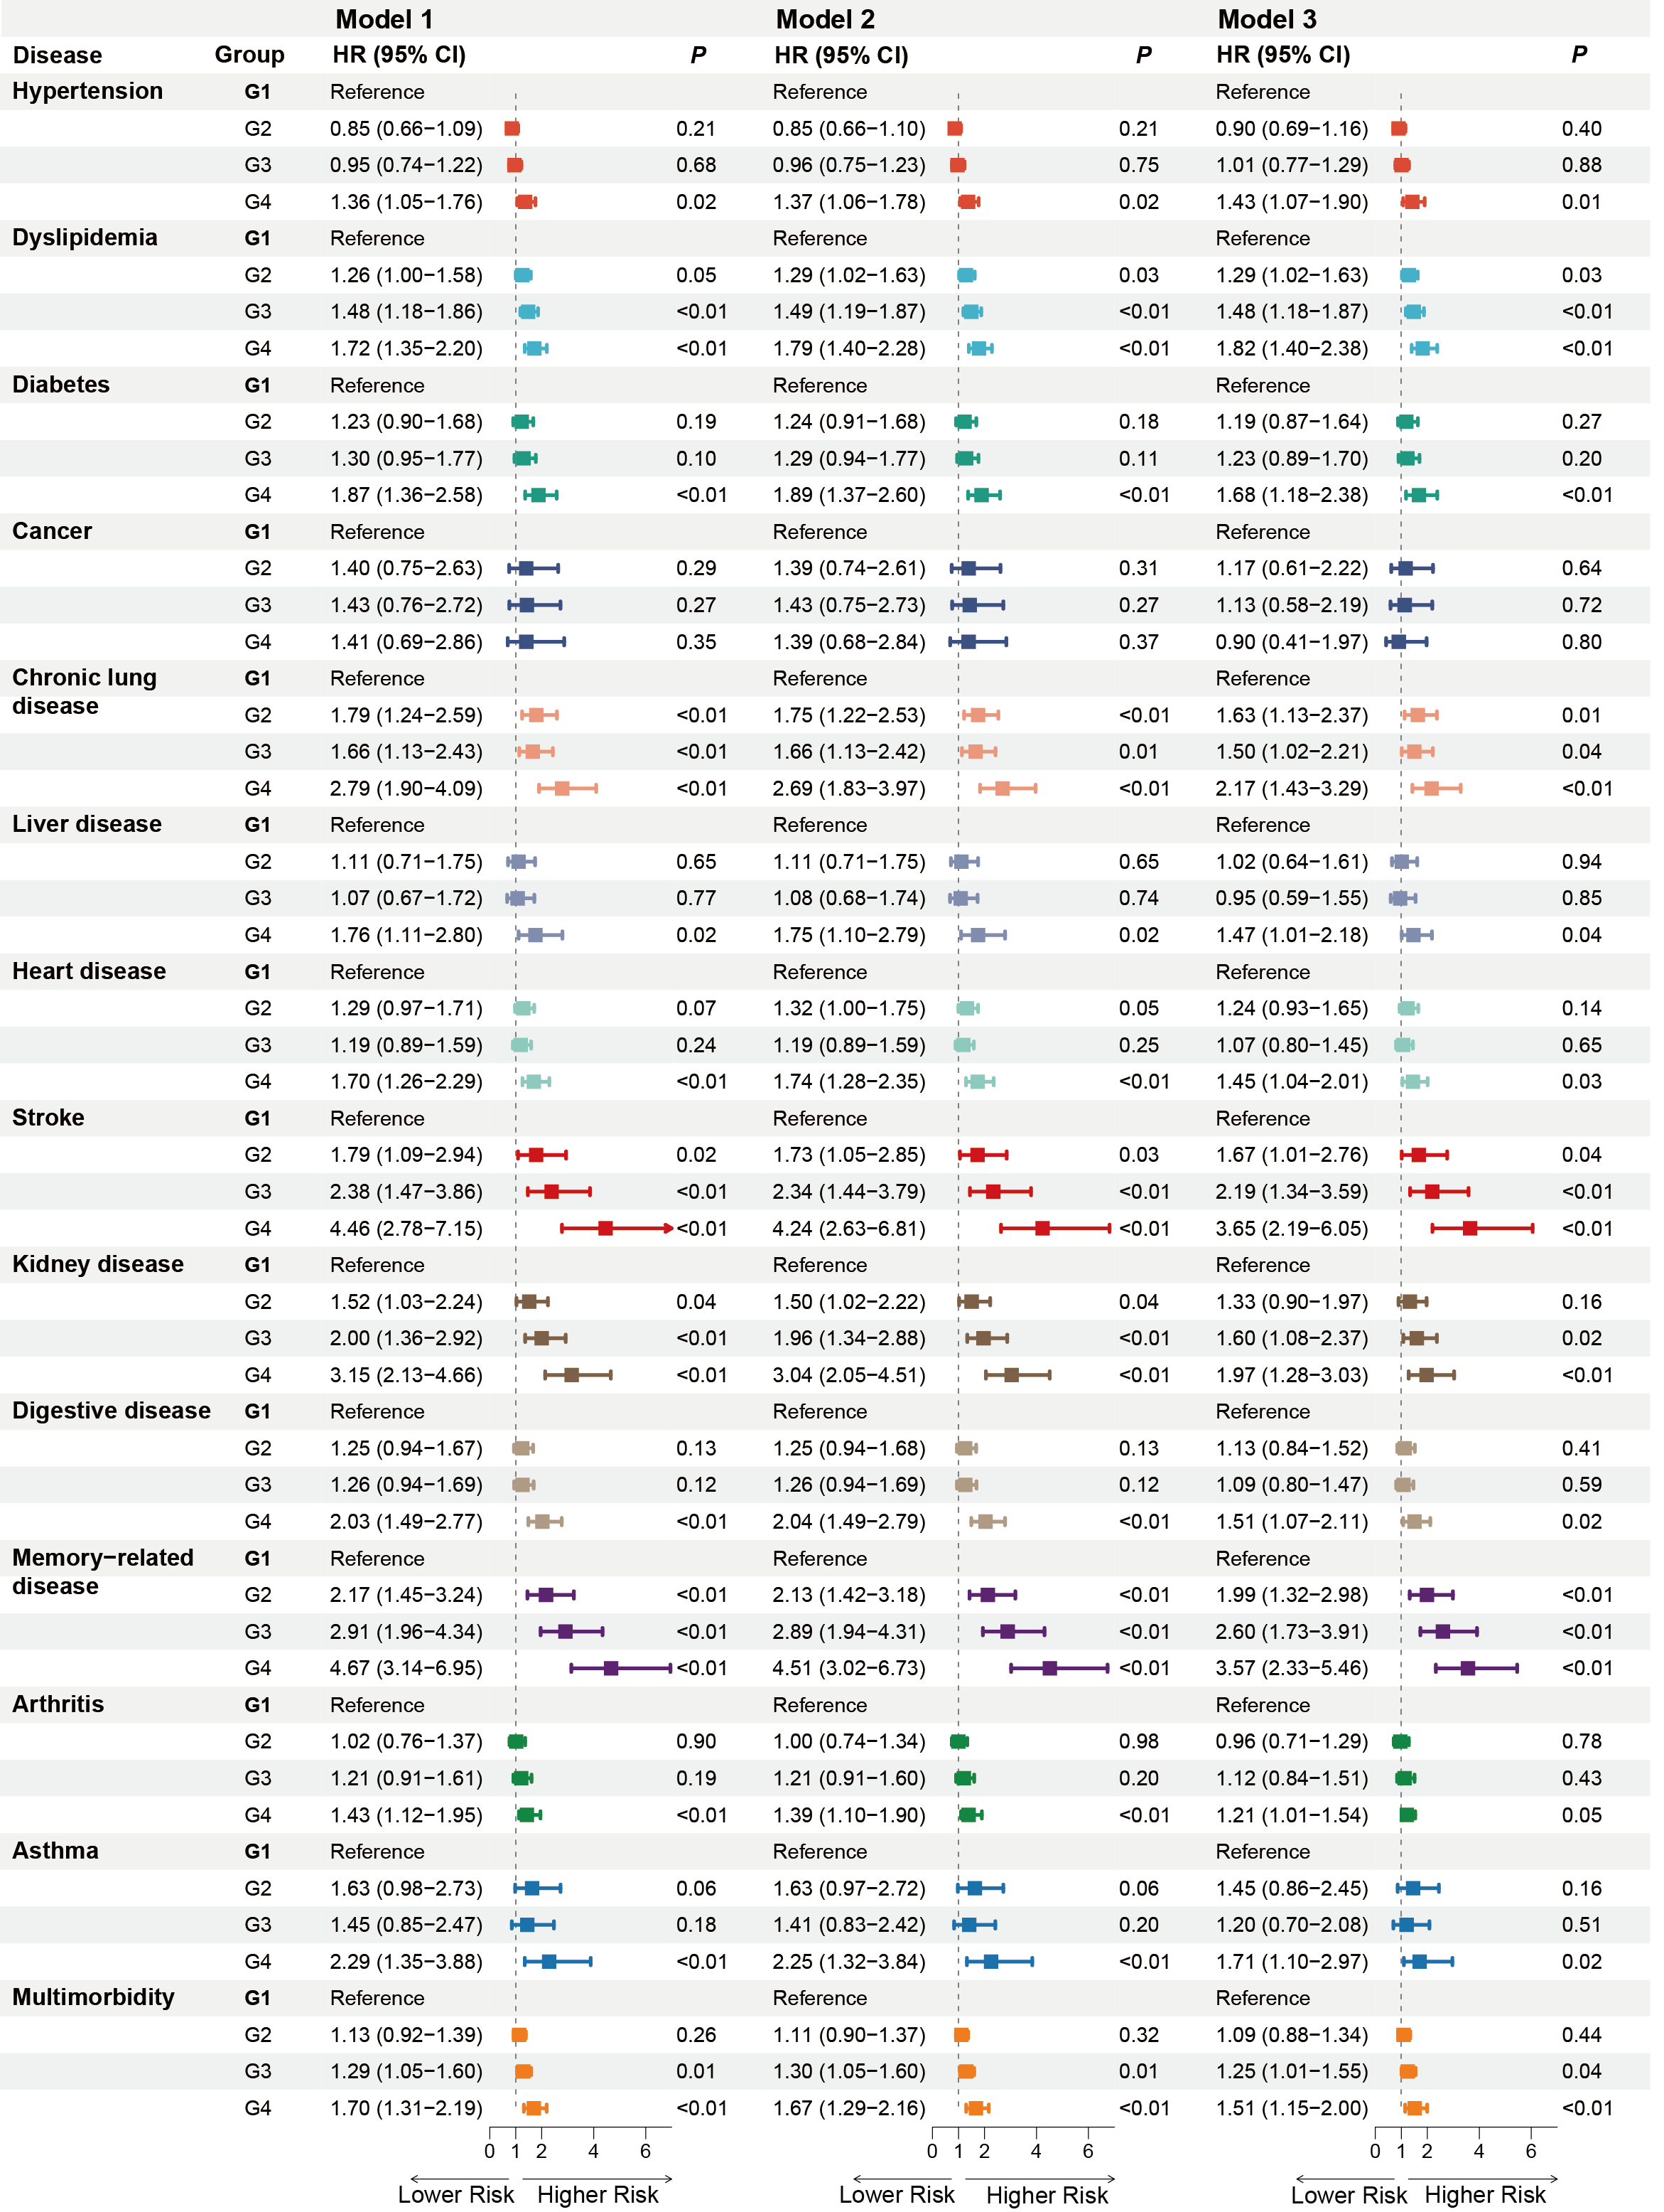
Figure S7. Forest plot of joint sleep–depression trajectories and risk of multiple incident chronic diseases and multimorbidity during the 2018–2020 follow-up period.

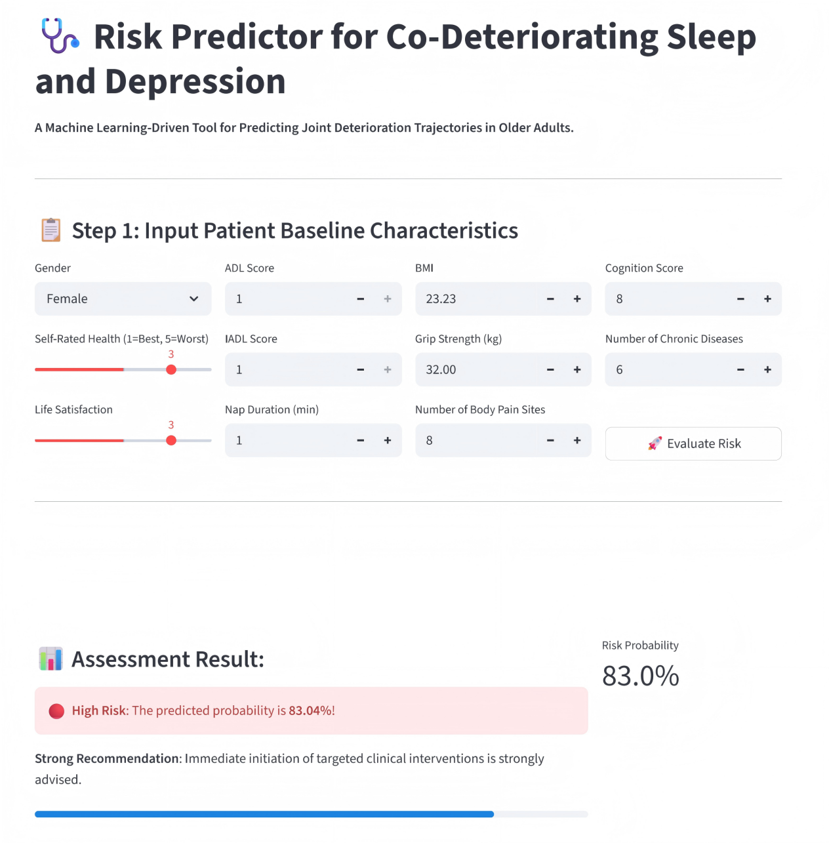
Figure S8. Web-based risk calculator for predicting membership in the high-risk joint sleep–depression trajectory.

