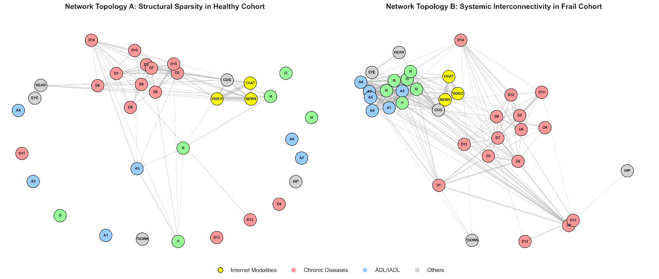
Figure S1. Network Topologies of Objective Health Indicators and Digital Modalities Stratified by Physical Cohorts
Notes: The figure illustrates the correlation networks of forty-two objective health indicators and three digital usage modalities across the healthy cohort (Topology A) and the frail cohort (Topology B). Nodes represent specific variables including chronic diseases (labeled D), activities of daily living (labeled A), instrumental activities of daily living (labeled I), other physical conditions, and digital modalities. Edges represent Pearson correlation coefficients between these variables. To ensure visual clarity, only absolute correlations exceeding the threshold of 0.05 are displayed. The thickness of each edge is strictly proportional to the absolute strength of the correlation. Both network visualizations were generated using a spring layout algorithm to map the systemic interconnectivity.

Table S1: Detailed definitions of the 42 indicators for objective health assessment
Domain | Variable Name | Definition / Measurement | Direction (Risk)
1. Physical Functioning | Running/Jogging | Difficulty with running or jogging about 1 km (Recoded: 1=Difficulty, 0=No difficulty) | (-)
(9 Indicators) | Walking 1km | Difficulty with walking 1 km (Recoded: 1=Difficulty, 0=No difficulty) | (-)
 | Walking 100m | Difficulty with walking 100 meters (Recoded: 1=Difficulty, 0=No difficulty) | (-)
 | Chair Rise | Difficulty getting up from a chair after sitting for a long period (Recoded: 1=Difficulty, 0=No difficulty) | (-)
 | Climbing Stairs | Difficulty climbing several flights of stairs without resting (Recoded: 1=Difficulty, 0=No difficulty) | (-)
 | Stooping/Kneeling | Difficulty with stooping, kneeling, or crouching (Recoded: 1=Difficulty, 0=No difficulty) | (-)
 | Reaching Arms | Difficulty reaching or extending arms above shoulder level (Recoded: 1=Difficulty, 0=No difficulty) | (-)
 | Lifting Weights | Difficulty lifting or carrying weights over 10 jin (approx. 5kg) (Recoded: 1=Difficulty, 0=No difficulty) | (-)
 | Picking up Coin | Difficulty picking up a small coin from a table (Recoded: 1=Difficulty, 0=No difficulty) | (-)
2. ADL (Activities of Daily Living) | Dressing | Difficulty dressing oneself (taking clothes out, putting on, fastening) (1=Yes, 0=No) | (-)
(6 Indicators) | Bathing | Difficulty bathing or showering (1=Yes, 0=No) | (-)
 | Eating | Difficulty eating (cutting food, feeding oneself) (1=Yes, 0=No) | (-)
 | Bed Transfer | Difficulty getting into or out of bed (1=Yes, 0=No) | (-)
 | Toileting | Difficulty using the toilet (getting up/down) (1=Yes, 0=No) | (-)
 | Continence | Difficulty controlling urination and defecation (1=Yes, 0=No) | (-)
3. IADL (Instrumental ADL) | Household Chores | Difficulty doing chores (cleaning, dishes, bed-making) (1=Yes, 0=No) | (-)
(6 Indicators) | Preparing Meals | Difficulty preparing hot meals (1=Yes, 0=No) | (-)
 | Shopping | Difficulty shopping for groceries (deciding and paying) (1=Yes, 0=No) | (-)
 | Managing Money | Difficulty paying bills, tracking expenses, or managing assets (1=Yes, 0=No) | (-)
 | Taking Medications | Difficulty taking the right portion of medication on time (1=Yes, 0=No) | (-)
 | Phone Calls | Difficulty making phone calls (1=Yes, 0=No) | (-)
4. Chronic Diseases | Hypertension | Diagnosed with Hypertension by a doctor (1=Yes, 0=No) | (-)
(14 Indicators) | Dyslipidemia | Diagnosed with Dyslipidemia (high cholesterol/lipids) (1=Yes, 0=No) | (-)
 | Diabetes | Diagnosed with Diabetes or high blood sugar (1=Yes, 0=No) | (-)
 | Cancer | Diagnosed with Cancer or malignant tumor (excl. minor skin cancer) (1=Yes, 0=No) | (-)
 | Lung Disease | Diagnosed with Chronic lung diseases (e.g., bronchitis, emphysema) (1=Yes, 0=No) | (-)
 | Liver Disease | Diagnosed with Liver disease (excl. fatty liver, tumors) (1=Yes, 0=No) | (-)
 | Heart Disease | Diagnosed with Heart attack, coronary heart disease, angina, etc. (1=Yes, 0=No) | (-)
 | Stroke | Diagnosed with Stroke (1=Yes, 0=No) | (-)
 | Kidney Disease | Diagnosed with Kidney disease (excl. tumors) (1=Yes, 0=No) | (-)
 | Digestive Disease | Diagnosed with Stomach or other digestive diseases (1=Yes, 0=No) | (-)
 | Psychiatric Problems | Diagnosed with Emotional, nervous, or psychiatric problems (1=Yes, 0=No) | (-)
 | Memory Disease | Diagnosed with Memory-related disease (e.g., dementia, Parkinson’s) (1=Yes, 0=No) | (-)
 | Arthritis | Diagnosed with Arthritis or rheumatism (1=Yes, 0=No) | (-)
 | Asthma | Diagnosed with Asthma (1=Yes, 0=No) | (-)
5. Health Behaviors | Smoking Status | Currently has the habit of smoking (1=Current smoker, 0=Quit/Never) | (-)
(2 Indicators) | Drinking Frequency | Drinking alcoholic beverages at least once a month in the past year (1=Yes, 0=No) | (-)
6. Geriatric Syndromes & Sensory | History of Falls | Have fallen down (1=Yes, 0=No) | (-)
(4 Indicators) | Hip Fracture | Have ever fractured hip (1=Yes, 0=No) | (-)
 | Vision Impairment | Interviewer observation: Poor eyesight (1=Yes, 0=No) | (-)
 | Hearing Impairment | Interviewer observation: Poor hearing without hearing-aid (1=Yes, 0=No) | (-)
7. Cognitive Function | Global Cognition | Composite score (0-31) summing: Time orientation (0-5), Calculation (0-5), Drawing (0-1), Immediate recall (0-10), Delayed recall (0-10). Note: Lower scores indicate worse cognitive function. | (+) *

