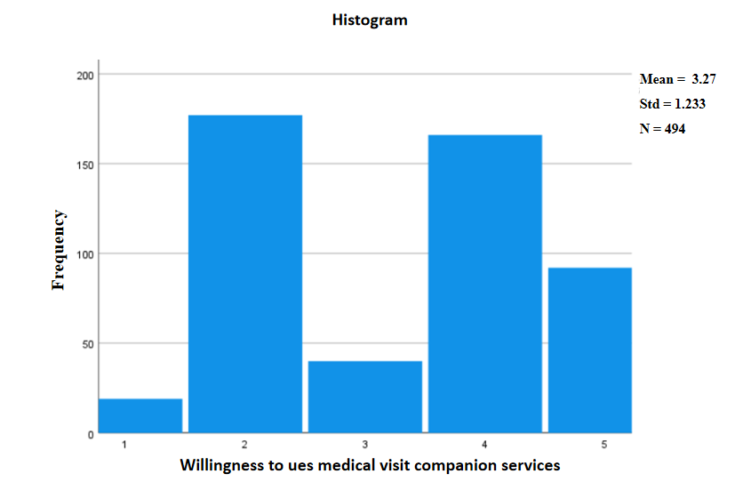
Supplementary Figure 1 Histogram of older adults’ willingness to use medical visit companion services.

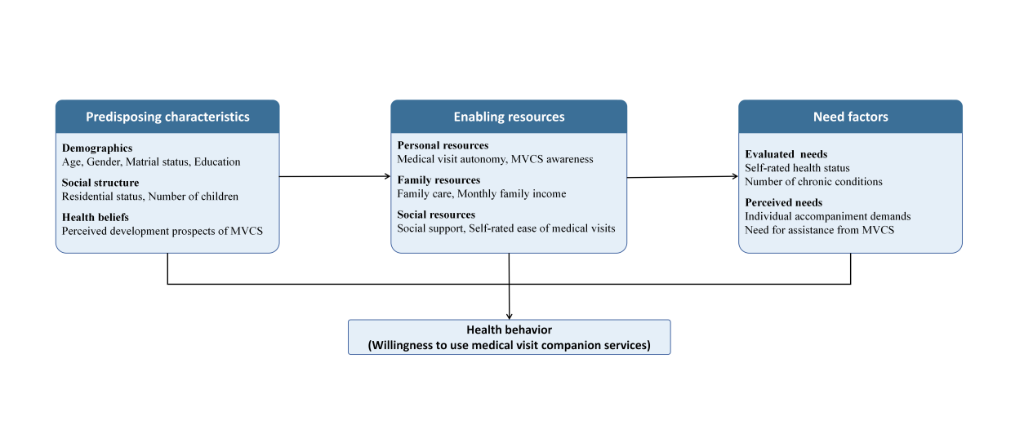
Supplementary Figure 2 Conceptual framework of willingness to use medical visit companion services based on the Andersen health behavior model.
Supplementary Table 1 Specific needs for assistance from medical visit companion services among participants (n=494).
Variables | Need (%) | Mean ± SD | Rank
Post-service evaluation of service quality | 388 (78.54) | 4.15±0.93 | 1
Auxiliary guidance during medical examinations | 409 (82.79) | 4.12±1.01 | 2
Medical appointment scheduling | 365 (73.89) | 3.90±1.22 | 3
Taking medicines in the hospital | 361 (73.08) | 3.90±1.13 | 4
Accompaniment during medical visits | 349 (70.65) | 3.89±1.15 | 5
Assistance in emotional regulation | 360 (72.87) | 3.88±1.06 | 6
Hospital selection tailored to the patient's condition | 337 (68.22) | 3.79±1.23 | 7
Instructions on the utilization of MVCS | 343 (69.43) | 3.79±1.19 | 8
Mastery of disease management information | 348 (70.45) | 3.78±1.10 | 9
Assistance in communication with medical professionals | 337 (68.22) | 3.76±1.21 | 10
Guidance for patients on rational medication use | 338 (68.42) | 3.71±1.29 | 11
Picking up and dropping off patients | 302 (61.13) | 3.66±1.31 | 12
Scheduling of medical visit timing | 294 (59.51) | 3.48±1.28 | 13
Physician-ordered prescription delivery services | 244 (49.39) | 3.31±1.28 | 14
Assistance in accessing telehealth services | 247 (50.00) | 3.23±1.38 | 15
Total score |  | 56.36±12.13
Note: “Need” refers to respondents who selected “Strongly demand” or “Demand”.

Supplementary Table 2 Multicollinearity diagnostics for the multivariable Model.
Variable | VIF
Age | 1.156
Education | 1.138
Number of children | 1.189
Self-rated ease of medical visits | 1.100
MVCS awareness | 1.210
Social support | 1.078
Medical visit autonomy | 1.120
Individualized accompaniment  demands | 1.313
Self-rated health status | 1.195
Need for assistance from MVCS | 1.263

Supplementary Table 3 Categorical variables assignment method.
Factor | Variable | Treatment in Model | Assignment and coding
Outcome | Willingness to use MVCS | Ordinal | Very unwilling = 1, Unwilling = 2, Fair = 3, Willing = 4, Very willing = 5
Predisposing characteristics | Age | Categorical | 60-69 = 0 (Ref), 70-79 = 1, 80 = 2
Predisposing characteristics | Education | Categorical | Primary or below = 0 (Ref), Secondary = 1, High school = 2, Junior college = 3, Higher education = 4
 | Number of children | Categorical | 1 = 0 (Ref); 0 = 1; 2 = 2; ≥3 = 3
Enabling resources | Self-rated ease of medical visits | Continuous score | Very good = 5, Good = 4, Fair = 3, Poor = 2, Very poor = 1
 | MVCS awareness | Continuous score | Very clear = 5, Clear = 4, Fair = 3, Completely unclear = 2, Unclear = 1
 | Social support | Continuous score | Total score of the social support rating scale (ranging from 12 to 66)
 | Medical visit autonomy | Binary | Non-independent medical visits = 0 (Ref), Independent medical visits = 1
Enabling resources | Individualized accompaniment  demands | Continuous score | Strongly demand = 5, Demand = 4, Fair = 3, No demand = 2, Strongly no demand =1
 | Self-rated health status | Continuous score | Very good = 5, Good = 4, Fair = 3, Poor = 2, Very poor = 1
 | Need for assistance from MVCS | Continuous score | Total score of the need for assistance from MVCS questionnaire (ranging from 15 to 75)

Supplementary Table 4 Cumulative odds model of factors associated with older adults’ willingness to use medical visit companion services (n = 494).
Factor | Variable | B | SE | Wald | p-value |  | OR |  | 95% CI
Predisposing characteristics | Age (Control group：60-69）
Predisposing characteristics | 70-79 | -1.124 | 0.333 | 11.436 | 0.030 | 0.653 |  | 0.444~0.960
Predisposing characteristics | ≥80 | -0.426 | 0.197 | 4.696 | <0.001 | 0.325 |  | 0.169~0.623
Predisposing characteristics | Education (Control group: Primary school or below）
Predisposing characteristics | Secondary school | 0.253 | 0.212 | 1.426 | 0.232 | 1.288 |  | 0.850~1.950
Predisposing characteristics | High school | 1.279 | 0.282 | 20.551 | <0.001 | 3.592 |  | 2.066~6.243
Predisposing characteristics | Junior college | 0.067 | 0.381 | 0.031 | 0.861 | 1.069 |  | 0.507~2.253
Predisposing characteristics | Higher education | 0.124 | 0.542 | 0.052 | 0.819 | 1.132 |  | 0.392~3.273
Predisposing characteristics | Number of children (Control group： 1）
 | 0 | -0.788 | 0.766 | 1.058 | 0.304 | 0.455 |  | 0.101~2.041
 | 2 | -0.808 | 0.206 | 15.460 | <0.001 | 0.446 |  | 0.298~0.667
 | ≥3 | -1.103 | 0.282 | 15.242 | <0.001 | 0.332 |  | 0.191~0.577
Enabling resources | Self-rated ease of medical visits | -0.341 | 0.089 | 14.857 | <0.001 | 0.711 |  | 0.598~0.846
Enabling resources | MVCS awareness | 0.296 | 0.091 | 10.613 | 0.001 | 1.345 |  | 1.125~1.608
Enabling resources | Social support | -0.070 | 0.016 | 18.038 | <0.001 | 0.933 |  | 0.903~0.963
 | Medical visit autonomy（Control group: Non-independent medical visits)
 |  | -0.436 | 0.185 | 5.563 | 0.018 | 0.646 |  | 0.450~0.929
Need factors | Individualized accompaniment  demands | 0.349 | 0.114 | 9.338 | 0.002 | 1.418 |  | 1.133~1.774
 | Self-rated health status | -0.478 | 0.098 | 24.045 | <0.001 | 0.620 |  | 0.512~0.750
 | Need for assistance from MVCS | 0.042 | 0.009 | 23.551 | <0.001 | 1.043 |  | 1.025~1.061
Note: χ²(df) = 230.827(16), p < 0.001 Nagelkerke R² = 0.399, Cox＆Snell R² = 0.373.

Supplementary Table 5 Definitions and classifications of determinants affecting older adults’ willingness to use medical visit companion services.
Factor | Variable | Notation
Predisposing characteristics | Age | B01
Predisposing characteristics | Education | B02
Predisposing characteristics | Number of children | B03
Enabling resources | Self-rated ease of medical visits | B04
Enabling resources | MVCS awareness | B05
Enabling resources | Social support | B06
Enabling resources | Medical visit autonomy | B07
Need factors | Individualized accompaniment demands | B08
Need factors | Self-rated health status | B09
Need factors | Need for assistance from MVCS | B10

Supplementary Table 6 Adjacency matrix of influencing factors for older adults’ willingness to use medical visit companion services.
 | B01 | B02 | B03 | B04 | B05 | B6 | B07 | B08 | B09 | B10
B01 | 0 | 0 | 0 | 1 | 1 | 0 | 1 | 1 | 1 | 1
B02 | 0 | 0 | 0 | 1 | 1 | 0 | 1 | 0 | 1 | 1
B03 | 0 | 0 | 0 | 0 | 0 | 1 | 0 | 0 | 1 | 1
B04 | 0 | 0 | 0 | 0 | 0 | 0 | 0 | 0 | 1 | 1
B05 | 0 | 0 | 0 | 0 | 0 | 0 | 1 | 0 | 1 | 1
B06 | 0 | 0 | 0 | 0 | 1 | 0 | 1 | 0 | 1 | 1
B07 | 0 | 0 | 0 | 0 | 1 | 0 | 0 | 0 | 1 | 1
B08 | 0 | 0 | 0 | 0 | 1 | 0 | 1 | 0 | 1 | 1
B09 | 0 | 0 | 0 | 0 | 0 | 0 | 0 | 0 | 0 | 1
B10 | 0 | 0 | 0 | 0 | 0 | 0 | 0 | 0 | 1 | 0

Supplementary Table 7 Reachability matrix of influencing factors for older adults’ willingness to use medical visit companion services.
 | B01 | B02 | B03 | B04 | B05 | B6 | B07 | B08 | B09 | B10
B01 | 1 | 0 | 0 | 1 | 1 | 0 | 1 | 1 | 1 | 1
B02 | 0 | 1 | 0 | 1 | 1 | 0 | 1 | 0 | 1 | 1
B03 | 0 | 0 | 1 | 0 | 1 | 1 | 1 | 0 | 1 | 1
B04 | 0 | 0 | 0 | 1 | 0 | 0 | 0 | 0 | 1 | 1
B05 | 0 | 0 | 0 | 0 | 1 | 0 | 1 | 0 | 1 | 1
B06 | 0 | 0 | 0 | 0 | 1 | 1 | 1 | 0 | 1 | 1
B07 | 0 | 0 | 0 | 0 | 1 | 0 | 1 | 0 | 1 | 1
B08 | 0 | 0 | 0 | 0 | 1 | 0 | 1 | 1 | 1 | 1
B09 | 0 | 0 | 0 | 0 | 0 | 0 | 0 | 0 | 1 | 1
B10 | 0 | 0 | 0 | 0 | 0 | 0 | 0 | 0 | 1 | 1

Supplementary Table 8 Reachability sets, antecedent sets, and their intersections for the influencing factors.
 | Reachability set | Antecedent set | Intersection
B01 | 1,4,5,7,8,9,10 | 1 | 1
B02 | 2,4,5,7,9,10 | 2 | 2
B03 | 3,5,6,7,9,10 | 3 | 3
B06 | 5,6,7,9,10 | 3,6 | 6
B08 | 5,7,8,9,10 | 1.8 | 8
B04 | 4,9,10 | 1,2,4 | 4
B05 | 5,7,9,10 | 1,2,3,5,6,7,8 | 5,7
B07 | 5,7,9,10 | 1,2,3,5,6,7,8 | 5,7
B09 | 9,10 | 1,2,3,4,5,6,7,8,9,10 | 9,10
B10 | 9,10 | 1,2,3,4,5,6,7,8,9,10 | 9,10

