Table of Contents
Supplementary document Retrieval Strategy 2
Variance Decomposition Plot 8
Sensitivity Analysis Plot 9
Trim-and-Fill Plot 10
Forest plot of the multilevel meta-analysis with small-sample corrected robust variance estimation 11
Posterior Optimal Dose Distribution Plot 11
Global Density Overlay (Observed yi vs. multiple yrep densities) 12
Interval Plot: Showing posterior predictive intervals for each observation and plotting observed values 13
ECDF Comparison 13
Full-text articles excluded after eligibility assessment and reasons for exclusion 13
Additional baseline and WBV intervention characteristics of the included studies 15
Inter-Rater Agreement Results for Each ROB2 Domain 18
Summary of Findings —GRADE 18
Subgroup Analysis of WBV on Dynamic Balance in Elderly Stroke Patients 19
Bayesian model specification and overall MCMC diagnostics 20
Parameter-level MCMC diagnostics 21
Dose–response model settings and posterior-derived dose estimates 22
Complete meta-regression results for potential moderators 23

Supplementary document Retrieval Strategy
The electronic literature search was conducted across multiple databases, including PubMed, Web of Science, PsycINFO, the Cochrane Library, and the CNKI International Version. The search covered all records from the inception of these databases up to December 26, 2025. Only studies published in English or Chinese were eligible for inclusion. Unpublished grey literature, non-original studies, review articles, case reports, comments, and editorials were systematically excluded. Where applicable, database filters were used to apply restrictions on publication type, language, and date during the search; otherwise, these restrictions were enforced during the title/abstract or full-text screening phases.

1. PubMed
Database: PubMed
Search date: December 26, 2025
Date range: From database inception to December 26, 2025
Language restriction: English or Chinese
Publication-type restriction: Randomized controlled trials and clinical trials were targeted; reviews, case reports, comments, and editorials were excluded where possible.
Search string:
(
"Stroke"[Mesh] OR "Cerebrovascular Disorders"[Mesh] OR "Brain Ischemia"[Mesh] OR "Hemiplegia"[Mesh]
OR stroke[tiab] OR "cerebrovascular accident"[tiab] OR "cerebrovascular accidents"[tiab]
OR "brain ischemia"[tiab] OR hemiplegia[tiab] OR hemiplegic[tiab]
OR "cerebral infarction"[tiab] OR "brain attack"[tiab]
)
AND
(
"Vibration"[Mesh]
OR "whole body vibration"[tiab] OR "whole-body vibration"[tiab]
OR WBV[tiab] OR "vibration training"[tiab] OR "vibration therapy"[tiab]
)
AND
(
"Postural Balance"[Mesh]
OR balance[tiab] OR "postural balance"[tiab] OR "postural control"[tiab]
OR equilibrium[tiab] OR "postural stability"[tiab]
OR "Berg Balance Scale"[tiab] OR BBS[tiab]
OR "Sensory Organization Test"[tiab] OR SOT[tiab]
OR "Trunk Impairment Scale"[tiab] OR TIS[tiab]
OR "Limits of Stability"[tiab] OR LOS[tiab]
OR "Community Balance and Mobility Scale"[tiab] OR "CB&M"[tiab]
)
AND
(
"Randomized Controlled Trial"[Publication Type]
OR "Controlled Clinical Trial"[Publication Type]
OR randomized[tiab] OR randomised[tiab] OR randomization[tiab]
OR randomly[tiab] OR "random allocation"[tiab]
OR "clinical trial"[tiab] OR "control group"[tiab] OR RCT[tiab]
)
NOT
(
"Review"[Publication Type]
OR "Case Reports"[Publication Type]
OR "Comment"[Publication Type]
OR "Editorial"[Publication Type]
)
Filters applied:
Publication date: from database inception to December 26, 2025; language: English or Chinese.

2. Web of Science
Database: Web of Science Core Collection
Search date: December 26, 2025
Date range: From database inception to December 26, 2025
Language restriction: English or Chinese
Document-type restriction: Articles were targeted; reviews, editorial materials, letters, and other non-original records were excluded during screening.
Search string:
TS=(
(
stroke OR "cerebrovascular accident" OR "cerebrovascular accidents"
OR hemiplegia OR hemiplegic OR "brain ischemia"
OR "cerebral infarction" OR "brain attack"
)
AND
(
"whole body vibration" OR "whole-body vibration"
OR WBV OR "vibration training" OR "vibration therapy"
)
AND
(
balance OR "postural balance" OR "postural control"
OR equilibrium OR "postural stability"
OR "Berg Balance Scale" OR BBS
OR "Sensory Organization Test" OR SOT
OR "Trunk Impairment Scale" OR TIS
OR "Limits of Stability" OR LOS
OR "Community Balance and Mobility Scale" OR "CB&M"
)
AND
(
"randomized controlled trial" OR "randomised controlled trial"
OR randomized OR randomised OR randomization
OR randomly OR "random allocation"
OR RCT OR "clinical trial" OR "control group"
)
)
Filters applied:
Timespan: all years to December 26, 2025; language: English or Chinese; document type: Article.

3. PsycINFO
Database: PsycINFO
Search date: December 26, 2025
Date range: From database inception to December 26, 2025
Language restriction: English or Chinese
Document-type restriction: Peer-reviewed journal articles were targeted; reviews, case reports, editorials, comments, dissertations, and other non-original records were excluded where possible.
Search strategy:
1. exp Stroke/ OR exp Cerebrovascular Accident/ OR exp Hemiplegia/
OR (stroke OR "cerebrovascular accident" OR "cerebrovascular accidents"
OR hemiplegia OR hemiplegic OR "brain ischemia"
OR "cerebral infarction" OR "brain attack").ti,ab,id.
2. exp Vibration/ OR exp "Whole-Body Vibration"/
OR ("whole body vibration" OR "whole-body vibration"
OR WBV OR "vibration training" OR "vibration therapy").ti,ab,id.
3. exp Balance/ OR exp Postural Control/ OR exp Equilibrium/
OR (balance OR "postural balance" OR "postural control"
OR equilibrium OR "postural stability"
OR "Berg Balance Scale" OR BBS
OR "Sensory Organization Test" OR SOT
OR "Trunk Impairment Scale" OR TIS
OR "Limits of Stability" OR LOS
OR "Community Balance and Mobility Scale" OR "CB&M").ti,ab,id.
4. exp Randomized Controlled Trials/
OR (randomized OR randomised OR randomization
OR randomly OR "random allocation"
OR "control group" OR RCT OR "clinical trial").ti,ab,id.
5. 1 AND 2 AND 3 AND 4
6. Limit 5 to English or Chinese language.
7. Limit 6 to records published from database inception to December 26, 2025.
Filters applied:
Language: English or Chinese; publication date: from database inception to December 26, 2025; document type: peer-reviewed journal article where available.

4. Cochrane Library
Database: Cochrane Library
Search date: December 26, 2025
Date range: From database inception to December 26, 2025
Language restriction: English or Chinese
Record-type restriction: Trials were targeted. Reviews and protocols were not included in the quantitative synthesis.
Search strategy:
#1 [mh "Stroke"] OR [mh "Cerebrovascular Disorders"] OR [mh "Brain Ischemia"] OR [mh "Hemiplegia"]
OR (stroke OR "cerebrovascular accident" OR "cerebrovascular accidents"
OR hemiplegia OR hemiplegic OR "brain ischemia"
OR "cerebral infarction" OR "brain attack"):ti,ab,kw
#2 [mh "Vibration"]
OR ("whole body vibration" OR "whole-body vibration"
OR WBV OR "vibration training" OR "vibration therapy"):ti,ab,kw
#3 [mh "Postural Balance"]
OR (balance OR "postural balance" OR "postural control"
OR equilibrium OR "postural stability"
OR "Berg Balance Scale" OR BBS
OR "Sensory Organization Test" OR SOT
OR "Trunk Impairment Scale" OR TIS
OR "Limits of Stability" OR LOS
OR "Community Balance and Mobility Scale" OR "CB&M"):ti,ab,kw
#4 [mh "Randomized Controlled Trials"]
OR (randomized OR randomised OR randomization
OR randomly OR "random allocation"
OR "control group" OR RCT OR "clinical trial"):ti,ab,kw
#5 #1 AND #2 AND #3 AND #4
Filters applied:
Publication date: from database inception to December 26, 2025; language: English or Chinese where available; record type: trials.

5. CNKI International Version
Database: CNKI International Version
Search date: December 26, 2025
Date range: From database inception to December 26, 2025
Language restriction: Chinese or English
Document-type restriction: Journal articles were targeted; reviews, case reports, comments, editorials, and non-original studies were excluded during screening.
Search string:
SU=(全身振动 OR 全身振动训练 OR 全身震动 OR WBV OR 振动训练 OR 振动疗法)
AND
SU=(脑卒中 OR 中风 OR 脑血管意外 OR 偏瘫 OR 脑梗死)
AND
SU=(平衡 OR 姿势控制 OR 平衡能力 OR 姿势稳定性 OR Berg平衡量表 OR BBS)
AND
SU=(随机对照试验 OR 随机 OR 随机分组 OR 对照 OR RCT)
Filters applied:
Publication date: from database inception to December 26, 2025; language: Chinese or English; document type: journal article.

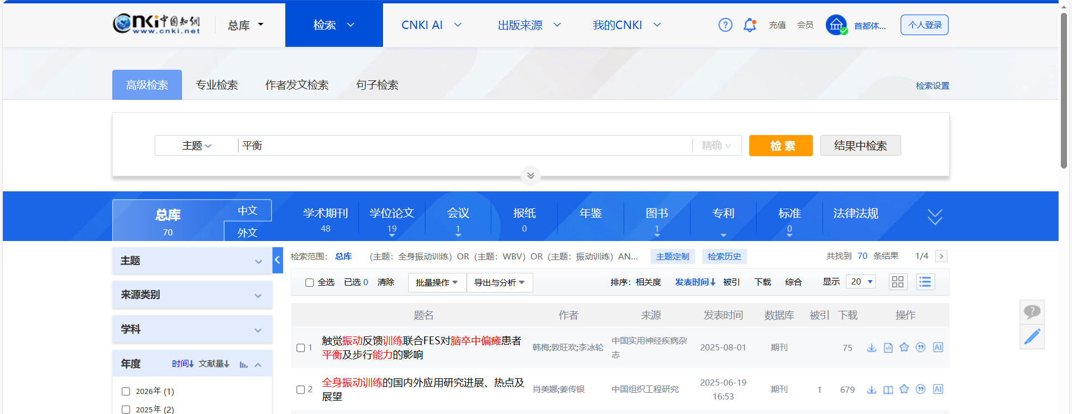

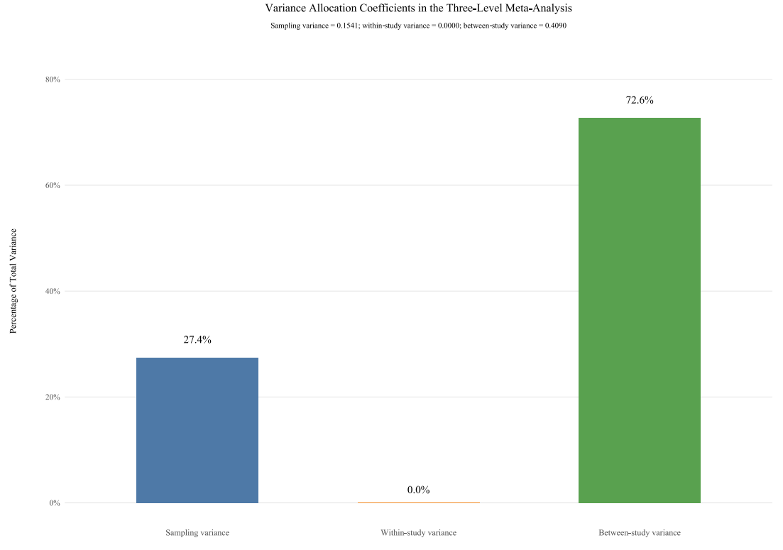

Variance Decomposition Plot
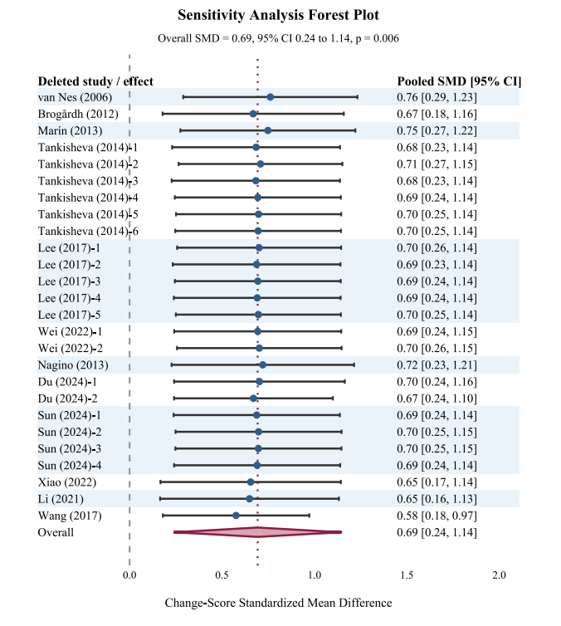

Sensitivity Analysis Plot

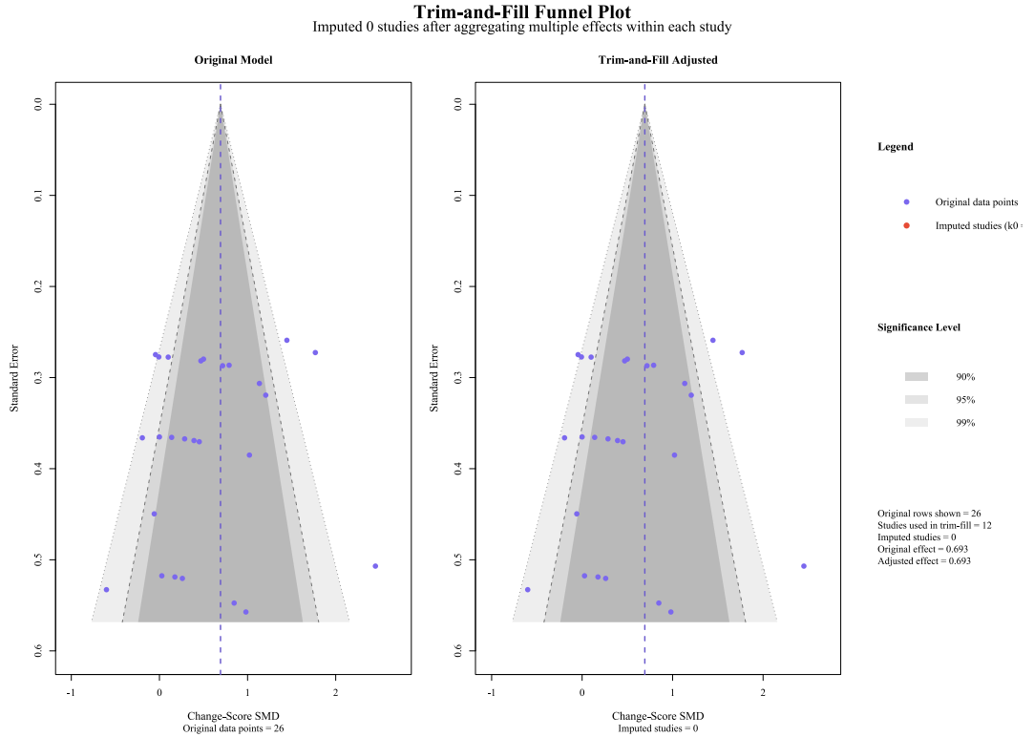

Trim-and-Fill Plot

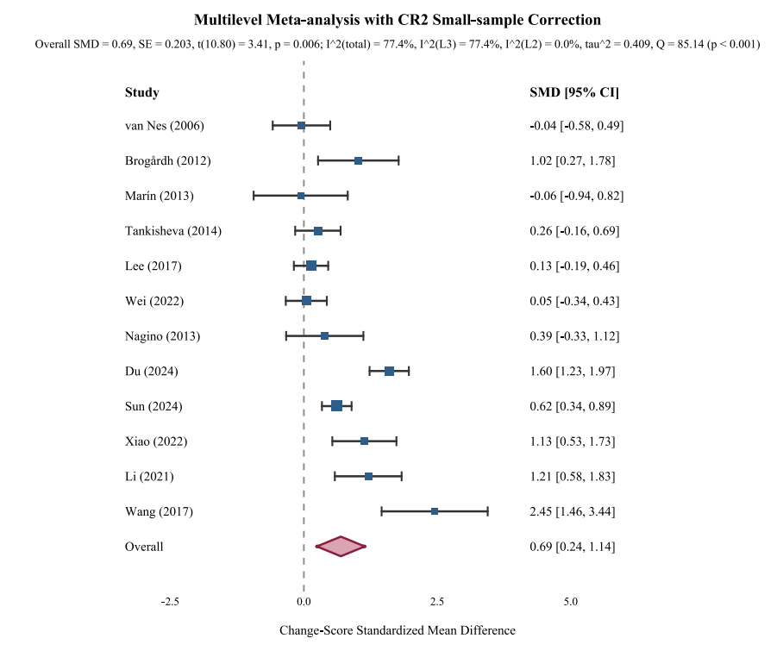

Forest plot of the multilevel meta-analysis with small-sample corrected robust variance estimation
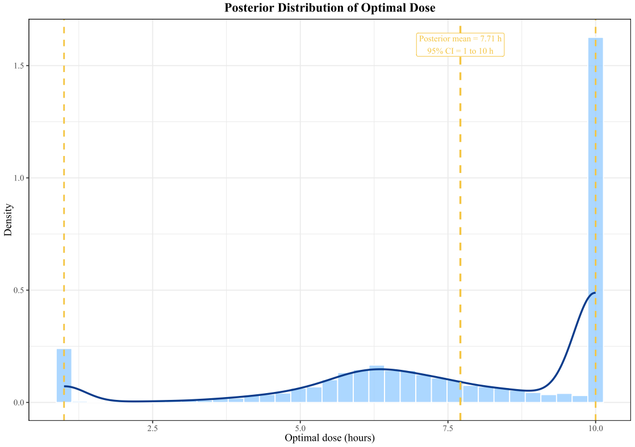

Posterior Optimal Dose Distribution Plot
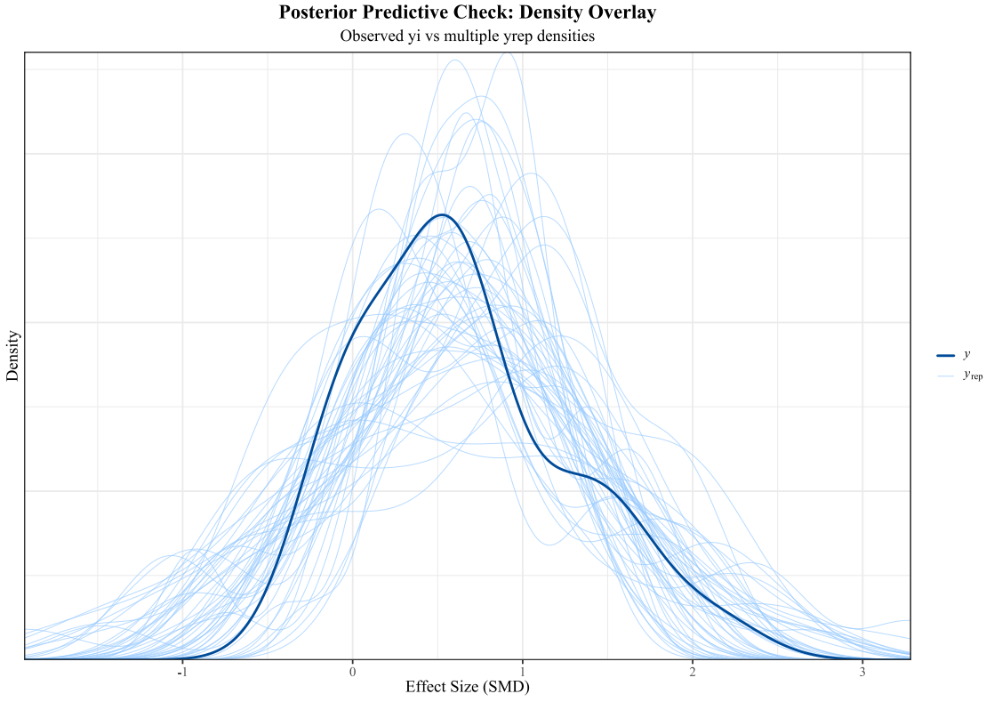

Global Density Overlay (Observed yi vs. multiple yrep densities)
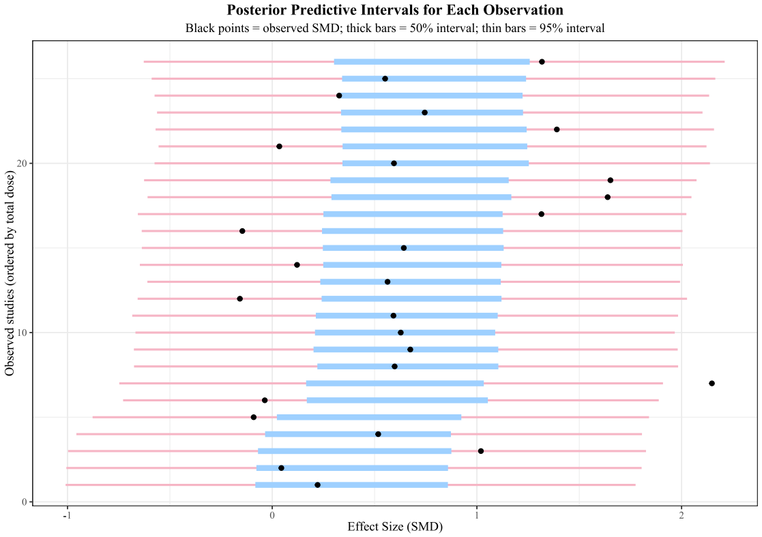

Interval Plot: Showing posterior predictive intervals for each observation and plotting observed values

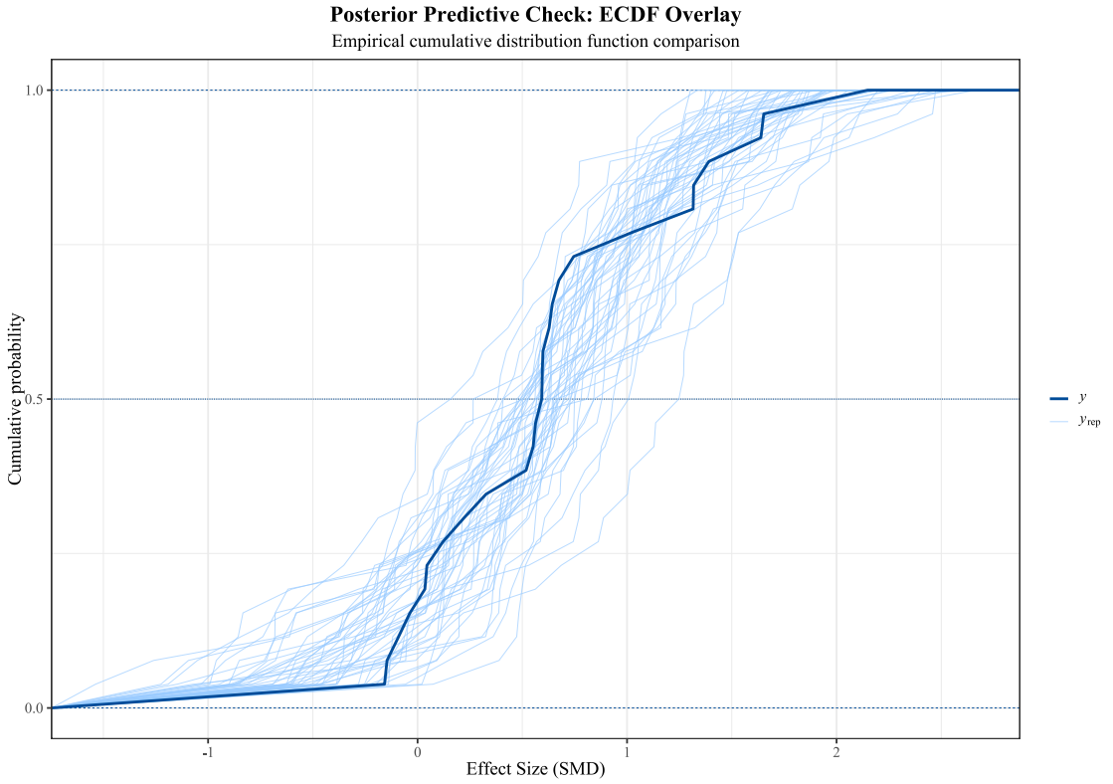

ECDF Comparison

Full-text articles excluded after eligibility assessment and reasons for exclusion
No. | Study | Title | Reason for exclusion | Specific explanation
1 | Yang et al., 2015 | The effect of whole body vibration on balance, gait performance and mobility in people with stroke: A systematic review and meta-analysis | Secondary literature | This was a systematic review and meta-analysis, not an original RCT.
2 | Lu et al., 2015 | Effects of whole body vibration training on people with chronic stroke: A systematic review and meta-analysis | Secondary literature | This was a systematic review and meta-analysis, not an original RCT.
3 | Liao et al., 2014 | Effects of whole-body vibration therapy on body functions and structures, activity, and participation poststroke: A systematic review | Secondary literature | This was a systematic review, not an original RCT.
4 | Costantino et al., 2018 | Effects of single or multiple sessions of whole body vibration in stroke: Is there any evidence to support the clinical use in rehabilitation? | Secondary literature | This was a systematic review focusing on WBV in stroke rehabilitation, not an original RCT.
5 | Chan et al., 2012 | Effects of a single session of whole body vibration on ankle plantarflexion spasticity and gait performance in patients with chronic stroke: A randomized controlled trial | Intervention protocol not eligible | This study examined the immediate effect of a single WBV session rather than a structured multi-session intervention protocol.
6 | Tihanyi et al., 2007 | One session of whole body vibration increases voluntary muscle strength transiently in patients with stroke | Intervention protocol not eligible | This study evaluated the transient effect of one WBV session and did not meet the criterion for structured WBV training.
7 | van Nes et al., 2004 | Short-term effects of whole body vibration on postural control in unilateral chronic stroke patients: Preliminary evidence | Study design not eligible | This was preliminary evidence and did not meet the predefined RCT-based eligibility criteria for quantitative synthesis.
8 | Bacha et al., 2016 | Impact of sensorimotor training with whole body vibration platform on balance and functional mobility of an elderly individual after a stroke: Case report | No eligible control group | This was a case report involving one individual and did not include an eligible control group.
9 | Naghdi et al., 2013 | The short-term effects of plantar vibration on balance impairment in a patient with stroke | No eligible control group | This was a case report and did not include a randomized control group.
10 | Xie et al., 2021 | Retrospective study of effect of whole-body vibration training on balance and walking function in stroke patients | Study design not eligible | This was a retrospective observational study rather than an RCT.
11 | Liao et al., 2014 | Leg muscle activity during whole-body vibration in individuals with chronic stroke | Outcome not eligible | This study primarily assessed muscle activity during WBV rather than clinical dynamic balance outcomes.
12 | Liao et al., 2015 | Effects of vibration intensity, exercise, and motor impairment on leg muscle activity induced by whole-body vibration in people with stroke | Outcome not eligible | This study focused on electromyographic muscle activity under different WBV conditions rather than dynamic balance outcomes.
13 | Huang et al., 2020 | Whole-body vibration modulates leg muscle reflex and blood perfusion among people with chronic stroke: A randomized controlled crossover trial | Outcome not eligible | This study assessed physiological responses, including leg muscle reflex and blood perfusion, rather than eligible dynamic balance outcomes.
14 | Ahn et al., 2019 | Effects of whole-body vibration on upper extremity function and grip strength in patients with subacute stroke: A randomized single-blind controlled trial | Outcome not eligible | The outcomes focused on upper-extremity function and grip strength rather than dynamic balance or postural control.
15 | Dang and Chen, 2019 | Effects of whole-body vibration training on upper limb function in patients with stroke | Outcome not eligible | The study focused on upper-limb function and did not report eligible dynamic balance outcomes.
16 | Guo et al., 2015 | Whole body vibration training improves walking performance of stroke patients with knee hyperextension: A randomized controlled pilot study | Outcome not eligible | The study focused on walking performance and knee hyperextension rather than eligible dynamic balance outcomes.
17 | Choi et al., 2017 | Whole-body vibration combined with treadmill training improves walking performance in post-stroke patients: A randomized controlled trial | Outcome not eligible | The primary outcomes focused on walking performance rather than eligible dynamic balance outcomes.
18 | Alp et al., 2018 | The impact of whole body vibration therapy on spasticity and disability of the patients with poststroke hemiplegia | Outcome not eligible | The study primarily assessed spasticity, disability, and gait-related outcomes rather than eligible dynamic balance outcomes.
19 | Caliandro et al., 2012 | Focal muscle vibration in the treatment of upper limb spasticity: A pilot randomized controlled trial in patients with chronic stroke | Intervention not eligible | The intervention was focal muscle vibration applied to the upper limb rather than whole-body vibration training.
20 | Tavernese et al., 2013 | Segmental muscle vibration improves reaching movement in patients with chronic stroke: A randomized controlled trial | Intervention not eligible | The intervention was segmental muscle vibration for upper-limb reaching movement rather than whole-body vibration training.

Additional baseline and WBV intervention characteristics of the included studies
Author/Year | Time since stroke | Sex distribution (T/C) | Baseline balance impairment | Vibration frequency | Amplitude | Posture during WBV | Supervised
van Nes et al., 2006 | Within 6 weeks; 38.9 ± 9.2 / 34.2 ± 11.1 days | 16/11 vs 14/12 | Moderate-to-severe balance impairment; BBS <40; baseline BBS 23.9 ± 14.8 / 23.7 ± 18.6 | 30 Hz | 3 mm | Standing squat position with slight hip, knee, and ankle flexion; patients unable to stand independently were supported by a bench | Yes
Brogårdh et al., 2012 | Chronic; 37.4 ± 31.8 / 33.1 ± 29.2 months | 13/3 vs 12/3 | Mild-to-moderate impairment; baseline BBS 50.0 ± 2.8 / 52.6 ± 1.6 | 25 Hz | 3.75 mm; placebo 0.2 mm | Barefoot static standing with knees flexed 45°–60°; hand support if needed | Yes
Marín et al., 2013 | Chronic; 4.3 ± 2.0 / 4.3 ± 3.0 years | 6/5 vs 5/4 | Baseline BBS 48.5 ± 5.4 / 44.0 ± 11.4 | 5–21 Hz | 4–6 mm peak-to-peak | Standing with 30° knee flexion; vibration applied in mediolateral and anteroposterior axes | Yes
Tankisheva et al., 2014 | Chronic; 7.7 ± 8.6 / 5.2 ± 3.6 years | 4/3 vs 6/2 | Mild-to-moderate impairment; FAC median 5; impaired SOT performance | 35 and 40 Hz | 1.7 and 2.5 mm | Static and dynamic squat exercises, including toe standing, high squat, deep squat, wide-stance squat, and one-legged squat | Yes
Lee et al., 2017 | Subacute; within 2 months; 18.4 ± 6.9 / 25.3 ± 12.2 days | 8/7 vs 7/8 | Severe sitting-balance impairment; unable to maintain sitting balance independently for 30 s; baseline BBS 0.4 ± 0.6 / 0.3 ± 0.4 | 40 Hz | NR | Seated on vibration platform and leaning on the platform column; therapist corrected posture when needed | Yes
Wei & Cai, 2022 | Chronic; ≥6 months; 36.69 ± 20.32 / 31.23 ± 19.33 months | 21/5 vs 21/5 | Baseline BBS 39.08 ± 9.20 / 37.62 ± 9.24 | 26 Hz; comparator 0 Hz | NR | Barefoot standing on side-alternating platform with knees flexed 30° | Yes
Nagino et al., 2013 | Chronic; >6 months; 11.3 ± 1.2 / 8.7 ± 1.1 months | 8/7 vs 10/5 | Baseline BBS 36.3 ± 9.2 / 30.1 ± 10.9 | 20 Hz | 3 mm | Standing squat posture with slight hip, knee, and ankle flexion; support bar and safety harness used | Yes
Du et al., 2024 | ≤6 months; 91.34 ± 5.01 / 89.39 ± 5.10 days | 24/14 vs 23/15 | Baseline BBS 31.34 ± 5.79 / 31.29 ± 5.88; LOS 64.71 ± 3.88 / 65.02 ± 4.15 | 30 Hz | 2.6 mm | Barefoot standing, feet shoulder-width apart, hands holding handle, knees flexed 15°–45°; squatting or lateral weight shifting permitted | Yes
Sun et al., 2024 | ≤6 months; 51.75 ± 26.56 / 46.16 ± 22.97 days | 18/10 vs 18/7 | Baseline BBS 38.82 ± 2.28 / 39.24 ± 2.24; CB&M 22.93 ± 10.08 / 21.68 ± 13.18 | 12–20 Hz | 2.0–4.0 mm | Standing side-alternating vertical vibration, knees slightly flexed 15°–30° | Yes
Xiao et al., 2022 | >3 months; 130.35 ± 18.37 / 125.33 ± 20.32 days | 13/12 vs 14/11 | Baseline BBS 19.44 ± 5.13 / 18.65 ± 4.07 | NR; Program 3 | 4 mm | Progressive standing tasks, including standing, weight shifting, half squat, forward lunge, deep squat, and assisted single-leg stance | NR
Li et al., 2021 | ≤3 months; 53.68 ± 8.88 / 53.28 ± 11.72 days | 18/7 vs 12/13 at baseline; final sex distribution NR | Baseline BBS 38.71 ± 4.28 / 39.64 ± 3.84 | 12 Hz | NR | Standing on platform, hands holding crossbar, feet shoulder-width apart, knees slightly flexed within 15° | NR
Wang et al., 2017 | Acute/early stage; within 1 month; 21.50 ± 5.71 / 19.00 ± 4.47 days | 9/6 vs 8/6 | Baseline BBS 14.40 ± 1.88 / 14.50 ± 0.52 | Progressive; Program 3, starting at 2 Hz | 4 mm | Progressive standing tasks, including standing, weight shifting, half squat, forward lunge, deep squat, and single-leg stance | Yes
Notes: T/C = treatment/control; BBS = Berg Balance Scale; SOT = Sensory Organization Test; FAC = Functional Ambulation Categories; LOS = Limits of Stability; CB&M = Community Balance and Mobility Scale; NR = not reported.

Inter-Rater Agreement Results for Each ROB2 Domain
The table below displays the simple agreement rate, Cohen's Kappa, and Weighted Kappa calculated separately for each domain (D1-D5).
Domain | Simple agreement rate | Cohen’s Kappa (κ) | Weighted Kappa | Strength of Agreement (Cohen’s Kappa)
D1 (Randomization process) | 92.3% | 0.755 | 0.755 | Good
D2 (Deviations from intended interventions) | 61.5% | 0.000 | 0.000 | Slight
D3 (Missing outcome data) | 92.3% | 0.847 | 0.847 | Almost perfect
D4 (Measurement of the outcome) | 76.9% | 0.552 | 0.552 | Moderate
D5 (Selection of the reported result) | 100% | 1.000 | 1.000 | Complete agreement
Note: The inter-rater agreement between the two reviewers for each ROB2 domain was assessed. The Simple Agreement Rate​ was calculated as the percentage of studies for which both reviewers assigned identical judgments (Low, Some concerns, or High). Cohen's Kappa (κ)​ statistic, which accounts for chance agreement, was calculated from 3x3 contingency tables. Weighted Kappa​ was also computed using linear weights (0, 0.5, 1) to grant partial credit for adjacent rating disagreements (e.g., Low vs. Some concerns). The strength of agreement based on Cohen's Kappa was interpreted as follows: 0.81–1.00 = "Perfect/Almost Perfect", 0.61–0.80 = "Substantial/Good", 0.41–0.60 = "Moderate", 0.21–0.40 = "Fair", 0.00–0.20 = "Slight", and <0.00 = "Poor".

Summary of Findings —GRADE
GRADE domain | Judgment | Rationale
Risk of Bias | Serious (downgrade 1 level) | Across the included studies, the final ROB2 judgments were predominantly “Some concerns” rather than low risk. The most common issues were insufficient reporting of randomization/allocation concealment, limited blinding or potential deviations from intended interventions, and lack of prespecified protocols/analysis plans.
Inconsistency | Serious (downgrade 1 level) | Statistical heterogeneity was substantial (I² = 72.6%). Although the pooled effect favored the intervention, the magnitude of effect varied across studies/effects, supporting downgrading for inconsistency.
Indirectness | Not serious | The included studies were generally well aligned with the review question in terms of population (stroke/hemiplegic stroke patients), intervention (WBV-based interventions), comparators (usual rehabilitation, sham vibration, or active rehabilitation controls), and clinically relevant functional outcomes. No major indirectness in population, intervention, comparator, or outcome was identified.
Imprecision | Not serious | The pooled effect size was 0.69 with a 95% CI of 0.27 to 1.11, which did not cross the line of no effect. The total sample size was 486 across 12 studies with 26 effect sizes, and the leave-one-out sensitivity analysis showed that the pooled estimate remained positive and statistically stable after removal of each study/effect, supporting no downgrading for imprecision.
Publication Bias | Undetected | Funnel plot inspection and Egger’s test did not provide clear evidence of asymmetry. However, the assessment was constrained by the limited number of included studies and the presence of statistically dependent effect sizes. Consequently, the possibility of publication bias and small-study effects cannot be ruled out.
Overall certainty of evidence | Low | The overall certainty of the evidence was rated as low. Initially, the evidence was classified as high certainty because it included only randomised controlled trials. However, it was subsequently downgraded by one level due to concerns about risk of bias and by another level for inconsistency. While no clear evidence of publication bias was identified, this domain was approached with caution due to the limited number of studies and the dependence of the effect sizes on them.

Subgroup Analysis of WBV on Dynamic Balance in Elderly Stroke Patients
Dimensionality | sort | K | I² | Effect model | SMD and 95%CI | P | P-interaction​​​
Intervention frequency/week |  |  |  |  |  |  | < 0.001
 | 5 | 15 | 65.7% | Random | 0.54(0.26, 0.83) | < 0.001
 | ≤ 3 | 9 | 0.0% | Random | 0.52(0.18, 0.85) | 0.002
 | 6 | 2 | 0.0% | Random | 1.65(1.28, 2.02) | < 0.001
Intervention cycle/week |  |  |  |  |  |  | 0.612
 | 6 | 14 | 68.2% | Random | 0.68(0.36, 1.01) | < 0.001
 | > 6 | 2 | 50.7% | Random | 0.98(0.21, 1.76) | 0.013
 | < 6 | 10 | 71.5% | Random | 0.54(0.12, 0.97) | 0.012
Intervention time/minute |  |  |  |  |  |  | 0.890
 | < 15 | 12 | 76.3% | Random | 0.63(0.29, 0.97) | < 0.001
 | ≥ 15 | 14 | 61.4% | Random | 0.66(0.31, 1.02) | < 0.001
Age |  |  |  |  |  |  | 0.351
 | < 65 | 17 | 62.3% | Random | 0.55(0.24, 0.87) | < 0.001
 | ≥ 65 | 9 | 76.3% | Random | 0.78(0.41, 1.16) | < 0.001
Subject Type |  |  |  |  |  |  | 0.595
 | Subacute | 13 | 75.9% | Random | 0.64(0.31, 0.98) | < 0.001
 | Chronic | 12 | 39.9% | Random | 0.52(0.21, 0.83) | < 0.001
Intervention mode1 |  |  |  |  |  |  | 0.937
 | WBV+ | 16 | 76.0% | Random | 0.64(0.33, 0.95) | < 0.001
 | WBV | 10 | 48.4% | Random | 0.66(0.27, 1.04) | < 0.001
Scale type |  |  |  |  |  |  | 0.468
 | BBS | 13 | 78.5% | Random | 0.69(0.31, 1.07) | < 0.001
 | SOT | 6 | 0.0% | Random | 0.57(0.14, 1.00) | 0.009
 | TIS | 4 | 1.7% | Random | 0.29(-0.08, 0.65) | 0.123
 | CB&M | 2 | 0.0% | Random | 0.61(0.22, 1.00) | 0.002
Amplitude (mm) |  |  |  |  |  |  | 0.255
 | 3 | 6 | 20.6% | Random | 0.54(0.28, 0.81) | < 0.001
 | > 3 | 4 | 82.2% | Random | 0.95(0.02, 1.89) | 0.046
 | < 3 | 8 | 58.9% | Random | 0.97(0.49, 1.44) | < 0.001
Frequency (Hz) |  |  |  |  |  |  | 0.879
 | ≥ 30 | 14 | 73.6% | Random | 0.57(0.21, 0.94) | 0.002
 | < 30 | 10 | 40.8% | Random | 0.54(0.29, 0.79) | < 0.001
Note:​ SMD, Standardized Mean Difference; statistical significance is defined as a 95% Confidence Interval (95% CI) that does not include zero. P-interaction is the p-value for tests of subgroup differences. Subject type subgroup definitions: Subacute, Elderly patients with subacute stroke; Chronic, Elderly patients with chronic stroke. Intervention mode1: WBV+, whole-body vibration-based combined interventions; WBV, whole-body vibration alone. Scale type subgroup definitions: BBS = Berg Balance Scale; SOT = Sensory Organization Test; TIS = Trunk Impairment Scale; LOS = Limits of Stability; CB&M = Community Balance and Mobility Scale.

Bayesian model specification and overall MCMC diagnostics
Item | Description
Model type | Bayesian dose–response meta-regression using a quadratic term
Outcome variable | Standardized mean difference (SMD)
Dose variable | Total intervention dose in hours
Model formula | SMD ~ Total_Dose_Hours + I(Total_Dose_Hours²)
Likelihood | Gaussian likelihood
Weighting method | Inverse-variance weights were used: Weight = 1 / Variance
Prior distribution for regression coefficients | Normal (location = 0, scale = 2.5, autoscale = TRUE)
Prior distribution for intercept | Normal (location = 0, scale = 5, autoscale = TRUE)
Prior distribution for residual scale parameter | Exponential (rate = 1, autoscale = TRUE)
Number of MCMC chains | 4
Iterations per chain | 4000
Warm-up / burn-in per chain | 1000
Post-warm-up draws per chain | 3000
Total post-warm-up posterior draws | 12000
Random seed | 12345
MCMC control settings | adapt_delta = 0.99; max_treedepth = 15
Convergence diagnostics | R-hat range = 1.000 to 1.001; maximum R-hat = 1.001; bulk ESS range = 4314.8 to 6818.1; tail ESS range = 4820.6 to 6653.2
R-hat range | 1.000 to 1.001
Maximum R-hat | 1.001
Bulk effective sample size range | 4314.8 to 6818.1
Minimum bulk effective sample size | 4314.8
Tail effective sample size range | 4820.6 to 6653.2
Minimum tail effective sample size | 4820.6
Posterior predictive checks | Posterior predictive checks included density overlay, posterior predictive interval plot, and ECDF overlay
Software | R 4.5.1; rstanarm 2.32.2; posterior 1.6.1; metafor 4.8.0
Note: ESS, effective sample size; ECDF, empirical cumulative distribution function; MCMC, Markov chain Monte Carlo; SMD, standardized mean difference. The Bayesian dose–response analysis used a quadratic term for the dose variable rather than restricted cubic splines.

Parameter-level MCMC diagnostics
Parameter | Mean | Median | SD | R-hat | Bulk ESS | Tail ESS
Intercept | 0.279 | 0.281 | 0.424 | 1.001 | 5117.2 | 6653.2
Total_Dose_Hours | 0.111 | 0.110 | 0.169 | 1.000 | 4326.9 | 5068.9
Total_Dose_Hours² | −0.006 | −0.006 | 0.015 | 1.000 | 4314.8 | 4820.6
Sigma | 0.642 | 0.631 | 0.096 | 1.001 | 6818.1 | 6472.5
Note: ESS, effective sample size; SD, standard deviation. R-hat values close to 1.00 and large effective sample sizes indicated satisfactory convergence and sampling efficiency for all key model parameters.

Dose–response model settings and posterior-derived dose estimates
Item | Description
Dose variable | Total intervention dose
Unit | Hours
Model form | Quadratic Bayesian dose–response model
Restricted cubic splines used | No. The current model used a quadratic term rather than restricted cubic splines.
Number of knots | Not applicable
Knot placement method | Not applicable
Knot locations | Not applicable
Observed dose range | 1 to 10 hours
Prediction grid | 600 equally spaced values from 1 to 10 hours
Derivation of the point estimate of the optimal dose | Because the pooled SMD was positive, the dose corresponding to the highest fitted posterior mean SMD on the prediction grid was defined as the model-derived optimal dose.
Point estimate of optimal dose | 9.098 hours
SMD at the point estimate of optimal dose | 0.784
Derivation of the posterior optimal dose distribution | For each posterior draw, the dose corresponding to the highest expected SMD across the 600-point prediction grid was identified; the posterior distribution of these dose values was then summarized.
Posterior mean optimal dose | 7.710 hours
Posterior median optimal dose | 8.332 hours
Posterior mode optimal dose | 9.989 hours
95% credible interval for posterior optimal dose | 1.000 to 10.000 hours
Posterior mean optimal SMD | 0.919
Posterior median optimal SMD | 0.893
Posterior mode optimal SMD | 0.867
95% credible interval for posterior optimal SMD | 0.563 to 1.429
Recommended interval rule | Point estimate of optimal dose ± 1.5 hours
Recommended interval | 7.598 to 10.598 hours
Interpretation | The model-derived dose estimate should be interpreted as exploratory and hypothesis-generating rather than as a validated clinical prescription.
Note: The current Bayesian dose–response analysis used a quadratic model rather than restricted cubic splines; therefore, the number, placement method, and locations of spline knots were not applicable. Given the limited number of included studies and the wide posterior uncertainty, the model-derived dose estimate should be interpreted cautiously as exploratory and hypothesis-generating.

Complete meta-regression results for potential moderators
Moderator | Variable type | Category or contrast | Reference category | No. of studies | No. of effect sizes | No. of effect sizes in reference category | β | SE | 95% CI | P value | QM | QM df | QM P value | τ², intercept-only model | τ², moderator model | R² analogue (%)
Motion frequency | Continuous | Per 1-unit increase | Not applicable | 12 | 26 | Not applicable | 0.136 | 0.103 | −0.065 to 0.337 | 0.186 | 1.748 | 1 | 0.186 | 0.256 | 0.239 | 6.82
Intervention time | Continuous | Per 1-unit increase | Not applicable | 12 | 26 | Not applicable | 0.064 | 0.053 | −0.039 to 0.167 | 0.224 | 1.480 | 1 | 0.224 | 0.256 | 0.241 | 6.06
Exercise time | Continuous | Per 1-unit increase | Not applicable | 12 | 26 | Not applicable | −0.011 | 0.012 | −0.035 to 0.013 | 0.365 | 0.821 | 1 | 0.365 | 0.256 | 0.259 | −0.97
Age | Continuous | Per 1-unit increase | Not applicable | 12 | 26 | Not applicable | −0.005 | 0.032 | −0.067 to 0.057 | 0.882 | 0.022 | 1 | 0.882 | 0.256 | 0.272 | −6.20
Subject type | Categorical | Subacute, reference category | Subacute | 5 | 13 | 13 | Reference | Reference | Reference | Reference | 5.557 | 2 | 0.062 | 0.256 | 0.219 | 14.59
Subject type | Categorical | Acute vs Subacute | Subacute | 1 | 1 | 13 | 1.499 | 0.679 | 0.168 to 2.830 | 0.027 | 5.557 | 2 | 0.062 | 0.256 | 0.219 | 14.59
Subject type | Categorical | Chronic vs Subacute | Subacute | 6 | 12 | 13 | −0.117 | 0.241 | −0.590 to 0.355 | 0.627 | 5.557 | 2 | 0.062 | 0.256 | 0.219 | 14.59
Scale type | Categorical | BBS, reference category | BBS | 11 | 13 | 13 | Reference | Reference | Reference | Reference | 4.684 | 4 | 0.321 | 0.256 | 0.240 | 6.36
Scale type | Categorical | CB&M vs BBS | BBS | 1 | 2 | 13 | −0.076 | 0.432 | −0.923 to 0.772 | 0.861 | 4.684 | 4 | 0.321 | 0.256 | 0.240 | 6.36
Scale type | Categorical | LOS vs BBS | BBS | 1 | 1 | 13 | 0.966 | 0.581 | −0.172 to 2.105 | 0.096 | 4.684 | 4 | 0.321 | 0.256 | 0.240 | 6.36
Scale type | Categorical | SOT vs BBS | BBS | 1 | 6 | 13 | −0.094 | 0.338 | −0.757 to 0.569 | 0.781 | 4.684 | 4 | 0.321 | 0.256 | 0.240 | 6.36
Scale type | Categorical | TIS vs BBS | BBS | 1 | 4 | 13 | −0.393 | 0.348 | −1.075 to 0.289 | 0.259 | 4.684 | 4 | 0.321 | 0.256 | 0.240 | 6.36
Amplitude | Continuous | Per 1-unit increase | Not applicable | 9 | 18 | Not applicable | 0.025 | 0.237 | −0.440 to 0.490 | 0.916 | 0.011 | 1 | 0.916 | 0.254 | 0.276 | −8.52
Frequency | Continuous | Per 1-unit increase | Not applicable | 10 | 24 | Not applicable | −0.008 | 0.011 | −0.030 to 0.013 | 0.445 | 0.584 | 1 | 0.445 | 0.202 | 0.208 | −2.56
Note: β represents the meta-regression coefficient. For continuous moderators, β represents the expected change in SMD per one-unit increase in the moderator. For categorical moderators, β represents the contrast between the listed category and the reference category. The reference categories for categorical moderators were selected automatically as the categories with the largest number of effect sizes; ties were resolved alphabetically. SE, standard error; CI, confidence interval; SMD, standardized mean difference; BBS, Berg Balance Scale; CB&M, Community Balance and Mobility Scale; LOS, Limits of Stability; SOT, Sensory Organization Test; TIS, Trunk Impairment Scale; REML, restricted maximum likelihood. The R² analogue was calculated as the proportional reduction in τ² compared with the intercept-only random-effects model. Negative R² analogue values indicate that the estimated residual heterogeneity was larger in the moderator model than in the intercept-only model. All models were fitted using random-effects meta-regression with REML and inverse-variance weighting. Given the limited number of studies and effect sizes, these meta-regression results should be interpreted as exploratory.

