Appendix 2

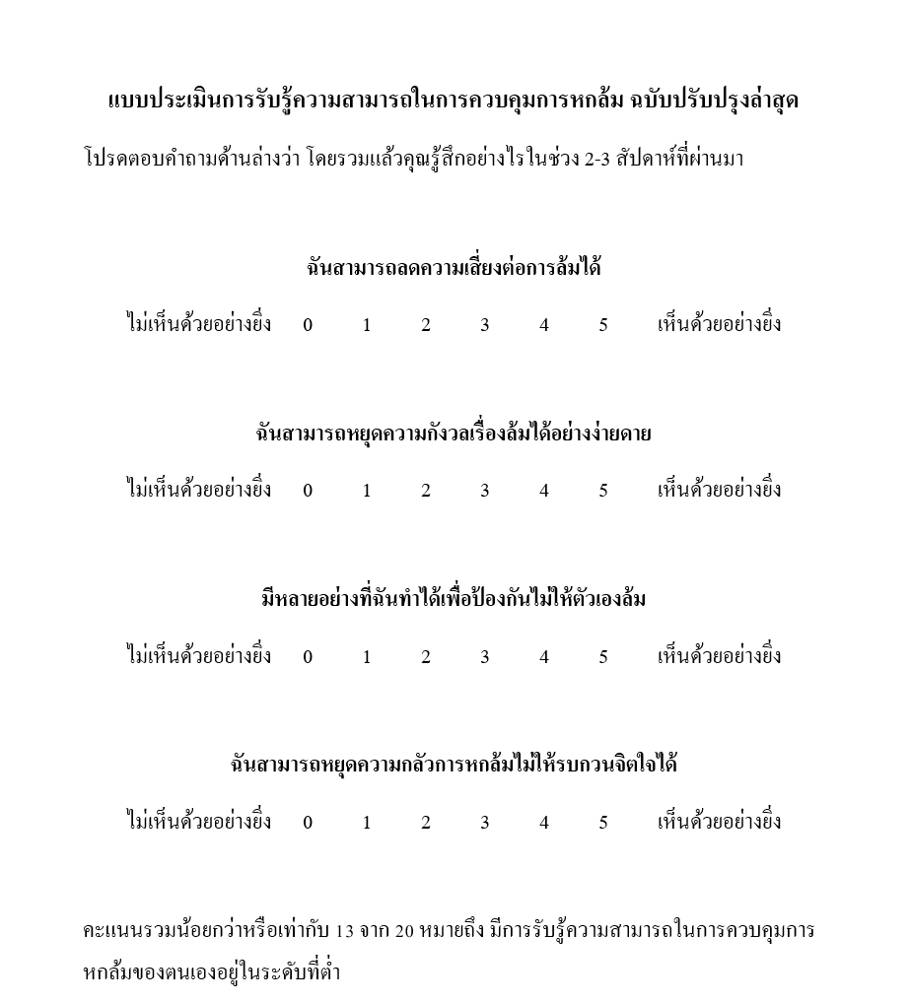
The Thai version of UP-COF

Reference: Tantrongphak, K., Anantapong, K., & Suriyaamarit, D. (2025). The Thai Version of the Updated Perceived Control Over Falling Scale: A Study of Cross-Cultural Adaptation, Reliability, and Validity in Older Adults. Journal of Health Science and Medical Research, 0, e20251268. doi:http://dx.doi.org/10.31584/jhsmr.20251268

