Supplementary material
- Supplementary Figure
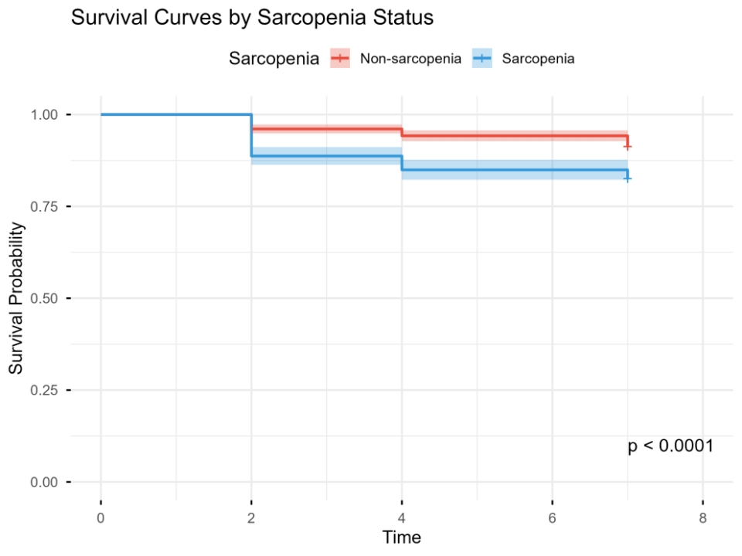
Figure A Kaplan–Meier survival curves between sarcopenia status in association with incident comorbidity
- Supplementary Table
Table B Multivariable Cox regression analysis of sarcopenia status in association with incident comorbidity
Sarcopenia status | Events | Person-years | Incidence rate(per 1000 py) | Model 1 |  | Model 2*
 |  |  |  | OR(95%CI) | P value | OR(95%CI) | P value
No sarcopenia | 1431 | 10017 | 142.86 | 1(ref) |  | 1(ref)
Sarcopenia | 200 | 706 | 283.27 | 2.093(1.581,2.772) | ＜0.001 | 1.453(1.072,1.97) | ＜0.05

Model1:unadjusted
Model 2: adjusted for age, gender, education, residence, marital status, ever/current smoke, ever/current alcohol, other comorbidities(hypertension, hyperglycaemia, cancer, lung disease, heart disease, stroke, arthritis, hypercholesterolaemia, liver disease, kidney disease, digestive system disease) and obesity judgment

