Table A1: Baseline characteristics of women lost to follow-up before last cognitive assessment and those completing it (N = 6,377).

 | Completed last assessment  (n = 5,226) |  | Lost to follow-up  (n = 1,151) |  | Overall  (N = 6,377)
Age
Mean (SD) | 66.1 (3.95) |  | 66.9 (4.53) |  | 66.2 (4.07)
Median [Min, Max] | 65.4 [60.4, 87.1] |  | 66.0 [60.4, 89.9] |  | 65.5 [60.4, 89.9]
BMI
Mean (SD) | 25.8 (4.44) |  | 25.4 (4.50) |  | 25.7 (4.46)
Median [Min, Max] | 25.1 [15.7, 51.5] |  | 24.6 [14.3, 47.3] |  | 25.0 [14.3, 51.5]
Missing | 1 (0.0%) |  | 4 (0.3%) |  | 5 (0.1%)
Highest attained education
LPN/LVN, associate’s degree, registered nurse | 3,414 (65.3%) |  | 804 (69.9%) |  | 4,218 (66.1%)
Bachelor’s degree or higher education | 1,728 (33.1%) |  | 337 (29.3%) |  | 2,065 (32.4%)
Missing | 84 (1.6%) |  | 10 (0.9%) |  | 94 (1.5%)
Smoking status
never | 2,765 (52.9%) |  | 576 (50.0%) |  | 3,341 (52.4%)
past | 1,980 (37.9%) |  | 415 (36.1%) |  | 2,395 (37.6%)
current | 475 (9.1%) |  | 160 (13.9%) |  | 635 (10.0%)
Missing | 6 (0.1%) |  | 0 (0%) |  | 6 (0.1%)
Strenuous physical activity
rarely/never | 2,220 (42.5%) |  | 531 (46.1%) |  | 2,751 (43.1%)
<1 time/week | 862 (16.5%) |  | 179 (15.6%) |  | 1,041 (16.3%)
1 time per week | 432 (8.3%) |  | 89 (7.7%) |  | 521 (8.2%)
2-3 times/week | 1,093 (20.9%) |  | 206 (17.9%) |  | 1,299 (20.4%)
≥ 4 times/week | 614 (11.7%) |  | 146 (12.7%) |  | 760 (11.9%)
Missing | 5 (0.1%) |  | 0 (0%) |  | 5 (0.1%)
Alcohol use
Rarely/never | 2,431 (46.5%) |  | 608 (52.8%) |  | 3,039 (47.7%)
1-3 drinks/month | 618 (11.8%) |  | 126 (10.9%) |  | 744 (11.7%)
1-6 drinks/week | 1,535 (29.4%) |  | 277 (24.1%) |  | 1,812 (28.4%)
1+ drinks/day |  | 638 (12.2%) |  | 140 (12.2%) |  | 778 (12.2%)
Missing |  | 4 (0.1%) |  | 0 (0%) |  | 4 (0.1%)
Hormone replacement
therapy use
never |  | 2,210 (42.3%) |  | 511 (44.4%) |  | 2,721 (42.7%)
past |  | 933 (17.9%) |  | 219 (19.0%) |  | 1,152 (18.1%)
current |  | 2,076 (39.7%) |  | 418 (36.3%) |  | 2,494 (39.1%)
Missing |  | 7 (0.1%) |  | 3 (0.3%) |  | 10 (0.2%)
Baseline history of diabetes
No |  | 5,060 (96.8%) |  | 1,093 (95.0%) |  | 6,153 (96.5%)
Yes |  | 165 (3.2%) |  | 58 (5.0%) |  | 223 (3.5%)
Missing |  | 1 (0.0%) |  | 0 (0%) |  | 1 (0.0%)
Baseline history of hypertension
No |  | 3,171 (60.7%) |  | 649 (56.4%) |  | 3,820 (59.9%)
Yes |  | 2,053 (39.3%) |  | 502 (43.6%) |  | 2,555 (40.1%)
Missing |  | 2 (0.0%) |  | 0 (0%) |  | 2 (0.0%)
Baseline treatment of high blood pressure
No |  | 4,087 (78.2%) |  | 855 (74.3%) |  | 4,942 (77.5%)
Yes |  | 1,136 (21.7%) |  | 291 (25.3%) |  | 1,427 (22.4%)
Missing |  | 3 (0.1%) |  | 5 (0.4%) |  | 8 (0.1%)
Baseline history of hypercholesterolemia (cholesterol 240+)
No |  | 2,955 (56.5%) |  | 680 (59.1%) |  | 3,635 (57.0%)
Yes |  | 2,268 (43.4%) |  | 471 (40.9%) |  | 2,739 (43.0%)
Missing |  | 3 (0.1%) |  | 0 (0%) |  | 3 (0.0%)
Baseline treatment of hypercholesterolemia
No |  | 4,891 (93.6%) |  | 1,082 (94.0%) |  | 5,973 (93.7%)
Yes |  | 328 (6.3%) |  | 69 (6.0%) |  | 397 (6.2%)
Missing  BMI: Body Mass Index (calculated as weight in kilograms divided by height in meters squared); LPVN: Licensed Practical Vocational Nurse |  | 7 (0.1%) |  | 0 (0%) |  | 7 (0.1%)
Table A2: Performance of included women at first and last cognitive assessment by global cognitive performance quintiles.

 | 1st quintile  (n = 1,019) | 2nd quintile  (n = 1,018) | 3rd quintile  (n = 1,019) | 4th quintile  (n = 1,018) | 5th quintile  (n = 1,019) | Overall  (N = 5,093)
TICS¹
First assessment
Mean (SD) | 34.9 (2.48) | 34.8 (2.49) | 34.4 (2.43) | 34.3 (2.41) | 33.6 (2.57) | 34.4 (2.51)
Median [Min, Max] | 35.0 [23.0, 41.0] | 35.0 [25.0, 41.0] | 35.0 [24.0, 41.0] | 34.0 [23.0, 41.0] | 34.0 [21.0, 41.0] | 35.0 [21.0, 41.0]
Last assessment
Mean (SD) | 32.4 (3.31) | 33.8 (2.64) | 34.3 (2.56) | 35.0 (2.44) | 35.9 (2.59) | 34.3 (2.96)
Median [Min, Max] | 33.0 [12.0, 40.0] | 34.0 [25.0, 41.0] | 34.0 [24.0, 41.0] | 35.0 [25.0, 41.0] | 36.0 [24.0, 41.0] | 34.0 [12.0, 41.0]
Immediate East Boston Memory Test²
First assessment
Mean (SD) | 10.2 (1.47) | 9.99 (1.42) | 9.77 (1.53) | 9.57 (1.47) | 8.79 (1.55) | 9.66 (1.56)
Median [Min, Max] | 10.0 [5.00, 12.0] | 10.0 [4.00, 12.0] | 10.0 [3.00, 12.0] | 10.0 [3.00, 12.0] | 9.00 [0, 12.0] | 10.0 [0, 12.0]
Last assessment
Mean (SD) | 8.22 (1.68) | 9.36 (1.59) | 9.84 (1.55) | 10.3 (1.52) | 10.6 (1.43) | 9.66 (1.76)
Median [Min, Max] | 8.00 [0, 12.0] | 10.0 [2.00, 12.0] | 10.0 [4.00, 12.0] | 10.0 [3.00, 12.0] | 11.0 [6.00, 12.0] | 10.0 [0, 12.0]
Delayed East Boston Memory Test²
First assessment
Mean (SD) | 9.74 (1.75) | 9.67 (1.52) | 9.57 (1.55) | 9.32 (1.59) | 8.55 (1.65) | 9.37 (1.67)
Median [Min, Max] | 10.0 [0, 12.0] | 10.0 [0, 12.0] | 10.0 [0, 12.0] | 10.0 [0, 12.0] | 8.00 [0, 12.0] | 10.0 [0, 12.0]
Last assessment
Mean (SD) | 7.61 (2.43) | 9.13 (1.68) | 9.53 (1.59) | 10.0 (1.63) | 10.3 (1.47) | 9.32 (2.03)
Median [Min, Max] | 8.00 [0, 12.0] | 9.00 [0, 12.0] | 10.0 [0, 12.0] | 10.0 [0, 12.0] | 10.0 [0, 12.0] | 10.0 [0, 12.0]
Delayed 10 word list³
First assessment
Mean (SD) | 3.42 (2.32) | 3.33 (2.10) | 2.99 (1.99) | 2.96 (1.84) | 2.57 (1.80) | 3.05 (2.04)
Median [Min, Max] | 3.00 [0, 10.0] | 3.00 [0, 10.0] | 3.00 [0, 10.0] | 3.00 [0, 10.0] | 2.00 [0, 10.0] | 3.00 [0, 10.0]
Last assessment
Mean (SD) | 2.26 (1.94) | 3.00 (2.03) | 3.38 (2.05) | 3.82 (2.06) | 4.77 (2.40) | 3.45 (2.26)
Median [Min, Max] | 2.00 [0, 10.0] | 3.00 [0, 10.0] | 3.00 [0, 10.0] | 4.00 [0, 10.0] | 4.00 [0, 10.0] | 3.00 [0, 10.0]
Category fluency test⁴
First assessment
Mean (SD) | 18.4 (5.07) | 18.5 (4.96) | 17.9 (4.54) | 17.9 (4.84) | 16.6 (4.67) | 17.9 (4.87)
Median [Min, Max] | 18.0 [6.00, 43.0] | 18.0 [4.00, 37.0] | 18.0 [5.00, 35.0] | 18.0 [6.00, 36.0] | 16.0 [0, 33.0] | 18.0 [0, 43.0]
Last assessment
Mean (SD) | 15.6 (4.62) | 17.3 (4.94) | 18.1 (4.73) | 18.9 (5.11) | 19.3 (5.45) | 17.8 (5.15)
Median [Min, Max] | 15.0 [5.00, 32.0] | 17.0 [5.00, 38.0] | 18.0 [6.00, 44.0] | 18.0 [5.00, 38.0] | 19.0 [6.00, 49.0] | 17.0 [5.00, 49.0]
Z-score difference [global change score]⁵
Mean (SD) | -0.929 (0.410) | -0.305 (0.114) | 0.0377 (0.0896) | 0.366 (0.107) | 0.943 (0.338) | 0.0224 (0.677)
Median [Min, Max] | -0.821 [-4.69, -0.512] | -0.304 [-0.512, -0.120] | 0.0370 [-0.119, 0.188] | 0.362 [0.188, 0.567] | 0.846 [0.569, 2.76] | 0.0370 [-4.69, 2.76]
¹ Telephone Interview of Cognitive Status (TICS) (max. 41 points)
² Max. 12 points
³ Max. 10 points
⁴ Women were asked to name as many animals as possible in one minute
⁵ Global test scores were generated by averaging Z-scores of the performance in each of the five tests

Table A3: Performance of eligible women at first cognitive assessment by follow-up status (N = 6,377).

First assessment | Completed last assessment  (n = 5,226) | Lost to follow-up  (n = 1,151) | Overall  (N = 6,377)
TICS¹
Mean (SD) | 34.4 (2.54) | 33.5 (3.39) | 34.2 (2.73)
Median [Min, Max] | 35.0 [21.0, 41.0] | 34.0 [4.00, 41.0] | 34.0 [4.00, 41.0]
Missing | 0 (0%) | 15 (1.3%) | 15 (0.2%)
Immediate East Boston Memory Test²
Mean (SD) | 9.65 (1.56) | 9.25 (1.68) | 9.58 (1.59)
Median [Min, Max] | 10.0 [0, 12.0] | 10.0 [0, 12.0] | 10.0 [0, 12.0]
Missing | 1 (0.0%) | 4 (0.3%) | 5 (0.1%)
Delayed East Boston Memory Test²
Mean (SD) | 9.36 (1.67) | 8.90 (2.20) | 9.28 (1.79)
Median [Min, Max] | 10.0 [0, 12.0] | 9.00 [0, 12.0] | 10.0 [0, 12.0]
Missing | 0 (0%) | 16 (1.4%) | 16 (0.3%)
Immediate 10 word list³
Mean (SD) | 4.87 (1.73) | 4.63 (1.92) | 4.83 (1.77)
Median [Min, Max] | 5.00 [0, 10.0] | 4.00 [0, 10.0] | 5.00 [0, 10.0]
Missing | 1 (0.0%) | 12 (1.0%) | 13 (0.2%)
Delayed 10 word list³
Mean (SD) | 3.04 (2.04) | 2.71 (2.33) | 2.98 (2.10)
Median [Min, Max] | 3.00 [0, 10.0] | 2.00 [0, 10.0] | 3.00 [0, 10.0]
Missing | 0 (0%) | 16 (1.4%) | 16 (0.3%)
Category fluency test⁴
Mean (SD) | 17.8 (4.87) | 16.1 (5.07) | 17.5 (4.95)
Median [Min, Max] | 18.0 [0, 43.0] | 16.0 [0, 34.0] | 17.0 [0, 43.0]
Missing | 1 (0.0%) | 23 (2.0%) | 24 (0.4%)
¹ Telephone Interview of Cognitive Status (TICS) (max. 41 points)
² Max. 12 points
³ Max. 10 points
⁴ Women were asked to name as many animals as possible in one minute

Table A4: HRs for total stroke by global cognition, weighted by participation weights
Global cognitive performance quintiles: | 1st quintile  (n = 1,019)  HR (95%CIs) | 2nd quintile  (n = 1,018)  HR (95%CIs) | 3rd quintile  (n = 1,019)  HR (95%CIs) | 4th quintile  (n = 1,018)  HR (95%CIs) | 5th quintile  (n = 1,019)  HR [reference]
Stroke, N | 60 | 62 | 60 | 53 | 67
adjusted¹ | 1.08 (0.76-1.54) | 1.02 (0.71-1.45) | 0.99 (0.69-1.41) | 0.79 (0.54-1.15) | 1 (ref)
Abbreviations: CI: Confidence Interval, HR: Hazard Ratio, ref: reference group
¹Adjusted for age, strenuous physical activity, alcohol use, smoking status, BMI (calculated as weight in kilograms divided by height in meters squared), highest attained educational level, hormone replacement therapy, high blood pressure, treatment of high blood pressure, high cholesterol, treatment of high cholesterol, and diabetes at baseline
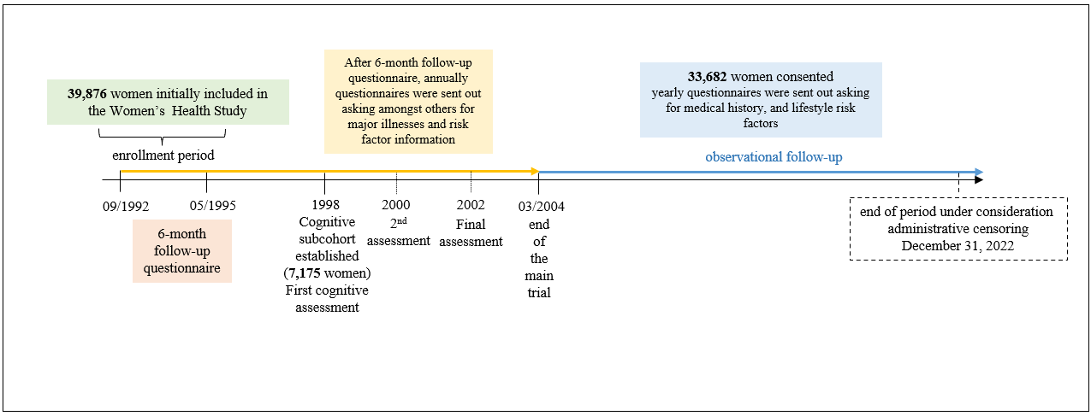
eFigure1: Timeline plot of the Women’s Health Study, the cognitive subcohort, and of the data collection procedure.

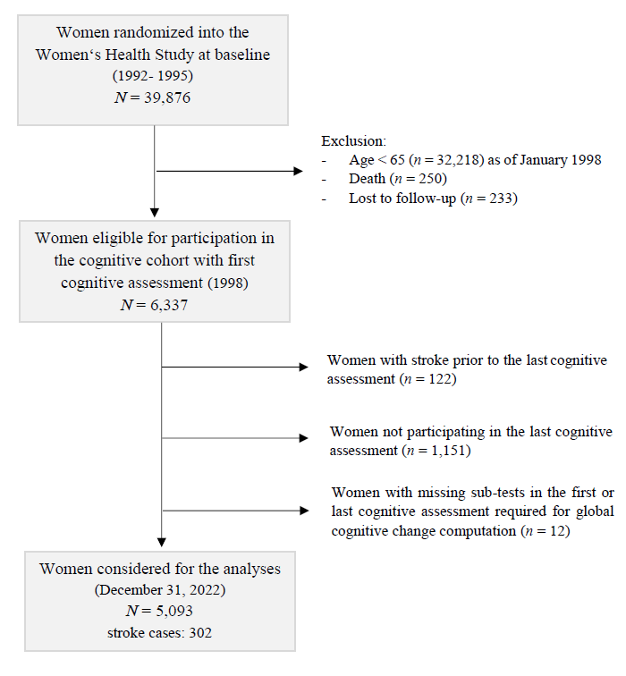
eFigure 2: Flow chart for participant selection and exclusions from the WHS (cognitive cohort).

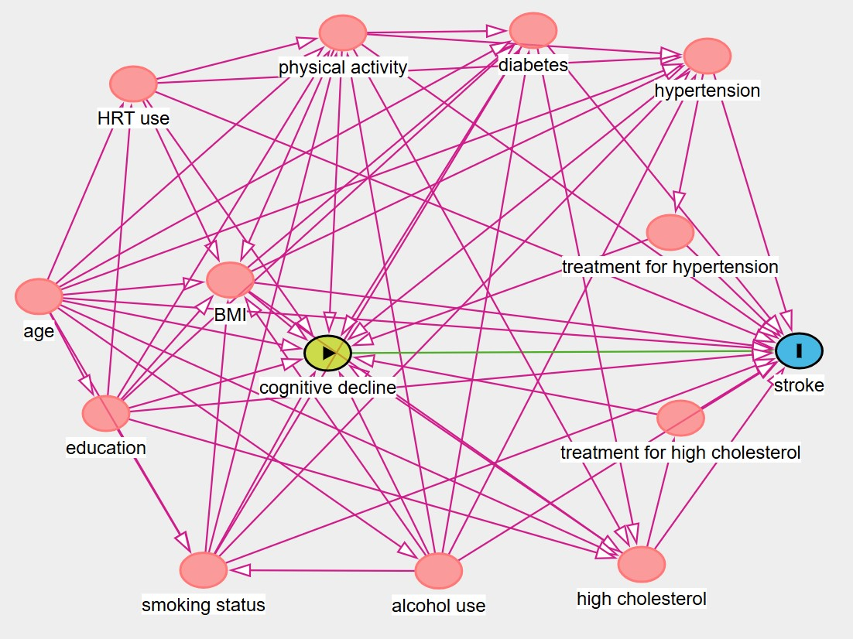
BMI: Calculated as weight in kilograms divided by height in meters squared
HRT: Hormone replacement therapy
eFigure 3: Directed acyclic graph (DAG) for the effect of “cognitive decline“ on “stroke”.

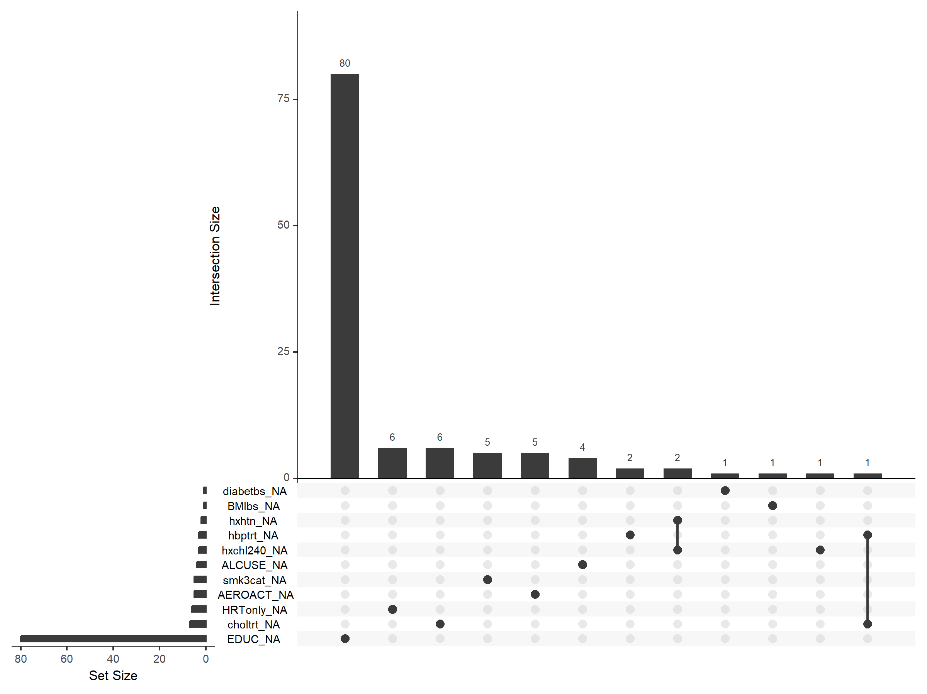
diabetbs: diabetes at baseline; BMIbs: Body Mass Index at baseline; hxhtn: hypertension; hbptrt: treatment for high blood pressure; hxchl240: high cholesterol; ALCUSE: alcohol use category; smk3cat: smoking status (three categories); AEROACT: physical activity level; HRTonly: Hormone Replacement Therapy; choltrt: treatment for high cholesterol; EDUC: educational level

eFigure4: UpSet plot showing numbers and patterns of missing data across adjustment variables.

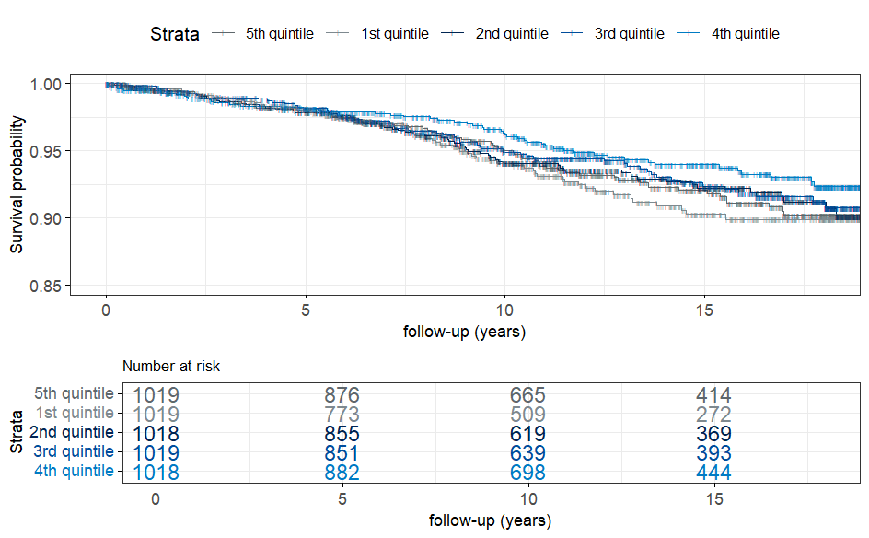
Person-time was calculated from the last cognitive assessment until the date of diagnosis of confirmed stroke, loss to follow-up, death, or the end of the study (December 31, 2022), whichever occurred first.
eFigure 5: Kaplan Meier curves for stroke-free survival of included women from the WHS cognitive cohort (N = 5,093).

