Supplementary Table S1. Operational definitions and ascertainment of postoperative complications
Complication | Operational Definition | Data source
 | Positive Confusion Assessment Method (CAM) score documented in nursing or physician notes (presence of acute onset/fluctuating course, inattention, and either disorganized thinking or altered level of consciousness | Daily nursing assessments (CAM scores)
Pneumonia | Required both clinical and radiological criteria: (1) Clinical: at least two of: new or worsening cough, purulent sputum, temperature >38°C, white blood cell count >10,000/μL or <4,000/μL; AND (2) Radiological: new or progressive infiltrate, consolidation, or cavitation on chest radiograph or CT scan; OR microbiologically confirmed (positive culture from blood, pleural fluid, or bronchoalveolar lavage) with compatible clinical picture. | Microbiology reports (sputum cultures, blood cultures); radiology reports; antibiotic prescription records; daily vital signs; laboratory data
Cardiac events | Composite of: (1) Acute myocardial infarction: rise/fall of cardiac troponin >99th percentile URL + at least one of: ischemic symptoms, new ECG changes, imaging evidence of new wall motion abnormality, or intracoronary thrombus on angiography; (2) New arrhythmia: atrial fibrillation, atrial flutter, or ventricular tachycardia requiring pharmacological intervention (e.g., antiarrhythmics, rate control) or electrical cardioversion; (3) Acute heart failure: new pulmonary edema on chest imaging + requiring IV diuretics or inotropic support. | Troponin results; ECG reports; cardiology consultation notes; echocardiogram reports; medication administration records
Gastrointestinal bleeding | Overt bleeding (hematemesis, melena, hematochezia, or nasogastric aspirate containing blood) PLUS hemoglobin drop ≥2 g/dL from pre-bleed level PLUS need for transfusion of ≥2 units packed red blood cells or endoscopic/surgical intervention. | Endoscopy reports; transfusion records; serial hemoglobin values; gastroenterology consultation notes; progress notes
Cerebrovascular events | Ischemic stroke: new focal neurological deficit lasting ≥24 hours with imaging confirmation (CT or MRI) of acute infarction; Intracranial hemorrhage: new focal neurological deficit with imaging evidence of intracerebral, subarachnoid, or subdural hemorrhage. | Neurology consultation notes; imaging reports (CT brain, MRI brain); discharge summaries

Supplementary Table S2 Perioperative serum sodium dynamics by admission hyponatremia status
Time point | Normonatremia (n=1658) | Mild hyponatremia (n=191) | Moderate-to-severe hyponatremia (n=52)
Admission
Median (IQR), mmol/L | 140.0 (138.0-142.0) | 133.0 (131.2-134.0) | 126.1(121.5-128.0)
Missing, (n, %) | 0 (0) | 0 (0) | 0 (0)
Postoperative day 1
Median (IQR), mmol/L | 139.0 (137.0-141.3) | 137.0 (133.2-139.0) | 136.8 (133.0-139.0)
Missing, (n, %) | 0 (0) | 0 (0) | 0 (0)
Postoperative day 3
Median (IQR), mmol/L | 140.0 (137.0-142.0) | 139.0 (137.1-142.9) | 139.6 (136.2-141.8)
Missing, (n, %) | 773 (46.7%) | 24 (12.6%) | 7 (13.5%)
Postoperative day 5
Median (IQR), mmol/L | 140.0 (137.0-142.8) | 140.4 (137.4-144.0) | 138.9 (134.9-141.9)
Missing, (n, %) | 966 (58.3%) | 32 (16.8%) | 9 (17.3%)
IQR = interquartile range.

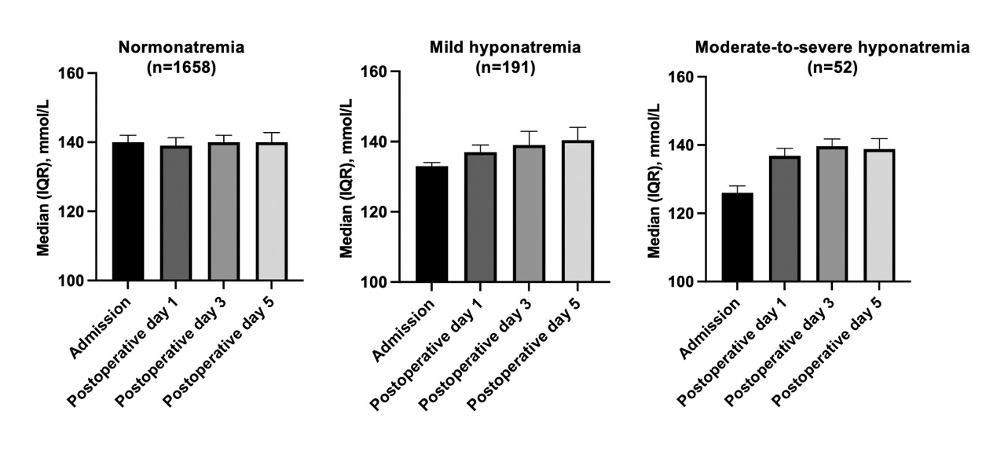

Supplementary Fig. 1 Perioperative serum sodium dynamics

Supplementary Table S4 Subgroup analysis for the association between preoperative hyponatremia and 30-day mortality
Subgroup | Normonatremia | Hyponatremia | Ajusted HR (95%CI) | P for Interaction
Age |  |  |  | 0.464
< 80 years | 10/682 | 3/76 | Not performed
≥ 80 years | 55/976 | 14/167 | 1.05 (0.56-1.99)
Sex |  |  |  | 0.919
Male | 22/521 | 5/86 | Not performed
Female | 43/1137 | 12/157 | 1.48 (0.74-2.97)
Fracture type |  |  |  | 0.682
Femoral neck | 21/724 | 5/89 | Not performed
Trochanteric | 44/934 | 12/154 | 1.29 (0.64-2.63)
PNI |  |  |  | 0.047
< 45 | 53/1060 | 11/177 | 1.24 (0.27-5.64)
≥ 45 | 12/598 | 6/60 | Not performed
BMI |  |  |  | 0.874
< 18.5 | 17/170 | 3/28 | Not performed
≥ 18.5 | 48/1488 | 14/215 | 1.32(0.68-2.57)
Surgical procedure |  |  |  | 0.692
Internal fixation | 52/1150 | 14/178 | 1.24 (0.65-2.37)
Arthroplasty | 13/508 | 3/65 | Not performed
ASA grade |  |  |  | 0.516
Ⅰ–Ⅱ | 18/798 | 4/115 | Not performed
Ⅲ–Ⅳ | 47/860 | 13/128 | 1.54 (0.78-3.05)

For subgroup analyses, if the number of events in any stratum was <10, multivariable adjustment was not performed; only descriptive data are presented. In strata with ≥10 events, fully adjusted Cox models (including postoperative hyponatremia and complications) were applied.
Adjusted for age, sex, fracture type, ASA grade, CCI, PNI, BMI, preoperative anemia, comorbidities, surgical procedure type, intraoperative blood loss, postoperative hyponatremia, and postoperative complications. Multivariable analysis not performed due to limited events (<10) in the hyponatremia group. Descriptive data are available.

Supplementary Table S5 Subgroup analysis for the association between preoperative hyponatremia and 1-year mortality
Subgroup | Normonatremia | Hyponatremia | Ajusted HR (95%CI) | P for Interaction
Age |  |  |  | 0.264
< 80 years | 56/682 | 13/76 | 2.00 (1.03-3.89)
≥ 80 years | 169/976 | 41/167 | 1.03 (0.71-1.50)
Sex |  |  |  | 0.560
Male | 84/521 | 24/86 | 1.41 (0.84-2.39)
Female | 141/1137 | 30/157 | 1.07 (0.70-1.64)
Fracture type |  |  |  | 0.941
Femoral neck | 83/724 | 17/89 | 0.98 (0.54-1.77)
Trochanteric | 142/934 | 37/154 | 1.28 (0.87-1.90)
PNI |  |  |  | 0.456
< 45 | 185/1060 | 45/177 | 1.12 (0.77-1.63)
≥ 45 | 40/598 | 9/60 | Not performed
BMI |  |  |  | 0.634
< 18.5 | 41/170 | 6/28 | Not performed
≥ 18.5 | 184/1488 | 48/215 | 1.28 (0.90-1.81)
Surgical procedure |  |  |  | 0.417
Internal fixation | 171/1150 | 40/178 | 1.12 (0.77-1.63)
Arthroplasty | 54/508 | 14/65 | 1.53 (0.78-3.01)
ASA grade |  |  |  | 0.120
Ⅰ–Ⅱ | 74/798 | 17/115 | 1.10 (0.61-2.01)
Ⅲ–Ⅳ | 151/860 | 37/128 | 1.30 (0.87-1.93)

For subgroup analyses, if the number of events in the hyponatremia group was <10, multivariable adjustment was not performed; only descriptive data are presented. In strata with ≥10 events, fully adjusted Cox models were applied, including age, sex, fracture type, ASA grade, CCI, PNI, BMI, preoperative anemia, comorbidities, surgical procedure type, intraoperative blood loss, postoperative hyponatremia, and postoperative complications. Multivariable analysis not performed due to limited events (<10) in the hyponatremia group. Descriptive data are available.

Supplementary Table 6 Distribution of patients, hyponatremia severity, and outcomes by 10-year age increments
Age group  (years) | Sodium status | n (%) | Postoperative complications n (%) | 30-day mortality n (%) | 1-year mortality n (%)
60-69 | Normal | 224 (91.1) | 224(91.1) | 18 (8.0) | 1 (0.4)
(n = 246) | Mild | 18 (7.3) | 18(7.3) | 2 (11.1) | 1 (5.6)
 | Moderate-severe | 4 (1.6) | 4(1.6) | 0 (0.0) | 0 (0.0)
70-79 | Normal | 458 (89.5) | 458(89.5) | 63 (13.8) | 9 (2.0)
(n = 512) | Mild | 41 (8.0) | 41(8.0) | 7 (17.1) | 0 (0.0)
 | Moderate-severe | 13 (2.5) | 13(2.5) | 6 (16.2) | 2 (15.4)
80-89 | Normal | 783 (85.6) | 783(85.6) | 152 (19.4) | 43 (5.5)
(n = 915) | Mild | 103 (11.3) | 103(11.3) | 33 (32.0) | 7 (6.8)
 | Moderate-severe | 29 (12.7) | 29(12.7) | 14 (48.3) | 4 (13.8)
≥ 90 | Normal | 193 (84.6) | 193(84.6) | 80 (41.5) | 12 (6.2)
(n = 228) | Mild | 29 (12.7) | 29(12.7) | 20 (70.0) | 1 (3.4)
 | Moderate-severe | 6 (2.6) | 6(2.6) | 4 (66.6) | 2 (33.3)
Data are presented as n (%). Percentages in the first n (%) column represent the distribution of hyponatremia severity within each age group. Percentages in the outcome columns represent the incidence of each outcome within each stratum (age group × sodium status).

