Additional file 1. Supplementary Material
An Interpretable Prediction Model for Severe Sepsis-Associated Acute Kidney Injury in Older ICU Patients With Sepsis: A Prospective Multicenter Cohort Study

Supplementary Tables
Supplementary Table 1. Baseline characteristics of the training and internal temporal validation cohorts.
Variables | Training cohort | Validation cohort | p-value
Demographics
Age, years | 73.00 [69.00; 79.00] | 73.00 [68.00; 80.00] | 0.888
Male sex, n (%) | 574 (66.4%) | 258 (69.5%) | 0.290
Comorbidities
Diabetes mellitus, n (%) | 307 (35.5%) | 121 (32.6%) | 0.361
Chronic kidney disease, n (%) | 241 (27.9%) | 94 (25.3%) | 0.402
Hematological disease, n (%) | 58 (6.7%) | 23 (6.2%) | 0.803
COPD, n (%) | 87 (10.1%) | 34 (9.2%) | 0.677
Malignancy, n (%) | 215 (24.9%) | 107 (28.8%) | 0.157
Severity and clinical status
APACHE II score | 15.00 [12.00; 18.00] | 15.00 [13.00; 19.00] | 0.465
SOFA score | 9.00 [7.00; 11.00] | 9.00 [7.00; 11.00] | 0.351
Infection sites
Abdominal infection, n (%) | 288 (33.3%) | 98 (26.4%) | 0.019
Bloodstream infection, n (%) | 200 (23.1%) | 112 (30.2%) | 0.010
Laboratory markers
WBC, ×10^9/L | 10.97 [7.74; 15.44] | 11.46 [8.06; 15.74] | 0.203
Neutrophils, ×10^9/L | 9.52 [6.28; 13.70] | 9.85 [6.59; 13.89] | 0.182
Monocytes, ×10^9/L | 0.46 [0.27; 0.71] | 0.48 [0.29; 0.72] | 0.370
Lactate, mmol/L | 2.86 [2.01; 3.77] | 2.77 [1.94; 3.74] | 0.642
PCT, ng/mL | 2.32 [0.97; 8.90] | 2.16 [0.81; 7.09] | 0.139
CRP, mg/L | 107.00 [58.61; 191.70] | 107.00 [49.60; 160.00] | 0.055
Albumin, g/L | 32.16 [30.00; 35.00] | 32.75 [29.68; 35.00] | 0.861
PaO2/FiO2 ratio | 290.00 [230.00; 362.00] | 293.33 [231.11; 371.43] | 0.743
Immune markers
IL-6, pg/mL | 65.29 [32.61; 131.90] | 57.88 [29.13; 121.60] | 0.118
NK-cell percentage | 14.87 [11.43; 19.57] | 14.59 [11.85; 19.28] | 0.750
CD4+ T-cell percentage | 41.61 [34.68; 49.49] | 41.83 [35.70; 49.42] | 0.929
CD8+ T-cell percentage | 22.73 [16.72; 31.40] | 24.40 [18.80; 33.90] | 0.018
B-cell percentage | 14.05 [8.60; 20.60] | 13.83 [8.10; 20.10] | 0.800
CD4+/CD8+ T-cell ratio | 1.88 [1.15; 2.76] | 1.76 [1.11; 2.51] | 0.061
C3, g/L | 0.81 [0.69; 0.96] | 0.84 [0.70; 0.98] | 0.076
C4, g/L | 0.17 [0.12; 0.21] | 0.17 [0.12; 0.21] | 0.778
Note: Continuous variables are presented as median [Q1; Q3], whereas categorical variables are expressed as n (%). Between-group comparisons were performed using the Wilcoxon rank-sum test or Fisher's exact test. APACHE II, Acute Physiology and Chronic Health Evaluation II; SOFA, Sequential Organ Failure Assessment; CKD, chronic kidney disease; COPD, chronic obstructive pulmonary disease; WBC, white blood cell count; PCT, procalcitonin; CRP, C-reactive protein.

Supplementary Table 2. Baseline characteristics of patients with non-severe and severe SA-AKI in the training cohort.
Variables | Non-severe SA-AKI | Severe SA-AKI | p-value
Demographics
Age, years | 73.00 [69.00; 79.00] | 73.00 [68.00; 78.50] | 0.314
Male sex, n (%) | 438 (63.6%) | 136 (77.3%) | <0.001
Comorbidities
Diabetes mellitus, n (%) | 243 (35.3%) | 64 (36.4%) | 0.792
Chronic kidney disease, n (%) | 153 (22.2%) | 88 (50.0%) | <0.001
Hematological disease, n (%) | 48 (7.0%) | 10 (5.7%) | 0.616
COPD, n (%) | 66 (9.6%) | 21 (11.9%) | 0.399
Malignancy, n (%) | 190 (27.6%) | 25 (14.2%) | <0.001
Severity and clinical status
APACHE II score | 15.00 [12.00; 18.00] | 18.00 [15.00; 20.50] | <0.001
SOFA score | 8.00 [6.00; 10.00] | 11.00 [9.00; 13.00] | <0.001
Infection sites
Abdominal infection, n (%) | 242 (35.1%) | 46 (26.1%) | 0.025
Bloodstream infection, n (%) | 154 (22.4%) | 46 (26.1%) | 0.316
Laboratory markers
WBC, ×10^9/L | 10.58 [7.64; 14.62] | 12.51 [8.09; 17.67] | 0.003
Neutrophils, ×10^9/L | 9.21 [6.26; 13.11] | 11.06 [6.30; 16.07] | 0.007
Monocytes, ×10^9/L | 0.46 [0.27; 0.69] | 0.49 [0.26; 0.84] | 0.319
Lactate, mmol/L | 2.70 [1.92; 3.55] | 3.46 [2.60; 4.26] | <0.001
PCT, ng/mL | 2.07 [0.83; 7.17] | 4.03 [1.44; 18.33] | <0.001
CRP, mg/L | 107.00 [55.00; 185.06] | 118.61 [80.94; 209.77] | 0.008
Albumin, g/L | 32.36 [30.00; 35.00] | 31.54 [28.13; 35.13] | 0.032
PaO2/FiO2 ratio | 294.29 [234.86; 366.67] | 277.76 [219.36; 340.00] | 0.055
Immune markers
IL-6, pg/mL | 53.89 [29.20; 105.48] | 137.59 [79.97; 281.03] | <0.001
NK-cell percentage | 15.70 [12.43; 20.28] | 11.27 [8.19; 15.07] | <0.001
CD4+ T-cell percentage | 43.94 [36.46; 50.89] | 34.58 [29.54; 41.02] | <0.001
CD8+ T-cell percentage | 22.52 [16.80; 31.40] | 23.45 [16.71; 31.39] | 0.740
B-cell percentage | 14.10 [8.80; 20.30] | 13.94 [7.00; 23.55] | 0.409
CD4+/CD8+ T-cell ratio | 1.87 [1.14; 2.69] | 1.91 [1.22; 2.89] | 0.437
C3, g/L | 0.85 [0.72; 0.98] | 0.71 [0.58; 0.81] | <0.001
C4, g/L | 0.17 [0.13; 0.22] | 0.15 [0.11; 0.19] | <0.001
Note: Continuous and categorical variables are presented as median [Q1; Q3] and as n (%), respectively. Between-group comparisons were performed using the Wilcoxon rank-sum test or Fisher's exact test. APACHE II, Acute Physiology and Chronic Health Evaluation II; SOFA, Sequential Organ Failure Assessment; CKD, chronic kidney disease; COPD, chronic obstructive pulmonary disease; WBC, white blood cell count; PCT, procalcitonin; CRP, C-reactive protein.

Supplementary Figures
Supplementary Figure 1. Univariable logistic regression analysis of candidate variables associated with severe SA-AKI in the training cohort.
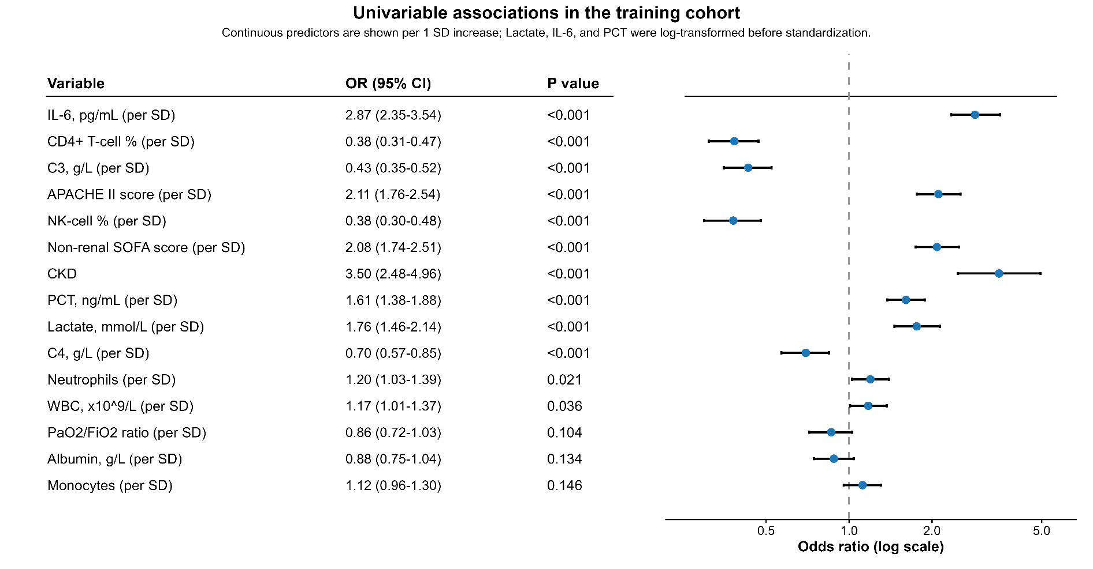

Supplementary Figure 2. Spearman correlation heatmap of key candidate variables in the training cohort.
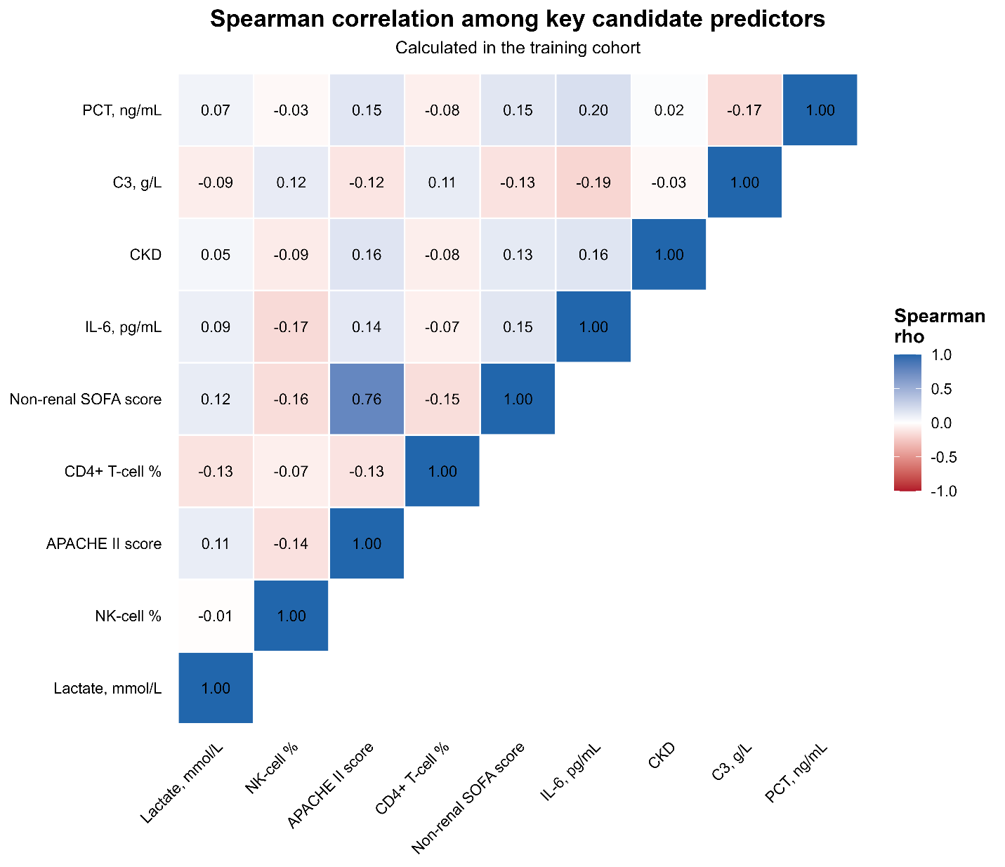

Supplementary Figure 3. Selection of the optimal number of predictors. Panel A shows discrimination across candidate models; Panel B shows the validation Brier score; Panel C shows the maximum VIF; Panel D shows validation ROC curves around the selected model size.
