Interview questionnaire
Assessment of nutritional status among elderly persons seeking health care in tertiary care hospitals of Mangalore
- Serial Number:
- Name of the hospital: a. Public Hospital b. Private Hospital
- Age (in years)…….. 4. Gender: Male/Female
- Education of the participant: ……………………….
- Occupation of the participant: …………………………………..
- Education of the head of the family: ……………………….
- Occupation of the head of the family: …………………………………..
- Socio Economic status (As per Kuppuswamy Classification):
a. Class 1 b. Class 2 c. Class 3 d. Class 4 e. Class 5
- Marital status: a. Single b. Married c. Widowed d. Divorced
- Living status: a. With spouse b. With children c. With spouse and children d. Only relatives e. Alone
- Financial status: a. Dependent b. Independent
- Hypertension a. Yes b. No
- Diabetes a. Yes b. No
- Dyslipidemia a. Yes b. No
- Thyroid disease a. Yes b. No 15. Heart disease a. Yes b. No
- Any other disease (specify)………………….
- Weight in kgs……………………… 18. Height in mts…………………………
19.Body Mass Index(BMI)…………………………..kg/m²
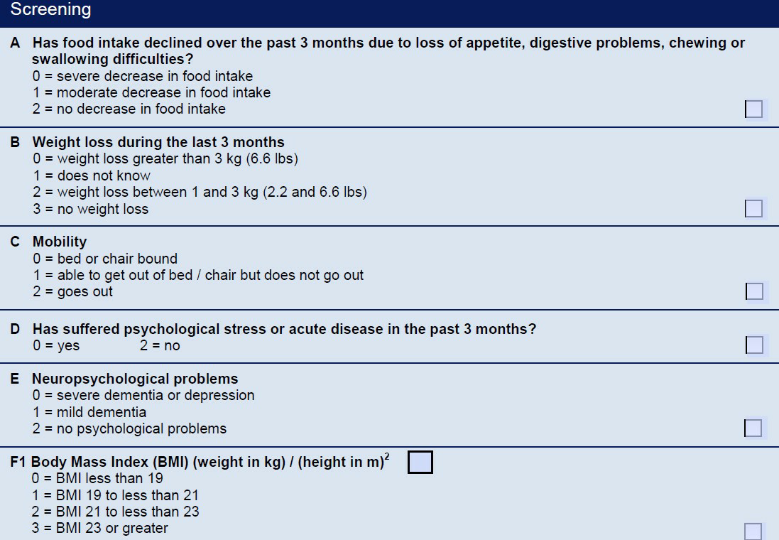

12-14 points: Normal nutritional status
8-11 points: At risk of malnutrition
0-7 points: Malnourished
MNA Score: __________
Interpretation of MNA score: __________

