Supplementary Materials
Internet use and incident myocardial infarction in community-dwelling older adults: a 13-year longitudinal cohort study
Supplementary Table S1. Sensitivity analyses of the primary estimate
Analysis | n (events) | HR (95% CI) | P value
Primary model (Model 4) | 4,120 (429) | 0.78 (0.62–0.99) | .04
Alternative estimation approach
IPTW, stabilised weights, 10 covariatesᵃ | 4,120 (429) | 0.72 (0.57–0.91) | .007
IPTW, stabilised weights, 13 covariates incl. SESᵇ | 4,120 (429) | 0.76 (0.60–0.96) | .02
Latency (reverse-causation) analysesᶜ
Excluding events in the first year | 3,338 (345) | 0.77 (0.60–1.00) | .05
Excluding events in the first 2 years | 2,776 (276) | 0.71 (0.53–0.94) | .02
Excluding events in the first 3 years | 2,522 (229) | 0.73 (0.53–1.00) | .05
Multiple imputation of household income
Pooled across 5 NHATS imputations (Rubin's rules) | 4,120 (429) | 0.78 (0.62–0.98) | .04
Cohort definition
Including participants with prevalent MI at baselineᵈ | 4,807 (602) | 0.81 (0.67–0.99) | .04
Additional covariate
Adding baseline arthritis to the primary modelᶠ | 4,113 (428) | 0.78 (0.62–0.99) | .04
Replication in a later baseline round (2015)
Round 5 (2015) baseline, without full SES adjustmentᵉ | 5,280 (512) | 0.80 (0.65–0.98) | .04
Round 5 (2015) baseline, + full SES adjustment (covariate set matching primary model) | 3,731 (381) | 0.80 (0.62–1.02) | .07
Abbreviations: CI, confidence interval; HR, hazard ratio; IPTW, inverse probability of treatment weighting; MI, myocardial infarction; SES, socioeconomic status.
ᵃ Propensity score estimated by logistic regression including sex, age group, education, race or ethnicity (categorical), heart disease, diabetes, hypertension, lung disease, stroke and smoking history (10 covariates); the model contained only variables classified as confounders in the primary analysis, and no mediator. Stabilised weights were trimmed at the 1st and 99th percentiles.
ᵇ As above, with the addition of household income quartile, Medicaid coverage and marital status (13 covariates).
ᶜ Participants with an event within the specified window were excluded and the primary model refitted.
ᵈ Model additionally adjusted for prevalent MI at baseline. P for interaction between internet use and prevalent MI = .86. Stratified estimates: no prevalent MI, HR 0.78 (95% CI 0.62–0.99); prevalent MI, HR 0.88 (95% CI 0.61–1.28).
ᵉ Later-baseline replication cohort constructed with internet use measured at Round 5 (2015) as the exposure and incident MI over Rounds 6–14 as the outcome. Round 5 includes continuing members of the 2011 cohort together with a refresh sample; this cohort is therefore not fully independent of the original sample. See Supplementary Table S2.
ᶠ Physician-diagnosed arthritis (NHATS item HC2d) was not included in the primary covariate set; this analysis adds it to the primary model. Seven participants with missing arthritis status were excluded, leaving 4,113 participants and 428 events. The estimate is unchanged from the primary model.

Supplementary Table S2. Replication cohort using Round 5 (2015) as baseline
Model | HR (95% CI) | P value
Model 1: unadjusted | 0.65 (0.55–0.77) | <.001
Model 2: + sex, age group, education, race or ethnicity | 0.80 (0.65–0.99) | .04
Model 3: + heart disease, diabetes, hypertension, lung disease, stroke, smoking history (no socioeconomic adjustment) | 0.80 (0.65–0.98) | .04
Model 4: + household income quartile, Medicaid coverage, marital status (covariate set matching the 2011 primary model)ᵃ | 0.80 (0.62–1.02) | .07
Cohort: participants interviewed in NHATS Round 5 (2015), free of MI at that round, with internet use recorded and at least one follow-up interview in Rounds 6–14 (n = 5,280 for Models 1–3; 512 incident MI events). Model 4 was restricted to participants with complete socioeconomic data (n = 3,731; 381 events).
Note on model numbering: the covariate blocks are added in a different order from Table 2 of the main text. In this cohort the comorbidity and smoking block precedes the socioeconomic block, so Model 3 here is a model without socioeconomic adjustment, and Model 4 corresponds in covariate content to Model 4 (the primary model) of the main analysis.
ᵃ The reduced sample size for Model 4 reflects the fact that household income was not re-elicited from all continuing respondents in Round 5; where the Round 5 value was not collected, the Round 1 value was carried forward, and participants entering at the Round 5 sample refresh without a prior income measurement could not be included.
Baseline internet use prevalence was 52.2% in the Round 5 cohort compared with 45.4% in the Round 1 cohort, consistent with the substantial expansion of internet access among older adults between 2011 and 2015. Despite this shift in the exposure distribution, the estimate with socioeconomic adjustment matching the primary model is close to that obtained in the Round 1 cohort (HR 0.80 vs 0.78; 95% CI 0.62–1.02 in the Round 5 cohort), indicating that the association is not specific to the 2011 digital environment.

Supplementary Table S3. Exposure specificity: internet use versus device ownership and email use
Baseline exposure | n | HR (95% CI) | P value
Internet use (primary exposure) | 4,120 | 0.78 (0.62–0.99) | .04
Owns a cellular telephone | 4,120 | 1.19 (0.85–1.67) | .31
Owns a computer | 3,980 | 0.95 (0.75–1.21) | .69
Sends or receives email or text messages | 4,119 | 0.96 (0.76–1.21) | .72
All models adjusted for the covariates of the primary model (Model 4). Device ownership alone was not associated with incident MI in these analyses; however, this comparison cannot distinguish an effect of internet use itself from residual confounding by socioeconomic position or related characteristics.

Supplementary Table S4. E-value sensitivity analysis for unmeasured confounding
Estimate | Value | E-value
Primary model (Model 4) point estimate | HR 0.78 | 1.87
Primary model upper 95% confidence limit | HR 0.99 | 1.14
The E-value is the minimum strength of association, on the risk ratio scale, that an unmeasured confounder would need to have with both internet use and incident MI — conditional on the measured covariates — to fully explain away the observed association (VanderWeele and Ding, 2017).
Interpretation. An unmeasured confounder would need to be associated with both internet use and MI by a risk ratio of at least 1.87 each to move the point estimate to the null, and by a risk ratio of only 1.14 each to move the upper confidence limit to the null. We do not regard an E-value of this magnitude as reassuring. Although household income, Medicaid coverage, marital status and education are adjusted for in the primary model, these are imperfect measures of socioeconomic position, and unmeasured dimensions — wealth, health literacy, area-level deprivation and lifetime occupational status — could plausibly generate confounding of this strength either individually or jointly. The E-value is therefore reported to quantify how fragile the estimate is, and not as evidence that the association is robust to unmeasured confounding. (E-values are calculated from the unrounded estimates: point estimate 0.783 and upper 95% confidence limit 0.986.)

Supplementary Table S5. Covariates included in the propensity score model for the IPTW analysis
# | Covariate | Coding
1 | Sex | Male / female
2 | Age group | Ordinal, 6 categories (65–69 to ≥90 years)
3 | Education | Ordinal, 9-level scale
4 | Race or ethnicity | Categorical; non-Hispanic White as the reference (indicator terms for non-Hispanic Black, Hispanic and other non-Hispanic)
5 | Heart disease | Yes / no
6 | Diabetes | Yes / no
7 | Hypertension | Yes / no
8 | Lung disease | Yes / no
9 | Stroke | Yes / no
10 | Smoking history | Ever / never
11 | Household income quartileᵃ | Quartiles of imputed total household income
12 | Medicaid coverageᵃ | Yes / no
13 | Marital statusᵃ | Married or partnered / not
ᵃ Covariates 11–13 were included only in the 13-covariate propensity score model with socioeconomic adjustment. The 10-covariate model comprised covariates 1–10, all of which are confounders in the primary analysis; no mediator was included in either model.
Stabilised inverse probability weights were derived from a logistic regression propensity score model and trimmed at the 1st and 99th percentiles.

Supplementary Table S6. Comparison of participants aged 70–74 years with all other participants
Characteristic | Aged 70–74 y  (n = 969) | All other ages  (n = 3,151) | Standardised difference
Internet use, % | 53 | 43 | 0.20
Female, % | 57 | 59 | −0.03
Education, mean (9-level scale) | 5.5 | 5.4 | 0.04
Medicaid coverage, % | 13 | 12 | 0.04
Heart disease, % | 10 | 14 | −0.12
Diabetes, % | 27 | 21 | 0.14
Stroke, % | 7 | 9 | −0.07
Smoking history, % | 57 | 48 | 0.17
Vigorous physical activity, % | 43 | 40 | 0.06
Incident MI during follow-up, % | 10.4 | 10.4 | 0.00
Non-Hispanic White, % | 67 | 72 | −0.11
Household income, median, US $ | 32,000 | 31,000 | 0.04
Married or partnered, % | 56 | 53 | 0.07
Body mass index, mean, kg/m² | 28.3 | 27.4 | 0.17
Follow-up, mean, years | 7.0 | 6.2 | 0.18
MI incidence, per 1,000 person-years | 15.0 | 16.9 | —
Participants aged 70–74 years differed only modestly from the remainder of the cohort: no measured characteristic exceeded a standardised difference of 0.20, the largest differences being in internet use itself (0.20), body mass index (0.17), smoking history (0.17) and diabetes (0.14), while household income, education, Medicaid coverage and marital status were closely comparable. The crude proportion developing MI was the same in the two groups (10.4%); the incidence rate was somewhat lower in this stratum (15.0 vs 16.9 per 1,000 person-years) because its mean follow-up was longer (7.0 vs 6.2 years). None of these differences provides an obvious explanation for the lower stratum-specific hazard ratio. The stronger point estimate observed in this stratum (HR 0.51, 95% CI 0.31–0.83) was not accompanied by a significant interaction across age groups (P for interaction = .57). Given that eight interaction tests were conducted without correction for multiplicity, we interpret this stratum-specific estimate as most likely reflecting chance variation, and we do not offer a substantive explanation for it in the main text.
Standardised differences are reported because no formal hypothesis tests were planned for this descriptive comparison; values below 0.10 are conventionally regarded as negligible and values below 0.20 as small.

Supplementary Figure S1. Directed acyclic graph used for covariate selection
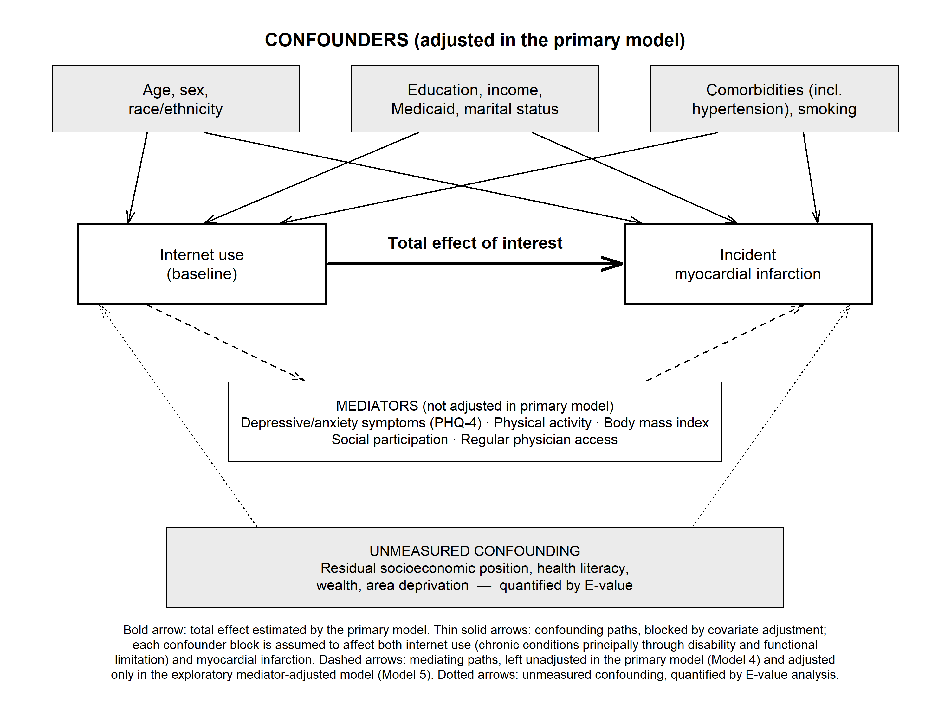
The directed acyclic graph specifies the assumed causal structure linking internet use to incident myocardial infarction. Variables classified as common causes of both exposure and outcome (demographic characteristics, socioeconomic position, baseline comorbidities and smoking history) were adjusted for in the primary model. Variables classified as plausible mediators — depressive and anxiety symptoms, physical activity, body mass index, social participation and regular physician access — were deliberately left unadjusted in the primary model, because conditioning on a mediator biases the estimate of the total effect; these variables were added only in an exploratory model (Model 5). Unmeasured confounding, in particular residual socioeconomic position, remains an open backdoor path and was quantified using E-value analysis.

