eTable 1. Comprehensive List of Diagnostic and Procedure Codes Used for Cohort Definition, Outcome Assessment, and Control Analyses
Category | Variable/Outcome | Codes (ICD-10-CM / CPT / ATC)
Inclusion Criteria
 | Type 2 Diabetes Mellitus | ICD-10-CM: E11
 | Index Surgery | Operative procedures:  CPT: 10000–69990  ICD-10-PCS: Section 0 (Medical and Surgical)
Exposure
 | SGLT2 Inhibitors | ATC: A10BK (Empagliflozin, Dapagliflozin, Canagliflozin, Ertugliflozin)
Primary Outcome
 | Postoperative Delirium | ICD-10-CM: F05, R41.0
 | Medication Proxies (Sensitivity) | ATC: N05AD01 (Haloperidol), N05AH04 (Quetiapine), N05CM18 (Dexmedetomidine)
Secondary Outcomes
 | All-cause mortality | Death record in EHR; ICD-10-CM: R99
 | Coded cognitive diagnostic outcomes | ICD-10-CM: G31.84, R41.8, F06.7
Safety Outcomes
 | Sepsis | ICD-10-CM: A41, A41.9
 | Surgical Site Infection | ICD-10-CM: T81.4, T81.40XA, T81.41XA, T81.42XA
 | Urinary Tract Infection | ICD-10-CM: N39.0
 | Hemorrhage | ICD-10-CM: R58, T81.0, D62
 | Respiratory Complications | ICD-10-CM: J95.8, J96, J80, J81.0
Positive Controls
 | MACE (Cardiovascular) | ICD-10-CM: I21, I22, I63
 | MAKE (Kidney) | ICD-10-CM: N17, Z99.2; CPT: 90935, 90937, 90945, 90947
Negative Controls
 | Burn | ICD-10-CM: T20–T31
 | Appendicitis | ICD-10-CM: K35
 | Hernia | ICD-10-CM: K40–K46
 | Irritable Bowel Syndrome | ICD-10-CM: K58
 | Common Cold | ICD-10-CM: J00
 | Cellulitis | ICD-10-CM: L03 (excluding L03.31)
 | Injuries or Falls | ICD-10-CM: W00–W19
Note: The broad procedural code range captures operative interventions across surgical specialties; non-operative or minor diagnostic procedures were excluded using prespecified code lists. Outcome definitions were applied to diagnoses recorded after the index surgical date within the specified follow-up windows. Medication Proxies: Used in sensitivity analyses to capture delirium cases potentially missed by diagnosis codes alone. Baseline Exclusions: Codes for dementia (F00–F03, G30, G31) and prior delirium (F05, R41.0) were used to exclude patients during the 12-month baseline period.

eTable 2. Complete Baseline Characteristics of Propensity Score–Matched Patients
Characteristic | Before Propensity Score Matching |  |  | After Propensity Score Matching
 | SGLT2i Users | Non-Users | SMD | SGLT2i Users | Non-Users | SMD
 | (N = 63,227) | (N = 1,494,402) |  | (N = 63,095) | (N = 63,095)
Demographics
Age at Index, mean (SD), y | 64.0 (6.20) | 64.0 (6.24) | 0.103 | 64.0 (6.20) | 65.0 (6.14) | 0.009
Sex: Female | 25,073 (39.7) | 738,194 (49.4) | 0.197 | 25,042 (39.7) | 25,152 (39.9) | 0.004
Race
White | 41,226 (65.2) | 990,917 (66.3) | 0.023 | 41,155 (65.2) | 41,474 (65.7) | 0.011
Black or African American | 9,009 (14.3) | 286,546 (19.2) | 0.132 | 9,001 (14.3) | 9,026 (14.3) | 0.001
Asian | 3,665 (5.8) | 64,901 (4.3) | 0.066 | 3,645 (5.8) | 3,288 (5.2) | 0.025
American Indian / Alaska Native | 371 (0.6) | 9,534 (0.6) | 0.007 | 370 (0.6) | 405 (0.6) | 0.007
Native Hawaiian / Pacific Islander | 296 (0.5) | 10,679 (0.7) | 0.032 | 296 (0.5) | 428 (0.7) | 0.028
Other Race | 3,943 (6.2) | 54,847 (3.7) | 0.119 | 3,921 (6.2) | 3,569 (5.7) | 0.024
Unknown Race | 4,717 (7.5) | 76,978 (5.2) | 0.095 | 4,707 (7.5) | 4,905 (7.8) | 0.012
BMI, mean (SD), kg/m² | 31.97 (6.88) | 32.77 (7.36) | 0.112 | 31.98 (6.89) | 32.69 (7.29) | 0.100
BMI ≥ 30 kg/m² | 21,129 (33.4) | 454,960 (30.4) | 0.064 | 21,082 (33.4) | 21,150 (33.5) | 0.002
Operative Characteristics
Anesthesia Typeᵃ
General Anesthesia | 11,571 (18.3) | 216,688 (14.5) | 0.104 | 10,348 (16.4) | 10,348 (16.4) | <0.001
Regional / Neuraxial | 8,789 (13.9) | 171,856 (11.5) | 0.073 | 7,887 (12.5) | 7,887 (12.5) | <0.001
Care Setting
Outpatient Service | 22,785 (36.0) | 539,256 (36.1) | 0.001 | 22,758 (36.1) | 23,090 (36.6) | 0.011
Inpatient Service | 5,717 (9.0) | 79,010 (5.3) | 0.146 | 5,678 (9.0) | 5,855 (9.3) | 0.010
Emergency Dept Service | 5,735 (9.1) | 148,226 (9.9) | 0.029 | 5,723 (9.1) | 5,871 (9.3) | 0.008
Surgical Category
Cardiovascular System | 2,446 (3.9) | 121,961 (8.2) | 0.181 | 2,445 (3.9) | 2,458 (3.9) | 0.001
Digestive System | 257 (0.4) | 17,005 (1.1) | 0.084 | 257 (0.4) | 271 (0.4) | 0.003
Musculoskeletal System | 254 (0.4) | 17,785 (1.2) | 0.089 | 254 (0.4) | 288 (0.5) | 0.008
Integumentary System | 299 (0.5) | 17,238 (1.2) | 0.076 | 299 (0.5) | 311 (0.5) | 0.003
Respiratory System | 66 (0.1) | 4,147 (0.3) | 0.040 | 66 (0.1) | 84 (0.1) | 0.008
Nervous System | 101 (0.2) | 6,777 (0.5) | 0.053 | 101 (0.2) | 102 (0.2) | <0.001
Urinary System | 71 (0.1) | 6,854 (0.5) | 0.065 | 71 (0.1) | 111 (0.2) | 0.017
Coronary Therapeutic Services | 713 (1.1) | 5,650 (0.4) | 0.087 | 700 (1.1) | 639 (1.0) | 0.009
CABG | 10 (<0.1) | 195 (<0.1) | 0.002 | 10 (<0.1) | 10 (<0.1) | <0.001
Comorbidities
Hypertensive diseases | 34,155 (54.0) | 620,478 (41.5) | 0.252 | 34,060 (54.0) | 34,771 (55.1) | 0.023
Ischemic heart diseases | 12,286 (19.4) | 160,546 (10.7) | 0.245 | 12,210 (19.4) | 12,332 (19.6) | 0.005
Pulmonary heart disease | 1,876 (3.0) | 26,501 (1.8) | 0.079 | 1,865 (3.0) | 1,786 (2.8) | 0.008
Cerebrovascular diseases | 3,262 (5.2) | 56,308 (3.8) | 0.067 | 3,247 (5.2) | 3,337 (5.3) | 0.006
Lipid metabolism disorders | 31,069 (49.1) | 496,049 (33.2) | 0.328 | 30,972 (49.1) | 31,717 (50.3) | 0.024
Overweight and obesity | 11,203 (17.7) | 186,830 (12.5) | 0.146 | 11,167 (17.7) | 11,449 (18.2) | 0.012
T2DM w/ kidney complications | 6,068 (9.6) | 83,613 (5.6) | 0.152 | 6,039 (9.6) | 6,141 (9.7) | 0.006
T2DM w/ ophthalmic complications | 2,887 (4.6) | 40,160 (2.7) | 0.101 | 2,877 (4.6) | 2,948 (4.7) | 0.005
T2DM w/ neuro. complications | 6,388 (10.1) | 79,983 (5.4) | 0.179 | 6,363 (10.1) | 6,551 (10.4) | 0.010
Chronic kidney disease (CKD) | 6,213 (9.8) | 125,503 (8.4) | 0.050 | 6,190 (9.8) | 6,386 (10.1) | 0.010
Acute respiratory failure | 1,267 (2.0) | 16,721 (1.1) | 0.071 | 1,258 (2.0) | 1,229 (2.0) | 0.003
Heart failure | 6,555 (10.4) | 70,145 (4.7) | 0.216 | 6,499 (10.3) | 6,658 (10.6) | 0.008
Atrial fibrillation and flutter | 4,548 (7.2) | 65,114 (4.4) | 0.122 | 4,523 (7.2) | 4,666 (7.4) | 0.009
Diseases of liver | 3,309 (5.2) | 63,413 (4.2) | 0.047 | 3,301 (5.2) | 3,299 (5.2) | <0.001
Sepsis | 1,126 (1.8) | 19,933 (1.3) | 0.043 | 1,121 (1.8) | 1,267 (2.0) | 0.017
Viral hepatitis | 448 (0.7) | 17,725 (1.2) | 0.049 | 448 (0.7) | 636 (1.0) | 0.032
Dissem. intravascular coag. (DIC) | 10 (0.02) | 287 (0.02) | 0.003 | 10 (0.02) | 15 (0.02) | 0.006
Urinary tract infection | 1,507 (2.4) | 41,905 (2.8) | 0.027 | 1,502 (2.4) | 2,219 (3.5) | 0.067
Other disorders of ear | 1,705 (2.7) | 34,084 (2.3) | 0.027 | 1,702 (2.7) | 1,880 (3.0) | 0.017
Visual disturbances/blindness | 1,204 (1.9) | 26,929 (1.8) | 0.008 | 1,202 (1.9) | 1,547 (2.5) | 0.038
Neuro-Psychiatric & Lifestyle
Tobacco use | 794 (1.3) | 22,038 (1.5) | 0.019 | 794 (1.3) | 966 (1.5) | 0.023
Nicotine dependence | 3,054 (4.8) | 78,859 (5.3) | 0.020 | 3,051 (4.8) | 3,049 (4.8) | <0.001
Alcohol related disorders | 458 (0.7) | 12,826 (0.9) | 0.015 | 458 (0.7) | 617 (1.0) | 0.027
Mood [affective] disorders | 4,576 (7.2) | 99,707 (6.7) | 0.022 | 4,565 (7.2) | 4,786 (7.6) | 0.013
Anxiety/somatoform disorders | 3,934 (6.2) | 86,342 (5.8) | 0.019 | 3,925 (6.2) | 4,131 (6.6) | 0.013
Schizophrenia | 59 (0.1) | 2,438 (0.2) | 0.020 | 59 (0.1) | 106 (0.2) | 0.021
Medications, No. (%)
Antidiabetics
Metformin | 34,322 (54.3) | 268,286 (18.0) | 0.817 | 34,193 (54.2) | 35,144 (55.7) | 0.030
Insulins and analogues | 20,472 (32.4) | 188,965 (12.7) | 0.486 | 20,365 (32.3) | 20,664 (32.8) | 0.010
Sulfonylureas | 14,514 (23.0) | 95,539 (6.4) | 0.481 | 14,426 (22.9) | 14,765 (23.4) | 0.013
DPP-4 inhibitors | 10,766 (17.0) | 46,849 (3.1) | 0.474 | 10,660 (16.9) | 10,624 (16.8) | 0.002
GLP-1 analogues | 14,320 (22.7) | 43,849 (2.9) | 0.618 | 14,193 (22.5) | 13,108 (20.8) | 0.042
Thiazolidinediones | 3,750 (5.9) | 17,591 (1.2) | 0.259 | 3,705 (5.9) | 3,532 (5.6) | 0.012
Alpha glucosidase inhibitors | 280 (0.4) | 977 (0.1) | 0.075 | 274 (0.4) | 188 (0.3) | 0.023
Other glucose lowering drugs | 1,767 (2.8) | 6,488 (0.4) | 0.188 | 1,754 (2.8) | 978 (1.6) | 0.085
Cardiovascular / Systemic
Beta blocking agents | 21,940 (34.7) | 246,988 (16.5) | 0.426 | 21,840 (34.6) | 22,336 (35.4) | 0.017
RAS agents | 35,827 (56.7) | 364,485 (24.3) | 0.696 | 35,701 (56.6) | 36,507 (57.9) | 0.026
HMG CoA reductase inhibitors | 38,775 (61.3) | 383,966 (25.7) | 0.770 | 38,643 (61.3) | 39,669 (62.9) | 0.034
Diuretics | 20,710 (32.8) | 261,885 (17.5) | 0.357 | 20,629 (32.7) | 21,226 (33.6) | 0.020
Calcium channel blockers | 14,697 (23.3) | 187,027 (12.5) | 0.283 | 14,636 (23.2) | 15,042 (23.8) | 0.015
Antihypertensives (Other) | 3,869 (6.1) | 62,459 (4.2) | 0.088 | 3,859 (6.1) | 4,005 (6.4) | 0.010
Antiarrhythmics (Class I & III) | 7,719 (12.2) | 123,468 (8.3) | 0.131 | 7,668 (12.2) | 7,731 (12.3) | 0.003
Aspirin | 14,456 (22.9) | 151,316 (10.1) | 0.348 | 14,377 (22.8) | 14,629 (23.2) | 0.010
Corticosteroids (Systemic) | 14,188 (22.4) | 225,056 (15.1) | 0.190 | 14,118 (22.4) | 14,299 (22.7) | 0.007
Corticosteroids (Local) | 9,563 (15.1) | 139,521 (9.3) | 0.177 | 9,504 (15.1) | 9,641 (15.3) | 0.006
Corticosteroids (Dermatological) | 17,411 (27.5) | 258,483 (17.3) | 0.247 | 17,332 (27.5) | 17,455 (27.7) | 0.004
Thyroid therapy | 6,955 (11.0) | 90,995 (6.1) | 0.176 | 6,932 (11.0) | 7,081 (11.2) | 0.008
Antiinfectives (Systemic) | 32,250 (51.0) | 541,993 (36.3) | 0.301 | 32,140 (50.9) | 31,715 (50.3) | 0.014
Antineoplastic agents | 2,384 (3.8) | 33,277 (2.2) | 0.091 | 2,376 (3.8) | 2,367 (3.8) | 0.001
Immunosuppressants | 1,763 (2.8) | 28,890 (1.9) | 0.056 | 1,755 (2.8) | 1,757 (2.8) | <0.001
Antihistamines (Systemic) | 9,131 (14.4) | 135,535 (9.1) | 0.167 | 9,093 (14.4) | 9,293 (14.7) | 0.009
CNS / Psychotropic
Analgesics (Total) | 29,163 (46.1) | 418,147 (28.0) | 0.383 | 29,054 (46.1) | 29,635 (47.0) | 0.019
Opioids | 11,658 (18.4) | 202,270 (13.5) | 0.134 | 11,603 (18.4) | 12,489 (19.8) | 0.036
Other Analgesics/Antipyretics | 27,036 (42.8) | 361,240 (24.2) | 0.402 | 26,930 (42.7) | 27,267 (43.2) | 0.011
Antimigraine preparations | 1,431 (2.3) | 24,800 (1.7) | 0.044 | 1,424 (2.3) | 1,456 (2.3) | 0.003
Antiepileptics | 11,723 (18.5) | 143,508 (9.6) | 0.259 | 11,673 (18.5) | 11,891 (18.9) | 0.009
Anti-parkinson drugs | 1,270 (2.0) | 17,443 (1.2) | 0.067 | 1,266 (2.0) | 1,288 (2.0) | 0.003
Psycholeptics | 11,044 (17.5) | 163,256 (10.9) | 0.188 | 10,993 (17.4) | 11,076 (17.6) | 0.004
Benzodiazepine derivatives | 2,688 (4.3) | 45,666 (3.1) | 0.064 | 2,683 (4.3) | 3,039 (4.8) | 0.027
Hypnotics and sedatives | 7,213 (11.4) | 104,074 (7.0) | 0.154 | 7,168 (11.4) | 7,175 (11.4) | <0.001
Psychoanaleptics | 13,009 (20.6) | 175,866 (11.8) | 0.241 | 12,966 (20.6) | 13,453 (21.3) | 0.019
SSRI | 6,116 (9.7) | 86,307 (5.8) | 0.146 | 6,097 (9.7) | 6,670 (10.6) | 0.030
Non-selective monoamine reuptake | 1,460 (2.3) | 21,580 (1.4) | 0.064 | 1,455 (2.3) | 1,693 (2.7) | 0.024
MAO inhibitors | 10 (<0.1) | 31 (<0.1) | 0.015 | 10 (<0.1) | 10 (<0.1) | <0.001
Other antidepressants | 6,916 (10.9) | 86,083 (5.8) | 0.188 | 6,895 (10.9) | 6,776 (10.7) | 0.006
Psychostimulants/ADHD/Nootropics | 945 (1.5) | 14,056 (0.9) | 0.051 | 943 (1.5) | 889 (1.4) | 0.007
Drugs used in addictive disorders | 1,391 (2.2) | 21,030 (1.4) | 0.060 | 1,385 (2.2) | 1,368 (2.2) | 0.002
Laboratory Values & Vitals
HbA1c, mean (SD), % | 7.96 (1.77) | 7.12 (1.81) | 0.466 | 7.96 (1.77) | 7.93 (1.93) | 0.020
HbA1c > 7% | 19,105 (30.2) | 175,628 (11.8) | 0.466 | 19,014 (30.1) | 19,598 (31.1) | 0.020
eGFR, mean (SD), mL/min/1.73m² | 75.0 (26.7) | 73.0 (29.1) | 0.080 | 75.0 (26.7) | 74.0 (26.7) | 0.045
eGFR < 15 mL/min | 903 (1.4) | 38,023 (2.5) | 0.080 | 902 (1.4) | 954 (1.5) | 0.007
Systolic BP, mean (SD), mmHg | 129.6 (18.7) | 133.8 (19.5) | 0.217 | 129.6 (18.7) | 130.9 (19.0) | 0.069
Systolic BP > 130 mmHg | 21,117 (33.4) | 532,993 (35.7) | 0.048 | 21,103 (33.5) | 21,826 (34.6) | 0.024
Diastolic BP, mean (SD), mmHg | 74.2 (10.9) | 75.8 (11.3) | 0.145 | 74.2 (10.9) | 74.3 (10.9) | 0.016
Diastolic BP > 80 mmHg | 15,595 (24.7) | 395,344 (26.5) | 0.041 | 15,586 (24.7) | 16,035 (25.4) | 0.016
Heart Rate, mean (SD), bpm | 78.7 (14.0) | 77.7 (14.0) | 0.073 | 78.7 (14.0) | 78.2 (14.1) | 0.040
Heart Rate > 100 bpm | 4,094 (6.5) | 79,116 (5.3) | 0.050 | 4,083 (6.5) | 4,238 (6.7) | 0.010
Respiratory Rate, mean (SD), bpm | 17.1 (2.5) | 17.2 (2.5) | 0.024 | 17.1 (2.5) | 17.1 (2.5) | 0.009
Respiratory Rate > 18 bpm | 7,194 (11.4) | 137,466 (9.2) | 0.072 | 7,160 (11.4) | 7,180 (11.4) | 0.001
Body Temperature, mean (SD), °F | 97.6 (2.9) | 97.8 (2.2) | 0.057 | 97.6 (2.9) | 97.7 (2.8) | 0.020
Temp > 100.4 °F | 354 (0.6) | 9,886 (0.7) | 0.013 | 353 (0.6) | 360 (0.6) | 0.002
Leukocytes, mean (SD), 10³/µL | 10.3 (98.4) | 11.6 (127.0) | 0.012 | 10.3 (98.6) | 10.9 (113.9) | 0.006
Leukocytes > 11 10³/µL | 4,416 (7.0) | 85,112 (5.7) | 0.053 | 4,398 (7.0) | 4,537 (7.2) | 0.009
Hemoglobin, mean (SD), g/dL | 13.6 (2.2) | 13.0 (2.1) | 0.299 | 13.6 (2.2) | 13.6 (2.0) | 0.005
Hemoglobin < 10 g/dL | 1,975 (3.1) | 59,759 (4.0) | 0.047 | 1,974 (3.1) | 2,009 (3.2) | 0.003
Platelets, mean (SD), 10³/µL | 242 (82.3) | 242 (84.9) | 0.004 | 242 (82.3) | 242 (80.0) | 0.002
Platelets < 150 10³/µL | 2,935 (4.6) | 62,892 (4.2) | 0.021 | 2,929 (4.6) | 2,988 (4.7) | 0.004
Total Bilirubin, mean (SD), mg/dL | 0.66 (0.88) | 0.66 (1.00) | 0.009 | 0.66 (0.88) | 0.65 (0.84) | 0.021
Total Bilirubin > 1.3 mg/dL | 1,965 (3.1) | 33,131 (2.2) | 0.055 | 1,959 (3.1) | 1,971 (3.1) | 0.001
Sodium, mean (SD), mmol/L | 138.5 (3.2) | 138.7 (3.3) | 0.066 | 138.5 (3.2) | 138.5 (3.3) | 0.002
Sodium > 145 mmol/L | 508 (0.8) | 12,401 (0.8) | 0.003 | 508 (0.8) | 510 (0.8) | <0.001
C-Reactive Protein, mean (SD), mg/L | 41.5 (67.9) | 38.8 (64.8) | 0.041 | 41.6 (68.0) | 39.7 (63.9) | 0.029
CRP ≥ 10 mg/L | 1,535 (2.4) | 25,565 (1.7) | 0.050 | 1,529 (2.4) | 1,572 (2.5) | 0.004
Abbreviations: BMI, body mass index; CABG, coronary artery bypass grafting; DIC, disseminated intravascular coagulation; DPP-4, dipeptidyl peptidase-4; eGFR, estimated glomerular filtration rate; HbA1c, glycated hemoglobin; MAO, monoamine oxidase; RAS, renin-angiotensin system; SD, standard deviation; SGLT2i, sodium-glucose cotransporter-2 inhibitors; SMD, standardized mean difference; SSRI, selective serotonin reuptake inhibitors. Note: Data are No. (%) unless otherwise indicated. All antidiabetic agents other than SGLT2 inhibitors were included as baseline covariates in the propensity score model.

eTable 3. Temporal Trends in Risk of Postoperative Delirium and All-Cause Mortality Stratified by Follow-up Duration
Outcome and Time Point | SGLT2i Cohort(N = 63,095) | Non-SGLT2i Cohort(N = 63,095) | Relative Risk
 | No. (%) | No. (%) | HR (95% CI) | P Valueᵃ | Fragility Indexᵇ
Postoperative Delirium
Day 1 | 379 (0.60) | 506 (0.80) | Not Calculatedᶜ | <.001 | 66
Day 3 | 1,253 (1.99) | 1,545 (2.45) | 0.81 (0.75–0.87) | <.001 | 186
Day 7 | 2,511 (3.98) | 2,857 (4.53) | 0.87 (0.83–0.92) | <.001 | 202
Day 30 | 3,843 (6.09) | 4,221 (6.69) | 0.91 (0.87–0.95) | <.001 | 205
Day 90 | 5,024 (7.96) | 5,345 (8.47) | 0.93 (0.90–0.97) | .001 | 128
≥180 Days (Long-term) | 13,643 (21.62) | 16,216 (25.70) | 0.91 (0.89–0.93) | <.001 | 2,269
All-Cause Mortality
Day 7 | 134 (0.21) | 164 (0.26) | 0.82 (0.65–1.03) | .08 | —
Day 30 | 394 (0.62) | 451 (0.71) | 0.87 (0.76–1.00) | .047 | —
Day 90 | 760 (1.20) | 908 (1.44) | 0.84 (0.76–0.92) | <.001 | 66
≥180 Days (Long-term) | 4,486 (7.11) | 7,727 (12.25) | 0.66 (0.64–0.68) | <.001 | 3,014
Abbreviations: CI, confidence interval; HR, hazard ratio; SGLT2i, sodium-glucose cotransporter-2 inhibitors.
Note: Data are presented as No. (%) of patients unless otherwise indicated. a. P values were calculated using the log-rank test. b. The Fragility Index represents the minimum number of event status changes (from non-event to event, or vice versa) required to turn a statistically significant result into a non-significant one (P ≥ .05). A higher index indicates greater robustness of the finding. Dashes (—) indicate outcomes where the association was not statistically significant, rendering the fragility index inapplicable. c. HRs for Day 1 were not calculated due to the extremely short observation window violating proportional hazards assumptions.

eTable 4. Sensitivity Analyses for Postoperative Delirium and 30-Day Mortality
Sensitivity Scenario | SGLT2i EventsNo. (%) | Non-SGLT2i EventsNo. (%) | Adjusted HR (95% CI) | P Value | Fragility Index
Outcome: Postoperative Delirium
Outcome Definition (Robustness)
Broad Definition (Diagnosis codes OR Medication Proxies)ᵃ | 3,178 (5.04) | 3,571 (5.66) | 0.89 (0.85–0.93) | <.001 | 156
Exposure Window Definition
Rx filled within 3 days pre-op | 993 (4.48) | 1,151 (5.19) | 0.86 (0.79–0.94) | <.001 | 68
Rx filled within 30 days pre-op | 1,672 (4.43) | 1,880 (4.98) | 0.89 (0.83–0.95) | <.001 | 92
Population Exclusions
Excluding history of bariatric surgery | 2,288 (4.23) | 2,535 (4.69) | 0.90 (0.85–0.95) | <.001 | 112
Excluding severe hyperglycemiaᵇ | 1,943 (3.99) | 2,072 (4.25) | 0.94 (0.88–1.00) | .036 | 7
Excluding extreme BMIᶜ | 2,022 (4.13) | 2,229 (4.56) | 0.90 (0.85–0.96) | .001 | 80
Outcome: 30-Day Mortality
Exposure Window Definition
Rx filled within 3 days pre-op | 174 (0.78) | 179 (0.81) | 0.97 (0.79–1.20) | .80 | —
Rx filled within 30 days pre-op | 279 (0.74) | 302 (0.80) | 0.93 (0.79–1.09) | .35 | —
Population Exclusions
Excluding history of bariatric surgery | 348 (0.64) | 394 (0.73) | 0.88 (0.76–1.02) | .09 | —
Excluding severe hyperglycemiaᵇ | 274 (0.56) | 271 (0.56) | 1.01 (0.86–1.20) | .89 | —
Excluding extreme BMIᶜ | 292 (0.60) | 352 (0.72) | 0.83 (0.71–0.97) | .018 | 10
Abbreviations: BMI, body mass index; CI, confidence interval; HR, hazard ratio; Rx, prescription. Note: Sensitivity analyses were conducted to verify the robustness of the primary findings against potential confounding factors. a. Broad Definition: Defined as the presence of ICD-10 diagnosis codes (F05, R41.0) OR the new administration of antipsychotics/sedatives (e.g., haloperidol, quetiapine, dexmedetomidine) typically used for acute delirium management. b. Severe hyperglycemia was defined as preoperative blood glucose ≥16.7 mmol/L (≥300 mg/dL). c. Extreme BMI was defined as BMI ≥40.0 kg/m² or ≤18.5 kg/m².

eTable 5. Subgroup Analysis of Postoperative Delirium and 30-Day Mortality Stratified by Surgical Category
Surgical Category | No. of Patients | Postoperative Delirium (7 Days) |  |  | 30-Day Mortality
 | (SGLT2i / Non) | Events (SGLT2i / Non) | aHR (95% CI) | P Value | Events (SGLT2i / Non) | aHR (95% CI) | P Value
Cardiovascular Operations | 37,283 / 37,283 | 1,758 / 2,144 | 0.82 (0.77–0.87) | <.001 | 258 / 344 | 0.75 (0.64–0.88) | <.001
Respiratory Surgeries | 1,444 / 1,444 | 171 / 228 | 0.72 (0.59–0.88) | .001 | 53 / 82 | 0.64 (0.45–0.90) | .01
Digestive Tract Procedures | 5,236 / 5,236 | 218 / 197 | 1.10 (0.91–1.34) | .31 | 50 / 39 | 1.28 (0.84–1.95) | .25
Musculoskeletal Interventions | 4,048 / 4,048 | 123 / 124 | 1.00 (0.78–1.28) | .97 | 13 / 14 | 0.94 (0.44–1.99) | .86
Skin Procedures | 3,156 / 3,156 | 100 / 91 | 1.10 (0.83–1.47) | .49 | 0 / 0 | — | —
Neurosurgical Interventions | 1,687 / 1,687 | 99 / 83 | 1.20 (0.90–1.61) | .21 | 14 / 13 | 1.08 (0.51–2.30) | .84
Kidney, Ureter, Bladder | 1,819 / 1,819 | 77 / 98 | 0.78 (0.58–1.05) | .09 | 15 / 21 | 0.71 (0.37–1.38) | .31
Others | 3,751 / 3,751 | 99 / 83 | 1.20 (0.89–1.60) | .23 | 15 / <10 | 1.50 (0.68–3.34) | .32
Note: Adjusted hazard ratios were estimated using Cox proportional hazards models within each surgical category. Interaction testing was performed as an exploratory aggregate-level heterogeneity analysis. For each surgical category, log(HR) and standard errors were derived from the reported adjusted HR and 95% CI. Across the 8 surgical categories, inverse-variance–weighted heterogeneity testing yielded Cochran Q = 26.26, df = 7, and P for heterogeneity = 0.00045. An exploratory contrast comparing cardiovascular/respiratory surgeries with all other surgical categories yielded an approximate P for interaction = 0.000014. These analyses should be interpreted as subgroup heterogeneity analyses rather than individual-level Cox interaction models. Differences in surgical complexity, monitoring intensity, delirium ascertainment, anesthesia practice, and postoperative care pathways may contribute to the observed pattern. Dash (—) indicates insufficient events to calculate HR.

eTable 6. Target Trial Specification and Emulation Using TriNetX Data
Protocol Component | Ideal Target Trial (The "Gold Standard") | Emulation Using TriNetX Data (Your Study) | Operationalization and Key Assumptions
Eligibility Criteria | Adults aged ≥60 with T2DM scheduled for major surgery. No history of dementia or recent delirium. | Inclusion: Age ≥60, T2DM (ICD-10 E11), undergoing surgery (CPT/ICD-10-PCS).  Exclusion: Dementia codes, prior delirium, or antipsychotic use in prior 12 months. | By strictly applying exclusion criteria to the baseline period (washout), you define a "clean" cohort similar to RCT enrollment.
Treatment Strategies | Random assignment to initiate SGLT2 inhibitors or standard of care (placebo/active control) prior to surgery. | Exposure: New initiation of SGLT2i (ATC A10BK) within 90 days pre-op.  Comparator: Active comparator (non-users) with identical eligibility. | New User Design is the core of TTE. It avoids "prevalent user bias" and "immortal time bias" by synchronizing the start of follow-up with treatment initiation.
Assignment Procedures | Random assignment at baseline, ensuring balance of risk factors between groups. | Propensity Score Matching (1:1): Matching on 60+ covariates including demographics, comorbidities, medications, and lab values. | Propensity score matching was used to improve balance in measured baseline covariates, but unmeasured confounding may remain.
Follow-up Period | Starts at randomization (Time Zero) and ends at outcome, death, or administrative end of study. | Start: Date of index surgery (Time Zero aligned for both groups).  End: 7 days (POD), 5 years (Long-term), or censoring. | Explicitly defining Time Zero prevents "immortal time bias" (misclassifying unexposed time as exposed).
Outcomes | Clinically assessed delirium using validated tools (e.g., CAM-ICU). | Primary: Clinically recorded ICD-10-CM codes for delirium (F05, R41.0).  Sensitivity: Added medication proxies (e.g., haloperidol) to capture subtle cases. | Diagnosis codes were used to identify clinically coded delirium. Medication proxies were used in sensitivity analyses to assess potential undercoding, but they do not replace prospective delirium adjudication.
Causal Contrast | Intention-to-Treat (ITT): Comparing groups based on assigned treatment, regardless of future adherence. | ITT Analogue: Comparing groups based on initial prescription (initiation) regardless of subsequent discontinuation. | This estimates the effect of prescribing the drug, which is the most relevant question for clinical policy and avoids selection bias from post-baseline changes.
Analysis Plan | Cox proportional hazards model to estimate Hazard Ratio (HR). | Cox proportional hazards model in the matched cohort; Robustness checks using E-value and Negative Controls. | Negative control outcomes were used as a partial check against broad healthy-user bias or nonspecific outcome ascertainment differences, but they cannot eliminate residual confounding.

eFigure 1. Short-Term Coded Cognitive Diagnostic Outcomes Within 30 Days After Surgery.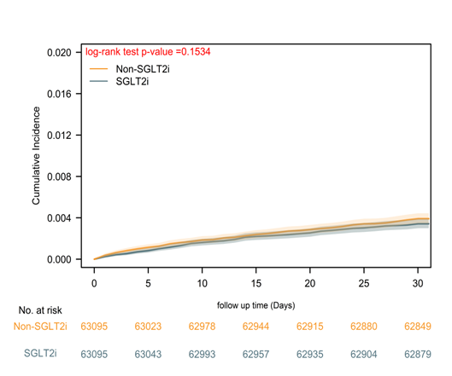
This short-term analysis showed no statistically significant difference in coded cognitive diagnostic outcomes within 30 days. Because the outcome was based on EHR diagnosis codes rather than standardized neuropsychological testing, it should not be interpreted as formally adjudicated POCD.

eFigure 2. Exploratory Medication-Subgroup Patterns for Clinically Coded Postoperative Delirium.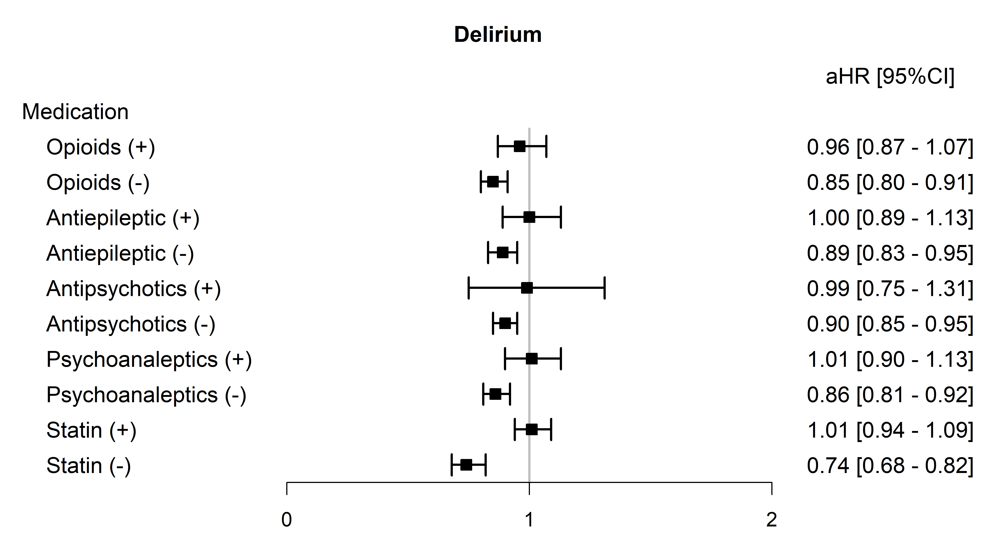
Note: This forest plot shows subgroup patterns according to baseline use of selected central nervous system–active medications and statins. These findings are exploratory and should not be interpreted as evidence of a specific anti-inflammatory mechanism or causal effect modification.
Abbreviations: CI, confidence interval; aHR, adjusted hazard ratio.

eFigure 3. Central Illustration. Biological Plausibility and Methodological Caveats for Preoperative SGLT2 Inhibitor Research. 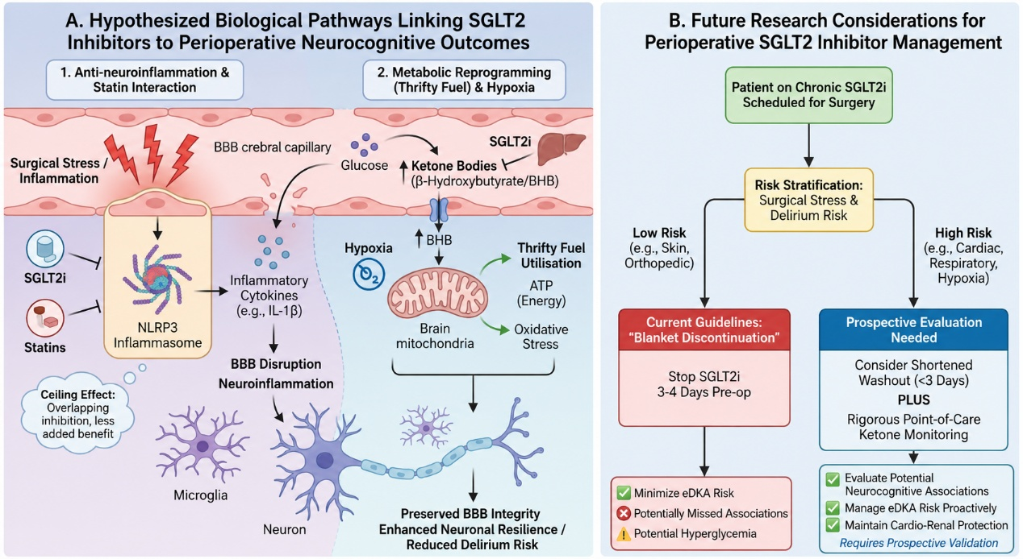
Note: This schematic summarizes hypothesized pathways that may link SGLT2 inhibitor use with perioperative neurocognitive outcomes, including inflammation, blood–brain barrier integrity, mitochondrial metabolism, ketone-body metabolism, and vascular homeostasis. These pathways were not directly measured in this EHR-based study. The figure also emphasizes the need for prospective studies with adjudicated medication exposure, perioperative ketone monitoring, standardized delirium assessment, and better control of surgical and anesthesia-related confounding.

