Additional File 2 — Supplementary Tables and Figures
Manuscript title: C-reactive Protein-to-Albumin Ratio Adds Independent Prognostic Value to the Clinical Frailty Scale in Older Emergency Department Patients: A Multicenter Cohort Study
This file contains five supplementary tables (S1–S5) and two supplementary figures (S1–S2) referenced in the main manuscript.

Table S1. Mortality location and severity proxies
Provides the location-specific breakdown of in-hospital mortality and ICU severity indicators that contextualize the cohort’s mortality rate within the Korean tertiary-care setting.
 | Non-frail (CFS < 5) | Frail (CFS ≥ 5) | Total
ED disposition (overall) | n = 3,715 | n = 2,213 | n = 5,928
Discharged from ED | 2,142 (57.7%) | 852 (38.5%) | 2,994 (50.5%)
Died in ED | 1 (0.03%) | 17 (0.8%) | 18 (0.3%)
Admitted to ward | 1,206 (32.5%) | 951 (43.0%) | 2,157 (36.4%)
Admitted to ICU | 366 (9.9%) | 393 (17.8%) | 759 (12.8%)
In-hospital mortality by location
ED death rate | 1/1 (100%) | 17/17 (100%) | 18/18 (100%)
Ward death rate | 28/1,206 (2.3%) | 80/951 (8.4%) | 108/2,157 (5.0%)
ICU death rate | 49/366 (13.4%) | 63/393 (16.0%) | 112/759 (14.8%)
Distribution of in-hospital deaths (% of total deaths, N = 238)
ED | — | — | 18 (7.6%)
Ward | — | — | 108 (45.4%)
ICU | — | — | 112 (47.1%)
Severity proxies among ICU admissions (N = 759)
Altered AVPU at presentation, n (%) | — | — | 237 (31.2%)
Lactate > 2 mmol/L (≈ 18 mg/dL), n (%) | — | — | 240 (31.6%)
Median ICU/hospital LOS, days [IQR] | — | — | 12 [6–22]
30-day in-hospital mortality | 71 (1.9%) | 153 (6.9%) | 224 (3.8%)
Interpretation. The 4.0% in-hospital mortality observed in this cohort is somewhat lower than rates reported from some Western ED cohorts of older adults; this reflects the case-mix of the three Korean tertiary EDs in this study and Korean practice patterns in ICU triage thresholds. The 14.8% ICU mortality similarly reflects a Korean tertiary ICU case-mix that includes patients who would be managed in step-down or high-dependency beds in some Western health systems. Thirty-one percent of ICU patients had altered AVPU and 32% had elevated lactate, with median ICU stay of 12 days, confirming genuine critical-care intensity, but with a broader case-mix than a narrow Western definition of ICU. The 5.0% ward-level mortality reflects Korean hospitalization patterns in which patients with comfort-care preferences and unexpected deteriorations are managed on general wards. The frailty-associated relative mortality risk was largest on the ward (3.6×) and attenuated within ICU (1.2×), suggesting that frailty’s incremental prognostic information is most actionable for patients destined for non-critical-care beds—exactly the population that the proposed CFS + CAR framework is intended to triage.

Table S2. Univariable (unadjusted) prognostic performance
Presented in parallel to the multivariable adjusted analysis (main Tables 2 and 3) for direct comparison with prior CFS literature that reports unadjusted associations.
Outcome / Model | Unadjusted OR (95% CI); p | AUROC (95% CI) | ΔAUC vs. CFS-alone | p (DeLong)
In-hospital mortality
CFS alone | 1.50 (1.40–1.61); <0.001 | 0.703 (0.666–0.737) | reference | —
CAR alone (per unit log[1+CAR]) | 1.47 (1.30–1.67); <0.001 | 0.637 (0.597–0.677) | −0.066 | <0.001
CFS + CAR (unadjusted combination) | CFS 1.44; CAR 1.35 | 0.726 (0.691–0.759) | +0.023 | 0.013
Hospital admission
CFS alone | 1.25 (1.21–1.30); <0.001 | 0.609 (0.595–0.623) | reference | —
CAR alone | 1.31 (1.23–1.39); <0.001 | 0.599 (0.585–0.613) | −0.010 | 0.27
CFS + CAR (unadjusted combination) | CFS 1.22; CAR 1.25 | 0.634 (0.620–0.649) | +0.025 | <0.001
ICU admission
CFS alone | 1.22 (1.14–1.29); <0.001 | 0.602 (0.579–0.621) | reference | —
CAR alone | 1.19 (1.07–1.31); <0.001 | 0.565 (0.543–0.586) | −0.037 | 0.020
CFS + CAR (unadjusted combination) | CFS 1.20; CAR 1.13 | 0.613 (0.592–0.632) | +0.011 | 0.022
In the unadjusted combined model, both predictors retained statistically significant independent associations with the outcome, paralleling the multivariable adjusted analysis presented in main Table 2.

Table S3. Sensitivity analyses
Robustness of incremental CFS + CAR performance across inflammation strata, comorbidity sensitivity adjustment, and the alternative outcome of 30-day in-hospital mortality.
Sensitivity analysis | N | Mortality, n (%) | Baseline AUROC | Full AUROC | ΔAUC | CFS aOR (p) | log(1+CAR) aOR (p)
Sepsis-likely (CRP ≥ 50 mg/L OR lactate > 2 mmol/L) | 2,073 | 155 (7.5) | 0.850 | 0.852 | +0.003 | 1.11 (0.052) | 1.03 (0.679)
Low inflammation (CRP < 10 mg/L AND lactate ≤ 2 mmol/L) | 2,892 | 59 (2.0) | 0.909 | 0.923 | +0.014 | 1.11 (0.214) | 2.55 (0.020)
Baseline + kidney dysfunction (Cr ≥ 1.5) + anaemia (Hb < 12) | 5,928 | 238 (4.0) | 0.874 | 0.884 | +0.010 | 1.12 (0.007) | 1.22 (<0.001)
30-day in-hospital mortality | 5,928 | 224 (3.8) | 0.872 | 0.886 | +0.014 | 1.13 (0.007) | 1.29 (<0.001)
SpO₂-documented subset, with SpO₂ covariate | 2,999 | 175 (5.8) | 0.853 | 0.862 | +0.009 | 1.08 (0.111) | 1.24 (0.001)
First encounter per patient | 5,235 | 206 (3.9) | 0.875 | 0.885 | +0.010 | 1.13 (0.009) | 1.26 (<0.001)
The incremental contribution of the combined CFS + CAR signal was preserved across (i) the addition of laboratory-based comorbidity proxies, arguing against confounding by unmeasured comorbidity; and (ii) the alternative outcome of 30-day in-hospital mortality, confirming that the principal findings are not driven by deaths occurring late in prolonged hospitalizations. In the sepsis-likely subgroup, where systemic inflammation already drives most of the prognostic signal, CFS retained borderline significance and CAR was no longer independently associated, consistent with attenuation of the inflammatory-axis information when its variance is constrained by inclusion criteria. In the low-inflammation subgroup, CAR retained a strong independent association (aOR 2.55), arguing against CAR functioning solely as a sepsis biomarker.

Table S4. Comparison of included (N = 5,928) and excluded (N = 369) older ED patients
To enable transparent assessment of selection bias arising from complete-case exclusion of patients with missing CFS, CRP, or albumin.
Variable | Included (N = 5,928) | Excluded (N = 369) | p | SMD
Demographics
Age, years | 76 [70–83] | 75 [69–82] | 0.052 | 0.10
Male, n (%) | 2,673 (45.1) | 198 (53.7) | 0.002 | 0.17
Study site, n (%) |  |  | <0.001
Ewha Womans Univ. Seoul | 2,896 (48.9) | 6 (1.6) |  | 1.30
Ewha Womans Univ. Mokdong | 2,013 (34.0) | 352 (95.4) |  | 1.68
Chung-Ang Univ. Gwangmyeong | 1,019 (17.2) | 11 (3.0) |  | 0.49
Korean Triage and Acuity Scale, n (%) |  |  | <0.001
Level 1 (Resuscitation) | 40 (0.7) | 0 (0.0) |  | 0.12
Level 2 (Emergent) | 987 (16.6) | 23 (6.2) |  | 0.33
Level 3 (Urgent) | 4,280 (72.2) | 220 (59.6) |  | 0.27
Level 4 (Less urgent) | 573 (9.7) | 112 (30.4) |  | 0.54
Level 5 (Non-urgent) | 48 (0.8) | 14 (3.8) |  | 0.20
Clinical Frailty Scale | 4 [3–6] | 4 [3–5] | 0.385 | 0.06
Systolic blood pressure, mmHg | 138 [119–156] | 138 [123–154] | 0.592 | 0.04
Diastolic blood pressure, mmHg | 73 [63–84] | 72 [63–82] | 0.355 | 0.03
Heart rate, /min | 85 [72–99] | 86 [75–98] | 0.364 | 0.03
Respiratory rate, /min | 20 [20–20] | 20 [18–20] | <0.001 | 0.27
Body temperature, °C | 36.8 [36.4–37.3] | 36.7 [36.4–37.0] | <0.001 | 0.14
Oxygen saturation (when measured), % | 97 [96–98] | 98 [97–98] | 0.135 | 0.25
Altered AVPU (V/P/U), n (%) | 491 (8.3) | 3 (0.8) | <0.001 | 0.36
White blood cell count, ×10⁹/L | 7.5 [5.7–10.4] | 8.0 [6.5–10.2] | 0.155 | 0.05
Haemoglobin, g/dL | 12.2 [10.5–13.6] | 12.3 [10.9–13.4] | 0.973 | 0.00
Creatinine, mg/dL | 0.8 [0.7–1.1] | 0.9 [0.7–1.3] | 0.076 | 0.03
C-reactive protein, mg/L | 4.0 [0.8–28.6] | — | — | —
Albumin, g/dL | 4.0 [3.4–4.3] | — | — | —
C-reactive protein-to-albumin ratio (CAR) | 1.0 [0.2–7.9] | — | — | —
Hospital admission, n (%) | 2,916 (49.2) | 93 (25.2) | <0.001 | 0.51
ICU admission, n (%) | 759 (12.8) | 13 (3.5) | <0.001 | 0.34
In-hospital mortality, n (%) | 238 (4.0) | 3 (0.8) | 0.003 | 0.21
ED length of stay, min | 206 [136–299] | 102 [60–174] | <0.001 | 0.74
Continuous variables, median [IQR]; categorical, n (%). p from Mann–Whitney U or χ² test. SMD, standardized mean difference; |SMD| < 0.10 indicates a negligible difference. Exposure variables (CRP, albumin, CAR) were unavailable in excluded patients by definition. Among excluded patients, SpO₂ and ancillary laboratory values were documented only in a minority (SpO₂ n = 92; WBC/haemoglobin n = 83; creatinine n = 60).

Table S5. Comparison of in-hospital survivors and non-survivors (N = 5,928)
Provided in response to reviewer request for a direct comparison of patients who died in hospital versus those who survived.
Variable | Survivors (N = 5,690) | Non-survivors (N = 238) | p
Age, years | 76 [70–83] | 81 [75–86] | <0.001
Clinical Frailty Scale | 4 [3–6] | 6 [4–7] | <0.001
Frail (CFS ≥ 5), n (%) | 2,053 (36.1) | 160 (67.2) | <0.001
Systolic blood pressure, mmHg | 139 [121–157] | 114 [89–139] | <0.001
Heart rate, /min | 84 [72–98] | 98 [78–112] | <0.001
Altered AVPU (V/P/U), n (%) | 371 (6.5) | 120 (50.4) | <0.001
C-reactive protein, mg/L | 3.8 [0.8–27.2] | 16.8 [1.6–91.9] | <0.001
Albumin, g/dL | 4.0 [3.5–4.3] | 3.3 [2.7–4.1] | <0.001
C-reactive protein-to-albumin ratio (CAR) | 0.98 [0.20–7.40] | 4.70 [0.48–33.25] | <0.001
CAR upper quartile (> 7.91), n (%) | 1,375 (24.2) | 107 (45.0) | <0.001
Continuous variables, median [IQR]; categorical, n (%). p from Mann–Whitney U or χ² test.

Figure S1. Calibration plot for in-hospital mortality
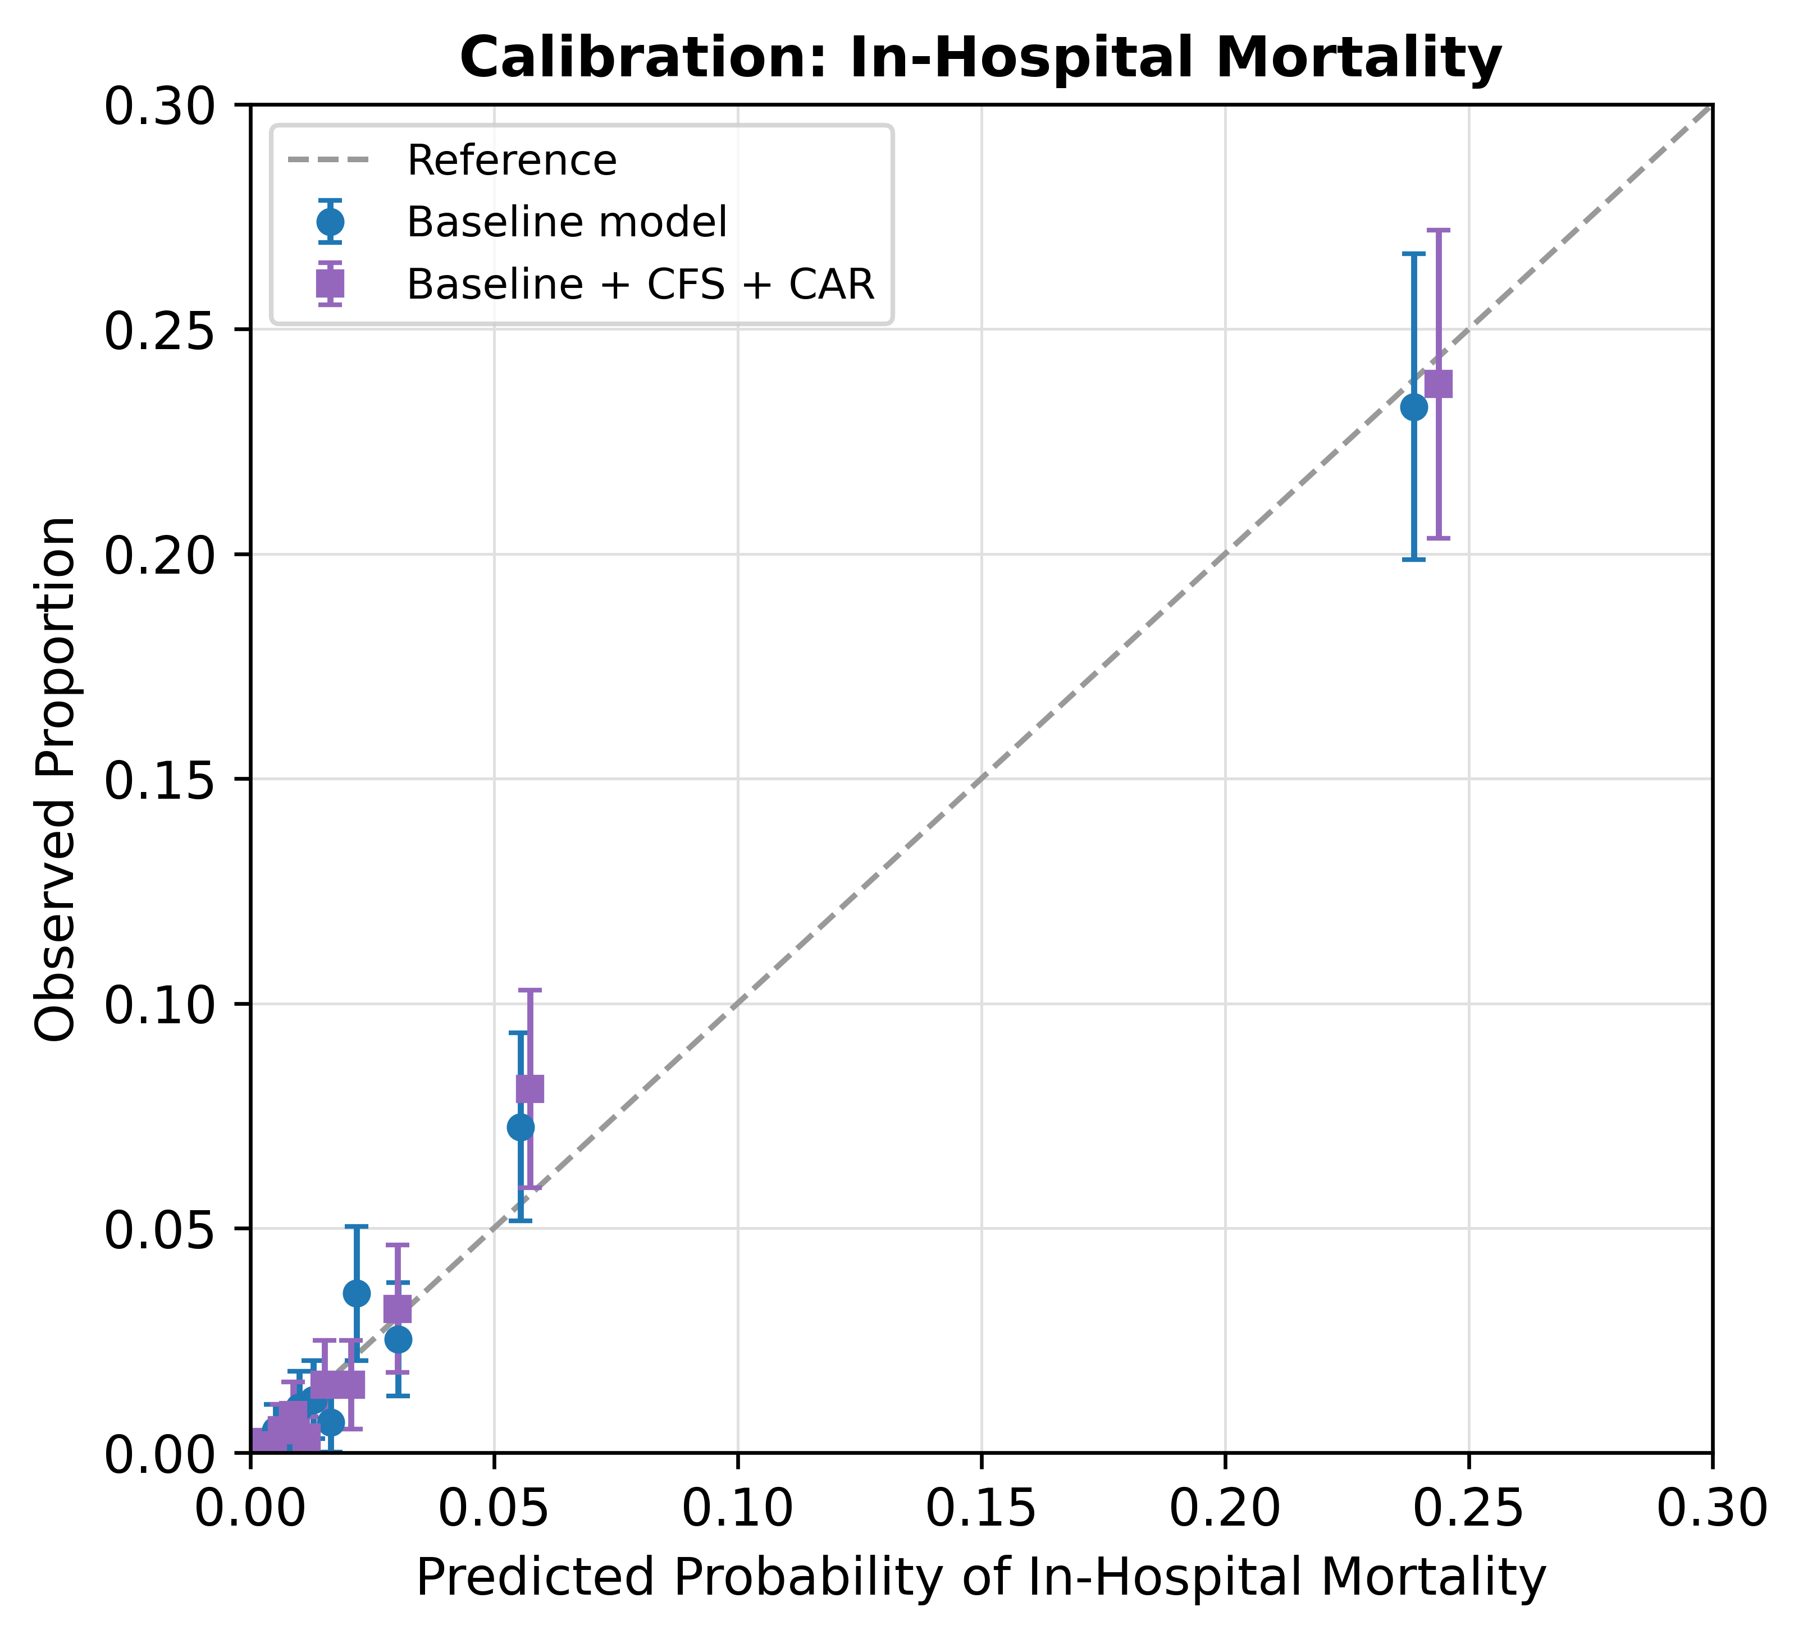
Decile-binned observed versus predicted probabilities for the baseline and the baseline + CFS + CAR models; the dashed line denotes perfect calibration.

Figure S2. Decision-curve analysis for in-hospital mortality
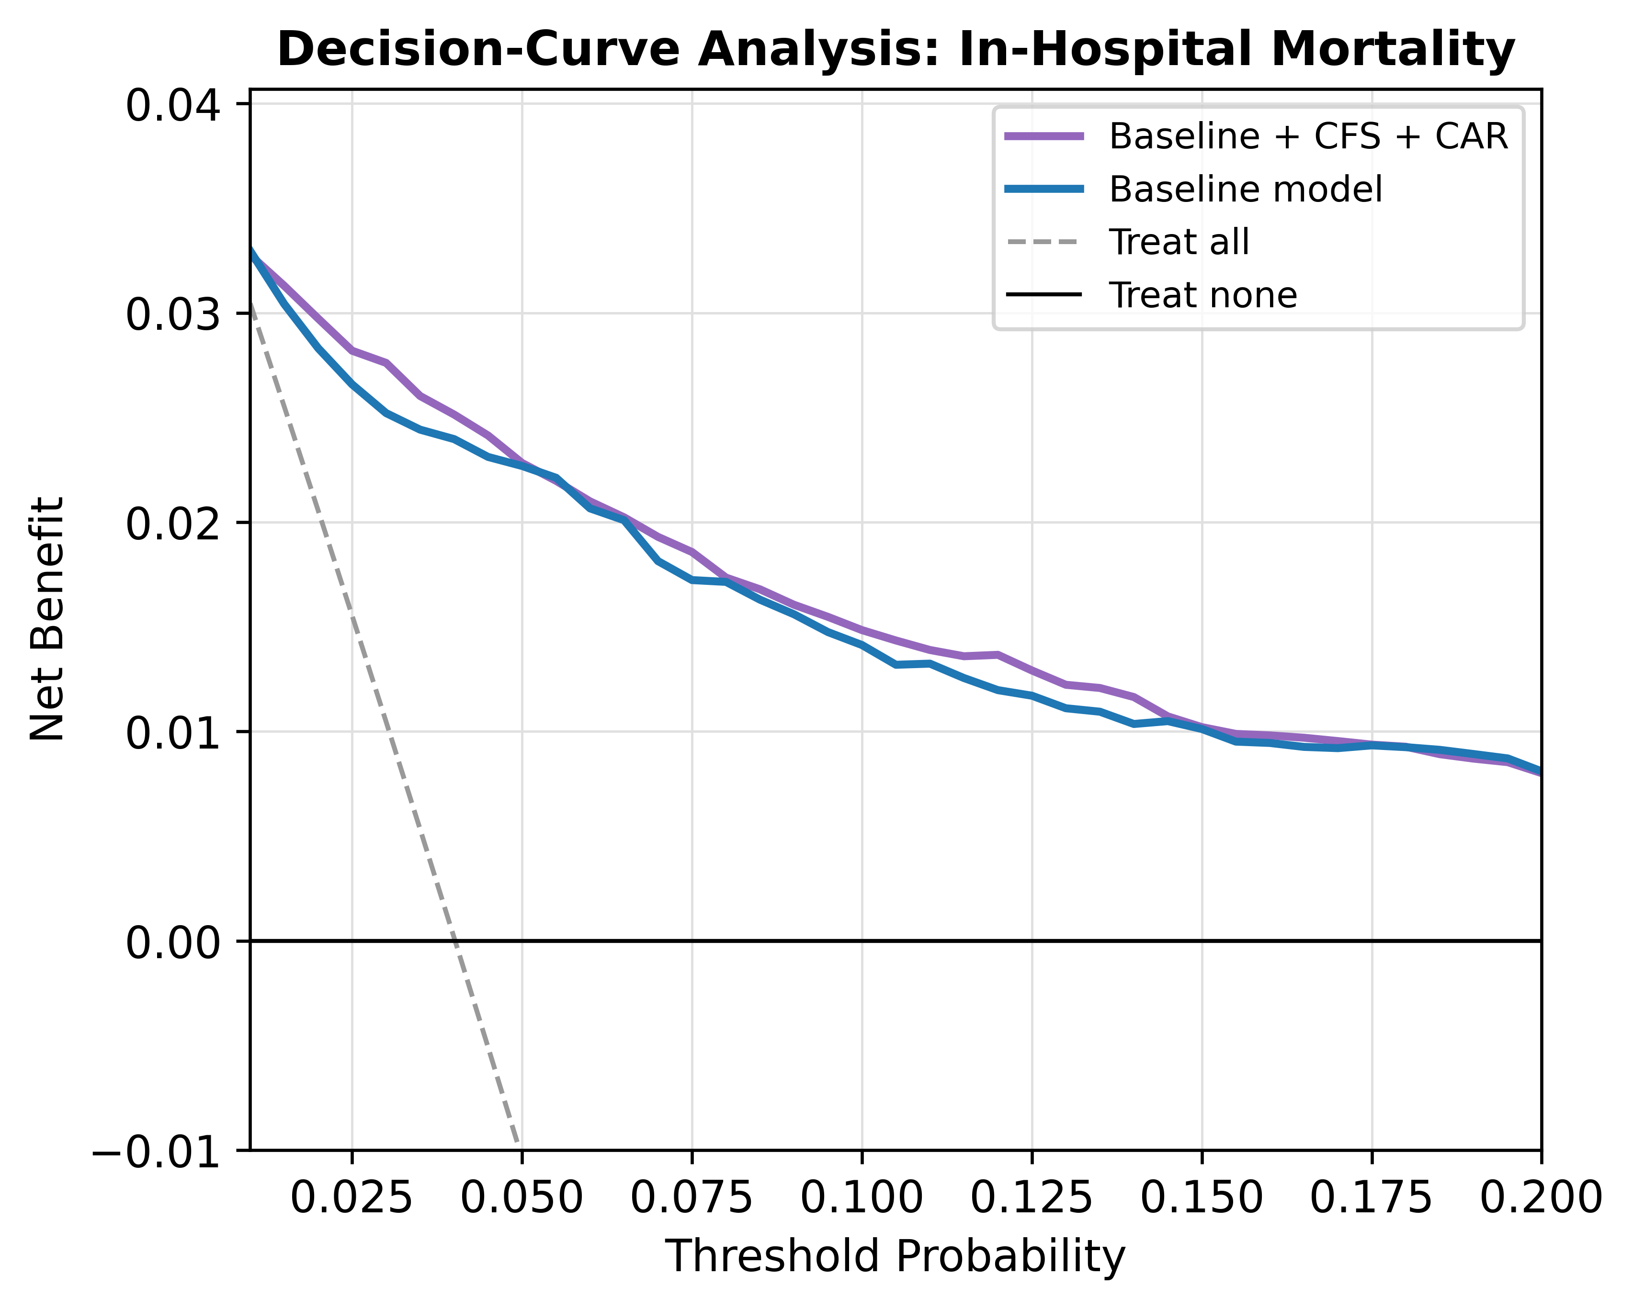
Net benefit of the baseline and the baseline + CFS + CAR models versus the treat-all and treat-none strategies across threshold probabilities of 1–20%.

