Supplementary Material
Early Prediction of Clinical Deterioration in Older Adults With Suspected Infection Admitted From the Emergency Department to General Wards: A Multicenter Machine Learning Study
Contents:
Table S1. TRIPOD+AI reporting checklist
Table S2. Proportion of missing values per variable
Table S3. Model performance at clinically defined operating thresholds
Table S4. Proposed risk tiers and illustrative clinical actions
Table S5. Cumulative proportion of composite events within increasing time windows after ward admission (blanking-period sensitivity analysis)
Figure S1. Decision-curve analysis

Table S1. TRIPOD+AI reporting checklist

Item | D/E | Checklist item | Reported in
Title
1 | D;E | Identify the study as developing or evaluating a multivariable prediction model, the target population, and the outcome to be predicted | Title
Abstract
2 | D;E | Structured summary (see TRIPOD+AI for Abstracts checklist) | Abstract
Introduction
3a | D;E | Healthcare context and rationale for developing/evaluating the model, including references to existing models | Introduction
3b | D;E | Target population and intended purpose of the model in the care pathway, including intended users | Introduction
3c | D;E | Known health inequalities between sociodemographic groups | Not assessed (Discussion, Limitations)
4 | D;E | Study objectives, specifying development and/or validation | Introduction
Methods
5a | D;E | Sources of data (development and evaluation separately), rationale, and representativeness | Methods, Study Setting and Population
5b | D;E | Dates of participant data, including start and end of accrual | Methods (2016–2023)
6a | D;E | Key elements of the study setting, including number and location of centres | Methods, Study Setting and Population
6b | D;E | Eligibility criteria for participants | Methods, Study Setting and Population
6c | D;E | Treatments received and how handled, if relevant | Methods (ED management variables)
7 | D;E | Data pre-processing and quality checking | Methods, Data Extraction and Feature Preparation; Table S2
8a | D;E | Outcome definition and time horizon, including how and when assessed and rationale | Methods, Outcome (48-hour composite)
8b | D;E | Qualifications of outcome assessors, if subjective | Not applicable (objective EHR-defined outcome)
8c | D;E | Blinding of outcome assessment | Not applicable
9a | D | Choice of initial predictors and any pre-selection before model building | Methods, Data Extraction and Feature Preparation
9b | D;E | Definition of all predictors, including how and when measured | Methods; Table 1
9c | D;E | Qualifications of predictor assessors, if subjective | Not applicable (structured EHR variables)
10 | D;E | How study size was arrived at and its justification | Methods; Results (events and events per variable)
11 | D;E | How missing data were handled; reasons for omitting data | Methods, Data Extraction; Table S2
12a | D | How data were used (development and evaluation), including partitioning | Methods, Model Development and Validation (patient-level split)
12b | D | How predictors were handled (functional form, rescaling, transformation) | Methods, Model Development and Validation
12c | D | Type of model, rationale, building steps, hyperparameter tuning, internal validation | Methods, Model Development and Validation
12d | D;E | Handling and quantification of heterogeneity across clusters | External validation across hospitals (Methods; Results)
12e | D;E | Measures and plots used to evaluate model performance and compare models | Methods, Evaluation of Model Performance
12f | E | Model updating (e.g., recalibration) from evaluation | Methods (isotonic recalibration)
12g | E | How model predictions were calculated (formula, code, object, API) | Availability of data and materials; GitHub repository
13 | D;E | Class imbalance methods, why and how, and any subsequent recalibration | Methods (AUPRC as primary metric; no resampling)
14 | D;E | Approaches used to address model fairness and their rationale | Not formally assessed (Discussion, Limitations)
15 | D | Model output (e.g., probabilities, classification) and threshold identification | Methods; Tables S3–S4
16 | D;E | Differences between development and evaluation data (setting, eligibility, outcome, predictors) | Methods; Table 1; Results
17 | D;E | Ethics committee approval and informed consent or waiver | Methods, Ethics
Open science
18a | D;E | Source of funding and role of funders | Funding
18b | D;E | Conflicts of interest and financial disclosures | Declarations, Competing interests
18c | D;E | Where the study protocol can be accessed, or that none was prepared | No protocol was prepared
18d | D;E | Registration information, or that the study was not registered | The study was not registered
18e | D;E | Availability of the study data | Availability of data and materials
18f | D;E | Availability of the analytical code | Availability of data and materials; GitHub repository
Patient and public involvement
19 | D;E | Patient and public involvement, or a statement of no involvement | No patient or public involvement
Results
20a | D;E | Flow of participants, including numbers with and without the outcome | Figure 1
20b | D;E | Characteristics overall and by data source, including key dates, predictors, and missing data | Table 1
20c | E | Comparison with development data of the distribution of important predictors | Table 1 (standardized mean differences)
21 | D;E | Number of participants and outcome events in each analysis | Methods; Results
22 | D | Full model specification to allow predictions in new individuals | Availability of data and materials; GitHub repository
23a | D;E | Model performance estimates with confidence intervals, including key subgroups | Results; Figures 2–3; Tables S3–S4
23b | D;E | Results of any heterogeneity in performance across clusters | Results (external validation)
24 | E | Results of any model updating | Results; Figure 3 (calibration)
Discussion
25 | D;E | Overall interpretation of results, including fairness and prior studies | Discussion
26 | D;E | Limitations of the study and their effects | Discussion, Limitations
27a | D | How poor-quality or unavailable input data should be handled at implementation | Discussion; imputation pipeline (GitHub repository)
27b | D | Whether users interact with the input data or model, and expertise required | Discussion (EHR-embedded, automated scoring)
27c | D;E | Next steps for future research on applicability and generalisability | Discussion
Adapted from Collins GS, Moons KGM, Dhiman P, et al. TRIPOD+AI statement: updated guidance for reporting clinical prediction models that use regression or machine learning methods. BMJ. 2024;385:e078378. D, applies to model development; E, applies to model evaluation.

Table S2. Proportion of missing values per variable
Variable | Overall, % | Development, % | External, %
Body mass index | 44.8 | 35.1 | 71.5
Body temperature_a | 0.1 | 0.1 | <0.1
Heart rate_a | 0.6 | 0.7 | 0.2
Systolic BP_a | 1.4 | 1.7 | 0.7
Diastolic BP_a | 1.6 | 1.9 | 0.9
Respiratory rate_a | 0.3 | 0.4 | 0.1
Body temperature_e | <0.1 | <0.1 | <0.1
Heart rate_e | <0.1 | <0.1 | <0.1
Systolic BP_e | 0.3 | 0.3 | 0.2
Diastolic BP_e | <0.1 | <0.1 | <0.1
Respiratory rate_e | 0.1 | 0.1 | <0.1
White blood cell | 2.4 | 2.8 | 1.4
Segmented neutrophil | 4.8 | 5.5 | 2.8
Band neutrophil† | 4.8 | 5.5 | 2.8
Hemoglobin | 4.6 | 4.8 | 4.1
Platelet | 5.2 | 5.5 | 4.4
Glucose | 9.0 | 10.5 | 4.8
Creatinine | 10.2 | 9.4 | 12.5
AST | 76.8 | 71.1 | 92.6
ALT | 23.9 | 29.3 | 9.1
Total bilirubin | 72.0 | 74.9 | 63.8
Sodium | 5.4 | 6.1 | 3.7
Potassium | 5.2 | 5.7 | 3.6
C-reactive protein | 4.0 | 3.6 | 4.9
Albumin | 85.2 | 86.7 | 81.1
Troponin I | 55.5 | 64.2 | 31.8
Blood pH | 88.0 | 83.9 | 99.4

Table S3. Model performance at clinically defined operating thresholds
Model | Operating point | Threshold | Sensitivity, % | Specificity, % | PPV, % | NPV, % | Alerts per true positive
Internal test set
CatBoost | 90% sensitivity | 0.013 | 93.2 | 52.0 | 5.5 | 99.6 | 18.2
CatBoost | 80% sensitivity | 0.033 | 80.4 | 73.6 | 8.3 | 99.2 | 12.0
CatBoost | Youden index | 0.033 | 80.4 | 73.6 | 8.3 | 99.2 | 12.0
XGBoost | 90% sensitivity | 0.019 | 91.8 | 52.6 | 5.5 | 99.5 | 18.3
XGBoost | 80% sensitivity | 0.024 | 82.1 | 70.2 | 7.6 | 99.2 | 13.1
XGBoost | Youden index | 0.024 | 82.1 | 70.2 | 7.6 | 99.2 | 13.1
External test set
CatBoost | 90% sensitivity | 0.007 | 90.9 | 48.6 | 2.9 | 99.7 | 34.6
CatBoost | 80% sensitivity | 0.023 | 81.2 | 67.1 | 4.0 | 99.5 | 25.1
CatBoost | Youden index | 0.057 | 71.1 | 79.3 | 5.5 | 99.4 | 18.3
XGBoost | 90% sensitivity | 0.004 | 97.3 | 22.1 | 2.1 | 99.8 | 48.6
XGBoost | 80% sensitivity | 0.019 | 87.5 | 53.5 | 3.1 | 99.6 | 32.6
XGBoost | Youden index | 0.048 | 72.0 | 77.9 | 5.2 | 99.4 | 19.3
Thresholds achieve 90% and 80% sensitivity and the Youden-index maximum, applied to isotonic-calibrated probabilities. PPV, positive predictive value; NPV, negative predictive value. Alerts per true positive = 1/PPV.

Table S4. Proposed risk tiers and illustrative clinical actions
Risk tier | Calibrated 48-h risk | Patients, n (%) | Observed deterioration rate | Suggested clinical action
Low | < 1% | 18,313 (51.8%) | 0.34% | Routine ward care and standard monitoring
Intermediate | 1% to < 10% | 15,165 (42.9%) | 1.95% | Enhanced monitoring and earlier clinical reassessment
High | ≥ 10% | 1,883 (5.3%) | 12.06% | Senior or ICU review and reconsideration of monitoring intensity
Tiers are based on the isotonic-calibrated 48-hour risk from the CatBoost model in the external validation cohort (overall event rate 1.65%). The high-risk tier comprised 5.3% of patients but had an observed deterioration rate of 12.06%, approximately seven times the overall rate. Suggested actions are illustrative and require prospective validation.

Table S5. Cumulative proportion of composite events within increasing time windows after ward admission (blanking-period sensitivity analysis)

Time after ward admission | Development | External
≤ 1 h | 5.2% | 2.0%
≤ 2 h | 14.9% | 4.6%
≤ 4 h | 31.1% | 9.6%
≤ 6 h | 43.7% | 16.9%
≤ 12 h | 54.4% | 32.1%
≤ 24 h | 73.8% | 53.9%
Values are the cumulative proportion of composite events occurring within each window after ward admission.

Figure S1. Decision-curve analysis
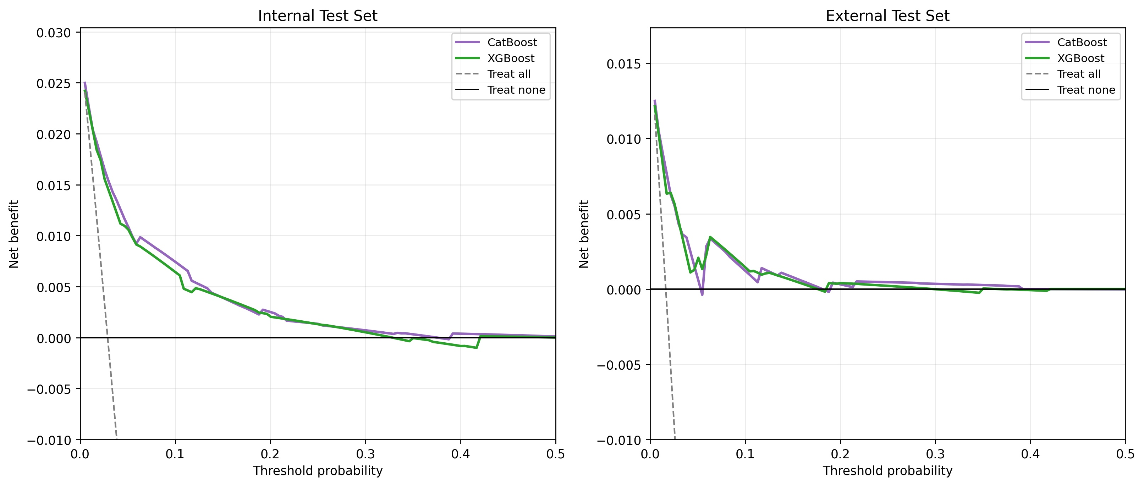
Net benefit of the CatBoost and XGBoost models across threshold probabilities in the internal and external test sets, compared with treat-all and treat-none strategies. Across the clinically relevant range, both models provided higher net benefit than either default strategy.

