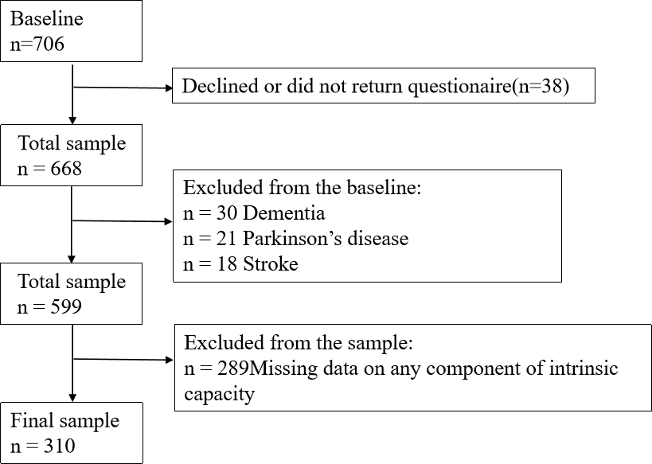

Figure S1 Assembly of the study sample

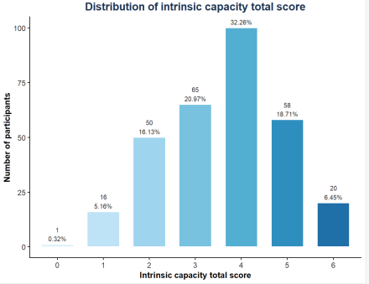
Figure S2 Distribution of intrinsic capacity total score

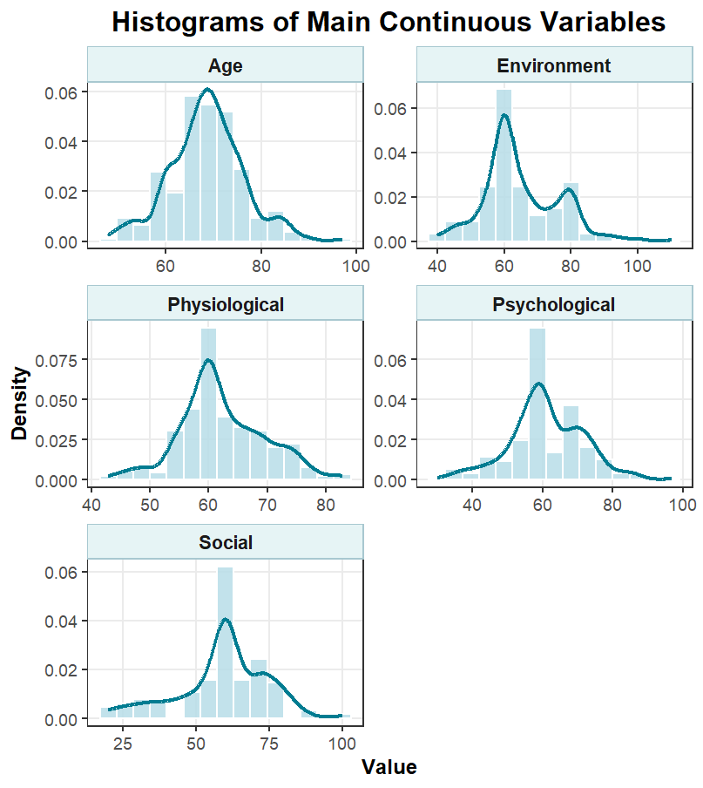Figure S3 Histograms of main continuous variables

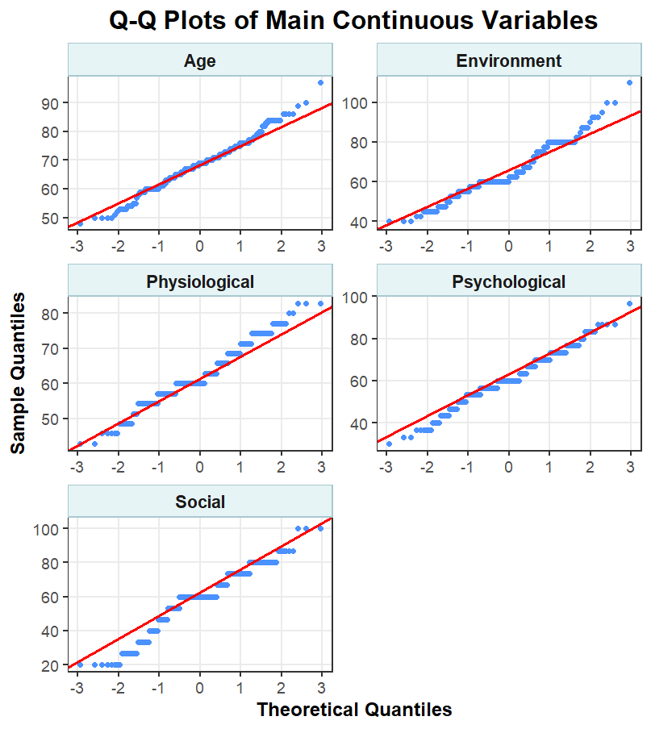
Figure S4 Q-Q plots of main continuous variables

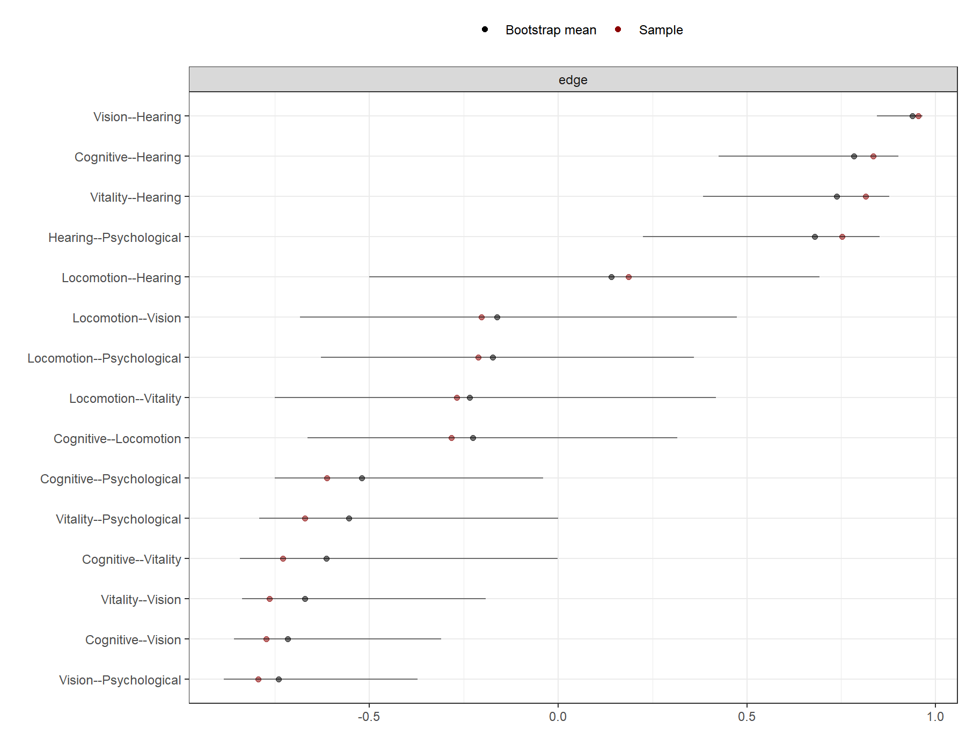
Figure S5 Bootstrap 95% confidence intervals for IC network edge weights

