Additional file 1. Supplementary material
This supplement provides selected exploratory correlations (Table S1 and Figure S2), primary-model diagnostics (Table S2), sensitivity analyses incorporating waist-to-hip ratio (Table S3), a physical-activity specification sensitivity analysis (Table S4), deterministic replacement sensitivity analyses for missing grip strength (Table S5), terminal-digit assessment of recorded BP values (Table S6 and Figure S3), BP rounding and site-exclusion sensitivity analyses (Table S7), and the full-model forest plot (Figure S1). All site/altitude coefficients are conditional on the three fixed sites and do not incorporate replicated between-site variability.

Table S1. Selected exploratory correlations
Variable pair | N | Spearman ρ | P value | Pearson r | P value
Site/altitude vs SBP | 454 | 0.205 | <0.001 | 0.235 | <0.001
Site/altitude vs DBP | 454 | 0.142 | 0.002 | 0.133 | 0.005
Site/altitude vs grip strength | 433 | -0.229 | <0.001 | -0.269 | <0.001
Session duration vs SBP | 454 | -0.094 | 0.046 | -0.072 | 0.126
Session duration vs DBP | 454 | -0.063 | 0.181 | -0.062 | 0.185
Session duration vs grip strength | 433 | 0.098 | 0.041 | 0.076 | 0.114
Physical-activity frequency vs session duration | 454 | 0.827 | <0.001 | 0.729 | <0.001
BMI vs DBP | 454 | 0.116 | 0.013 | 0.110 | 0.019
Site/altitude vs WHR | 439 | 0.415 | <0.001 | 0.399 | <0.001
WHR vs DBP | 439 | 0.075 | 0.116 | 0.043 | 0.374
BMI vs WHR | 439 | 0.206 | <0.001 | 0.182 | <0.001
Spearman correlations were used as the primary exploratory measure; Pearson coefficients are shown only as sensitivity checks for direction and general magnitude. Site/altitude denotes the three sites coded by their elevations. WHR, waist-to-hip ratio; BMI, body mass index; SBP, systolic blood pressure; DBP, diastolic blood pressure.

Table S2. Model diagnostics for the primary multivariable models
Outcome | N | Adjusted R² | Residual SD | Max VIF | Breusch–Pagan P | Shapiro–Wilk P
Systolic BP | 454 | 0.062 | 11.086 | 2.994 | 0.011 | 0.002
Diastolic BP | 454 | 0.023 | 8.737 | 2.994 | 0.005 | <0.001
Grip strength | 433 | 0.158 | 7.021 | 3.106 | 0.009 | <0.001
VIF values were below conventional concern thresholds, indicating that multicollinearity was not a major concern after including physical-activity frequency and session duration simultaneously. Breusch–Pagan tests indicated heteroskedasticity, motivating HC3 robust-standard-error inference. Shapiro–Wilk results are reported descriptively as residual-distribution diagnostics. VIF, variance inflation factor; SD, standard deviation; BP, blood pressure.

Table S3. Sensitivity analyses incorporating waist-to-hip ratio
Model and outcome | Predictor | β (95% CI) | P value
Model A: SBP (n = 439) | Site/altitude, per 1000 m | 3.82 (1.85 to 5.79) | <0.001
 | BMI, per kg/m² | 0.21 (−0.08 to 0.50) | 0.155
 | WHR, per unit | 13.53 (−3.72 to 30.78) | 0.124
Model A: DBP (n = 439) | Site/altitude, per 1000 m | 2.05 (0.46 to 3.65) | 0.012
 | BMI, per kg/m² | 0.29 (0.08 to 0.51) | 0.008
 | WHR, per unit | −2.70 (−15.04 to 9.64) | 0.668
Model A: Grip strength (n = 418) | Site/altitude, per 1000 m | −2.83 (−4.11 to −1.56) | <0.001
 | BMI, per kg/m² | 0.11 (−0.08 to 0.30) | 0.248
 | WHR, per unit | −8.99 (−20.02 to 2.04) | 0.110
Model B: SBP (n = 439) | Site/altitude, per 1000 m | 3.68 (1.71 to 5.64) | <0.001
 | WHR, per unit | 15.97 (−1.14 to 33.08) | 0.067
Model B: DBP (n = 439) | Site/altitude, per 1000 m | 1.85 (0.28 to 3.42) | 0.021
 | WHR, per unit | 0.73 (−11.15 to 12.61) | 0.904
Model B: Grip strength (n = 418) | Site/altitude, per 1000 m | −2.94 (−4.19 to −1.69) | <0.001
 | WHR, per unit | −7.56 (−18.41 to 3.29) | 0.172
Model A added waist-to-hip ratio (WHR) to the primary covariate set while retaining body mass index (BMI); Model B replaced BMI with WHR. Both models were adjusted for age, sex, site/altitude, physical-activity frequency, and session duration. Model A additionally included both BMI and WHR, whereas Model B included WHR without BMI. Analyses were restricted to participants with a recorded WHR (n = 439 for SBP and DBP; n = 418 for grip strength). WHR was taken from the recorded two-decimal field in the analytic extract. Only the coefficients for site/altitude, BMI where applicable, and WHR are displayed; all specified adjustment covariates were retained in the fitted models. Coefficients are ordinary least-squares estimates with HC3 robust 95% confidence intervals and P values. The largest variance inflation factor for the WHR term across Models A and B was 1.41. β, unstandardized regression coefficient; CI, confidence interval; WHR, waist-to-hip ratio; BMI, body mass index; SBP, systolic blood pressure; DBP, diastolic blood pressure; VIF, variance inflation factor; HC3, heteroskedasticity-consistent standard errors (type 3). The site/altitude estimates are conditional on the three fixed sites and do not incorporate replicated between-site variability.

Table S4. Sensitivity analysis omitting session duration and retaining physical-activity frequency
Model and outcome | Predictor | β (95% CI) | P value
SBP (n = 454) | Age, years | 0.10 (-0.27 to 0.48) | 0.581
 | Male sex | 1.55 (-0.52 to 3.61) | 0.142
 | Site/altitude, per 1000 m | 4.51 (2.84 to 6.19) | <0.001
 | BMI, kg/m² | 0.26 (-0.01 to 0.54) | 0.059
 | Low-frequency physical activity vs sedentary | -1.89 (-6.34 to 2.57) | 0.407
 | Regular physical activity vs sedentary | -4.15 (-8.12 to -0.17) | 0.041
DBP (n = 454) | Age, years | -0.10 (-0.39 to 0.18) | 0.477
 | Male sex | -1.02 (-2.66 to 0.63) | 0.227
 | Site/altitude, per 1000 m | 1.98 (0.60 to 3.35) | 0.005
 | BMI, kg/m² | 0.27 (0.06 to 0.47) | 0.010
 | Low-frequency physical activity vs sedentary | -0.03 (-2.82 to 2.75) | 0.981
 | Regular physical activity vs sedentary | -1.55 (-3.83 to 0.73) | 0.183
Grip strength (n = 433) | Age, years | -0.29 (-0.51 to -0.06) | 0.015
 | Male sex | 4.32 (2.97 to 5.66) | <0.001
 | Site/altitude, per 1000 m | -3.25 (-4.38 to -2.11) | <0.001
 | BMI, kg/m² | 0.05 (-0.13 to 0.23) | 0.556
 | Low-frequency physical activity vs sedentary | 0.74 (-2.03 to 3.51) | 0.602
 | Regular physical activity vs sedentary | 2.14 (-0.14 to 4.43) | 0.066
All models were adjusted for age, sex, site/altitude, BMI, and physical-activity frequency; session duration was omitted. Coefficients are ordinary least-squares estimates with HC3 robust 95% confidence intervals and P values. The site/altitude and BMI–DBP estimates were essentially unchanged from the primary models. The nominal regular-physical-activity coefficient for SBP (P = 0.041) was specification-sensitive and was not interpreted. The maximum VIF was 1.04. β, unstandardized regression coefficient; CI, confidence interval; BMI, body mass index; SBP, systolic blood pressure; DBP, diastolic blood pressure; VIF, variance inflation factor; HC3, heteroskedasticity-consistent standard errors (type 3).

Table S5. Deterministic replacement sensitivity analyses for missing grip strength
Analysis | Predictor | β (95% CI) | P value
Site- and sex-specific mean replacement (n = 454) | Age, years | -0.28 (-0.50 to -0.06) | 0.011
 | Male sex | 4.17 (2.88 to 5.45) | <0.001
 | Site/altitude, per 1000 m | -3.36 (-4.44 to -2.28) | <0.001
 | BMI, kg/m² | 0.04 (-0.14 to 0.22) | 0.654
 | Low-frequency physical activity vs sedentary | -1.17 (-5.32 to 2.97) | 0.579
 | Regular physical activity vs sedentary | 0.46 (-2.75 to 3.66) | 0.780
 | 30–60 min/session vs <30 min/session | 2.66 (-1.27 to 6.58) | 0.185
 | ≥60 min/session vs <30 min/session | 1.19 (-3.29 to 5.67) | 0.603
Lowest-site sex-specific mean replacement (n = 454) | Age, years | -0.22 (-0.44 to 0.01) | 0.057
 | Male sex | 4.76 (3.46 to 6.06) | <0.001
 | Site/altitude, per 1000 m | -2.87 (-3.97 to -1.78) | <0.001
 | BMI, kg/m² | 0.07 (-0.11 to 0.24) | 0.461
 | Low-frequency physical activity vs sedentary | -0.80 (-4.96 to 3.37) | 0.708
 | Regular physical activity vs sedentary | 1.02 (-2.25 to 4.29) | 0.541
 | 30–60 min/session vs <30 min/session | 2.09 (-1.86 to 6.04) | 0.299
 | ≥60 min/session vs <30 min/session | 0.48 (-3.79 to 4.76) | 0.824
Grip strength was missing for 21 of 454 participants (4.6%). Missingness differed across site/altitude groups and by age; within Nagqu/4500 m it was also more frequent among men. Site differences were assessed using Pearson’s chi-square test, the Nagqu sex comparison using a continuity-corrected chi-square test, and age using Welch’s t test. Two deterministic replacement sensitivity analyses were performed; they were not formal imputations or models of a missing-not-at-random mechanism. The first used site- and sex-specific means. The second assigned every missing value the sex-specific mean of Linzhi/3100 m, a conservative scenario relative to the observed gradient. The site/altitude coefficient remained negative with 95% CIs excluding zero in both analyses. All models were adjusted for age, sex, site/altitude, BMI, physical-activity frequency, and session duration, with HC3 robust standard errors.

Table S6. Mutually exclusive terminal-digit categories in the blood-pressure readings, by site/altitude group
BP component | Site/altitude group | N | Unique values | Terminal digit 0, n (%) | Terminal digit 5, n (%) | Other terminal digit, n (%) | Across-group χ² P
SBP | Linzhi, 3100 m | 157 | 7 | 156 (99.4) | 0 (0.0) | 1 (0.6) | <0.001
SBP | Lhasa, 3650 m | 113 | 27 | 70 (61.9) | 9 (8.0) | 34 (30.1)
SBP | Nagqu, 4500 m | 184 | 28 | 95 (51.6) | 20 (10.9) | 69 (37.5)
DBP | Linzhi, 3100 m | 157 | 6 | 156 (99.4) | 0 (0.0) | 1 (0.6) | <0.001
DBP | Lhasa, 3650 m | 113 | 28 | 45 (39.8) | 12 (10.6) | 56 (49.6)
DBP | Nagqu, 4500 m | 184 | 31 | 90 (48.9) | 7 (3.8) | 87 (47.3)
Terminal-digit categories are mutually exclusive. Across-group χ² tests compared the 0/5/other terminal-digit distribution across the three site/altitude groups for each BP component (SBP χ² = 98.83; DBP χ² = 138.49; both df = 4). In Linzhi/3100 m, SBP values took only seven distinct values and DBP values only six. BP, blood pressure; SBP, systolic blood pressure; DBP, diastolic blood pressure.

Table S7. Blood-pressure rounding and site-exclusion sensitivity analyses using the primary covariate set
Sensitivity analysis | Predictor | β (95% CI) | P value
SBP rounded to nearest 10 mmHg (n = 454) | Age, years | 0.07 (-0.31 to 0.45) | 0.716
 | Male sex | 1.26 (-0.86 to 3.37) | 0.243
 | Site/altitude, per 1000 m | 4.74 (3.03 to 6.45) | <0.001
 | BMI, kg/m² | 0.24 (-0.04 to 0.52) | 0.093
 | Low-frequency physical activity vs sedentary | -1.36 (-8.75 to 6.03) | 0.718
 | Regular physical activity vs sedentary | -4.72 (-9.43 to -0.01) | 0.049
 | 30–60 min/session vs <30 min/session | -1.09 (-8.09 to 5.92) | 0.761
 | ≥60 min/session vs <30 min/session | 1.26 (-8.69 to 11.22) | 0.804
DBP rounded to nearest 10 mmHg (n = 454) | Age, years | -0.14 (-0.43 to 0.15) | 0.339
 | Male sex | -0.95 (-2.60 to 0.70) | 0.258
 | Site/altitude, per 1000 m | 2.24 (0.87 to 3.61) | 0.001
 | BMI, kg/m² | 0.26 (0.06 to 0.47) | 0.012
 | Low-frequency physical activity vs sedentary | 2.38 (-0.93 to 5.68) | 0.158
 | Regular physical activity vs sedentary | 0.81 (-2.38 to 4.00) | 0.619
 | 30–60 min/session vs <30 min/session | -2.97 (-6.41 to 0.46) | 0.090
 | ≥60 min/session vs <30 min/session | -6.57 (-12.72 to -0.42) | 0.036
SBP excluding the 3100 m site (n = 297) | Age, years | 0.02 (-0.42 to 0.46) | 0.937
 | Male sex | 1.08 (-1.28 to 3.43) | 0.371
 | Site/altitude, per 1000 m | -1.23 (-4.19 to 1.72) | 0.413
 | BMI, kg/m² | 0.38 (0.10 to 0.66) | 0.009
 | Low-frequency physical activity vs sedentary | -6.17 (-17.09 to 4.75) | 0.268
 | Regular physical activity vs sedentary | -4.41 (-9.80 to 0.98) | 0.109
 | 30–60 min/session vs <30 min/session | -2.00 (-11.49 to 7.49) | 0.679
 | ≥60 min/session vs <30 min/session | 4.33 (-6.96 to 15.61) | 0.452
DBP excluding the 3100 m site (n = 297) | Age, years | -0.02 (-0.39 to 0.35) | 0.910
 | Male sex | -1.14 (-3.36 to 1.07) | 0.311
 | Site/altitude, per 1000 m | 5.62 (2.98 to 8.26) | <0.001
 | BMI, kg/m² | 0.08 (-0.19 to 0.36) | 0.552
 | Low-frequency physical activity vs sedentary | 2.17 (-3.05 to 7.40) | 0.415
 | Regular physical activity vs sedentary | 0.73 (-3.10 to 4.55) | 0.709
 | 30–60 min/session vs <30 min/session | -3.32 (-7.84 to 1.19) | 0.149
 | ≥60 min/session vs <30 min/session | -4.20 (-10.27 to 1.87) | 0.175
Grip strength excluding the 3100 m site (n = 280) | Age, years | -0.19 (-0.45 to 0.07) | 0.148
 | Male sex | 1.63 (0.05 to 3.22) | 0.044
 | Site/altitude, per 1000 m | -4.17 (-6.21 to -2.12) | <0.001
 | BMI, kg/m² | -0.09 (-0.31 to 0.14) | 0.439
 | Low-frequency physical activity vs sedentary | -0.41 (-5.66 to 4.84) | 0.878
 | Regular physical activity vs sedentary | 1.75 (-1.85 to 5.35) | 0.341
 | 30–60 min/session vs <30 min/session | 0.18 (-4.30 to 4.66) | 0.938
 | ≥60 min/session vs <30 min/session | 0.60 (-5.41 to 6.62) | 0.844
All models were adjusted for age, sex, site/altitude, BMI, physical-activity frequency, and session duration, with HC3 robust standard errors; every coefficient in the covariate set is reported. BP was rounded to the nearest 10 mmHg using R’s round() function, with midpoint values rounded to the nearest even multiple of 10. The main directional findings were unchanged; the nominal regular-physical-activity coefficient for SBP (P = 0.049) was sensitive to this convention and was not interpreted. Excluding Linzhi/3100 m removed the SBP–site/altitude and BMI–DBP associations, while BMI became associated with SBP and the DBP–site/altitude association became larger. The inverse grip-strength association remained directionally consistent.

Figure S1. Full primary-model regression coefficients (95% CI)
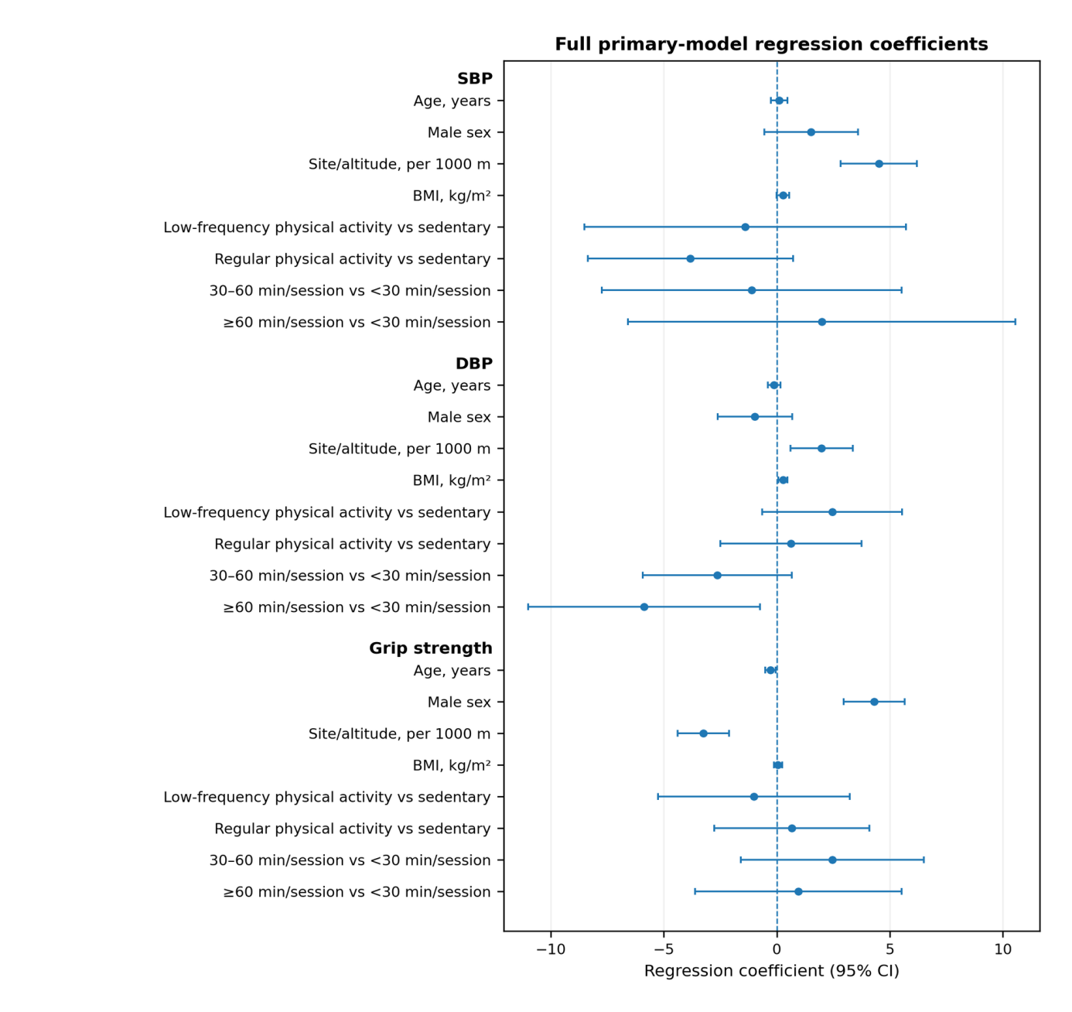
The forest plot displays the fully adjusted coefficients for all predictors in the three primary models, with HC3 robust 95% confidence intervals. The site/altitude coefficient represents an across-site trend because each altitude corresponded to one site; its interval estimate is conditional on the three fixed sites and does not incorporate replicated between-site variability. The plot is provided in the supplement to avoid redundancy with Table 2 of the main manuscript.

Figure S2. Exploratory Spearman correlation matrix
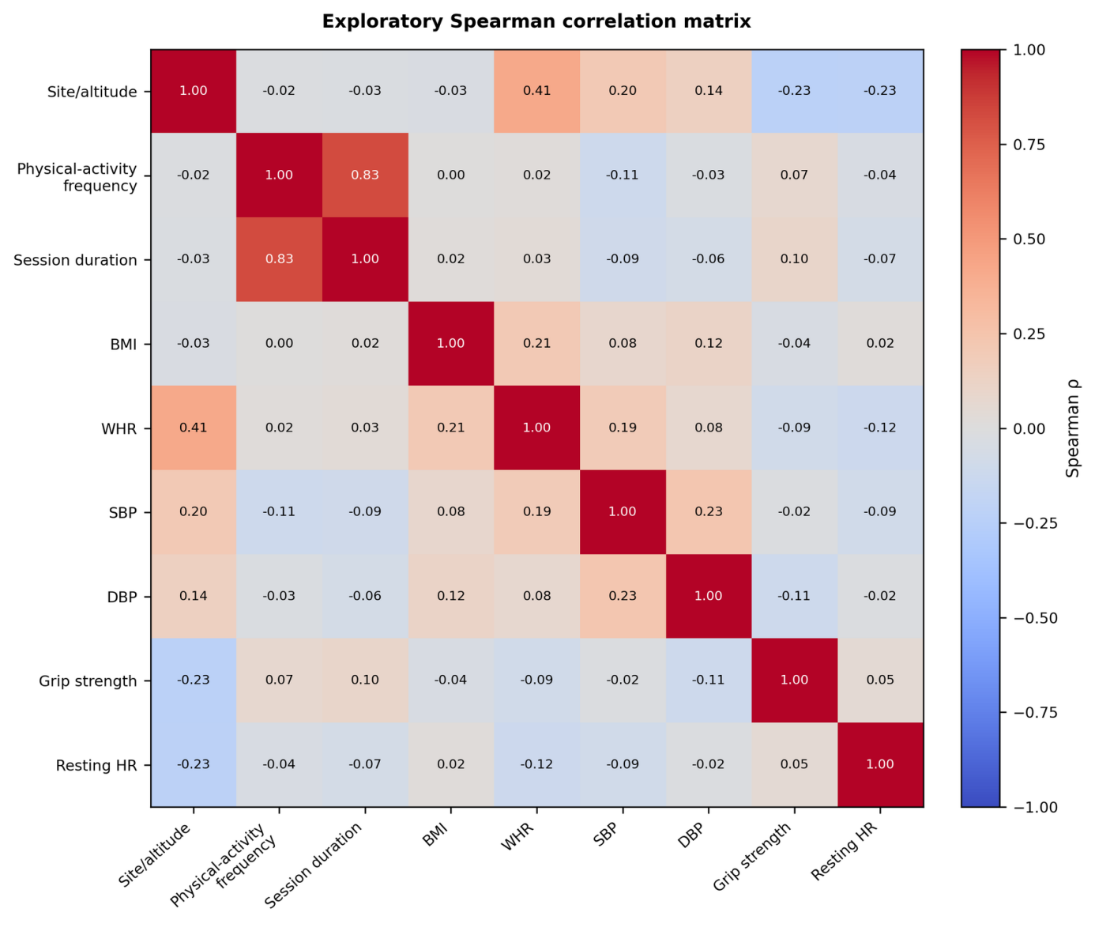
The matrix is descriptive and summarizes pairwise Spearman correlations among the study variables. Site/altitude denotes the three sites coded by their elevations. Resting HR, resting heart rate; WHR, waist-to-hip ratio; SBP, systolic blood pressure; DBP, diastolic blood pressure.

Figure S3. Terminal-digit heaping in the blood-pressure readings
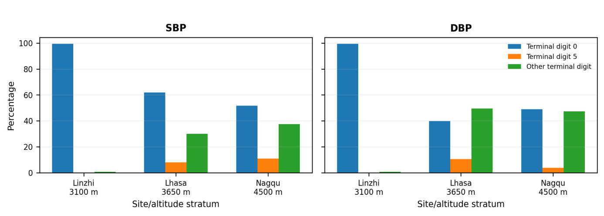
Terminal-digit heaping was most pronounced in Linzhi/3100 m, where 99.4% of both SBP and DBP values ended in 0. This pattern is interpreted as measurement or recording coarsening rather than a physiological distribution.

