Electronic database search
Participants: older adults OR aged OR elderly OR older individuals OR older people
Interventions: Vagus nerve stimulation OR vagal nerve stimulation OR transcutaneous vagus nerve stimulation OR transcutaneous vagal nerve stimulation OR transcutaneous auricular vagus nerve stimulation OR auricular vagus nerve stimulation OR auricular vagal nerve stimulation OR taVNS OR aVNS OR tVNS OR non-invasive vagus nerve stimulation OR nVNS
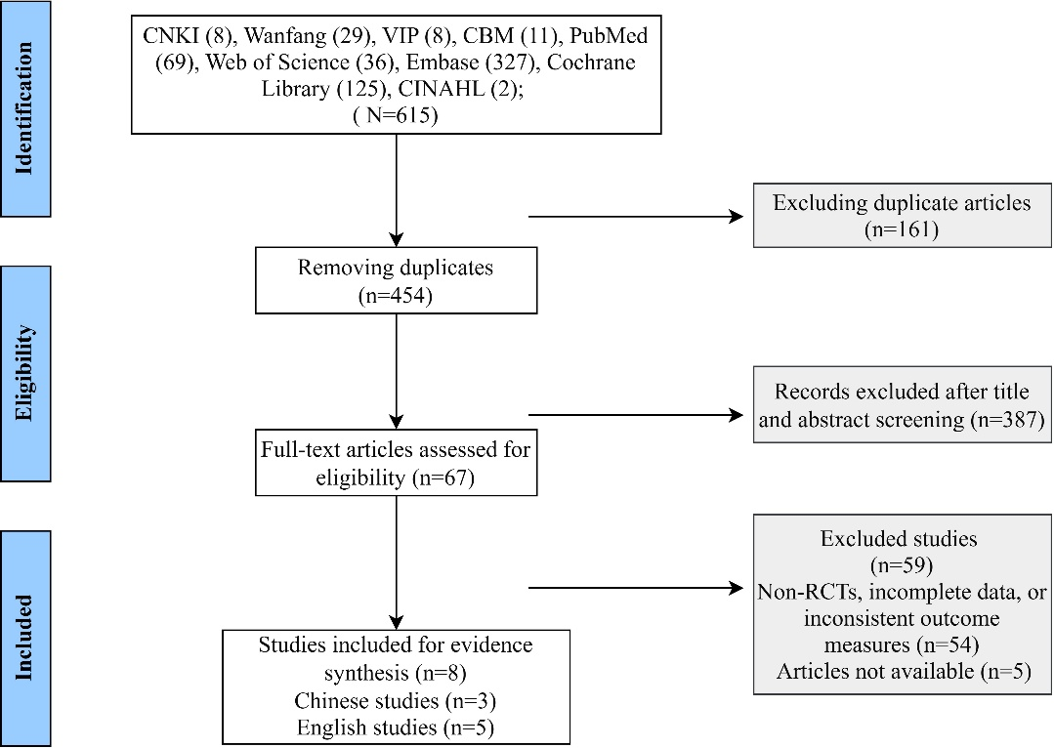
Outcomes and mechanistic indicators: autonomic nervous system OR parasympathetic nervous system OR cardiac vagal modulation OR Heart rate variability OR HRV OR heart rate variability analysis OR sympathovagal balance OR intrinsic capacity OR functional capacity OR functional ability OR functional reserve OR physiological reserve OR healthy ageing OR healthy aging" OR active ageing OR active aging OR resilience OR cognition OR cognitive function OR cognitive ability OR cognitive decline OR memory OR attention OR executive function OR information processing speed OR mobility OR physical performance OR motor function OR gait OR gait speed OR balance OR physical activity OR exercise OR aerobic exercise OR strength training OR sensory function OR sensory perception OR hearing OR vision OR visual function OR visual acuity OR vitality OR fatigue OR tired* OR wear* OR exhaust* OR asthenia OR metabolism OR inflammation OR oxidative stress OR mental health OR psychological OR psychosocial OR distress OR depress* OR anxiety OR happiness OR well-being OR mental disorder*
eFigure1 Literature search and study selection process for the development of the taVNS intervention protocol

