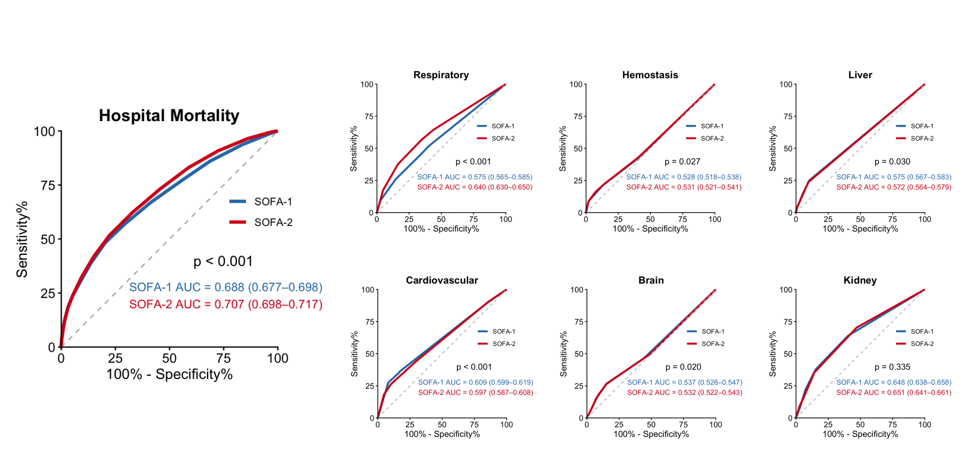
eFigure 1 Receiver operating characteristic curves for overall SOFA-1 and SOFA-2 scores and their individual organ-specific components to predict in-hospital mortality in MIMIC-IV participants
Abbreviation: SOFA, Sequential Organ Failure Assessment

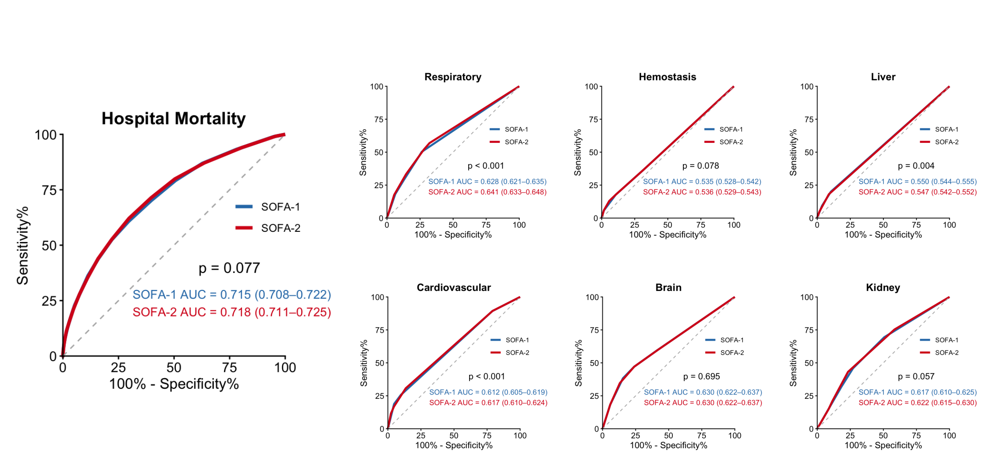
eFigure 2 Receiver operating characteristic curves for overall SOFA-1 and SOFA-2 scores and their individual organ-specific components to predict in-hospital mortality in eICU-CRD participants
Abbreviation: SOFA, Sequential Organ Failure Assessment

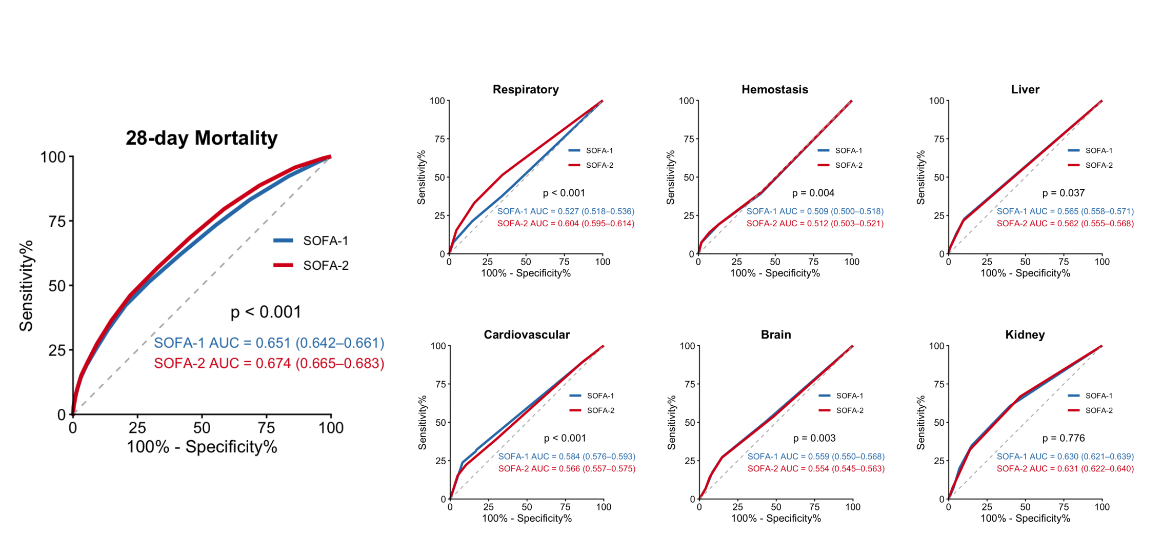
eFigure 3 Receiver operating characteristic curves for overall SOFA-1 and SOFA-2 scores and their individual organ-specific components to predict 28-day mortality in MIMIC-IV participants
Abbreviation: SOFA, Sequential Organ Failure Assessment

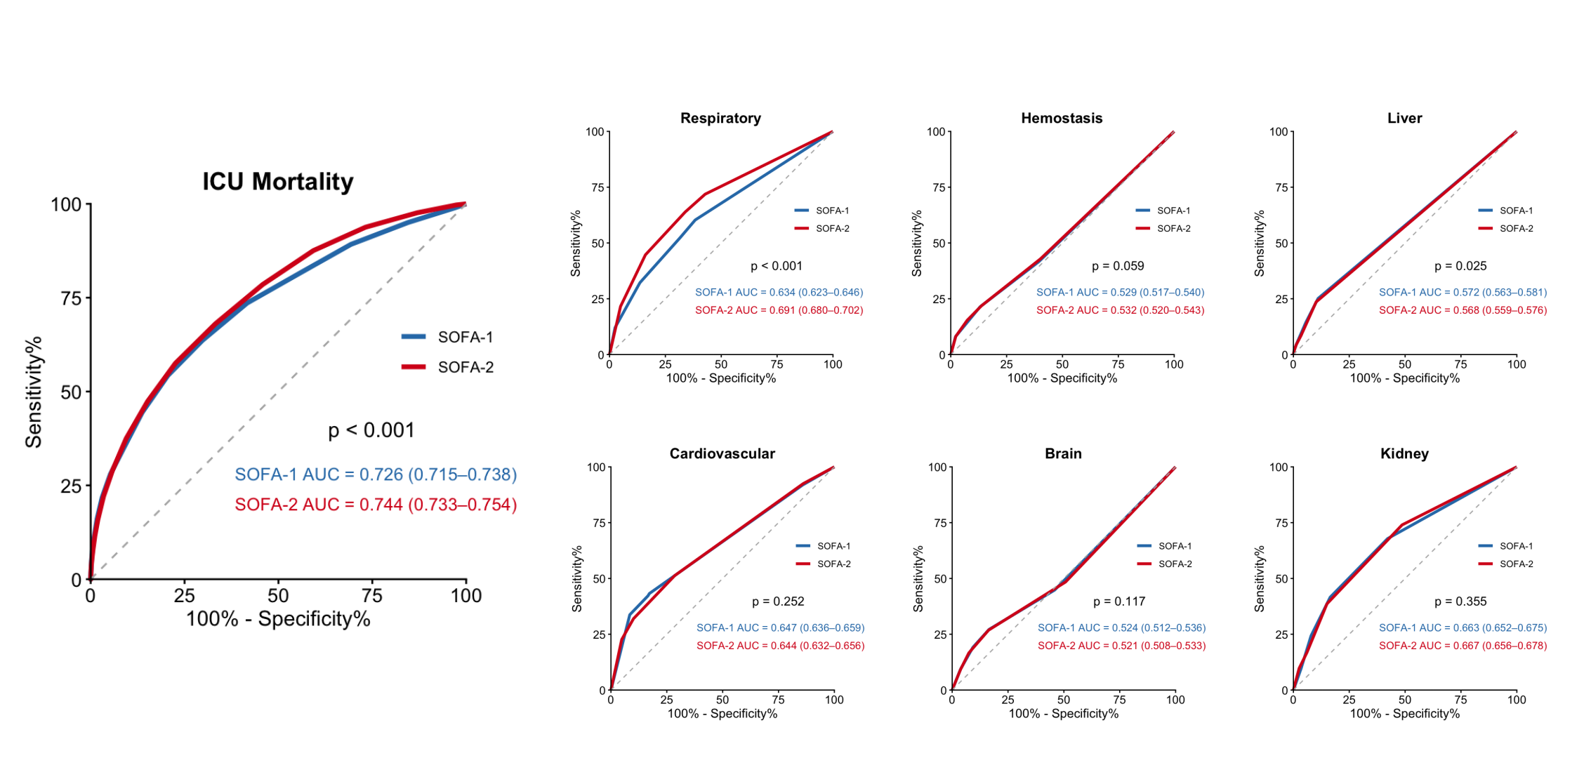
eFigure 4. Sensitivity analysis including patients aged 90 years or older: ROC curves for ICU mortality in MIMIC-IV participants
Abbreviation: SOFA, Sequential Organ Failure Assessment

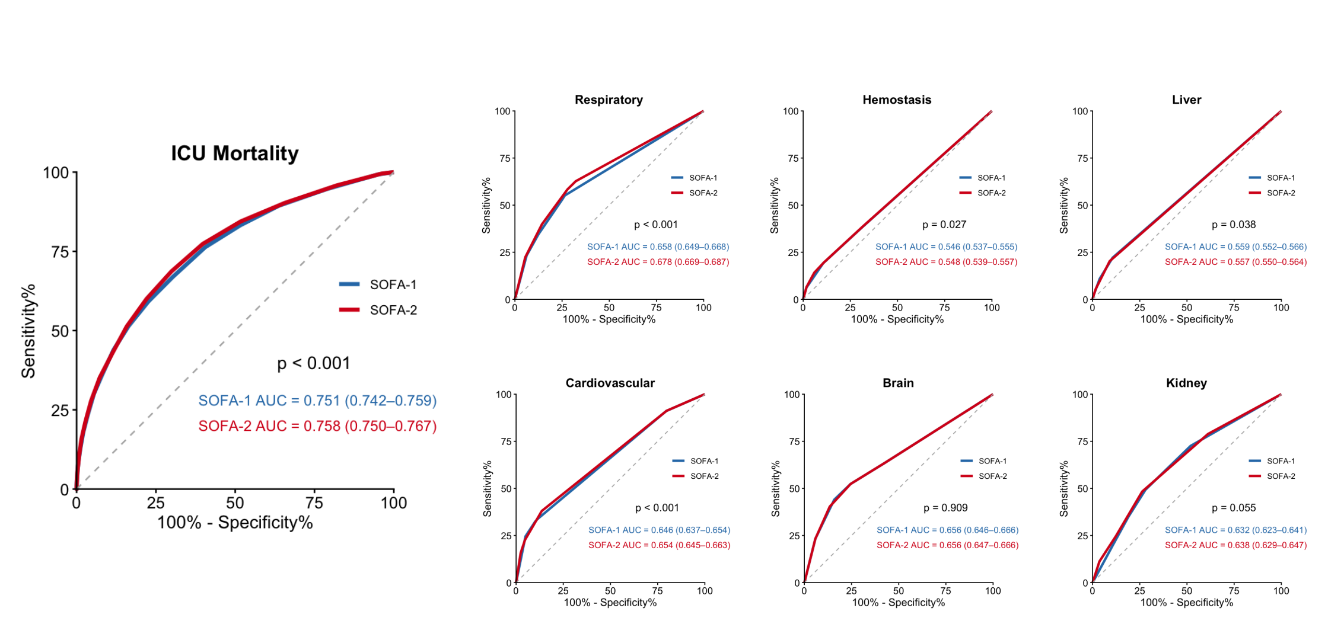
eFigure 5. Sensitivity analysis including patients aged 90 years or older: ROC curves for ICU mortality in eICU-CRD participants
Abbreviation: SOFA, Sequential Organ Failure Assessment

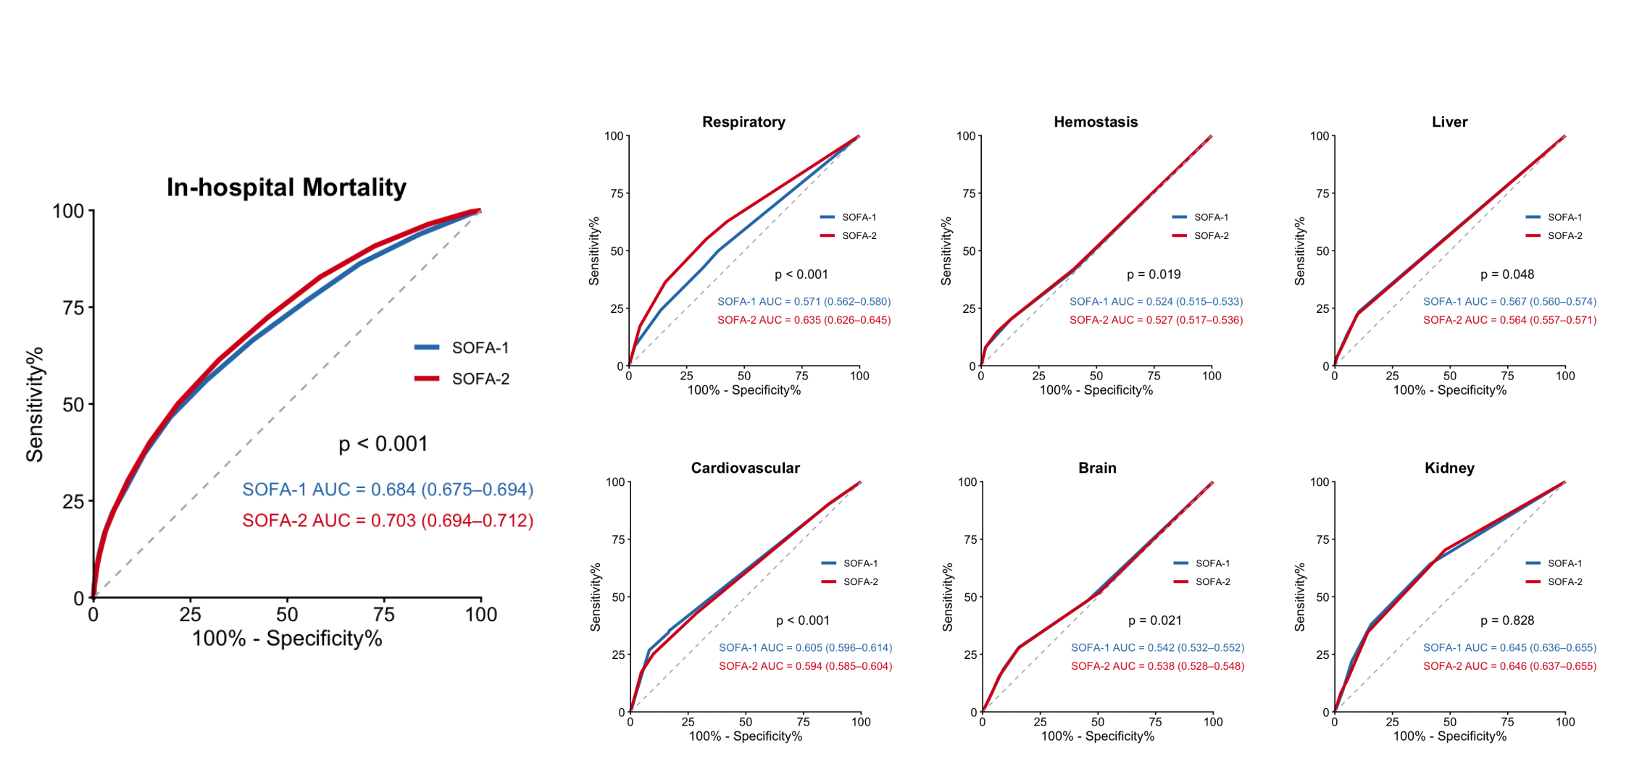
eFigure 6. Sensitivity analysis including patients aged 90 years or older: ROC curves for in-hospital mortality in MIMIC-IV participants
Abbreviation: SOFA, Sequential Organ Failure Assessment

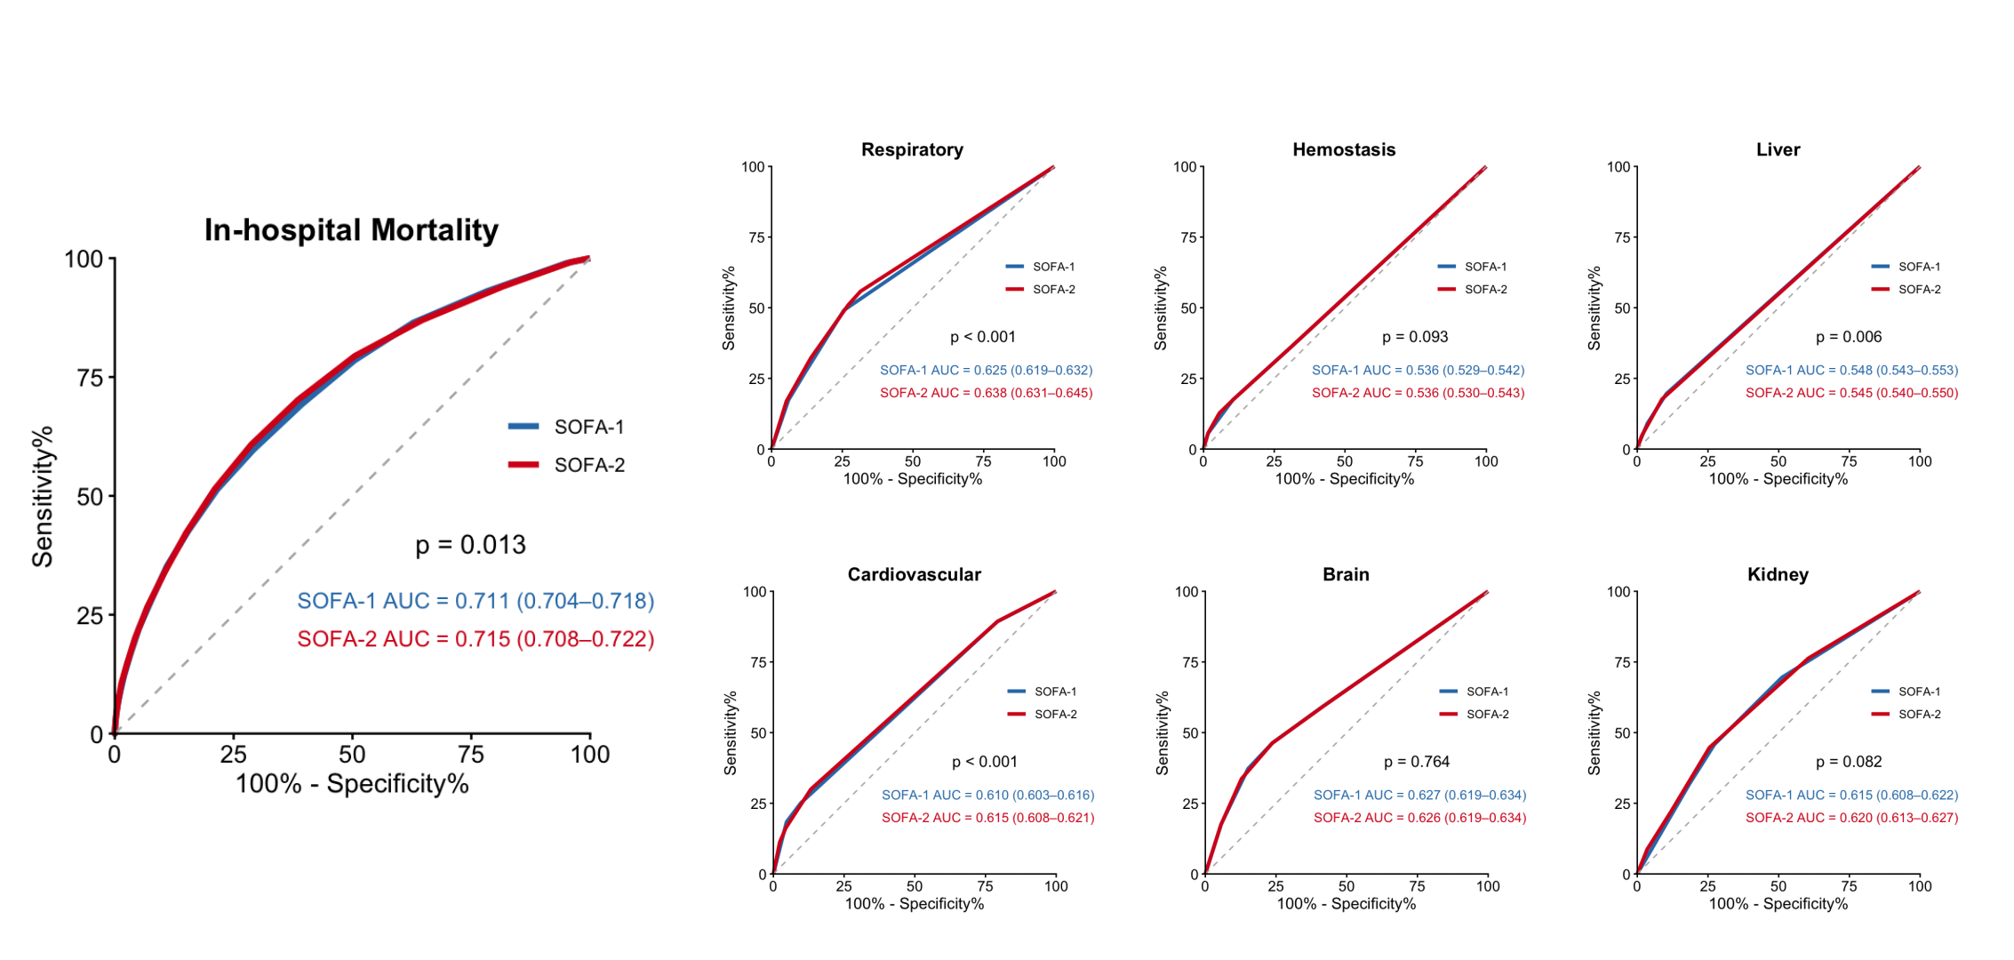
eFigure 7. Sensitivity analysis including patients aged 90 years or older: ROC curves for in-hospital mortality in eICU-CRD participants
Abbreviation: SOFA, Sequential Organ Failure Assessment

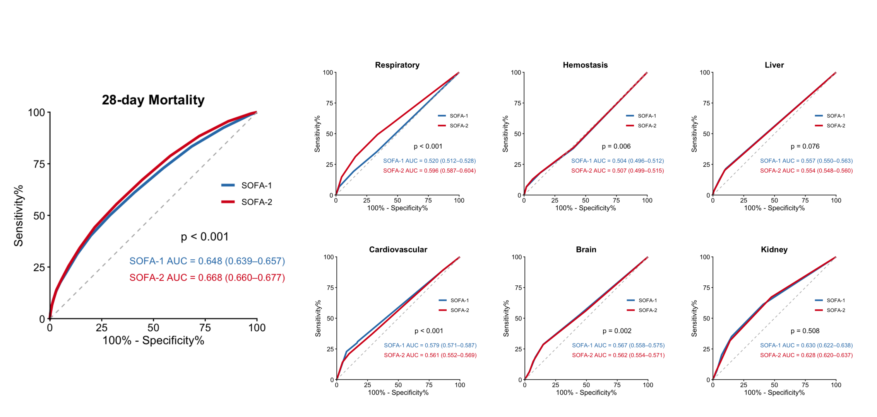
eFigure 8. Sensitivity analysis including patients aged 90 years or older: ROC curves for 28-day mortality in MIMIC-IV participants
Abbreviation: SOFA, Sequential Organ Failure Assessment

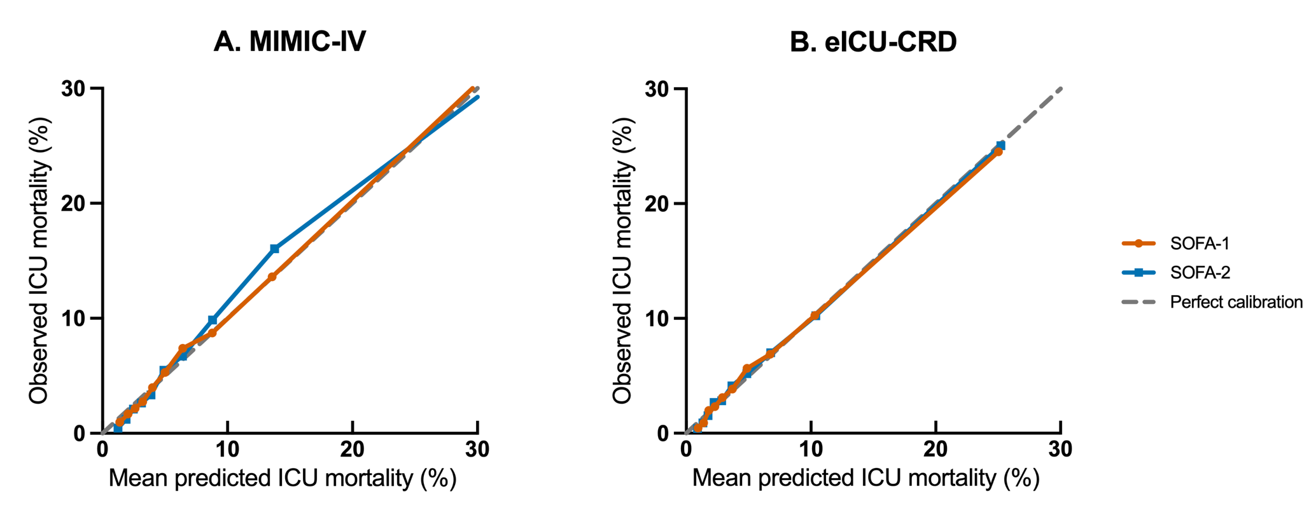
eFigure 9. Calibration plots for ICU mortality in multivariable Model C
(A) MIMIC-IV cohort. (B) eICU-CRD cohort. Calibration plots compare observed ICU mortality with mean predicted ICU mortality across deciles of predicted risk. The dashed diagonal line indicates perfect calibration. Model C included the corresponding total SOFA score, age, sex, documented sepsis, baseline comorbidities, white blood cell count, hemoglobin, blood glucose, and heart rate.
Abbreviations: SOFA, Sequential Organ Failure Assessment; ICU, intensive care unit.

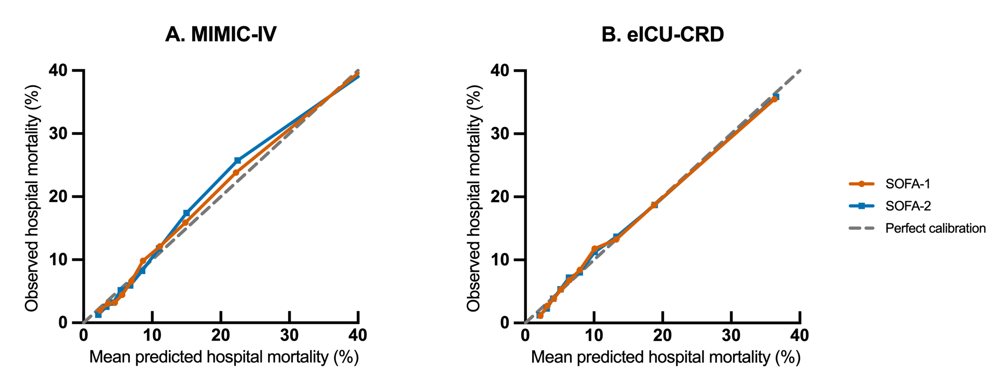
eFigure 10. Calibration plots for in-hospital mortality in multivariable Model C
(A) MIMIC-IV cohort. (B) eICU-CRD cohort. Calibration plots compare observed in-hospital mortality with mean predicted in-hospital mortality across deciles of predicted risk. The dashed diagonal line indicates perfect calibration. Model C included the corresponding total SOFA score, age, sex, documented sepsis, baseline comorbidities, white blood cell count, hemoglobin, blood glucose, and heart rate.
Abbreviations: SOFA, Sequential Organ Failure Assessment.

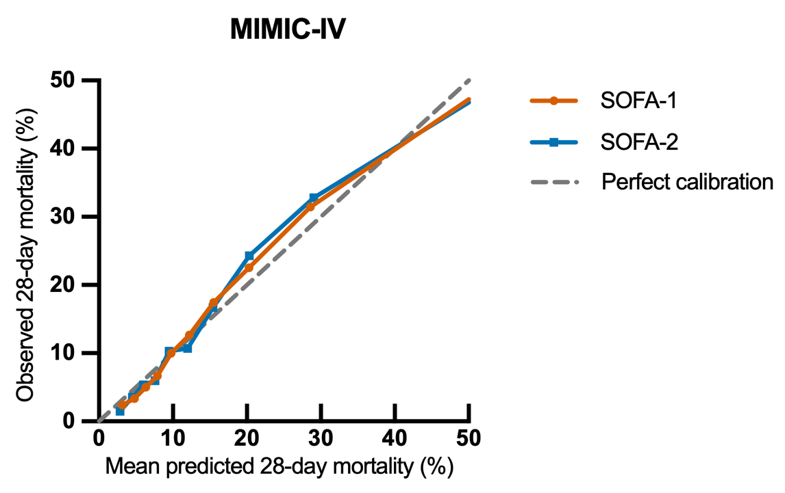
eFigure 11. Calibration plot for 28-day mortality in multivariable Model C in the MIMIC-IV cohort
The calibration plot compares observed 28-day mortality with mean predicted 28-day mortality across deciles of predicted risk. The dashed diagonal line indicates perfect calibration. Model C included the corresponding total SOFA score, age, sex, documented sepsis, baseline comorbidities, white blood cell count, hemoglobin, blood glucose, and heart rate.
Abbreviations: SOFA, Sequential Organ Failure Assessment.

eTable 1. Primary reasons for ICU admission in the MIMIC-IV and eICU-CRD cohorts (mutually exclusive hierarchical classification)
Primary reason for ICU admission | MIMIC-IV, n (%) | eICU-CRD, n (%)
Sepsis / infection-related admission | 3,618 (13.9%) | 8,233 (15.3%)
Respiratory failure / respiratory disease | 3,959 (15.2%) | 7,332 (13.7%)
Cardiovascular disease / shock / cardiac admission | 9,923 (38.0%) | 16,288 (30.3%)
Postoperative admission | 2,157 (8.3%) | 11,352 (21.1%)
Neurologic conditions | 3,330 (12.8%) | 2,952 (5.5%)
Renal disease | 406 (1.6%) | 844 (1.6%)
Trauma | 1,899 (7.3%) | 1,381 (2.6%)
Other / unclassified | 812 (3.1%) | 5,315 (9.9%)
Total | 26,104 (100.0%) | 53,697 (100.0%)
Notes: Admission categories were assigned using a predefined hierarchical algorithm based on diagnosis information extracted from MIMIC-IV and eICU-CRD. When multiple potential categories were identified for a single ICU admission, the final classification was determined according to clinical priority (sepsis, respiratory failure, cardiovascular disease/shock, postoperative admission, neurologic disease, renal disease, trauma, and other). Therefore, each ICU admission was assigned to one mutually exclusive category, and percentages sum to 100% within each cohort.

eTable 2 Subgroup analyses of discriminative performance of SOFA-1 and SOFA-2 scores in predicting ICU mortality
Cohort | Subgroup | Performance measure | SOFA-1 | SOFA-2 | P-value
MIMIC-IV | Male | Sensitivity | 0.577 (0.547-0.606) | 0.604 (0.575-0.633) | 0.017
MIMIC-IV | Male | Specificity | 0.764 (0.757-0.771) | 0.743 (0.736-0.751) | <0.001
MIMIC-IV | Male | PPV | 0.169 (0.157-0.181) | 0.164 (0.153-0.175) | <0.001
MIMIC-IV | Male | NPV | 0.956 (0.952-0.960) | 0.958 (0.953-0.961) | <0.001
MIMIC-IV | Male | LR+ | 2.44 (2.30-2.59) | 2.35 (2.23-2.49)
MIMIC-IV | Male | LR− | 0.55 (0.52-0.59) | 0.53 (0.50-0.57)
MIMIC-IV | Female | Sensitivity | 0.540 (0.508-0.572) | 0.568 (0.536-0.600) | 0.027
MIMIC-IV | Female | Specificity | 0.823 (0.816-0.831) | 0.802 (0.794-0.810) | <0.001
MIMIC-IV | Female | PPV | 0.218 (0.202-0.235) | 0.208 (0.192-0.224) | <0.001
MIMIC-IV | Female | NPV | 0.952 (0.947-0.956) | 0.953 (0.949-0.958) | <0.001
MIMIC-IV | Female | LR+ | 3.06 (2.85-3.29) | 2.87 (2.69-3.07)
MIMIC-IV | Female | LR− | 0.56 (0.52-0.60) | 0.54 (0.50-0.58)
MIMIC-IV | 65-79 | Sensitivity | 0.582 (0.555-0.610) | 0.618 (0.590-0.645) | 0.001
MIMIC-IV | 65-79 | Specificity | 0.783 (0.777-0.789) | 0.763 (0.757-0.770) | <0.001
MIMIC-IV | 65-79 | PPV | 0.171 (0.160-0.182) | 0.167 (0.156-0.178) | <0.001
MIMIC-IV | 65-79 | NPV | 0.961 (0.957-0.964) | 0.963 (0.960-0.966) | <0.001
MIMIC-IV | 65-79 | LR+ | 2.69 (2.54-2.84) | 2.61 (2.48-2.75)
MIMIC-IV | 65-79 | LR− | 0.53 (0.50-0.57) | 0.50 (0.47-0.54)
MIMIC-IV | 80-89 | Sensitivity | 0.525 (0.490-0.559) | 0.541 (0.506-0.575) | 0.263
MIMIC-IV | 80-89 | Specificity | 0.805 (0.796-0.814) | 0.782 (0.772-0.791) | <0.001
MIMIC-IV | 80-89 | PPV | 0.227 (0.208-0.246) | 0.212 (0.195-0.230) | <0.001
MIMIC-IV | 80-89 | NPV | 0.940 (0.934-0.945) | 0.940 (0.934-0.946) | <0.001
MIMIC-IV | 80-89 | LR+ | 2.70 (2.49-2.92) | 2.47 (2.29-2.67)
MIMIC-IV | 80-89 | LR− | 0.59 (0.55-0.64) | 0.59 (0.55-0.63)
eICU-CRD | Male | Sensitivity | 0.607 (0.583-0.630) | 0.702 (0.680-0.723) | <0.001
eICU-CRD | Male | Specificity | 0.752 (0.746-0.757) | 0.668 (0.662-0.673) | <0.001
eICU-CRD | Male | PPV | 0.136 (0.128-0.144) | 0.120 (0.113-0.126) | <0.001
eICU-CRD | Male | NPV | 0.967 (0.965-0.970) | 0.972 (0.970-0.974) | <0.001
eICU-CRD | Male | LR+ | 2.44 (2.34-2.55) | 2.11 (2.04-2.19)
eICU-CRD | Male | LR− | 0.52 (0.49-0.56) | 0.45 (0.42-0.48)
eICU-CRD | Female | Sensitivity | 0.594 (0.569-0.619) | 0.689 (0.665-0.712) | <0.001
eICU-CRD | Female | Specificity | 0.790 (0.784-0.795) | 0.717 (0.711-0.723) | <0.001
eICU-CRD | Female | PPV | 0.152 (0.143-0.161) | 0.133 (0.126-0.141) | <0.001
eICU-CRD | Female | NPV | 0.968 (0.966-0.971) | 0.973 (0.971-0.976) | <0.001
eICU-CRD | Female | LR+ | 2.82 (2.69-2.97) | 2.43 (2.34-2.53)
eICU-CRD | Female | LR− | 0.51 (0.48-0.55) | 0.43 (0.40-0.47)
eICU-CRD | 65-79 | Sensitivity | 0.635 (0.614-0.656) | 0.726 (0.707-0.745) | <0.001
eICU-CRD | 65-79 | Specificity | 0.761 (0.757-0.766) | 0.680 (0.675-0.684) | <0.001
eICU-CRD | 65-79 | PPV | 0.139 (0.132-0.146) | 0.121 (0.116-0.127) | <0.001
eICU-CRD | 65-79 | NPV | 0.972 (0.970-0.974) | 0.976 (0.974-0.978) | <0.001
eICU-CRD | 65-79 | LR+ | 2.66 (2.56-2.76) | 2.27 (2.20-2.34)
eICU-CRD | 65-79 | LR− | 0.48 (0.45-0.51) | 0.40 (0.38-0.43)
eICU-CRD | 80-89 | Sensitivity | 0.534 (0.504-0.564) | 0.636 (0.607-0.665) | <0.001
eICU-CRD | 80-89 | Specificity | 0.788 (0.782-0.795) | 0.717 (0.710-0.724) | <0.001
eICU-CRD | 80-89 | PPV | 0.151 (0.140-0.163) | 0.137 (0.127-0.147) | <0.001
eICU-CRD | 80-89 | NPV | 0.960 (0.956-0.963) | 0.966 (0.962-0.969) | <0.001
eICU-CRD | 80-89 | LR+ | 2.52 (2.37-2.69) | 2.25 (2.14-2.37)
eICU-CRD | 80-89 | LR− | 0.59 (0.56-0.63) | 0.51 (0.47-0.55)
Abbreviations: SOFA, Sequential Organ Failure Assessment; PPV, positive predictive value; NPV, negative predictive value; LR+, positive likelihood ratio; LR−, negative likelihood ratio; CI, confidence interval.
Notes: Sensitivity, specificity, PPV, NPV, LR+, and LR− were calculated using cutoff values derived from ROC analysis based on the Youden index. For ICU mortality, the cutoffs were 6.5 for SOFA-1 and 6.5 for SOFA-2 in MIMIC-IV, and 6.5 for SOFA-1 and 5.5 for SOFA-2 in eICU-CRD. Because SOFA scores are integer-based, cutoffs of 6.5 and 5.5 correspond to scores ≥7 and ≥6, respectively. PPV and NPV are dependent on outcome prevalence and should be interpreted with caution.

eTable 3. Multivariable logistic regression analysis of SOFA-1 and SOFA-2 scores for ICU mortality, by organ domains
Cohort | Model | Domain | SOFA-1 OR (95% CI); P-value | SOFA-1 C-index (95% CI) | SOFA-2 OR (95% CI); P-value | SOFA-2 C-index (95% CI) | P-value for C-index comparison
MIMIC-IV | Unadjusted | Respiratory | 1.52 (1.47-1.57); <0.001 | 0.641 (0.628-0.653) | 1.70 (1.65-1.76); <0.001 | 0.697 (0.685-0.709) | <0.001
MIMIC-IV | Unadjusted | Hemostasis | 1.30 (1.24-1.36); <0.001 | 0.533 (0.521-0.545) | 1.26 (1.21-1.31); <0.001 | 0.536 (0.524-0.549) | 0.058
MIMIC-IV | Unadjusted | Liver | 1.68 (1.60-1.77); <0.001 | 0.581 (0.571-0.591) | 1.68 (1.59-1.77); <0.001 | 0.576 (0.566-0.586) | 0.022
MIMIC-IV | Unadjusted | Cardiovascular | 1.67 (1.61-1.72); <0.001 | 0.650 (0.638-0.663) | 1.77 (1.70-1.83); <0.001 | 0.646 (0.633-0.659) | 0.134
MIMIC-IV | Unadjusted | Brain | 1.20 (1.16-1.24); <0.001 | 0.520 (0.508-0.533) | 1.20 (1.15-1.24); <0.001 | 0.517 (0.503-0.530) | 0.068
MIMIC-IV | Unadjusted | Kidney | 1.63 (1.58-1.69); <0.001 | 0.666 (0.654-0.678) | 1.71 (1.65-1.77); <0.001 | 0.671 (0.659-0.683) | 0.147
MIMIC-IV | Model A | Respiratory | 1.56 (1.51-1.61); <0.001 | 0.661 (0.648-0.674) | 1.72 (1.67-1.78); <0.001 | 0.713 (0.701-0.725) | <0.001
MIMIC-IV | Model A | Hemostasis | 1.32 (1.25-1.38); <0.001 | 0.572 (0.559-0.585) | 1.27 (1.22-1.32); <0.001 | 0.576 (0.563-0.589) | 0.005
MIMIC-IV | Model A | Liver | 1.71 (1.63-1.80); <0.001 | 0.627 (0.614-0.640) | 1.71 (1.62-1.81); <0.001 | 0.625 (0.612-0.638) | 0.188
MIMIC-IV | Model A | Cardiovascular | 1.67 (1.61-1.72); <0.001 | 0.671 (0.658-0.684) | 1.77 (1.71-1.84); <0.001 | 0.662 (0.649-0.675) | 0.003
MIMIC-IV | Model A | Brain | 1.19 (1.15-1.24); <0.001 | 0.565 (0.552-0.578) | 1.19 (1.14-1.24); <0.001 | 0.562 (0.549-0.576) | 0.049
MIMIC-IV | Model A | Kidney | 1.64 (1.58-1.69); <0.001 | 0.684 (0.672-0.696) | 1.72 (1.66-1.78); <0.001 | 0.687 (0.675-0.699) | 0.357
MIMIC-IV | Model B | Respiratory | 1.59 (1.54-1.64); <0.001 | 0.754 (0.743-0.766) | 1.65 (1.60-1.71); <0.001 | 0.783 (0.773-0.794) | <0.001
MIMIC-IV | Model B | Hemostasis | 1.19 (1.13-1.25); <0.001 | 0.718 (0.706-0.729) | 1.17 (1.13-1.22); <0.001 | 0.719 (0.708-0.731) | 0.002
MIMIC-IV | Model B | Liver | 1.34 (1.27-1.42); <0.001 | 0.726 (0.715-0.738) | 1.32 (1.24-1.40); <0.001 | 0.724 (0.713-0.736) | 0.005
MIMIC-IV | Model B | Cardiovascular | 1.47 (1.42-1.53); <0.001 | 0.751 (0.741-0.762) | 1.61 (1.54-1.67); <0.001 | 0.749 (0.737-0.760) | 0.142
MIMIC-IV | Model B | Brain | 1.17 (1.12-1.22); <0.001 | 0.721 (0.709-0.732) | 1.17 (1.13-1.22); <0.001 | 0.720 (0.709-0.732) | 0.500
MIMIC-IV | Model B | Kidney | 1.57 (1.50-1.63); <0.001 | 0.748 (0.738-0.759) | 1.66 (1.59-1.74); <0.001 | 0.752 (0.741-0.762) | 0.132
MIMIC-IV | Model C | Respiratory | 1.58 (1.52-1.63); <0.001 | 0.773 (0.762-0.783) | 1.62 (1.57-1.67); <0.001 | 0.797 (0.787-0.807) | <0.001
MIMIC-IV | Model C | Hemostasis | 1.21 (1.15-1.28); <0.001 | 0.754 (0.743-0.764) | 1.19 (1.14-1.24); <0.001 | 0.755 (0.744-0.765) | 0.030
MIMIC-IV | Model C | Liver | 1.36 (1.28-1.44); <0.001 | 0.759 (0.749-0.770) | 1.34 (1.25-1.42); <0.001 | 0.758 (0.748-0.768) | 0.047
MIMIC-IV | Model C | Cardiovascular | 1.45 (1.40-1.51); <0.001 | 0.773 (0.763-0.783) | 1.58 (1.51-1.64); <0.001 | 0.769 (0.758-0.780) | 0.025
MIMIC-IV | Model C | Brain | 1.16 (1.11-1.20); <0.001 | 0.755 (0.744-0.765) | 1.16 (1.11-1.21); <0.001 | 0.755 (0.744-0.765) | 0.456
MIMIC-IV | Model C | Kidney | 1.54 (1.48-1.61); <0.001 | 0.771 (0.761-0.781) | 1.63 (1.55-1.71); <0.001 | 0.774 (0.764-0.784) | 0.127
eICU-CRD | Unadjusted | Respiratory | 1.54 (1.51-1.58); <0.001 | 0.660 (0.651-0.670) | 1.61 (1.57-1.65); <0.001 | 0.679 (0.670-0.689) | <0.001
eICU-CRD | Unadjusted | Hemostasis | 1.36 (1.31-1.41); <0.001 | 0.545 (0.536-0.555) | 1.30 (1.26-1.34); <0.001 | 0.547 (0.537-0.556) | 0.032
eICU-CRD | Unadjusted | Liver | 1.75 (1.66-1.83); <0.001 | 0.563 (0.555-0.570) | 1.84 (1.74-1.94); <0.001 | 0.560 (0.553-0.567) | 0.022
eICU-CRD | Unadjusted | Cardiovascular | 1.75 (1.71-1.80); <0.001 | 0.649 (0.640-0.658) | 1.99 (1.92-2.05); <0.001 | 0.657 (0.648-0.666) | <0.001
eICU-CRD | Unadjusted | Brain | 1.58 (1.54-1.61); <0.001 | 0.659 (0.649-0.669) | 1.59 (1.55-1.63); <0.001 | 0.659 (0.649-0.669) | 0.998
eICU-CRD | Unadjusted | Kidney | 1.36 (1.33-1.39); <0.001 | 0.634 (0.625-0.644) | 1.40 (1.37-1.44); <0.001 | 0.639 (0.630-0.649) | 0.110
eICU-CRD | Model A | Respiratory | 1.55 (1.52-1.59); <0.001 | 0.678 (0.668-0.688) | 1.62 (1.59-1.66); <0.001 | 0.695 (0.685-0.704) | <0.001
eICU-CRD | Model A | Hemostasis | 1.36 (1.31-1.42); <0.001 | 0.561 (0.551-0.572) | 1.31 (1.27-1.35); <0.001 | 0.563 (0.553-0.574) | 0.013
eICU-CRD | Model A | Liver | 1.76 (1.68-1.85); <0.001 | 0.586 (0.575-0.597) | 1.85 (1.75-1.96); <0.001 | 0.584 (0.574-0.595) | 0.231
eICU-CRD | Model A | Cardiovascular | 1.75 (1.71-1.80); <0.001 | 0.661 (0.651-0.671) | 1.99 (1.93-2.06); <0.001 | 0.669 (0.658-0.679) | <0.001
eICU-CRD | Model A | Brain | 1.58 (1.54-1.62); <0.001 | 0.672 (0.661-0.682) | 1.59 (1.56-1.63); <0.001 | 0.671 (0.661-0.682) | 0.468
eICU-CRD | Model A | Kidney | 1.36 (1.33-1.39); <0.001 | 0.641 (0.631-0.650) | 1.41 (1.37-1.44); <0.001 | 0.648 (0.638-0.658) | 0.020
eICU-CRD | Model B | Respiratory | 1.53 (1.50-1.57); <0.001 | 0.722 (0.713-0.731) | 1.60 (1.56-1.64); <0.001 | 0.732 (0.723-0.741) | <0.001
eICU-CRD | Model B | Hemostasis | 1.29 (1.24-1.34); <0.001 | 0.650 (0.640-0.660) | 1.25 (1.21-1.29); <0.001 | 0.652 (0.642-0.662) | <0.001
eICU-CRD | Model B | Liver | 1.59 (1.51-1.68); <0.001 | 0.661 (0.651-0.671) | 1.66 (1.57-1.76); <0.001 | 0.660 (0.650-0.670) | 0.317
eICU-CRD | Model B | Cardiovascular | 1.64 (1.60-1.69); <0.001 | 0.705 (0.695-0.714) | 1.88 (1.82-1.95); <0.001 | 0.709 (0.699-0.719) | 0.004
eICU-CRD | Model B | Brain | 1.59 (1.55-1.62); <0.001 | 0.725 (0.716-0.734) | 1.60 (1.56-1.64); <0.001 | 0.725 (0.716-0.735) | 0.458
eICU-CRD | Model B | Kidney | 1.32 (1.29-1.35); <0.001 | 0.681 (0.672-0.690) | 1.37 (1.33-1.41); <0.001 | 0.684 (0.675-0.694) | 0.155
eICU-CRD | Model C | Respiratory | 1.46 (1.42-1.49); <0.001 | 0.756 (0.747-0.764) | 1.52 (1.48-1.55); <0.001 | 0.763 (0.755-0.771) | <0.001
eICU-CRD | Model C | Hemostasis | 1.30 (1.25-1.36); <0.001 | 0.724 (0.715-0.733) | 1.25 (1.21-1.30); <0.001 | 0.726 (0.717-0.734) | <0.001
eICU-CRD | Model C | Liver | 1.53 (1.45-1.61); <0.001 | 0.729 (0.720-0.738) | 1.60 (1.50-1.69); <0.001 | 0.729 (0.720-0.738) | 0.919
eICU-CRD | Model C | Cardiovascular | 1.53 (1.49-1.58); <0.001 | 0.747 (0.738-0.756) | 1.72 (1.66-1.78); <0.001 | 0.747 (0.739-0.756) | 0.766
eICU-CRD | Model C | Brain | 1.51 (1.47-1.54); <0.001 | 0.760 (0.752-0.769) | 1.52 (1.48-1.56); <0.001 | 0.761 (0.752-0.769) | 0.209
eICU-CRD | Model C | Kidney | 1.28 (1.24-1.31); <0.001 | 0.733 (0.724-0.741) | 1.32 (1.28-1.35); <0.001 | 0.734 (0.726-0.743) | 0.214
Abbreviations: SOFA, Sequential Organ Failure Assessment; OR, odds ratio; CI, confidence interval; ICU, intensive care unit.
Notes: ORs represent the change in odds of ICU mortality per 1-point increase in the corresponding SOFA score. Model A was adjusted for age and sex. Model B was further adjusted for documented sepsis and baseline comorbidities, including cardiovascular disease, diabetes, neurological disease, chronic kidney disease, chronic obstructive pulmonary disease, malignancy, and liver disease. Model C was further adjusted for white blood cell count, hemoglobin, blood glucose, and heart rate; the corresponding units were ×10⁹/L, g/dL, mg/dL, and beats/min, respectively. P-values for C-index comparison indicate paired comparisons between SOFA-1 and SOFA-2 within the same cohort, model, and score domain.

eTable 4. Full model C covariate estimates for ICU mortality, presented as odds ratios with 95% confidence intervals.
Covariate | MIMIC-IV SOFA-1 model | MIMIC-IV SOFA-2 model | eICU-CRD SOFA-1 model | eICU-CRD SOFA-2 model
Total SOFA score | 1.29 (1.27-1.31); <0.001 | 1.31 (1.29-1.33); <0.001 | 1.25 (1.24-1.26); <0.001 | 1.27 (1.25-1.28); <0.001
Age | 1.03 (1.02-1.04); <0.001 | 1.03 (1.02-1.04); <0.001 | 1.02 (1.01-1.03); <0.001 | 1.02 (1.02-1.03); <0.001
Male sex | 0.79 (0.71-0.87); <0.001 | 0.79 (0.71-0.87); <0.001 | 0.94 (0.87-1.02); 0.116 | 0.93 (0.86-1.00); 0.048
Documented sepsis | 2.02 (1.82-2.25); <0.001 | 2.09 (1.88-2.33); <0.001 | 1.47 (1.35-1.60); <0.001 | 1.52 (1.40-1.66); <0.001
Cardiovascular comorbidity | 1.20 (1.08-1.33); <0.001 | 1.18 (1.06-1.30); 0.002 | 1.23 (1.13-1.33); <0.001 | 1.22 (1.13-1.32); <0.001
Diabetes | 0.86 (0.77-0.96); 0.006 | 0.87 (0.78-0.97); 0.011 | 0.86 (0.79-0.94); <0.001 | 0.86 (0.79-0.93); <0.001
Neurologic comorbidity | 1.86 (1.66-2.07); <0.001 | 1.84 (1.65-2.06); <0.001 | 1.22 (1.12-1.34); <0.001 | 1.25 (1.14-1.36); <0.001
Chronic kidney disease | 0.99 (0.88-1.10); 0.798 | 1.01 (0.90-1.13); 0.893 | 1.02 (0.93-1.12); 0.648 | 1.00 (0.92-1.10); 0.961
COPD | 1.32 (1.18-1.47); <0.001 | 1.32 (1.18-1.47); <0.001 | 1.13 (1.03-1.23); 0.007 | 1.13 (1.03-1.23); 0.009
Malignancy | 1.50 (1.33-1.70); <0.001 | 1.50 (1.32-1.69); <0.001 | 1.27 (1.16-1.39); <0.001 | 1.26 (1.15-1.38); <0.001
Chronic liver disease | 1.68 (1.46-1.94); <0.001 | 1.56 (1.36-1.81); <0.001 | 1.37 (1.15-1.64); <0.001 | 1.37 (1.14-1.64); <0.001
White blood cell count | 1.003 (1.000-1.006); 0.083 | 1.002 (0.999-1.006); 0.131 | 1.020 (1.016-1.024); <0.001 | 1.020 (1.017-1.024); <0.001
Hemoglobin | 1.10 (1.08-1.13); <0.001 | 1.11 (1.08-1.13); <0.001 | 1.02 (1.00-1.03); 0.052 | 1.03 (1.01-1.04); 0.005
Glucose | 1.001 (1.001-1.002); <0.001 | 1.001 (1.001-1.002); <0.001 | 1.001 (1.001-1.002); <0.001 | 1.001 (1.001-1.002); <0.001
Heart rate | 1.005 (1.003-1.007); <0.001 | 1.004 (1.002-1.006); <0.001 | 1.013 (1.011-1.014); <0.001 | 1.012 (1.011-1.014); <0.001
Abbreviations: SOFA, Sequential Organ Failure Assessment; OR, odds ratio; CI, confidence interval; ICU, intensive care unit; COPD, chronic obstructive pulmonary disease; CNS, central nervous system.
Notes: This table presents full covariate estimates from Model C for ICU mortality. Model C included the corresponding SOFA score, age, sex, documented sepsis, baseline comorbidities, white blood cell count, hemoglobin, blood glucose, and heart rate. ORs are presented with 95% confidence intervals. Odds ratios for continuous variables were calculated per 1-unit increase in the original measurement unit: age per 1-year, total SOFA score per 1-point, white blood cell count per 1 × 10⁹/L, hemoglobin per 1 g/dL, blood glucose per 1 mg/dL, and heart rate per 1 beat/min.
eTable 5. Variance inflation factors for covariates included in Model C for ICU mortality
Covariate | MIMIC-IV SOFA-1 model | MIMIC-IV SOFA-2 model | eICU-CRD SOFA-1 model | eICU-CRD SOFA-2 model | Maximum VIF across total and organ-specific Model C models
Total SOFA score | 1.36 | 1.33 | 1.19 | 1.20 | 1.53
Age | 1.07 | 1.07 | 1.04 | 1.04 | 1.08
Male sex | 1.06 | 1.05 | 1.03 | 1.03 | 1.06
Documented sepsis | 1.13 | 1.12 | 1.12 | 1.11 | 1.15
Cardiovascular comorbidity | 1.12 | 1.13 | 1.08 | 1.08 | 1.14
Diabetes | 1.17 | 1.17 | 1.22 | 1.22 | 1.23
Neurologic comorbidity | 1.07 | 1.07 | 1.03 | 1.03 | 1.10
Chronic kidney disease | 1.17 | 1.16 | 1.10 | 1.10 | 1.47
COPD | 1.02 | 1.02 | 1.03 | 1.03 | 1.04
Malignancy | 1.05 | 1.04 | 1.03 | 1.03 | 1.06
Chronic liver disease | 1.07 | 1.07 | 1.03 | 1.03 | 1.16
White blood cell count | 1.06 | 1.06 | 1.12 | 1.12 | 1.13
Hemoglobin | 1.20 | 1.19 | 1.11 | 1.11 | 1.21
Glucose | 1.14 | 1.14 | 1.22 | 1.22 | 1.22
Heart rate | 1.02 | 1.02 | 1.08 | 1.08 | 1.08
Abbreviations: SOFA, Sequential Organ Failure Assessment; VIF, variance inflation factor; ICU, intensive care unit; COPD, chronic obstructive pulmonary disease; CNS, central nervous system.
Notes: VIF values are dimensionless and are shown for all variables included in the total SOFA score models in Model C, including the SOFA score variable and adjustment variables. SOFA scores are measured in points. Units for continuous adjustment variables were as follows: age, years; white blood cell count, ×10⁹/L; hemoglobin, g/dL; blood glucose, mg/dL; and heart rate, beats/min. The final column presents the maximum VIF observed for each variable across all Model C models, including total and organ-specific SOFA score models. All VIF values were below 5, suggesting no evidence of serious multicollinearity.

eTable 6. Multivariable logistic regression analysis of SOFA-1 and SOFA-2 scores for in-hospital mortality
Cohort | Model | Domain | SOFA-1 OR (95% CI); P-value | SOFA-1 C-index (95% CI) | SOFA-2 OR (95% CI); P-value | SOFA-2 C-index (95% CI) | P-value for C-index comparison
MIMIC-IV | Unadjusted | Total | 1.26 (1.24-1.27); <0.001 | 0.688 (0.677-0.698) | 1.28 (1.26-1.29); <0.001 | 0.707 (0.698-0.717) | <0.001
MIMIC-IV | Unadjusted | Respiratory | 1.27 (1.24-1.31); <0.001 | 0.575 (0.565-0.585) | 1.48 (1.44-1.52); <0.001 | 0.640 (0.630-0.650) | <0.001
MIMIC-IV | Unadjusted | Hemostasis | 1.29 (1.24-1.34); <0.001 | 0.528 (0.518-0.538) | 1.25 (1.21-1.29); <0.001 | 0.531 (0.521-0.541) | 0.027
MIMIC-IV | Unadjusted | Liver | 1.70 (1.63-1.78); <0.001 | 0.575 (0.567-0.583) | 1.72 (1.64-1.81); <0.001 | 0.572 (0.564-0.579) | 0.030
MIMIC-IV | Unadjusted | Cardiovascular | 1.49 (1.45-1.53); <0.001 | 0.609 (0.599-0.619) | 1.52 (1.47-1.57); <0.001 | 0.597 (0.587-0.608) | <0.001
MIMIC-IV | Unadjusted | Brain | 1.22 (1.19-1.26); <0.001 | 0.537 (0.526-0.547) | 1.22 (1.18-1.26); <0.001 | 0.532 (0.522-0.543) | 0.020
MIMIC-IV | Unadjusted | Kidney | 1.59 (1.54-1.63); <0.001 | 0.648 (0.638-0.658) | 1.63 (1.58-1.69); <0.001 | 0.651 (0.641-0.661) | 0.335
MIMIC-IV | Model A | Total | 1.27 (1.25-1.28); <0.001 | 0.706 (0.696-0.715) | 1.29 (1.27-1.30); <0.001 | 0.724 (0.714-0.733) | <0.001
MIMIC-IV | Model A | Respiratory | 1.31 (1.27-1.35); <0.001 | 0.613 (0.602-0.623) | 1.50 (1.46-1.54); <0.001 | 0.667 (0.656-0.677) | <0.001
MIMIC-IV | Model A | Hemostasis | 1.31 (1.26-1.37); <0.001 | 0.589 (0.579-0.600) | 1.27 (1.23-1.31); <0.001 | 0.593 (0.583-0.604) | <0.001
MIMIC-IV | Model A | Liver | 1.74 (1.67-1.82); <0.001 | 0.636 (0.625-0.646) | 1.77 (1.69-1.86); <0.001 | 0.633 (0.623-0.644) | 0.080
MIMIC-IV | Model A | Cardiovascular | 1.49 (1.45-1.53); <0.001 | 0.641 (0.630-0.651) | 1.53 (1.48-1.58); <0.001 | 0.628 (0.618-0.639) | <0.001
MIMIC-IV | Model A | Brain | 1.21 (1.17-1.25); <0.001 | 0.586 (0.575-0.597) | 1.21 (1.17-1.25); <0.001 | 0.583 (0.572-0.594) | 0.002
MIMIC-IV | Model A | Kidney | 1.59 (1.54-1.64); <0.001 | 0.673 (0.663-0.683) | 1.65 (1.60-1.70); <0.001 | 0.673 (0.663-0.683) | 1.000
MIMIC-IV | Model B | Total | 1.22 (1.20-1.23); <0.001 | 0.773 (0.764-0.782) | 1.24 (1.23-1.26); <0.001 | 0.785 (0.776-0.793) | <0.001
MIMIC-IV | Model B | Respiratory | 1.36 (1.32-1.40); <0.001 | 0.752 (0.743-0.761) | 1.47 (1.43-1.51); <0.001 | 0.774 (0.765-0.782) | <0.001
MIMIC-IV | Model B | Hemostasis | 1.19 (1.14-1.25); <0.001 | 0.738 (0.729-0.747) | 1.17 (1.13-1.21); <0.001 | 0.739 (0.730-0.748) | 0.005
MIMIC-IV | Model B | Liver | 1.34 (1.28-1.41); <0.001 | 0.745 (0.736-0.753) | 1.34 (1.26-1.41); <0.001 | 0.743 (0.734-0.752) | 0.008
MIMIC-IV | Model B | Cardiovascular | 1.30 (1.26-1.34); <0.001 | 0.753 (0.744-0.762) | 1.39 (1.34-1.44); <0.001 | 0.752 (0.743-0.761) | 0.155
MIMIC-IV | Model B | Brain | 1.19 (1.15-1.23); <0.001 | 0.741 (0.732-0.751) | 1.19 (1.15-1.23); <0.001 | 0.741 (0.732-0.750) | 0.238
MIMIC-IV | Model B | Kidney | 1.51 (1.45-1.56); <0.001 | 0.760 (0.751-0.768) | 1.57 (1.51-1.63); <0.001 | 0.761 (0.752-0.769) | 0.393
MIMIC-IV | Model C | Total | 1.22 (1.20-1.24); <0.001 | 0.786 (0.778-0.795) | 1.25 (1.23-1.26); <0.001 | 0.797 (0.789-0.805) | <0.001
MIMIC-IV | Model C | Respiratory | 1.34 (1.30-1.39); <0.001 | 0.768 (0.759-0.777) | 1.44 (1.40-1.48); <0.001 | 0.786 (0.777-0.794) | <0.001
MIMIC-IV | Model C | Hemostasis | 1.20 (1.15-1.26); <0.001 | 0.762 (0.753-0.770) | 1.18 (1.14-1.23); <0.001 | 0.762 (0.754-0.771) | 0.027
MIMIC-IV | Model C | Liver | 1.35 (1.28-1.42); <0.001 | 0.766 (0.758-0.774) | 1.35 (1.27-1.43); <0.001 | 0.765 (0.757-0.774) | 0.076
MIMIC-IV | Model C | Cardiovascular | 1.28 (1.24-1.32); <0.001 | 0.770 (0.762-0.779) | 1.35 (1.30-1.40); <0.001 | 0.768 (0.760-0.777) | 0.019
MIMIC-IV | Model C | Brain | 1.18 (1.14-1.22); <0.001 | 0.763 (0.755-0.772) | 1.18 (1.14-1.22); <0.001 | 0.763 (0.754-0.771) | 0.266
MIMIC-IV | Model C | Kidney | 1.48 (1.43-1.54); <0.001 | 0.776 (0.768-0.784) | 1.54 (1.48-1.60); <0.001 | 0.777 (0.769-0.785) | 0.470
eICU-CRD | Unadjusted | Total | 1.23 (1.23-1.24); <0.001 | 0.715 (0.708-0.722) | 1.25 (1.24-1.26); <0.001 | 0.718 (0.711-0.725) | 0.077
eICU-CRD | Unadjusted | Respiratory | 1.43 (1.40-1.45); <0.001 | 0.628 (0.621-0.635) | 1.47 (1.44-1.49); <0.001 | 0.641 (0.633-0.648) | <0.001
eICU-CRD | Unadjusted | Hemostasis | 1.30 (1.26-1.35); <0.001 | 0.535 (0.528-0.542) | 1.26 (1.23-1.29); <0.001 | 0.536 (0.529-0.543) | 0.078
eICU-CRD | Unadjusted | Liver | 1.63 (1.57-1.70); <0.001 | 0.550 (0.544-0.555) | 1.73 (1.65-1.81); <0.001 | 0.547 (0.542-0.552) | 0.004
eICU-CRD | Unadjusted | Cardiovascular | 1.57 (1.53-1.60); <0.001 | 0.612 (0.605-0.619) | 1.74 (1.70-1.79); <0.001 | 0.617 (0.610-0.624) | <0.001
eICU-CRD | Unadjusted | Brain | 1.46 (1.43-1.49); <0.001 | 0.630 (0.622-0.637) | 1.47 (1.45-1.50); <0.001 | 0.630 (0.622-0.637) | 0.695
eICU-CRD | Unadjusted | Kidney | 1.32 (1.29-1.34); <0.001 | 0.617 (0.610-0.625) | 1.36 (1.33-1.39); <0.001 | 0.622 (0.615-0.630) | 0.057
eICU-CRD | Model A | Total | 1.24 (1.23-1.25); <0.001 | 0.723 (0.716-0.730) | 1.26 (1.25-1.26); <0.001 | 0.727 (0.720-0.734) | 0.019
eICU-CRD | Model A | Respiratory | 1.45 (1.42-1.47); <0.001 | 0.654 (0.647-0.662) | 1.48 (1.46-1.51); <0.001 | 0.663 (0.656-0.671) | <0.001
eICU-CRD | Model A | Hemostasis | 1.31 (1.27-1.35); <0.001 | 0.571 (0.563-0.579) | 1.26 (1.23-1.30); <0.001 | 0.573 (0.565-0.581) | <0.001
eICU-CRD | Model A | Liver | 1.65 (1.59-1.72); <0.001 | 0.592 (0.584-0.600) | 1.76 (1.67-1.84); <0.001 | 0.592 (0.584-0.599) | 0.323
eICU-CRD | Model A | Cardiovascular | 1.57 (1.54-1.61); <0.001 | 0.636 (0.628-0.644) | 1.75 (1.71-1.80); <0.001 | 0.640 (0.632-0.648) | 0.002
eICU-CRD | Model A | Brain | 1.47 (1.44-1.50); <0.001 | 0.651 (0.643-0.659) | 1.48 (1.45-1.51); <0.001 | 0.650 (0.642-0.658) | 0.124
eICU-CRD | Model A | Kidney | 1.31 (1.29-1.34); <0.001 | 0.630 (0.622-0.637) | 1.37 (1.34-1.39); <0.001 | 0.635 (0.628-0.643) | 0.022
eICU-CRD | Model B | Total | 1.23 (1.22-1.24); <0.001 | 0.742 (0.736-0.749) | 1.24 (1.23-1.25); <0.001 | 0.745 (0.738-0.752) | 0.040
eICU-CRD | Model B | Respiratory | 1.43 (1.41-1.46); <0.001 | 0.701 (0.694-0.708) | 1.46 (1.44-1.49); <0.001 | 0.706 (0.699-0.713) | 0.010
eICU-CRD | Model B | Hemostasis | 1.25 (1.21-1.29); <0.001 | 0.651 (0.644-0.659) | 1.21 (1.18-1.25); <0.001 | 0.653 (0.645-0.661) | <0.001
eICU-CRD | Model B | Liver | 1.51 (1.44-1.58); <0.001 | 0.660 (0.652-0.667) | 1.58 (1.50-1.66); <0.001 | 0.659 (0.652-0.667) | 0.400
eICU-CRD | Model B | Cardiovascular | 1.48 (1.44-1.51); <0.001 | 0.685 (0.677-0.692) | 1.66 (1.62-1.71); <0.001 | 0.686 (0.678-0.693) | 0.286
eICU-CRD | Model B | Brain | 1.48 (1.45-1.51); <0.001 | 0.706 (0.699-0.713) | 1.49 (1.46-1.52); <0.001 | 0.706 (0.699-0.714) | 0.795
eICU-CRD | Model B | Kidney | 1.27 (1.25-1.30); <0.001 | 0.672 (0.665-0.679) | 1.33 (1.30-1.36); <0.001 | 0.676 (0.668-0.683) | 0.024
eICU-CRD | Model C | Total | 1.21 (1.20-1.22); <0.001 | 0.761 (0.754-0.767) | 1.22 (1.21-1.23); <0.001 | 0.763 (0.757-0.769) | 0.022
eICU-CRD | Model C | Respiratory | 1.37 (1.34-1.39); <0.001 | 0.732 (0.725-0.739) | 1.40 (1.37-1.43); <0.001 | 0.735 (0.729-0.742) | 0.010
eICU-CRD | Model C | Hemostasis | 1.26 (1.22-1.30); <0.001 | 0.710 (0.703-0.717) | 1.22 (1.19-1.25); <0.001 | 0.711 (0.704-0.718) | <0.001
eICU-CRD | Model C | Liver | 1.44 (1.38-1.51); <0.001 | 0.714 (0.707-0.720) | 1.51 (1.44-1.59); <0.001 | 0.714 (0.707-0.721) | 0.588
eICU-CRD | Model C | Cardiovascular | 1.39 (1.36-1.42); <0.001 | 0.722 (0.716-0.729) | 1.53 (1.48-1.57); <0.001 | 0.723 (0.716-0.729) | 0.984
eICU-CRD | Model C | Brain | 1.41 (1.39-1.44); <0.001 | 0.737 (0.731-0.744) | 1.43 (1.40-1.46); <0.001 | 0.738 (0.731-0.744) | 0.470
eICU-CRD | Model C | Kidney | 1.24 (1.22-1.27); <0.001 | 0.718 (0.711-0.724) | 1.29 (1.26-1.32); <0.001 | 0.719 (0.713-0.726) | 0.064
Abbreviations: SOFA, Sequential Organ Failure Assessment; OR, odds ratio; CI, confidence interval.
Notes: ORs represent the change in odds of in-hospital mortality per 1-point increase in the corresponding SOFA score. Model A was adjusted for age and sex. Model B was further adjusted for documented sepsis and baseline comorbidities, including cardiovascular disease, diabetes, neurological disease, chronic kidney disease, chronic obstructive pulmonary disease, malignancy, and liver disease. Model C was further adjusted for white blood cell count, hemoglobin, blood glucose, and heart rate; the corresponding units were ×10⁹/L, g/dL, mg/dL, and beats/min, respectively. P-values for C-index comparison indicate paired comparisons between SOFA-1 and SOFA-2 within the same cohort, model, and score domain.

eTable 7. Full model C covariate estimates for in-hospital mortality, presented as odds ratios with 95% confidence intervals.
Variable | MIMIC-IV SOFA-1 model | MIMIC-IV SOFA-2 model | eICU-CRD SOFA-1 model | eICU-CRD SOFA-2 model
SOFA score variable | 1.22 (1.20-1.24); <0.001 | 1.25 (1.23-1.26); <0.001 | 1.21 (1.20-1.22); <0.001 | 1.22 (1.21-1.23); <0.001
Age | 1.04 (1.03-1.05); <0.001 | 1.04 (1.03-1.05); <0.001 | 1.03 (1.03-1.04); <0.001 | 1.03 (1.03-1.04); <0.001
Male sex | 0.79 (0.73-0.86); <0.001 | 0.79 (0.73-0.86); <0.001 | 0.96 (0.90-1.02); 0.150 | 0.95 (0.89-1.00); 0.062
Documented sepsis | 2.46 (2.25-2.69); <0.001 | 2.50 (2.28-2.73); <0.001 | 1.46 (1.36-1.56); <0.001 | 1.49 (1.39-1.59); <0.001
Cardiovascular comorbidity | 1.22 (1.12-1.33); <0.001 | 1.19 (1.10-1.30); <0.001 | 1.22 (1.15-1.30); <0.001 | 1.21 (1.14-1.29); <0.001
Diabetes | 0.86 (0.79-0.94); 0.001 | 0.87 (0.79-0.95); 0.002 | 0.88 (0.82-0.94); <0.001 | 0.87 (0.82-0.93); <0.001
Neurologic comorbidity | 2.14 (1.95-2.34); <0.001 | 2.14 (1.95-2.35); <0.001 | 1.33 (1.25-1.42); <0.001 | 1.35 (1.26-1.44); <0.001
Chronic kidney disease | 1.06 (0.96-1.16); 0.262 | 1.07 (0.97-1.17); 0.177 | 1.08 (1.00-1.15); 0.044 | 1.06 (0.99-1.14); 0.112
COPD | 1.27 (1.16-1.40); <0.001 | 1.27 (1.16-1.40); <0.001 | 1.25 (1.17-1.33); <0.001 | 1.24 (1.16-1.33); <0.001
Malignancy | 2.07 (1.88-2.28); <0.001 | 2.08 (1.88-2.29); <0.001 | 1.39 (1.30-1.49); <0.001 | 1.39 (1.30-1.49); <0.001
Chronic liver disease | 1.97 (1.74-2.23); <0.001 | 1.86 (1.64-2.10); <0.001 | 1.58 (1.37-1.82); <0.001 | 1.59 (1.38-1.83); <0.001
White blood cell count | 1.003 (1.001-1.006); 0.014 | 1.003 (1.000-1.006); 0.031 | 1.018 (1.015-1.021); <0.001 | 1.018 (1.015-1.022); <0.001
Hemoglobin | 1.07 (1.05-1.09); <0.001 | 1.08 (1.06-1.10); <0.001 | 1.01 (1.00-1.03); 0.047 | 1.02 (1.01-1.03); 0.005
Glucose | 1.001 (1.001-1.001); <0.001 | 1.001 (1.001-1.001); <0.001 | 1.001 (1.001-1.001); <0.001 | 1.001 (1.001-1.001); <0.001
Heart rate | 1.007 (1.005-1.009); <0.001 | 1.006 (1.004-1.008); <0.001 | 1.013 (1.012-1.015); <0.001 | 1.013 (1.012-1.014); <0.001
Abbreviations: SOFA, Sequential Organ Failure Assessment; OR, odds ratio; CI, confidence interval; COPD, chronic obstructive pulmonary disease.
Notes: Values are presented as OR (95% CI); P-value. This simplified table presents Model C covariate estimates for the total SOFA score models. Model C included the corresponding total SOFA score, age, sex, documented sepsis, baseline comorbidities, white blood cell count, hemoglobin, blood glucose, and heart rate. ORs for SOFA scores represent the change in odds of in-hospital mortality per 1-point increase in the corresponding total SOFA score. Odds ratios for continuous variables were calculated per 1-unit increase in the original measurement unit: age per 1-year, total SOFA score per 1-point, white blood cell count per 1 × 10⁹/L, hemoglobin per 1 g/dL, blood glucose per 1 mg/dL, and heart rate per 1 beat/min.

eTable 8. Variance inflation factors for variables included in Model C for in-hospital mortality
Variable | MIMIC-IV SOFA-1 total model | MIMIC-IV SOFA-2 total model | eICU-CRD SOFA-1 total model | eICU-CRD SOFA-2 total model | Maximum VIF across total and organ-specific Model C models
SOFA score variable | 1.36 | 1.33 | 1.19 | 1.20 | 1.53
Age | 1.07 | 1.07 | 1.04 | 1.04 | 1.08
Male sex | 1.06 | 1.05 | 1.03 | 1.03 | 1.06
Documented sepsis | 1.13 | 1.12 | 1.12 | 1.11 | 1.15
Cardiovascular comorbidity | 1.12 | 1.13 | 1.08 | 1.08 | 1.14
Diabetes | 1.17 | 1.17 | 1.22 | 1.22 | 1.23
Neurologic comorbidity | 1.07 | 1.07 | 1.03 | 1.03 | 1.10
Chronic kidney disease | 1.17 | 1.16 | 1.10 | 1.10 | 1.47
COPD | 1.02 | 1.02 | 1.03 | 1.03 | 1.04
Malignancy | 1.05 | 1.04 | 1.03 | 1.03 | 1.06
Chronic liver disease | 1.07 | 1.07 | 1.03 | 1.03 | 1.16
White blood cell count | 1.06 | 1.06 | 1.12 | 1.12 | 1.13
Hemoglobin | 1.20 | 1.19 | 1.11 | 1.11 | 1.21
Glucose | 1.14 | 1.14 | 1.22 | 1.22 | 1.22
Heart rate | 1.02 | 1.02 | 1.08 | 1.08 | 1.08
Abbreviations: SOFA, Sequential Organ Failure Assessment; VIF, variance inflation factor; COPD, chronic obstructive pulmonary disease.
Notes: VIF values are dimensionless and are shown for all variables included in the total SOFA score models in Model C, including the SOFA score variable and adjustment variables. SOFA scores are measured in points. Units for continuous adjustment variables were as follows: age, years; white blood cell count, ×10⁹/L; hemoglobin, g/dL; blood glucose, mg/dL; and heart rate, beats/min. The final column presents the maximum VIF observed for each variable across all Model C models, including total and organ-specific SOFA score models. All VIF values were below 5, suggesting no evidence of serious multicollinearity.
eTable 9. Multivariable logistic regression analysis of SOFA-1 and SOFA-2 scores for 28-day mortality
Cohort | Model | Domain | SOFA-1 OR (95% CI); P-value | SOFA-1 C-index (95% CI) | SOFA-2 OR (95% CI); P-value | SOFA-2 C-index (95% CI) | P-value for C-index comparison
MIMIC-IV | Unadjusted | Total | 1.20 (1.19-1.22); <0.001 | 0.651 (0.642-0.661) | 1.23 (1.22-1.24); <0.001 | 0.674 (0.665-0.683) | <0.001
MIMIC-IV | Unadjusted | Respiratory | 1.11 (1.08-1.14); <0.001 | 0.527 (0.518-0.536) | 1.36 (1.33-1.39); <0.001 | 0.604 (0.595-0.614) | <0.001
MIMIC-IV | Unadjusted | Hemostasis | 1.17 (1.13-1.22); <0.001 | 0.509 (0.500-0.518) | 1.17 (1.14-1.21); <0.001 | 0.512 (0.503-0.521) | 0.004
MIMIC-IV | Unadjusted | Liver | 1.65 (1.58-1.72); <0.001 | 0.565 (0.558-0.571) | 1.69 (1.61-1.77); <0.001 | 0.562 (0.555-0.568) | 0.037
MIMIC-IV | Unadjusted | Cardiovascular | 1.38 (1.35-1.42); <0.001 | 0.584 (0.576-0.593) | 1.37 (1.33-1.41); <0.001 | 0.566 (0.557-0.575) | <0.001
MIMIC-IV | Unadjusted | Brain | 1.27 (1.24-1.30); <0.001 | 0.559 (0.550-0.568) | 1.26 (1.23-1.30); <0.001 | 0.554 (0.545-0.563) | 0.003
MIMIC-IV | Unadjusted | Kidney | 1.52 (1.48-1.56); <0.001 | 0.630 (0.621-0.639) | 1.55 (1.51-1.60); <0.001 | 0.631 (0.622-0.640) | 0.776
MIMIC-IV | Model A | Total | 1.22 (1.20-1.23); <0.001 | 0.686 (0.677-0.695) | 1.24 (1.23-1.25); <0.001 | 0.705 (0.696-0.714) | <0.001
MIMIC-IV | Model A | Respiratory | 1.15 (1.12-1.18); <0.001 | 0.604 (0.595-0.614) | 1.39 (1.36-1.42); <0.001 | 0.654 (0.645-0.663) | <0.001
MIMIC-IV | Model A | Hemostasis | 1.20 (1.15-1.25); <0.001 | 0.603 (0.594-0.612) | 1.19 (1.15-1.23); <0.001 | 0.606 (0.597-0.616) | <0.001
MIMIC-IV | Model A | Liver | 1.71 (1.64-1.78); <0.001 | 0.645 (0.636-0.654) | 1.75 (1.67-1.84); <0.001 | 0.642 (0.633-0.652) | 0.040
MIMIC-IV | Model A | Cardiovascular | 1.39 (1.35-1.42); <0.001 | 0.640 (0.631-0.649) | 1.38 (1.34-1.42); <0.001 | 0.626 (0.617-0.636) | <0.001
MIMIC-IV | Model A | Brain | 1.25 (1.22-1.29); <0.001 | 0.614 (0.604-0.623) | 1.25 (1.21-1.29); <0.001 | 0.611 (0.602-0.621) | 0.004
MIMIC-IV | Model A | Kidney | 1.53 (1.49-1.57); <0.001 | 0.668 (0.659-0.677) | 1.57 (1.53-1.62); <0.001 | 0.667 (0.658-0.676) | 0.525
MIMIC-IV | Model B | Total | 1.18 (1.16-1.19); <0.001 | 0.763 (0.755-0.771) | 1.21 (1.19-1.22); <0.001 | 0.774 (0.766-0.781) | <0.001
MIMIC-IV | Model B | Respiratory | 1.20 (1.17-1.24); <0.001 | 0.745 (0.737-0.753) | 1.37 (1.34-1.41); <0.001 | 0.764 (0.756-0.771) | <0.001
MIMIC-IV | Model B | Hemostasis | 1.10 (1.05-1.14); <0.001 | 0.739 (0.731-0.748) | 1.10 (1.07-1.14); <0.001 | 0.740 (0.732-0.748) | 0.027
MIMIC-IV | Model B | Liver | 1.34 (1.28-1.41); <0.001 | 0.745 (0.737-0.753) | 1.35 (1.28-1.42); <0.001 | 0.744 (0.736-0.752) | 0.026
MIMIC-IV | Model B | Cardiovascular | 1.24 (1.21-1.28); <0.001 | 0.749 (0.741-0.757) | 1.28 (1.24-1.32); <0.001 | 0.747 (0.739-0.755) | 0.015
MIMIC-IV | Model B | Brain | 1.24 (1.21-1.28); <0.001 | 0.745 (0.737-0.753) | 1.25 (1.21-1.29); <0.001 | 0.745 (0.737-0.753) | 0.196
MIMIC-IV | Model B | Kidney | 1.46 (1.41-1.51); <0.001 | 0.756 (0.749-0.764) | 1.51 (1.45-1.56); <0.001 | 0.757 (0.749-0.764) | 0.863
MIMIC-IV | Model C | Total | 1.18 (1.16-1.19); <0.001 | 0.777 (0.770-0.785) | 1.21 (1.20-1.23); <0.001 | 0.787 (0.779-0.794) | <0.001
MIMIC-IV | Model C | Respiratory | 1.18 (1.15-1.22); <0.001 | 0.762 (0.754-0.769) | 1.35 (1.32-1.38); <0.001 | 0.776 (0.769-0.784) | <0.001
MIMIC-IV | Model C | Hemostasis | 1.11 (1.06-1.15); <0.001 | 0.760 (0.752-0.767) | 1.11 (1.07-1.15); <0.001 | 0.760 (0.752-0.768) | 0.019
MIMIC-IV | Model C | Liver | 1.34 (1.28-1.41); <0.001 | 0.764 (0.756-0.771) | 1.35 (1.28-1.43); <0.001 | 0.763 (0.756-0.771) | 0.109
MIMIC-IV | Model C | Cardiovascular | 1.22 (1.19-1.26); <0.001 | 0.765 (0.758-0.773) | 1.25 (1.20-1.29); <0.001 | 0.763 (0.756-0.771) | 0.003
MIMIC-IV | Model C | Brain | 1.23 (1.19-1.27); <0.001 | 0.764 (0.756-0.771) | 1.23 (1.19-1.27); <0.001 | 0.763 (0.756-0.771) | 0.222
MIMIC-IV | Model C | Kidney | 1.44 (1.39-1.49); <0.001 | 0.772 (0.764-0.779) | 1.48 (1.42-1.54); <0.001 | 0.772 (0.764-0.779) | 0.937
Abbreviations: SOFA, Sequential Organ Failure Assessment; OR, odds ratio; CI, confidence interval.
Notes: The 28-day mortality analysis was performed in the MIMIC-IV cohort. ORs represent the change in odds of 28-day mortality per 1-point increase in the corresponding SOFA score. Model A was adjusted for age and sex. Model B was further adjusted for documented sepsis and baseline comorbidities, including cardiovascular disease, diabetes, neurological disease, chronic kidney disease, chronic obstructive pulmonary disease, malignancy, and liver disease. Model C was further adjusted for white blood cell count, hemoglobin, blood glucose, and heart rate; the corresponding units were ×10⁹/L, g/dL, mg/dL, and beats/min, respectively. P-values for C-index comparison indicate paired comparisons between SOFA-1 and SOFA-2 within the same model and score domain
eTable 10. Full model C covariate estimates for 28-day mortality, presented as odds ratios with 95% confidence intervals.
Variable | MIMIC-IV SOFA-1 model | MIMIC-IV SOFA-2 model
SOFA score variable | 1.18 (1.16-1.19); <0.001 | 1.21 (1.20-1.23); <0.001
Age | 1.06 (1.05-1.06); <0.001 | 1.06 (1.05-1.06); <0.001
Male sex | 0.80 (0.74-0.86); <0.001 | 0.79 (0.74-0.85); <0.001
Documented sepsis | 2.15 (1.98-2.34); <0.001 | 2.15 (1.97-2.33); <0.001
Cardiovascular comorbidity | 1.20 (1.11-1.30); <0.001 | 1.17 (1.09-1.27); <0.001
Diabetes | 0.88 (0.81-0.95); 0.002 | 0.89 (0.82-0.96); 0.004
Neurologic comorbidity | 2.23 (2.05-2.42); <0.001 | 2.25 (2.07-2.44); <0.001
Chronic kidney disease | 1.12 (1.03-1.22); 0.010 | 1.12 (1.03-1.22); 0.008
COPD | 1.29 (1.18-1.40); <0.001 | 1.28 (1.18-1.40); <0.001
Malignancy | 2.67 (2.44-2.91); <0.001 | 2.70 (2.47-2.95); <0.001
Chronic liver disease | 2.10 (1.87-2.36); <0.001 | 1.97 (1.75-2.22); <0.001
White blood cell count | 1.004 (1.001-1.007); 0.003 | 1.003 (1.001-1.006); 0.012
Hemoglobin | 1.07 (1.05-1.09); <0.001 | 1.08 (1.06-1.10); <0.001
Glucose | 1.001 (1.001-1.001); <0.001 | 1.001 (1.001-1.001); <0.001
Heart rate | 1.009 (1.007-1.010); <0.001 | 1.008 (1.006-1.010); <0.001
Abbreviations: SOFA, Sequential Organ Failure Assessment; OR, odds ratio; CI, confidence interval; COPD, chronic obstructive pulmonary disease.
Notes: Values are presented as OR (95% CI); P-value. The 28-day mortality analysis was performed in the MIMIC-IV cohort. This simplified table presents Model C covariate estimates for the total SOFA score models. Model C included the corresponding total SOFA score, age, sex, documented sepsis, baseline comorbidities, white blood cell count, hemoglobin, blood glucose, and heart rate. ORs for SOFA scores represent the change in odds of 28-day mortality per 1-point increase in the corresponding total SOFA score. Odds ratios for continuous variables were calculated per 1-unit increase in the original measurement unit: age per 1-year, total SOFA score per 1-point, white blood cell count per 1 × 10⁹/L, hemoglobin per 1 g/dL, blood glucose per 1 mg/dL, and heart rate per 1 beat/min.
eTable 11. Variance inflation factors for variables included in Model C for 28-day mortality
Variable | MIMIC-IV SOFA-1 total model | MIMIC-IV SOFA-2 total model | Maximum VIF across total and organ-specific Model C models
SOFA score variable | 1.36 | 1.33 | 1.53
Age | 1.07 | 1.07 | 1.08
Male sex | 1.06 | 1.05 | 1.06
Documented sepsis | 1.13 | 1.12 | 1.15
Cardiovascular comorbidity | 1.12 | 1.13 | 1.14
Diabetes | 1.17 | 1.17 | 1.17
Neurologic comorbidity | 1.07 | 1.07 | 1.10
Chronic kidney disease | 1.17 | 1.16 | 1.47
COPD | 1.02 | 1.02 | 1.03
Malignancy | 1.05 | 1.04 | 1.06
Chronic liver disease | 1.07 | 1.07 | 1.16
White blood cell count | 1.06 | 1.06 | 1.06
Hemoglobin | 1.20 | 1.19 | 1.21
Glucose | 1.14 | 1.14 | 1.14
Heart rate | 1.02 | 1.02 | 1.02
Abbreviations: SOFA, Sequential Organ Failure Assessment; VIF, variance inflation factor; COPD, chronic obstructive pulmonary disease.
Notes: The 28-day mortality analysis was performed in the MIMIC-IV cohort. VIF values are dimensionless and are shown for all variables included in the total SOFA score models in Model C, including the SOFA score variable and adjustment variables. SOFA scores are measured in points. Units for continuous adjustment variables were as follows: age, years; white blood cell count, ×10⁹/L; hemoglobin, g/dL; blood glucose, mg/dL; and heart rate, beats/min. The final column presents the maximum VIF observed for each variable across all Model C models, including total and organ-specific SOFA score models. All VIF values were below 5, suggesting no evidence of serious multicollinearity.
eTable 12. Distribution of SOFA-2 respiratory component scores using the primary and PaO₂/FiO₂-only scoring approaches
Respiratory score | Primary SOFA-2 respiratory, P/F + S/F fallback | P/F-only SOFA-2 respiratory
0 | 2312 (8.9%) | 2274 (8.7%)
1 | 2396 (9.2%) | 2257 (8.6%)
2 | 4794 (18.3%) | 3818 (14.6%)
3 | 3299 (12.6%) | 2990 (11.4%)
4 | 1653 (6.3%) | 1421 (5.4%)
Missing | 11683 (44.7%) | 13377 (51.2%)
0 + Missing treated as 0 | 13995 (53.5%) | 15651 (59.9%)

eTable 13. Data quality-control rules and missing-data handling for major variables used in descriptive and multivariable analyses
Panel A. Data quality-control rules for implausible vital-sign values
Variable | Plausible range / data-cleaning rule | MIMIC-IV values set to missing by QC, n (%) | MIMIC-IV available n; missing n (%) | eICU-CRD values set to missing by QC, n (%) | eICU-CRD available n; missing n (%) | Applied analyses
Heart rate, beats/min (max) | 20-250 beats/min; values outside the range were set to missing | 3 (0.01%) | 26,101; 3 (0.01%) | 0 (0.00%) | 49,893; 3,804 (7.08%) | Descriptive analyses and Model C covariate
Respiratory rate, breaths/min (max) | 3-80 breaths/min; values outside the range were set to missing | 43 (0.16%) | 26,017; 87 (0.33%) | 6 (0.01%) | 48,283; 5,414 (10.08%) | Descriptive analyses
Mean arterial pressure, mmHg (min) | 20-250 mmHg; values outside the range were set to missing; eICU-CRD sentinel values of -1 and 9999 were also set to missing | 595 (2.28%) | 25,506; 598 (2.29%) | 4,205 (7.83%) | 49,492; 4,205 (7.83%) | Descriptive analyses
Temperature, °C (max) | 25-45 °C; values outside the range were set to missing after Fahrenheit-to-Celsius conversion where applicable | 47 (0.18%) | 25,110; 994 (3.81%) | 0 (0.00%) | 51,707; 1,990 (3.71%) | Descriptive analyses
Panel B. Missingness and handling of major Model C covariates and lactate
Variable | Role in analysis | MIMIC-IV available n; missing n (%) | eICU-CRD available n; missing n (%) | Handling in analysis
White blood cell count, ×10⁹/L (max) | Model C covariate | 25,950; 154 (0.59%) | 51,107; 2,590 (4.82%) | Imputed using MICE
Hemoglobin, g/dL (min) | Model C covariate | 25,955; 149 (0.57%) | 51,369; 2,328 (4.34%) | Imputed using MICE
Blood glucose, mg/dL (max) | Model C covariate | 25,979; 125 (0.48%) | 52,599; 1,098 (2.04%) | Imputed using MICE
Heart rate, beats/min (max) | Model C covariate | 26,101; 3 (0.01%) | 49,893; 3,804 (7.08%) | Imputed using MICE
Lactate, mmol/L (max) | Descriptive variable only | 19,006; 7,098 (27.19%) | 19,034; 34,663 (64.55%) | Excluded from multivariable regression models because of high missingness; analyzed only among patients with available measurements
Abbreviations: MICE, multiple imputation by chained equations; QC, quality control; SOFA, Sequential Organ Failure Assessment; ICU, intensive care unit.
Notes: Values outside the predefined physiologically plausible ranges were set to missing rather than winsorized. These additional quality-control rules were applied before generating descriptive summaries and before extracting regression covariates, but they did not redefine the SOFA-1 or SOFA-2 scoring algorithms. Missing Model C covariates were imputed using MICE with predictive mean matching. Five imputed datasets were generated. The imputation model included age, sex, documented sepsis, baseline comorbidities, SOFA score variables, outcome variables, and the Model C covariates, including white blood cell count, hemoglobin, blood glucose, and heart rate. Lactate is not a component of either SOFA-1 or SOFA-2 and was not included as an adjustment covariate because of high missingness. The distributions and ranges of imputed continuous variables were inspected across imputed datasets, and no implausible imputed values were identified.

eTable 14. Calibration performance of multivariable Model C incorporating SOFA-1 or SOFA-2 for mortality outcomes
Cohort | Outcome | Model | N | Events | Event rate | Brier score | Calibration intercept | Calibration slope
MIMIC-IV | ICU mortality | Model C with SOFA-1 | 26,104 | 2,083 | 8.0% | 0.064 | 6.409 × 10⁻⁴ | 0.993
MIMIC-IV | ICU mortality | Model C with SOFA-2 | 26,104 | 2,083 | 8.0% | 0.064 | 1.040 × 10⁻⁴ | 0.992
eICU-CRD | ICU mortality | Model C with SOFA-1 | 53,697 | 3,220 | 6.0% | 0.050 | -3.008 × 10⁻⁵ | 0.996
eICU-CRD | ICU mortality | Model C with SOFA-2 | 53,697 | 3,220 | 6.0% | 0.050 | 1.673 × 10⁻⁴ | 0.996
MIMIC-IV | In-hospital mortality | Model C with SOFA-1 | 26,104 | 3,257 | 12.5% | 0.093 | -3.604 × 10⁻⁴ | 1.002
MIMIC-IV | In-hospital mortality | Model C with SOFA-2 | 26,104 | 3,257 | 12.5% | 0.093 | 1.928 × 10⁻⁵ | 0.998
eICU-CRD | In-hospital mortality | Model C with SOFA-1 | 53,697 | 5,768 | 10.7% | 0.085 | 2.072 × 10⁻⁵ | 0.997
eICU-CRD | In-hospital mortality | Model C with SOFA-2 | 53,697 | 5,768 | 10.7% | 0.085 | -1.229 × 10⁻⁴ | 0.996
MIMIC-IV | 28-day mortality | Model C with SOFA-1 | 26,104 | 4,160 | 15.9% | 0.114 | -3.663 × 10⁻⁴ | 1.005
MIMIC-IV | 28-day mortality | Model C with SOFA-2 | 26,104 | 4,160 | 15.9% | 0.113 | -2.518 × 10⁻⁴ | 1.003
Abbreviations: SOFA, Sequential Organ Failure Assessment; ICU, intensive care unit.
Notes: Calibration performance was assessed using out-of-fold predicted probabilities from 10-fold cross-validation. Model C included the corresponding total SOFA score, age, sex, documented sepsis, baseline comorbidities, white blood cell count, hemoglobin, blood glucose, and heart rate. Brier scores quantify overall prediction error, with lower values indicating better performance. Calibration intercepts close to 0 and calibration slopes close to 1 indicate better calibration. The 28-day mortality analysis was performed in the MIMIC-IV cohort only.

