Supplementary Material
Title: Associations of smoking cessation duration with all-cause and selected cause-specific mortality among older adults in Shenzhen, China: a prospective cohort study of 501,932 participants
Yuan Wei, PhD ¹, Wenqing Ni, MMed ¹, Yan Zhang, MMed ¹, Hongmin Zhang, MMed ¹, Yijin Zheng, MMed ¹, Jiale Zhong¹, MBBS ¹, Hui Li¹, MBBS ¹, Chengxiong Zhou, MBBS ¹, Xueli Yuan, MMed ^{1*}, Jian Xu, PhD ^{1*}
Author affiliations
¹ Department of Elderly Health Management, Shenzhen Center for Chronic Disease Control (Shenzhen Dermatology Hospital, Shenzhen Institute of Dermatology), Shenzhen, China

*Corresponding Author: Jian Xu, PhD, Department of Elderly Health Management, Shenzhen Center for Chronic Disease Control, Shenzhen 518020, China;
E-mail address: anniexu73@126.com.

Xueli Yuan, MMed, Shenzhen Center for Chronic Disease Control (Shenzhen Dermatology Hospital, Shenzhen Institute of Dermatology), Shenzhen 518020, China;
E-mail address: xueli-abc@163.com.

Supplement List
Supplement 1. Figure S1. Flowchart of study population.
Supplement 2. Figure S2. Smoking duration among tobacco users.
Supplement 3. Figure S3. Smoking cessation duration among former smokers.
Supplement 4. Table S1. Smoking duration among older adults by smoking status.
Supplement 5. Table S2. Cessation duration among older adults by smoking status.
Supplement 6. Supplement to the estimated glomerular filtration rate (eGFR) calculation method.
Supplement 7. Table S3. Association of smoking cessation with all-cause mortality among Chinese older adults, stratified by age (< 70 years vs. ≥ 70 years).
Supplement 8. Table S4. Association of smoking cessation with all-cause mortality among Chinese older adults, stratified by smoking duration.
Supplement 9. Table S5. Association of smoking cessation with all-cause mortality among Chinese older adults, stratified by exercise.
Supplement 10. Table S6. Association of smoking cessation with all-cause mortality among Chinese older adults, stratified by BMI.
Supplement 11. Table S7. Association of smoking cessation with all-cause mortality among Chinese older adults, stratified by sex.
Supplement 12. Table S8. Association of smoking cessation with cancer mortality among Chinese older adults, stratified by age.
Supplement 13. Table S9. Association of smoking cessation with cancer mortality among Chinese older adults, stratified by smoking duration.
Supplement 14. Table S10. Association of smoking cessation with cancer mortality among Chinese older adults, stratified by exercise.
Supplement 15. Table S11. Association of smoking cessation with cancer mortality among Chinese older adults, stratified by BMI.
Supplement 16. Table S12. Association of smoking cessation with cancer mortality among Chinese older adults, stratified by sex.
Supplement 17. Table S13. Sensitivity analyses with excluding participants who died within the first 2 year of follow-up.
Supplement 18. Table S14. Sensitivity analyses with excluding participants whose smoking duration was less than 20 years.
Supplement 19. Table S15. Sensitivity analyses with excluding participants with two or more of the following diseases: Hypertension, Diabetes, CKD, Fatty liver disease and Anemia.
Supplement 20. Table S16. Sensitivity analyses excluding participants with baseline CVD, cancer, COPD, or poor self-rated health.
Supplement 21. Table S17. Sensitivity analyses excluding participants enrolled in 2021 and adjusting for recruitment year.
Supplement 22. Table S18. Sensitivity analyses excluding participants who were neither current nor former smokers.
Supplement 23. Table S19. Sensitivity analyses using never smokers as the reference group.
Supplement 24. Table S20. Sensitivity analyses using competing risk models for cause-specific mortality, including CVD death and cancer death.
Supplement 25. Table S21. Association of smoking cessation with all-cause mortality among Chinese older adults, stratified by age (< 80 years vs. ≥ 80 years).

This supplement has been provided by the authors to give readers additional information about their work.

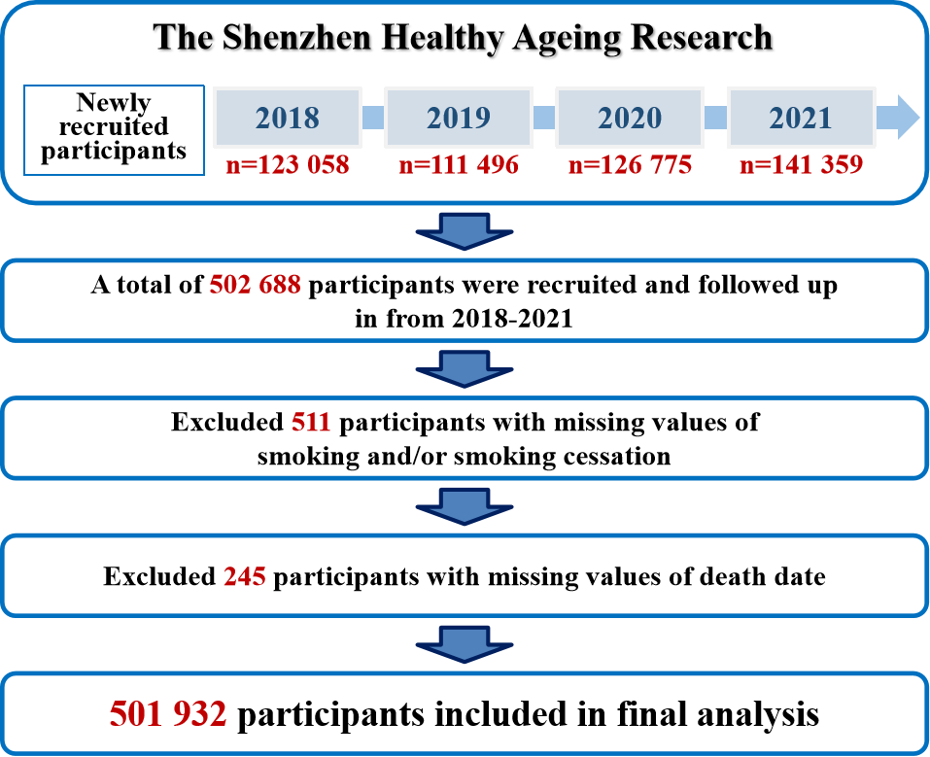
Supplement 1. Figure S1. Flowchart of study population.
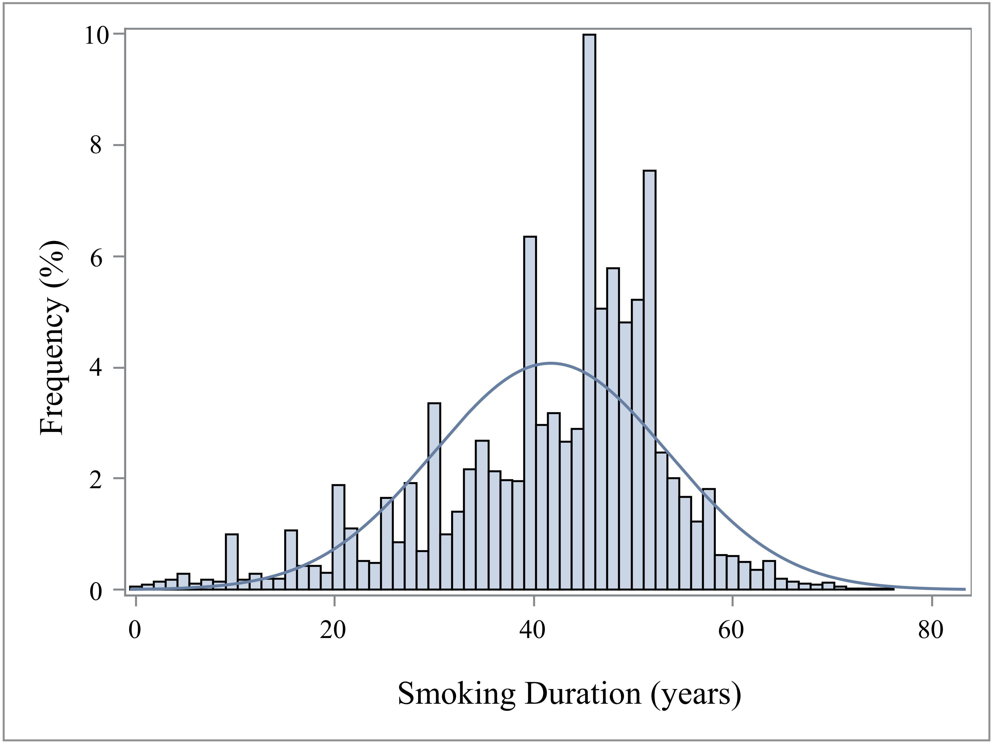
Supplement 2. Figure S2. Smoking duration among tobacco users. (N=92 589; Median=45; Mean=41.69; IQR=14; SD=11.75). Tobacco users included current smokers and former smokers.
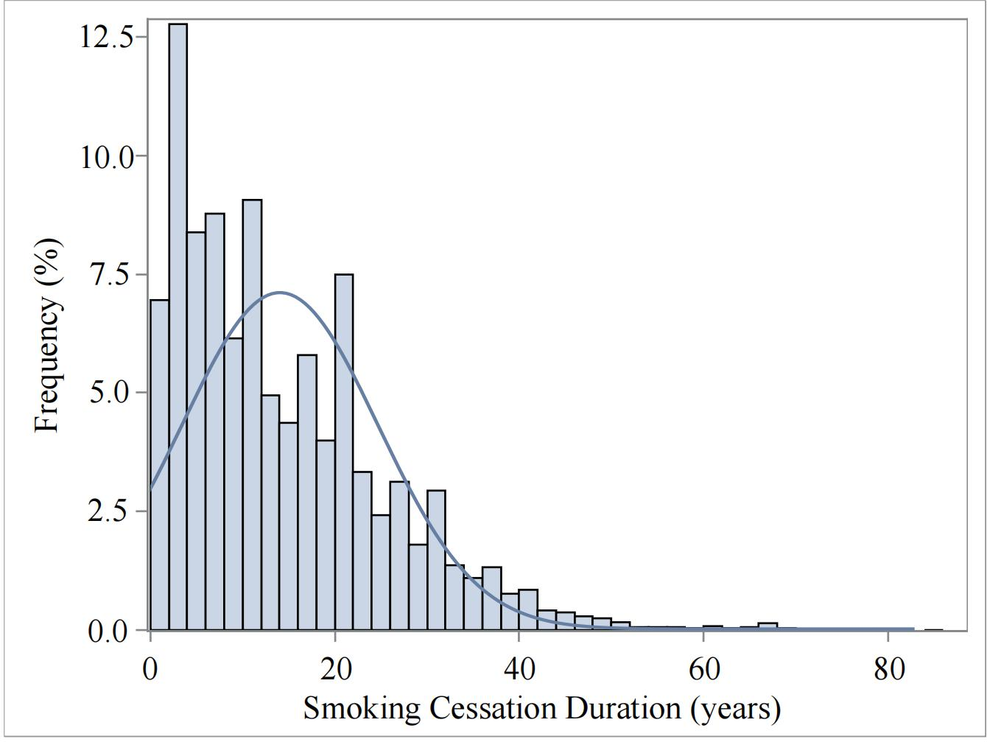
Supplement 3. Figure S3. Smoking cessation duration among former smokers.
(N=39 686; Median=11; Mean=13.96; IQR=16; SD=11.43).

Supplement 4. Table S1. Smoking duration among older adults by smoking status (years).
Smoking status | N | Mean | SD | Median | IQR
Current smokers | 52903 | 47 | 8.67 | 48 | 7
Transient quitters | 3729 | 46 | 8.39 | 47 | 8
Recent quitters | 10209 | 43 | 8.01 | 44 | 8
Long-term quitters | 25748 | 30 | 10.61 | 30 | 15

Supplement 5. Table S2. Cessation duration among older adults by smoking status (years).
Smoking status | N | Mean | SD | Median | IQR
Transient quitters | 3729 | 0.72 | 0.45 | 1 | 1
Recent quitters | 10209 | 3.79 | 1.50 | 4 | 3
Long-term quitters | 25748 | 19.19 | 10.07 | 17 | 13

Supplement 6. Supplement to the estimated glomerular filtration rate (eGFR) calculation method.
eGFR was calculated using the Chronic Kidney Disease Epidemiology Collaboration (CKD-EPI)
eGFR = 144 × (Scr/0.7)^{-0.329} × (0.993)^{Age} (if female and Scr ≤ 62 μmol/L)
eGFR = 144 × (Scr/0.7)^{-1.209} × (0.993)^{Age} (if female and Scr > 62 μmol/L)
eGFR = 141 × (Scr/0.9)^{-0.411} × (0.993)^{Age} (if male and Scr ≤ 80 μmol/L)
eGFR = 141 × (Scr/0.9)^{-1.209} × (0.993)^{Age} (if male and Scr > 80 μmol/L)
where Scr is serum creatinine concentration (in mg/dL) and Age is in years.

Supplement 7. Table S3. Association of smoking cessation with all-cause mortality among Chinese older adults, stratified by age (< 70 years vs. ≥ 70 years).
Variable | n | Model 1ª | Model 2^{b} | Model 3^{c} | Model 4^{d}
Age, years
Age < 70
Current smokers | 32 805 | 1.00 (ref) | 1.00 (ref) | 1.00 (ref) | 1.00 (ref)
Transient quitters | 2455 | 1.96 (1.48-2.59) | 1.95 (1.47-2.59) | 1.82 (1.37-2.41) | 1.61 (1.21-2.14)
Recent quitters | 6469 | 1.23 (0.98-1.54) | 1.23 (0.98-1.54) | 1.18 (0.94-1.48) | 1.09 (0.87-1.37)
Long-term quitters | 13 362 | 0.77 (0.63-0.94) | 0.80 (0.71-0.90) | 0.78 (0.63-0.95) | 0.72 (0.59-0.89)
Never smokers | 221 060 | 0.51 (0.46-0.57) | 0.74 (0.61-0.91) | 0.83 (0.74-0.94) | 0.80 (0.71-0.91)
Age ≥ 70
Current smokers | 20 098 | 1.00 (ref) | 1.00 (ref) | 1.00 (ref) | 1.00 (ref)
Transient quitters | 1274 | 1.73 (1.32-2.27) | 1.83 (1.39-2.40) | 1.70 (1.30-2.24) | 1.65 (1.26-2.17)
Recent quitters | 3740 | 1.19 (0.99-1.44) | 1.22 (1.01-1.48) | 1.21 (1.00-1.47) | 1.13 (0.93-1.37)
Long-term quitters | 12 386 | 1.08 (0.95-1.22) | 0.90 (0.79-1.02) | 1.02 (0.90-1.16) | 0.99 (0.87-1.13)
Never smokers | 188 283 | 0.85 (0.78-0.92) | 0.85 (0.78-0.93) | 0.95 (0.87-1.04) | 0.93 (0.85-1.01)
Hazard ratios and 95% confidence intervals estimated using Cox proportional hazards models.
ª Crude models with no adjustment for covariates.
^{b} Adjusted for age and sex.
^{c} Adjusted for age, sex, nation, household registration, self-rated health, BMI, marital status, education, alcohol intake status and exercise.
^{d} Adjusted for age, sex, nation, household registration, self-rated health, BMI, marital status, education, alcohol intake status, exercise, hypertension, diabetes, CKD, fatty liver disease, anemia, CVD, Cancer and COPD.

Supplement 8. Table S4. Association of smoking cessation with all-cause mortality among Chinese older adults, stratified by smoking duration.
Variable | n | Model 1ª | Model 2^{b} | Model 3^{c} | Model 4^{d}
Smoking duration, years
Smoking duration ≤ 45
Current smokers | 17 086 | 1.00 (ref) | 1.00 (ref) | 1.00 (ref) | 1.00 (ref)
Transient quitters | 1498 | 1.45 (0.99-2.15) | 1.69 (1.15-2.50) | 1.51 (1.02-2.23) | 1.40 (0.95-2.08)
Recent quitters | 6495 | 1.15 (0.91-1.45) | 1.23 (0.97-1.55) | 1.17 (0.92-1.48) | 1.06 (0.83-1.34)
Long-term quitters | 24 690 | 1.40 (1.20-1.63) | 0.90 (0.77-1.05) | 1.03 (0.87-1.21) | 0.96 (0.81-1.13)
Smoking duration > 45
Current smokers | 35 817 | 1.00 (ref) | 1.00 (ref) | 1.00 (ref) | 1.00 (ref)
Transient quitters | 2231 | 1.94 (1.55-2.43) | 2.02 (1.61-2.53) | 1.88 (1.50-2.36) | 1.77 (1.40-2.22)
Recent quitters | 3714 | 1.62 (1.34-1.96) | 1.30 (1.07-1.57) | 1.31 (1.08-1.59) | 1.21 (1.00-1.48)
Long-term quitters | 1058 | 2.72 (2.10-3.51) | 0.98 (0.76-1.27) | 1.16 (0.89-1.53) | 1.14 (0.86-1.49)
Hazard ratios and 95% confidence intervals estimated using Cox proportional hazards models.
ª Crude models with no adjustment for covariates.
^{b} Adjusted for age and sex.
^{c} Adjusted for age, sex, nation, household registration, self-rated health, BMI, marital status, education, alcohol intake status and exercise.
^{d} Adjusted for age, sex, nation, household registration, self-rated health, BMI, marital status, education, alcohol intake status, exercise, hypertension, diabetes, CKD, fatty liver disease, anemia, CVD, Cancer and COPD.

Supplement 9. Table S5. Association of smoking cessation with all-cause mortality among Chinese older adults, stratified by exercise.
Variable | n | Model 1ª | Model 2^{b} | Model 3^{c} | Model 4^{d}
Exercise
Yes
Current smokers | 36 948 | 1.00 (ref) | 1.00 (ref) | 1.00 (ref) | 1.00 (ref)
Transient quitters | 2712 | 1.45 (1.19-1.77) | 1.52 (1.25-1.86) | 1.43 (1.17-1.75) | 1.40 (1.14-1.71)
Recent quitters | 7838 | 1.02 (0.82-1.26) | 1.05 (0.85-1.30) | 1.05 (0.82-1.26) | 1.03 (0.79-1.21)
Long-term quitters | 20 859 | 1.02 (0.90-1.15) | 0.82 (0.73-0.93) | 0.84 (0.75-0.96) | 0.84 (0.73-0.94)
Never smokers | 307 446 | 0.71 (0.65-0.77) | 0.78 (0.71-0.85) | 0.78 (0.71-0.84) | 0.76 (0.70-0.84)
No
Current smokers | 15 955 | 1.00 (ref) | 1.00 (ref) | 1.00 (ref) | 1.00 (ref)
Transient quitters | 1017 | 1.99 (1.55-2.56) | 2.22 (1.73-2.86) | 1.77 (1.27-2.46) | 1.71 (1.22-2.38)
Recent quitters | 2371 | 1.39 (1.03-1.88) | 1.39 (1.03-1.88) | 1.52 (1.20-1.93) | 1.38 (1.08-1.76)
Long-term quitters | 4889 | 1.44 (1.20-1.74) | 1.02 (0.85-1.24) | 1.04 (0.86-1.26) | 0.99 (0.82-1.20)
Never smokers | 101 897 | 1.04 (0.93-1.16) | 1.01 (0.90-1.13) | 1.05 (0.93-1.18) | 1.01 (0.90-1.15)
Hazard ratios and 95% confidence intervals estimated using Cox proportional hazards models.
ª Crude models with no adjustment for covariates.
^{b} Adjusted for age and sex.
^{c} Adjusted for age, sex, nation, household registration, self-rated health, BMI, marital status, education and alcohol intake status.
^{d} Adjusted for age, sex, nation, household registration, self-rated health, BMI, marital status, education, alcohol intake status, hypertension, diabetes, CKD, fatty liver disease, anemia, CVD, Cancer and COPD.
Supplement 10. Table S6. Association of smoking cessation with all-cause mortality among Chinese older adults, stratified by BMI.
Variable | n | Model 1ª | Model 2^{b} | Model 3^{c} | Model 4^{d}
BMI
Underweight
Current smokers | 2787 | 1.00 (ref) | 1.00 (ref) | 1.00 (ref) | 1.00 (ref)
Transient quitters | 179 | 2.72 (1.63-4.53) | 3.50 (2.10-5.85) | 2.80 (1.67-4.72) | 2.26 (1.34-3.82)
Recent quitters | 379 | 2.10 (1.40-3.17) | 1.99 (1.32-3.00) | 1.69 (1.11-2.56) | 1.55 (1.01-2.38)
Long-term quitters | 714 | 1.20 (0.82-1.77) | 0.96 (0.65-1.42) | 0.96 (0.65-1.43) | 0.91 (0.61-1.35)
Never smokers | 14 595 | 0.92 (0.75-1.13) | 1.06 (0.85-1.31) | 1.10 (0.88-1.37) | 1.03 (0.82-1.29)
Normal weight
Current smokers | 28 548 | 1.00 (ref) | 1.00 (ref) | 1.00 (ref) | 1.00 (ref)
Transient quitters | 1909 | 1.88 (1.45-2.44) | 1.99 (1.53-2.58) | 1.80 (1.38-2.34) | 1.75 (1.34-2.27)
Recent quitters | 4846 | 1.24 (1.01-1.52) | 1.25 (1.02-1.53) | 1.20 (0.98-1.47) | 1.10 (0.90-1.35)
Long-term quitters | 11 581 | 1.25 (1.08-1.44) | 0.93 (0.81-1.08) | 1.00 (0.86-1.16) | 0.96 (0.83-1.11)
Never smokers | 20 2275 | 0.89 (0.81-0.97) | 0.91 (0.83-1.00) | 0.96 (0.87-1.06) | 0.93 (0.85-1.03)
Overweight
Current smokers | 18 010 | 1.00 (ref) | 1.00 (ref) | 1.00 (ref) | 1.00 (ref)
Transient quitters | 1341 | 1.25 (0.83-1.89) | 1.38 (0.92-2.08) | 1.35 (0.89-2.03) | 1.28 (0.85-1.92)
Recent quitters | 4063 | 1.12 (0.86-1.46) | 1.18 (0.91-1.54) | 1.16 (0.89-1.51) | 1.10 (0.84-1.43)
Long-term quitters | 10 861 | 0.95 (0.78-1.14) | 0.75 (0.62-0.91) | 0.79 (0.65-0.95) | 0.76 (0.63-0.93)
Never smokers | 151 812 | 0.70 (0.62-0.79) | 0.73 (0.64-0.83) | 0.77 (0.68-0.88) | 0.76 (0.67-0.87)
Obesity
Current smokers | 3567 | 1.00 (ref) | 1.00 (ref) | 1.00 (ref) | 1.00 (ref)
Transient quitters | 300 | 1.83 (0.87-3.84) | 1.99 (0.95-4.17) | 1.93 (0.92-4.05) | 1.87 (0.89-3.94)
Recent quitters | 921 | 0.72 (0.37-1.41) | 0.72 (0.37-1.42) | 0.71 (0.36-1.39) | 0.71 (0.36-1.41)
Long-term quitters | 2592 | 1.12 (0.76-1.65) | 0.84 (0.57-1.24) | 0.88 (0.59-1.30) | 0.87 (0.58-1.29)
Never smokers | 40 661 | 0.69 (0.52-0.90) | 0.65 (0.49-0.87) | 0.67 (0.50-0.91) | 0.67 (0.50-0.90)
Hazard ratios and 95% confidence intervals estimated using Cox proportional hazards models.
ª Crude models with no adjustment for covariates.
^{b} Adjusted for age and sex.
^{c} Adjusted for age, sex, nation, household registration, self-rated health, BMI, marital status, education, alcohol intake status and exercise.
^{d} Adjusted for age, sex, nation, household registration, self-rated health, BMI, marital status, education, alcohol intake status, exercise, hypertension, diabetes, CKD, fatty liver disease, anemia, CVD, Cancer and COPD.

Supplement 11. Table S7. Association of smoking cessation with all-cause mortality among Chinese older adults, stratified by sex.
Variable | n | Model 1ª | Model 2^{b} | Model 3^{c} | Model 4^{d}
Sex
Men
Current smokers | 50 561 | 1.00 (ref) | 1.00 (ref) | 1.00 (ref) | 1.00 (ref)
Transient quitters | 3640 | 1.73 (1.42-2.11) | 1.89 (1.55-2.30) | 1.75 (1.44-2.13) | 1.65 (1.35-2.01)
Recent quitters | 10 002 | 1.18 (1.02-1.36) | 1.22 (1.05-1.41) | 1.21 (1.04-1.40) | 1.11 (0.96-1.29)
Long-term quitters | 25 313 | 1.06 (0.96-1.18) | 0.86 (0.77-0.96) | 0.95 (0.85-1.06) | 0.92 (0.82-1.02)
Never smokers | 135 486 | 1.12 (1.05-1.21) | 0.85 (0.79-0.91) | 0.92 (0.86-0.99) | 0.90 (0.83-0.97)
Women
Current smokers | 2342 | 1.00 (ref) | 1.00 (ref) | 1.00 (ref) | 1.00 (ref)
Transient quitters | 89 | 1.54 (0.37-6.35) | 1.96 (0.47-8.07) | 2.08 (0.50-8.59) | 2.33 (0.57-9.62)
Recent quitters | 207 | 1.35 (0.49-3.75) | 1.12 (0.40-3.10) | 0.94 (0.34-2.61) | 0.98 (0.35-2.73)
Long-term quitters | 1435 | 1.10 (0.54-2.26) | 0.83 (0.40-1.69) | 0.98 (0.48-2.02) | 0.98 (0.48-2.00)
Never smokers | 273 857 | 0.76 (0.57-1.02) | 0.88 (0.66-1.19) | 0.97 (0.72-1.30) | 0.97 (0.72-1.30)
Hazard ratios and 95% confidence intervals estimated using Cox proportional hazards models.
ª Crude models with no adjustment for covariates.
^{b} Adjusted for age
^{c} Adjusted for age, nation, household registration, self-rated health, BMI, marital status, education, alcohol intake status and exercise.
^{d} Adjusted for age, nation, household registration, self-rated health, BMI, marital status, education, alcohol intake status, exercise, hypertension, diabetes, CKD, fatty liver disease, anemia, CVD, Cancer and COPD.

Supplement 12. Table S8. Association of smoking cessation with cancer mortality among Chinese older adults, stratified by age.
Variable | n | Model 1ª | Model 2^{b} | Model 3^{c} | Model 4^{d}
Age, years
Age < 70
Current smokers | 32 805 | 1.00 (ref) | 1.00 (ref) | 1.00 (ref) | 1.00 (ref)
Transient quitters | 2455 | 2.07 (1.40-3.06) | 2.07 (1.40-3.06) | 1.97 (1.33-2.92) | 1.69 (1.14-2.51)
Recent quitters | 6469 | 1.11 (0.79-1.54) | 1.10 (0.79-1.54) | 1.09 (0.78-1.53) | 0.98 (0.70-1.38)
Long-term quitters | 13 362 | 0.67 (0.49-0.90) | 0.68 (0.57-0.81) | 0.73 (0.61-0.87) | 0.70 (0.58-0.84)
Never smokers | 221 060 | 0.45 (0.38-0.52) | 0.65 (0.48-0.87) | 0.68 (0.50-0.92) | 0.62 (0.46-0.84)
Age ≥ 70
Current smokers | 20 098 | 1.00 (ref) | 1.00 (ref) | 1.00 (ref) | 1.00 (ref)
Transient quitters | 1274 | 2.16 (1.48-3.15) | 2.20 (1.51-3.21) | 2.12 (1.45-3.10) | 2.03 (1.39-2.97)
Recent quitters | 3740 | 1.12 (0.83-1.52) | 1.12 (0.83-1.51) | 1.14 (0.84-1.55) | 1.03 (0.76-1.40)
Long-term quitters | 12 386 | 0.85 (0.69-1.04) | 0.76 (0.61-0.93) | 0.82 (0.66-1.01) | 0.78 (0.63-0.97)
Never smokers | 188 283 | 0.56 (0.49-0.64) | 0.67 (0.58-0.77) | 0.72 (0.62-0.83) | 0.70 (0.60-0.80)
Hazard ratios and 95% confidence intervals estimated using Cox proportional hazards models.
ª Crude models with no adjustment for covariates.
^{b} Adjusted for age and sex.
^{c} Adjusted for age, sex, nation, household registration, self-rated health, BMI, marital status, education, alcohol intake status and exercise.
^{d} Adjusted for age, sex, nation, household registration, self-rated health, BMI, marital status, education, alcohol intake status, exercise, hypertension, diabetes, CKD, fatty liver disease, anemia, CVD, Cancer and COPD.

Supplement 13. Table S9. Association of smoking cessation with cancer mortality among Chinese older adults, stratified by smoking duration.
Variable | n | Model 1ª | Model 2^{b} | Model 3^{c} | Model 4^{d}
Smoking duration, years
Smoking duration ≤ 45
Current smokers | 17 086 | 1.00 (ref) | 1.00 (ref) | 1.00 (ref) | 1.00 (ref)
Transient quitters | 1498 | 1.53 (0.86-2.72) | 1.62 (0.91-2.88) | 1.55 (0.87-2.75) | 1.42 (0.80-2.53)
Recent quitters | 6495 | 1.17 (0.83-1.66) | 1.18 (0.83-1.67) | 1.17 (0.82-1.66) | 1.06 (0.74-1.50)
Long-term quitters | 24 690 | 1.14 (0.90-1.45) | 0.86 (0.68-1.09) | 0.90 (0.71-1.14) | 0.84 (0.66-1.07)
Smoking duration > 45
Current smokers | 35 817 | 1.00 (ref) | 1.00 (ref) | 1.00 (ref) | 1.00 (ref)
Transient quitters | 2231 | 2.33 (1.71-3.17) | 2.38 (1.75-3.24) | 2.32 (1.70-3.16) | 2.15 (1.57-2.93)
Recent quitters | 3714 | 1.41 (1.04-1.90) | 1.21 (0.90-1.63) | 1.22 (0.91-1.66) | 1.09 (0.81-1.48)
Long-term quitters | 1058 | 1.98 (1.28-3.08) | 1.02 (0.66-1.59) | 1.04 (0.67-1.62) | 1.00 (0.64-1.56)
Hazard ratios and 95% confidence intervals estimated using Cox proportional hazards models.
ª Crude models with no adjustment for covariates.
^{b} Adjusted for age and sex.
^{c} Adjusted for age, sex, nation, household registration, self-rated health, BMI, marital status, education, alcohol intake status and exercise.
^{d} Adjusted for age, sex, nation, household registration, self-rated health, BMI, marital status, education, alcohol intake status, exercise, hypertension, diabetes, CKD, fatty liver disease, anemia, CVD, Cancer and COPD.

Supplement 14. Table S10. Association of smoking cessation with cancer mortality among Chinese older adults, stratified by exercise.
Variable | n | Model 1ª | Model 2^{b} | Model 3^{c} | Model 4^{d}
Exercise
Yes
Current smokers | 36 948 | 1.00 (ref) | 1.00 (ref) | 1.00 (ref) | 1.00 (ref)
Transient quitters | 2712 | 2.01 (1.45-2.77) | 2.11 (1.53-2.91) | 2.07 (1.50-2.86) | 1.91 (1.39-2.65)
Recent quitters | 7838 | 0.91 (0.69-1.20) | 0.92 (0.70-1.22) | 0.92 (0.70-1.22) | 0.86 (0.65-1.13)
Long-term quitters | 20 859 | 0.78 (0.64-0.95) | 0.67 (0.55-0.82) | 0.70 (0.57-0.85) | 0.67 (0.54-0.81)
Never smokers | 307 446 | 0.52 (0.46-0.58) | 0.62 (0.55-0.71) | 0.64 (0.57-0.74) | 0.62 (0.55-0.71)
No
Current smokers | 15 955 | 1.00 (ref) | 1.00 (ref) | 1.00 (ref) | 1.00 (ref)
Transient quitters | 1017 | 2.10 (1.27-3.48) | 2.18 (1.31-3.60) | 2.00 (1.20-3.33) | 1.90 (1.14-3.15)
Recent quitters | 2371 | 1.77 (1.22-2.58) | 1.75 (1.20-2.55) | 1.71 (1.17-2.50) | 1.42 (0.97-2.10)
Long-term quitters | 4889 | 1.16 (0.83-1.62) | 0.96 (0.69-1.34) | 0.98 (0.70-1.37) | 0.94 (0.67-1.32)
Never smokers | 101 897 | 0.65 (0.54-0.78) | 0.85 (0.70-1.04) | 0.93 (0.76-1.15) | 0.89 (0.72-1.10)
Hazard ratios and 95% confidence intervals estimated using Cox proportional hazards models.
ª Crude models with no adjustment for covariates.
^{b} Adjusted for age and sex.
^{c} Adjusted for age, sex, nation, household registration, self-rated health, BMI, marital status, education and alcohol intake status.
^{d} Adjusted for age, sex, nation, household registration, self-rated health, BMI, marital status, education, alcohol intake status, hypertension, diabetes, CKD, fatty liver disease, anemia, CVD, Cancer and COPD.
Supplement 15. Table S11. Association of smoking cessation with cancer mortality among Chinese older adults, stratified by BMI.
Variable | n | Model 1ª | Model 2^{b} | Model 3^{c} | Model 4^{d}
BMI
Underweight
Current smokers | 2787 | 1.00 (ref) | 1.00 (ref) | 1.00 (ref) | 1.00 (ref)
Transient quitters | 179 | 3.14 (1.60-6.15) | 3.45 (1.76-6.78) | 3.14 (1.57-6.25) | 2.22 (1.10-4.49)
Recent quitters | 379 | 1.14 (0.54-2.40) | 1.10 (0.52-2.31) | 1.03 (0.49-2.19) | 0.92 (0.43-1.97)
Long-term quitters | 714 | 0.63 (0.31-1.26) | 0.54 (0.27-1.10) | 0.55 (0.27-1.12) | 0.49 (0.24-1.01)
Never smokers | 14 595 | 0.45 (0.33-0.61) | 0.60 (0.42-0.84) | 0.60 (0.42-0.86) | 0.54 (0.37-0.77)
Normal weight
Current smokers | 28 548 | 1.00 (ref) | 1.00 (ref) | 1.00 (ref) | 1.00 (ref)
Transient quitters | 1909 | 2.16 (1.50-3.10) | 2.22 (1.54-3.19) | 2.07 (1.44-2.99) | 1.98 (1.37-2.85)
Recent quitters | 4846 | 1.22 (0.91-1.65) | 1.22 (0.90-1.64) | 1.20 (0.89-1.62) | 1.05 (0.78-1.43)
Long-term quitters | 11 581 | 1.00 (0.80-1.25) | 0.85 (0.67-1.06) | 0.87 (0.69-1.09) | 0.82 (0.65-1.03)
Never smokers | 20 2275 | 0.59 (0.52-0.68) | 0.73 (0.64-0.85) | 0.76 (0.66-0.89) | 0.74 (0.64-0.86)
Overweight
Current smokers | 18 010 | 1.00 (ref) | 1.00 (ref) | 1.00 (ref) | 1.00 (ref)
Transient quitters | 1341 | 1.25 (0.68-2.31) | 1.32 (0.71-2.44) | 1.30 (0.70-2.42) | 1.23 (0.66-2.28)
Recent quitters | 4063 | 1.03 (0.68-1.55) | 1.05 (0.70-1.58) | 1.05 (0.69-1.58) | 0.98 (0.65-1.48)
Long-term quitters | 10 861 | 0.75 (0.56-1.02) | 0.65 (0.48-0.88) | 0.66 (0.48-0.90) | 0.63 (0.47-0.87)
Never smokers | 151 812 | 0.54 (0.45-0.65) | 0.66 (0.54-0.80) | 0.70 (0.57-0.85) | 0.68 (0.55-0.83)
Obesity
Current smokers | 3567 | 1.00 (ref) | 1.00 (ref) | 1.00 (ref) | 1.00 (ref)
Transient quitters | 300 | 4.04 (1.48-11.02) | 4.27 (1.56-11.65) | 4.02 (1.47-11.04) | 3.84 (1.39-10.55)
Recent quitters | 921 | 1.27 (0.47-3.47) | 1.26 (0.46-3.43) | 1.13 (0.41-3.11) | 1.16 (0.42-3.18)
Long-term quitters | 2592 | 1.33 (0.67-2.66) | 1.06 (0.53-2.12) | 0.97 (0.48-1.97) | 0.94 (0.46-1.91)
Never smokers | 40 661 | 0.78 (0.46-1.30) | 0.80 (0.47-1.37) | 0.78 (0.45-1.36) | 0.76 (0.44-1.32)
Hazard ratios and 95% confidence intervals estimated using Cox proportional hazards models.
ª Crude models with no adjustment for covariates.
^{b} Adjusted for age and sex.
^{c} Adjusted for age, sex, nation, household registration, self-rated health, BMI, marital status, education, alcohol intake status and exercise.
^{d} Adjusted for age, sex, nation, household registration, self-rated health, BMI, marital status, education, alcohol intake status, exercise, hypertension, diabetes, CKD, fatty liver disease, anemia, CVD, Cancer and COPD.

Supplement 16. Table S12. Association of smoking cessation with cancer mortality among Chinese older adults, stratified by sex.
Variable | n | Model 1ª | Model 2^{b} | Model 3^{c} | Model 4^{d}
Sex
Men
Current smokers | 50 561 | 1.00 (ref) | 1.00 (ref) | 1.00 (ref) | 1.00 (ref)
Transient quitters | 3640 | 2.00 (1.52-2.63) | 2.11 (1.61-2.78) | 2.03 (1.54-2.67) | 1.87 (1.42-2.46)
Recent quitters | 10 002 | 1.10 (0.88-1.37) | 1.12 (0.90-1.40) | 1.13 (0.90-1.42) | 1.02 (0.81-1.28)
Long-term quitters | 25 313 | 0.83 (0.70-0.99) | 0.73 (0.61-0.86) | 0.78 (0.66-0.93) | 0.75 (0.63-0.89)
Never smokers | 135 486 | 0.81 (0.72-0.90) | 0.68 (0.61-0.75) | 0.73 (0.65-0.82) | 0.71 (0.63-0.80)
Women
Current smokers | 2342 | 1.00 (ref) | 1.00 (ref) | 1.00 (ref) | 1.00 (ref)
Transient quitters | 89 | 2.33 (0.31-17.67) | 2.60 (0.34-19.72) | 2.71 (0.36-20.55) | 2.78 (0.37-21.06)
Recent quitters | 207 | 1.20 (0.91-1.48) | 1.22(0.95-1.51) | 1.24 (0.96-1.53) | 1.26(0.97-1.55)
Long-term quitters | 1435 | 0.74 (0.17-3.22) | 0.61 (0.14-2.69) | 0.66 (0.15-2.91) | 0.65 (0.15-2.84)
Never smokers | 273 857 | 0.69 (0.41-1.15) | 0.75 (0.45-1.24) | 0.76 (0.46-1.27) | 0.75 (0.45-1.25)
Hazard ratios and 95% confidence intervals estimated using Cox proportional hazards models.
ª Crude models with no adjustment for covariates.
^{b} Adjusted for age
^{c} Adjusted for age, nation, household registration, self-rated health, BMI, marital status, education, alcohol intake status and exercise.
^{d} Adjusted for age, nation, household registration, self-rated health, BMI, marital status, education, alcohol intake status, exercise, hypertension, diabetes, CKD, fatty liver disease, anemia, CVD, Cancer and COPD.

Supplement 17. Table S13. Sensitivity analyses with excluding participants who died within the first 2 year of follow-up.
Variable | n | Model 1ª | Model 2^{b} | Model 3^{c} | Model 4^{d}
All-Cause Mortality
Current smokers | 52 199 | 1.00 (ref) | 1.00 (ref) | 1.00 (ref) | 1.00 (ref)
Transient quitters | 3645 | 1.42 (1.08-2.18) | 1.56 (1.10-2.39) | 1.48 (1.11-2.27) | 1.41 (1.09-2.17)
Recent quitters | 10 053 | 1.22 (0.94-1.59) | 1.27 (0.97-1.65) | 1.25 (0.96-1.63) | 1.17 (0.90-1.53)
Long-term quitters | 25 401 | 1.18 (0.98-1.41) | 0.93 (0.77-1.11) | 1.00 (0.83-1.20) | 0.97 (0.81-1.17)
Never smokers | 404 474 | 0.80 (0.71-0.90) | 0.85 (0.75-0.96) | 0.93 (0.82-1.00) | 0.91 (0.80-0.99)
CVD Mortality
Current smokers | 52 199 | 1.00 (ref) | 1.00 (ref) | 1.00 (ref) | 1.00 (ref)
Transient quitters | 3645 | 1.22 (0.71-2.11) | 1.39 (0.81-2.39) | 1.28 (0.74-2.20) | 1.20 (0.70-2.08)
Recent quitters | 10 053 | 0.91 (0.62-1.32) | 0.96 (0.66-1.40) | 0.92 (0.63-1.35) | 0.87 (0.59-1.28)
Long-term quitters | 25 401 | 1.07 (0.84-1.36) | 0.81 (0.63-1.02) | 0.89 (0.69-1.13) | 0.84 (0.66-1.08)
Never smokers | 404 474 | 0.95 (0.82-1.10) | 0.90 (0.77-1.05) | 0.96 (0.82-1.13) | 0.93 (0.79-1.09)
Cancer Mortality
Current smokers | 52 199 | 1.00 (ref) | 1.00 (ref) | 1.00 (ref) | 1.00 (ref)
Transient quitters | 3645 | 1.51 (1.01-2.26) | 1.59 (1.07-2.38) | 1.54 (1.03-2.31) | 1.50 (1.00-2.24)
Recent quitters | 10 053 | 0.88 (0.64-1.20) | 0.89 (0.65-1.22) | 0.88 (0.64-1.21) | 0.83 (0.60-1.14)
Long-term quitters | 25 401 | 0.90 (0.73-1.11) | 0.77 (0.62-0.95) | 0.79 (0.63-0.97) | 0.76 (0.62-0.94)
Never smokers | 404 474 | 0.51 (0.45-0.58) | 0.61 (0.53-0.70) | 0.65 (0.57-0.75) | 0.64 (0.55-0.74)
Hazard ratios and 95% confidence intervals estimated using Cox proportional hazards models.
ª Crude models with no adjustment for covariates.
^{b} Adjusted for age and sex.
^{c} Adjusted for age, sex, nation, household registration, self-rated health, BMI, marital status, education, alcohol intake status and exercise.
^{d} Adjusted for age, sex, nation, household registration, self-rated health, BMI, marital status, education, alcohol intake status, exercise, hypertension, diabetes, CKD, fatty liver disease, anemia, CVD, Cancer and COPD.
Supplement 18. Table S14. Sensitivity analyses with excluding participants whose smoking duration was less than 20 years.
Variable | n | Model 1ª | Model 2^{b} | Model 3^{c} | Model 4^{d}
All-Cause Mortality
Current smokers | 50 994 | 1.00 (ref) | 1.00 (ref) | 1.00 (ref) | 1.00 (ref)
Transient quitters | 3646 | 1.73 (1.42-2.11) | 1.89 (1.55-2.30) | 1.76 (1.44-2.15) | 1.67 (1.37-2.04)
Recent quitters | 9979 | 1.17 (1.01-1.36) | 1.21 (1.05-1.41) | 1.19 (1.02-1.38) | 1.11 (0.96-1.29)
Long-term quitters | 21595 | 1.11 (1.00-1.24) | 0.85 (0.76-0.95) | 0.93 (0.83-1.04) | 0.89 (0.80-1.00)
Never smokers | 409 343 | 0.78 (0.73-0.84) | 0.80 (0.75-0.86) | 0.88 (0.82-0.95) | 0.86 (0.80-0.92)
CVD Mortality
Current smokers | 50 994 | 1.00 (ref) | 1.00 (ref) | 1.00 (ref) | 1.00 (ref)
Transient quitters | 3646 | 1.23 (0.83-1.82) | 1.37 (0.92-2.02) | 1.24 (0.84-1.84) | 1.19 (0.80-1.76)
Recent quitters | 9979 | 1.05 (0.81-1.36) | 1.10 (0.85-1.43) | 1.05 (0.81-1.37) | 1.01 (0.77-1.32)
Long-term quitters | 21595 | 1.11 (0.93-1.32) | 0.83 (0.69-0.99) | 0.92 (0.76-1.11) | 0.88 (0.73-1.06)
Never smokers | 409 343 | 0.90 (0.81-1.01) | 0.85 (0.76-0.96) | 0.91 (0.80-1.03) | 0.89 (0.78-1.00)
Cancer Mortality
Current smokers | 50 994 | 1.00 (ref) | 1.00 (ref) | 1.00 (ref) | 1.00 (ref)
Transient quitters | 3646 | 1.98 (1.50-2.61) | 2.08 (1.58-2.74) | 2.02 (1.53-2.66) | 1.86 (1.41-2.46)
Recent quitters | 9979 | 1.09 (0.87-1.36) | 1.11 (0.88-1.39) | 1.12 (0.89-1.40) | 1.01 (0.80-1.27)
Long-term quitters | 21595 | 0.90 (0.75-1.07) | 0.76 (0.64-0.91) | 0.81 (0.68-0.97) | 0.76 (0.64-0.91)
Never smokers | 409 343 | 0.54 (0.48-0.59) | 0.66 (0.59-0.73) | 0.70 (0.63-0.79) | 0.68 (0.60-0.76)
Hazard ratios and 95% confidence intervals estimated using Cox proportional hazards models.
ª Crude models with no adjustment for covariates.
^{b} Adjusted for age and sex.
^{c} Adjusted for age, sex, nation, household registration, self-rated health, BMI, marital status, education, alcohol intake status and exercise.
^{d} Adjusted for age, sex, nation, household registration, self-rated health, BMI, marital status, education, alcohol intake status, exercise, hypertension, diabetes, CKD, fatty liver disease, anemia, CVD, Cancer and COPD.

Supplement 19. Table S15. Sensitivity analyses with excluding participants with two or more of the following diseases: Hypertension, Diabetes, CKD, Fatty liver disease and Anemia.
Variable | n | Model 1ª | Model 2^{b} | Model 3^{c} | Model 4^{d}
All-Cause Mortality
Current smokers | 35 546 | 1.00 (ref) | 1.00 (ref) | 1.00 (ref) | 1.00 (ref)
Transient quitters | 2345 | 1.80 (1.37-2.35) | 1.97 (1.51-2.58) | 1.83 (1.40-2.40) | 1.76 (1.34-2.30)
Recent quitters | 6244 | 1.20 (0.98-1.47) | 1.22 (1.00-1.50) | 1.21 (0.99-1.49) | 1.14 (0.93-1.40)
Long-term quitters | 15 063 | 1.01 (0.87-1.17) | 0.80 (0.69-0.93) | 0.89 (0.76-1.04) | 0.85 (0.73-1.00)
Never smokers | 244 389 | 0.78 (0.71-0.85) | 0.86 (0.78-0.94) | 0.96 (0.87-1.06) | 0.94 (0.85-1.04)
CVD Mortality
Current smokers | 35 546 | 1.00 (ref) | 1.00 (ref) | 1.00 (ref) | 1.00 (ref)
Transient quitters | 2345 | 0.81 (0.40-1.65) | 0.91 (0.45-1.86) | 0.84 (0.41-1.71) | 0.83 (0.41-1.69)
Recent quitters | 6244 | 1.03 (0.70-1.53) | 1.07 (0.72-1.58) | 1.04 (0.70-1.55) | 1.04 (0.70-1.55)
Long-term quitters | 15 063 | 0.98 (0.74-1.29) | 0.74 (0.56-0.98) | 0.84 (0.63-1.12) | 0.82 (0.62-1.09)
Never smokers | 244 389 | 0.95 (0.81-1.12) | 0.94 (0.79-1.12) | 1.05 (0.88-1.26) | 1.04 (0.88-1.25)
Cancer Mortality
Current smokers | 35 546 | 1.00 (ref) | 1.00 (ref) | 1.00 (ref) | 1.00 (ref)
Transient quitters | 2345 | 2.35 (1.68-3.26) | 2.47 (1.78-3.44) | 2.32 (1.66-3.24) | 2.15 (1.54-3.00)
Recent quitters | 6244 | 1.12 (0.83-1.49) | 1.12 (0.84-1.50) | 1.10 (0.82-1.48) | 0.99 (0.74-1.34)
Long-term quitters | 15 063 | 0.84 (0.67-1.05) | 0.73 (0.58-0.91) | 0.76 (0.61-0.96) | 0.72 (0.57-0.90)
Never smokers | 244 389 | 0.54 (0.47-0.61) | 0.67 (0.58-0.76) | 0.74 (0.64-0.85) | 0.71 (0.61-0.82)
Hazard ratios and 95% confidence intervals estimated using Cox proportional hazards models.
ª Crude models with no adjustment for covariates.
^{b} Adjusted for age and sex.
^{c} Adjusted for age, sex, nation, household registration, self-rated health, BMI, marital status, education, alcohol intake status and exercise.
^{d} Adjusted for age, sex, nation, household registration, self-rated health, BMI, marital status, education, alcohol intake status, exercise, hypertension, diabetes, CKD, fatty liver disease, anemia, CVD, Cancer and COPD.

Supplement 20. Table S16. Sensitivity analyses excluding participants with baseline CVD, cancer, COPD, or poor self-rated health.
Variable | n | Model 1ª | Model 2^{b} | Model 3^{c} | Model 4^{d}
All-Cause Mortality
Current smokers | 48 404 | 1.00 (ref) | 1.00 (ref) | 1.00 (ref) | 1.00 (ref)
Transient quitters | 3204 | 1.54 (1.22-1.93) | 1.69 (1.34-2.12) | 1.60 (1.27-2.02) | 1.55 (1.23-1.95)
Recent quitters | 8634 | 0.97 (0.81-1.15) | 1.00 (0.84-1.20) | 1.02 (0.86-1.22) | 1.00 (0.84-1.19)
Long-term quitters | 21 930 | 0.94 (0.84-1.06) | 0.76 (0.67-0.86) | 0.84 (0.74-0.95) | 0.83 (0.73-0.93)
Never smokers | 368 613 | 0.72 (0.67-0.77) | 0.78 (0.72-0.84) | 0.85 (0.78-0.92) | 0.83 (0.77-0.90)
CVD Mortality
Current smokers | 48 404 | 1.00 (ref) | 1.00 (ref) | 1.00 (ref) | 1.00 (ref)
Transient quitters | 3204 | 0.87 (0.53-1.45) | 0.98 (0.59-1.63) | 0.93 (0.56-1.53) | 0.88 (0.53-1.46)
Recent quitters | 8634 | 0.93 (0.68-1.25) | 0.98 (0.72-1.32) | 0.98 (0.72-1.33) | 0.95 (0.70-1.29)
Long-term quitters | 21 930 | 0.98 (0.80-1.20) | 0.76 (0.63-0.93) | 0.85 (0.69-1.04) | 0.82 (0.67-1.00)
Never smokers | 368 613 | 0.80 (0.71-0.91) | 0.79 (0.70-0.90) | 0.85 (0.75-0.97) | 0.83 (0.73-0.94)
Cancer Mortality
Current smokers | 48 404 | 1.00 (ref) | 1.00 (ref) | 1.00 (ref) | 1.00 (ref)
Transient quitters | 3204 | 1.73 (1.26-2.38) | 1.83 (1.33-2.51) | 1.75 (1.27-2.41) | 1.70 (1.24-2.34)
Recent quitters | 8634 | 0.85 (0.65-1.12) | 0.87 (0.66-1.13) | 0.87 (0.66-1.14) | 0.86 (0.65-1.12)
Long-term quitters | 21 930 | 0.73 (0.60-0.88) | 0.63 (0.52-0.76) | 0.66 (0.54-0.80) | 0.66 (0.54-0.80)
Never smokers | 368 613 | 0.52 (0.47-0.58) | 0.65 (0.58-0.73) | 0.69 (0.61-0.78) | 0.68 (0.60-0.76)
Hazard ratios and 95% confidence intervals estimated using Cox proportional hazards models.
ª Crude models with no adjustment for covariates.
^{b} Adjusted for age and sex.
^{c} Adjusted for age, sex, nation, household registration, BMI, marital status, education, alcohol intake status and exercise.
^{d} Adjusted for age, sex, nation, household registration, BMI, marital status, education, alcohol intake status, exercise, hypertension, diabetes, CKD, fatty liver disease and anemia.

Supplement 21. Table S17. Sensitivity analyses excluding participants enrolled in 2021 and adjusting for recruitment year.
Variable | N | Model 1ª | Model 2^{b} | Model 3^{c} | Model 4^{d}
All-Cause Mortality
Current smokers | 34 031 | 1.00 (ref) | 1.00 (ref) | 1.00 (ref) | 1.00 (ref)
Transient quitters | 2370 | 1.68 (1.37-2.05) | 1.85 (1.51-2.27) | 1.71 (1.39-2.09) | 1.62 (1.32-1.99)
Recent quitters | 6309 | 1.16 (0.99-1.34) | 1.20 (1.03-1.39) | 1.17 (1.00-1.36) | 1.09 (0.94-1.27)
Long-term quitters | 16 239 | 1.07 (0.96-1.19) | 0.84 (0.75-0.93) | 0.93 (0.83-1.04) | 0.90 (0.80-1.00)
Never smokers | 301 723 | 0.78 (0.73-0.83) | 0.80 (0.75-0.86) | 0.89 (0.83-0.96) | 0.87 (0.81-0.93)
CVD Mortality
Current smokers | 34 031 | 1.00 (ref) | 1.00 (ref) | 1.00 (ref) | 1.00 (ref)
Transient quitters | 2370 | 1.11 (0.73-1.68) | 1.26 (0.83-1.91) | 1.13 (0.75-1.71) | 1.08 (0.71-1.63)
Recent quitters | 6309 | 1.02 (0.78-1.33) | 1.07 (0.82-1.40) | 1.01 (0.77-1.33) | 0.98 (0.75-1.28)
Long-term quitters | 16 239 | 1.12 (0.93-1.34) | 0.84 (0.70-1.00) | 0.94 (0.78-1.12) | 0.90 (0.75-1.08)
Never smokers | 301 723 | 0.90 (0.80-1.00) | 0.84 (0.75-0.95) | 0.92 (0.81-1.04) | 0.90 (0.79-1.01)
Cancer Mortality
Current smokers | 34 031 | 1.00 (ref) | 1.00 (ref) | 1.00 (ref) | 1.00 (ref)
Transient quitters | 2370 | 1.99 (1.51-2.63) | 2.09 (1.58-2.76) | 2.00 (1.51-2.65) | 1.85 (1.40-2.45)
Recent quitters | 6309 | 1.08 (0.86-1.36) | 1.09 (0.87-1.37) | 1.09 (0.86-1.37) | 0.99 (0.78-1.25)
Long-term quitters | 16 239 | 0.85 (0.72-1.01) | 0.73 (0.61-0.86) | 0.77 (0.65-0.92) | 0.73 (0.62-0.87)
Never smokers | 301 723 | 0.54 (0.49-0.60) | 0.66 (0.59-0.74) | 0.71 (0.64-0.80) | 0.69 (0.61-0.77)
Hazard ratios and 95% confidence intervals estimated using Cox proportional hazards models.
ª Crude models with no adjustment for covariates.
^{b} Adjusted for age and sex.
^{c} Adjusted for age, sex, nation, household registration, self-rated health, recruitment year, BMI, marital status, education, alcohol intake status and exercise.
^{d} Adjusted for age, sex, nation, household registration, self-rated health, recruitment year, BMI, marital status, education, alcohol intake status, exercise, hypertension, diabetes, CKD, fatty liver disease, anemia, CVD, Cancer and COPD.

Supplement 22. Table S18. Sensitivity analyses excluding participants who were neither current nor former smokers.
Variable | N | Model 1ª | Model 2^{b} | Model 3^{c} | Model 4^{d}
All-Cause Mortality
Current smokers | 52 903 | 1.00 (ref) | 1.00 (ref) | 1.00 (ref) | 1.00 (ref)
Transient quitters | 3729 | 1.75 (1.44-2.12) | 1.89 (1.55-2.30) | 1.77 (1.45-2.15) | 1.65 (1.35-2.01)
Recent quitters | 10 209 | 1.19 (1.03-1.38) | 1.22 (1.06-1.41) | 1.20 (1.03-1.39) | 1.10 (0.95-1.28)
Long-term quitters | 25 748 | 1.07 (0.96-1.19) | 0.87 (0.78-0.96) | 0.92 (0.82-1.03) | 0.89 (0.80-0.99)
CVD Mortality
Current smokers | 52 903 | 1.00 (ref) | 1.00 (ref) | 1.00 (ref) | 1.00 (ref)
Transient quitters | 3729 | 1.19 (0.81-1.77) | 1.31 (0.89-1.94) | 1.19 (0.80-1.76) | 1.13 (0.76-1.67)
Recent quitters | 10 209 | 1.05 (0.81-1.36) | 1.09 (0.84-1.41) | 1.03 (0.79-1.34) | 0.99 (0.76-1.28)
Long-term quitters | 25 748 | 1.12 (0.94-1.34) | 0.90 (0.75-1.07) | 0.92 (0.77-1.11) | 0.89 (0.74-1.08)
Cancer Mortality
Current smokers | 52 903 | 1.00 (ref) | 1.00 (ref) | 1.00 (ref) | 1.00 (ref)
Transient quitters | 3729 | 2.04 (1.56-2.68) | 2.14 (1.63-2.80) | 2.07 (1.57-2.72) | 1.90 (1.44-2.50)
Recent quitters | 10 209 | 1.10 (0.88-1.38) | 1.11 (0.89-1.39) | 1.12 (0.89-1.40) | 1.00 (0.79-1.26)
Long-term quitters | 25 748 | 0.84 (0.71-1.00) | 0.71 (0.60-0.85) | 0.76 (0.63-0.90) | 0.72 (0.60-0.86)
Hazard ratios and 95% confidence intervals estimated using Cox proportional hazards models.
ª Crude models with no adjustment for covariates.
^{b} Adjusted for age and sex.
^{c} Adjusted for age, sex, nation, household registration, self-rated health, smoking duration, BMI, marital status, education, alcohol intake status and exercise.
^{d} Adjusted for age, sex, nation, household registration, self-rated health, smoking duration, BMI, marital status, education, alcohol intake status, exercise, hypertension, diabetes, CKD, fatty liver disease, anemia, CVD, Cancer and COPD.

Supplement 23. Table S19. Sensitivity analyses using never smokers as the reference group.
Variable | N | Model 1ª | Model 2^{b} | Model 3^{c} | Model 4^{d}
All-Cause Mortality
Current smokers | 52 903 | 1.27 (1.19-1.35) | 1.23 (1.14-1.31) | 1.12 (1.04-1.20) | 1.15 (1.07-1.23)
Transient quitters | 3729 | 2.21 (1.83-2.66) | 2.35 (1.95-2.84) | 2.00 (1.66-2.42) | 1.95 (1.61-2.36)
Recent quitters | 10 209 | 1.50 (1.32-1.72) | 1.51 (1.32-1.73) | 1.35 (1.18-1.56) | 1.29 (1.12-1.49)
Long-term quitters | 25 748 | 1.36 (1.24-1.48) | 1.02 (0.94-1.12) | 1.04 (0.94-1.14) | 1.02 (0.93-1.13)
Never smokers | 409 343 | 1.00 (ref) | 1.00 (ref) | 1.00 (ref) | 1.00 (ref)
CVD Mortality
Current smokers | 52 903 | 1.10 (0.98-1.22) | 1.16 (1.03-1.30) | 1.08 (0.96-1.21) | 1.11 (0.98-1.25)
Transient quitters | 3729 | 1.32 (0.90-1.92) | 1.57 (1.07-2.30) | 1.34 (0.91-1.96) | 1.31 (0.89-1.92)
Recent quitters | 10 209 | 1.16 (0.91-1.47) | 1.28 (1.01-1.64) | 1.15 (0.90-1.47) | 1.13 (0.88-1.44)
Long-term quitters | 25 748 | 1.23 (1.06-1.42) | 0.98 (0.84-1.13) | 1.01 (0.86-1.18) | 0.99 (0.85-1.16)
Never smokers | 409 343 | 1.00 (ref) | 1.00 (ref) | 1.00 (ref) | 1.00 (ref)
Cancer Mortality
Current smokers | 52 903 | 1.82 (1.65-2.02) | 1.49 (1.34-1.66) | 1.39 (1.25-1.56) | 1.44 (1.29-1.62)
Transient quitters | 3729 | 3.71 (2.86-4.80) | 3.18 (2.45-4.14) | 2.87 (2.20-3.74) | 2.75 (2.11-3.58)
Recent quitters | 10 209 | 2.01 (1.63-2.47) | 1.66 (1.34-2.05) | 1.56 (1.26-1.94) | 1.46 (1.17-1.81)
Long-term quitters | 25 748 | 1.54 (1.33-1.78) | 1.07 (0.92-1.25) | 1.07 (0.91-1.25) | 1.05 (0.89-1.23)
Never smokers | 409 343 | 1.00 (ref) | 1.00 (ref) | 1.00 (ref) | 1.00 (ref)
Hazard ratios and 95% confidence intervals estimated using Cox proportional hazards models.
ª Crude models with no adjustment for covariates.
^{b} Adjusted for age and sex.
^{c} Adjusted for age, sex, nation, household registration, self-rated health, BMI, marital status, education, alcohol intake status and exercise.
^{d} Adjusted for age, sex, nation, household registration, self-rated health, BMI, marital status, education, alcohol intake status, exercise, hypertension, diabetes, CKD, fatty liver disease, anemia, CVD, Cancer and COPD.

Supplement 24. Table S20. Sensitivity analyses using competing risk models for cause-specific mortality, including CVD death and cancer death.
Variable | N | Model 1ª | Model 2^{b} | Model 3^{c} | Model 4^{d}
CVD Mortality
Current smokers | 52 903 | 1.00 (ref) | 1.00 (ref) | 1.00 (ref) | 1.00 (ref)
Transient quitters | 3729 | 1.18 (0.80-1.75) | 1.32 (0.89-1.96) | 1.21 (0.82-1.79) | 1.15 (0.78-1.70)
Recent quitters | 10 209 | 1.05 (0.81-1.33) | 1.10 (0.85-1.42) | 1.05 (0.81-1.36) | 1.01 (0.78-1.31)
Long-term quitters | 25 748 | 1.12 (0.94-1.34) | 0.85 (0.71-1.01) | 0.93 (0.78-1.12) | 0.89 (0.75-1.07)
Never smokers | 409 343 | 0.92(0.82-1.02) | 0.87 (0.77-0.98) | 0.93 (0.82-1.05) | 0.91 (0.81-1.02)
Cancer Mortality
Current smokers | 52 903 | 1.00 (ref) | 1.00 (ref) | 1.00 (ref) | 1.00 (ref)
Transient quitters | 3729 | 2.02 (1.54-2.65) | 2.11 (1.61-2.77) | 2.03 (1.54-2.68) | 1.86 (1.43-2.46)
Recent quitters | 10 209 | 1.10 (0.88-1.37) | 1.11 (0.88-1.38) | 1.11 (0.89-1.39) | 1.00 (0.80-1.26)
Long-term quitters | 25 748 | 0.84 (0.71-1.00) | 0.72 (0.61-0.85) | 0.76 (0.64-0.91) | 0.72 (0.61-0.86)
Never smokers | 409 343 | 0.55 (0.50-0.61) | 0.67 (0.61-0.75) | 0.72 (0.64-0.80) | 0.69 (0.62-0.77)
Hazard ratios and 95% confidence intervals estimated using Cox proportional hazards models.
ª Crude models with no adjustment for covariates.
^{b} Adjusted for age and sex.
^{c} Adjusted for age, sex, nation, household registration, self-rated health, BMI, marital status, education, alcohol intake status and exercise.
^{d} Adjusted for age, sex, nation, household registration, self-rated health, BMI, marital status, education, alcohol intake status, exercise, hypertension, diabetes, CKD, fatty liver disease, anemia, CVD, Cancer and COPD.

Supplement 25. Table S21. Association of smoking cessation with all-cause mortality among Chinese older adults, stratified by age (< 80 years vs. ≥ 80 years).
Variable | n | Model 1ª | Model 2^{b} | Model 3^{c} | Model 4^{d}
Age, years
Age < 80
Current smokers | 51025 | 1.00 (ref) | 1.00 (ref) | 1.00 (ref) | 1.00 (ref)
Transient quitters | 3634 | 1.80 (1.46-2.22) | 1.86 (1.51-2.30) | 1.72 (1.39-2.12) | 1.59 (1.29-1.96)
Recent quitters | 9883 | 1.21 (1.03-1.42) | 1.20 (1.03-1.41) | 1.19 (1.01-1.39) | 1.09 (0.93-1.28)
Long-term quitters | 23966 | 0.98 (0.87-1.10) | 0.85 (0.75-0.96) | 0.92 (0.82-1.04) | 0.88 (0.78-1.00)
Never smokers | 376820 | 0.64 (0.60-0.69) | 0.83 (0.76-0.89) | 0.89 (0.82-0.97) | 0.87 (0.80-0.94)
Age ≥ 80
Current smokers | 1878 | 1.00 (ref) | 1.00 (ref) | 1.00 (ref) | 1.00 (ref)
Transient quitters | 95 | 2.23 (1.29-3.85) | 2.16 (1.25-3.72) | 2.36 (1.36-4.08) | 2.50 (1.44-4.32)
Recent quitters | 326 | 1.33 (0.91-1.94) | 1.34 (0.92-1.95) | 1.35 (0.92-1.97) | 1.26 (0.86-1.84)
Long-term quitters | 1782 | 0.91 (0.73-1.14) | 0.88 (0.70-1.10) | 1.01 (0.80-1.26) | 0.98 (0.78-1.23)
Never smokers | 32523 | 0.81 (0.69-0.94) | 0.89 (0.76-1.04) | 0.95 (0.81-1.12) | 0.94 (0.80-1.10)
Hazard ratios and 95% confidence intervals estimated using Cox proportional hazards models.
ª Crude models with no adjustment for covariates.
^{b} Adjusted for age and sex.
^{c} Adjusted for age, sex, nation, household registration, self-rated health, BMI, marital status, education, alcohol intake status and exercise.
^{d} Adjusted for age, sex, nation, household registration, self-rated health, BMI, marital status, education, alcohol intake status, exercise, hypertension, diabetes, CKD, fatty liver disease, anemia, CVD, Cancer and COPD.

