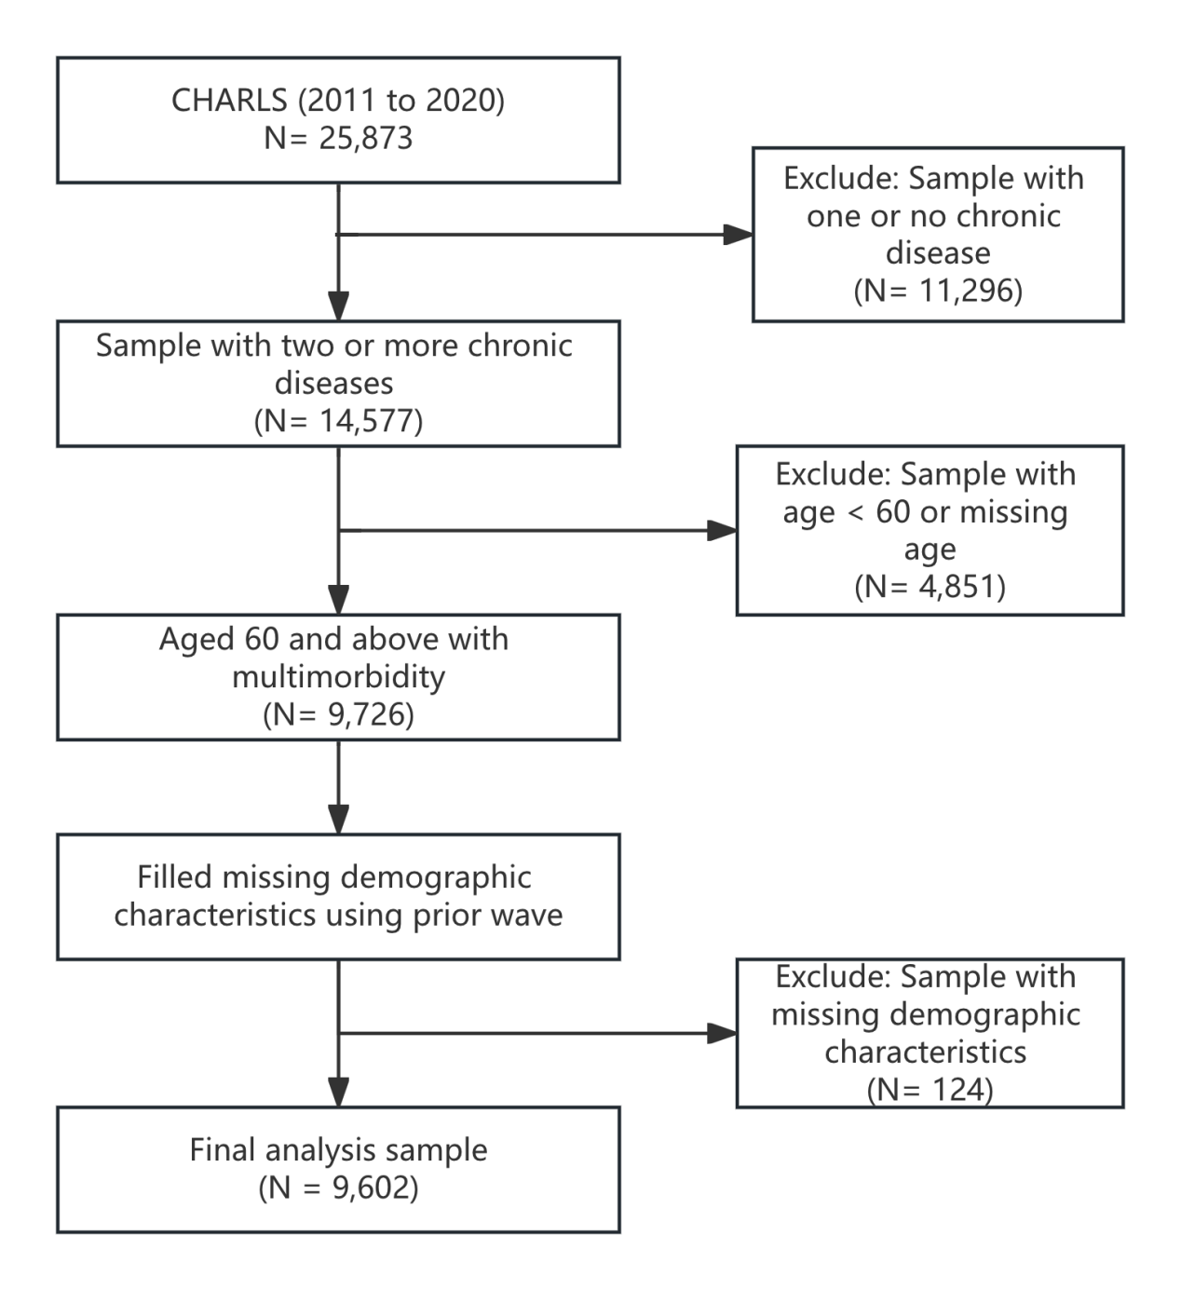
Figure S1 Flowchart of Sample

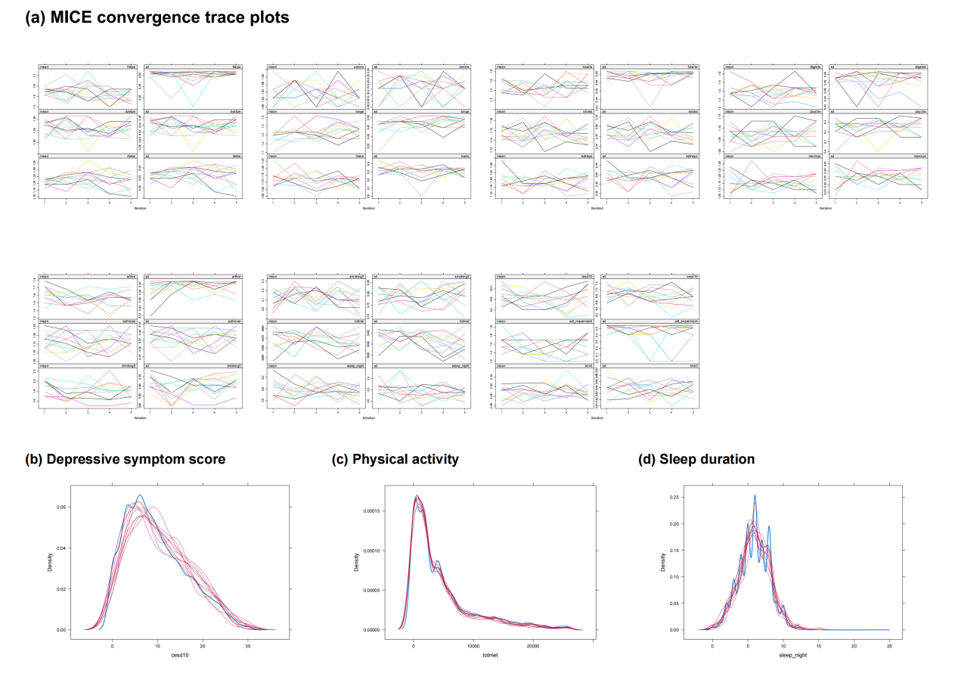
Figure S2 MICE diagnostics

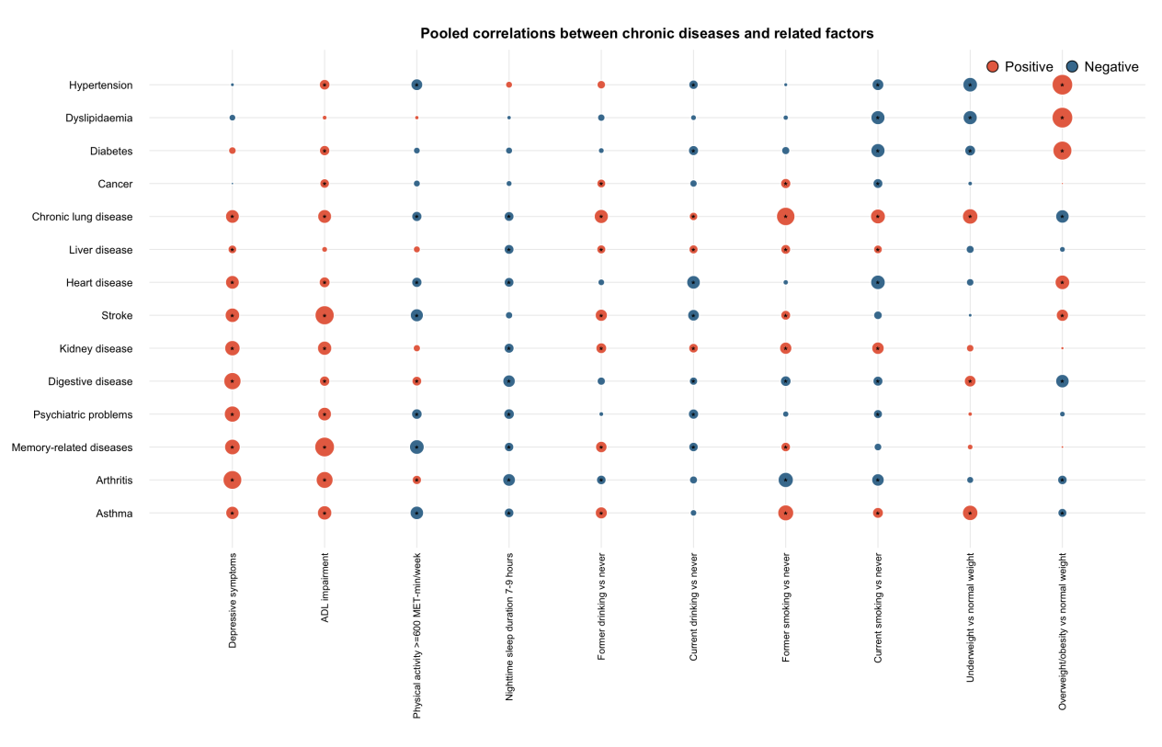
Note: Circle size represents the absolute pooled Spearman correlation coefficient. Orange and blue circles indicate positive and negative correlations, respectively. Asterisks indicate associations that remained significant after Benjamini–Hochberg false-discovery-rate correction. Correlations were estimated separately in each of the 10 imputed datasets and pooled using Fisher’s z transformation. Smoking and drinking statuses were compared with never use, and BMI categories were compared with normal weight.
Figure S3 in the Appendix for details

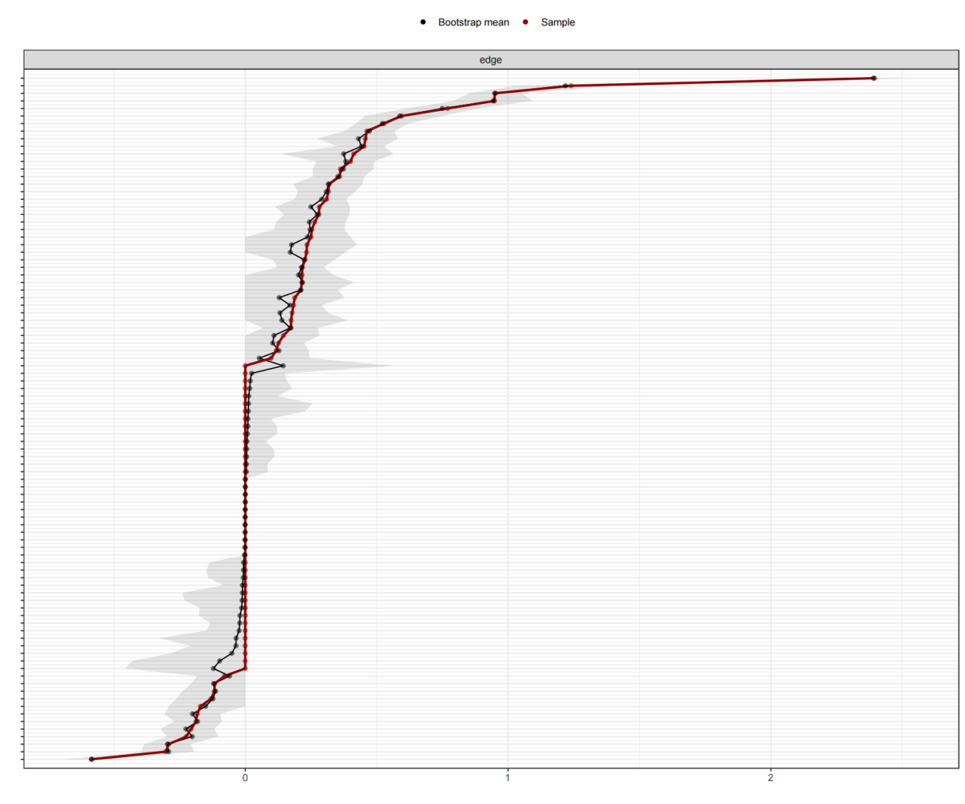
Figure S4 Bootstrap 95% confidence intervals for chronic-disease edge weights

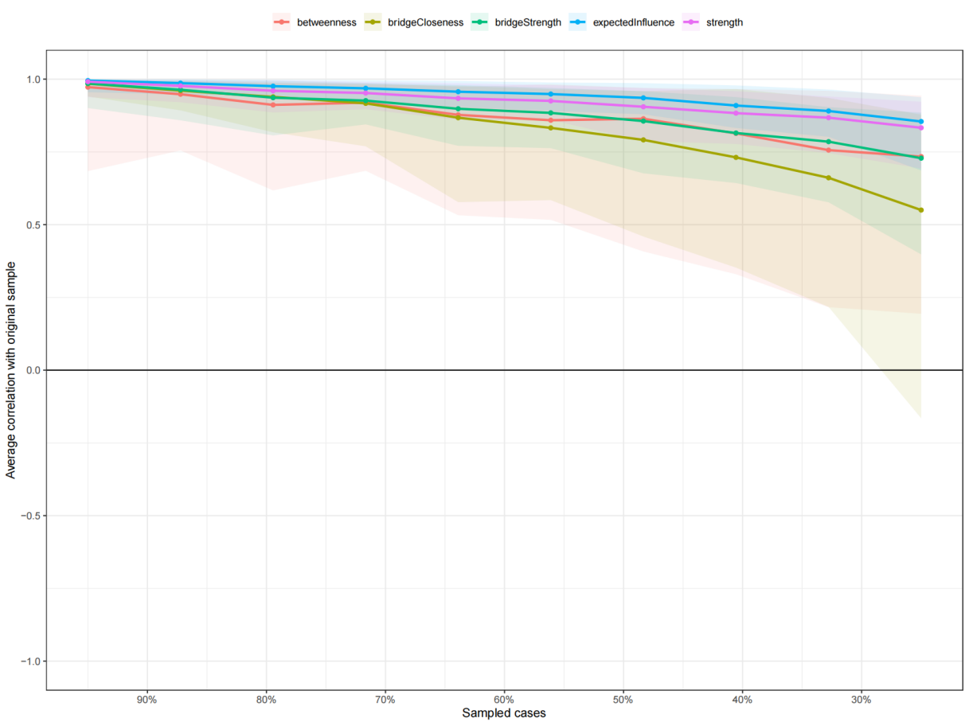
Figure S5 Case-dropping bootstrap stability of centrality indices in the chronic-disease network.

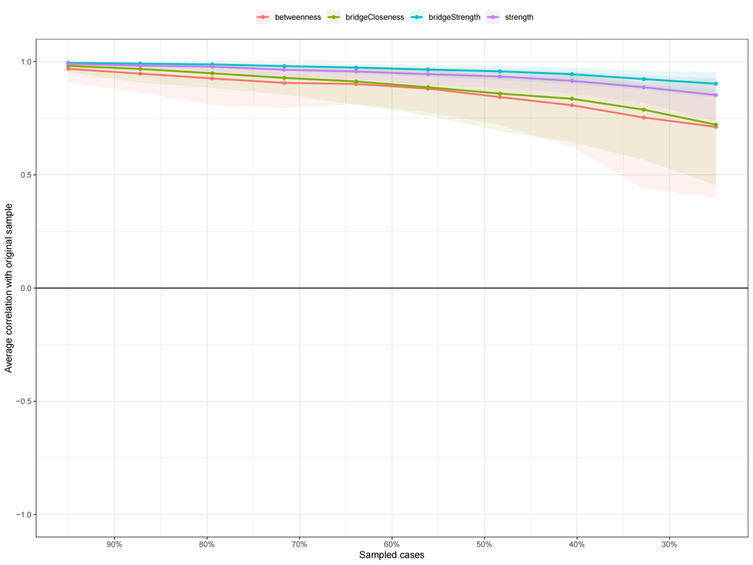
Figure S6 Case-dropping stability of the complete mixed-network edge-magnitude centrality and bridge indices

