Supplementary Appendix

Associations of frailty and COVID-19 severity with long-term health outcomes of COVID-19 among older people.

BMC Geriatrics

Authors
Bas F.M. van Raaij, Veerle M.G.T.H. van der Klei, Jesse M. van den Berg, Raymond Noordam, Harmke A. Polinder-Bos, Julia Minnema, Lisanne Tap, Jacobien J. Hoogerwerf, Petra J.M. Elders, Marieke T. Blom, Dennis O. Mook-Kanamori, Jan Festen, Jeannette B. Peters, Simon P. Mooijaart, Jacobijn Gussekloo, on behalf of the COOP consortium, COVID-OLD study and CliniCo study.
Contents
Appendix 1. Details of the COVID-OLD cohort . . . . . . . . . . . . . . . . . . . . . . . . . . . . . . . . . . . . . . . . . . | 3
Appendix 2. Details of the CliniCo cohort . . . . . . . . . . . . . . . . . . . . . . . . . . . . . . . . . . . . . . . . . . . . . . | 5
Appendix 3. Details of the primary care cohort . . . . . . . . . . . . . . . . . . . . . . . . . . . . . . . . . . . . . . . . . | 7
Appendix 4. Patient and public involvement . . . . . . . . . . . . . . . . . . . . . . . . . . . . . . . . . . . . . . . . . . . . | 9
Appendix 5. Questionnaire translated from Dutch . . . . . . . . . . . . . . . . . . . . . . . . . . . . . . . . . . . . . . . | 11
Appendix 6. Overview of post-COVID symptoms categorisation . . . . . . . . . . . . . . . . . . . . . . . . . . . | 14
Appendix 7. Comparison of baseline characteristics . . . . . . . . . . . . . . . . . . . . . . . . . . . . . . . . . . . | 15
Appendix 8. Median ratings of health dimensions at the time of follow-up . . . . . . . . . . . . . . . . . . . | 16
Appendix 9. Comparison of long-term health outcomes in participants from the primary care cohort based on the year of acute COVID-19 . . . . . . . . . . . . . . . . . . . . . . . . . . . . . . . . . . . . . . . . . . | 17
Appendix 10. Long-term health outcomes in participants stratified for both their frailty status and COVID-19 severity . . . . . . . . . . . . . . . . . . . . . . . . . . . . . . . . . . . . . . . . . . . . . . . . . . . . . . . . . . . . . | 18
Appendix 11. Results of multiplicative interaction analysis . . . . . . . . . . . . . . . . . . . . . . . . . . . . . . . . | 19
Appendix 12. STROBE checklist for observational studies . . . . . . . . . . . . . . . . . . . . . . . . . . . . . . . . | 20

Appendix 1. Details of the COVID-OLD cohort

The COVID-OLD cohort
The COVID-OLD study, a multicenter retrospective cohort study in the Netherlands, included older people hospitalised for COVID-19 during one of the four pandemic waves between February 2020 and April 2022. The included hospitals in this study varied from peripheral hospitals to large teaching and academic medical centers. Follow-up was only performed in patients of the first (February 27–May 15, 2020) or second wave (September 1–December 31, 2020). The flowchart with inclusions and exclusions for this follow-up study is shown in Figure S1.

COVID-19 diagnosis
During the start of the pandemic, PCR-tests were not always rapidly and widely available and a COVID-19 diagnosis was based on the combination of symptoms, abnormalities on imaging of the chest and elevated inflammatory markers or a positive PCR-test for COVID-19. From September 2020 onwards all patients in the COVID-OLD cohort had a confirmed COVID-19 diagnosis based on a positive PCR-test.

Vaccinations
The Dutch vaccination program for COVID-19 started on 6 January 2021, shortly after the end of the second wave and after the end of the inclusion period for this follow-up study.

Figure S1. Flowchart of the COVID-OLD study

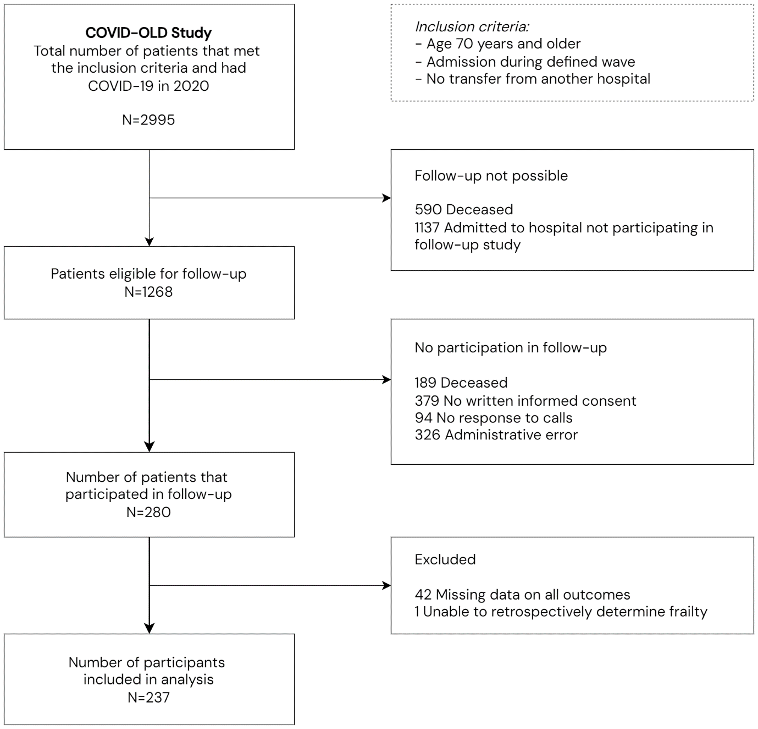

Appendix 2. Details of the CliniCo cohort

The CliniCo cohort
The CliniCo study, a multicenter retrospective cohort study in the Netherlands, included older people hospitalised for COVID-19 between February and December 2020. The included hospitals in this study varied from peripheral hospitals to large teaching and academic medical centers. The flowchart for this follow-up study with inclusions and exclusions is shown in Figure S2.

COVID-19 diagnosis
During the start of the pandemic, PCR-tests were not always rapidly and widely available and a COVID-19 diagnosis was based on the combination of symptoms, abnormalities on imaging of the chest and elevated inflammatory markers or a positive PCR-test for COVID-19. From April 2020 onwards all patients in the CliniCo cohort had a confirmed COVID-19 diagnosis based on a positive PCR-test.

Vaccinations
The Dutch vaccination program for COVID-19 started on 6 January 2021, shortly after the end of the inclusion period of this cohort.

Figure S2. Flowchart of the CliniCo study

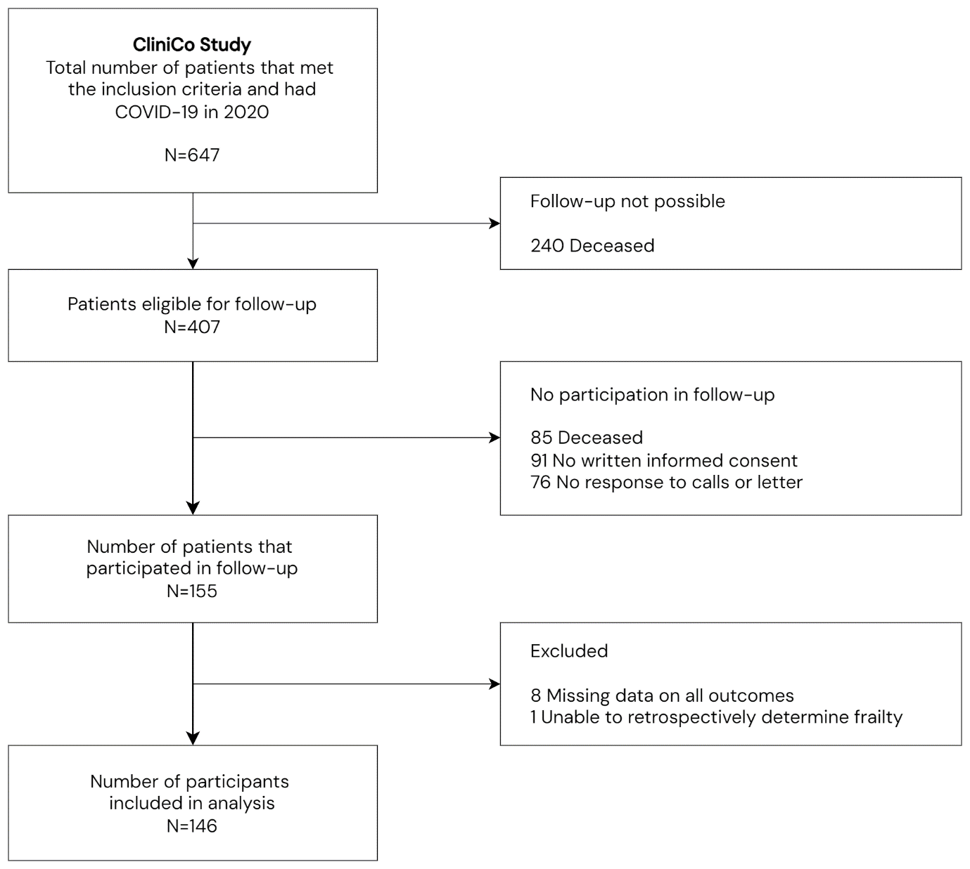

Appendix 3. Details of the primary care cohort

The primary care cohort
In the primary care cohort, 14 general practices were recruited to participate in this study. Older people with acute COVID-19 between February 2020 and December 2021 were invited for follow-up.
The general practices were located in two provinces of the Netherlands: South-Holland and North-Holland. The flowchart for this follow-up study with inclusions and exclusions is shown in Figure S3.

COVID-19 diagnosis
During the start of the pandemic, PCR-tests were not always rapidly and widely available and a COVID-19 diagnosis was based on the combination of symptoms, abnormalities on imaging of the chest and elevated inflammatory markers or a positive PCR-test for COVID-19. From July 2020 onwards all patients in the primary care cohort had a confirmed COVID-19 diagnosis based on a positive PCR-test.

Vaccinations
The Dutch vaccination program for COVID-19 started on 6 January 2021, meaning that older people included between January 2021 and December 2021 had the chance to be vaccinated. Vaccination status for COVID-19 was not largely available from routine care data in primary care practices and is therefore unknown in the present study. The vaccination coverage of the first series of COVID-19 vaccinations in people aged 70 years and older ranged from 92 to 93% in the Netherlands [1].

References
- RIVM. De coronaprik. Available from: https://coronadashboard.rijksoverheid.nl/landelijk/de-coronaprik. Last Accessed Sept 2023.

Figure S3. Flowchart of participants from primary care

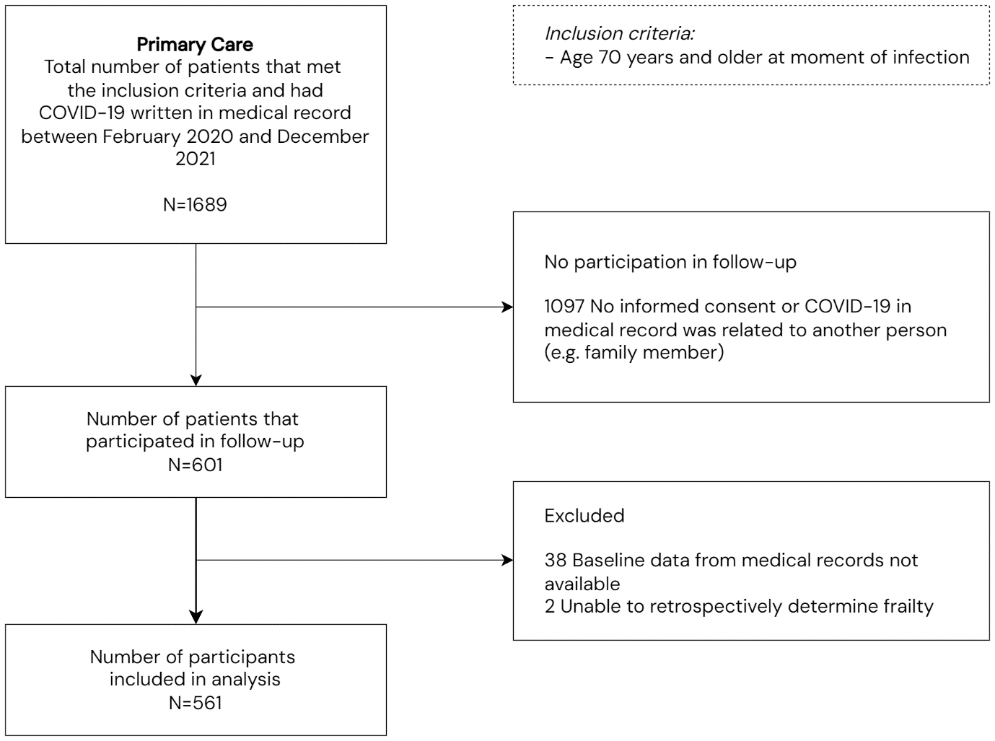

Appendix 4. Patient and public involvement

Table S1. Patient and public involvement (PPI) according to the GRIPP2 short form

Section and topic | Item
1. Aim
 | We gave voice to older people to include their thoughts and experiences (with among others healthcare and the COVID-19 pandemic in the Dutch context) by collaborating with them in all research stages of this study about long-term health outcomes of COVID-19 in older people.
2. Methods
We recruited ten older people to participate in the COOP Seniors Advisory Board of whom 70% were women. Their median age was 75 years (IQR: 70-80) and all of them were higher educated.*
Their medical and professional backgrounds were diverse: some had a history of mild COVID-19 or other disease, their frailty status ranged from fit to mildly frail and their previous professions were related to health care, research, anthropology, education and finances. In addition, 70% also represented another senior organisation spread across the Netherlands.

The Board participated during this COOP project
according to all five roles of the Involvement-Matrix: listener, co-thinker, advisor, partner and decision-maker [1]. Their chairman was part of the steering committee of the larger COOP-consortium and was co-leader of this substudy on long-term health outcomes. He was involved from the very beginning in defining the research question and drafting the grant application. Subsequently, the Board was involved in the study design, in carrying out pilots with the follow-up questionnaire from the lay perspective and in interpretation of the results.

The Board had multiple meetings, either online or in person, with the presence of at least one junior and one senior researcher from this substudy.
3. Results
The Seniors Advisory Board impacted this substudy as below:

- Highlighted the relevance of broad, self-reported health outcomes, in addition to more traditional outcomes that are frequently researched such as mortality, and showed their interest in post-COVID symptoms (as evidence was very limited in specifically older populations). They proposed to collect both typical symptoms after COVID-19 and self-perceived decline in health as outcomes and thus, significantly impacted the research question.

- Improved readability and clarity of the follow-up questionnaire after a pilot-study. For this purpose, the Board arranged that some of their acquaintances who did experience severe COVID-19 early on in the pandemic also participated in the pilot-study.

- Their interpretation of results (e.g. adaptation to new life circumstances) and suggestions for further research (e.g. prediction of self-reported outcomes) were used in the discussion. Their chairman was also a co-author on this article.

A few suggestions of the Board could not be implemented in this substudy, mainly due to pragmatic reasons. For instance, the Board advised an experimental open question to be added to the questionnaire about the largest self-perceived impact of COVID-19 and/or the pandemic. Although this question was included in data-collection, we were unable to analyse this data in time due to the large number of collected variables and the difficulty of combining qualitative and quantitative data in one article.
4. Discussion and Conclusions
 | Involvement of the Seniors Advisory Board enhanced the content of this study from older people’s perspective and widened interpretations of the results by the diverse thoughts that were proposed. Due to time constraints, not all suggestions of the Board could be analysed so far, which are worthwhile future research.
5. Reflections, critical perspective
Involvement of the Seniors Advisory Board was overall very positive and was rapidly established via the large network of the COOP consortium. This rapid establishment was crucial for early implementation of the Boards perspectives in the study design and allowed us to collect health outcomes that were relevant for older people themselves.

The Board unfortunately did not compromise of severely frail older people which could have hampered the inclusion of the perspective of this specific group of older people. The Board participated in many substudies of the COOP consortium which was relatively time-consuming.

* Based on the Dutch level of education scale by Verhage (1964). COOP=Covid-19 Outcomes in Older People.

References
- Smits DW, van Meeteren K, Klem M, et al.; Designing a tool to support patient and public involvement in research projects: the Involvement Matrix. Res Involv Engagem 2020;6:30. doi: 10.1186/s40900-020-00188-4.

Appendix 5. Questionnaire translated from Dutch

Table S2

Topic |  | Questions
General | 1 | What is your date of birth?
 | 2 | What is the name of your general practice?*
 | 3 | What is the highest level of education that u have completed?†
 |  | - No or lower level education (e.g. primary school)
 |  | - Middle level education (e.g. secondary school)
 |  | - Higher level of education (e.g. university degree)
 | 4 | How severely ill have u been from corona?*
 |  | - I had almost no complaints
 |  | - I did have complaints, but I required no medical assistance from my general practitioner
 |  | - I did have complaints and received care from my general practitioner
 |  | - I have been hospitalised for corona
 | 5 | Did you receive intensive care treatment?
Symptoms | 6 | Do you currently experience shortness of breath?
 |  | - Not present
 |  | - Yes, new symptom
 |  | - Yes, pre-existing symptom that remained stable
 |  | - Yes, pre-existing symptom that worsened since corona
 | 7 | Do you currently experience fatigue?
 |  | - Not present
 |  | - Yes, new symptom
 |  | - Yes, pre-existing symptom that remained stable
 |  | - Yes, pre-existing symptom that worsened since corona
 | 8 | Do you currently have difficulties concentrating?
 |  | - Not present
 |  | - Yes, new symptom
 |  | - Yes, pre-existing symptom that remained stable
 |  | - Yes, pre-existing symptom that worsened since corona
 | 9 | Do you currently have difficulties with your memory?
 |  | - Not present
 |  | - Yes, new symptom
 |  | - Yes, pre-existing symptom that remained stable
 |  | - Yes, pre-existing symptom that worsened since corona
 | 10 | Do you currently experience physical or mental complaints during physical activity (e.g. when hiking)?
 |  | - Not present
 |  | - Yes, new symptom
 |  | - Yes, pre-existing symptom that remained stable
 |  | - Yes, pre-existing symptom that worsened since corona
Health dimensions | 11 | How do you rate your physical health currently on a scale from 1 to 10?
 | 12 | Did you have a different experience of your physical health shortly before you got corona?
 |  | - Yes, it was better
 |  | - Yes, it was worse
 |  | - No, it has been stable
 |  | - I do not know
 | 13 | How do you rate your mental well-being currently on a scale from 1 to 10?
 | 14 | Did you have a different experience of your mental well-being shortly before you got corona?
 |  | - Yes, it was better
 |  | - Yes, it was worse
 |  | - No, it has been stable
 |  | - I do not know
 | 15 | How do you rate the meaningfulness of your life currently on a scale from 1 to 10?
 | 16 | Did you have a different experience of the meaningfulness of your life shortly before you got corona?
 |  | - Yes, it was more meaningful
 |  | - Yes, it was less meaningful
 |  | - No, it has been stable
 |  | - I do not know
 | 17 | How do you rate your quality of life currently on a scale from 1 to 10?
 | 18 | Did you have a different experience of your quality of life shortly before you got corona?
 |  | - Yes, it was better
 |  | - Yes, it was worse
 |  | - No, it has been stable
 |  | - I do not know
 | 19 | How do you rate your social participation currently on a scale from 1 to 10?
 | 20 | Did you have a different experience of your social participation shortly before you got corona?
 |  | - Yes, it was better
 |  | - Yes, it was worse
 |  | - No, it has been stable
 |  | - I do not know
 | 21 | How do you rate your ability to perform daily functioning tasks currently on a scale from 1 to 10?
 | 22 | Did you have a different experience of your ability to perform daily functioning tasks shortly before you got corona?
 |  | - Yes, it was easier
 |  | - Yes, it was more difficult
 |  | - No, it has been stable
 |  | - I do not know

* Only for participants from primary care.
† Category is scored based on the Dutch level of education scale by Verhage (1964).

Appendix 6. Overview of post-COVID symptoms categorisation

Table S3. Overview of symptoms categorisation at follow-up in all participants (N=944)

 | No symptoms* |  |  | Post-COVID symptom
 | Not present | Pre-existing and stable |  | New symptom | Pre-existing and worse
Dyspnoea | 602 (65) | 74 (8) |  | 179 (19) | 79 (9)
Fatigue | 547 (58) | 72 (8) |  | 242 (26) | 76 (8)
Concentration | 747 (8) | 37 (4) |  | 131 (14) | 23 (3)
Memory | 732 (78) | 48 (5) |  | 127 (14) | 32 (3)
Physical activity | 563 (60) | 73 (8) |  | 220 (24) | 81 (9)

Data are n (%). * No symptoms or symptoms considered to be unrelated to COVID-19.

Missing values:
10 dyspnoea, 7 fatigue, 6 difficulty concentrating, 5 memory problems, 7 complaints during physical activity.
Appendix 7. Comparison of baseline characteristics

Table S4. Baseline characteristics of study participants stratified for both their frailty status and COVID-19 severity

Characteristic | Fit with mild COVID-19  (N=396) | Fit with severe COVID-19  (N=290) | Frail with mild COVID-19  (N=125) | Frail with severe COVID-19 (N=133)
Age, years | 74.0 [71.0-77.0] | 74.0 [72.0-77.0] | 77.0 [72.0-82.0] | 78.0 [73.0-82.0]
Sex, men | 223 (56) | 202 (70) | 45 (36) | 75 (56)
Body mass index, kg/m² | 26.9 ± 4.1 | 26.5 ± 4.4 | 27.6 ± 4.1 | 28.8 ± 4.8
Charlson comorbidity index, score (0-33) | 1 [0-3] | 1 [0-2] | 2 [1-4] | 1 [1-3]
Education
Low | 44 (11) | 74 (26) | 32 (26) | 48 (36)
Mid | 172 (44) | 129 (45) | 63 (51) | 64 (48)
High | 178 (45) | 84 (29) | 29 (23) | 21 (16)
COVID-19
ICU admission in hospitalised participants | 0 | 46 (16) | 0 | 8 (6)
Time between infection and follow-up, months | 27 [18-33] | 28 [22-31] | 26 [18-34] | 28 [21-30]

Data are mean±SD, median [IQR] or n (%). CFS=clinical frailty scale. Body mass index and Charlson Comorbidity Index for patients from primary care were evaluated at the moment of follow-up with a lookback window of 3 year.

Number of missing values:
282 body mass index, 31 Charlson Comorbidity Index, 6 Education

Appendix 8. Median ratings of health dimensions at the time of follow-up

Table S5

Health dimensions | All participants (N=944) |  | Frailty status |  |  | COVID-19 severity
Health dimensions | All participants (N=944) |  | Fit (N=686) | Frail (N=258) |  | Mild (N=521) | Severe (N=423)
Bodily functions | 7 [7-8] |  | 8 [7-8] | 7 [6-8] |  | 8 [7-8] | 7 [6-8]
Mental well-being | 8 [7-9] |  | 8 [7-9] | 8 [7-8] |  | 8 [8-9] | 8 [7-8]
Meaningfulness | 8 [7-9] |  | 8 [8-9] | 8 [7-8] |  | 8 [8-9] | 8 [7-9]
Quality of life | 8 [7-9] |  | 8 [7-9] | 8 [7-8] |  | 8 [8-9] | 8 [7-8]
Participation | 8 [7-9] |  | 8 [7-9] | 8 [7-8] |  | 8 [7-9] | 8 [7-8]
Daily functioning | 8 [7-9] |  | 8 [8-9] | 8 [7-8] |  | 8 [8-9] | 8 [7-8]

Data are median [IQR].

Missing values:
7 bodily function. 8 mental well-being, 8 meaningfulness, 10 quality of life, 6 participation, 7 daily functioning.

Appendix 9. Comparison of long-term health outcomes in participants from the primary care cohort based on the year of acute COVID-19

Table S6

Outcome | Year of acute COVID-19
Outcome | 2020 (N=255) | 2021 (N=266)
Post-COVID symptoms
Dyspnoea | 33 (13) | 35 (13)
Fatigue | 44 (17) | 45 (17)
Difficulty concentrating | 23 (9) | 21 (8)
Memory problems | 18 (7) | 15 (6)
Complaints during physical activity | 35 (14) | 40 (15)
≥1 symptom | 60 (24) | 56 (21)
≥ 2 symptoms | 42 (17) | 45 (17)
Self-perceived decline in dimensions of health
Bodily functions | 51 (21) | 49 (19)
Mental well-being | 28 (11) | 26 (10)
Meaningfulness | 19 (8) | 24 (9)
Quality of life | 29 (12) | 33 (13)
Participation | 19 (8) | 24 (9)
Daily functioning | 27 (11) | 26 (10)

Missing values:
9 dyspnoea, 5 fatigue, 4 difficulty concentrating, 3 memory problems, 4 complaints during physical activity, 20 bodily function. 18 mental well-being, 8 meaningfulness, 13 quality of life, 16 participation, 16 daily functioning.

Appendix 10. Long-term health outcomes in participants stratified for both their frailty status and COVID-19 severity

Table S7

Outcomes | Fit with mild COVID-19  (N=396) | Fit with severe COVID-19 (N=290) | Frail with mild COVID-19  (N=125) | Frail with severe COVID-19  (N=133)
Post-COVID symptoms
Dyspnoea | 41 (11) | 124 (43) | 27 (22) | 66 (50)
Fatigue | 61 (16) | 144 (50) | 28 (23) | 85 (65)
Difficulty concentrating | 29 (7) | 74 (26) | 15 (12) | 36 (28)
Memory problems | 19 (5) | 81 (28) | 14 (11) | 45 (34)
Complaints during physical activity | 52 (13) | 144 (50) | 23 (19) | 82 (63)
≥1 symptom | 80 (20) | 204 (71) | 36 (29) | 106 (80)
≥ 2 symptoms | 59 (15) | 170 (59) | 28 (22) | 93 (71)
Self-perceived decline in dimensions of health
Bodily functions | 72 (19) | 156 (55) | 28 (24) | 88 (70)
Mental well-being | 38 (10) | 76 (27) | 16 (14) | 52 (40)
Meaningfulness | 26 (7) | 49 (17) | 17 (14) | 39 (32)
Quality of life | 41 (11) | 87 (31) | 21 (18) | 56 (44)
Participation | 28 (7) | 60 (21) | 15 (13) | 32 (25)
Daily functioning | 32 (8) | 65 (23) | 21 (18) | 52 (42)

Missing values:
10 dyspnoea, 7 fatigue, 6 difficulty concentrating, 5 difficulty with memory, 7 complaints during physical activity, 32 bodily function. 29 mental well-being, 28 meaningfulness, 26 quality of life, 21 participation, 29 daily functioning.

Appendix 11. Results of multiplicative interaction analysis

Table S8

 | All participants (N=944)
 | P value for multiplicative interaction*
Post-COVID symptoms
Dyspnoea | 0.080
Fatigue | 0.616
Difficulty concentrating | 0.279
Memory problems | 0.537
Complaints with physical activity | 0.729
Self-perceived decline in dimensions of health
Bodily functions | 0.391
Mental well-being | 0.619
Meaningfulness | 0.961
Quality of life | 0.991
Participation | 0.335
Daily functioning | 0.966

* Multiplicative interaction was analysed with binary logistic regression with the following variables: clinical frailty scale, COVID-19 disease severity and the interaction term (clinical frailty scale*COVID-19 disease severity).

Appendix 12. STROBE checklist for observational studies

Table S9

Section/Topic |  | Checklist Item | Page*
 |  | Title and abstract
Title and abstract | 1a | Indicate the study’s design with a commonly used term in the title or the abstract | 1
 | 1b | Provide in the abstract an informative and balanced summary of what was done and what was found | 5
 |  | Introduction
Background | 2 | Explain the scientific background and rationale for the investigation being reported | 6
Objectives | 3 | State specific objectives, including any prespecified hypotheses | 6
 |  | Methods
Study design | 4 | Present key elements of study design early in the paper | 7
Setting | 5 | Describe the setting, locations, and relevant dates, including periods of recruitment, exposure, follow-up, and data collection | 7
Participants | 6a | Give the eligibility criteria, and the sources and methods of selection of participants. Describe methods of follow-up | 7
Participants | 6b | For matched studies, give matching criteria and number of exposed and unexposed | NA
Variables | 7 | Clearly define all outcomes, exposures, predictors, potential confounders, and effect modifiers. Give diagnostic criteria, if applicable | 9
Data sources | 8 | For each variable of interest, give sources of data and details of methods of assessment (measurement). Describe comparability of assessment methods if there is more than one group | 7
Bias | 9 | Describe any efforts to address potential sources of bias | 8
Study size | 10 | Explain how the study size was arrived at | Appendix 1-3
Quantitative variables | 11 | Explain how quantitative variables were handled in the analyses. If applicable, describe which groupings were chosen and why | 10
Statistical methods | 12a | Describe all statistical methods, including those used to control for confounding | 10
 | 12b | Describe any methods used to examine subgroups and interactions | 10
 | 12c | Explain how missing data were addressed | 8
 | 12d | If applicable, explain how loss to follow-up was addressed | 10
 | 12e | Describe any sensitivity analyses | 10
 |  | Results
Participants | 13a | Report numbers of individuals at each stage of study—eg numbers potentially eligible, examined for eligibility, confirmed eligible, included in the study, completing follow-up, and analysed | 12
 | 13b | Give reasons for non-participation at each stage | Appendix 1-3
 | 13c | Consider use of a flow diagram | Appendix 1-3
Descriptive data | 14a | Give characteristics of study participants (eg demographic, clinical, social) and information on exposures and potential confounders | 12
 | 14b | Indicate number of participants with missing data for each variable of interest | 23
 | 14c | Summarise follow-up time (eg, average and total amount) | 23
Outcome data | 15 | Report numbers of outcome events or summary measures over time | 24
Main results | 16a | Give unadjusted estimates and, if applicable, confounder-adjusted estimates and their precision (eg, 95% confidence interval). Make clear which confounders were adjusted for and why they were included | 24
 | 16b | Report category boundaries when continuous variables were categorized | 24
 | 16c | If relevant, consider translating estimates of relative risk into absolute risk for a meaningful time period | NA
Other analyses | 17 | Report other analyses done—eg analyses of subgroups and interactions, and sensitivity analyses | Appendices
 |  | Discussion
Key results | 18 | Summarise key results with reference to study objectives | 14
Limitations | 19 | Discuss limitations of the study, taking into account sources of potential bias or imprecision. Discuss both direction and magnitude of any potential bias | 16
Interpretation | 20 | Give a cautious overall interpretation of results considering objectives, limitations, multiplicity of analyses, results from similar studies, and other relevant evidence | 14
Generalisability | 21 | Discuss the generalisability (external validity) of the study results | 14
 |  | Other information
 | 22 | Give the source of funding and the role of the funders for the present study and, if applicable, for the original study on which the present article is based | 18

* Page numbers are based on the final draft before the manuscript was submitted
NA=not applicable

