Appendix 1: Multi-component high-intensity interval training programme.
- Bicycling
Position: Seated position on a cycle ergometer (lower or upper limbs depending on availability).  Dose: 1–3 sets of 4–6 intervals of 30–60 seconds each.  Intensity: 70–90% HRmax; Borg Scale: 15–18.  Equipment: Cycle ergometer (lower or upper limbs).  Muscle group: Lower or upper limb muscles (preferably lower limbs).  Recovery: 15–30 seconds between intervals; 2 minutes between sets.  Progression: Sequence progression: intervals; sets and finally duration.  Instruction: Sitting on a cycle ergometer, pedal as you would on a bike. | 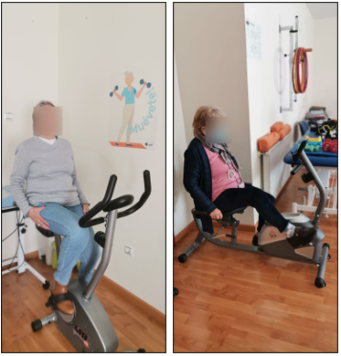
- Seated knee extension and standing knee flexion exercises
Position: Seated position for knee extension and standing position for knee flexion. Knee flexions are performed to stand by a chair or a stable bar.  Dose: 1–3 sets of 8–12 repetitions.  Intensity: Borg Scale: 15–18; 60–80% 1RM.  Equipment: Ankle weights of varying loads for extension and flexion.  Muscle group: Knee extensors and flexors.  Recovery: 60 seconds rest between sets.  Progression: Sequence progression: repetitions; sets and finally load.  Instruction: Sitting, extend your knees upward until they are completely straight. Standing, bend your knees completely backwards. | 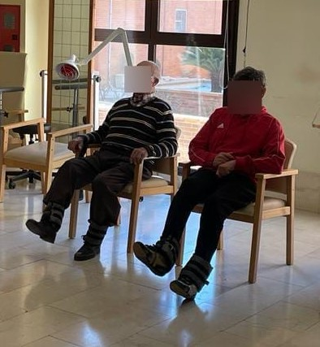
- Elbow flexion and extension exercises
Position: Standing or seated position with arms alongside the body.  Dose: 1–3 sets of 8–12 repetitions.  Intensity: Borg Scale: 15–18; 60–80% 1RM.  Equipment: Dumbbells of varying loads.  Muscle group: Elbow flexors and extensors.  Recovery: 60 seconds rest between sets.  Progression: Sequence progression: repetitions; sets and finally load.  Instruction: Standing with your arms at your sides, bend your elbows completely upwards. Standing with your arms bent above your head, stretch your elbows completely upwards. | 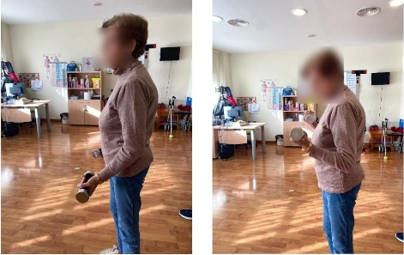  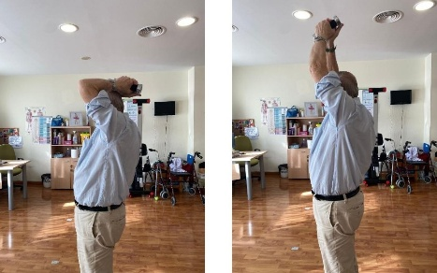
- Plantar flexion (calf raise) exercise
Position: Standing position, feet shoulder-width apart.  Dose: 1–3 sets of 8–12 repetitions.  Intensity: Borg Scale: 15–18; 60–80% 1RM.  Equipment: External loads of varying weights.  Muscle group: Plantar flexor muscles.  Recovery: 60 seconds rest between sets.  Progression: Sequence progression: repetitions; sets and finally load.  Instruction: Standing, raise your heels and lift your calves. | 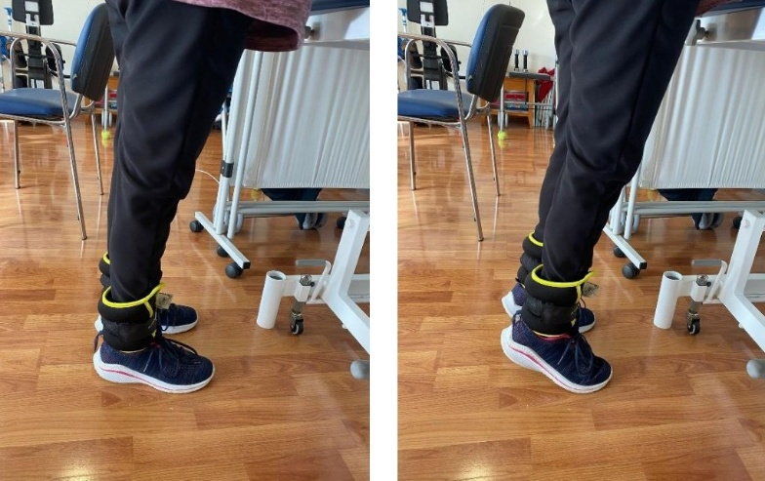
- Rowing
Position: Seated position on a rowing machine.  Dose: 1–3 sets of 4–6 intervals of 30–60 seconds each.  Intensity: 70–90% HRmax; Borg Scale: 15–18.  Equipment: Rowing machine.  Muscle group: Hip and knee extensor muscles; scapular stabilising muscles.  Recovery: 15–30 seconds between intervals; 2 minutes between sets.  Progression: Sequence progression: intervals; sets and finally duration.  Instruction: Sit on the machine and place your feet on the pedals. Grasp the handle and pull towards you, bringing your elbows back. | 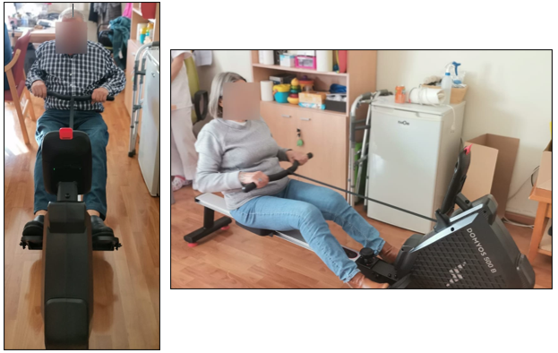
- Sit-to-stand exercise (chair squat)
Position: Standing in front of a chair, feet hip-width apart.  Dose: 1–3 sets of 4–6 intervals of 30–60 seconds each.  Intensity: 70–90% HRmax; Borg Scale: 15–18.  Equipment: Chair.  Muscle group: Hip and knee extensor muscles.  Recovery: 15–30 seconds between intervals; 2 minutes between sets.  Progression: Sequence progression: intervals; sets and finally duration.  Instruction: Stand up from the chair without using your hands. | 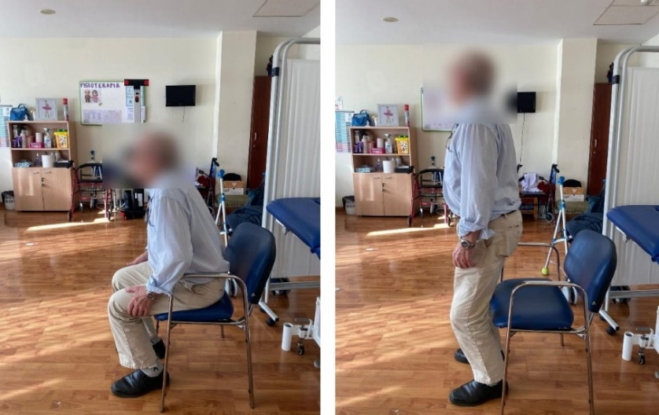
- Shoulder abduction exercise
Position: Standing position with arms alongside the body.  Dose: 1–3 sets of 8–12 repetitions.  Intensity: Borg Scale: 15–18; 60–80% 1RM.  Equipment: Dumbbells.  Muscle group: Shoulder abductors.  Recovery: 60 seconds rest between sets.  Progression: Sequence progression: repetitions; sets and finally load  Instruction: Standing with your arms at your sides, raise your arm out to the side. | 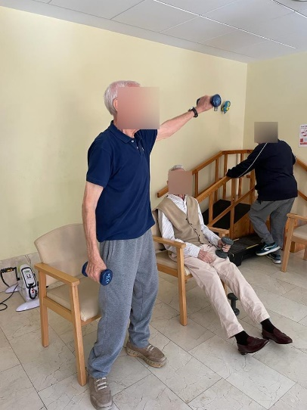
- Step-ups (stair climbing exercise)
Position: Standing position in front of an adjustable-height step.  Dose: 1–3 sets of 4–6 intervals of 30–60 seconds each.  Intensity: 70–90% HRmax; Borg Scale: 15–18.  Equipment: Adjustable-height step.  Muscle group: Hip and knee extensor muscles.  Recovery: 15–30 seconds between intervals; 2 minutes between sets.  Progression: Sequence progression: repetitions; sets and finally step height.  Instruction: Standing, place one foot on the box, and then step up with the other. | 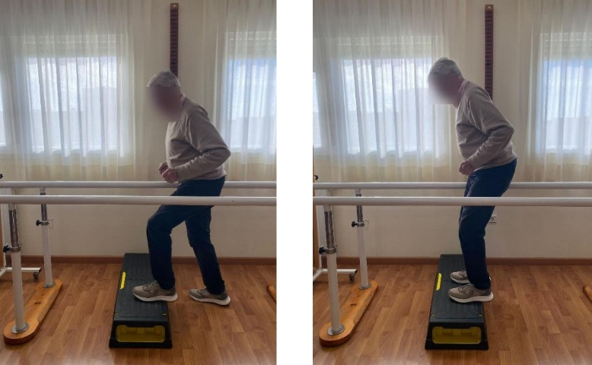
Abbreviations: HRmax = maximum heart rate; Borg = Borg Scale; 1RM = One-Repetition Maximum; s = seconds.

