Additional file 1: Supplementary methods, tables, and figures

Supplementary methods

Strict construction of item-based covariates
Pain-site burden was calculated only when all 15 pain-site indicators were observed. Social inactivity was assigned only when all 11 social-activity indicators were observed. Other multimorbidity was calculated only when all 12 non-arthritis chronic conditions were classifiable. These rules prevent missing item responses from being counted as negative responses.

Stabilised inverse-probability-of-observation weights
For every origin wave with a classifiable state, the denominator model estimated the probability that the next scheduled wave had a classifiable state. Predictors were origin state, pain, sleep, IADL impairment, social inactivity, multimorbidity, age, sex, education, marital status, residence, smoking, alcohol use, CESD-10 score, and survey interval. Explicit missing categories were used for categorical variables. Age and CESD-10 were median-imputed within the weight model with corresponding missingness indicators. The numerator included origin state and survey interval. Probabilities were bounded to 0.01–0.99. Weights among observed transitions were truncated at the first and 99th percentiles.

Primary transition-specific models
Each logistic GEE used an exchangeable working correlation, robust participant-clustered standard errors, and the stabilised observation weight. The two models beginning in the neither-condition state estimate incident occurrence of each component: a direct transition to comorbidity is therefore an event in both models. The remaining models use a single destination definition.

Sensitivity analyses
Prespecified checks evaluated unweighted complete-case GEE models, observation-weighted models without continuous CESD-10, a CESD-10 threshold of 12, current-wave rather than cumulative arthritis, and restriction to participants observed at every wave. The complete-panel analysis was unweighted because next-wave observation was structurally complete within the restricted cohort.

Software and reproducibility
Analyses were performed in R version 4.5.0. The simulation-based confidence intervals used 1,200 draws and random seed 20260719.

Supplementary tables
Table S1. Variables required in the harmonised participant-wave input dataset
Input variable(s) | Definition | Expected coding | Analysis rule
ID | Participant identifier | Unique participant ID | Used for clustering and longitudinal linkage
wave | CHARLS survey wave | 1, 2, 3, 4, or 5 | Mapped to 2011, 2013, 2015, 2018, and 2020
age | Age in years | Numeric | Eligibility requires age ≥60 years at Wave 1; modelled per 5 years
arthre | Self-reported physician-diagnosed arthritis/rheumatism | 0=no, 1=yes, NA=missing | Carried forward after the first positive report in the primary analysis
cesd10 | CESD-10 total score | 0–30; NA when unavailable | Score ≥10 defines elevated depressive symptoms; ≥12 used in sensitivity analysis
sleep | Night-time sleep duration in hours | Numeric 0–24 | Categorised as <6, 6–8, and >8 hours
iadl | Instrumental activities of daily living summary | Numeric; NA=missing | Any value >0 defines IADL impairment
gender | Sex | 1=male, 0=female | Recoded to female indicator
edu | Education | 1=no formal schooling, 2=primary, 3=middle, 4=high school or above | Categorical covariate
marry | Married/partnered status | 0=no, 1=yes | Binary covariate
rural | Rural residence | 0=urban, 1=rural | Binary covariate
smokev | Self-reported ever smoking history | 0=no, 1=yes | Positive responses were carried forward after the first reported occurrence.
drinkev | Self-reported ever alcohol-consumption history | 0=no, 1=yes | Positive responses were carried forward after the first reported occurrence.
da042s1–da042s15 | Pain at 15 anatomical sites | Each item: 0=no, 1=yes | Pain count calculated only when all 15 items are observed
social1–social11 | Participation in 11 social activities | Each item: 0=no, 1=yes | Social inactivity assigned only when all 11 items are observed
hibpe–memrye | Twelve physician-diagnosed chronic conditions other than arthritis | Each item: 0=no, 1=yes | Each condition carried forward; multimorbidity count requires all 12 to be classifiable
Positive reports of arthritis, other physician-diagnosed chronic conditions, ever smoking, and ever alcohol consumption were carried forward after the first positive report in the primary analysis.
Table S2. Wave-specific distribution of the four states among classifiable respondents
Wave | Neither condition | Arthritis only | Elevated depressive symptoms only | Comorbidity
1 | 2,869 (41.4) | 1,193 (17.2) | 1,518 (21.9) | 1,343 (19.4)
2 | 2,567 (44.6) | 1,335 (23.2) | 941 (16.3) | 919 (15.9)
3 | 2,017 (36.5) | 1,490 (27.0) | 781 (14.1) | 1,240 (22.4)
4 | 1,427 (31.0) | 1,380 (30.0) | 570 (12.4) | 1,229 (26.7)
5 | 983 (27.6) | 1,008 (28.3) | 482 (13.5) | 1,092 (30.6)
Percentages are conditional on having a classifiable state at the corresponding survey wave and are not design-weighted national estimates.
Table S3. Interval-specific observed transition probabilities
Survey interval | Transition | Observed probability, % | Origin intervals, n
2011–2013 | Incident arthritis | 2.6 | 2,290
2011–2013 | Incident elevated depressive symptoms | 15.7 | 2,290
2011–2013 | Arthritis only → comorbidity | 23.7 | 986
2011–2013 | Elevated depressive symptoms only → comorbidity | 2.2 | 1,174
2011–2013 | Comorbidity persistence | 57.0 | 1,076
2013–2015 | Incident arthritis | 14.9 | 2,215
2013–2015 | Incident elevated depressive symptoms | 19.4 | 2,215
2013–2015 | Arthritis only → comorbidity | 31.6 | 1,156
2013–2015 | Elevated depressive symptoms only → comorbidity | 14.1 | 803
2013–2015 | Comorbidity persistence | 71.6 | 797
2015–2018 | Incident arthritis | 12.6 | 1,575
2015–2018 | Incident elevated depressive symptoms | 20.8 | 1,575
2015–2018 | Arthritis only → comorbidity | 32.5 | 1,149
2015–2018 | Elevated depressive symptoms only → comorbidity | 13.6 | 594
2015–2018 | Comorbidity persistence | 67.1 | 992
2018–2020 | Incident arthritis | 4.5 | 1,039
2018–2020 | Incident elevated depressive symptoms | 25.3 | 1,039
2018–2020 | Arthritis only → comorbidity | 34.2 | 989
2018–2020 | Elevated depressive symptoms only → comorbidity | 5.3 | 378
2018–2020 | Comorbidity persistence | 73.0 | 867
Probabilities are calculated within the origin state for each survey interval.
Table S4. Sample sizes for the five primary transition-specific models
Transition | Person-intervals | Events | Participants | Event percentage
Incident arthritis* | 6,875 | 597 | 3,082 | 8.7
Incident elevated depressive symptoms† | 6,875 | 1,323 | 3,082 | 19.2
Arthritis only → comorbidity | 4,074 | 1,257 | 2,129 | 30.9
Elevated depressive symptoms only → comorbidity | 2,809 | 223 | 1,771 | 7.9
Comorbidity persistence | 3,524 | 2,341 | 1,911 | 66.4
Incident arthritis includes arthritis only or comorbidity at the next wave; incident elevated depressive symptoms includes elevated depressive symptoms only or comorbidity.
Table S5. Sensitivity analyses for multisite pain
Analysis | Incident arthritis* | Incident elevated depressive symptoms† | Arthritis only → comorbidity | Elevated depressive symptoms only → comorbidity | Comorbidity persistence
Primary: observation-weighted, CESD-adjusted | 2.09 (1.61–2.72) | 1.48 (1.23–1.77) | 1.40 (1.19–1.65) | 1.92 (1.39–2.67) | 1.27 (1.07–1.50)
Unweighted complete-case | 2.10 (1.62–2.72) | 1.50 (1.25–1.80) | 1.37 (1.17–1.61) | 1.94 (1.41–2.67) | 1.28 (1.09–1.52)
Observation-weighted without CESD adjustment | 2.17 (1.67–2.81) | 1.65 (1.38–1.97) | 1.51 (1.28–1.77) | 2.06 (1.48–2.86) | 1.44 (1.22–1.69)
CESD-10 threshold ≥12 | 1.89 (1.49–2.41) | 1.46 (1.21–1.76) | 1.35 (1.15–1.58) | 2.30 (1.49–3.54) | 1.31 (1.09–1.57)
Current-wave arthritis report | 1.90 (1.47–2.46) | 1.48 (1.24–1.77) | 1.56 (1.31–1.85) | 1.86 (1.34–2.58) | 1.34 (1.13–1.59)
Complete five-wave cohort (unweighted) | 2.03 (1.45–2.86) | 1.46 (1.16–1.85) | 1.35 (1.11–1.65) | 2.43 (1.56–3.79) | 1.30 (1.05–1.60)
All estimates compare pain at two or more sites with no pain and are adjusted for the primary model covariates unless the analysis description states otherwise.
Table S6. Missing origin-wave covariates among 18,080 valid adjacent-wave transitions
Variable | Missing intervals, n | Missing intervals, %
Pain-site category | 22 | 0.12
Night-time sleep-duration category | 285 | 1.58
IADL impairment | 2 | 0.01
No social participation | 2 | 0.01
At least two other chronic conditions | 503 | 2.78
Age | 0 | 0.00
Sex | 0 | 0.00
Education | 11 | 0.06
Marital status | 5 | 0.03
Rural residence | 0 | 0.00
Smoking status used in analysis | 0 | 0.00
Alcohol-use status used in analysis | 4 | 0.02
Origin-wave CESD-10 score | 0 | 0.00
A transition was valid when both origin and next-wave states were classifiable. The primary regression models used complete origin-wave model covariates.
Table S7. Observation-weight diagnostics
Metric | Value
Eligible origin intervals with observed origin state | 22,819
Intervals with observed next-wave state | 18,080
Observed-next proportion | 0.792
Raw stabilised weight, 1st percentile | 0.824
Raw stabilised weight, median | 0.952
Raw stabilised weight, 99th percentile | 1.666
Raw stabilised weight, maximum | 4.047
Truncated stabilised weight, minimum | 0.824
Truncated stabilised weight, maximum | 1.666
Weights were truncated at the first and 99th percentiles among transitions with an observed next-wave state.
Table S8. Full results from the primary weighted transition-specific GEE models
Transition | Predictor | Estimate | P value
Incident arthritis* | Pain at 1 site vs none | 1.59 (1.21–2.09) | <0.001
Incident arthritis* | Pain at ≥2 sites vs none | 2.09 (1.61–2.72) | <0.001
Incident arthritis* | Sleep <6 h vs 6–8 h | 1.03 (0.85–1.26) | 0.752
Incident arthritis* | Sleep >8 h vs 6–8 h | 1.20 (0.92–1.58) | 0.181
Incident arthritis* | IADL impairment | 0.91 (0.71–1.17) | 0.470
Incident arthritis* | No social participation | 0.96 (0.80–1.15) | 0.678
Incident arthritis* | ≥2 other chronic conditions | 1.20 (1.00–1.45) | 0.051
Incident arthritis* | Age per 5 years | 0.98 (0.91–1.06) | 0.608
Incident arthritis* | Women vs men | 1.10 (0.85–1.43) | 0.469
Incident arthritis* | Primary school vs no formal schooling | 0.96 (0.78–1.18) | 0.709
Incident arthritis* | Middle school vs no formal schooling | 0.66 (0.50–0.88) | 0.004
Incident arthritis* | High school or above vs no formal schooling | 0.71 (0.48–1.05) | 0.084
Incident arthritis* | Married/partnered vs not | 0.93 (0.74–1.18) | 0.560
Incident arthritis* | Rural vs urban | 1.30 (1.07–1.57) | 0.008
Incident arthritis* | Ever smoked vs never | 1.02 (0.80–1.31) | 0.843
Incident arthritis* | Ever drank alcohol vs never | 0.95 (0.78–1.17) | 0.651
Incident arthritis* | CESD-10 per 5-point increase | 1.19 (1.01–1.40) | 0.039
Incident arthritis* | 2013–2015 vs 2011–2013 | 6.19 (4.63–8.28) | <0.001
Incident arthritis* | 2015–2018 vs 2011–2013 | 5.66 (4.16–7.69) | <0.001
Incident arthritis* | 2018–2020 vs 2011–2013 | 1.53 (1.02–2.30) | 0.039
Incident elevated depressive symptoms† | Pain at 1 site vs none | 1.42 (1.16–1.75) | <0.001
Incident elevated depressive symptoms† | Pain at ≥2 sites vs none | 1.48 (1.23–1.77) | <0.001
Incident elevated depressive symptoms† | Sleep <6 h vs 6–8 h | 1.11 (0.96–1.28) | 0.150
Incident elevated depressive symptoms† | Sleep >8 h vs 6–8 h | 1.11 (0.91–1.36) | 0.298
Incident elevated depressive symptoms† | IADL impairment | 1.25 (1.06–1.48) | 0.008
Incident elevated depressive symptoms† | No social participation | 1.03 (0.91–1.17) | 0.658
Incident elevated depressive symptoms† | ≥2 other chronic conditions | 1.28 (1.12–1.47) | <0.001
Incident elevated depressive symptoms† | Age per 5 years | 1.07 (1.01–1.14) | 0.017
Incident elevated depressive symptoms† | Women vs men | 1.54 (1.27–1.88) | <0.001
Incident elevated depressive symptoms† | Primary school vs no formal schooling | 0.95 (0.81–1.12) | 0.568
Incident elevated depressive symptoms† | Middle school vs no formal schooling | 0.81 (0.66–0.99) | 0.040
Incident elevated depressive symptoms† | High school or above vs no formal schooling | 0.68 (0.51–0.91) | 0.009
Incident elevated depressive symptoms† | Married/partnered vs not | 1.02 (0.85–1.22) | 0.842
Incident elevated depressive symptoms† | Rural vs urban | 1.41 (1.22–1.63) | <0.001
Incident elevated depressive symptoms† | Ever smoked vs never | 1.16 (0.97–1.40) | 0.100
Incident elevated depressive symptoms† | Ever drank alcohol vs never | 1.04 (0.89–1.21) | 0.612
Incident elevated depressive symptoms† | CESD-10 per 5-point increase | 1.89 (1.68–2.12) | <0.001
Incident elevated depressive symptoms† | 2013–2015 vs 2011–2013 | 1.18 (1.01–1.38) | 0.042
Incident elevated depressive symptoms† | 2015–2018 vs 2011–2013 | 1.43 (1.20–1.71) | <0.001
Incident elevated depressive symptoms† | 2018–2020 vs 2011–2013 | 1.60 (1.30–1.96) | <0.001
Arthritis only → comorbidity | Pain at 1 site vs none | 1.13 (0.90–1.43) | 0.292
Arthritis only → comorbidity | Pain at ≥2 sites vs none | 1.40 (1.19–1.65) | <0.001
Arthritis only → comorbidity | Sleep <6 h vs 6–8 h | 1.22 (1.04–1.42) | 0.016
Arthritis only → comorbidity | Sleep >8 h vs 6–8 h | 1.01 (0.80–1.28) | 0.944
Arthritis only → comorbidity | IADL impairment | 1.40 (1.18–1.66) | <0.001
Arthritis only → comorbidity | No social participation | 1.13 (0.98–1.30) | 0.101
Arthritis only → comorbidity | ≥2 other chronic conditions | 1.34 (1.15–1.56) | <0.001
Arthritis only → comorbidity | Age per 5 years | 0.97 (0.90–1.04) | 0.352
Arthritis only → comorbidity | Women vs men | 1.42 (1.13–1.78) | 0.002
Arthritis only → comorbidity | Primary school vs no formal schooling | 0.78 (0.65–0.93) | 0.006
Arthritis only → comorbidity | Middle school vs no formal schooling | 0.66 (0.51–0.84) | 0.001
Arthritis only → comorbidity | High school or above vs no formal schooling | 0.48 (0.32–0.70) | <0.001
Arthritis only → comorbidity | Married/partnered vs not | 1.07 (0.89–1.29) | 0.483
Arthritis only → comorbidity | Rural vs urban | 1.63 (1.38–1.92) | <0.001
Arthritis only → comorbidity | Ever smoked vs never | 1.13 (0.92–1.39) | 0.249
Arthritis only → comorbidity | Ever drank alcohol vs never | 1.02 (0.87–1.21) | 0.789
Arthritis only → comorbidity | CESD-10 per 5-point increase | 1.89 (1.64–2.18) | <0.001
Arthritis only → comorbidity | 2013–2015 vs 2011–2013 | 1.43 (1.16–1.76) | <0.001
Arthritis only → comorbidity | 2015–2018 vs 2011–2013 | 1.64 (1.33–2.02) | <0.001
Arthritis only → comorbidity | 2018–2020 vs 2011–2013 | 1.64 (1.30–2.07) | <0.001
Elevated depressive symptoms only → comorbidity | Pain at 1 site vs none | 1.49 (0.97–2.29) | 0.070
Elevated depressive symptoms only → comorbidity | Pain at ≥2 sites vs none | 1.92 (1.39–2.67) | <0.001
Elevated depressive symptoms only → comorbidity | Sleep <6 h vs 6–8 h | 1.60 (1.17–2.20) | 0.003
Elevated depressive symptoms only → comorbidity | Sleep >8 h vs 6–8 h | 1.12 (0.62–2.02) | 0.715
Elevated depressive symptoms only → comorbidity | IADL impairment | 1.18 (0.87–1.59) | 0.290
Elevated depressive symptoms only → comorbidity | No social participation | 1.03 (0.77–1.39) | 0.831
Elevated depressive symptoms only → comorbidity | ≥2 other chronic conditions | 1.24 (0.92–1.67) | 0.152
Elevated depressive symptoms only → comorbidity | Age per 5 years | 0.90 (0.79–1.03) | 0.117
Elevated depressive symptoms only → comorbidity | Women vs men | 0.96 (0.63–1.49) | 0.872
Elevated depressive symptoms only → comorbidity | Primary school vs no formal schooling | 0.82 (0.56–1.19) | 0.301
Elevated depressive symptoms only → comorbidity | Middle school vs no formal schooling | 0.67 (0.36–1.25) | 0.210
Elevated depressive symptoms only → comorbidity | High school or above vs no formal schooling | 1.09 (0.53–2.22) | 0.819
Elevated depressive symptoms only → comorbidity | Married/partnered vs not | 1.18 (0.83–1.68) | 0.345
Elevated depressive symptoms only → comorbidity | Rural vs urban | 1.06 (0.76–1.47) | 0.729
Elevated depressive symptoms only → comorbidity | Ever smoked vs never | 0.86 (0.58–1.28) | 0.469
Elevated depressive symptoms only → comorbidity | Ever drank alcohol vs never | 0.78 (0.54–1.13) | 0.193
Elevated depressive symptoms only → comorbidity | CESD-10 per 5-point increase | 1.25 (1.06–1.47) | 0.009
Elevated depressive symptoms only → comorbidity | 2013–2015 vs 2011–2013 | 8.01 (5.03–12.76) | <0.001
Elevated depressive symptoms only → comorbidity | 2015–2018 vs 2011–2013 | 7.23 (4.48–11.68) | <0.001
Elevated depressive symptoms only → comorbidity | 2018–2020 vs 2011–2013 | 2.48 (1.31–4.70) | 0.005
Comorbidity persistence | Pain at 1 site vs none | 1.07 (0.82–1.40) | 0.599
Comorbidity persistence | Pain at ≥2 sites vs none | 1.27 (1.07–1.50) | 0.007
Comorbidity persistence | Sleep <6 h vs 6–8 h | 1.18 (1.01–1.38) | 0.040
Comorbidity persistence | Sleep >8 h vs 6–8 h | 0.74 (0.56–0.99) | 0.042
Comorbidity persistence | IADL impairment | 1.21 (1.04–1.41) | 0.013
Comorbidity persistence | No social participation | 1.05 (0.90–1.22) | 0.553
Comorbidity persistence | ≥2 other chronic conditions | 1.35 (1.15–1.58) | <0.001
Comorbidity persistence | Age per 5 years | 0.84 (0.78–0.91) | <0.001
Comorbidity persistence | Women vs men | 1.43 (1.13–1.82) | 0.003
Comorbidity persistence | Primary school vs no formal schooling | 0.90 (0.74–1.09) | 0.297
Comorbidity persistence | Middle school vs no formal schooling | 1.15 (0.87–1.51) | 0.339
Comorbidity persistence | High school or above vs no formal schooling | 0.77 (0.45–1.34) | 0.355
Comorbidity persistence | Married/partnered vs not | 0.84 (0.70–1.02) | 0.078
Comorbidity persistence | Rural vs urban | 1.31 (1.10–1.56) | 0.002
Comorbidity persistence | Ever smoked vs never | 1.23 (0.99–1.53) | 0.063
Comorbidity persistence | Ever drank alcohol vs never | 0.93 (0.78–1.10) | 0.383
Comorbidity persistence | CESD-10 per 5-point increase | 1.65 (1.50–1.80) | <0.001
Comorbidity persistence | 2013–2015 vs 2011–2013 | 1.85 (1.51–2.27) | <0.001
Comorbidity persistence | 2015–2018 vs 2011–2013 | 1.55 (1.27–1.89) | <0.001
Comorbidity persistence | 2018–2020 vs 2011–2013 | 2.06 (1.66–2.57) | <0.001
Estimate is adjusted odds ratio (95% confidence interval). All coefficients, including survey-interval and education indicators, are shown.
Table S9. Covariate-standardised next-wave probabilities
Transition | Exposure | Level | Probability, % | 95% CI
Incident arthritis* | pain | 0 | 7.6 | 7.0–8.4
Incident arthritis* | pain | 1 | 11.4 | 9.3–14.0
Incident arthritis* | pain | ≥2 | 14.2 | 11.8–17.1
Incident arthritis* | sleep | <6 | 8.7 | 7.6–10.2
Incident arthritis* | sleep | 6–8 | 8.4 | 7.8–9.4
Incident arthritis* | sleep | >8 | 9.9 | 8.0–12.3
Incident elevated depressive symptoms† | pain | 0 | 18.8 | 17.8–20.0
Incident elevated depressive symptoms† | pain | 1 | 24.5 | 21.3–28.3
Incident elevated depressive symptoms† | pain | ≥2 | 25.1 | 22.4–28.3
Incident elevated depressive symptoms† | sleep | <6 | 21.1 | 19.5–23.2
Incident elevated depressive symptoms† | sleep | 6–8 | 19.5 | 18.4–20.9
Incident elevated depressive symptoms† | sleep | >8 | 21.2 | 18.4–24.4
Arthritis only → comorbidity | pain | 0 | 29.3 | 27.5–31.4
Arthritis only → comorbidity | pain | 1 | 31.7 | 27.9–35.9
Arthritis only → comorbidity | pain | ≥2 | 36.1 | 33.5–38.8
Arthritis only → comorbidity | sleep | <6 | 34.3 | 31.9–36.9
Arthritis only → comorbidity | sleep | 6–8 | 30.4 | 28.6–32.3
Arthritis only → comorbidity | sleep | >8 | 30.5 | 26.6–35.2
Elevated depressive symptoms only → comorbidity | pain | 0 | 5.9 | 5.0–7.5
Elevated depressive symptoms only → comorbidity | pain | 1 | 8.3 | 6.3–11.5
Elevated depressive symptoms only → comorbidity | pain | ≥2 | 10.4 | 8.9–12.7
Elevated depressive symptoms only → comorbidity | sleep | <6 | 9.3 | 8.2–11.4
Elevated depressive symptoms only → comorbidity | sleep | 6–8 | 6.2 | 5.1–7.9
Elevated depressive symptoms only → comorbidity | sleep | >8 | 6.8 | 4.4–11.0
Comorbidity persistence | pain | 0 | 61.6 | 58.6–64.5
Comorbidity persistence | pain | 1 | 63.1 | 57.7–67.7
Comorbidity persistence | pain | ≥2 | 66.5 | 64.5–68.5
Comorbidity persistence | sleep | <6 | 66.7 | 64.5–68.7
Comorbidity persistence | sleep | 6–8 | 63.4 | 60.8–65.7
Comorbidity persistence | sleep | >8 | 57.0 | 51.3–62.1
Probabilities were estimated from the primary weighted models and standardised using the normalised observation-weighted distribution of the corresponding analytic sample. These estimates provide an absolute-probability interpretation complementary to the odds ratios reported in the primary analyses.
Table S10. Distribution of CESD-10 scores within two points of the cutoff value of 10
CESD-10 score | n | %
8 | 1,507 | 23.67
9 | 1,521 | 23.89
10 | 1,161 | 18.24
11 | 1,095 | 17.20
12 | 1,082 | 17.00

Supplementary figures
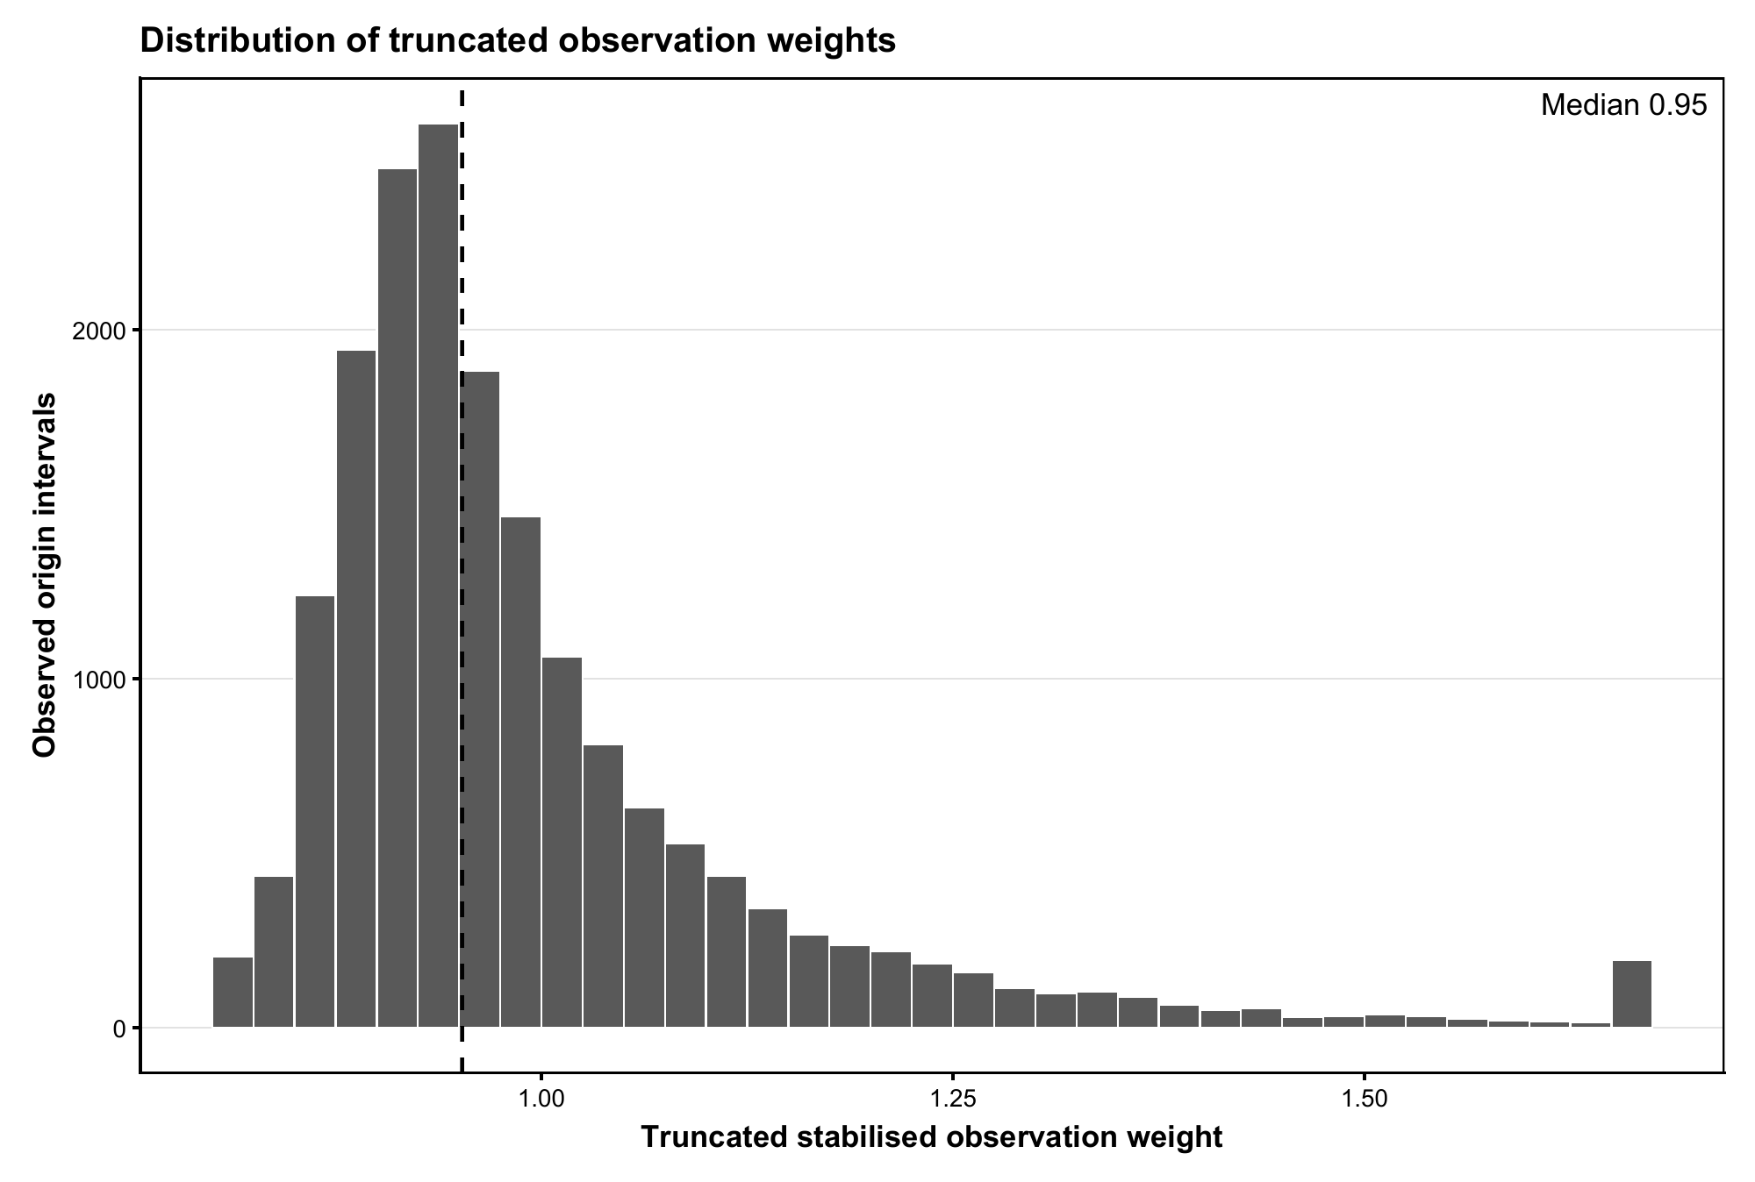
Figure S1. Distribution of truncated stabilised observation weights. The vertical dashed line marks the median weight. Raw weights were truncated at the first and 99th percentiles.
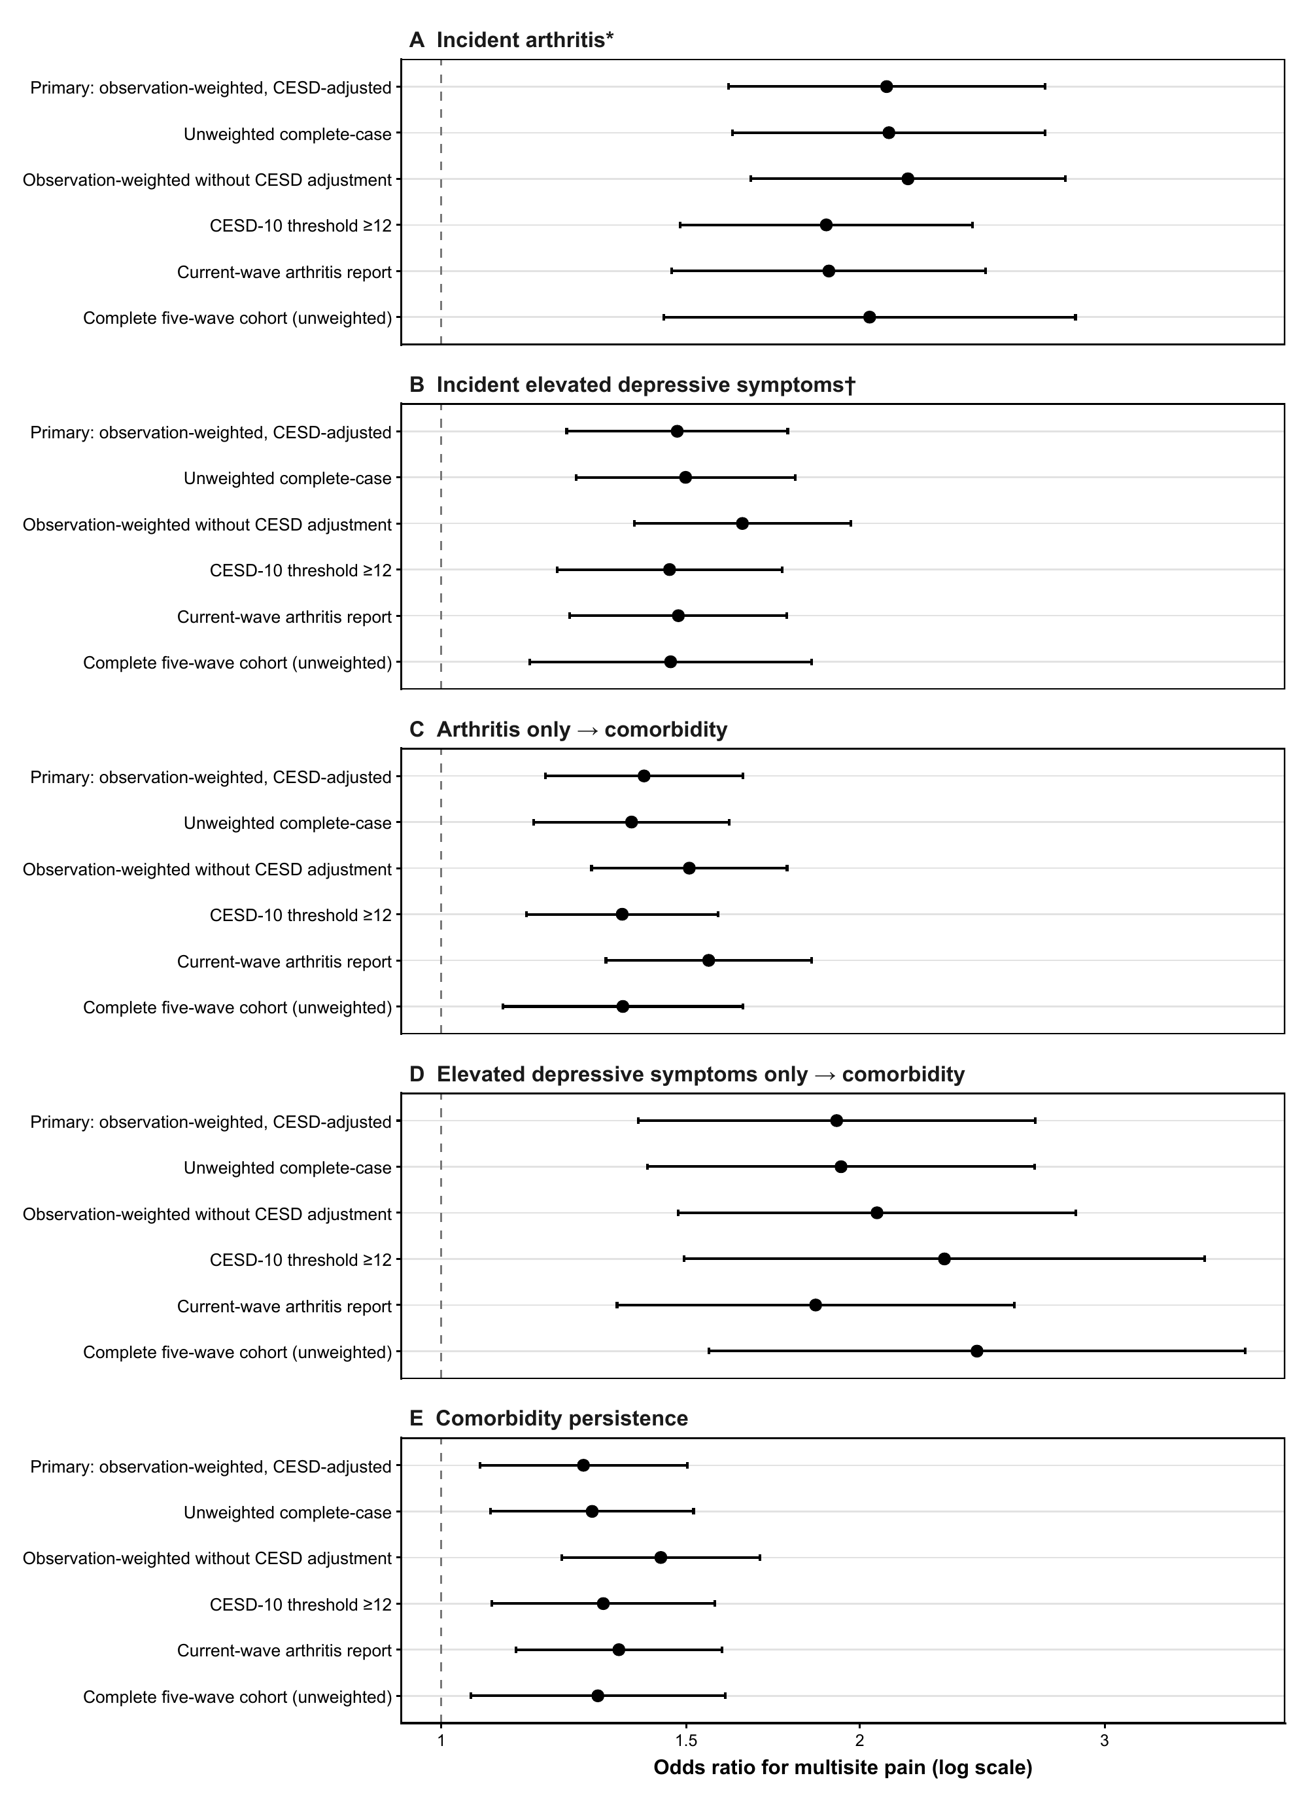
Figure S2. Sensitivity analyses for the association of multisite pain with each transition. Points are odds ratios comparing pain at two or more sites with no pain; bars are 95% confidence intervals. The complete five-wave cohort analysis was unweighted.

