Supplementary material: Text 1, Table S1-S15 and Figures S1-S4
Associations of Physical Activity, Dietary Quality, and Their Changes with All-Cause Mortality in Older Chinese Adults: A Prospective Study

Table of Content
Text S1 Detailed definitions and classification of covariates.
Table S1 Components of physical activity and diet quality score.
Table S2 The numbers (percentages) of participants with missing covariates.
Table S3 Classification of pa-diet quality trajectory groups (G1-G16) according to baseline and repeated assessments.
Table S4 Joint trajectory models’ results of model fitting process.
Table S5 Time-varying covariates in each model.
Table S6 Variance inflation factor of the adjusted covariates.
Table S7 Comparison of baseline characteristics between participants included in and excluded from the final analytical sample within the baseline population (N = 28,034)
Table S8 Baseline characteristics of participants by quartiles of PA (n=11,528).
Table S9 Baseline characteristics of participants by quartiles of SHE (n=11,528).
Table S10 Baseline characteristics of participants by quartiles of DDS (n=11,528).
Table S11 Tests of interaction between different combinations of the exposures for all-cause mortality outcome.
Table S12 Hazard ratios and 95% confidence intervals for all-cause mortality associated with joint change patterns in physical activity and diet quality in the complete-case analysis (n = 10,599).
Table S13 Hazard ratios and 95% confidence intervals for all-cause mortality associated with joint change patterns in physical activity and diet quality after excluding participants who died during the first follow-up interval following the repeated assessments (n = 6141).
Table S14 Hazard ratios and 95% confidence intervals for all-cause mortality associated with joint change patterns in physical activity and diet quality in the CLHLS sampling-weighted analysis (n = 11,528).
Table S15 Hazard ratios and 95% confidence intervals for all-cause mortality associated with joint change patterns in physical activity and diet quality using combined CLHLS sampling weights and stabilized inverse probability of selection weights (n = 11,528).
Fig. S1 Flowchart of participant selection for the secondary three-measurement GBMTM analysis.
Fig. S2 Kaplan-Meier curves for all-cause mortality by joint physical activity and diet quality trajectory groups.
Fig. S3 Dose-response relationships between physical activity and diet and all-cause mortality, modeled using Cox proportional hazards with quartic restricted cubic splines.
Fig. S4 Association of mutually adjusted annual change in PA, SHE, and DDS with all-cause mortality per 1-point difference in each exposure, stratified by key baseline characteristics.

Text S1 Detailed definitions and classification of covariates.
Demographic characteristics included age, gender, place of residence (urban or rural), occupation (manual laborer, non-manual laborer or other), years of education (0/1–5/>5 years), marital status (married or other), and living condition (with household members, solitary, or at nursing home). Lifestyle indicators comprised smoking status (current smoker, former smoker, or non-smoker), drinking status (current drinker, former drinker, or non-drinker), and body mass index (BMI, kg/m2). Participants were categorized into four BMI groups: underweight (<18.5 kg/m2), normal weight (18.5-23.9 kg/m2), overweight (24.0-27.9 kg/m2), and obese (≥28kg/m2). Health status encompassed self-reported medical conditions (e.g., hypertension, diabetes, heart diseases, lung diseases, stroke, cancer) and physical functions. Physical functions were evaluated using activities of daily living (ADL) status and physical performance measured by three tests. ADL was assessed using six basic activities: feeding, dressing, transferring, bathing, toileting, and continence. Participants reporting impairment in at least one activity were classified as having ADL disability. Physical performance was evaluated using three tasks: standing up from a chair, picking up a book from the floor, and turning approximately 360° without assistance. Participants unable to complete at least one task independently were classified as having a physical functional limitation.

Table S1. Components of physical activity and diet quality score.
Lifestyle factors | Category | Score
Physical activity*
Regular exercise | Yes | 2
 | No | 0
Housework tasks | Almost every day/Not every day, but at least once a week | 2
 | Not every week, but at least once a month | 1
 | Not every month, but sometimes/Never | 0
Personal outdoor activities | Almost every day/Not every day, but at least once a week | 2
 | Not every week, but at least once a month | 1
 | Not every month, but sometimes/Never | 0
Gardening | Almost every day/Not every day, but at least once a week | 2
 | Not every week, but at least once a month | 1
 | Not every month, but sometimes/Never | 0
Rearing domestic animals/pets | Almost every day/Not every day, but at least once a week | 2
 | Not every week, but at least once a month | 1
 | Not every month, but sometimes/Never | 0
Reading | Almost every day/Not every day, but at least once a week | 2
 | Not every week, but at least once a month | 1
 | Not every month, but sometimes/Never | 0
Playing cards/mahjong | Almost every day/Not every day, but at least once a week | 2
 | Not every week, but at least once a month | 1
 | Not every month, but sometimes/Never | 0
Watching TV/listening to the radio | Almost every day/Not every day, but at least once a week | 2
 | Not every week, but at least once a month | 1
 | Not every month, but sometimes/Never | 0
Attending social activities | Almost every day/Not every day, but at least once a week | 2
 | Not every week, but at least once a month | 1
 | Not every month, but sometimes/Never | 0
Diet quality#
Simplified Healthy Eating Index#
Fresh vegetables consumption | Every day or almost every day/Quite often | 2
 | Occasionally | 1
 | Rarely or never | 0
Fresh fruit consumption | Every day or almost every day/Quite often | 2
 | Occasionally | 1
 | Rarely or never | 0
Beans consumption | Almost every day/Not every day, but at least once a week | 2
 | Not every week, but at least once a month | 1
 | Not every month, but occasionally/Rarely or never | 0
Garlic consumption | Almost every day/Not every day, but at least once a week | 2
 | Not every week, but at least once a month | 1
 | Not every month, but occasionally/Rarely or never | 0
Tea consumption | Almost every day/Not every day, but at least once a week | 2
 | Not every week, but at least once a month | 1
 | Not every month, but occasionally/Rarely or never | 0
Egg consumption | Almost every day/Not every day, but at least once a week | 2
 | Not every week, but at least once a month | 1
 | Not every month, but occasionally/Rarely or never | 0
Fish consumption | Almost every day/Not every day, but at least once a week | 2
 | Not every week, but at least once a month | 1
 | Not every month, but occasionally/Rarely or never | 0
Salty vegetables consumption | Almost every day/Not every day, but at least once a week | 0
 | Not every week, but at least once a month | 1
 | Not every month, but occasionally/Rarely or never | 2
Sugar consumption | Almost every day/Not every day, but at least once a week | 0
 | Not every week, but at least once a month | 1
 | Not every month, but occasionally/Rarely or never | 2
Dietary Diversity Score#
Fresh vegetables consumption | Every day or almost every day/Quite often | 1
 | Occasionally/Rarely or never | 0
Fresh fruit consumption | Every day or almost every day/Quite often | 1
 | Occasionally/Rarely or never | 0
Beans consumption | Almost every day/Not every day, but at least once a week | 1
 | Not every week, but at least once a month/  Not every month, but occasionally/Rarely or never | 0
Garlic consumption | Almost every day/Not every day, but at least once a week | 1
 | Not every week, but at least once a month/  Not every month, but occasionally/Rarely or never | 0
Tea consumption | Almost every day/Not every day, but at least once a week | 1
 | Not every week, but at least once a month/  Not every month, but occasionally/Rarely or never | 0
Egg consumption | Almost every day/Not every day, but at least once a week | 1
 | Not every week, but at least once a month/  Not every month, but occasionally/Rarely or never | 0
Fish consumption | Almost every day/Not every day, but at least once a week | 1
 | Not every week, but at least once a month/  Not every month, but occasionally/Rarely or never | 0
Salty vegetables consumption | Almost every day/Not every day, but at least once a week | 1
 | Not every week, but at least once a month/  Not every month, but occasionally/Rarely or never | 0
Meat consumption | Almost every day/Not every day, but at least once a week | 1
 | Not every week, but at least once a month/  Not every month, but occasionally/Rarely or never | 0
* The physical activity score ranged from 0 to 18, with higher scores indicating more frequent activity.
# The SHE comprised nine food groups: fruits, fresh vegetables, fish, bean products, tea, garlic, eggs, sugar, and salt-preserved vegetables. For the first seven food groups, consumption frequencies of “almost daily or frequently,” “occasionally,” and “rarely or never” were scored 2, 1, and 0, respectively; sugar and salt-preserved vegetables were reverse-scored as 0, 1, and 2, respectively. The total SHE score ranged from 0 to 18, with higher scores indicating greater adherence to a healthier dietary pattern. The DDS comprised nine food groups: meat, fish, eggs, bean products, fruits, fresh vegetables, salt-preserved vegetables, tea, and garlic. Daily or frequent consumption of each food group was assigned 1 point, whereas less frequent consumption was assigned 0 points. The total DDS ranged from 0 to 9, with higher scores indicating greater dietary diversity. Staple cereals and cooking oils were excluded from the DDS because they were consumed almost universally in this population. SHE, Simplified Healthy Eating Index; DDS, Dietary Diversity Score.

Table S2. The numbers (percentages) of participants with missing covariates.
Covariates | Primary analysis |  | Secondary analysis
Covariates | n | % | n | %
Marital status | 5 | 0.04 | 0 | 0.00
Living condition | 11 | 0.10 | 1 | 0.02
Occupation | 39 | 0.34 | 13 | 0.22
Years of education | 39 | 0.34 | 13 | 0.22
Smoking status | 12 | 0.10 | 5 | 0.08
Drinking status | 12 | 0.10 | 4 | 0.07
Financial support | 5 | 0.04 | 1 | 0.02
BMI | 32 | 0.28 | 2 | 0.03
Hypertension | 377 | 3,27 | 207 | 3.45
Diabetes | 386 | 3.35 | 221 | 3.68
Heart disease | 358 | 3.11 | 206 | 3.43
Lung disease | 372 | 3.23 | 210 | 3.50
Stroke | 362 | 3.14 | 207 | 3.45
Cancer | 478 | 4.15 | 266 | 4.43
ADL disability | 25 | 0.22 | 4 | 0.07
Physical limitation | 28 | 0.24 | 8 | 0.13
Abbreviation: ADL, activities of daily living; BMI, body mass index.

Table S3. Classification of pa-diet quality trajectory groups (G1-G16) according to baseline and repeated assessments.
ID | Trajectory Groups | Baseline |  | Repeated assessments
ID | Trajectory Groups | PA | SHE or DDS | PA | SHE or DDS
G1 | LLLL | L | L | L | L
G2 | LLLH | L | L | L | H
G3 | LLHL | L | L | H | L
G4 | LLHH | L | L | H | H
G5 | LHLL | L | H | L | L
G6 | LHLH | L | H | L | H
G7 | LHHL | L | H | H | L
G8 | LHHH | L | H | H | H
G9 | HLLL | H | L | L | L
G10 | HLLH | H | L | L | H
G11 | HLHL | H | L | H | L
G12 | HLHH | H | L | H | H
G13 | HHLL | H | H | L | L
G14 | HHLH | H | H | L | H
G15 | HHHL | H | H | H | L
G16 | HHHH | H | H | H | H
PA, physical activity; SHE, Simplified Healthy Eating Index; DDS, Dietary Diversity Score. Participants were grouped based on high (H) or low (L) levels of baseline and repeated measures of PA and SHE/DDS.

Table S4. Joint trajectory models’ results of model fitting process.
Number of classes | Polynomial degree | AIC | BIC | Minimum  APPA | Minimum OCC | Minimum group size, %
PA-SHE
6 | (1 1 1 1 1 1), (1 1 1 1 1 1) | 179464.33 | 179815.31 | 0.70 | 5.50 | 2.71
6 | (2 2 2 2 2 2), (2 2 2 2 2 2) | 179466.64 | 179895.61 | 0.60 | 5.75 | 7.41
5 | (1 1 1 1 1), (1 1 1 1 1) | 179652.27 | 179940.85 | 0.73 | 6.14 | 8.85
5 | (2 2 2 2 2), (2 2 2 2 2) | 179628.38 | 179994.95 | 0.73 | 6.11 | 8.92
4 | (1 1 1 1),  (1 1 1 1) | 180054.15 | 180288.14 | 0.74 | 5.66 | 15.86
4 | (2 2 2 2),  (2 2 2 2) | 180027.11 | 180307.89 | 0.75 | 5.62 | 15.88
3 | (1 1 1),  (1 1 1) | 180652.20 | 180831.59 | 0.83 | 5.02 | 22.07
3 | (2 2 2),  (2 2 2) | 180625.32 | 180835.90 | 0.83 | 5.05 | 21.90
2 | (1 1), (1 1) | 181782.05 | 181899.04 | 0.88 | 6.79 | 41.36
2 | (2 2), (2 2) | 181764.11 | 181904.50 | 0.88 | 6.87 | 41.43
1 | (1), (1) | 185042.02 | 185096.61 | 1.00 | - | 100.00
1 | (2), (2) | 185028.95 | 185091.34 | 1.00 | - | 100.00
PA-DDS
6 | (1 1 1 1 1 1), (1 1 1 1 1 1) | 168211.81 | 168570.59 | 0.65 | 5.49 | 7.39
6 | (2 2 2 2 2 2), (2 2 2 2 2 2) | 168165.25 | 168609.82 | 0.65 | 5.49 | 4.63
5 | (1 1 1 1 1), (1 1 1 1 1) | 168411.91 | 168708.29 | 0.72 | 6.06 | 8.17
5 | (2 2 2 2 2), (2 2 2 2 2) | 168301.98 | 168660.76 | 0.70 | 6.10 | 8.16
4 | (1 1 1 1),  (1 1 1 1) | 168737.66 | 168971.65 | 0.76 | 5.70 | 10.50
4 | (2 2 2 2),  (2 2 2 2) | 168627.42 | 168916.00 | 0.77 | 5.88 | 10.55
3 | (1 1 1),  (1 1 1) | 169407.68 | 169587.07 | 0.79 | 8.02 | 31.26
3 | (2 2 2),  (2 2 2) | 169295.51 | 169521.69 | 0.80 | 8.26 | 30.83
2 | (1 1), (1 1) | 170674.67 | 170791.67 | 0.88 | 6.50 | 42.58
2 | (2 2), (2 2) | 170612.96 | 170761.15 | 0.88 | 6.53 | 42.74
1 | (1), (1) | 173710.17 | 173764.76 | 1.00 | - | 100.00
1 | (2), (2) | 173647.74 | 173717.93 | 1.00 | - | 100.00
Abbreviation: AIC, Akaike information criterion; BIC, Bayesian information criterion; APPA, average posterior probability of assignment; OCC, odds of correct classification. Minimum APPA represents the lowest class-specific average posterior probability of assignment across all identified trajectory groups. Minimum OCC represents the lowest class-specific odds of correct classification across all groups, indicating the weakest classification performance among the identified groups.

Table S5. Time-varying covariates in each model.
 | Covariates that violated the proportional hazard assumption
 | Baseline PA | ∆PA
Model 1 | Age | Age
Model 2 | Age, BMI, Drink | Age, Living condition, BMI, Drink
Model 3 | Age, BMI, Drink, Stroke | Age, BMI, Drink, Hypertension, Stroke
Model 4 | Age, BMI, Drink, Hypertension, Stroke | Age, BMI, Drink, Hypertension, Stroke
 | Baseline SHE | ∆SHE
Model 1 | Age | Age
Model 2 | Age, Living condition, BMI, Drink | Age, Living condition, BMI, Drink
Model 3 | Age, BMI, Drink, Hypertension, Stroke | Age, BMI, Drink, Hypertension, Stroke
Model 4 | Age, BMI, Drink, Hypertension, Stroke | Age, BMI, Drink, Hypertension, Stroke
 | Baseline DDS | ∆DDS
Model 1 | Age | Age
Model 2 | Age, Living condition, BMI, Drink | Age, Living condition, BMI, Drink
Model 3 | Age, BMI, Drink, Hypertension, Stroke | Age, BMI, Drink, Hypertension, Stroke
Model 4 | Age, BMI, Drink, Hypertension, Stroke | Age, BMI, Drink, Hypertension, Stroke
 | PA-SHE Joint change patterns
Model 4 | Age, BMI, Drink, Hypertension, Stroke
 | PA-DDS Joint change patterns
Model 4 | Age, BMI, Drink, Hypertension, Stroke
 | PA-SHE Joint trajectories
Model 4 | Age, marital status, Hypertension, Physical limitation
 | PA-DDS Joint trajectories
Model 4 | Age, marital status, Hypertension, Physical limitation
Abbreviation: ADL, activities of daily living; BMI, body mass index; PA, physical activity; SHE, simplified healthy eating index; DDS, dietary diversity score
Covariates in the models: Model1: Adjusted for age, sex; Model2: variables in Model 1 + living condition, years of education, marital status, BMI, financial support, occupation, residence, smoking status, drinking status; Model3: variables in Model2 + hypertension, diabetes, heart diseases, lung diseases, stroke, cancer, ADL disability, Physical limitation; Model4: variables in Model3 + Baseline PA, Baseline SHE, Baseline DDS.

Table S6. Variance inflation factor of the adjusted covariates.
Covariates | VIF
Age | 1.289
Sex | 1,315
Residence | 1.045
Occupation | 1.061
Marital status | 1.240
Living condition | 1.062
Years of education | 1.239
Financial support | 1.036
BMI | 1.041
Smoking status | 1.186
Drinking status | 1.106
Hypertension | 1.038
Diabetes | 1.019
Heart disease | 1.042
Lung disease | 1.011
Stroke | 1.030
Cancer | 1.003
ADL disability | 1.151
Physical limitation | 1.143
Baseline PA | 1.245
Baseline SHE | 1.410
Baseline DDS | 1.391
Abbreviation: VIF, variance inflation factor; ADL, activities of daily living; BMI, body mass index; PA, physical activity; SHE, simplified healthy eating index; DDS, dietary diversity score.

Table S7 Comparison of baseline characteristics between participants included in and excluded from the final analytical sample within the baseline population (N = 28,034)
Variables | Overall  (n = 28,034) | Included  (n = 11,528) | Excluded  (n = 16,506) | P value | SMD
Age, years | 86.33 ± 12.83 | 81.90 ± 12.00 | 89.40 ± 12.50 | <0.001
Sex |  |  |  | <0.001 | 0.120
Male | 11630(41.49) | 5183(44.96) | 6447(39.06)
Female | 16404(58.51) | 6345(55.04) | 10059(60.94)
Living condition |  |  |  | 0.884 | 0.115
With household members | 23523(83.97) | 9659(83.87) | 13864(84.04)
Solitary | 3899(13.92) | 1716(14.90) | 2183(13.23)
At nursing home | 591(2.11) | 142(1.23) | 449(2.72)
Years of education |  |  |  | <0.001 | 0.158
0 | 17958(64.39) | 6905(60.10) | 11053(67.39)
1-5 | 5748(20.61) | 2737(23.82) | 3011(18.36)
>5 | 4184(15.00) | 1847(16.08) | 2337(14.25)
Marital status |  |  |  | <0.001 | 0.384
Married or partnered | 8750(31.22) | 4800(41.66) | 3950(23.93)
Not married | 19278(68.78) | 6723(58.34) | 12555(76.07)
Financial support |  |  |  | 0.354 | 0.011
Sufficient | 22172(79.13) | 9087(78.86) | 13085(79.32)
Insufficient | 5848(20.87) | 2436(21.14) | 3412(20.68)
Occupation |  |  |  | 0.037 | 0.036
Manual laborers | 25346(90.82) | 10453(90.98) | 14893(90.71)
Non-manual laborers | 1900(6.81) | 799(6.95) | 1101(6.71)
Other | 662(2.37) | 237(2.06) | 425(2.59)
Residence |  |  |  | <0.001 | 0.180
Urban | 10794(38.50) | 3849(33.39) | 6945(42.08)
Rural | 17240(61.50) | 7679(66.61) | 9561(57.92)
BMI |  |  |  | <0.001 | 0.174
< 18.5 kg/m² | 8303(35.41) | 3612(31.42) | 4691(39.24)
18.5-23.9 kg/m² | 11706(49.92) | 5988(52.09) | 5718(47.83)
24.0-27.9 kg/m² | 2636(11.24) | 1472(12.80) | 1164(9.74)
≥ 28kg/m² | 805(3.43) | 424(3.69) | 381(3.19)
Smoking status |  |  |  | <0.001 | 0.140
Current smoker | 5203(18.58) | 2509(21.79) | 2694(16.34)
Former smoker | 3580(12.78) | 1375(11.94) | 2205(13.37)
Nonsmoker | 19222(68.64) | 7632(66.27) | 11590(70.29)
Drinking status |  |  |  | <0.001 | 0.127
Current drinker | 5382(19.22) | 2546(22.11) | 2836(17.20)
Former drinker | 2657(9.49) | 994(8.63) | 1663(10.09)
Nondrinker | 19962(71.29) | 7976(69.26) | 11986(72.71)
Hypertension | 4669(17.28) | 2022(18.13) | 2647(16.68) | 0.002 | 0.038
Diabetes | 646(2.40) | 239(2.15) | 407(2.57) | 0.024 | 0.028
Heart diseases | 2283(8.44) | 924(8.27) | 1359(8.56) | 0.394 | 0.011
Lung diseases | 3162(11.69) | 1228(11.01) | 1934(12.18) | 0.003 | 0.037
Stroke | 1461(5.40) | 541(4.85) | 920(5.79) | <0.001 | 0.042
Cancer | 115(0.43) | 30(0.27) | 85(0.54) | <0.001 | 0.042
ADL disability | 7189(25.69) | 1456(12.66) | 5733(34.80) | <0.001 | 0.539
Physical limitation | 8827(31.57) | 2210(19.22) | 6617(40.19) | <0.001 | 0.472
Abbreviation: ADL, activities of daily living; BMI, body mass index; SMD, standardized mean difference.

Table S8 Baseline characteristics of participants by quartiles of PA (n=11,528).
Variables | PA quartile 1  (n = 4348) | PA quartile 2  (n = 2359) | PA quartile 3  (n = 2232) | PA quartile 4  (n = 2589) | P value
Age, years | 88.70 ± 11.10 | 80.60 ± 11.10 | 77.20 ± 10.20 | 75.60 ± 9.69 | <0.001
Sex |  |  |  |  | <0.001
Male | 1524(35.05) | 1007(42.69) | 1080(48.39) | 1572(60.72)
Female | 2824(64.95) | 1352(57.31) | 1152(51.61) | 1017(39.28)
Living condition |  |  |  |  | <0.001
With household members | 3600(82.80) | 1937(82.11) | 1866(83.60) | 2266(87.52)
Solitary | 665(15.29) | 397(16.83) | 348(15.59) | 307(11.86)
At nursing home | 83(1.91) | 25(1.06) | 18(0.81) | 16(0.62)
Years of education |  |  |  |  | <0.001
0 | 3384(77.83) | 1542(65.37) | 1215(54.44) | 792(30.59)
1-5 | 671(15.43) | 555(23.53) | 651(29.17) | 866(33.45)
>5 | 293(6.74) | 262(11.11) | 366(16.40) | 931(35.96)
Marital status |  |  |  |  | <0.001
Married or partnered | 1077(24.77) | 985(41.75) | 1153(51.66) | 1587(61.30)
Not married | 3271(75.23) | 1374(58.25) | 1079(48.34) | 1002(38.70)
Financial support |  |  |  |  | <0.001
Sufficient | 3309(76.10) | 1812(76.81) | 1735(77.73) | 2235(86.33)
Insufficient | 1039(23.90) | 547(23.19) | 497(22.27) | 354(13.67)
Occupation |  |  |  |  | <0.001
Manual laborers | 4166(95.81) | 2249(95.34) | 2065(92.52) | 2008(77.56)
Non-manual laborers | 94(2.16) | 68(2.88) | 131(5.87) | 507(19.58)
Other | 88(2.02) | 42(1.78) | 36(1.61) | 74(2.86)
Residence |  |  |  |  | <0.001
Urban | 1205(27.71) | 656(27.81) | 679(30.42) | 1309(50.56)
Rural | 3143(72.29) | 1703(72.19) | 1553(69.58) | 1280(49.44)
BMI |  |  |  |  | <0.001
< 18.5 kg/m² | 1753(40.32) | 718(30.44) | 608(27.24) | 546(21.09)
18.5-23.9 kg/m² | 2074(47.70) | 1273(53.96) | 1214(54.39) | 1441(55.66)
24.0-27.9 kg/m² | 381(8.76) | 296(12.55) | 316(14.16) | 482(18.62)
≥ 28kg/m² | 140(3.22) | 72(3.05) | 94(4.21) | 120(4.63)
Smoking status |  |  |  |  | <0.001
Current smoker | 719(16.54) | 483(20.47) | 556(24.91) | 752(29.05)
Former smoker | 456(10.49) | 253(10.72) | 248(11.11) | 419(16.18)
Nonsmoker | 3173(72.98) | 1623(68.80) | 1428(63.98) | 1418(54.77)
Drinking status |  |  |  |  | <0.001
Current drinker | 752(17.30) | 521(22.09) | 538(24.10) | 740(28.58)
Former drinker | 363(8.35) | 204(8.65) | 190(8.51) | 239(9.23)
Nondrinker | 3233(74.36) | 1634(69.27) | 1504(67.38) | 1610(62.19)
Hypertension | 710(16.33) | 442(18.74) | 417(18.68) | 527(20.36) | <0.001
Diabetes | 57(1.31) | 47(1.99) | 45(2.02) | 97(3.75) | <0.001
Heart diseases | 277(6.37) | 178(7.55) | 199(8.92) | 296(11.43) | <0.001
Lung diseases | 439(10.10) | 270(11.45) | 248(11.11) | 308(11.90) | 0.100
Stroke | 212(4.88) | 110(4.66) | 121(5.42) | 121(4.67) | 0.598
Cancer | 11(0.25) | 3(0.13) | 7(0.31) | 10(0.39) | 0.347
ADL disability | 1099(25.28) | 186(7.88) | 94(4.21) | 80(3.09) | <0.001
Physical limitation | 1553(35.72) | 299(12.67) | 208(9.32) | 156(6.03) | <0.001
∆PA (points per year) | 0.31 ± 1.03 | -0.19 ± 1.15 | -0.48 ± 1.14 | -0.96 ± 1.24 | <0.001
Baseline SHE (points) | 9.87 ± 2.73 | 10.20 ± 2.72 | 10.60 ± 2.62 | 11.60 ± 2.60 | <0.001
∆SHE (points per year) | 0.07 ± 1.14 | 0.03 ± 1.11 | -0.01 ± 1.06 | -0.04 ± 1.05 | <0.001
Baseline DDS (points) | 3.59 ± 2.01 | 3.79 ± 2.05 | 3.95 ± 2.03 | 4.66 ± 2.06 | <0.001
∆DDS (points per year) | 0.12 ± 0.83 | 0.10 ± 0.83 | 0.03 ± 0.79 | -0.02 ± 0.83 | <0.001
Abbreviation: ADL, activities of daily living; BMI, body mass index; PA, physical activity; SHE, simplified healthy eating index; DDS, dietary diversity score.

Table S9 Baseline characteristics of participants by quartiles of SHE (n=11,528).
Variables | SHE quartile 1  (n = 4196) | SHE quartile 2  (n = 1674) | SHE quartile 3  (n = 2917) | SHE quartile 4  (n = 2741) | P value
Age, years | 83.20 ± 11.90 | 81.70 ± 11.90 | 81.50 ± 11.80 | 80.40 ± 12.00 | <0.001
Sex |  |  |  |  | <0.001
Male | 1586(37.80) | 713(42.59) | 1401(48.03) | 1483(54.10)
Female | 2610(62.20) | 961(57.41) | 1516(51.97) | 1258(45.90)
Living condition |  |  |  |  | <0.001
With household members | 3315(79.00) | 1419(84.77) | 2519(86.36) | 2416(88.14)
Solitary | 817(19.47) | 240(14.34) | 366(12.55) | 294(10.73)
At nursing home | 64(1.53) | 15(0.90) | 32(1.10) | 31(1.13)
Years of education |  |  |  |  | <0.001
0 | 2985(71.14) | 1030(61.53) | 1662(56.98) | 1256(45.82)
1-5 | 849(20.23) | 419(25.03) | 741(25.40) | 734(26.78)
>5 | 362(8.63) | 225(13.44) | 514(17.62) | 751(27.40)
Marital status |  |  |  |  | <0.001
Married or partnered | 1458(34.75) | 695(41.52) | 1281(43.91) | 1368(49.91)
Not married | 2738(65.25) | 979(58.48) | 1636(56.09) | 1373(50.09)
Financial support |  |  |  |  | <0.001
Sufficient | 2856(68.06) | 1347(80.47) | 2442(83.72) | 2446(89.24)
Insufficient | 1340(31.94) | 327(19.53) | 475(16.28) | 295(10.76)
Occupation |  |  |  |  | <0.001
Manual laborers | 4017(95.73) | 1567(93.61) | 2615(89.65) | 2289(83.51)
Non-manual laborers | 105(2.50) | 74(4.42) | 232(7.95) | 389(14.19)
Other | 74(1.76) | 33(1.97) | 70(2.40) | 63(2.30)
Residence |  |  |  |  | <0.001
Urban | 1020(24.31) | 485(28.97) | 1077(36.92) | 1267(46.22)
Rural | 3176(75.69) | 1189(71.03) | 1840(63.08) | 1474(53.78)
BMI |  |  |  |  | <0.001
< 18.5 kg/m² | 1606(38.27) | 565(33.75) | 855(29.31) | 599(21.85)
18.5-23.9 kg/m² | 2083(49.64) | 886(52.93) | 1565(53.65) | 1468(53.56)
24.0-27.9 kg/m² | 403(9.60) | 176(10.51) | 396(13.58) | 500(18.24)
≥ 28kg/m² | 104(2.48) | 47(2.81) | 101(3.46) | 174(6.35)
Smoking status |  |  |  |  | <0.001
Current smoker | 815(19.42) | 363(21.68) | 681(23.35) | 651(23.75)
Former smoker | 426(10.15) | 195(11.65) | 342(11.72) | 413(15.07)
Nonsmoker | 2955(70.42) | 1116(66.67) | 1894(64.93) | 1677(61.18)
Drinking status |  |  |  |  | <0.001
Current drinker | 783(18.66) | 355(21.21) | 694(23.79) | 719(26.23)
Former drinker | 355(8.46) | 136(8.12) | 233(7.99) | 272(9.92)
Nondrinker | 3058(72.88) | 1183(70.67) | 1990(68.22) | 1750(63.85)
Hypertension | 742(17.68) | 272(16.25) | 515(17.66) | 567(20.69) | <0.001
Diabetes | 47(1.12) | 35(2.09) | 62(2.13) | 102(3.72) | <0.001
Heart diseases | 309(7.36) | 106(6.33) | 239(8.19) | 296(10.80) | <0.001
Lung diseases | 485(11.56) | 181(10.81) | 298(10.22) | 301(10.98) | 0.358
Stroke | 199(4.74) | 87(5.20) | 121(4.15) | 157(5.73) | 0.044
Cancer | 7(0.17) | 3(0.18) | 9(0.31) | 12(0.44) | 0.157
ADL disability | 561(13.37) | 225(13.44) | 342(11.72) | 331(12.08) | 0.112
Physical limitation | 946(22.55) | 318(19.00) | 513(17.59) | 439(16.02) | <0.001
Baseline PA (points) | 5.21 ± 3.27 | 5.78 ± 3.43 | 6.39 ± 3.60 | 7.27 ± 3.82 | <0.001
∆PA (points per year) | -0.20 ± 1.18 | -0.18 ± 1.22 | -0.25 ± 1.25 | -0.29 ± 1.27 | 0.005
∆SHE (points per year) | 0.67 ± 1.00 | 0.10 ± 0.92 | -0.22 ± 0.92 | -0.75 ± 0.93 | <0.001
Baseline DDS (points) | 2.45 ± 1.39 | 3.41 ± 1.62 | 4.38± 1.62 | 6.08 ± 1.54 | <0.001
∆DDS (points per year) | 0.37 ± 0.75 | 0.15 ± 0.76 | -0.03 ± 0.80 | -0.34 ± 0.80 | <0.001
Abbreviation: ADL, activities of daily living; BMI, body mass index; PA, physical activity; SHE, simplified healthy eating index; DDS, dietary diversity score.

Table S10 Baseline characteristics of participants by quartiles of DDS (n=11,528).
Variables | DDS quartile 1  (n = 3250) | DDS quartile 2  (n = 3884) | DDS quartile 3  (n = 1606) | DDS quartile 4  (n = 2788) | P value
Age, years | 82.20 ± 12.00 | 81.80 ± 11.90 | 82.20 ± 11.90 | 81.40 ± 12.20 | 0.028
Sex |  |  |  |  | <0.001
Male | 1268(39.02) | 1729(44.52) | 787(49.00) | 1399(50.18)
Female | 1982(60.98) | 2155(55.48) | 819(51.00) | 1389(49.82)
Living condition |  |  |  |  | <0.001
With household members | 2576(79.26) | 3226(83.06) | 1402(87.30) | 2465(88.41)
Solitary | 627(19.29) | 619(15.94) | 186(11.58) | 285(10.22)
At nursing home | 47(1.45) | 39(1.00) | 18(1.12) | 38(1.36)
Years of education |  |  |  |  | <0.001
0 | 2269(69.82) | 2394(61.64) | 872(54.30) | 1398(50.14)
1-5 | 689(21.20) | 932(24.00) | 420(26.15) | 702(25.18)
>5 | 292(8.98) | 558(14.37) | 314(19.55) | 688(24.68)
Marital status |  |  |  |  | <0.001
Married or partnered | 1186(36.49) | 1588(40.89) | 704(43.84) | 1324(47.49)
Not married | 2064(63.51) | 2296(59.11) | 902(56.16) | 1464(52.51)
Financial support |  |  |  |  | <0.001
Sufficient | 2186(67.26) | 3096(79.71) | 1340(83.44) | 2469(88.56)
Insufficient | 1064(32.74) | 788(20.29) | 266(16.56) | 319(11.44)
Occupation |  |  |  |  | <0.001
Manual laborers | 3107(95.60) | 3582(92.22) | 1426(88.79) | 2373(85.11)
Non-manual laborers | 96(2.95) | 217(5.59) | 148(9.22) | 339(12.16)
Other | 47(1.45) | 85(2.19) | 32(1.99) | 76(2.73)
Residence |  |  |  |  | <0.001
Urban | 762(23.45) | 1279(32.93) | 630(39.23) | 1178(42.25)
Rural | 2488(76.55) | 2605(67.07) | 976(60.77) | 1610(57.75)
BMI |  |  |  |  | <0.001
< 18.5 kg/m² | 1272(39.14) | 1254(32.29) | 460(28.64) | 639(22.92)
18.5-23.9 kg/m² | 1601(49.26) | 2035(52.39) | 870(54.17) | 1496(53.66)
24.0-27.9 kg/m² | 301(9.26) | 474(12.20) | 213(13.26) | 487(17.47)
≥ 28kg/m² | 76(2.34) | 121(3.12) | 63(3.92) | 166(5.95)
Smoking status |  |  |  |  | <0.001
Current smoker | 649(19.97) | 861(22.17) | 358(22.29) | 642(23.03)
Former smoker | 325(10.00) | 447(11.51) | 209(13.01) | 395(14.17)
Nonsmoker | 2276(70.03) | 2576(66.32) | 1039(64.69) | 1751(62.80)
Drinking status |  |  |  |  | <0.001
Current drinker | 587(18.06) | 848(21.83) | 367(22.85) | 749(26.87)
Former drinker | 236(7.26) | 360(9.27) | 137(8.53) | 263(9.43)
Nondrinker | 2427(74.68) | 2676(68.90) | 1102(68.62) | 1776(63.70)
Hypertension | 561(17.26) | 683(17.58) | 303(18.87) | 549(19.69) | 0.056
Diabetes | 52(1.60) | 74(1.91) | 30(1.87) | 90(3.23) | <0.001
Heart diseases | 232(7.14) | 305(7.85) | 158(9.84) | 255(9.15) | 0.002
Lung diseases | 365(11.23) | 436(11.23) | 185(11.52) | 279(10.01) | 0.305
Stroke | 157(4.83) | 186(4.79) | 74(4.61) | 147(5.27) | 0.738
Cancer | 5(0.15) | 5(0.13) | 7(0.44) | 14(0.50) | 0.008
ADL disability | 439(13.51) | 469(12.08) | 194(12.08) | 357(12.80) | 0.277
Physical limitation | 705(21.69) | 726(18.69) | 295(18.37) | 490(17.58) | <0.001
Baseline PA (points) | 5.20 ± 3.28 | 6.04 ± 3.52 | 6.39 ± 3.67 | 6.97 ± 3.81 | <0.001
∆PA (points per year) | -0.17 ± 1.15 | -0.23 ± 1.24 | -0.28 ± 1.27 | -0.28 ± 1.27 | 0.001
Baseline SHE (points) | 8.20 ± 2.00 | 9.97 ± 2.11 | 11.60 ± 2.02 | 13.10 ± 2.01 | <0.001
∆SHE (points per year) | 0.48 ± 1.03 | 0.12 ± 1.03 | -0.22 ± 1.06 | -0.52 ± 1.03 | <0.001
∆DDS (points per year) | 0.63 ± 0.69 | 0.15 ± 0.68 | -0.17 ± 0.70 | -0.57 ± 0.72 | <0.001
Abbreviation: ADL, activities of daily living; BMI, body mass index; PA, physical activity; SHE, simplified healthy eating index; DDS, dietary diversity score.

Table S11 Tests of interaction between different combinations of the exposures for all-cause mortality outcome.
Interaction terms in the model | Multiplicative interaction | Additive interaction
Interaction terms in the model | HR (95%CI) | RERI (95%CI) | AP (95%CI)
Baseline PA × Baseline SHE | 0.997(0.969, 1.025) | 0.003(-0.027, 0.034) | 0.003(-0.023, 0.029)
Baseline PA × Baseline DDS | 0.982(0.946, 1.020) | -0.015(-0.056, 0.026) | -0.013(-0.048, 0.023)
Baseline SHE × Baseline DDS | 0.998(0.961, 1.036) | -0.001(-0.040, 0.040) | -0.001(-0.036, 0.036)
∆PA × ∆SHE | 1.025(0.988, 1.065) | 0.038(-0.014, 0.089) | 0.025(-0.008, 0.058)
∆PA × ∆DDS | 0.996(0.960, 1.034) | 0.008(-0.044, 0.059) | 0.005(-0.028, 0.038)
∆SHE × ∆DDS | 1.020(0.992, 1.050) | 0.021(-0.008, 0.049) | 0.020(-0.007, 0.047)
Abbreviation: HR, hazard ratios; CI, confidence intervals; RERI, the relative excess risk due to interaction; AP, the attributable proportion due to interaction; PA, physical activity; SHE, simplified healthy eating index; DDS, dietary diversity score.

Table S12 Hazard ratios and 95% confidence intervals for all-cause mortality associated with joint change patterns in physical activity and diet quality in the complete-case analysis (n = 10,599).
Exposures | PA-SHE  HR (95%CI) | PA-DDS  HR (95%CI)
G1: LLLL | 1.00 (Ref) | 1.00 (Ref)
G2: LLLH | 0.871(0.770, 0.984) | 0.986(0.884, 1.101)
G3: LLHL | 0.661(0.560, 0.781) | 0.682(0.582, 0.801)
G4: LLHH | 0.698(0.579, 0.842) | 0.618(0.522, 0.730)
G5: LHLL | 0.944(0.849, 1.049) | 1.152(1.019, 1.302)
G6: LHLH | 0.891(0.796, 0.997) | 0.901(0.808, 1.005)
G7: LHHL | 0.555(0.466, 0.662) | 0.686(0.553, 0.851)
G8: LHHH | 0.567(0.485, 0.664) | 0.623(0.532, 0.729)
G9: HLLL | 0.911(0.803, 1.035) | 0.926(0.818, 1.049)
G10: HLLH | 0.942(0.802, 1.106) | 0.986(0.858, 1.133)
G11: HLHL | 0.617(0.539, 0.706) | 0.627(0.552, 0.713)
G12: HLHH | 0.565(0.482, 0.661) | 0.617(0.541, 0.704)
G13: HHLL | 0.882(0.779, 0.998) | 0.992(0.866, 1.136)
G14: HHLH | 0.906(0.799, 1.026) | 0.955(0.843, 1.081)
G15: HHHL | 0.526(0.462, 0.599) | 0.588(0.508, 0.681)
G16: HHHH | 0.540(0.479, 0.608) | 0.557(0.495, 0.628)
Abbreviation: HR, hazard ratios; CI, confidence intervals; PA, physical activity; SHE, simplified healthy eating index; DDS, dietary diversity score. Analysis is based on model 4 (see ‘Methods’). Definition for high PA: PA ≥6 points (both assessment); high diet quality: baseline SHE ≥10 points, follow-up SHE ≥11 points or DDS ≥4 points (both assessment). Groups were formed according to reaching a high (H) or low (L) level of baseline PA, baseline SHE/DDS, repeated PA and repeated SHE/DDS.

Table S13 Hazard ratios and 95% confidence intervals for all-cause mortality associated with joint change patterns in physical activity and diet quality after excluding participants who died during the first follow-up interval following the repeated assessments (n = 6141).
Exposures | PA-SHE  HR (95%CI) | PA-DDS  HR (95%CI)
G1: LLLL | 1.00 (Ref) | 1.00 (Ref)
G2: LLLH | 0.850(0.704, 1.027) | 0.911(0.769, 1.080)
G3: LLHL | 0.859(0.718, 1.027) | 0.820(0.693, 0.970)
G4: LLHH | 0.782(0.635, 0.964) | 0.722(0.602, 0.867)
G5: LHLL | 0.893(0.758, 1.053) | 1.018(0.846, 1.227)
G6: LHLH | 0.851(0.716, 1.010) | 0.896(0.756, 1.061)
G7: LHHL | 0.613(0.506, 0.742) | 0.721(0.572, 0.910)
G8: LHHH | 0.649(0.544, 0.776) | 0.711(0.592, 0.854)
G9: HLLL | 0.913(0.729, 1.142) | 0.852(0.693, 1.049)
G10: HLLH | 0.891(0.657, 1.209) | 0.945(0.730, 1.225)
G11: HLHL | 0.602(0.495, 0.732) | 0.629(0.526, 0.751)
G12: HLHH | 0.616(0.491, 0.774) | 0.709(0.591, 0.851)
G13: HHLL | 0.900(0.733, 1.105) | 1.081(0.856, 1.366)
G14: HHLH | 0.867(0.698, 1.077) | 0.957(0.768, 1.193)
G15: HHHL | 0.609(0.511, 0.725) | 0.686(0.566, 0.833)
G16: HHHH | 0.582(0.493, 0.687) | 0.585(0.493, 0.693)
Abbreviation: HR, hazard ratios; CI, confidence intervals; PA, physical activity; SHE, simplified healthy eating index; DDS, dietary diversity score. Analysis is based on model 4 (see ‘Methods’). Definition for high PA: PA ≥6 points (both assessment); high diet quality: baseline SHE ≥10 points, follow-up SHE ≥11 points or DDS ≥4 points (both assessment). Groups were formed according to reaching a high (H) or low (L) level of baseline PA, baseline SHE/DDS, repeated PA and repeated SHE/DDS.

Table S14 Hazard ratios and 95% confidence intervals for all-cause mortality associated with joint change patterns in physical activity and diet quality in the CLHLS sampling-weighted analysis (n = 11,528).
Exposures | PA-SHE  HR (95%CI) | PA-DDS  HR (95%CI)
G1: LLLL | 1.00 (Ref) | 1.00 (Ref)
G2: LLLH | 0.821(0.636, 1.059) | 1.089(0.862, 1.378)
G3: LLHL | 0.585(0.452, 0.756) | 0.669(0.528, 0.848)
G4: LLHH | 0.657(0.478, 0.904) | 0.607(0.459, 0.803)
G5: LHLL | 0.967(0.762, 1.228) | 1.068(0.817, 1.397)
G6: LHLH | 0.818(0.631, 1.060) | 0.924(0.720, 1.187)
G7: LHHL | 0.555(0.411, 0.748) | 0.638(0.463, 0.878)
G8: LHHH | 0.526(0.401, 0.691) | 0.607(0.457, 0.806)
G9: HLLL | 0.869(0.697, 1.082) | 0.919(0.750, 1.126)
G10: HLLH | 0.887(0.678, 1.159) | 0.944(0.745, 1.197)
G11: HLHL | 0.607(0.497, 0.742) | 0.689(0.572, 0.828)
G12: HLHH | 0.548(0.432, 0.694) | 0.673(0.553, 0.819)
G13: HHLL | 0.851(0.677, 1.071) | 1.025(0.805, 1.304)
G14: HHLH | 0.826(0.653, 1.044) | 0.905(0.711, 1.152)
G15: HHHL | 0.585(0.477, 0.719) | 0.657(0.528, 0.817)
G16: HHHH | 0.568(0.465, 0.693) | 0.574(0.472, 0.699)
Abbreviation: HR, hazard ratios; CI, confidence intervals; PA, physical activity; SHE, simplified healthy eating index; DDS, dietary diversity score. Analysis is based on model 4 (see ‘Methods’). Definition for high PA: PA ≥6 points (both assessment); high diet quality: baseline SHE ≥10 points, follow-up SHE ≥11 points or DDS ≥4 points (both assessment). Groups were formed according to reaching a high (H) or low (L) level of baseline PA, baseline SHE/DDS, repeated PA and repeated SHE/DDS.

Table S15 Hazard ratios and 95% confidence intervals for all-cause mortality associated with joint change patterns in physical activity and diet quality using combined CLHLS sampling weights and stabilized inverse probability of selection weights (n = 11,528).
Exposures | PA-SHE  HR (95%CI) | PA-DDS  HR (95%CI)
G1: LLLL | 1.00 (Ref) | 1.00 (Ref)
G2: LLLH | 0.887(0.792, 0.994) | 0.997(0.903, 1.102)
G3: LLHL | 0.670(0.573, 0.784) | 0.667(0.571, 0.779)
G4: LLHH | 0.690(0.578, 0.824) | 0.625(0.533, 0.731)
G5: LHLL | 0.933(0.845, 1.031) | 1.115(0.995, 1.250)
G6: LHLH | 0.913(0.824, 1.012) | 0.918(0.827, 1.018)
G7: LHHL | 0.564(0.475, 0.669) | 0.704(0.571, 0.867)
G8: LHHH | 0.551(0.472, 0.643) | 0.592(0.506, 0.694)
G9: HLLL | 0.937(0.836, 1.051) | 0.936(0.836, 1.048)
G10: HLLH | 0.954(0.823, 1.107) | 1.021(0.899, 1.160)
G11: HLHL | 0.617(0.545, 0.700) | 0.621(0.551, 0.700)
G12: HLHH | 0.579(0.499, 0.672) | 0.609(0.538, 0.690)
G13: HHLL | 0.886(0.788, 0.997) | 0.981(0.860, 1.118)
G14: HHLH | 0.915(0.814, 1.029) | 0.949(0.842, 1.070)
G15: HHHL | 0.528(0.468, 0.596) | 0.574(0.499, 0.660)
G16: HHHH | 0.529(0.472, 0.593) | 0.553(0.493, 0.621)
Abbreviation: HR, hazard ratios; CI, confidence intervals; PA, physical activity; SHE, simplified healthy eating index; DDS, dietary diversity score. Analysis is based on model 4 (see ‘Methods’). Definition for high PA: PA ≥6 points (both assessment); high diet quality: baseline SHE ≥10 points, follow-up SHE ≥11 points or DDS ≥4 points (both assessment). Groups were formed according to reaching a high (H) or low (L) level of baseline PA, baseline SHE/DDS, repeated PA and repeated SHE/DDS.

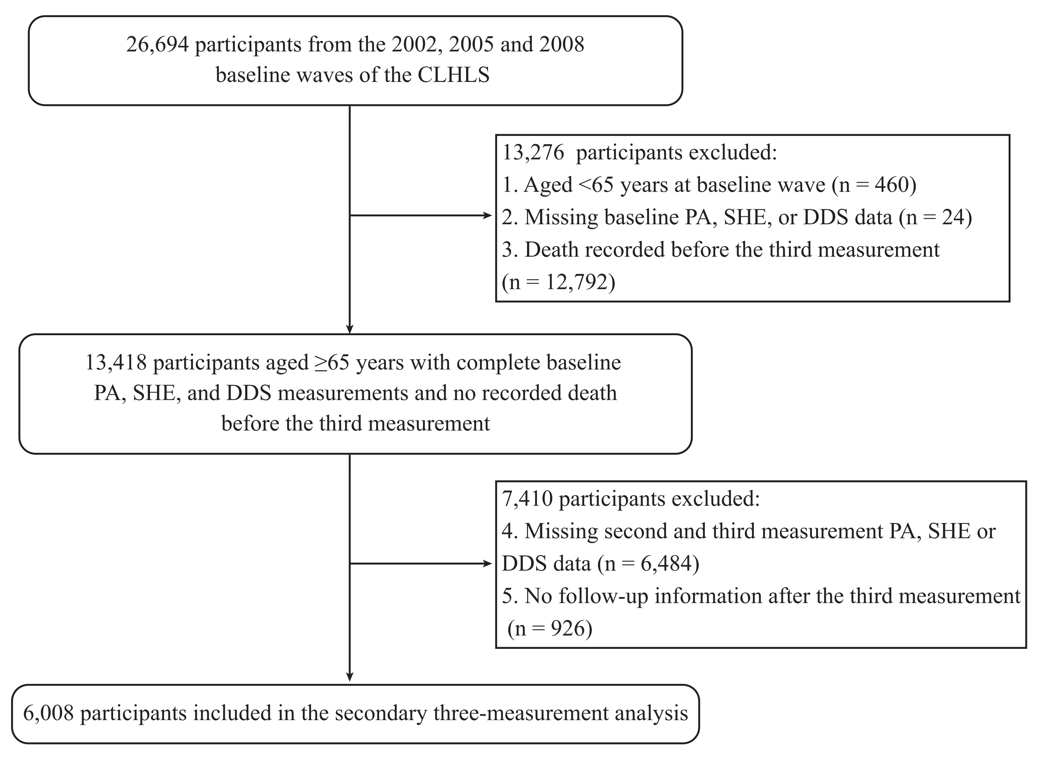
Fig. S1 Flowchart of participant selection for the secondary three-measurement GBMTM analysis.
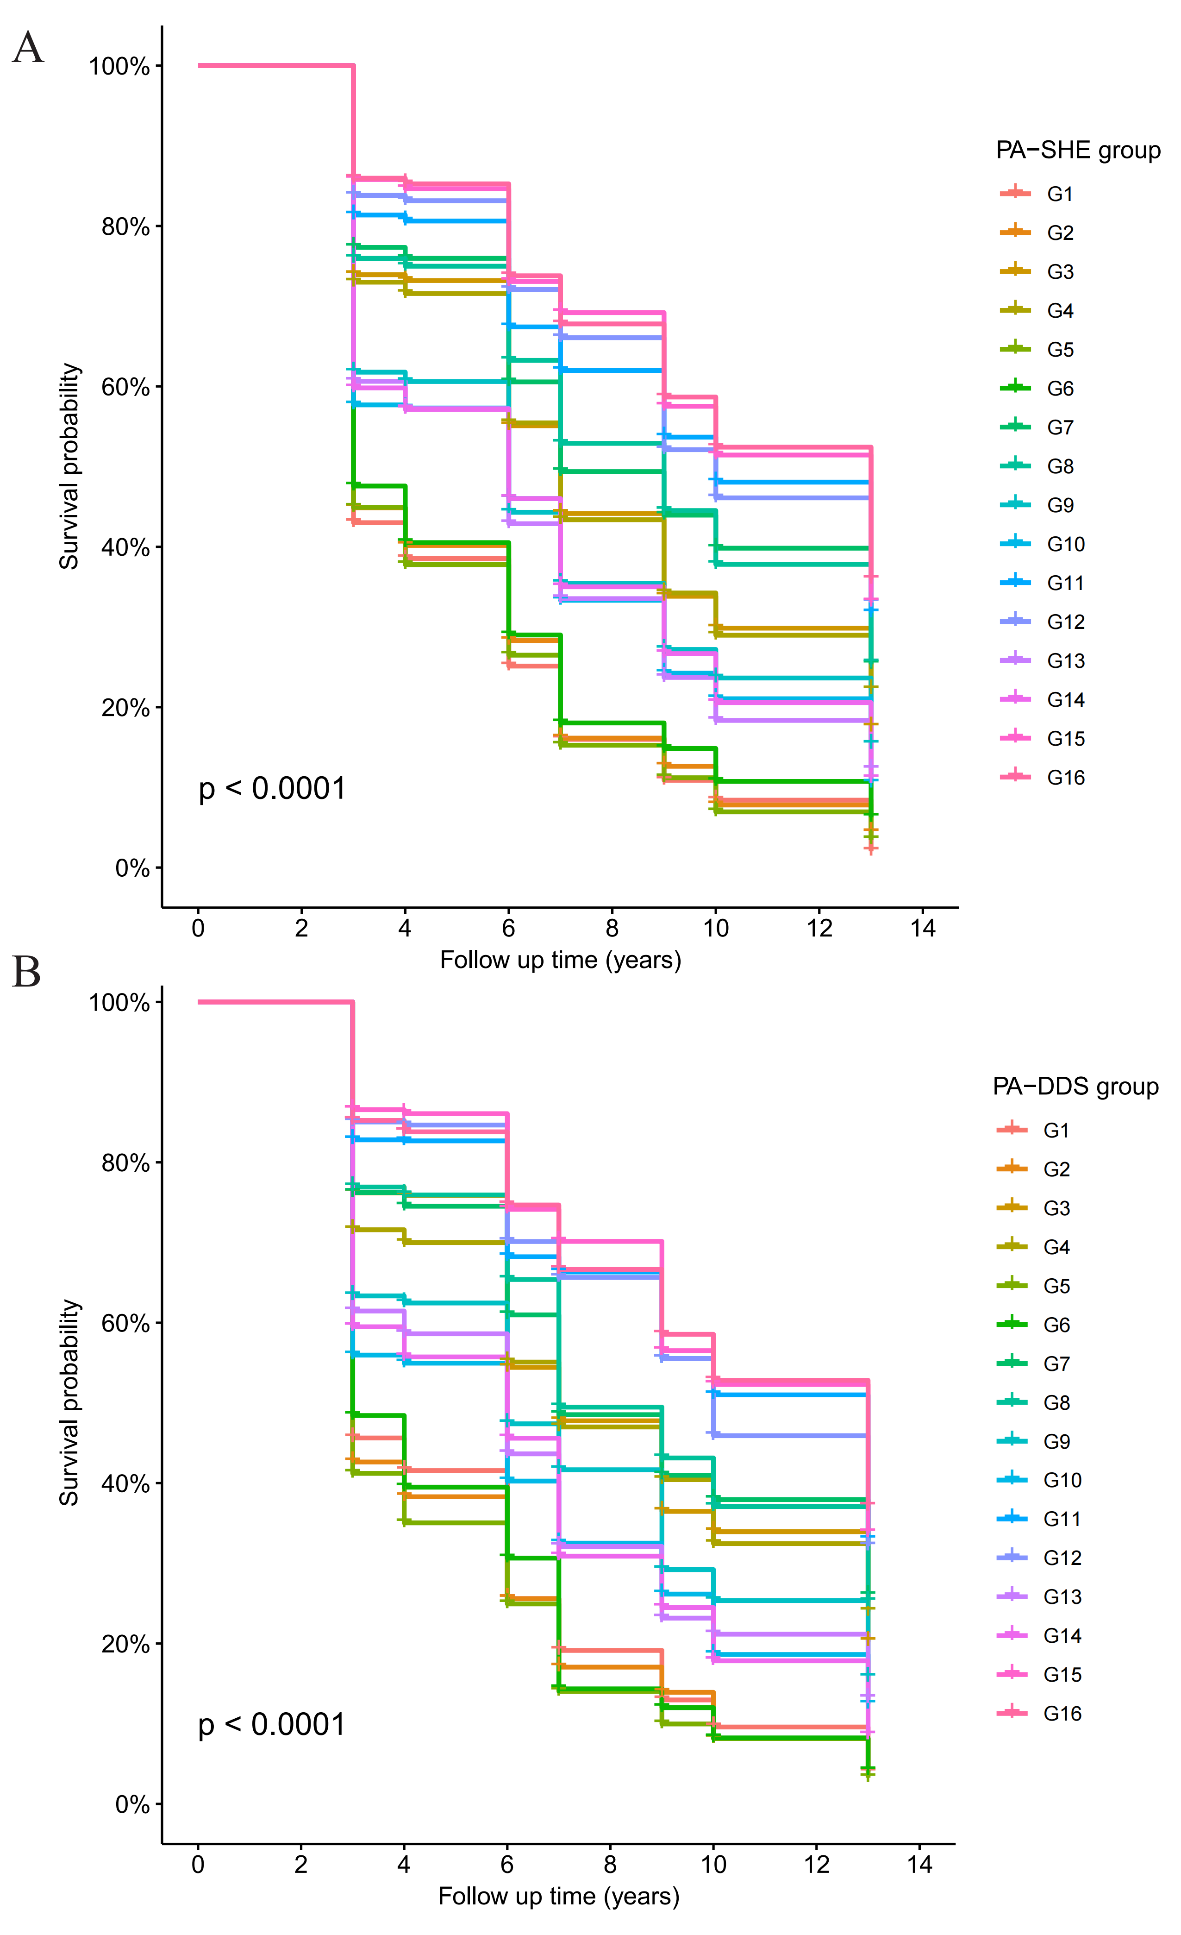
Fig. S2 Kaplan–Meier curves for all-cause mortality by joint physical activity and diet quality trajectory groups. Fig. S1A, PA and SHE; Fig. S1B, PA and DDS. Definition for high PA: PA ≥6 points (both assessment); high diet quality: baseline SHE ≥10 points, follow-up SHE ≥11 points or DDS ≥4 points (both assessment). PA, physical activity; SHE, simplified healthy eating index; DDS, dietary diversity score. Groups were formed according to reaching a high (H) or low (L) level of baseline PA, baseline SHE/DDS, repeated PA and repeated SHE/DDS as follows: G1=LLLL, G2=LLLH, G3=LLHL, G4=LLHH, G5=LHLL, G6=LHLH, 7=LHHL, G8=LHHH, G9=HLLL, G10=HLLH, G11=HLHL, G12=HLHH, G13=HHLL, G14=HHLH, G15=HHHL and G16=HHHH.
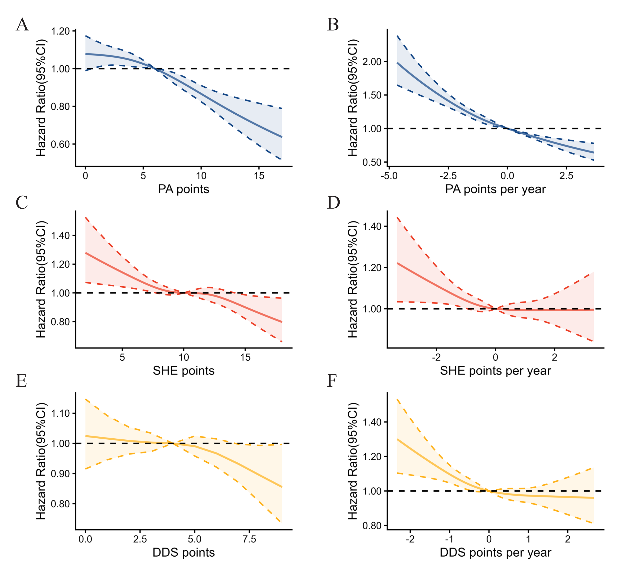
Fig. S3 Dose-response relationships between physical activity and diet and all-cause mortality, modeled using Cox proportional hazards with quartic restricted cubic splines. Analyses are based on Model 4 (see methods). PA, physical activity; SHE, simplified healthy eating index; DDS, dietary diversity score.
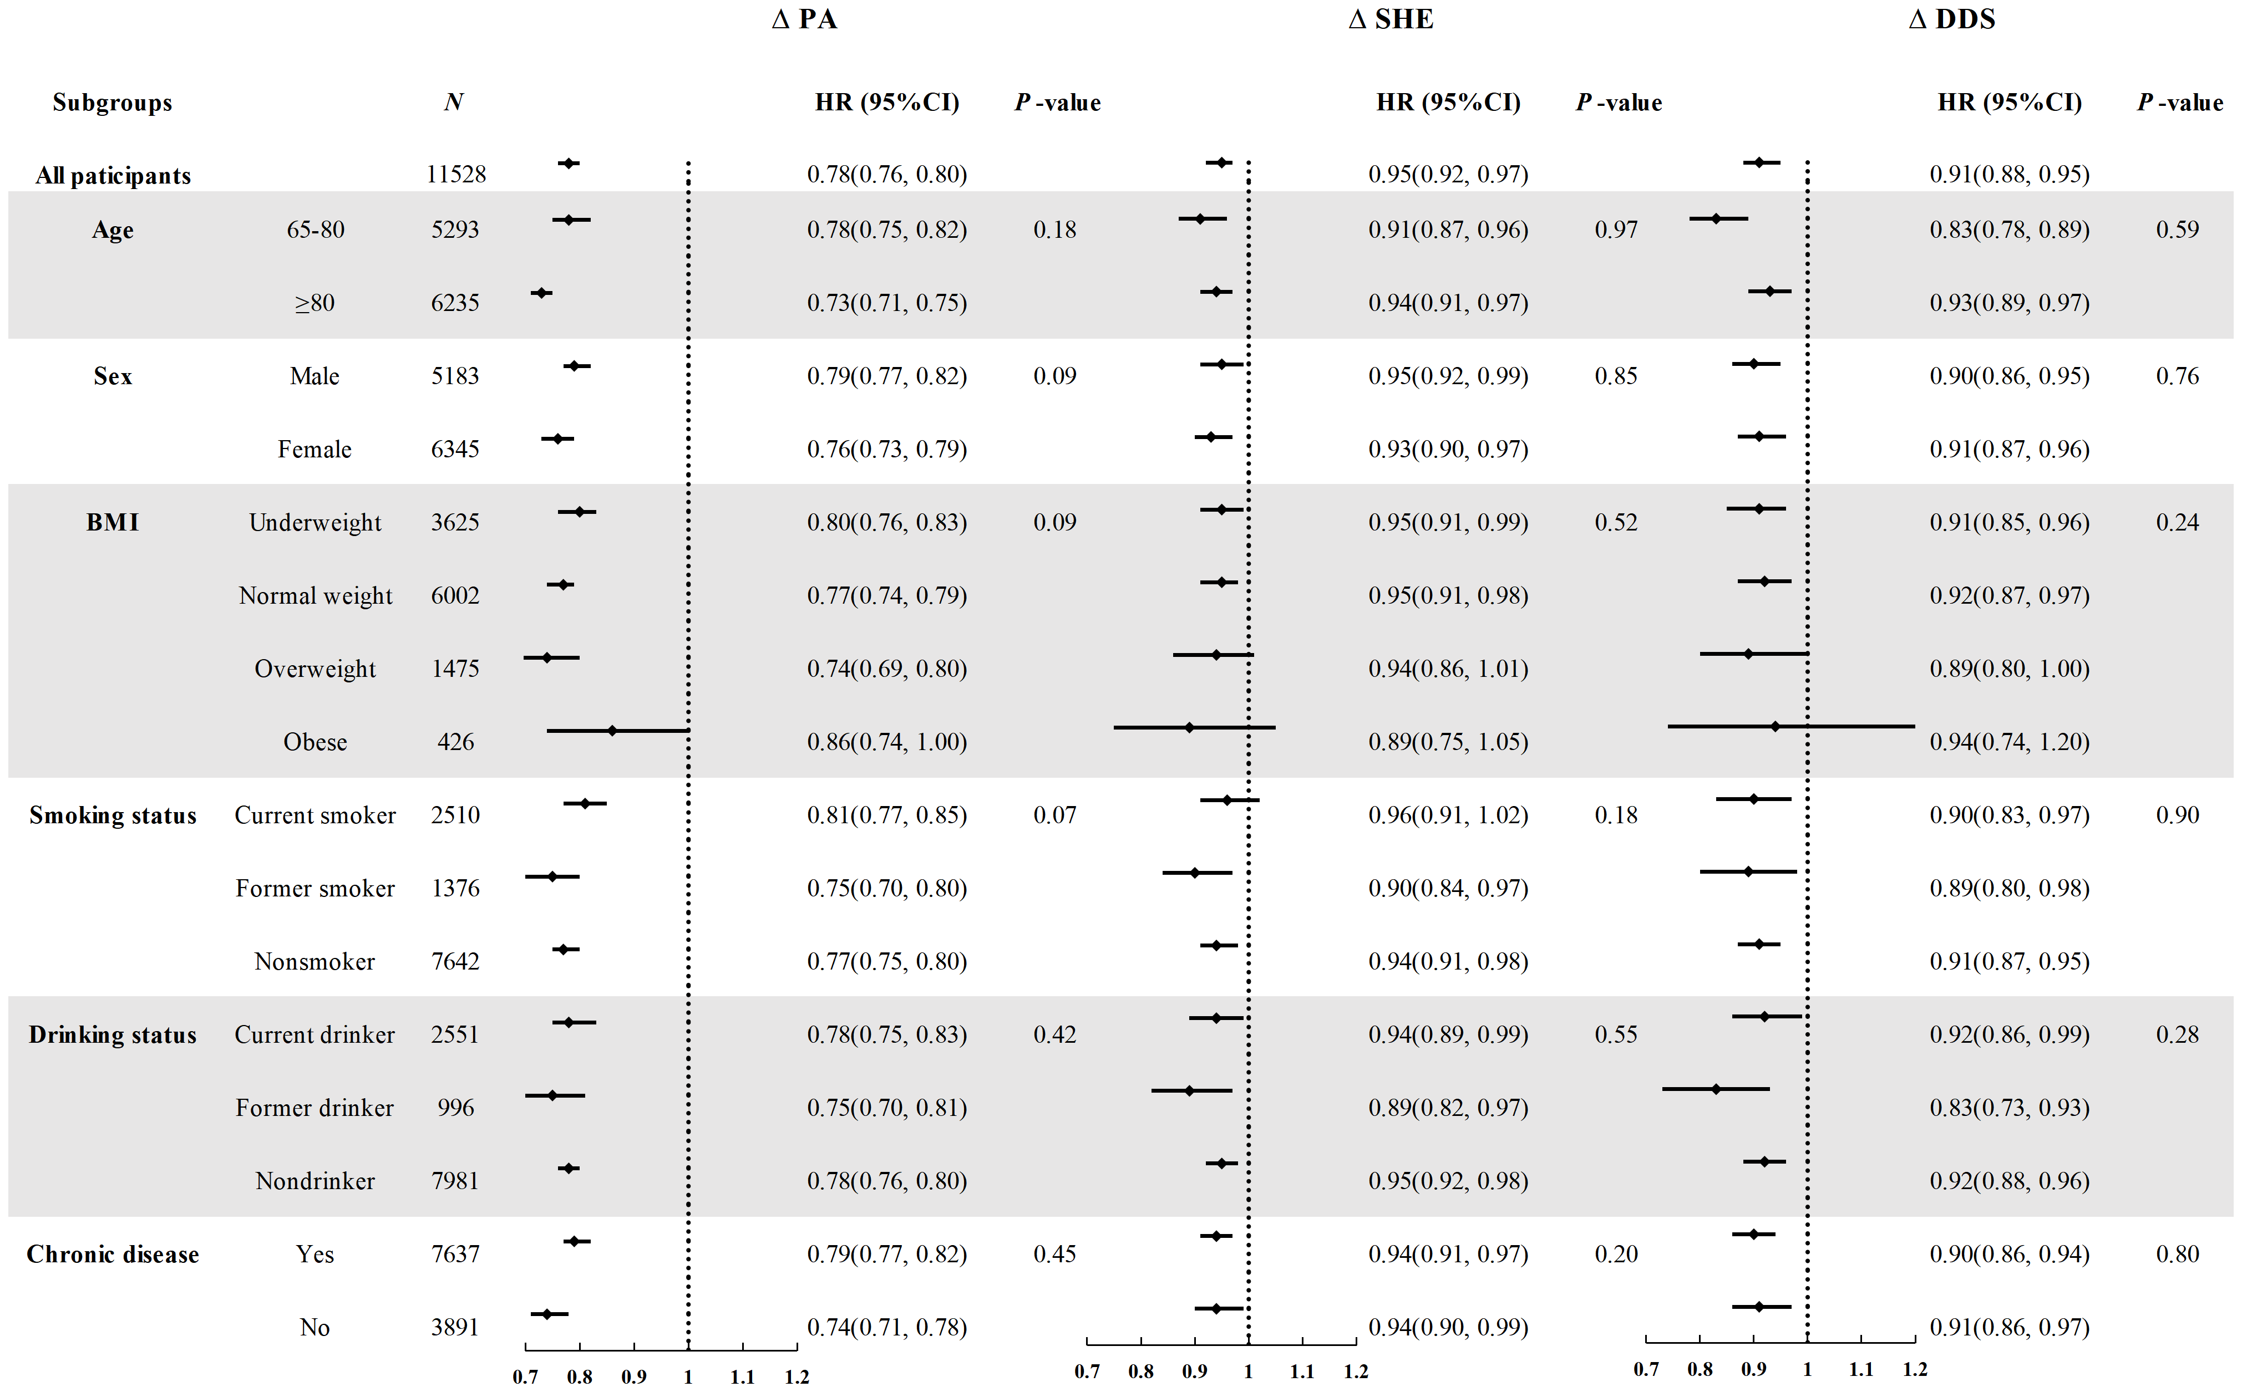
Fig. S4 Association of mutually adjusted annual change in PA, SHE, and DDS with all-cause mortality per 1-point difference in each exposure, stratified by key baseline characteristics. Analysis is based on model 4 (see ‘Methods’). PA, physical activity; SHE, simplified healthy eating index; DDS, dietary diversity score. Pre-existing chronic diseases were defined as having any of the following: hypertension, diabetes, cancer, heart diseases, lung diseases, stroke or cancer. P-values for interaction in subgroups.

