Appendix 1: The selected Gram Sabha Villages for the study
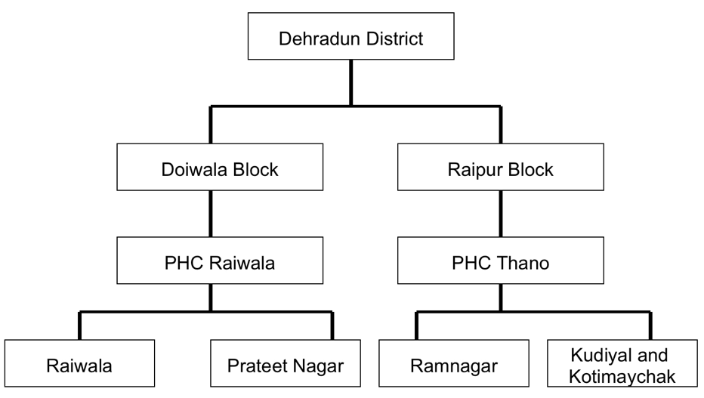

Appendix 2: Inclusion and Exclusion criteria for the study participants
Inclusion criteria:
1. Older male and female of age ≥ 60 years.
2. Participants willing to take part in the study.
Exclusion criteria:
1. People having prior study enrolment or already enrolled in another ongoing study.
2. Bed-bound older adults who were not able to perform walking speed assessment.
3. People who were diagnosed with any form of major neuro-cognitive disorder or screened positive for cognitive impairment by Hindi Mental State Examination (HMSE) Scale (score of less than or equal to 25).
4. Terminally ill older adults (life expectancy of less than 6 months).

Appendix 3: Sample Size calculation
Total population of village Raiwala 3426
Total population of Prateet Nagar 8785
Total population of Ramnagar 2308
Total population of Kudiyal and Kotimaychak 1485
Proportion of elderly in the population 8.6%
As per Niti Aayog “Elderly in India 2021” by Govt of India, Ministry of Statistics and Programme Implementation the proportion of older population in India has increased from 8.6% to 10.1% in 2021 [1].
The Decadal Growth in elderly population vis a vis of general population is 36%.
Hence, titan geriatric population, 16004 x [8.6% x (1 + 0.36)] = 1871 (rounded to nearest whole number).
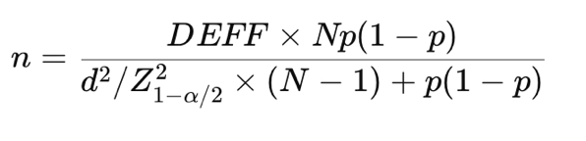
Sample size was calculated by the formula
Where,
Population size (N) = 1871
Expected prevalence (p) = 25.9% (based on the study by Kendhapedi KK et al. [2])

Margin of error (d) = 4%
Design effect (DEFF) = 1 (for simple random sampling)
Confidence level = 95% (Z = 1.96)
Putting all these values, the calculated sample size is rounded upto 370.
So, allocating sample size to each village, with the sampling fraction (1871/370 =5.0)
Raiwala (401/5) = 80.2
Prateet Nagar (1027/5) = 205.4
Ramnagar (269/5) = 53.8
Kudiyal & Kotimaychak (174/5) = 34.8
Total allocated sample size = 80.2 + 205.4 + 53.8 + 34.8 = 374 (rounded up to nearest whole number)
However, during data collection by door-to-door visits, we recruited a total of 722 participants, out of which 10 were excluded (1 bed-bound due to neck of femur fracture, 3 were suffering from major Neurocognitive disorder, 4 were suffering from terminal stage cancers with ECOG PS 4, 2 left the interview process midway). Hence, a total of 712 participants were analysed in the final analysis.
References:
- NSO (2021), Elderly in India, National Statistical Office, Ministry of Statistics & Programme Implementation, Government of India, New Delhi
- Kendhapedi KK, Devasenapathy N. Prevalence and factors associated with frailty among community-dwelling older people in rural Thanjavur district of South India: a cross-sectional study. BMJ Open. 2019 Oct 11;9(10):e032904. doi: 10.1136/bmjopen-2019-032904.

Appendix 4: Details of the Multivariate analysis with Model-fit diagnostics
Model | N | Hosmer–Lemeshow χ² | df | p-value | ROC AUC
Model 1 | 712 | 13.023 | 8 | 0.111 | 0.710
Model 2 | 712 | 9.224 | 8 | 0.324 | 0.725
Model 3 | 712 | 7.249 | 8 | 0.510 | 0.794
The Hosmer–Lemeshow test was performed using 10 groups of predicted risk. A non-significant p-value indicates no statistically significant evidence of lack of calibration.

• Model 1 adjusted for age (continuous, in years) and sex (female vs. male [reference]).
• Model 2 additionally included education level (categorical; highest education present in the sample as reference) and economic status (categorical; employed as reference).
• Model 3 further adjusted for major social factors (all binary-coded: living alone, financial independence, emotional support, frequent social participation, regular visitors, perceived usefulness to family/friends, living in own house, recent displacement, and frequent boredom).

Categorical predictors were dummy-coded, and reference categories were pre-specified. Complete-case analysis was performed; participants with missing data on outcome, age, sex, education, or economic status were excluded.
VIFs were calculated for all predictors in the fully adjusted Model 3. The separate binary questionnaire item 'Are you educated?' was excluded because formal education level was already included as a categorical predictor. Overall, the sequential models showed improving discrimination with addition of covariates. The Hosmer–Lemeshow tests did not indicate statistically significant lack of fit. Some education-related predictors in Model 3 showed VIFs above 5, indicating residual multicollinearity among education variables.

Appendix 5: Univariate analysis results of association of social factors with physical frailty

Social Factor | Frailty status
Social Factor | Robust,  n=26 | Pre-Frail, n=332 | Frail,  n=354 | P value | X²
Live Alone - (yes)  n= 44 | 0 (0%) | 16 (36.4%) | 28 (63.6%) | 0.1 | -
Live Alone - (no)  n= 668 |  | 316 (47.3%) | 326 (48.8%)
  26 (3.9%)
Educated - (yes)  n= 348 | 20 (5.7%) | 181 (52.0%) | 147 (42.2%) | <0.001 | 20.069
Educated - (no)  n = 364 | 6 (1.6%) | 151 (41.5%) | 207 (56.9%)
Financially independent - (yes)  n= 274 | 19 (6.9%) | 135 (49.3%) | 120 (43.8%) | <0.001 | 16.953
Financially independent - (no)  n= 438 | 7 (1.6%) | 197(45.0%) | 234 (53.4%)
Have a Person with whom you can share their feelings - (yes)  n= 644 | 22 (3.4%) | 313(48.6%) | 309(48.0%) | 0.005 | 10.751
Have a Person with whom you can share their feelings - (no)  n= 68 | 4(5.9%) | 19(27.9%) | 45(66.2%)
Goes out frequently for social or religious activities-(yes)  n= 506 | 25 (4.9%) | 283(55.9%) | 198(39.1%) | <0.001 | 79.833
Goes out frequently for social or religious activities-(no)  n= 206 | 1 (0.5%) | 49(23.8%) | 156(75.7%)
Friends or relatives do visit you regularly - (yes)  n= 647 | 26 (4.0%) | 308 (47.6%) | 313 (48.4%) | 0.036 | 6.624
Friends or relatives do visit you regularly - (no)  n= 65 | 0 (0.0%) | 24 (36.9%) | 41(63.1%)
Feel you are of any use to family or friends - (yes)  n= 502 | 22 (4.4%) | 290 (57.8%) | 190 (37.8%) | <0.001 | 96.021
Feel you are of any use to family or friends - (no)  n= 210 | 4 (1.9%) | 42 (20.0%) | 164 (78.1%)
Live in your own house - (yes)  n= 701 | 26 (3.7%) | 326 (46.5%) | 349 (49.8%) | 0.741 | 0.599
Live in your own house - (no)  n= 11 | 0 (0.0 %) | 6 (54.5%) | 5 (45.5%)
Displaced from your original place recently - (yes)  n= 14 | 1 (7.1%) | 9 (64.3%) | 4 (28.6%) | 0.257 | -
Displaced from your original place recently - (no)  n= 698 | 25 (3.6%) | 323 (46.3%) | 350 (50.1%)
Get bored frequently - (yes)  n= 142 | 1 (0.7%) | 32 (22.5%) | 109 (76.8%) | <0.001 | 52.390
Get bored frequently - (no)  n= 570 |  | 300 (52.6%) | 245 (43.0%)
  25 (4.4%)

