Exercise-Based Interventions for Cognitive Frailty in Older Adults: A Systematic Review and Network Meta-Analysis
Liyao Su¹ Wanhaier Abudoureheman² Yongmei Jin³ * Yancheng Wang¹ Shuyao Bai³ Siyuan Liu³
¹ Institutional affiliation: Shanghai University of Traditional Chinese Medicine, Shanghai, China
² Institutional affiliation: Longhua Hospital, Shanghai University of Traditional Chinese Medicine, Shanghai, China
³ Institutional affiliation: Seventh People’s Hospital of Shanghai University of Traditional Chinese Medicine, Shanghai, China
Corresponding author
Yongmei Jin
Department of Nursing, Seventh People’s Hospital of Shanghai University of Traditional Chinese Medicine
No. 358, Datong Road,
Shanghai, China
Email: sqhk2023_1@163.com

Abstract
Background: Cognitive frailty is a potentially reversible geriatric condition characterized by the coexistence of physical frailty or prefrailty and cognitive impairment in the absence of dementia. Exercise-based interventions may improve both cognitive and physical function, but their comparative effects across different exercise modalities remain uncertain.
Methods: This systematic review and network meta-analysis was conducted according to PRISMA-NMA guidance and prospectively registered in PROSPERO. PubMed, Embase, the Cochrane Library, Web of Science, MEDLINE via Ovid, Scopus, CNKI, Wanfang, VIP, Google Scholar, and ProQuest were searched from inception to August 16, 2026. Randomized controlled trials involving older adults with cognitive frailty were included. Bayesian random-effects network meta-analyses were performed for MoCA, MMSE, TUG, grip strength, and SPPB. Risk of bias was assessed using RoB 2, and certainty of evidence was evaluated using CINeMA.
Results: Nineteen publications representing 17 independent randomized trial datasets and 1,691 unique participants were included. For MoCA, multicomponent exercise (ME) showed the most favorable ranking profile (MD = 4.81, 95% CrI -0.27 to 10.66), whereas Baduanjin combined with cognitive training (BCCT) was the only intervention whose 95% CrI excluded the null (MD = 4.25, 95% CrI 0.22 to 8.39). Daily living rehabilitation training ranked highest for MMSE, Otago exercise for TUG, ME for grip strength, and Tai Chi for SPPB; however, the corresponding credible intervals all included the null. Substantial heterogeneity was observed for MoCA, while several physical-function networks were sparse and formal inconsistency assessment was frequently not possible. Sensitivity analyses generally preserved the main ranking patterns, although several leading nodes were supported by limited evidence. The certainty of evidence was predominantly moderate to low, with some comparisons rated as very low.
Conclusions: Exercise-based interventions showed potentially favorable but outcome-specific effects in older adults with cognitive frailty. ME and BCCT showed favorable signals for cognitive outcomes, while OE, ME, and TC ranked relatively highly for selected physical outcomes. However, sparse networks, imprecise estimates, substantial heterogeneity, and moderate-to-low certainty limit confidence in treatment rankings. These findings should therefore inform future comparative trials rather than be interpreted as definitive evidence for individualized exercise prescriptions.
Keywords: Cognitive frailty; Exercise intervention; Older adults; Network meta-analysis; Cognitive function; Physical function

1 Introduction
With the acceleration of global population aging, cognitive frailty (CF) has emerged as an important concern in geriatrics and healthy aging. CF is generally conceptualized as a potentially reversible or modifiable clinical condition characterized by the coexistence of physical frailty or prefrailty and cognitive impairment in the absence of established dementia [1]. Importantly, CF represents a distinct clinical construct and should not be equated with cognitive impairment or cognitive decline alone. Compared with either physical frailty or cognitive impairment in isolation, CF reflects the interaction between declining physical and cognitive capacities and may represent an important window for intervention before the development of more severe functional decline and adverse health outcomes [2]. Epidemiological evidence suggests that CF affects approximately 12.1% of community-dwelling older adults, with higher prevalence reported in some older subpopulations [3]. CF is associated with increased risks of falls, functional disability, hospitalization, dementia, and mortality, imposing substantial burdens on individuals and healthcare systems [4]. Given both its adverse consequences and potential modifiability, CF represents an important target for early identification and intervention in older adults.
CF is not merely the coexistence of physical frailty and cognitive impairment but may reflect complex interactions among the nervous, musculoskeletal, metabolic, and vascular systems [5]. Current evidence suggests that chronic low-grade inflammation, oxidative stress, mitochondrial dysfunction, neuroendocrine dysregulation, and vascular dysfunction may contribute to the development and progression of CF [6]. Physical frailty may aggravate systemic inflammation, oxidative damage, and loss of muscle function, thereby contributing to neurodegenerative changes and cognitive deterioration [7]. Conversely, cognitive impairment may reduce physical activity, exercise participation, and self-management capacity, which may further accelerate muscle weakness and loss of functional reserve [8]. These reciprocal effects may create a mutually reinforcing cycle between declining physical and cognitive function. In addition, impaired cerebral perfusion, metabolic abnormalities, and reduced neuroplasticity may weaken compensatory responses to aging-related damage and further contribute to parallel declines in cognitive and physical capacities [9]. Collectively, these overlapping mechanisms provide a biological rationale for interventions that address both physical and cognitive domains in older adults with CF.
Exercise has therefore been widely investigated as an accessible non-pharmacological strategy for CF because of its potential benefits across multiple physiological systems. Regular exercise can improve muscle strength, endurance, balance, and overall physical performance, while also contributing to improved frailty status and reduced risks of falls, disability, and functional dependence in older adults [10]. Beyond its musculoskeletal effects, exercise may support cognitive function by promoting neuroplasticity, increasing brain-derived neurotrophic factor (BDNF) expression, enhancing cerebral blood flow, and improving energy metabolism [11, 12]. Exercise may also favorably influence inflammatory, oxidative, mitochondrial, and vascular pathways that are implicated in the shared pathophysiology of physical and cognitive decline [13, 14]. Taken together, these multidimensional effects provide a plausible biological basis for investigating exercise-based interventions in older adults with CF.
However, despite growing evidence supporting the potential benefits of exercise for older adults with cognitive frailty, important uncertainties remain regarding the comparative effectiveness of different exercise approaches. Previous systematic reviews and meta-analyses have shown that exercise interventions can improve cognitive and physical outcomes in this population, while multicomponent exercise has also demonstrated potential benefits for overall cognitive function and frailty status. Nevertheless, existing reviews have generally evaluated exercise as an overall intervention or focused on selected exercise categories, and comparisons between specific exercise modalities have largely relied on conventional pairwise meta-analysis or subgroup analyses rather than direct and indirect comparisons across multiple competing interventions [15]. Multicomponent exercise, which generally incorporates two or more exercise components such as aerobic, resistance, balance, flexibility, or functional training, represents one increasingly studied approach. Considerable variation also exists across trials in intervention components, intensity, frequency, session duration, total intervention duration, and outcome assessment, further complicating interpretation of the comparative evidence. Therefore, although the overall benefits of exercise are increasingly recognized, the relative effects of different exercise modalities on cognitive and physical outcomes in older adults with cognitive frailty remain uncertain.
To address this gap, we used network meta-analysis (NMA), which allows several interventions to be compared within a common analytical model by combining direct and indirect evidence. Besides estimating relative treatment effects, NMA can generate probabilities for treatment rankings. However, these rankings should be considered alongside the estimated effects and certainty of the available evidence, and not in isolation [16]. Therefore, the present systematic review and NMA investigated the comparative effects of different exercise-based interventions on cognitive function, functional mobility, muscle strength and overall physical performance in older adults with CF. By examining these outcomes in the same evidence network, we sought to clarify where the evidence is consistent, identify remaining uncertainties and highlight priorities for future head-to-head trials.

2 Methods
This systematic review and network meta-analysis was conducted and reported in accordance with the Preferred Reporting Items for Systematic Reviews and Meta-Analyses extension for network meta-analyses (PRISMA-NMA) and relevant methodological guidance for network meta-analysis and multiple-intervention comparisons. The study protocol was prospectively registered in PROSPERO (CRD420251117009).
2.1 Data sources and search strategy
Two independent reviewers systematically searched nine bibliographic databases from inception to August 16, 2026: PubMed, Embase, the Cochrane Library, Web of Science, MEDLINE via Ovid, Scopus, CNKI, Wanfang Data, and VIP Database. Google Scholar and ProQuest were additionally searched for grey literature. The search strategy combined controlled vocabulary, including Medical Subject Headings (MeSH) where applicable, with free-text terms related to cognitive frailty and exercise-based interventions. Search strategies were adapted to each information source, and the reference lists of included studies were manually screened for additional eligible studies. For Google Scholar, the first 243 results ranked by relevance were screened. Complete search strategies and source-specific search details, including those for Web of Science, MEDLINE via Ovid, Google Scholar, and ProQuest, are provided in Appendix 1.
2.2 Inclusion and exclusion criteria
Study eligibility was determined according to the PICOS framework.
2.2.1. Population
Studies were eligible if they included adults aged ≥60 years with cognitive frailty, defined as the coexistence of physical frailty or prefrailty and cognitive impairment in the absence of established dementia. For the primary quantitative analysis, both components had to be verifiable from the eligibility criteria or participant assessments reported in the original study; the authors’ use of the term “cognitive frailty” alone was not considered sufficient. Physical frailty or prefrailty was assessed using validated or established instruments, including the Fried frailty phenotype, FRAIL scale, Clinical Frailty Scale, Edmonton Frailty Scale, or other recognized frailty measures. Cognitive impairment was assessed using the Montreal Cognitive Assessment (MoCA), Mini-Mental State Examination (MMSE), or other validated cognitive measures.
For each trial, we extracted the frailty instrument and threshold, cognitive assessment and cutoff, inclusion of prefrailty, and method used to exclude dementia, with trial-specific definitions reported in Appendix 2. Studies involving cognitive impairment alone, mild cognitive impairment without a defined frailty or prefrailty criterion, physical frailty alone, sarcopenia, or other conditions without confirmed cognitive frailty were excluded from the primary analysis. Studies with incompletely operationalized cognitive frailty were also excluded unless both the physical frailty/prefrailty and cognitive impairment components could be verified.
2.2.2. Interventions and comparators
Eligible interventions included: (1) single-modality exercise, such as resistance training, aerobic exercise, Baduanjin, Tai Chi, and yoga; (2) multicomponent exercise integrating two or more exercise components; and (3) exercise combined with structured cognitive training, such as Baduanjin combined with cognitive training (BCCT), exercise-based cognitive combined training (EBCCT), and exercise-cognitive training/multicomponent training (ECT/MCT).
Treatment nodes were defined according to the principal intervention components and therapeutic characteristics rather than the terminology used in the original studies. Interventions with clinically comparable components were grouped within the same node, whereas those with materially different features, including virtual-reality components
, attentional-priority strategies, or sequential versus simultaneous cognitive-motor delivery, were retained as separate nodes. Detailed node definitions, intervention components, included trials, participant numbers, and single-trial nodes are provided in the supplementary materials.
Studies combining exercise with non-exercise treatments, such as pharmacological therapy, nutritional supplementation, psychotherapy, or acupuncture, were excluded when the independent effect of exercise could not be isolated.
Comparator conditions were classified according to the intervention actually delivered. Usual care, wait-list control, health education without structured exercise, and routine daily activities were classified as inactive or minimal-intervention controls (CG), whereas comparators involving structured exercise or cognitive-motor training were classified as active controls (AC). CG and AC were modeled as separate nodes when both were present in an outcome network, and this classification was applied consistently across network construction and analysis.
2.2.3. Outcomes
Prespecified outcomes included global cognitive function, functional mobility, muscle strength, and composite physical performance. Global cognitive function was assessed using the MoCA and MMSE, functional mobility using the Timed Up and Go test (TUG), muscle strength using handgrip strength, and composite physical performance using the Short Physical Performance Battery (SPPB). Studies were required to report at least one of these outcomes with sufficient quantitative data for effect estimation.
2.2.4. Study design
Only randomized controlled trials (RCTs) were eligible for the primary analysis. Quasi-randomized studies were excluded from the primary analysis.
2.3 Study selection and data extraction
All records were imported into EndNote X9 and duplicates were removed. Two reviewers (LYS and WA) independently screened titles, abstracts, and full texts according to the predefined eligibility criteria, with disagreements resolved through discussion or consultation with a third reviewer (YMJ). Multiple publications from the same trial or participant cohort were linked to avoid double counting, with the most complete report used as the primary source. Publications, independent randomized trials, treatment arms, and unique participant cohorts were recorded separately, and reports from the same randomized cohort were treated as a single trial dataset for quantitative synthesis.
Data were independently extracted by two reviewers (LYS and YCW) using a standardized form, including study and participant characteristics, cognitive frailty diagnostic criteria, frailty instrument and threshold, cognitive assessment and cutoff, method of dementia exclusion, intervention and comparator characteristics, intervention frequency, session duration, total intervention duration, sample size by treatment arm, and prespecified outcome data. For multi-arm trials, all eligible arms were retained; shared comparator groups were entered only once, and correlations among treatment-effect estimates arising from a common comparator were accounted for through joint multi-arm modeling.
Post-intervention data were used for the primary analysis, with intention-to-treat data preferred where available. Missing statistics were derived from available information when possible or requested from the original authors. Where reported, adverse events, adherence or attendance, withdrawals and dropouts, and indicators of intervention feasibility were also extracted and summarized descriptively because of inconsistent reporting across trials.
2.4 Risk of bias assessment
Risk of bias was independently assessed by two reviewers (LYS and WA) using the Cochrane Risk of Bias 2 tool (RoB 2) for outcome-specific results contributing to the network meta-analysis. Five domains were evaluated: bias arising from the randomization process, bias due to deviations from intended interventions, bias due to missing outcome data, bias in measurement of the outcome, and bias in selection of the reported result. Each domain and the overall risk of bias were rated as low risk, some concerns, or high risk for each outcome-specific result (Appendix 3). Disagreements were resolved through discussion, with arbitration by a third reviewer when necessary.
2.5 Data synthesis and statistical analysis
2.5.1 Effect measures and Bayesian network meta-analysis model specification
For continuous outcomes, mean differences (MDs) with 95% credible intervals (CrIs) were used when studies applied the same scale or unit, whereas standardized mean differences (SMDs; Hedges’ g) were used when different instruments assessed the same construct. Effect directions were harmonized so that positive values indicated improvement, except for outcomes such as TUG, for which lower values represented better performance.
Bayesian random-effects network meta-analyses were conducted in R using the gemtc package, assuming a common between-study heterogeneity parameter within each outcome network. A Uniform(0,10) prior was assigned to τ in the primary models. Because several networks were small and sparse, sensitivity analyses used an alternative weakly informative half-normal prior, τ ~ Half-Normal (0, 1), to assess robustness to prior specification.
2.5.2 MCMC settings and convergence assessment
Markov Chain Monte Carlo (MCMC) simulations used three chains, with 1,000 adaptation iterations followed by 5,000 sampling iterations per chain and a thinning interval of 5. Convergence was assessed using trace and posterior density plots, the Brooks-Gelman-Rubin diagnostic, and effective sample sizes. Potential scale reduction factor (PSRF) values close to 1.00 were considered indicative of satisfactory convergence.
2.5.3 Assessment of transitivity, heterogeneity, and inconsistency
Transitivity was assessed descriptively by comparing potential effect modifiers across direct treatment comparisons, including age, sex, baseline cognitive and physical function, cognitive frailty criteria, intervention duration and frequency, session duration, care setting, and comparator type. Because several comparisons were informed by only one or a few trials, transitivity was considered plausible when no clear systematic imbalance in clinically important effect modifiers was identified, rather than regarded as statistically confirmed. Relevant comparison-level characteristics are presented in the supplementary materials.
Between-study heterogeneity was assessed using the posterior between-study standard deviation (τ), with network-level I² values from the frequentist framework used as supplementary measures.
Inconsistency was evaluated globally using the design-by-treatment interaction model and locally using node-splitting when both direct and indirect evidence were available. A p-value <0.05 together with clinically meaningful disagreement was considered suggestive of inconsistency. When formal testing was precluded by the network structure, inconsistency was considered not assessable rather than absent.
2.5.4 Treatment ranking and presentation of results
Posterior ranking probabilities and surface under the cumulative ranking curve (SUCRA) values were calculated for each intervention
. P-scores were additionally obtained using the frequentist netmeta framework as a supplementary ranking measure. Rankings were interpreted alongside relative effect estimates, uncertainty, and certainty of evidence and were not considered independent evidence of intervention superiority
. League tables and forest plots were used to present relative treatment effects and corresponding 95% CrIs.
2.5.5 Sensitivity analyses
Sensitivity analyses were performed to examine the robustness of the primary Bayesian network meta-analysis using three approaches: (1) leave-one-study-out analyses; (2) analyses excluding interventions that combined exercise with structured cognitive training or cognitive-motor components; and (3) use of
an alternative weakly informative half-normal prior for the between-study heterogeneity parameter τ. Robustness was assessed by examining changes in relative treatment effects, 95% CrIs, treatment rankings, SUCRA values, heterogeneity estimates, and supplementary P-scores.
2.5.6
Exploratory subgroup and supplementary analyses
Exploratory analyses were conducted for MoCA, MMSE, TUG, SPPB, and grip strength when sufficient data were available, focusing on intervention content, weekly frequency, and intervention duration
. These analyses used frequentist pairwise meta-analysis and are reported as MDs with 95% CIs. Because they were based on study-level characteristics and did not constitute formal interaction, network meta-regression, or dose-response analyses, the findings were considered hypothesis-generating and were not used to define optimal exercise prescriptions.
2.5.7 Publication bias and small-study effects
Publication bias and small-study effects were explored using comparison-adjusted funnel plots. Egger-type regression was formally interpreted when at least 10 independent source contrasts were available; analyses in smaller networks were considered exploratory because of limited statistical power. Begg and Thompson-Sharp tests were used as supplementary assessments where estimable. Non-significant asymmetry tests were not interpreted as evidence of the absence of publication bias, particularly in sparse networks or those containing single-study comparisons.
2.6 Certainty of evidence assessment
The confidence in each outcome-specific network relative treatment-effect estimate was assessed using the CINeMA framework, which is adapted from GRADE for network meta-analysis [17]. Six domains were evaluated: within-study bias, across-studies bias, indirectness, imprecision, heterogeneity, and incoherence. Each network comparison was rated as high, moderate, low, or very low certainty. CINeMA assessments were reported at the level of individual network comparisons rather than individual studies. The CINeMA framework and domain definitions are summarized in Appendix 4.

3 Results
3.1 Study selection and characteristics of included studies
A total of 19 publications were included in the final evidence synthesis, representing 17 independent randomized trial datasets and 1,691 unique participants after accounting for overlapping reports and shared comparator cohorts [18–36]. Two publications, Xia et al. and Ye et al., were reports from the same Baduanjin trial and were therefore linked as one participant cohort [28, 30]. The two Liu et al. (2024) reports shared the same 36-participant comparator group and were treated as one shared-control multi-arm dataset rather than two independent two-arm trials [29, 35]. The publication-trial-cohort-arm relationships are summarized in Table 1, and trial-specific cognitive frailty diagnostic criteria are provided in Appendix 2. The study selection process is shown in Figure 1.
3.2 Risk of bias assessment
Risk of bias was assessed using the Cochrane RoB 2 tool for relevant outcome-specific results. Among the 18 assessments presented in Appendix 5, six were rated as low risk [18, 20–23, 28], eleven as having some concerns [19, 24–27, 29, 31–33, 35, 36], and one as high risk overall [34]. Concerns arose mainly from the randomization process, whereas missing outcome data, outcome measurement, and selection of the reported result were generally judged to be at low risk. Han et al. was rated as high risk overall because of a high-risk judgement in the randomization domain [34].
3.3 Network structure and assessment of transitivity
Across the five outcomes (MoCA, MMSE, TUG, SPPB, and grip strength), the evidence networks were predominantly centered on the control group (CG). Motor-cognitive training, Baduanjin-based interventions, and resistance- or strength-oriented exercise had multiple direct comparisons with CG, whereas many other nodes were informed by single studies, resulting in sparse networks and greater reliance on indirect evidence. MoCA and MMSE included more intervention nodes and direct comparisons than the other outcome networks, while the grip-strength network was predominantly star-shaped without closed loops (Figure 2 and appendix 6).
No consistent systematic imbalance was identified in major potential effect modifiers across treatment comparisons, although variability remained in cognitive frailty definitions, baseline function, intervention characteristics, and comparator conditions. Transitivity was therefore considered plausible but not fully verifiable because several comparisons were informed by only one or a few studies.

Figure 1. PRISMA flow diagram of literature screening
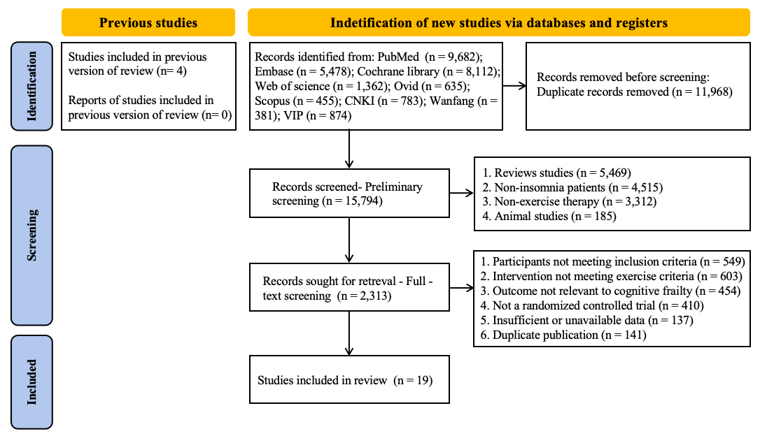

Table 1. Characteristics of included publications and trial records in the network meta-analysis
First author (year) | Country | Sample size |  | Age (Mean±SD) |  | Intervention  Details | Control | Duration | Frequency & Session Duration | Main outcomes measured
First author (year) | Country | Intervention | Control | Intervention | Control
L. Zheng et al. （2024） | China | 33 | 33 | 80.88±8.75 | 79.52±9.61 | DLRT | UC | 12 weeks | 2 sessions/week, 45 min | ⑤
Yoon, D.H. et al. (2018) | South Korea | 20 | 23 | 73.82±4.37 | 74.03±4.27 | RT | DA | 16 weeks | 3 sessions/week, 60 min | ①②④
X. Wang et al. (2024) | China | 60 | 60 | 66.90 ±4.54 | 67.64±5.49 | BE | UC | 24 weeks | 3 sessions/week, 60 min | ③
Y. Y. Liao et al. (2025) | China | 20 | 19 | 77.5 ± 5.8 | 79.3±6.9 | IBC | SC | 12 weeks | 3 sessions/week, 40 min | ③
Kwan RYC et al. (2024) | China | 146 | 147 | 75.2±7.1 | 73.9±6.6 | MCT | UC | 8 weeks | 2 sessions/week, 60 min | ③④
Kwan RYC et al. (2021) | China | 9 | 8 | 72.81±6.12 | 74.68±9.65 | MCT | UC | 8 weeks | 2 sessions/week, 30 min | ③④
J. Yuan et al. （2022） | China | 31/30 | 30 | 71.70±3.90/  71.30±5.00 | 70.80±4.20 | TC/MTC | DA | 24 weeks | 2 sessions/week, 60 min | ①④⑤
Ryan S. Falck et al. (2025) | Canada | 93 | 99 | 81.62±6.55 | 83.31±5.88 | HBE | UC | 1 year | - | ①③
X. Chen et al. (2021) | China | 29 | 30 | 84.59±4.21 | 84.75±5.41 | OE | HE | 12 weeks | 3 sessions/week, 36 min | ④
Y. Ye et al. (2024) | China | 51 | 51 | 67.68± 5.19 | 65.35±5.15 | BE | UC | 24 weeks | 3 sessions/week, 60 min | ③
N. Liu et al. (2024) | China | 36/34 | 36 | 71.89±4.73/  70.74±3.82 | 71.33±4.72 | MCT | UC | 8 weeks | 3 sessions/week, 54 min | ⑤
Y. Chen et al. (2023) | China | 33 | 33 | 66.79±5.61 | 67.85±5.41 | HIIT | HE | 12 weeks | 3 sessions/week, 36 min | ③
Y. Zhang et al. (2024) | China | 83 | 82 | 74.83±3.52 | 75.48±3.34 | BCCT | HE | 12 weeks | 3 sessions/week, 35 min | ③⑤
L. Yang et al. (2023) | China | 40 | 39 | 67.5±3.1 | 67.4±2.8 | BCCT | DA | 12 weeks | 3 sessions/week, 60 min | ②③
J. Han et al. (2022) | China | 28 | 28 | 78.82±3.45 | 78.57±2.33 | EBCCT | DA | 3 months | 2 sessions/week, 60 min | ②⑤
M. Ye et al. (2021) | China | 45 | 45 | 72.33±6.21 | 72.92±7.19 | ME | HE | 6 months | 3 sessions/week, 45 min | ②③
N. Liu et al. (2024) | China | 35 | 36 | 70.40±4.18 | 71.33±4.72 | MCT | UC | 8 weeks | 3 sessions/week, 30 min | ⑤
X. Lai et al. (2024) | China | 36 | 36 | 74.81±8.23 | 76.50±7.75 | MCT | HE | 16 weeks | 2 sessions/week, 30 min | ③④
R. Xia et al. (2020) | China | 51 | 51 | 67.68±5.19 | 65.35±5.15 | BE | HE | 24 weeks | 3 sessions/week, 60 min | ②③
Note: ① SPPB; ② Grip strength; ③ MoCA; ④ TUG; ⑤ MMSE. BE, Baduanjin exercise; IBC, interactive boxing-cycling; MCT, motor-cognitive training; HBE, home-based exercise; HIIT, high-intensity interval training; BCCT, Baduanjin combined with cognitive training; ME, multicomponent exercise; DLRT, daily living rehabilitation training; EBCCT, elastic-band exercise combined with cognitive training; TC, Tai Chi; MTC, mindful Tai Chi; ECT, exercise combined with cognitive training; RT, resistance training; OE, Otago exercise; CG, control group; AC, active comparator; UC, usual care; HE, health education; DA, daily activities; SC, stationary cycling. Publications are not equivalent to independent trials. Xia et al. and Ye et al. reported the same Baduanjin participant cohort and were counted as one independent trial dataset. The two Liu et al. (2024) reports shared the same 36-participant comparator group and were modeled as one shared-control multi-arm dataset; the shared comparator was counted only once in the analysis.
Figure 2. Network plot of exercise interventions for outcomes
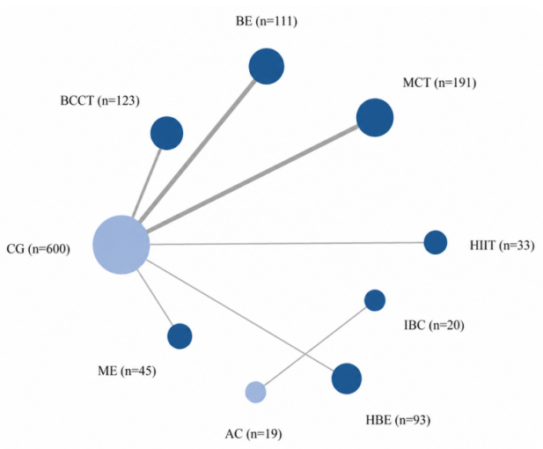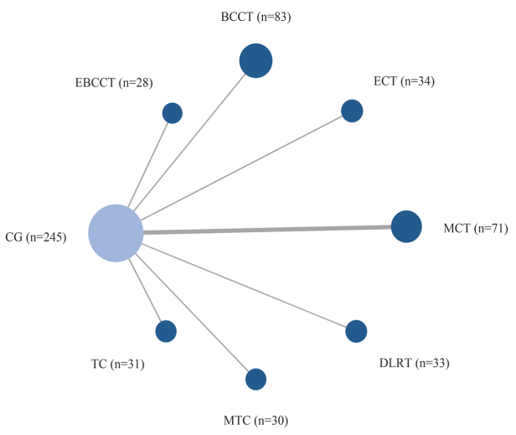
(MoCA) (MMSE)
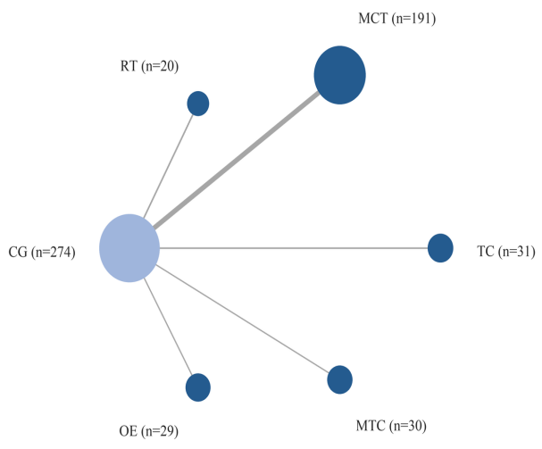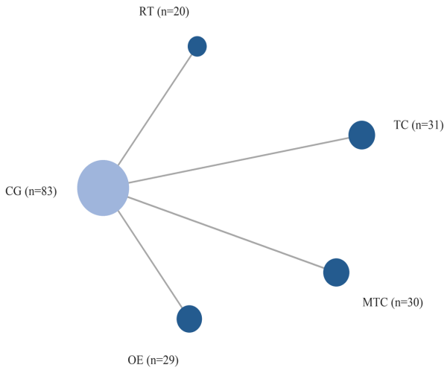
(TUG) (SPPB)
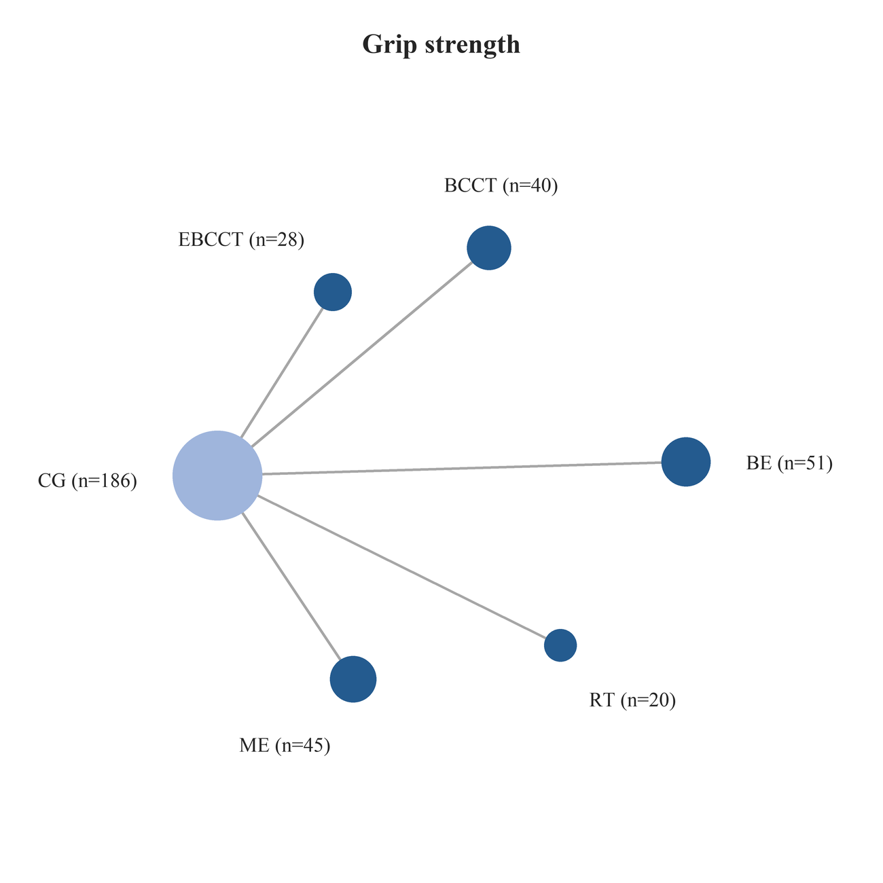
(Grip strength)
Note: Network plots show the evidence structure for each outcome. Each node represents an intervention or comparator, and node size is proportional to the total number of participants receiving that intervention. Each edge represents a direct comparison between two interventions, and edge thickness is proportional to the number of direct comparisons. CG was the main comparator across networks.

3.4 Main effects of exercise interventions
Detailed relative effect estimates and SUCRA values for each outcome are jointly presented in Figure 3. The following results are based on the updated intervention coding and the primary CG-connected network. For MoCA, the disconnected AC-IBC comparison was retained in the network component table but was not included in the primary SUCRA ranking. Detailed relative effect estimates, SUCRA values, and supplementary P-scores are provided in Appendix 6.
3.4.1 Global cognitive function
For global cognitive function, MoCA was used as the primary measure and MMSE as the secondary measure. To avoid double counting of the overlapping Baduanjin cohort reported by Xia et al. and Ye et al., duplicate MoCA data from this cohort were included only once in the network analysis [28, 30]. ME showed the largest estimated improvement versus CG (MD = 4.81, 95% CrI = -0.27 to 10.66; SUCRA = 83.5), followed by BCCT (MD = 4.25, 95% CrI = 0.22 to 8.39; SUCRA = 79.9). However, only BCCT had a 95% CrI excluding the null. BE, HIIT, and MCT showed positive but non-significant trends, whereas HBE showed no evidence of benefit.
For MMSE, DLRT ranked highest by SUCRA (MD = 4.59, 95% CrI = -8.20 to 17.12; SUCRA = 68.9), followed by VP-MCT (MD = 4.32, 95% CrI = -8.13 to 17.11; SUCRA = 68.1) and BCCT (MD = 4.04, 95% CrI = -9.13 to 16.85; SUCRA = 64.8). MCT, EBCCT, ECT, and MTC also showed positive point estimates, but all credible intervals crossed zero. TC showed a negative point estimate (MD = -0.60, 95% CrI = -13.42 to 12.39), with substantial uncertainty.
3.4.2 Physical performance
Physical performance was assessed using TUG. Because lower TUG values indicate better physical performance, the estimates are reported on the original scale, where negative MDs represent improvement. OE showed the most favourable estimated reduction in TUG time compared with CG (MD = -6.37, 95% CrI = -13.07 to 0.29; SUCRA = 95.0), followed by MCT (MD = -1.40, 95% CrI = -5.10 to 1.94; SUCRA = 60.2) and MTC (MD = -1.11, 95% CrI = -6.82 to 4.60; SUCRA = 53.2). However, all credible intervals crossed the null value, indicating that the evidence for TUG improvement remained uncertain.
3.4.3 Muscle strength
Muscle strength was assessed using grip strength. ME showed the largest estimated improvement compared with CG and ranked highest by SUCRA (MD = 7.01, 95% CrI = -5.67 to 20.01; SUCRA = 82.1). EBCCT, BE, and BCCT showed positive but statistically non-significant trends, with MDs of 2.93, 2.21, and 1.45, respectively. RT showed no evidence of benefit (MD = -0.12, 95% CrI = -13.41 to 13.19). No intervention for grip strength had a 95% credible interval excluding zero.
3.4.4 Composite physical function
Composite physical function was assessed using SPPB. TC had the highest SUCRA value and the largest positive point estimate compared with CG (MD = 0.66, 95% CrI = -8.39 to 9.95; SUCRA = 61.0). RT showed a near-null estimate (MD = 0.05, 95% CrI = -9.00 to 9.51), while MTC and OE showed slightly negative point estimates. None of the SPPB interventions had a credible interval excluding the null value, suggesting no robust evidence of superiority over CG for composite physical function in the updated analysis.

Figure 3. Effect of different interventions compared with control on outcome measures: network meta-analysis results
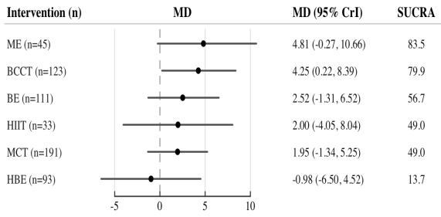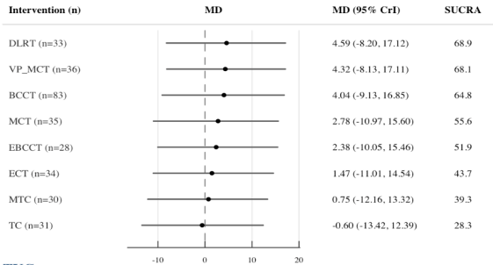

（MoCA) (MMSE)
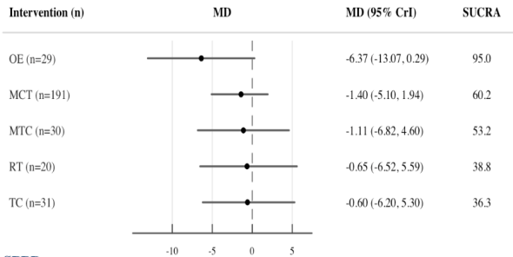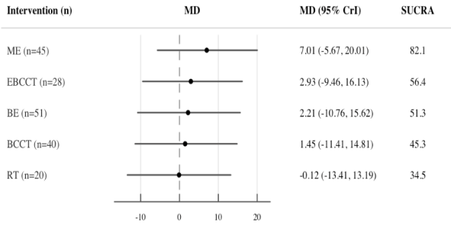
（TUG) (Grip strength)
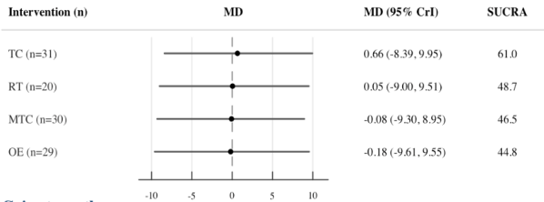
(SPPB)
Note: Detailed relative effect estimates and SUCRA values for each outcome are jointly presented in Figure 3. For each intervention, the forest plot shows the relative treatment effect compared with the control group and its 95% CrI, while the right-hand column provides the corresponding SUCRA value as supplementary ranking information. The SUCRA values were interpreted alongside the effect estimates and their uncertainty rather than as standalone evidence of intervention superiority.

3.5 Treatment ranking
Treatment ranking was summarized using posterior ranking probabilities and SUCRA values from the Bayesian network meta-analysis, with P-scores used as supplementary evidence. Figure 4 presents the interventions with the highest probability of ranking first for each outcome, while the full ranking distributions are provided in Appendix 6. Rankings were interpreted cautiously because of sparse networks and uncertainty in several comparisons.
For MoCA, ME showed the most favorable ranking profile (51.0%, SUCRA = 83.5), followed by BCCT (31.7%, SUCRA = 79.9), HIIT, BE, and MCT. This ranking pattern was broadly consistent with the effect estimates, although only BCCT showed a 95% CrI excluding the null. For MMSE, DLRT showed the most favorable ranking profile (27.1%; SUCRA = 68.9), followed by VP-MCT, BCCT, EBCCT, and MCT.
For TUG, where lower values indicate better performance, OE ranked highest with a clearly dominant probability of ranking first (88.5%; SUCRA = 95.0). The remaining interventions had much lower ranking probabilities; by rank-first probability, MTC, RT, TC, and MCT followed OE, whereas SUCRA ranked MCT second overall.
For grip strength, ME ranked highest (57.5%; SUCRA = 82.1), followed by EBCCT, BE, BCCT, and RT. For SPPB, TC showed the most favorable ranking profile (32.8%; SUCRA = 61.0), followed by RT, OE, and MTC among the available active interventions.
Overall, the ranking results were broadly consistent with the relative effect estimates but should be interpreted together with credible intervals, heterogeneity, inconsistency, and certainty of evidence rather than as standalone evidence of superiority.

Figure 4. Cumulative ranking probability curves of different interventions for improving the outcomes
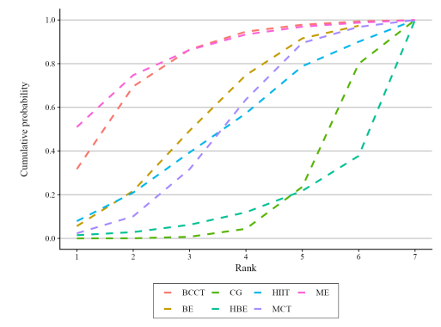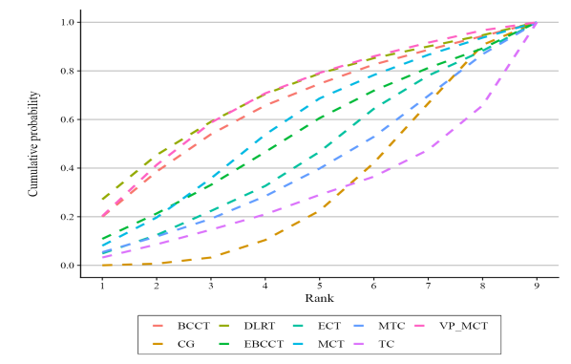
(MoCA) (MMSE)

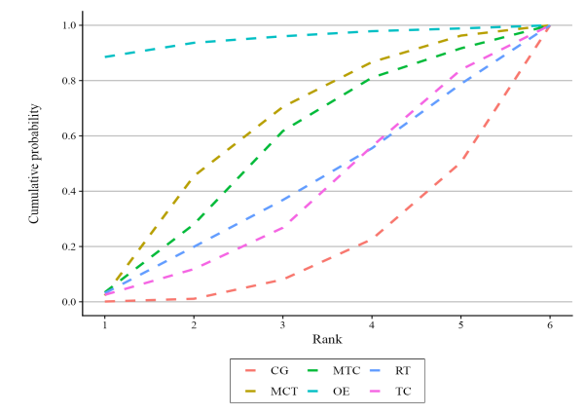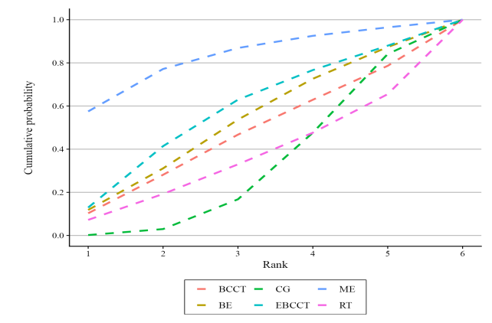
(TUG) (Grip strength)
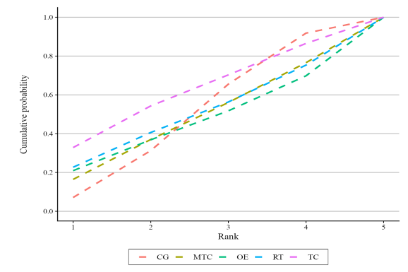
(SPPB)
Note: Cumulative ranking probability curves show the probability that each intervention ranks among the best interventions for each outcome. Curves closer to the upper-left corner indicate more favourable rankings. For TUG, rankings were interpreted in the direction of greater reduction in TUG time. Ranking results should be interpreted alongside effect estimates, uncertainty intervals, heterogeneity, inconsistency, and certainty of evidence.
3.6 Model convergence, heterogeneity, and inconsistency
Detailed convergence diagnostics, heterogeneity estimates, and inconsistency feasibility assessments are provided in Appendix 7.
3.6.1 Model convergence
Across the five Bayesian network meta-analysis models, numerical convergence diagnostics indicated adequate convergence. The PSRF point estimates ranged from 1.000 to 1.008, and the upper limits of the PSRF ranged from 1.000 to 1.030. Effective sample sizes ranged from 266 to 3725 across monitored parameters. For the heterogeneity parameter, the upper PSRF ranged from 1.008 to 1.030, indicating acceptable convergence, although sampling precision was lower for some sparse networks. Overall, no evidence of non-convergence was detected.
3.6.2 Heterogeneity analysis
In the supplementary frequentist framework, substantial heterogeneity was observed for MoCA (τ = 1.772, I² = 89.4%, Q = 37.75, df = 4, P < 0.001). For TUG, heterogeneity was not statistically significant (τ = 0, I² = 0%, Q = 0.86, df = 2, P = 0.650). For MMSE, SPPB, and grip strength, heterogeneity parameters could not be reliably estimated in the frequentist framework because the corresponding networks had zero degrees of freedom.
In the Bayesian random-effects models with the primary Uniform(0, 10) prior for τ, posterior heterogeneity estimates were imprecise, with wide 95% CrIs: MoCA τ = 2.36 (95% CrI = 0.90 to 6.01), MMSE τ = 5.11 (0.35 to 9.79), TUG τ = 1.80 (0.02 to 8.11),
SPPB τ = 4.19 (0.21 to 9.51), and grip strength τ = 5.07 (0.21 to 9.76). These findings reflect the sparse network structures and limited replicated comparisons, so treatment effects and rankings should be interpreted cautiously.
3.6.3 Inconsistency analysis
Inconsistency was assessed using design-by-treatment decomposition and node-splitting where possible. Formal inconsistency testing was limited by the sparse and predominantly control-centered network structures. In the MoCA network, Q decomposition showed significant total heterogeneity (Q = 37.75, df = 4, P < 0.0001), which was entirely attributable to within-design heterogeneity rather than between-design inconsistency. The main contributors were the CG:MCT design (Q = 24.56, df = 2, P < 0.0001) and the CG:BCCT design (Q = 12.30, df = 1, P = 0.0005). The between-design component had zero degrees of freedom and therefore could not be formally tested.
For TUG, Q decomposition did not indicate significant heterogeneity (Q = 0.86, df = 2, P = 0.6502), and the between-design component again had zero degrees of freedom. For MMSE, SPPB, and grip strength, design-by-treatment decomposition was not informative because the relevant components had zero degrees of freedom. Node-splitting analyses did not identify any comparison with both direct and indirect evidence across the five outcomes. Therefore, no formally testable inconsistency was detected, but this should be interpreted as a limitation of the sparse network structures rather than evidence of consistency.
3.7 Sensitivity and supplementary analyses
Full leave-one-study-out results, alternative-prior analyses, and exploratory subgroup summaries are provided in Appendix 8.
3.7.1 Sensitivity analyses
Leave-one-study-out sensitivity
analyses were conducted separately for each outcome. Overall, rankings were relatively stable for MoCA, TUG, and grip strength, but less stable for MMSE and SPPB because several leading nodes were supported by single studies. ME ranked first for MoCA in 7 of 10 leave-one-study-out models, OE remained highest for TUG in 5 of 6 models, and ME remained highest for grip strength in 4 of 5 models. For MMSE, the leading rank alternated mainly between DLRT and VP-MCT, while SPPB rankings changed when single-study nodes were removed.
In the sensitivity analysis excluding interventions that combined exercise with structured cognitive or cognitive-motor components, the remaining networks became smaller and more sparse. The CG-connected networks included 5, 1, 3, 3, and 3 independent model studies for MoCA, MMSE, TUG, SPPB, and grip strength, respectively. ME remained highest ranked for MoCA (SUCRA = 86.2) and grip strength (SUCRA = 85.0), OE remained highest for TUG, and TC ranked highest for SPPB. The MMSE network was reduced to a single TC-CG comparison and was therefore not informative for ranking.
The alternative weakly informative half-normal prior for τ produced smaller posterior heterogeneity estimates than the primary Uniform(0, 10) prior, with τ means ranging from 0.62 to 1.42 across outcomes. The main ranking patterns were broadly unchanged: ME and BCCT remained the leading MoCA interventions, DLRT and VP-MCT remained among the leading MMSE interventions, OE remained highest for TUG, ME remained highest for grip strength, and TC remained highest for SPPB. These sensitivity findings supported the overall robustness of the main conclusions but also highlighted the influence of sparse networks and single-study nodes.
3.7.2 Exploratory subgroup and supplementary pairwise analyses
Exploratory subgroup and parameter-based supplementary analyses were conducted using a frequentist pairwise meta-analysis framework and are presented as MDs with 95% CIs. These analyses were intended to supplement the Bayesian network meta-analysis and were not formal tests of interaction effects. Figure 5 presents exploratory analyses by intervention content, weekly frequency, and total intervention duration.
For MoCA, both exercise plus cognitive/dual-task interventions (MD = 2.98, 95% CI = 1.19 to 4.77) and exercise-only or mind-body interventions (MD = 2.13, 95% CI = 0.29 to 3.97) showed favorable effects. Three-times-weekly interventions showed a larger effect (MD = 3.40, 95% CI = 2.24 to 4.55) than twice-weekly interventions, and interventions lasting 12 to 16 weeks showed the most favorable duration-based estimate (MD = 3.83, 95% CI = 2.67 to 4.99).
For MMSE, favorable effects were mainly observed for exercise plus cognitive/dual-task interventions (MD = 2.87, 95% CI = 1.75 to 3.99), three-times-weekly interventions (MD = 3.14, 95% CI = 1.76 to 4.51), and interventions lasting 12 to 16 weeks (MD = 3.63, 95% CI = 2.36 to 4.90). The exercise-only or mind-body subgroup was based on a single study and did not show clear evidence of benefit.
For TUG, where lower values indicate better performance, negative MDs represent improvement. Exercise plus cognitive/dual-task interventions reduced TUG time (MD = -1.17, 95% CI = -1.53 to -0.82), while exercise-only or mind-body interventions showed a larger but more uncertain estimate (MD = -2.28, 95% CI = -5.76 to 1.20). Twice-weekly interventions were associated with reduced TUG time (MD = -0.99, 95% CI = -1.41 to -0.57).
For grip strength, exercise plus cognitive/dual-task interventions showed a small favorable effect (MD = 2.26, 95% CI = 0.05 to 4.48), while exercise-only or mind-body interventions showed a positive but
imprecise estimate (MD = 3.22, 95% CI = -0.96 to 7.39). For SPPB, subgroup estimates did not show clear evidence of benefit, with estimates close to the null and wide confidence intervals.
Overall, the exploratory subgroup findings were broadly consistent with the main network estimates, but they should be interpreted cautiously because several subgroups included only one or a few studies and were not based on randomized subgroup comparisons.
3.8 Small-study effects
Small-study effects were assessed using comparison-adjusted funnel plots. The primary CG-connected analyses included 10, 8, 7, 4, and 5 source contrasts for MoCA, MMSE, TUG, SPPB, and grip strength, respectively.
For MoCA, Egger-type regression showed no significant funnel plot asymmetry (P = 0.0895), consistent with non-significant Begg and
Thompson-Sharp tests (P = 0.7884 and P = 0.4438, respectively). For TUG, exploratory Egger-type regression was also non-significant (P = 0.8296), although the number of data points was below the conventional threshold for reliable testing. Formal regression-based assessments for MMSE, SPPB, and grip strength were not informative because of limited variation in comparison-adjusted effects.
Overall, no clear evidence of small-study effects was observed; however, these findings should be interpreted cautiously because of sparse networks and the predominance of single-study direct comparisons. Detailed small-study effect assessments and comparison-adjusted funnel plots are provided in Appendix 9.
3.9 Certainty of evidence
The certainty of evidence was evaluated using the CINeMA framework at the level of network treatment comparisons (Appendix 9). Overall, most network estimates were rated as moderate to low certainty, with some comparisons rated as very low. Downgrading was mainly due to within-study bias, indirectness, imprecision, and sparse network structures. Therefore, favorable point estimates or rankings should be interpreted cautiously alongside the corresponding risk-of-bias, heterogeneity, inconsistency,

and imprecision assessments.
Figure 5. Exploratory subgroup analysis, weekly-frequency sensitivity analysis, and descriptive supplementary analysis for outcomes

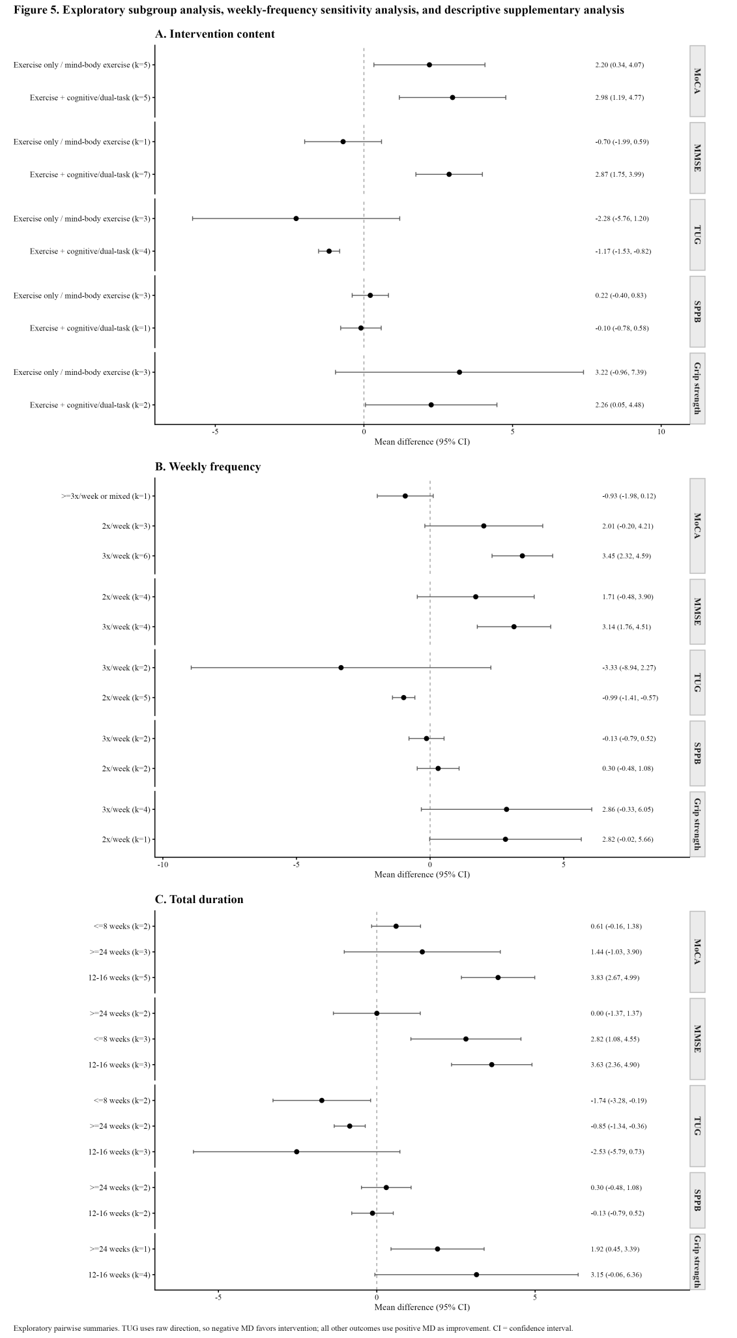

Note: Forest plots show exploratory pairwise pooled mean differences according to intervention content, weekly frequency, and total intervention duration. Points represent mean differences and horizontal lines represent 95% confidence intervals. The value of k indicates the number of intervention-control comparisons included in each subgroup. For MoCA, MMSE, SPPB, and grip strength, positive mean differences favor the intervention; for TUG, negative mean differences favor the intervention because lower TUG time indicates better physical performance. These analyses were exploratory and were not formal tests of subgroup interaction.

3.10 Safety, adherence, and feasibility
Reporting of adverse events, adherence, withdrawals, and feasibility was inconsistent across trials, precluding quantitative synthesis. Available trial-level information is summarized in Appendix 10.

4 Discussion
This NMA compared exercise-based interventions across cognitive and physical outcomes in older adults with cognitive frailty. The comparative patterns differed across outcomes. For MoCA, ME showed the most favorable ranking profile, whereas BCCT was the only intervention whose 95% CrI excluded the null. DLRT ranked highest for MMSE, OE for TUG, ME for grip strength, and TC for SPPB; however, the corresponding credible intervals generally included the null. Therefore, these rankings should be interpreted as relative probabilistic patterns rather than evidence of definitive superiority. Interpretation is further constrained by sparse networks, substantial heterogeneity in
cognitive outcomes, and predominantly moderate-to-low certainty of evidence. Some interventions also produced relatively large point estimates, particularly OE for TUG and ME for grip strength; however, their credible intervals were wide and included the null. Given the limited number of contributing studies and the presence of single-study nodes, these large estimates should not necessarily be interpreted as clinically robust effects.
In terms of cognitive outcomes, ME and BCCT showed favorable signals for MoCA, whereas DLRT ranked highest for MMSE; however, most corresponding estimates remained imprecise. Accordingly, the present findings should be interpreted as signals of potential benefit rather than definitive evidence of superiority for any specific intervention. Previous systematic reviews have similarly suggested that exercise, particularly multicomponent programs, may improve cognitive function in older adults with cognitive frailty, although effect sizes vary substantially across intervention types [15, 37]. Considerable between-study heterogeneity was observed for cognitive outcomes, particularly within the MoCA network. In the present analysis, this heterogeneity may reflect differences in baseline cognitive and physical function, intervention composition, training dose, comparator conditions, and
the operationalization of cognitive frailty across trials. Given the limited number of studies contributing to several comparisons, formal analyses to identify specific sources of heterogeneity were not feasible. Consequently, effect estimates and rankings for cognitive outcomes should be interpreted with caution, particularly when the network is sparse or when nodes are supported by only a few studies. In such contexts, ranking metrics should be considered alongside relative effects, credible intervals, and the certainty of evidence [38, 39].
The potential benefits of multicomponent exercise and combined exercise–cognitive interventions observed in this study may reflect multiple interacting physiological mechanisms, including improved cerebral perfusion, enhanced neuroplasticity, strengthened neuromuscular function, better metabolic regulation, and facilitation of muscle–brain axis signaling [40–42]. These pathways may plausibly influence both cognitive and physical domains and therefore provide a biological rationale for the cross-domain effects observed with some multicomponent interventions. However, these mechanisms were not directly tested in most randomized controlled trials included in this analysis. Current supportive evidence comes mainly from studies in general older adults, individuals with mild cognitive impairment, and selected mechanistic investigations, rather than from trials specifically in cognitively frail populations [43]. Thus, these biological mechanisms should be viewed as hypothetical explanations for our findings, rather than as direct evidence establishing the comparative superiority of multicomponent or combined exercise–cognitive interventions. Future studies incorporating neuroimaging, biomarkers, muscle function measures, and long-term follow-up are needed to further validate these potential pathways in cognitive frailty.
Exploratory subgroup analyses suggested that effect estimates varied by intervention type, weekly training frequency, and total intervention duration. For MoCA and MMSE, exercise combined with cognitive or dual-task training generally showed more favorable effects, with larger point estimates observed for interventions delivered three times weekly and lasting 12-16 weeks. For TUG, exercise plus cognitive or dual-task training and interventions delivered twice weekly suggested some improvement, whereas no clear advantage was observed across SPPB subgroups. Included studies also showed heterogeneity in training dose and delivery even when the intervention was classified as MCT. For example, Kwan et al. delivered an 8-week program with two sessions per week lasting either 30 or 60 minutes, whereas Lai et al. used a 16-week protocol with two 30-minute sessions weekly [22, 23, 31]. However, these subgroup analyses were based on study-level characteristics rather than randomized comparisons of different exercise doses, and no formal interaction or dose-response analyses were conducted. Accordingly, these findings should be interpreted as hypothesis-generating. They may inform future trials directly comparing different training frequencies, session durations, and intervention periods, but are insufficient to determine an optimal exercise dose.
Across exercise modalities, ME and traditional mind-body exercise showed potentially favorable signals. Despite favorable SUCRA rankings for MoCA and grip strength, the 95% credible intervals for both ME estimates included the null, and no firm conclusions could be drawn regarding its superiority over other exercise types. Previous randomized controlled trials in older adults with mild cognitive impairment have shown that comprehensive programs incorporating aerobic, resistance, balance, and cognitive stimulation components can improve selected cognitive and physical outcomes, providing some support for the
possible cross-domain effects of multicomponent training [44]. However, this evidence comes mainly from MCI populations, and considerable heterogeneity exists in the specific components and training doses used across ME studies. Baduanjin also showed favorable point estimates for some outcomes, including grip strength, although the corresponding network estimates remained imprecise. Randomized trials in older adults with cognitive frailty suggest that 24 weeks of Baduanjin training may improve MoCA scores, executive function and some measures of physical function, providing preliminary evidence of its potential value in this population [45, 46]. However, there is currently insufficient evidence to recommend Baduanjin as a preferred or first-line intervention. Future research should rigorously evaluate its efficacy, adherence, and safety.
The interpretation of our findings is constrained by heterogeneity in the definition of cognitive frailty and by the sparsity of the evidence network. Included studies varied in the instruments and thresholds used to assess frailty, the inclusion or exclusion of pre-frail participants, the cognitive screening tools and cut-offs applied, and the approaches used to exclude dementia. Previous work has highlighted the absence of a unified diagnostic criterion for cognitive frailty, and such operational heterogeneity may compromise the comparability of study populations and
the interpretability of intervention effects [47, 48]. Although no systematic imbalance in major effect modifiers was detected across direct comparisons, many comparisons were supported by only one or a few studies, limiting the ability to adequately evaluate the transitivity assumption. Most networks were star-shaped around the control group, with several nodes supported by single-study nodes and lacking closed loops; consequently, formal inconsistency testing was restricted, and the absence of detected inconsistency should not be equated with evidence of network consistency. Furthermore, high SUCRA values or probabilities of being ranked first may be influenced by small sample sizes, single-study nodes, and imprecise effect estimates. Methodological research has shown that treatment rankings in network meta-analysis carry inherent uncertainty, and high rankings do not necessarily indicate clear clinical superiority [49]. Therefore, the ranking results in this study should be interpreted in conjunction with relative effects, credible intervals, and CINeMA-based assessments of evidence certainty.
From a clinical perspective, the current findings suggest that different exercise modalities may have different outcome profiles rather than supporting a single optimal intervention for all older adults with cognitive frailty. ME and BCCT showed favorable signals for cognitive outcomes, OE ranked high for functional mobility, and ME showed potential benefits for grip strength. However, the precision and certainty of these estimates remain insufficient to justify specific individualized exercise prescriptions or the prioritization of any particular exercise modality. Previous studies have emphasized that when assessing exercise interventions in older adults with cognitive impairment or frailty, considerations should go beyond efficacy to include adherence, physical function, and
intervention feasibility [50, 51]. Clinical decision-making should therefore integrate baseline functional and cognitive status, safety risks, patient adherence and preferences, and implementation conditions. Moreover, inconsistent reporting of adverse events, adherence, dropouts, and feasibility across included studies limits comparisons of clinical acceptability and safety across exercise modalities. Previous systematic reviews have also reported incomplete reporting of implementation and safety outcomes [52]. Future studies should use more standardized definitions of cognitive frailty, improve direct comparisons between active interventions, and systematically report safety, adherence, and feasibility. Larger sample sizes and longer follow-up are also needed to further validate the clinical value of different intervention types and doses.
This study has several limitations. First, some outcome networks were sparse, with several intervention nodes supported by single studies, and the MoCA network exhibited substantial heterogeneity, reducing the stability of effect estimates and ranking results. Second, considerable variability existed in the specific components, intensity, frequency, and duration of MCT, ME, and other multicomponent interventions, limiting the identification of specific effective components. Third, subgroup analyses were primarily based on study-level characteristics without formal interaction tests or dose-response analyses, rendering these findings exploratory. Fourth, CINeMA assessments indicated that the overall certainty of evidence was predominantly moderate to low, with some comparisons rated as very low, indicating that many comparisons remain limited by imprecision, indirectness, or both. Finally, reporting of safety, adherence, feasibility, and long-term follow-up outcomes was inadequate, and several mechanistic interpretations were derived primarily from studies in general older adults, individuals with MCI, or experimental investigations; therefore, these mechanistic interpretations remain indirect and should be regarded as hypothesis-generating.

5 Conclusion
This systematic review and network meta-analysis suggests that exercise-based interventions may provide cognitive and physical benefits for older adults with cognitive frailty, although comparative effects varied across outcomes. ME and BCCT showed favorable signals for cognitive function, whereas OE, ME, and TC ranked relatively highly for functional mobility, grip strength, and composite physical performance
, respectively. However, most corresponding credible intervals included the null, and the certainty of evidence was predominantly moderate to low. Treatment rankings should therefore be interpreted cautiously in view of sparse networks, substantial heterogeneity, limited ability to assess inconsistency, and several single-study nodes. Current evidence is insufficient to support definitive individualized exercise prescriptions or the prioritization of a specific exercise modality. Future adequately powered head-to-head randomized trials should adopt standardized cognitive frailty definitions, compare clinically relevant exercise modalities and doses, and improve the reporting of safety, adherence, feasibility, and long-term outcomes.

Declarations
Abbreviations
CF: Cognitive frailty
NMA: Network meta-analysis
RCT: Randomized controlled trial
MoCA: Montreal Cognitive Assessment
MMSE: Mini-Mental State Examination
TUG: Timed Up and Go test
SPPB: Short Physical Performance Battery
ME: Multicomponent exercise
BE: Baduanjin exercise
MCT: Motor-cognitive training

BCCT: Baduanjin combined cognitive training
EBCCT: Exercise-based cognitive combined training
OE: Otago exercise
TC: Tai Chi
RT: Resistance training
HIIT: High-intensity interval training
AE: Aerobic exercise

Ethics approval and consent to participate
This study is a systematic review and network meta-analysis based on previously published randomized controlled trials. Therefore, ethical approval and informed consent were not required.

Consent for publication
Not applicable.

Availability of data and materials
All data generated or analyzed during this study are included in this published article and its supplementary information files. No new primary datasets were generated. The datasets supporting the conclusions of this study are derived from previously published randomized controlled trials, which are cited in the manuscript.

Competing interests
The authors declare that they have no competing interests.

Funding
The work was supported by the Shanghai Nursing Association Scientific Research Project (No. 2024MS-B03) and Western Medicine Nursing from the Pudong New Area Health Commission (No. PWZxk2022-06).

Authors’ contributions
Liyao Su: conceptualization, methodology, data extraction, formal analysis, writing—original draft.
Wanhaier Abudoureheman: data curation, validation, visualization.
Yancheng Wang: statistical support, software.
Shuyao Bai: literature screening and risk of bias assessment.
Siyuan Liu: supervision and manuscript revision.
Yongmei Jin: study design, supervision, critical revision of manuscript, and final approval.

Acknowledgements
The authors would like to thank all researchers whose studies were included in this systematic review and network meta-analysis.

References
1. Cozza M, Boccardi V. Cognitive frailty: A comprehensive clinical paradigm beyond cognitive decline. Ageing Res Rev. 2025;108:102738. https://doi.org/10.1016/j.arr.2025.102738.
2. Park C, Kim N, Won CW, Kim M. Predicting cognitive frailty in community-dwelling older adults: A machine learning approach based on multidomain risk factors. Sci Rep. 2025;15:18369. https://doi.org/10.1038/s41598-025-00844-3.
3. Zhang Y, Xia H, Jiang X, Wang Q, Hou L. Prevalence and outcomes of cognitive frailty among community-dwelling older adults: A systematic review and meta-analysis. Res Gerontol Nurs. 2024;17:202–12. https://doi.org/10.3928/19404921-20240621-01.
4. Bu Z, Huang A, Xue M, Li Q, Bai Y, Xu G. Cognitive frailty as a predictor of adverse outcomes among older adults: A systematic review and meta-analysis. Brain Behav. 2021;11:e01926. https://doi.org/10.1002/brb3.1926.
5. L S, M N, Ej A, Pw S, M M, S B, et al. Shared mechanisms for cognitive impairment and physical frailty: A model for complex systems. Alzheimer’s Dement (N Y N Y). 2020;6. https://doi.org/10.1002/trc2.12027.
6. Aguilar-Navarro SG, Mimenza-Alvarado AJ, Yeverino-Castro SG, Caicedo-Correa SM, Cano-Gutiérrez C. Cognitive frailty and aging: Clinical characteristics, pathophysiological mechanisms, and potential prevention strategies. Arch Med Res. 2025;56:103106. https://doi.org/10.1016/j.
arcmed.2024.103106.
7. Ma L, Chan P. Understanding the physiological links between physical frailty and cognitive decline. Aging Dis. 2020;11:405–18. https://doi.org/10.14336/AD.2019.0521.
8. Sui SX, Holloway-Kew KL, Hyde NK, Williams LJ, Leach S, Pasco JA. Muscle strength and gait speed rather than lean mass are better indicators for poor cognitive function in older men. Sci Rep. 2020;10:10367. https://doi.org/10.1038/s41598-020-67251-8.
9. van Dinther M, Hooghiemstra AM, Bron EE, Versteeg A, Leeuwis AE, Kalay T, et al. Lower cerebral blood flow predicts cognitive decline in patients with vascular cognitive impairment. Alzheimer’s Dement: J Alzheimer’s Assoc. 2024;20:136–44. https://doi.org/10.1002/alz.13408.
10. Prommaban A, Moonkayaow S, Phinyo P, Siviroj P, Sirikul W, Lerttrakarnnon P. The effect of exercise
program interventions on frailty, clinical outcomes, and biomarkers in older adults: A systematic review. J Clin Med. 2024;13:6570. https://doi.org/10.3390/jcm13216570.
11. Gomez-Pinilla F, Hillman C. The influence of exercise on cognitive abilities. Compr Physiol. 2013;3:403–28. https://doi.org/10.1002/cphy.c110063.
12. Norman JE, Rutkowsky J, Bodine S, Rutledge JC. The potential mechanisms of exercise-induced cognitive protection: A literature review. Curr Pharm Des. 2018;24:1827–31. https://doi.org/10.2174/1381612824666180406105149.
13. Joseph A-M, Adhihetty PJ, Leeuwenburgh C. Beneficial effects of exercise on age-related mitochondrial dysfunction and oxidative stress in skeletal muscle. J Physiol. 2016;594:5105–23. https://doi.org/10.1113/JP270659
.
14. Bliss ES, Wong RH, Howe PR, Mills DE. Benefits of exercise training on cerebrovascular and cognitive function in ageing. J Cereb Blood Flow Metab: Off J Int Soc Cereb Blood Flow Metab. 2021;41:447–70. https://doi.org/10.1177/0271678X20957807.
15. Luo H, Zheng Z, Yuan Z, Hu H, Sun C. The effectiveness of multicomponent exercise in older adults with cognitive frailty: a systematic review and meta-analysis. Arch Public HEALTH = Arch Belg Sante Publique. 2024;82:229. https://doi.org/10.1186/s13690-024-01441-y.
16. Su X, McDonough DJ, Chu H, Quan M, Gao Z. Application of network meta-analysis in the field of physical activity and health promotion. J Sport Health Sci. 2020;9:511–20. https://doi.org/10.1016/j.jshs.2020.07.011.
17. Nikolakopoulou A, Higgins JPT, Papakonstantinou T, Chaimani A, Del Giovane C, Egger M, et al. CINeMA: An approach for assessing confidence in the results of a network meta-analysis. PLoS Med. 2020;17:e1003082. https://doi.org/10.1371/journal.pmed.1003082.
18. Zheng L, Li X, Xu Y, Yang Y, Wan X, Ma X, et al. Effects of virtual reality-based activities of daily living rehabilitation training in older adults with cognitive frailty and activities of daily living impairments: A randomized controlled trial. J Am Med Dir Assoc. 2025;26:105397. https://doi.org/10.1016/
j.jamda.2024.105397.
19. Yoon DH, Lee J-Y, Song W. Effects of resistance exercise training on cognitive function and physical performance in cognitive frailty: A randomized controlled trial. J Nutr, Health Aging. 2018;22:944–51. https://doi.org/10.1007/s12603-018-1090-9.
20. Wang X, Wu J, Zhang H, Zheng G. Effect of baduanjin exercise on executive function in older adults with cognitive frailty: A randomized controlled trial. Clin Rehabil. 2024;38:510–9. https://doi.org/10.1177/02692155231215891.
21. Liao Y-Y, Hsu W-C, Wang KC, Liu C-L, Tseng W-Y, Lin Y-J. Effects of interactive boxing-cycling on dual-task walking and prefrontal cortex activation in older adults with cognitive frailty: A randomized controlled trial. Geriatr Nurs. 2025;61:654–61. https://doi.org/10.1016/j.gerinurse.2024.12.010
.
22. Kwan RYC,
Liu J, Sin OSK, Fong KNK, Qin J, Wong JCY, et al. Effects of virtual reality motor-cognitive training for older people with cognitive frailty: Multicentered randomized controlled trial. J Med Internet Res. 2024;26:e57809. https://doi.org/10.2196/57809.
23. Kwan RYC, Liu JYW, Fong KNK, Qin J, Leung PK-Y, Sin OSK, et al. Feasibility and effects of virtual reality motor-cognitive
training in community-dwelling older people with cognitive frailty: Pilot randomized controlled trial. JMIR Serious Games. 2021;9:e28400. https://doi.org/10.2196/28400.
24. Jiayuan Z, Xiang-Zi J, Li-
Na M, Jin-Wei Y, Xue Y. Effects of mindfulness-based tai chi chuan on physical performance and cognitive function among cognitive frailty older adults: A six-month follow-up of a randomized controlled trial. J Prev Alzheimer’s Dis. 2022;9:104–12. https://doi.org/10.14283/jpad.
2021.40.
25. Falck RS, Hsu CL, Davis JC, Rice J, Dao E, Dian L, et al. Effect of a home-based exercise program on subsequent falls among community-dwelling older adults with cognitive frailty: a sub-group analysis of a randomized controlled trial. Maturitas. 2025;191:108151. https://doi.org/10.1016/
j.maturitas.2024.108151.
26. Chen X, Zhao L, Liu Y, Zhou Z, Zhang H, Wei D, et al. Otago exercise programme for physical function and mental health among older adults with cognitive frailty during COVID-19: A randomised controlled trial. J Clin Nurs. 2021. https://doi.org/10.1111/jocn.15964.
27. Chen HY, Wei LH, Zhong MR, Liao ZP, Li YM. Effects of high-intensity interval training on cognitive frailty in older patients with coronary heart disease. Chin J Pract Nurs. 2023;39:587–92. [in Chinese].
28. Xia R. Mechanisms underlying the effects of Baduanjin on cognitive and physical function in older adults with cognitive frailty based on the triple-network model of the brain [doctoral dissertation]. Fujian University of Traditional Chinese Medicine; 2020. https://doi.org/10.27021/d.
cnki.gfjzc.2020.000004. [in Chinese].
29. Liu YN, Wang N, Zhao Y, Sun YQ, Li SX, Wei JF. Application of variable-priority cognitive-motor dual-task training in older patients with type 2 diabetes and cognitive frailty. Chin J Behav Med Brain Sci. 2024;33:611–7. [in Chinese].
30. Ye Y. Effects of Baduanjin on oxidative stress and chronic inflammation in older adults with cognitive frailty [master’s thesis]. Fujian University of Traditional Chinese Medicine; 2023. https://doi.org/10.27021/d.cnki.gfjzc.2022.000320. [in Chinese].
31. Lai XX, Chen BY, Liu XX, Li Q, Zhu HW, Huo XP. Effects of motor-cognitive dual-task training in older adults with cognitive frailty. Pract Geriatr. 2024;38:821–5. [in Chinese].
32. Zhang Y, Huang SY, Wu RK, Han ZF. Effects of Baduanjin combined with cognitive training in older patients with multimorbidity and cognitive frailty. Chin Foreign Med Res. 2024;3:135–7. [in Chinese].
33. Yang L, Wang XY, Yan HN. Clinical study of Baduanjin combined with cognitive training for cognitive frailty in older patients with diabetes. Chin Gen Pract. 2023;26:2848–53. [in Chinese].
34. Han J, Wang JQ, Gao J, Xie BQ. Effects of resistance-band exercise combined with cognitive training on cognitive frailty in community-dwelling older adults. Chin Nurs Res. 2022;36:624–9. [in Chinese].
35. Liu YN, Zhao Y, Wang N, Sun YQ, Wei JF, Wang WT. Effects of cognitive-motor dual-task training on cognitive frailty in older patients with diabetes. J Nurs Sci. 2024;39:6–10. [in Chinese].
36. Ye M, Li SG, Zhu ZT, Zhu HM. Effects of a multicomponent exercise prescription in older adults with cognitive frailty. Chin Gen Pract. 2021;24:460–6. [in Chinese].
37. Yuan Y, Wang S, Zhou C, Zhang A, Zhang S, Wang Y. Effects of exercise interventions on cognition, physical function and quality of life among older adults with cognitive frailty: A systematic review and meta-analysis. Geriatr Nur (Lond). 2025;62 Pt A:96–107. https://doi.org/10.1016/
j.gerinurse.2025.01.006.
38. Trinquart L, Attiche N, Bafeta A, Porcher R, Ravaud P. Uncertainty in treatment rankings: Reanalysis of network meta-analyses of randomized trials. Ann Intern Med. 2016;164:666–73. https://doi.org/10.7326/M15-2521.
39. Dias S, Caldwell DM. Network meta-analysis explained. Arch Dis Child Fetal Neonatal Ed. 2019;104:F8–12. https://doi.org/10.1136/
archdischild-2018-315224.
40. Bliss ES, Wong RH, Howe PR, Mills DE. Benefits of exercise training on cerebrovascular and cognitive function in ageing. J Cereb Blood Flow Metab: Off J Int Soc Cereb Blood Flow Metab. 2021;41:447–70. https://doi.org/10.1177/0271678X20957807.
41. Wang Z, Xu X, Yang X, Wang SS, Zhou Y, Li Y. Effects of multicomponent exercise on cognitive function in persons with mild cognitive impairment: A systematic review and meta-analysis. Int J Nurs Stud. 2024;158:104843. https://doi.org/10.1016/j.ijnurstu.2024.104843.
42. Akalp K, Ferreira JP, Soares CM, Ribeiro MJ, Teixeira AM. The effects of different types of exercises on cognition in older persons with mild cognitive impairment: A systematic review and meta-analysis. Arch Gerontol Geriatr. 2024;126:105541. https://doi.org/10.1016/j.archger.2024.105541.
43. Huang X, Zhao X, Cai Y, Wan Q. The cerebral changes induced by exercise interventions in people with mild cognitive impairment and alzheimer’s disease: A systematic review. Arch Gerontol Geriatr. 2022;98:104547. https://doi.org/10.1016/j.archger.2021
.104547.
44. Suzuki T, Shimada H, Makizako H, Doi T, Yoshida D, Tsutsumimoto K, et al. Effects of multicomponent exercise on cognitive function in older adults with amnestic mild cognitive impairment: A randomized controlled trial. BMC Neurol. 2012;12:128. https://doi.org/10.1186/1471-2377-12-128.
45. Ye Y, Wan M, Lin H, Xia R, He J, Qiu P, et al. Effects of baduanjin exercise on cognitive frailty, oxidative stress, and chronic inflammation in older adults with cognitive frailty: A randomized controlled trial. Front Public Health. 2024;12:1385542. https://doi.org/10.3389/fpubh.2024.1385542.
46. Wang X, Wu J, Zhang H, Zheng G. Effect of baduanjin exercise on executive function in older adults with cognitive frailty: A randomized controlled trial. Clin Rehabil. 2024;38:510–9. https://doi.org/10.1177/02692155231215891.
47. Dobie K, Barr CJ, George S, Baker N, Pankhurst M, van den Berg MEL. A systematic review of assessment tools for cognitive frailty: Use, psychometric properties, and clinical utility. J Frailty Aging. 2025;14:100033. https://doi.org/10.1016/
j.tjfa.2025.100033.
48. Tang KF, Teh P-L, Lee SWH. Cognitive frailty and functional disability among community-dwelling older adults: A systematic review. Innov Aging. 2023;7:
igad005. https://doi.org/10.1093/geroni/igad005.
49. Trinquart L, Attiche N, Bafeta A, Porcher R, Ravaud P. Uncertainty in treatment rankings: Reanalysis of network meta-analyses of randomized trials. Ann Intern Med. 2016;164:666–73. https://doi.org/10.7326/M15-2521.
50. Yuan Y, Wang S, Zhou C, Zhang A, Zhang S, Wang Y. Effects of exercise interventions on cognition, physical function and quality of life among older adults with cognitive frailty: A systematic review and meta-analysis. Geriatr Nur (Lond). 2025;62 Pt A:96–107. https://doi.org/10.1016/j.gerinurse.
2025.01.006.
51.
Li G, Teng G, Zhang W, Song T, Li Y, Wang Z, et al. Comparative effects of different physical exercises on cognitive
function and intervention adherence in older adults with cognitive impairment: A systematic review and network meta-analysis. Clin Psychol Rev. 2025;120:102604. https://doi.org/10.1016/j.cpr.2025.102604.
52. Shivgulam ME,
Liu H, Zafar Z, Cheema M, Ahmadi S, Theou O, et al. Exercise interventions improve frailty in patients living in
long-
term care: A systematic review and meta-analysis. J Am Med Dir Assoc.
2025;26:105945. https://doi.org/10.1016/j.jamda.2025.105945.

